Supplementary materials

Figure S1. Correlation of RNA viruses expression between vmNGS and metaRNA-Seq. Each colour represents a viral family. All hits are expressed in additive log-ratio (ALR) with MS2 as reference. The blue line corresponds to the regression curve.

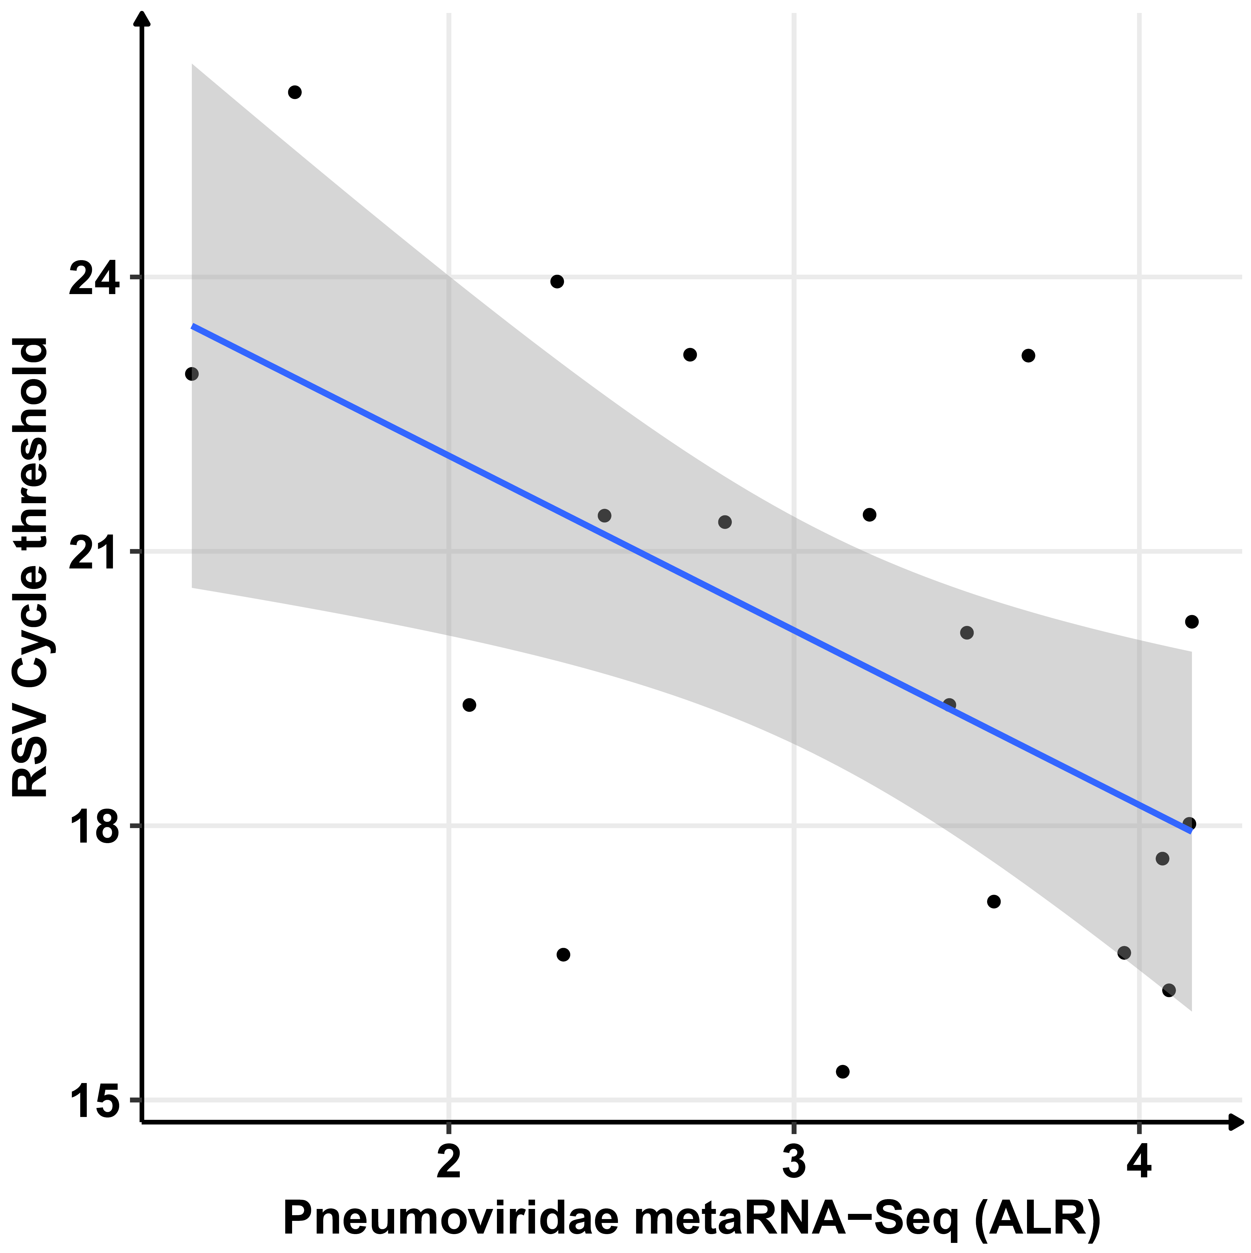
Figure S2. Correlation of RSV Cycle thresholds obtained by RT-PCR and Pneumoviridae ALR for metaRNA-Seq. The blue line represents the correlation curve.

Figure S3. Comparison of bacterial genera detected only by metaRNA-Seq. The lower panel corresponds to the number of positive samples and the distribution of relative abundances noted for the different bacterial genera.
Figure S4. Comparison of bacterial genera detected only by 16S-Seq. The lower panel corresponds to the number of positive samples and the distribution of relative abundances noted for the different bacterial genera.
Figure S5. Non-supervised hierarchical clustering in mRNA-Seq. The 2650 genes tested in mRNA-Seq were selected as they were expressed in all patients in mRNA-Seq and metaRNA-Seq. Heatmap colors are representative of log2RPM values.

