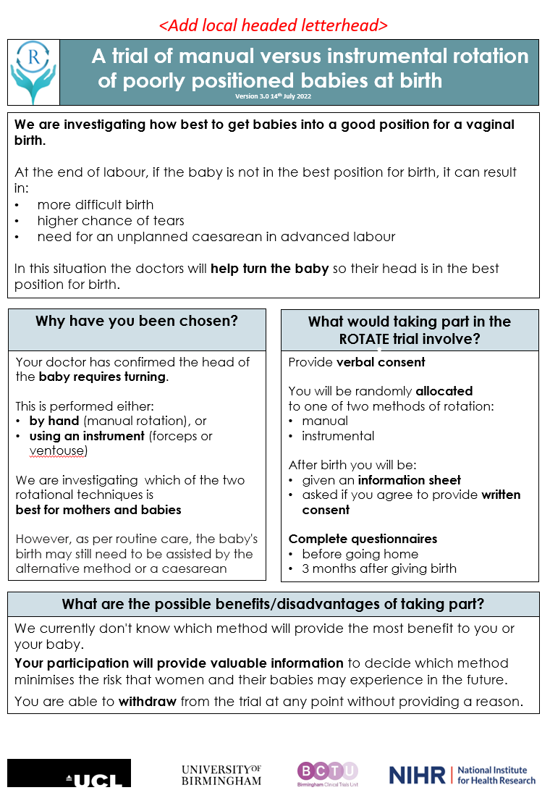
Additional file 1. Parent facing infographic for ROTATE

