Supplementary material

Characterization of the secondary structure, renaturation and physical ageing of gelatine adhesives
Elena Pulidoriª, Celia Duceª*, Emilia Bramanti^{b}*, Leila Birolo^{c}, Brunella Cipolletta^{c}, Laura Dello Ioio^{d}, Ilaria Bonaduceª

ª Department of Chemistry and Industrial Chemistry, University of Pisa, Via G. Moruzzi 13, 56124 Pisa, Italy
^{b} Institute of Chemistry of Organometallic Compounds, National Research Council, Via G. Moruzzi 1, 56124 Pisa, Italy
^{c} Department of Chemical Sciences, University of Naples Federico II, Complesso Universitario di Monte S. Angelo, Via Cinthia 21, 80126, Naples, Italy
^{d} Dello Ioio Restauri, Vico Equense, 80069, Naples, Italy

*Corresponding author

Table of content
- Table S1. Values of enthalpy relaxation and the peak temperature calculated at each time point using an annealing temperature of 40 °C and 30 °C.
- Table S2a. Glass transition temperature (t_{g}) and associated heat capacity change (∆Cp) determined from the first and second heating scans, onset temperature (t_{onset}), peak temperature (t_{peak}), width signal expressed as the difference between the temperature at the start and end of the event (∆t), and enthalpy (∆H) calculated for the two signals observed in the first heating scan only.
- Table S2b. Glass transition temperature (t_{g}) and associated heat capacity change (∆C_{p}) determined from the first and second heating scans, onset temperature (t_{onset}), peak temperature (t_{peak}), width signal expressed as the difference between the temperature at the start and end of the event (∆t), and enthalpy (∆H) calculated for the signals observed in the first heating scan for samples with several overlapping signals.
- Table S3. Temperature (°C) and mass loss (% w/w) of each degradation step observed during the TGA carried out under nitrogen flow.
- Table S4. Second mass loss peak temperature (t_{max}), maximum degradation rate (DTG_{max}) and width of the collagen degradation peak (Δonset-endset) obtained from TG and DTG curves recorded under nitrogen flow.
- Figure S1. ATR-FTIR spectra of collage, gelatine A, gelatine B, HP3, HP4, HP6, HP8, HM1, HM4, HM5, BM1, BM2, BM3, BM4, BM5 samples.
- Figure S2. DSC curves obtained during the second heating scan at 10 °C/min of collagen (red line), gelatine A and B (black line), hide-derived glues (green line), bone-derived glues (blue line)

Table S1. Values of enthalpy relaxation and the peak temperature calculated at each time point using an annealing temperature of 40 °C and 30 °C.
Annealing at 40 °C | t_{peak} (°C) |  |  |  | ∆H (J/g)
Annealing at 40 °C | 3h | 6h | 12h | 24 h | 3h | 6h | 12h | 24 h
HP3 | 62.0 | 62.5 | 63.1 | 63.5 | 5.2 | 5.5 | 6.4 | 6.8
HP4 | 62.1 | 62.9 | 63.3 | 63.8 | 4.4 | 5.3 | 6.0 | 6.5
HP6 | 59.0 | 59.6 | 60.0 | 60.4 | 5.5 | 6.2 | 6.6 | 7.0
HP8 | 59.1 | 59.7 | 60.3 | 60.7 | 4.3 | 4.5 | 4.5 | 4.6
BM5 | 61.3 | 62.3 | 63.0 | 63.5 | 5.5 | 6.6 | 7.3 | 7.9
Annealing at 30 °C | t_{peak} (°C) |  |  |  | ∆H (J/g)
Annealing at 30 °C | 3h | 6h | 12h | 24 h | 3h | 6h | 12h | 24 h
HP6 | 56.0 | 55.9 | 56.4 | 56.6 | 3.4 | 4.4 | 5.5 | 6.0

Table S2a. Glass transition temperature (t_{g}) and associated heat capacity change (∆Cp) determined from the first and second heating scans, onset temperature (t_{onset}), peak temperature (t_{peak}), width signal expressed as the difference between the temperature at the start and end of the event (∆t), and enthalpy (∆H) calculated for the two signals observed in the first heating scan only.
 |  |  | Signal in the 50-80 °C temperature range |  |  |  | Signal in the 80-110 °C temperature range
Sample | t_{g} (°C)  (1 ramp/2ramp) | ∆C_{p} (J/K∙g)  (1 ramp/2ramp) | t_{onset}  (°C) | t_{peak}  (°C) | ∆t  (°C) | ∆H  (J/g) | t_{onset}  (°C) | t_{peak}  (°C) | ∆t  (°C) | ∆H  (J/g)
Gelatine A | 68/59 | 0.65/0.53 | 68 | 72 | 21 | 6 | 90 | 95 | 34 | 11
Gelatine B | 62/54 | 0.82/0.76 | 62 | 68 | 34 | 12 | 88 | 95 | 30 | 3
HP3 | 63 ± 3/55.9 ± 0.6 | 1.006±0.006/0.71±0.04 | 64 ± 2 | 71.3 ± 0.6 | 33 ± 2 | 9.3 ± 0.9 | 81.1 ± 0.5 | 90 ± 3 | 25 ± 1 | 3.2 ± 0.7
HP4* | 59/58 | 0.65/0.53 | 59 | 63 | 22 | 5 | 86 | 95 | 23 | 1
HP6 | 67 ± 3/53 ± 2 | 1.1±0.1/0.7±0.2 | 70 ± 1 | 73 ± 2 | 20 ± 2 | 9 ± 1 | 87 ± 4 | 94 ± 1 | 28 ± 4 | 12 ± 1
HP8 | 52 ± 2/52 ± 2 | 0.71 ± 0.06/0.6 ± 0.1 | 52 ± 1 | 65 ± 4 | 29 ± 5 | 8 ± 4 | 75 ± 1 | 88.5 ± 0.2 | 35 ± 3 | 5.6 ± 0.8
HM1 | 73/62 | 0.9/0.5 | 73 | 79 | 31 | 7 | 94 | 100 | 29 | 9
HM4 | 57.2 ± 0.9/51 ± 0.5 | 0.65 ± 0.06/0.59 ± 0.06 | 59.61 ± 0.03 | 66.0 ± 0.6 | 28 ± 3 | 11.1 ± 0.9 | / | / | / | /
HM5 | 66 ± 1/55 ± 1 | 0.9 ± 0.1/0.94 ± 0.06 | 66.2 ± 0.6 | 71.5 ± 0.3 | 21 ± 4 | 7 ± 2 | 87.6 ± 0.2 | 94.5 ± 0.4 | 34 ± 1 | 10 ± 1
BM1 | 64 ± 2/56 ± 4 | 0.82 ± 0.06/0.67 ± 0.02 | 66 ± 3 | 69 ± 2 | 17 ± 2 | 8 ± 1 | 77 ± 1 | 88 ± 3 | 27 ± 2 | 7.0 ± 0.3
BM2 | 67/57 | 0.8/0.5 | 69 | 72 | 19 | 8 | 82 | 95 | 27 | 4
*HP4 is the only sample showing another signal in the 50-80 °C temperature range with t_{onset} = 71 °C, t_{peak} = 73 °C, ∆t = 12 °C and ∆H = 0.9 J/g

Table S2b. Glass transition temperature (t_{g}) and associated heat capacity change (∆C_{p}) determined from the first and second heating scans, onset temperature (t_{onset}), peak temperature (t_{peak}), width signal expressed as the difference between the temperature at the start and end of the event (∆t), and enthalpy (∆H) calculated for the signals observed in the first heating scan for samples with several overlapping signals.
Sample | t_{g} (°C)  (1 ramp/2ramp) | ∆C_{p} (W/g)  (1 ramp/2ramp) | t_{onset}  (°C) | t_{peak1}  (°C) | t_{peak2}  (°C) | t_{peak3}  (°C) | t_{peak4}  (°C) | ∆t (°C) | ∆H (J/g)
Collagen calf skin | 0.3/-2 | 1.2/1.3 | 43 | 52 | / | 82 | 109 | 85 | 18
BM3 | 63/54 | 1.3/1.1 | 65 | 69 | 77 | 84 | 97 | 64 | 25
BM4 | 62/52 | 1.0/0.9 | 64 | 68 | 76 | 88 | / | 49 | 22
BM5 | 67/58 | 1.1/0.9 | 67 | 69 | 74 | / | 95 | 45 | 13

Table S3. Temperature (°C) and mass loss (% w/w) of each degradation step observed during the TGA carried out under nitrogen flow.
n° step | Temperature (°C)/mass loss (% w/w)
n° step | Collagen from calf skin | Gelatine (type A) | Gelatine (type B) | HP3 | HP4
1  (Max, shoulder) | t_{max} = 38 °C | t_{max} = 51 °C | t_{max} = 45 °C  t_{s1} = 93 °C | t_{max} = 81 °C* | t_{max} = 47 °C
1  (Max, shoulder) | 5 % | 11 % | 13 % | 12 % | 12 %
2 | 170 °C | / | / | / | /
2 | 30 % | / | / | / | /
3  (Max, shoulder) | t_{max} = 326 °C  t_{s2} = 390 °C | t_{max} = 324 °C  t_{s4}=297 °C  t_{s3} = 213 °C  t_{s2} = 404 °C | t_{max} = 327 °C  t_{s4}=295 °C  t_{s3} = 218 °C  t_{s2} = 378 °C | t_{max} = 319 °C  t_{s3} = 215 °C  t_{s2} = 397 °C | t_{max} = 319 °C  t_{s3} = 212 °C  t_{s2} = 363 °C
3  (Max, shoulder) | 51 % | 70 % | 71 % | 74 % | 71 %
Residue at  900 °C | 14 % | 19 % | 16 % | 14 % | 17 %
n° step | Temperature (°C)/mass loss (%)
n° step | HP6 | HP8 | HM1 | HM4 | HM5
1  (Max, shoulder) | t_{max} = 106 °C* | t_{max} = 46 °C | t_{max} = 49 °C | t_{max} = 60 °C | t_{max} = 51 °C  t_{s1} = 97 °C
1  (Max, shoulder) | 12 % | 11 % | 12 % | 10 % | 12 %
2 | / | / | / | / | /
2 | / | / | / | / | /
3 | t_{max} = 306 °C  t_{s3} = 234 °C  t_{s2} = 390 °C | t_{max} = 310 °C  t_{s3} = 208 °C  t_{s2} = 375 °C | t_{max} = 323 °C  t_{s3} = 218 °C  t_{s2} = 383 °C | t_{max} = 309 °C  t_{s2} = 386 °C | t_{max} = 307 °C  t_{s2} = 380 °C
3 | 68 % | 72 % | 68 % | 73 % | 70 %
Residue at  900 °C | 20 % | 17 % | 20 % | 16 % | 18 %

* The reported temperature refers to a midpoint of the DTG signal, as the signal is broad, and no definite maximum can be determined.

n° step | Temperature (°C)/mass loss (%)
n° step | BM1 | BM2 | BM3 | BM4 | BM5
1  (Max, shoulder) | t_{max} = 52 °C | t_{max} = 49 °C | t_{max} = 45 °C | t_{max} = 47 °C | t_{max} = 46 °C
1  (Max, shoulder) | 11 % | 10 % | 11 % | 11 % | 11 %
2 | / | / | / | / | /
2 | / | / | / | / | /
3  (Max, shoulder) | t_{max} = 322 °C  t_{s3} = 210 °C  t_{s2} = 375 °C | t_{max} = 322 °C  t_{s3} = 201 °C  t_{s2} = 369 °C | t_{max} = 317 °C  t_{s3} = 201 °C  t_{s2} = 360 °C | t_{max} = 316 °C  t_{s3} = 208 °C  t_{s2} = 371 °C | t_{max} = 318 °C  t_{s3} = 205 °C  t_{s2} = 370 °C
3  (Max, shoulder) | 70 % | 71 % | 73 % | 70 % | 69 %
Residue at  900 °C | 19 % | 18 % | 16 % | 19 % | 20 %
* The reported temperature refers to a midpoint of the DTG signal, as the signal is broad, and no definite maximum can be determined.

Table S4. Second mass loss peak temperature (t_{max}), maximum degradation rate (DTG_{max}) and width of the collagen degradation peak (Δonset-endset) obtained from TG and DTG curves recorded under nitrogen flow.
Sample | t_{onset} | t_{endset} | t_{max}  (°C) | DTG_{max}  (%/°C) | ∆endset-onset  (°C)
Collagen from calf skin | 299 | 394 | 326 | 0.43 | 95
Gelatine type A | 287 | 375 | 324 | 0.57 | 88
Gelatine type B | 274 | 383 | 327 | 0.55 | 109
HP3 | 273 | 381 | 319 | 0.53 | 107
HP4 | 280 | 374 | 319 | 0.62 | 94
HP6 | 275 | 373 | 306 | 0.58 | 98
HP8 | 275 | 371 | 310 | 0.59 | 95
HM1 | 280 | 379 | 323 | 0.59 | 98
HM4 | 279 | 364 | 309 | 0.68 | 85
HM5 | 271 | 376 | 308 | 0.56 | 104
BM1 | 275 | 379 | 322 | 0.58 | 104
BM2 | 268 | 371 | 322 | 0.55 | 103
BM3 | 271 | 365 | 317 | 0.58 | 94
BM4 | 268 | 368 | 316 | 0.57 | 100
BM5 | 270 | 371 | 318 | 0.59 | 101

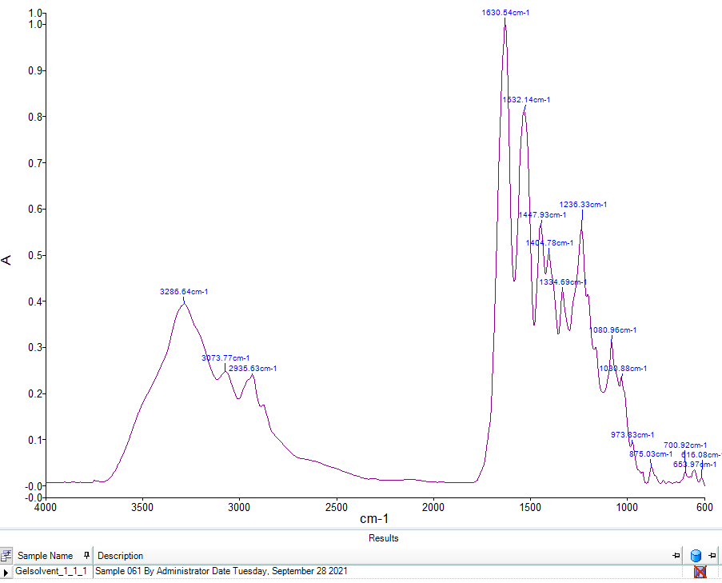
Figure S1. ATR-FTIR spectra of collage, gelatine A, gelatine B, HP3, HP4, HP6, HP8, HM1, HM4, HM5, BM1, BM2, BM3, BM4, BM5 samples.

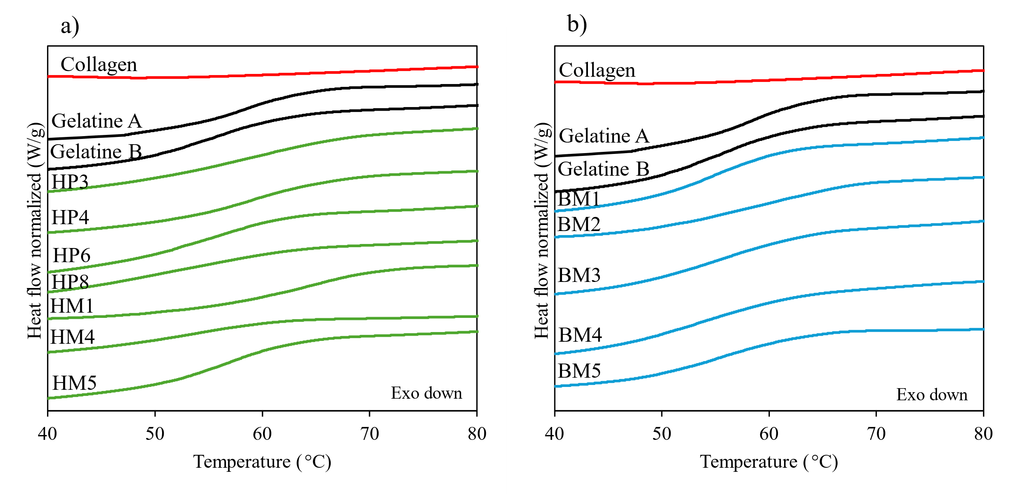
Figure S2. DSC curves obtained during the second heating scan at 10 °C/min of collagen (red line), gelatine A and B (black line), hide-derived glues (green line), bone-derived glues (blue line)

