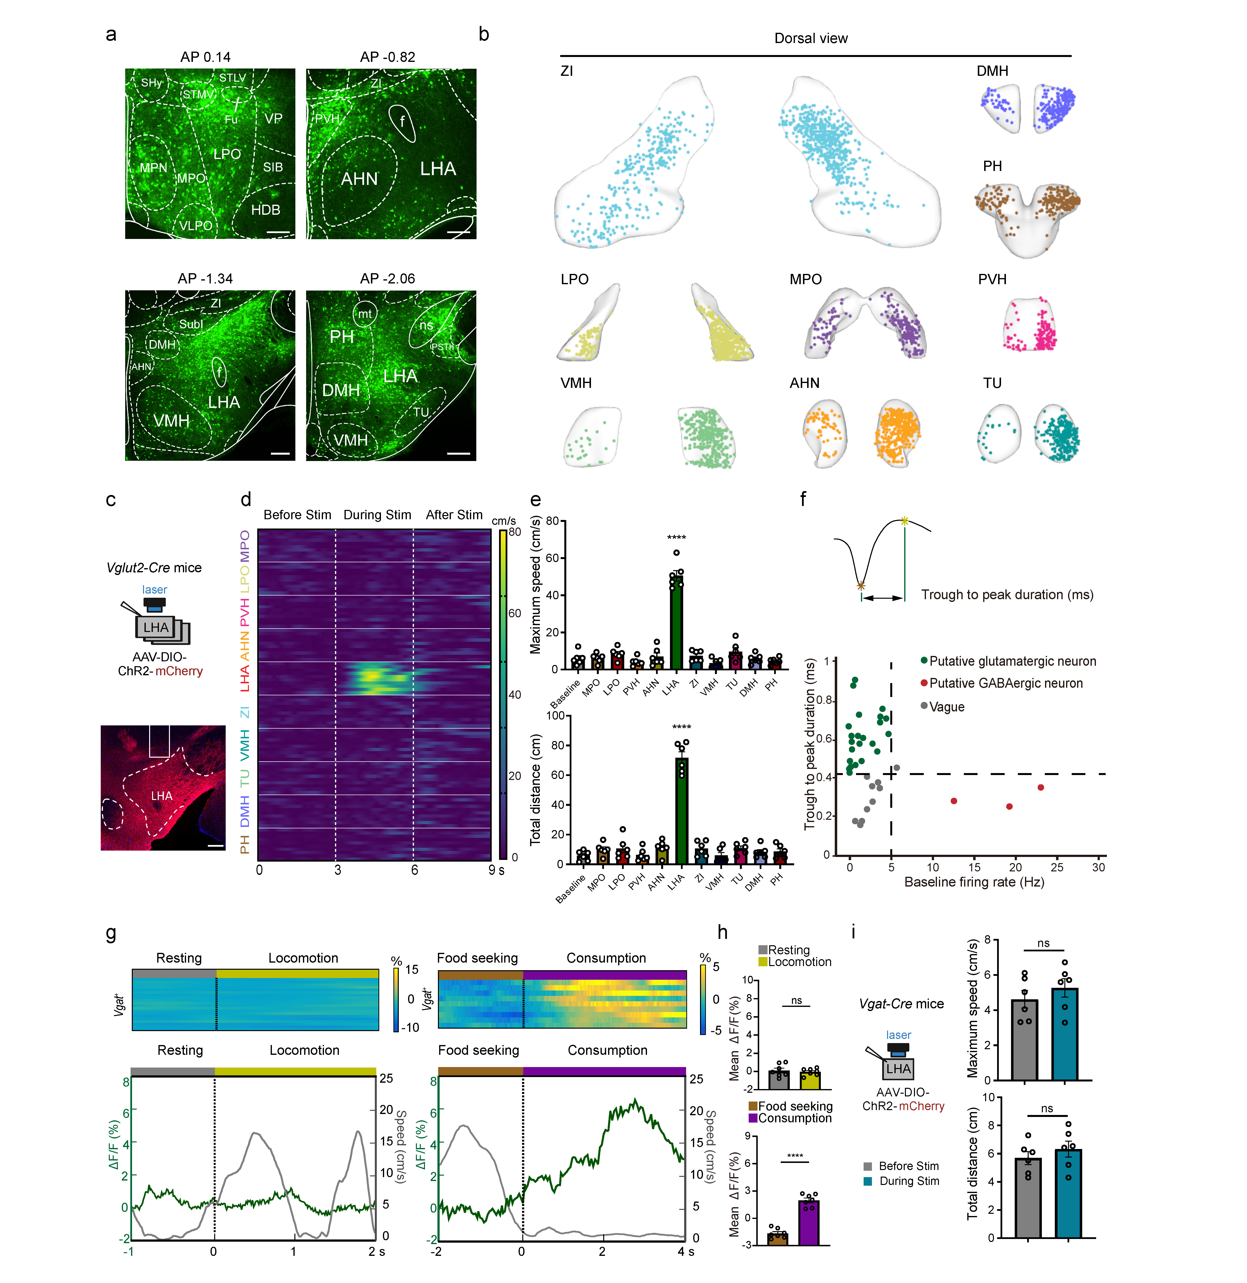 Extended Data Fig. 1 The hypothalamic nuclei labeled by PRV involved in hindlimb motor control. a, Representative image of brain areas showing PRV-EGFP labelled neurons in major regions of the hypothalamus. Scale bar, 200 μm. b, Reconstruction of PRV-EGFP labelled neurons in major regions of the hypothalamus innervating the hindlimb muscles. c, Top: strategy for activating LHA glutamatergic neurons. Bottom: representative images showing fiber-optic tip (white rectangles) and soma locations of LHA Vglut2⁺ neurons. Scale bar, 200 μm. d, The heatmap illustrating speed versus time during optical stimulation of different regions in the hypothalamus. e, Quantification of total distance and maximum speed correspond to optogenetic activation. One-way ANOVA, followed by Bonferroni post hoc test. n = 3 attempts per mouse; n = 6 mice per group. ****p < 0.0001. Error bars, SEM. f, Two criteria, the trough-to-peak duration (TPD) and the baseline firing rate (BFR), were used to categorize all speed-related neurons (n=37) that were plotted in 2D scatter plots. The putative principal cells, which are commonly considered as glutamatergic neurons, had a TPD > 0.42 ms and a BFR < 5 Hz, green dots. Conversely, the putative GABAergic neurons had a TPD < 0.42 ms and a BFR > 5 Hz, red dots. Gray dots represent neurons that are ambiguous, falling between GABAergic neurons and principal cells. g, Calcium dynamics of LHA Vgat⁺ neurons in response to onset of locomotion and consumption. h, Quantification of LHA Vgat⁺ neurons in response to onset of locomotion and consumption. n = 6 mice, 3-5 trials per mouse. Student’s t test (two-tailed, unpaired) was applied. ns, not significant; ****p < 0.0001. Error bars, SEM. i, Left: strategy for optical stimulation of LHA GABAergic neurons. Right: Quantification of maximum speed and total distance of mice before and during optical stimulation of LHA (n=6). Student’s t test (two-tailed, unpaired) was applied. ns, not significant. Error bars, SEM.

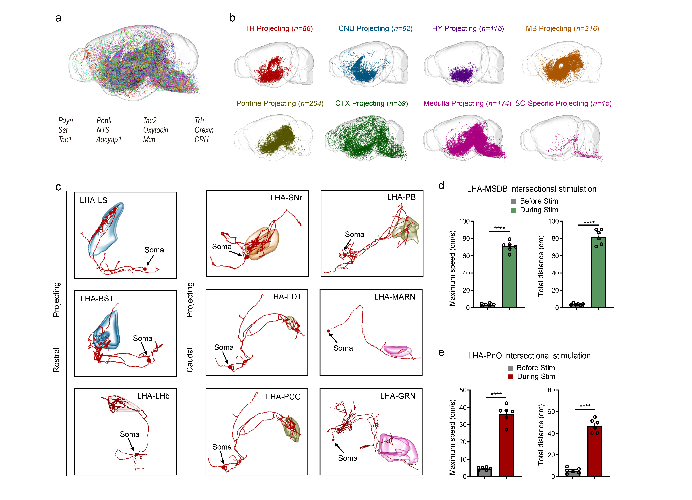 Extended Data Fig. 2 Axon morphologies and intersectional stimulation of LHA-MSDB and LHA-PnO pathway. a, Axon projections of all 916 reconstructed neurons expressing 12 different neuropeptides. Each neuron was labeled with a different color. b, Sagittal views of the morphology of neurons in different subtypes. c, The morphology of representative neurons in LHA projecting to the rostral side and caudal side. d, Quantification of maximum speed before and during optical stimulation of MSDB-projecting LHA neurons. n=6 mice per group. Student’s t test (two-tailed, unpaired) was applied. ****p < 0.0001. Error bars, SEM. e, Quantification of maximum speed before and during optical stimulation of PnO-projecting LHA neurons. n=6 mice per group. Student’s t test (two-tailed, unpaired) was applied. ****p < 0.0001. Error bars, SEM.

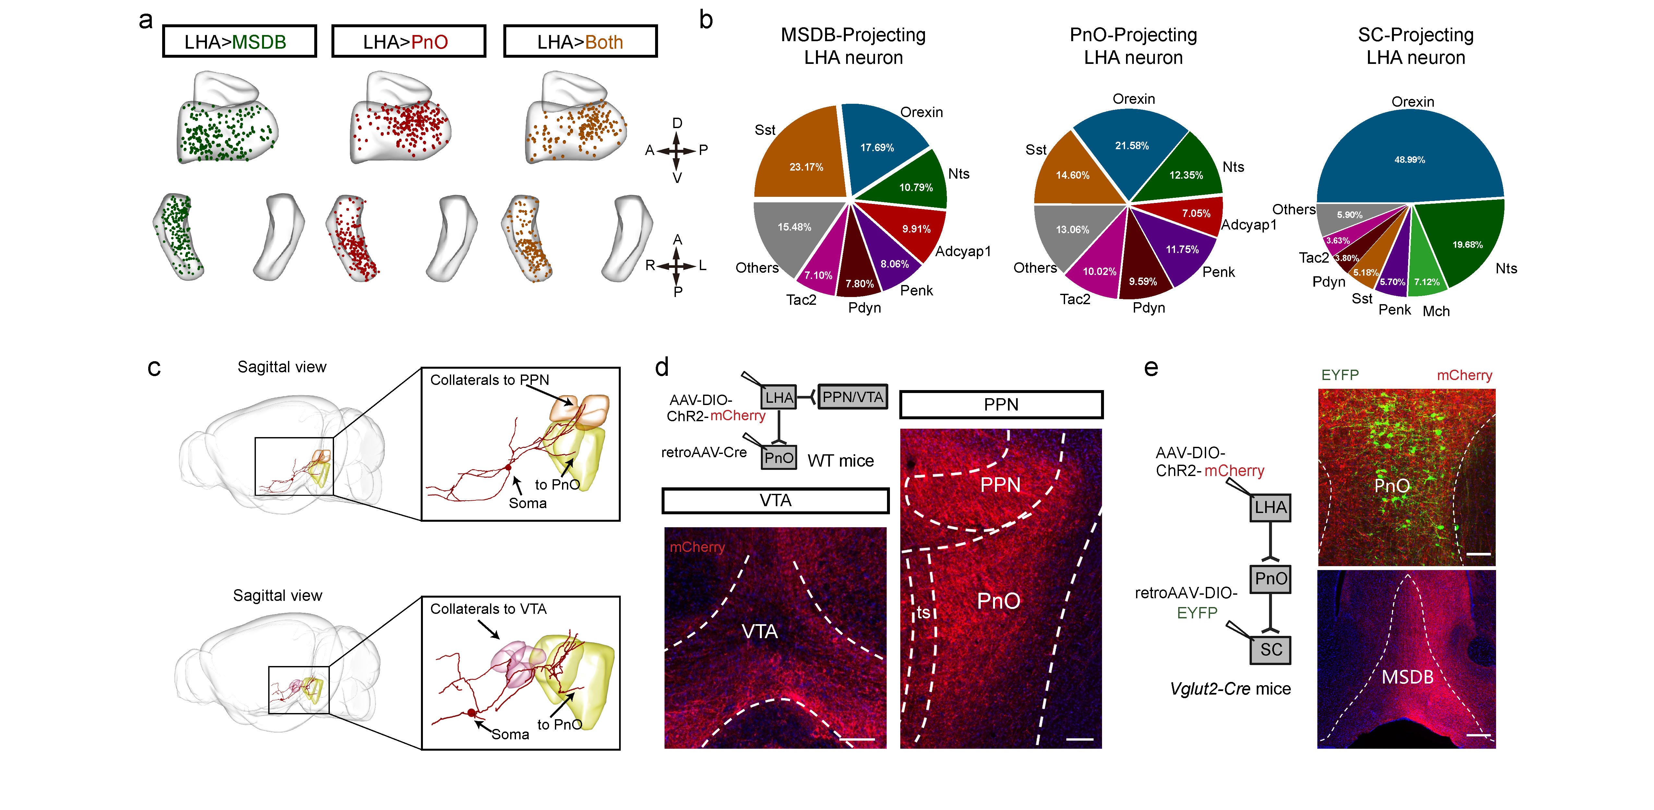 Extended Data Fig. 3 Single-neuron projectome reveals the diversity of peptide neurons project to PnO and MSDB. a, Soma distribution of only-MSDB-projecting neurons (left), only-PnO-projecting neurons (middle) and PnO & MSDB-projecting neurons (right) in LHA. b, Neural cell type projecting to MSDB (left), PnO (middle) and spinal cord (right). The percentage was calculated based on the normalized neuron counts scaled with the number of mice. c, Sagittal view of a representative LHA neuron which has projections to both PnO and PPN (top) or both PnO and VTA (bottom). d, Strategy for intersectional viral screening identifying collateral innervation of PnO-projecting LHA neurons. Collaterals of these neurons project to VTA and PPN. Scale bar, 200 μm. e, Strategy for viral screening identifying PnO but not MSDB as a bridge linking LHA and lumbar spinal cord. Scale bar, 200 μm.

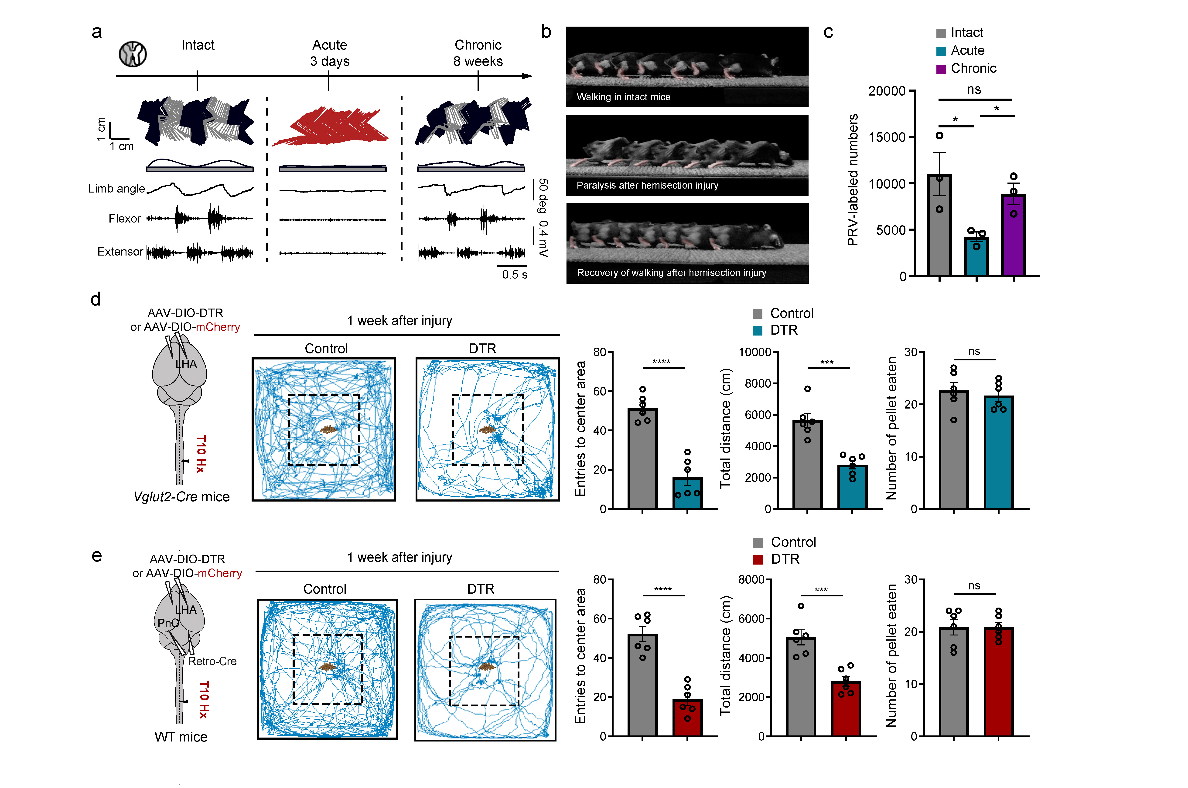 Extended Data Fig. 4 The LHA contributes to spontaneous locomotor recovery after T10 hemisection mice. a, Representative stick diagram decomposition of leg movements, oscillation of the whole limb (virtual limb linking the hip to the toe) and EMG activity of ankle muscles recorded in intact, at acute and chronic stage post T10 lateral hemisection. b, Chronophotography of mice illustrates the spontaneous locomotor recovery post lateral hemisection SCI. c, Quantification of numbers of PRV-labeled neurons in intact, acute injury and chronic injury mice. d, Left: trajectory of mice in open-field chambers with food pellets placed in the center with or without depletion of LHA glutamatergic neurons 1w after hemisection injury. Right: quantification of entries to center area, total distance and number of food pellets consumed by mice in open-field chambers with food pellets placed in the center. Student’s t test (two-tailed, unpaired) was applied. ns, not significant; ***p < 0.001; ****p < 0.0001. Error bars, SEM. e, Left: trajectory of mice in open-field chambers with food pellets placed in the center with or without depletion of PnO-projecting LHA neurons 1w after hemisection injury. Right: quantification of entries to center area, total distance and number of food pellets consumed by mice in open-field chambers with food pellets placed in the center. Student’s t test (two-tailed, unpaired) was applied. ns, not significant; ***p < 0.001; ****p < 0.0001. Error bars, SEM.

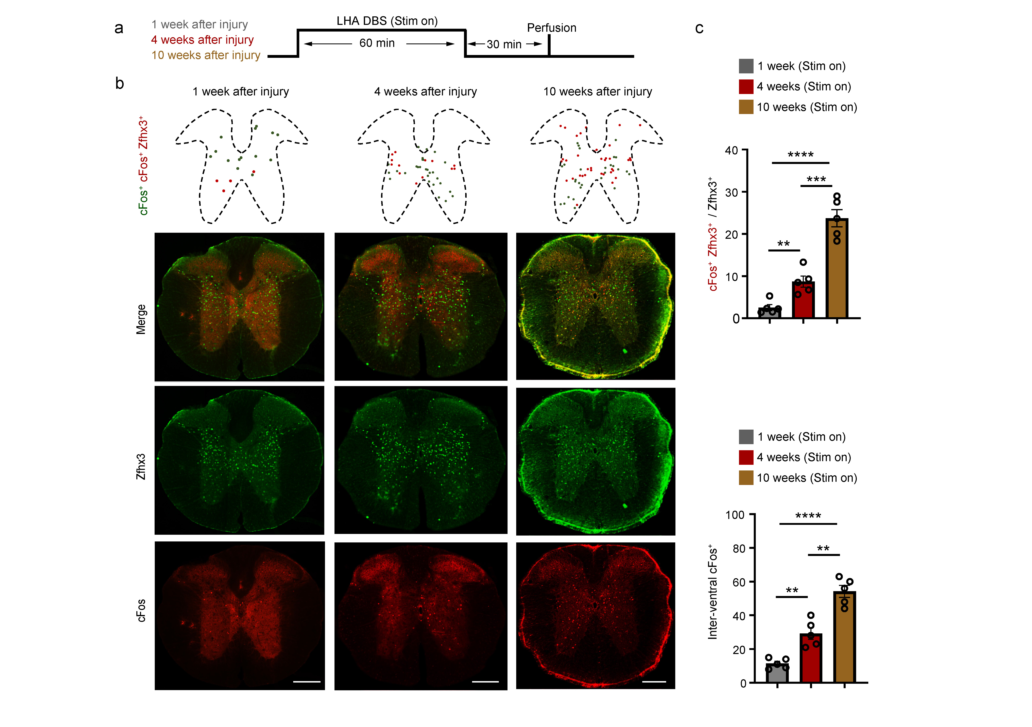 Extended Data Fig. 5 Precise DBS at cLHA acutely enables stepping in paralyzed mice through activation of Zfhx3 neurons. a, Experimental timeline for cFos staining. b, Schematics and representative raw images of transverse spinal cord sections showing cFos activation in Zfhx3 neurons from inter-lesion segment of mice in indicated groups. Left: stagger mice after LHA-DBS 1week post-injury; middle: stagger mice after LHA-DBS 4 weeks post-injury; right: stagger mice after LHA-DBS 10 weeks post-injury. Scale bar, 200 μm. c, Quantification of cFos and Zfhx3 expression in indicated groups. n=5 mice per group. Student’s t test (two-tailed, unpaired) was applied. **p < 0.01; ***p < 0.001; ****p < 0.0001. Error bars, SEM.

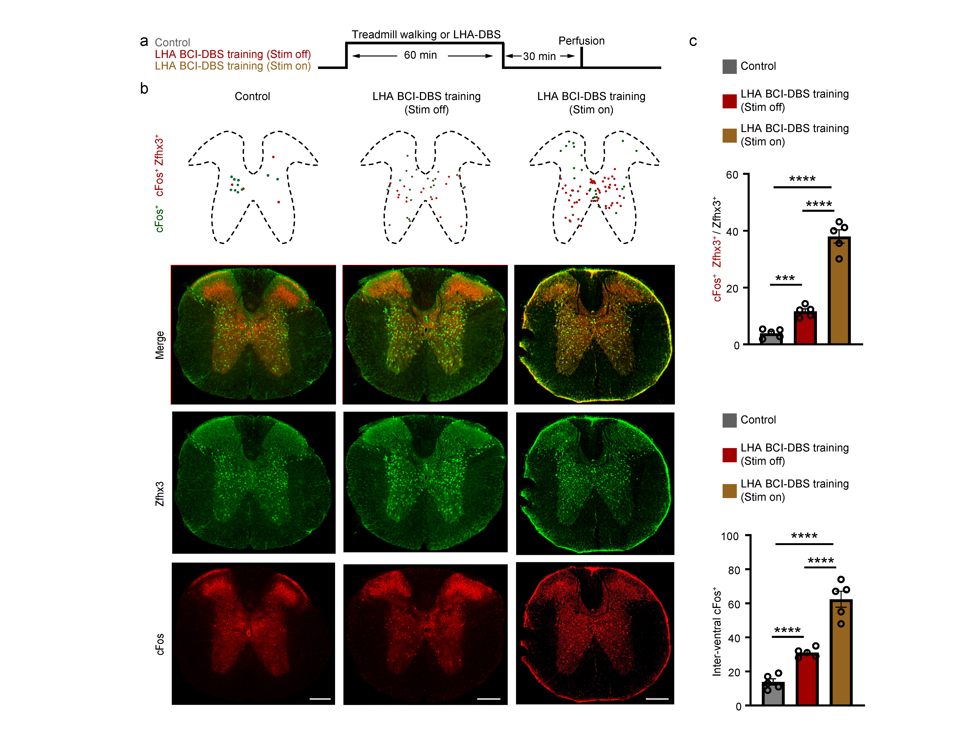 Extended Data Fig. 6 LHA-DBS training facilitates stepping through activation of Zfhx3 neurons. a, Experimental timeline for cFos staining. b, Schematics and representative raw images of transverse spinal cord sections showing cFos activation in Zfhx3 neurons from inter-lesion segment of mice in indicated groups. Left: control (stagger mice with locomotion in the open field before perfusion); middle: stagger mice with 6 weeks BCI-DBS training and stimulation off; right: stagger mice with 6 weeks BCI-DBS training and stimulation on. Scale bar, 200 μm. c, Quantification of cFos and Zfhx3 expression in indicated groups. n=5 mice per group. Student’s t test (two-tailed, unpaired) was applied. ***p < 0.001; ****p < 0.0001. Error bars, SEM.

