SUPPLEMENTARY INFORMATION

Supplementary Table S1

Source | Evidence | Dated evidence | % of dated evidence | Timestamp reference
Europe PMC | 9,420,155 | 9,420,155 | 100% | a
IMPC | 1,021,202 | 878,666 | 86% | b, c
Open Targets Genetics | 782,147 | 782,147 | 100% | b, c
Cancer Gene Census | 76,292 | 59,312 | 78% | b, c
UniProt curated variants | 26,384 | 26,384 | 100% | b, c
GEL PanelApp | 31,002 | 22,659 | 73% | b, c
Expression Atlas | 230,902 | 230,168 | 100% | b, c
Reactome | 10,276 | 9,953 | 97% | b, c
Orphanet | 6,246 | 4,964 | 79% | b, c
UniProt literature | 4,164 | 4,164 | 100% | b, c
Gene signatures | 389 | 389 | 100% | b, c
Cancer Biomarkers | 1,298 | 985 | 76% | d
ClinVar | 2,742,321 | 2,739,522 | 100% | e
ClinVar (somatic) | 17,007 | 17,007 | 100% | e
Gene2phenotype | 2,990 | 2,946 | 99% | f
Clingen | 2,071 | 2,044 | 99% | g
ChEMBL | 612,358 | 498,945 | 81% | h
SLAPenrich | 72,294 | 72,294 | 100% | i
Gene Burden | 27,373 | 27,373 | 100% | j
CRISPR Screens | 24,304 | 18,113 | 75% | k
Project Score | 1,838 | 1,838 | 100% | l
IntOGen | 4,350 | - | 0%
PROGENy | 378 | - | 0%
All | 15,117,741 | 14,820,028 | 98%

- http://ftp.ebi.ac.uk/pub/databases/opentargets/platform/23.06/output/etl/parquet/evidence/sourceId=europepmc/.
- https://ftp.ncbi.nlm.nih.gov/pubmed/baseline (last accessed on 24th July 2023).
- https://ftp.ncbi.nlm.nih.gov/pubmed/updatefiles (last accessed on 24th July 2023).
- https://www.cancergenomeinterpreter.org/2018/data/cgi_biomarkers_latest.zip.
- https://gist.github.com/DSuveges/48611eead49ae1bd9553516d72efe8e0.
- http://ftp.ebi.ac.uk/pub/databases/gene2phenotype/28_04_2023.
- https://search.clinicalgenome.org/kb/gene-validity/download.
- http://ftp.ebi.ac.uk/pub/databases/opentargets/platform/23.06/output/etl/parquet/evidence/sourceId=chembl/.
- Iorio 2018
- Karczewski 2022. Gene Burden projects, a manifold of whole-exome sequencing analysis on UK Biobank individuals.
- Tian 2021. CRISPRbrain database with functional genomics screens in differentiated human brain cell types.
- Behan 2019. Project Score aiming at identifying dependencies in cancer cell lines to guide precision medicine.
Supplementary Figure S2

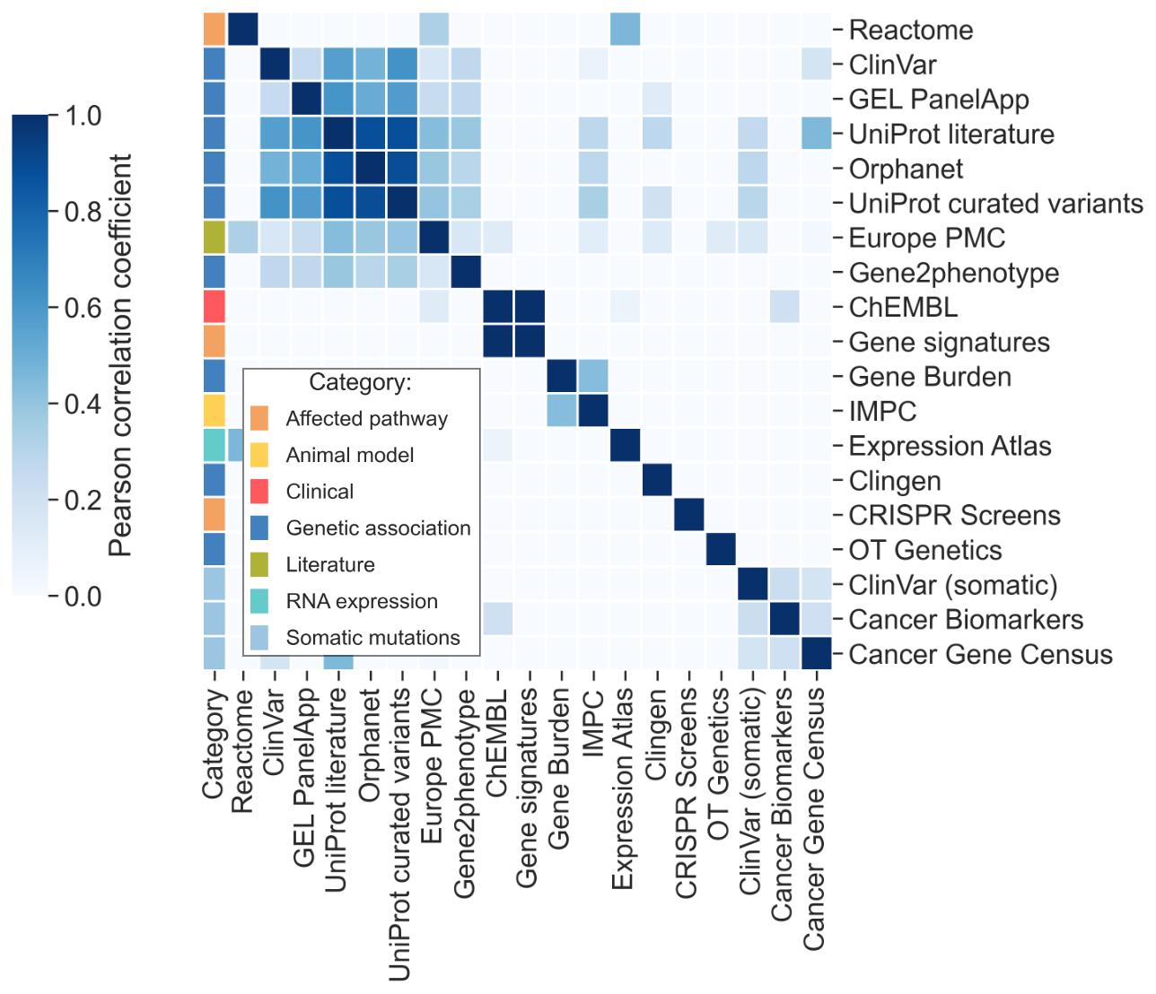

Overlap of novelty peaks of target-disease associations supported by multiple data resources. Each target-disease association has been mapped to the highest scoring novelty peak of each supporting resource and a pairwise correlation analysis has been performed between their onset years. Novelty peaks derived from genetic content resources are the most correlated. This phenomenon can be attributed to the fact that public biomedical data is captured in a variety of repositories and databases, many of which are subsequently incorporated into the Open Targets Platform, often leading to data redundancy. GEL PanelApp, Genomics England PanelApp. OT Genetics, Open Targets Genetics. IMPC, International Mouse Phenotype Consortium.

Supplementary Table S3

Novelty score threshold | Target-disease associations with novelty signal | Unique targets with novelty signal
1.0 | 0 | 0
0.9 | 0 | 0
0.8 | 8 | 6
0.7 | 27 | 24
0.6 | 82 | 73
0.5 | 929 | 828
0.4 | 1,574 | 1,289
0.3 | 2,369 | 1,752
0.2 | 3,734 | 2,378
0.1 | 7,311 | 3,837

Supplementary Table S4

Mechanism-of-action targets of drugs approved since 2000. a. Number of targets for each year of approval according to ChEMBL data. b. Number of targets with each type of novelty peak.
a |  |  | b
Drug approval year | Number of drug mechanism-of-action targets |  | Type of novelty peak | Number of drug mechanism-of-action targets
2000-2005 | 42 |  | Genetic association | 162
2006-2010 | 103 |  | Somatic mutation | 79
2011-2012 | 45 |  | Literature | 321
2013-2014 | 99 |  | RNA expression | 191
2015-2016 | 16 |  | Animal model | 157
2017-2018 | 37 |  | Affected pathway | 140
2019-2020 | 29 |  | No support | 1
2021-2022 | 36 |  | All | 407
All | 407

