Supporting Information

Reconfigurable azobenzene liquid crystal elastomers programming towards differentiated biomimetic actuations

Ting Liu^{1#}, Jiaxin Yang^{1#}, Jie Jiang², Lu Yin², Hongyuan Bai¹, Hongwei Ma¹, Tenglong Guo³*, Yue Zhao²*, Yang Li¹, Li Han¹*

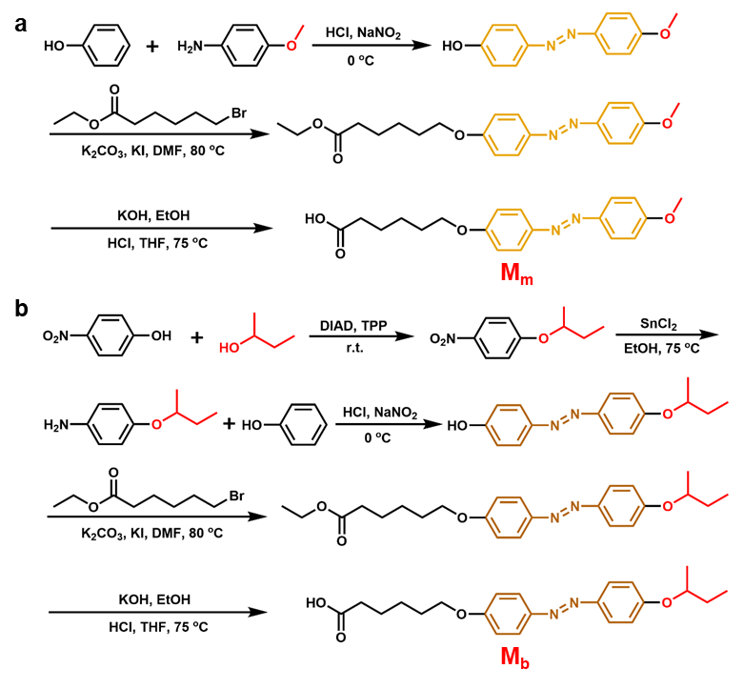
Scheme S1. Synthesis routes of monomers. a) AZO mesogen (M_{m}). b) AZO monomer (M_{b}).
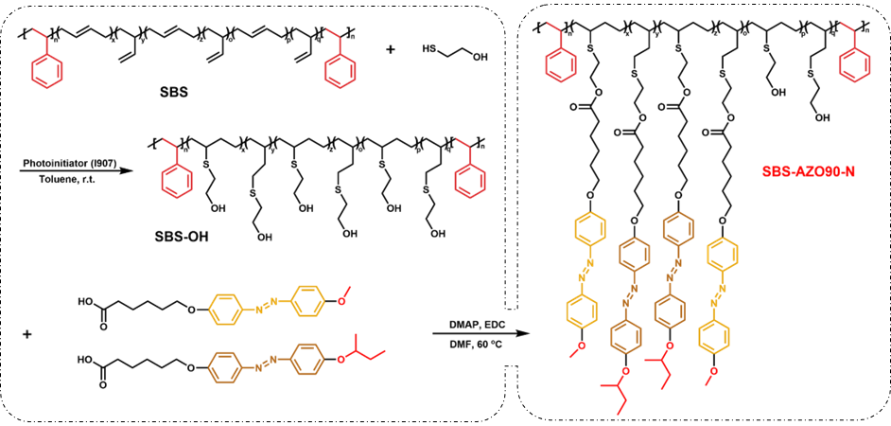
Scheme S2. Synthesis routes of azobenzene liquid crystal elastomers (SBS-AZO90-N).
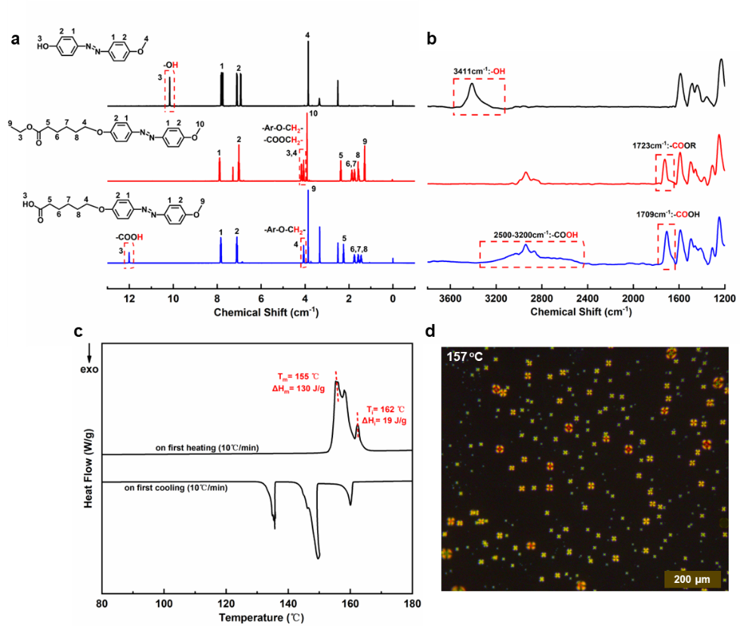
Fig. S1 a ¹H NMR spectra of M_{m} and intermediates. b FT-IR spectra of M_{m} and intermediates. c DSC curves of M_{m}. d POM (200 µm) image of M_{m} in LC phase.
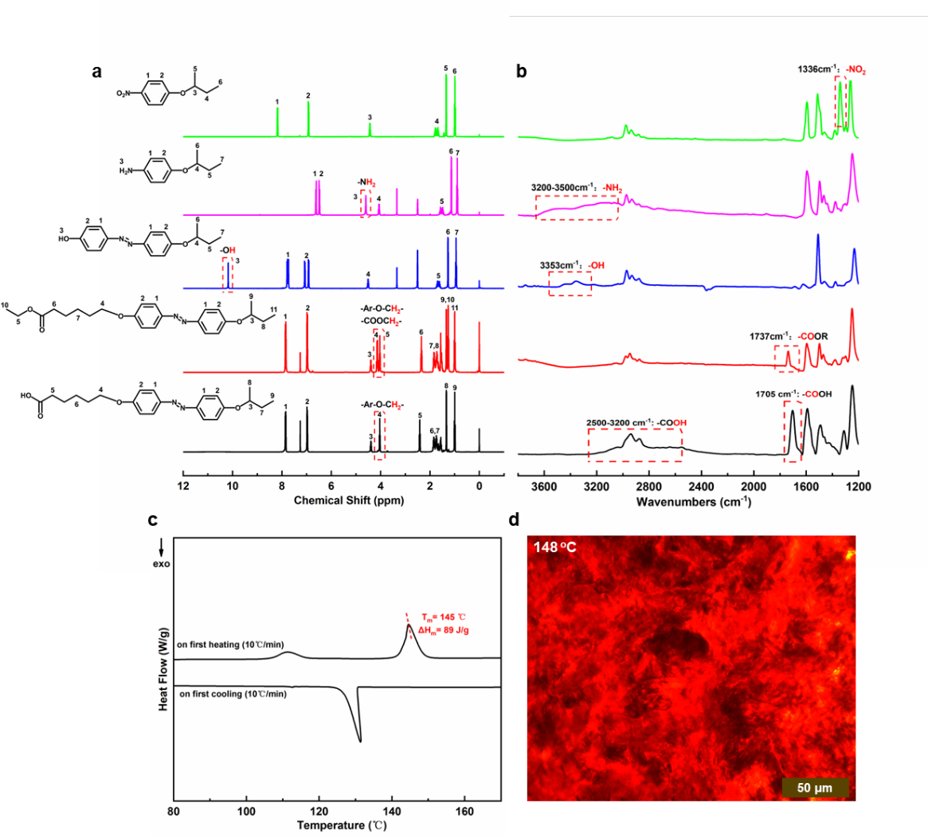
Fig. S2 a ¹H NMR spectra of M_{b} and intermediates. b FT-IR spectra of M_{b} and intermediates. c DSC curves of M_{b}. d POM (50 µm) image of M_{b} at 148 ℃.
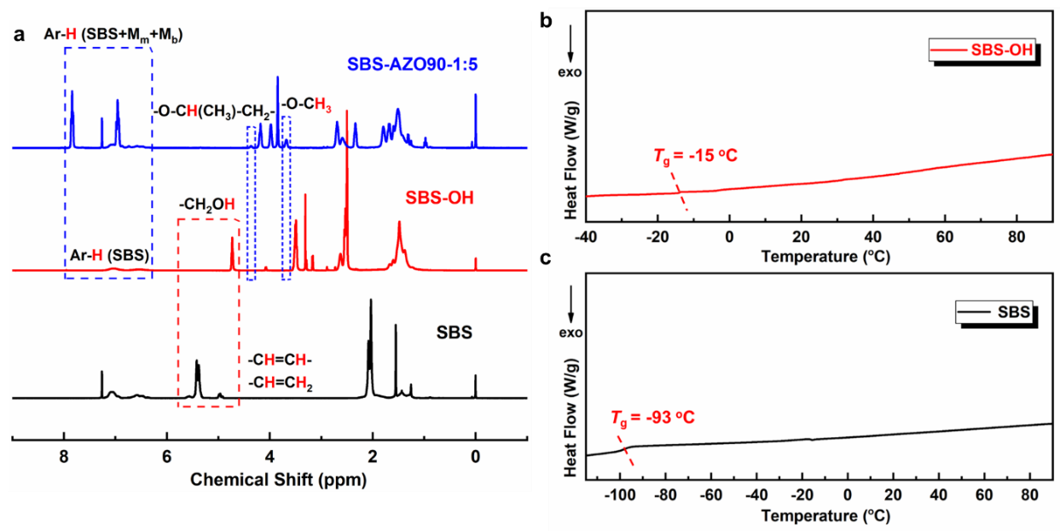
Fig. S3 a ¹H-NMR spectra of SBS-AZO90-1:5 and intermediates. b DSC curves of SBS-OH and c SBS.
Fig. S4 ¹H-NMR spectra of AZO-LCEs samples.

Table S1. The calculated grafting degrees based on ¹H-NMR spectra
Sample | Total grafting degrees | The grafting degrees of M_{b} | The grafting degrees of M_{m}
SBS-AZO90-0:5 | 76% | 0% | 76%
SBS-AZO90-1:5 | 70% | 17% | 56%
SBS-AZO90-2:5 | 71% | 29% | 49%
SBS-AZO90-3:5 | 73% | 38% | 45%
SBS-AZO90-4:5 | 73% | 45% | 38%
Fig. S5 DSC curves of AZO-LCEs samples.
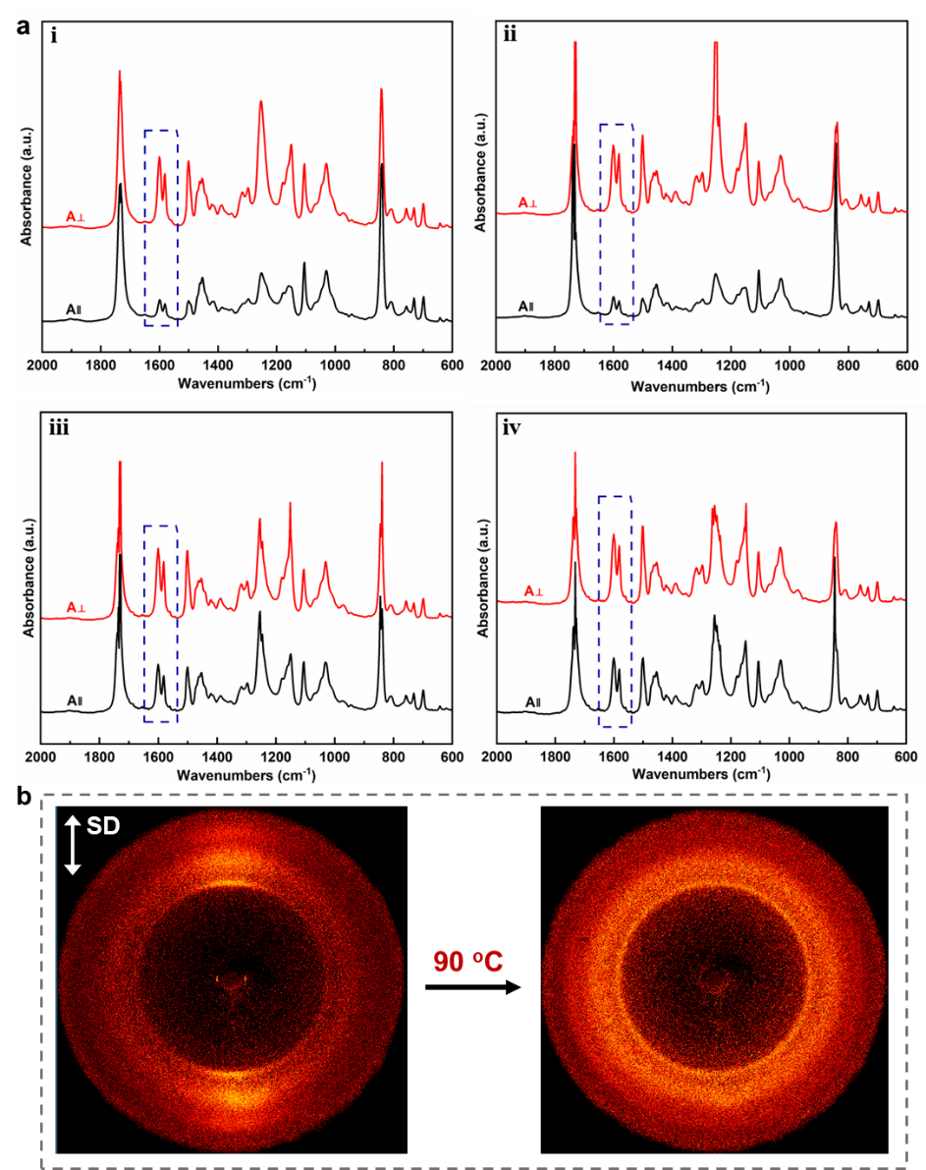
Fig. S6 a Polarized FT-IR spectra of SBS-AZO90-0:5 stretched to 200% (all others were written under the same stretching strain unless otherwise specified) at 90 ℃ thermal relaxation for ⅰ) 0 min, ⅱ) 2 min, ⅲ) 20 min, ⅳ) 40 min. b 2D-WAXD patterns of the monodomain SBS-AZO90-0:5 during thermal relaxation at 90 ℃ for 40 min.
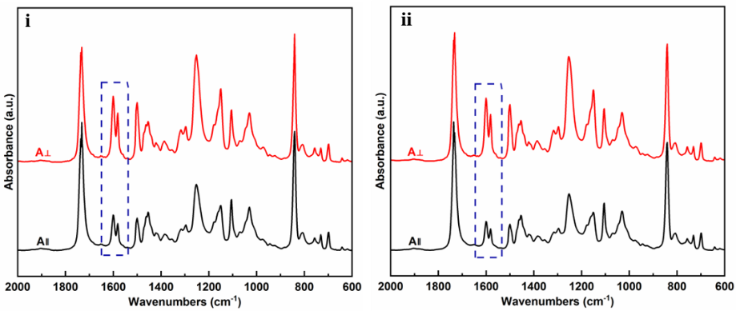
Fig. S7 Polarized FT-IR spectra of a monodomain SBS-AZO90-1:5 strip at 80 ℃ thermal relaxation for ⅰ) 0 h, ⅱ) 2 h.
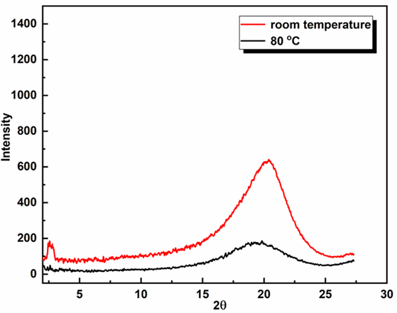
Fig. S8 1D-WAXD diffractograms for a monodomain SBS-AZO90-1:5 strip between 80 ℃ and r. t.
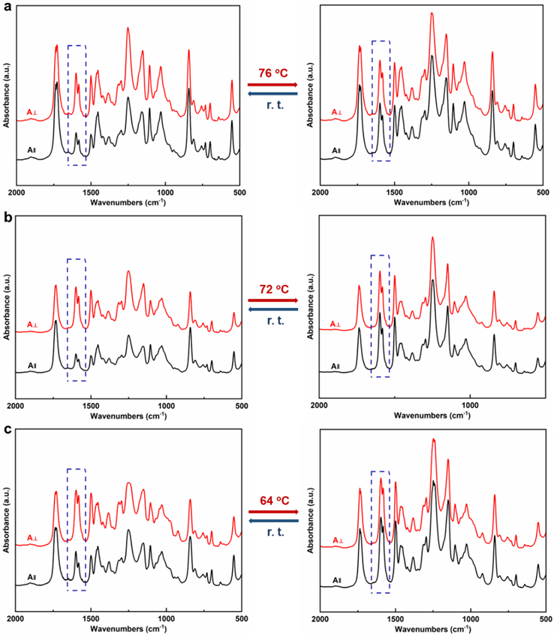
Fig.S9. Polarized FT-IR spectra for the infrared dichroism of a monodomain strip: a SBS-AZO90-2:5 recorded between 76 ℃ and r. t.; b SBS-AZO90-3:5 recorded between 72 ℃ and r. t.; c SBS-AZO90-4:5 recorded between 64 ℃ and r. t.
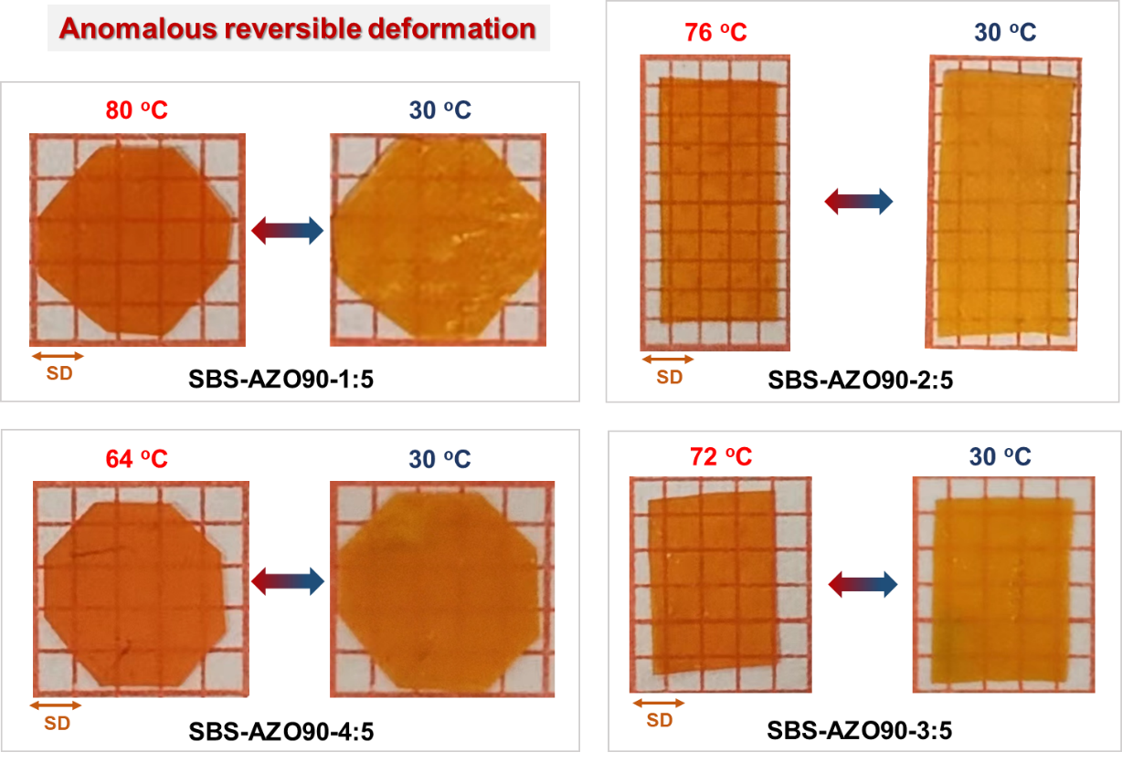
Fig. S10 Anomalous reversible shape changes of the monodomain SBS-AZO90-N strips.
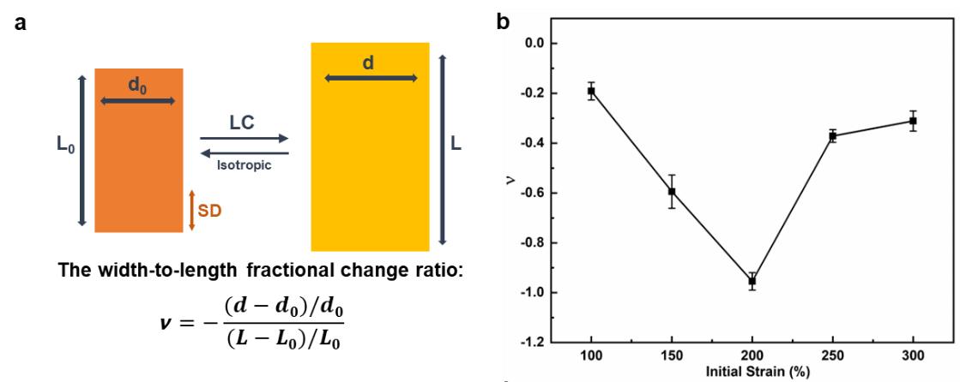
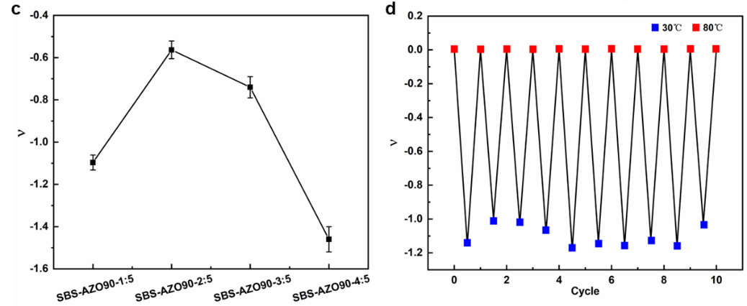
Fig. S11 a The definition of Poisson's ratio, ν. b Change in ν as a function of the different initial strains (100%~300%) used in preparing the oriented SBS-AZO90-1:5 strip. c The ν values of the oriented SBS-AZO90-N strips stretched to 200%. d) Reversible anomalous shape change cycles by thermally induced order-disorder phase transition.
The thermo-induced shape changes were measured, where Poisson's ratio ν shown in Fig. S11a was calculated to quantify the changes in the length and width directions, and further analyse the relative contribution of the main chain to the oriented mesogens to the changes. As shown in Fig. S11b, the negative ν first increased with increasing strain to a maximum value at 200% strain and then decreased at greater strains. It is proposed that the larger the negative ν is, the more the LC-isotropic phase transition of the oriented mesogens contributes to deformation, and when the negative ν is greater than 1, the change ratio in the width direction is greater than that in the length direction, which means that the contribution of the mesogens is dominant. Conversely, the contribution of the main chain is dominant. Thus, the maximum value at 200% strain indicates the dominant contribution of the mesogens relative to the main chain, while further elongation of the strip to strain increases the main chain orientation along the stretching direction so that the main chains make a greater contribution.
Subsequently, to evaluate the relative contribution of the main chains to the oriented mesogens to the actuation at different T_{LC-I}, the ν values of the oriented SBS-AZO90-N strips with different T_{LC-I} were measured at a fixed strain of 200%, as shown in Fig. S11c. The negative ν was greater than 1 for SBS-AZO90-1:5/4:5 but less than 1 for SBS-AZO90-2:5/3:5. This phenomenon arises from the conflicting roles of the mesogen content and T_{LC-I}, where on the one hand, reducing the M_{m} content (and consequently T_{LC-I}) generally decreases the degree of macroscopic deformation activated by T_{LC-I}, on the other hand, as the actuation temperature T_{LC-I} gradually decreases, the order-disorder transition degree of the soft segments in the main chains decreases, resulting in a smaller contribution to the actuation. Thus, for SBS-AZO90-1:5, the contribution of the mesogens is dominant, while it shifts to the dominance of the main chain for SBS-AZO90-2:5/3:5. Furthermore, for SBS-AZO90-4:5 with the negative ν greater than 1, it seems that the contribution of the mesogens is once again dominant, because the substantial reduction in T_{LC-I} is considerably more pronounced than the effect of the reduction in Mm content. Among these strips, the monodomain SBS-AZO90-4:5 strip stretched to 200% exhibited the best actuation performance, which strongly indicated that although T_{LC-I} was reduced, the mesogens still contributed to the dominant actuation under mild conditions through rational regulation. In addition, the reversibility of the thermo-induced anomalous deformation was evaluated to demonstrate the stability of the LC orientation locked in by the glassy PS phase. Taking an example, the anomalous deformations for monodomain SBS-AZO90-1:5 strip at 200% strain can also be repeated for many cycles (Fig. S11d).
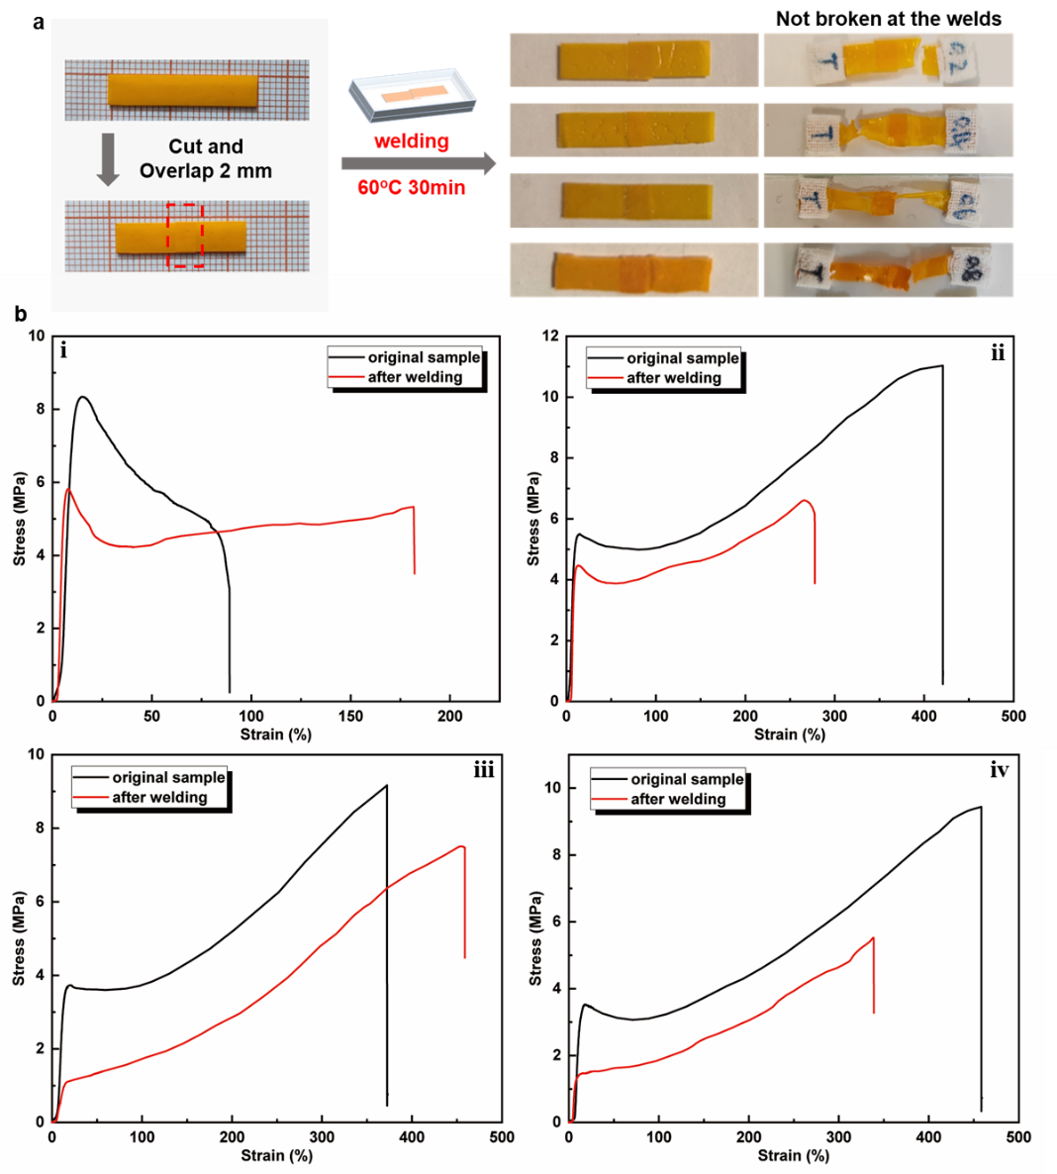
Fig. S12 a Photographs showing the welding process. The strips (25 mm×5 mm×60 μm) were first cut into two pieces, of which the edges were immediately overlapped by 2 mm, sandwiched between two glass slides without external force and heated at 60 ℃ for 30 min. Then the welding strips were subjected to stress-strain experiments to obtain the mechanical properties, and they did not break from the welds during the tensile tests. The breaking stresses were employed to evaluate the welding efficiency. b The stress-strain curves (10 mm min⁻¹) of the original films and welded films for ⅰ) SBS-AZO90-1:5; ⅱ) SBS-AZO90-2:5; ⅲ) SBS-AZO90-3:5; ⅳ) SBS-AZO90-4:5.
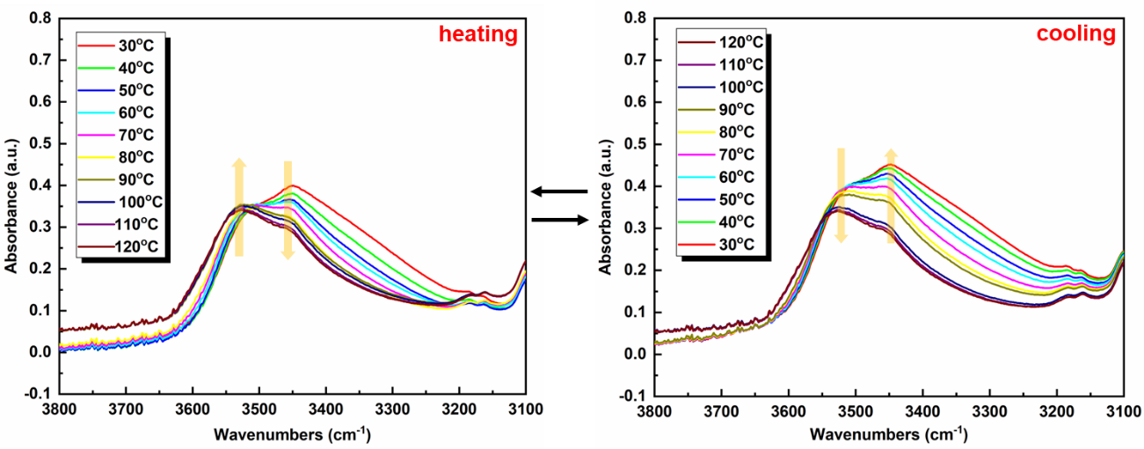
Fig. S13 The temperature-dependent in situ FT-IR spectra (cyclic temperature change process between 30-120 ℃) of SBS-AZO90-1:5.
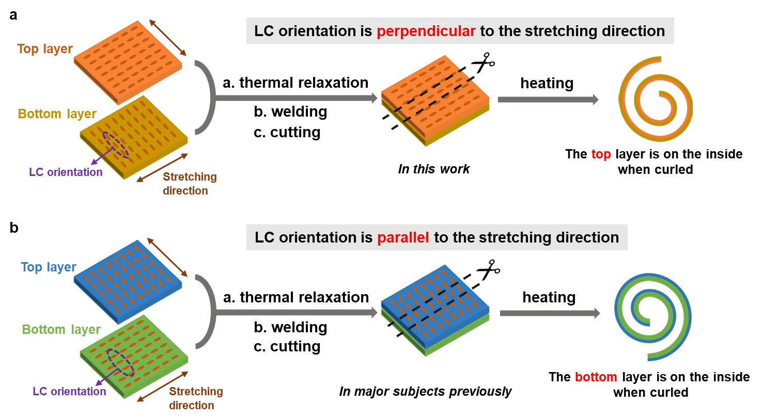
Fig. S14 Photographs showing different curling phenomena for a vertical; b parallel systems.
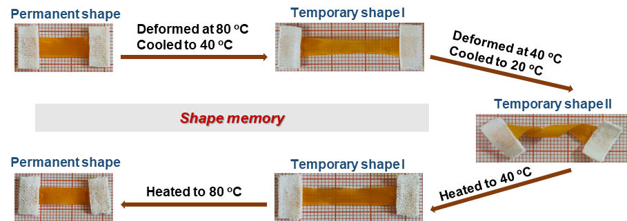
Fig. S15 The shape programming and recovery process of SBS-AZO90-1:5 strips.
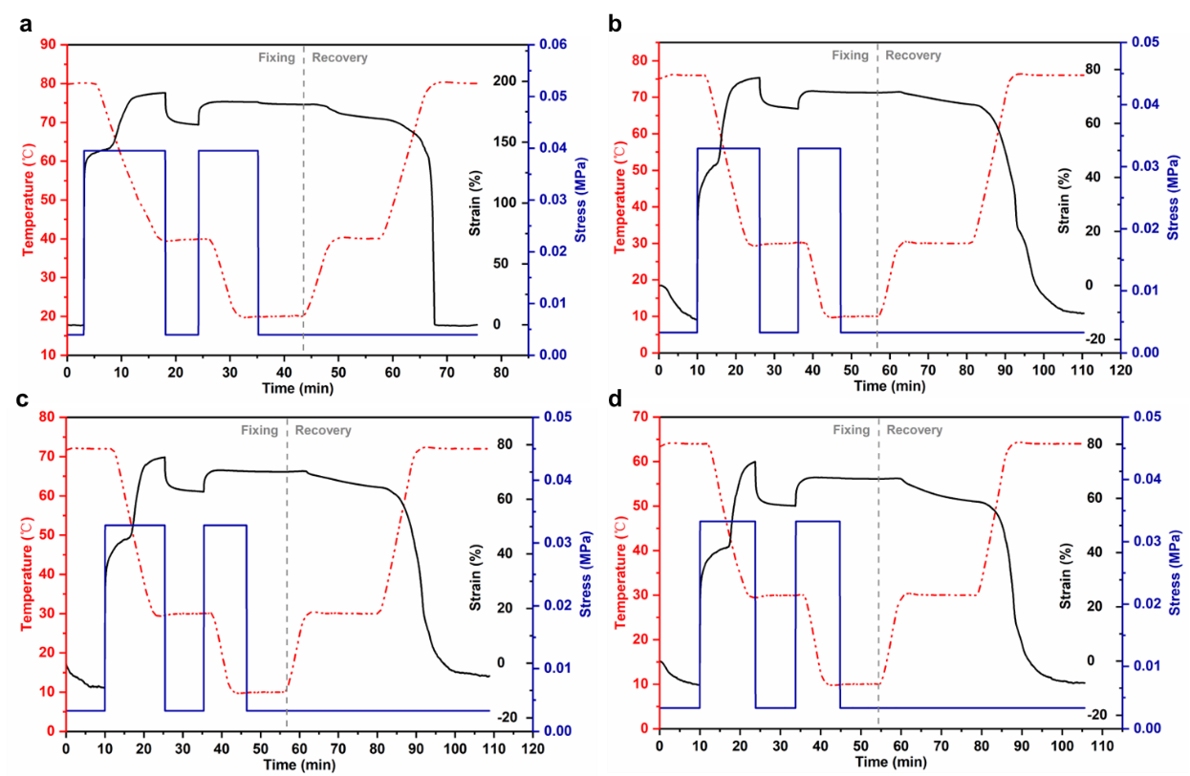
Fig. S16 Shape memory properties tested by DMA in controlled force mode of a SBS-AZO90-1:5; b SBS-AZO90-2:5; c SBS-AZO90-3:5; d SBS-AZO90-4:5.
The large temperature interval occurs between the T_{g} and T_{LC-I} with the glassy PS phase as a stable network, the triple shape memory (TSM) behaviours of AZO-LCEs were investigated. In brief, during the programming process, the strip in its original shape was first deformed at T_{high} (>T_{LC-I}) and fixed at T_{mid} (T_{g}< T_{mid}< T_{LC-I}) to obtain temporary shape I, followed by further programming at T_{mid} and fixing below T_{low} (<T_{g}) to achieve temporary shape II. The recovery process began as the temperature rose. Taking SBS-AZO90-1:5 as an example, three characteristic programming temperatures, T_{low}, T_{mid} and T_{high}, were set at 20 °C, 40 °C and 80 °C, respectively. The corresponding processes are shown in Fig. S15. Furthermore, quantitative analyses of the TSM behaviours were conducted for SBS-AZO90-N using DMA in stress-control mode (Fig. S16). All the AZO-LCEs presented TSM effects with above 80% fixing ratios and above 70% recovery ratios. The results are summarised in Table S2. Fast shape transitions and large deformations are highly promising for multifunctional applications.

Table S2. The shape fixity ratio (R_{f}) and shape recovery ratio (R_{r}) of SBS-AZO90-N.
Sample | R_{f1} (%) ª | R_{r1} (%) ^{b} | R_{f2} (%) ^{c} | R_{r2} (%) ^{d}
SBS-AZO90-1:5 | 86 | 100 | 90 | 71
SBS-AZO90-2:5 | 87 | 97 | 97 | 76
SBS-AZO90-3:5 | 85 | 94 | 97 | 78
SBS-AZO90-4:5 | 80 | 99 | 97 | 84
ª the shape fixity ratio (R_{f1}) and ^{b} shape recovery ratio (R_{r1}) primarily dominated by the self-assembly of mesogens; ^{c} the shape fixity ratio (R_{f2}) and ^{d} shape recovery ratio (R_{r2}) primarily dominated by the glass transition; Detailed calculation steps were conducted as described previously¹.
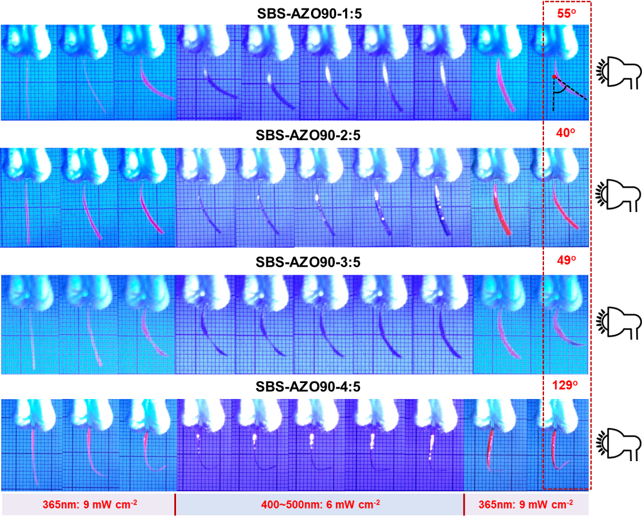
Fig. S17 Photographs showing the bending and recovering process of the monodomain SBS-AZO90-N strips stretched to 200% (20 mm×3 mm×60 µm) under irradiation with UV light (365 nm, 9 mW cm⁻²) and visible light (400-500 nm, 6 mW cm⁻²), respectively.
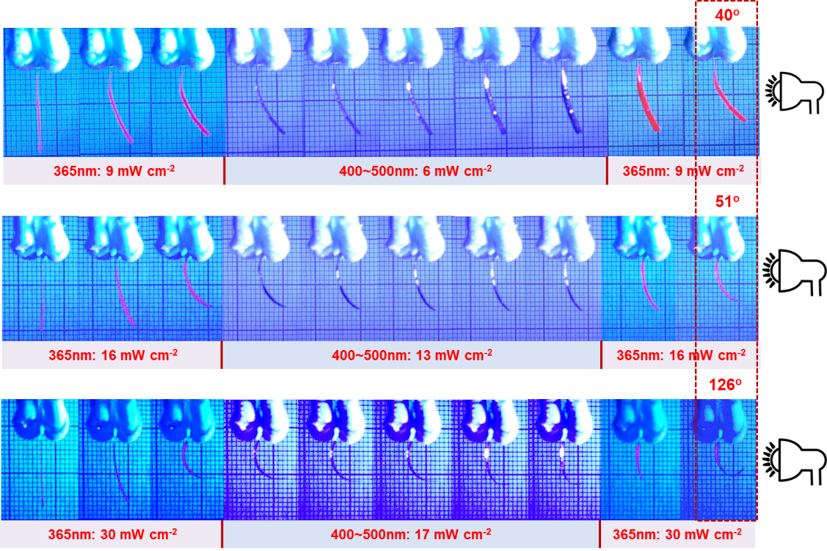
Fig. S18 Photographs showing the bending and recovering process of the SBS-AZO90-2:5 films stretched to 200% (20 mm×3 mm×60 µm) under irradiation with UV light and visible light of different intensities.
Owing to the photo-induced isomerisation of AZO molecules, the photomechanical properties of the monodomain SBS-AZO90-N strips were studied. As desired, all the monodomain SBS-AZO90-N strips bent towards light under UV light and underwent reversible bending and recovery under alternating UV and visible light irradiation. As typically shown in Fig. S17, as for SBS-AZO90-4:5, reducing T_{LC-I} by introducing M_{b} does not sacrifice the light-driven degree, instead, the maximum bending angle is achieved, followed by SBS-AZO90-1:5 and finally the remaining two AZO-LCEs. This phenomenon should stem from the synergistic effect of the mesogen content, the mechanical properties and transmittance of their films. The effect of UV light intensity on the bending degree was further investigated using SBS-AZ090-2:5 as an example (Fig. S18). As the light intensity was gradually increased, the bending degree increased.
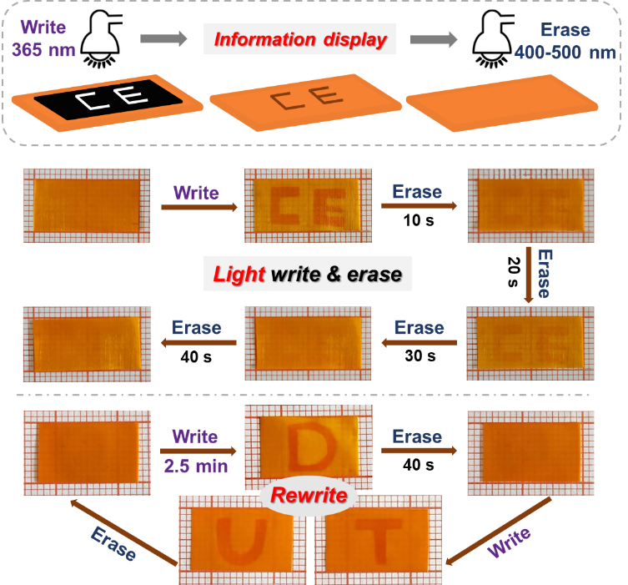
Fig. S19 Photoinduced patterns writing process on the SBS-AZO90-1:5 film using 365 nm UV light at 58 mW cm⁻² for 2.5 min (all others were written under the same condition unless otherwise specified) and erasing process by 400-500 nm visible light at 64 mW cm⁻².
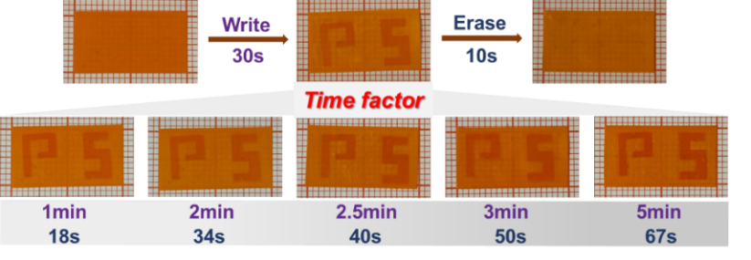
Fig. S20 Photographs showing the effects of write time on the storage life of information.
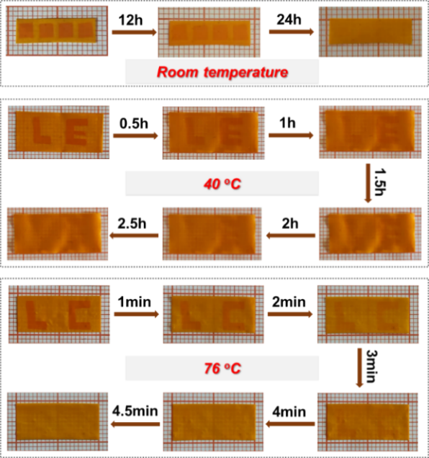
Fig. S21 Photographs showing the thermal storage life of information.
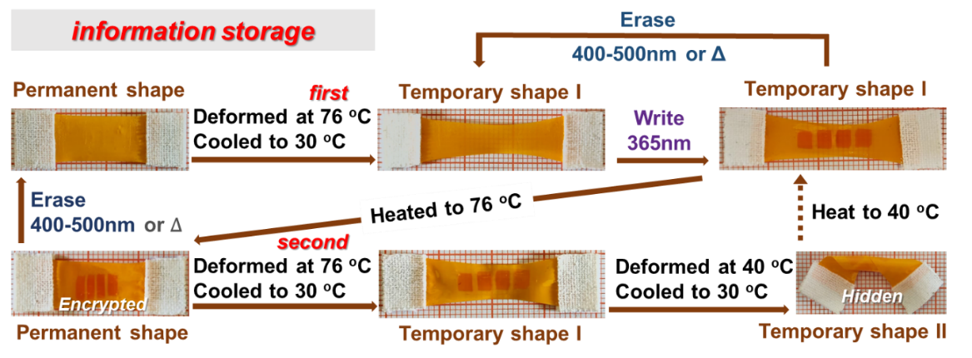
Fig. S22 2D/3D information storage and encryption modes through integrated triple shape memory behaviours.
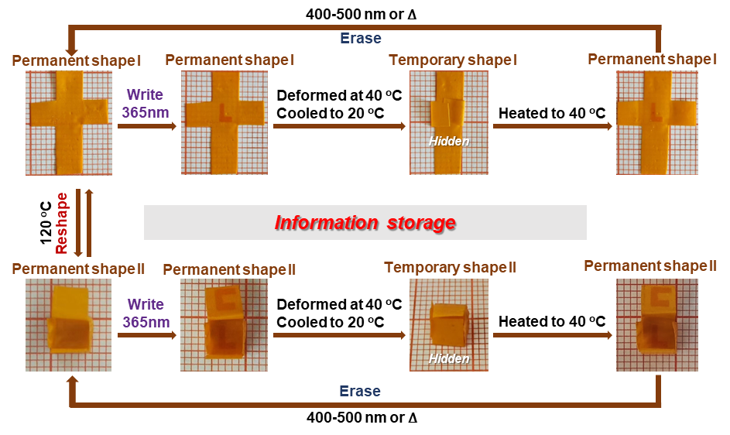
Fig. S23 2D/3D information storage and encryption modes through integrated shape memory and reshaping behaviours.
AZO molecules can also confer excellent photochromic property to materials. As shown in Fig. S19, the letters “C” and “E” were written in SBS-AZO90-1:5 film using a photomask under UV light irradiation and then completely erased after 40 s of visible light irradiation. Multiple repetitions did not affect the readability of the written information. The letters “D”, “U”, and “T” were also written in the same film. The effects of key factors (write time and temperature) on the information storage capacity were further investigated. The results show that the longer the writing time is, the longer the storage life of the information (Fig. S20), as well as the thermal storage capacity of the information at different temperatures, which deteriorates as the temperature increases but can still be stored for 4.5 min at 76 ℃ (Figure S21). This reversibility activated by light and heat allows information input and erased, and the AZO function provides an operational window for designing and building complex information storage behaviours.
Here, it is expected to achieve multidimensional information storage and encryption by combining shape memory deformations with a short operation time. For a typical SBS-AZO90-1:5 film, as shown in Fig. S22, four small squares were written when the strip was in temporary shape I. When heated to 76 °C, the strip reverted to the permanent shape, and the squares turned into rectangles to encrypt the information. By utilising the T_{g} to obtain temporary shape II, the information was hidden. Further integration of the reshaping deformation from the plastic PS phase, the information written and hidden on a 3D square shape were demonstrated (Fig. S23). Thermal deformation occurs in seconds, so hundreds of cycles can be performed without message loss. By synergistically utilising deformation process, combined with the photochromic property that AZO imparts, the multidimensional information storage and encryption modes were achieved.

Reference
1. Wen, Z.-B. et al. Fabrication of Liquid Crystalline Polyurethane Networks with a Pendant Azobenzene Group to Access Thermal/Photoresponsive Shape-Memory Effects. ACS Appl. Mater. Interfaces 9, 24947 (2017).

