Correlation Matrix
Correlation Matrix
 |  |  |  | S2 E1 SV |  | S2 E1 TV |  | S2 E2 SV |  | S2 E2 TV |  | S2 Hybrid E1 |  | S2 Hybrid E2
S2 E1 SV |  | Pearson's r |  | —
 |  | df |  | —
 |  | p-value |  | —
 |  | Spearman's rho |  | —
 |  | df |  | —
 |  | p-value |  | —
S2 E1 TV |  | Pearson's r |  | 0.615 |  | —
 |  | df |  | 73 |  | —
 |  | p-value |  | < .001 |  | —
 |  | Spearman's rho |  | 0.607 |  | —
 |  | df |  | 73 |  | —
 |  | p-value |  | < .001 |  | —
S2 E2 SV |  | Pearson's r |  | 0.545 |  | 0.513 |  | —
 |  | df |  | 74 |  | 73 |  | —
 |  | p-value |  | < .001 |  | < .001 |  | —
 |  | Spearman's rho |  | 0.584 |  | 0.501 |  | —
 |  | df |  | 74 |  | 73 |  | —
 |  | p-value |  | < .001 |  | < .001 |  | —
S2 E2 TV |  | Pearson's r |  | 0.405 |  | 0.537 |  | 0.492 |  | —
 |  | df |  | 74 |  | 73 |  | 74 |  | —
 |  | p-value |  | < .001 |  | < .001 |  | < .001 |  | —
 |  | Spearman's rho |  | 0.402 |  | 0.508 |  | 0.469 |  | —
 |  | df |  | 74 |  | 73 |  | 74 |  | —
 |  | p-value |  | < .001 |  | < .001 |  | < .001 |  | —
S2 Hybrid E1 |  | Pearson's r |  | 0.899 |  | 0.872 |  | 0.531 |  | 0.481 |  | —
 |  | df |  | 74 |  | 73 |  | 74 |  | 74 |  | —
 |  | p-value |  | < .001 |  | < .001 |  | < .001 |  | < .001 |  | —
 |  | Spearman's rho |  | 0.900 |  | 0.873 |  | 0.555 |  | 0.471 |  | —
 |  | df |  | 74 |  | 73 |  | 74 |  | 74 |  | —
 |  | p-value |  | < .001 |  | < .001 |  | < .001 |  | < .001 |  | —
S2 Hybrid E2 |  | Pearson's r |  | 0.554 |  | 0.608 |  | 0.879 |  | 0.848 |  | 0.587 |  | —
 |  | df |  | 74 |  | 73 |  | 74 |  | 74 |  | 74 |  | —
 |  | p-value |  | < .001 |  | < .001 |  | < .001 |  | < .001 |  | < .001 |  | —
 |  | Spearman's rho |  | 0.581 |  | 0.582 |  | 0.877 |  | 0.827 |  | 0.598 |  | —
 |  | df |  | 74 |  | 73 |  | 74 |  | 74 |  | 74 |  | —
 |  | p-value |  | < .001 |  | < .001 |  | < .001 |  | < .001 |  | < .001 |  | —

Reliability analysis
Scale Reliability Statistics
 |  | Cronbach's α |  |  |  | McDonald's ω
scale |  | 0.595 |  |  |  | 0.596
Scale Reliability Statistics
 |  |  |  | Cronbach's α
scale |  |  |  | 0.626

Scale Reliability Statistics
 |  | Cronbach's α
scale |  | 0.663

Scale Reliability Statistics
 |  | Cronbach's α
scale |  | 0.694

Scale Reliability Statistics
 |  | Cronbach's α
scale |  | 0.460

Scale Reliability Statistics
 |  | Cronbach's α
scale |  | 0.671

Scale Reliability Statistics
 |  | Cronbach's α
scale |  | 0.568

Scale Reliability Statistics
 |  | Cronbach's α
scale |  | 0.602

Scale Reliability Statistics
 |  | Cronbach's α
scale |  | 0.729

Reliability analysis:
Reliability Analysis
Coefficient of Variation (%): 21.87Standard Error of Measurement (SEM): 1.3556Standard Error of the Estimate (SEE): 1.4045Standard Error of Prediction (SEP): 2.3843
Intraclass Correlation Coefficients
Model |  | Measures |  | Type |  | ICC |  | Lower C.I. |  | Upper C.I.
one-way random |  | Agreement |  | ICC1 |  | 0.521 |  | 0.369 |  | 0.646
two-way random |  | Agreement |  | ICC2 |  | 0.524 |  | 0.374 |  | 0.648
two-way fixed |  | Consistency |  | ICC3 |  | 0.531 |  | 0.381 |  | 0.654
one-way random |  | Avg. Agreement |  | ICC1k |  | 0.685 |  | 0.539 |  | 0.785
two-way random |  | Avg. Agreement |  | ICC2k |  | 0.688 |  | 0.544 |  | 0.786
two-way fixed |  | Avg. Consistency |  | ICC3k |  | 0.694 |  | 0.551 |  | 0.791

Plot Reliability Data
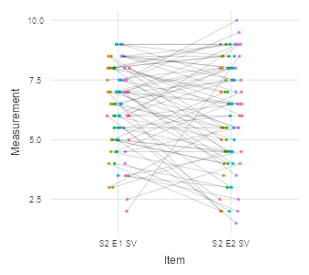
Reliability Analysis
Coefficient of Variation (%): 18.98Standard Error of Measurement (SEM): 1.2047Standard Error of the Estimate (SEE): 1.2406Standard Error of Prediction (SEP): 2.143
Intraclass Correlation Coefficients
Model |  | Measures |  | Type |  | ICC |  | Lower C.I. |  | Upper C.I.
one-way random |  | Agreement |  | ICC1 |  | 0.435 |  | 0.269 |  | 0.576
two-way random |  | Agreement |  | ICC2 |  | 0.460 |  | 0.273 |  | 0.607
two-way fixed |  | Consistency |  | ICC3 |  | 0.504 |  | 0.348 |  | 0.633
one-way random |  | Avg. Agreement |  | ICC1k |  | 0.606 |  | 0.424 |  | 0.731
two-way random |  | Avg. Agreement |  | ICC2k |  | 0.630 |  | 0.429 |  | 0.756
two-way fixed |  | Avg. Consistency |  | ICC3k |  | 0.670 |  | 0.517 |  | 0.775

Plot Reliability Data
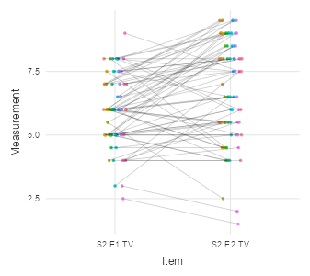

Reliability Analysis
Coefficient of Variation (%): 27.35Standard Error of Measurement (SEM): 1.5962Standard Error of the Estimate (SEE): 1.2481Standard Error of Prediction (SEP): 2.6014
Intraclass Correlation Coefficients
Model |  | Measures |  | Type |  | ICC |  | Lower C.I. |  | Upper C.I.
one-way random |  | Agreement |  | ICC1 |  | 0.277 |  | 0.0936 |  | 0.442
two-way random |  | Agreement |  | ICC2 |  | 0.289 |  | 0.1118 |  | 0.450
two-way fixed |  | Consistency |  | ICC3 |  | 0.299 |  | 0.1168 |  | 0.462
one-way random |  | Avg. Agreement |  | ICC1k |  | 0.434 |  | 0.1712 |  | 0.613
two-way random |  | Avg. Agreement |  | ICC2k |  | 0.448 |  | 0.2010 |  | 0.621
two-way fixed |  | Avg. Consistency |  | ICC3k |  | 0.460 |  | 0.2092 |  | 0.632

Plot Reliability Data
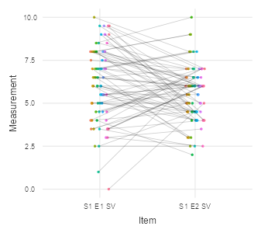
Reliability Analysis
Coefficient of Variation (%): 18.98Standard Error of Measurement (SEM): 1.2047Standard Error of the Estimate (SEE): 1.2406Standard Error of Prediction (SEP): 2.143
Intraclass Correlation Coefficients
Model |  | Measures |  | Type |  | ICC |  | Lower C.I. |  | Upper C.I.
one-way random |  | Agreement |  | ICC1 |  | 0.435 |  | 0.269 |  | 0.576
two-way random |  | Agreement |  | ICC2 |  | 0.460 |  | 0.273 |  | 0.607
two-way fixed |  | Consistency |  | ICC3 |  | 0.504 |  | 0.348 |  | 0.633
one-way random |  | Avg. Agreement |  | ICC1k |  | 0.606 |  | 0.424 |  | 0.731
two-way random |  | Avg. Agreement |  | ICC2k |  | 0.630 |  | 0.429 |  | 0.756
two-way fixed |  | Avg. Consistency |  | ICC3k |  | 0.670 |  | 0.517 |  | 0.775

Plot Reliability Data
Reliability Analysis
Coefficient of Variation (%): 19.9Standard Error of Measurement (SEM): 1.2104Standard Error of the Estimate (SEE): 1.0808Standard Error of Prediction (SEP): 2.0289
Intraclass Correlation Coefficients
Model |  | Measures |  | Type |  | ICC |  | Lower C.I. |  | Upper C.I.
one-way random |  | Agreement |  | ICC1 |  | 0.393 |  | 0.222 |  | 0.542
two-way random |  | Agreement |  | ICC2 |  | 0.395 |  | 0.224 |  | 0.542
two-way fixed |  | Consistency |  | ICC3 |  | 0.396 |  | 0.224 |  | 0.544
one-way random |  | Avg. Agreement |  | ICC1k |  | 0.565 |  | 0.363 |  | 0.703
two-way random |  | Avg. Agreement |  | ICC2k |  | 0.566 |  | 0.366 |  | 0.703
two-way fixed |  | Avg. Consistency |  | ICC3k |  | 0.568 |  | 0.366 |  | 0.705

Plot Reliability Data
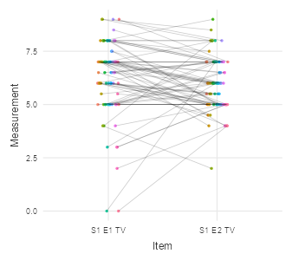
Reliability Analysis
Coefficient of Variation (%): 19.86Standard Error of Measurement (SEM): 2.3809Standard Error of the Estimate (SEE): 2.2351Standard Error of Prediction (SEP): 4.0733
Intraclass Correlation Coefficients
Model |  | Measures |  | Type |  | ICC |  | Lower C.I. |  | Upper C.I.
one-way random |  | Agreement |  | ICC1 |  | 0.404 |  | 0.234 |  | 0.551
two-way random |  | Agreement |  | ICC2 |  | 0.415 |  | 0.248 |  | 0.559
two-way fixed |  | Consistency |  | ICC3 |  | 0.431 |  | 0.263 |  | 0.573
one-way random |  | Avg. Agreement |  | ICC1k |  | 0.576 |  | 0.379 |  | 0.710
two-way random |  | Avg. Agreement |  | ICC2k |  | 0.587 |  | 0.397 |  | 0.717
two-way fixed |  | Avg. Consistency |  | ICC3k |  | 0.602 |  | 0.417 |  | 0.729

Plot Reliability Data
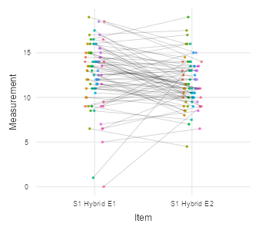
Reliability Analysis
Coefficient of Variation (%): 17.09Standard Error of Measurement (SEM): 2.1372Standard Error of the Estimate (SEE): 2.2948Standard Error of Prediction (SEP): 3.8012
Intraclass Correlation Coefficients
Model |  | Measures |  | Type |  | ICC |  | Lower C.I. |  | Upper C.I.
one-way random |  | Agreement |  | ICC1 |  | 0.570 |  | 0.428 |  | 0.685
two-way random |  | Agreement |  | ICC2 |  | 0.571 |  | 0.429 |  | 0.685
two-way fixed |  | Consistency |  | ICC3 |  | 0.573 |  | 0.431 |  | 0.688
one-way random |  | Avg. Agreement |  | ICC1k |  | 0.726 |  | 0.599 |  | 0.813
two-way random |  | Avg. Agreement |  | ICC2k |  | 0.727 |  | 0.601 |  | 0.813
two-way fixed |  | Avg. Consistency |  | ICC3k |  | 0.729 |  | 0.603 |  | 0.815

Plot Reliability Data
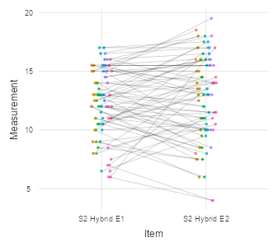
Reliability Analysis
Coefficient of Variation (%): 24.55Standard Error of Measurement (SEM): 1.4771Standard Error of the Estimate (SEE): 1.3705Standard Error of Prediction (SEP): 2.5118
Intraclass Correlation Coefficients
Model |  | Measures |  | Type |  | ICC |  | Lower C.I. |  | Upper C.I.
one-way random |  | Agreement |  | ICC1 |  | 0.405 |  | 0.288 |  | 0.511
two-way random |  | Agreement |  | ICC2 |  | 0.413 |  | 0.296 |  | 0.518
two-way fixed |  | Consistency |  | ICC3 |  | 0.424 |  | 0.308 |  | 0.528
one-way random |  | Avg. Agreement |  | ICC1k |  | 0.577 |  | 0.447 |  | 0.676
two-way random |  | Avg. Agreement |  | ICC2k |  | 0.585 |  | 0.456 |  | 0.682
two-way fixed |  | Avg. Consistency |  | ICC3k |  | 0.595 |  | 0.471 |  | 0.691

Plot Reliability Data
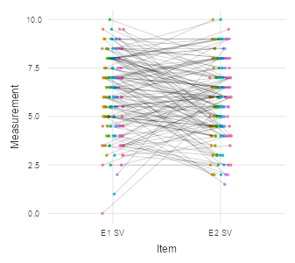
Reliability Analysis
Coefficient of Variation (%): 19.2Standard Error of Measurement (SEM): 1.1969Standard Error of the Estimate (SEE): 1.144Standard Error of Prediction (SEP): 2.0463
Intraclass Correlation Coefficients
Model |  | Measures |  | Type |  | ICC |  | Lower C.I. |  | Upper C.I.
one-way random |  | Agreement |  | ICC1 |  | 0.450 |  | 0.338 |  | 0.551
two-way random |  | Agreement |  | ICC2 |  | 0.452 |  | 0.340 |  | 0.552
two-way fixed |  | Consistency |  | ICC3 |  | 0.455 |  | 0.342 |  | 0.554
one-way random |  | Avg. Agreement |  | ICC1k |  | 0.621 |  | 0.505 |  | 0.710
two-way random |  | Avg. Agreement |  | ICC2k |  | 0.623 |  | 0.507 |  | 0.711
two-way fixed |  | Avg. Consistency |  | ICC3k |  | 0.625 |  | 0.510 |  | 0.713

Plot Reliability Data
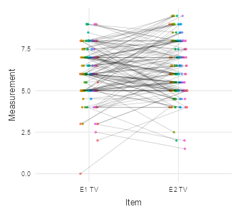
Reliability Analysis
Coefficient of Variation (%): 18.88Standard Error of Measurement (SEM): 2.3049Standard Error of the Estimate (SEE): 2.2995Standard Error of Prediction (SEP): 3.9913
Intraclass Correlation Coefficients
Model |  | Measures |  | Type |  | ICC |  | Lower C.I. |  | Upper C.I.
one-way random |  | Agreement |  | ICC1 |  | 0.497 |  | 0.389 |  | 0.591
two-way random |  | Agreement |  | ICC2 |  | 0.497 |  | 0.389 |  | 0.591
two-way fixed |  | Consistency |  | ICC3 |  | 0.497 |  | 0.389 |  | 0.591
one-way random |  | Avg. Agreement |  | ICC1k |  | 0.664 |  | 0.561 |  | 0.743
two-way random |  | Avg. Agreement |  | ICC2k |  | 0.664 |  | 0.561 |  | 0.743
two-way fixed |  | Avg. Consistency |  | ICC3k |  | 0.664 |  | 0.560 |  | 0.743

Plot Reliability Data
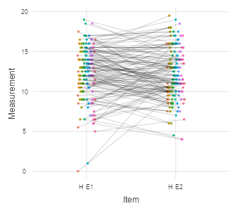
Paired Samples T-Test
Paired Samples T-Test
 |  |  |  |  |  | statistic |  | df |  | p
S1 E1 SV |  | S1 E2 SV |  | Student's t |  | 2.185 |  | 75.0 |  | 0.032
S1 E1 TV |  | S1 E2 TV |  | Student's t |  | 1.240 |  | 75.0 |  | 0.219
S1 Hybrid E1 |  | S1 Hybrid E2 |  | Student's t |  | 2.453 |  | 75.0 |  | 0.016
S2 E1 SV |  | S2 E2 SV |  | Student's t |  | 1.795 |  | 75.0 |  | 0.077
S2 E1 TV |  | S2 E2 TV |  | Student's t |  | -3.894 |  | 74.0 |  | < .001
S2 Hybrid E1 |  | S2 Hybrid E2 |  | Student's t |  | -1.347 |  | 75.0 |  | 0.182
E1 SV |  | E2 SV |  | Student's t |  | 2.834 |  | 151.0 |  | 0.005
E1 TV |  | E2 TV |  | Student's t |  | -1.542 |  | 149.0 |  | 0.125
H E1 |  | H E2 |  | Student's t |  | 0.646 |  | 151.0 |  | 0.519
Note. Hₐ μ _{Measure 1 - Measure 2} ≠ 0

Paired Samples T-Test
Paired Samples T-Test
 |  |  |  |  |  | Statistic |  | df |  | p
S1 E1 SV |  | S1 E2 SV |  | Student's t |  | 2.185 |  | 75.0 |  | 0.032
 |  |  |  | Wilcoxon W |  | 1692 | ᵃ |  |  | 0.034
S1 E1 TV |  | S1 E2 TV |  | Student's t |  | 1.240 |  | 75.0 |  | 0.219
 |  |  |  | Wilcoxon W |  | 1456 | ᵇ |  |  | 0.047
S1 Hybrid E1 |  | S1 Hybrid E2 |  | Student's t |  | 2.453 |  | 75.0 |  | 0.016
 |  |  |  | Wilcoxon W |  | 1955 | ᵈ |  |  | 0.002
S2 E1 SV |  | S2 E2 SV |  | Student's t |  | 1.795 |  | 75.0 |  | 0.077
 |  |  |  | Wilcoxon W |  | 1555 | ᵉ |  |  | 0.067
S2 E1 TV |  | S2 E2 TV |  | Student's t |  | -3.894 |  | 74.0 |  | < .001
 |  |  |  | Wilcoxon W |  | 617 | ᵉ |  |  | < .001
S2 Hybrid E1 |  | S2 Hybrid E2 |  | Student's t |  | -1.347 |  | 75.0 |  | 0.182
 |  |  |  | Wilcoxon W |  | 1097 | ᶠ |  |  | 0.300
E1 SV |  | E2 SV |  | Student's t |  | 2.834 |  | 151.0 |  | 0.005
 |  |  |  | Wilcoxon W |  | 6454 | ᵍ |  |  | 0.005
E1 TV |  | E2 TV |  | Student's t |  | -1.542 |  | 149.0 |  | 0.125
 |  |  |  | Wilcoxon W |  | 4035 | ʰ |  |  | 0.220
H E1 |  | H E2 |  | Student's t |  | 0.646 |  | 151.0 |  | 0.519
 |  |  |  | Wilcoxon W |  | 5924 | ⁱ |  |  | 0.213
Note. Hₐ μ _{Measure 1 - Measure 2} ≠ 0
ᵃ 4 pair(s) of values were tied
ᵇ 9 pair(s) of values were tied
ᵈ 2 pair(s) of values were tied
ᵉ 6 pair(s) of values were tied
ᶠ 5 pair(s) of values were tied
ᵍ 10 pair(s) of values were tied
ʰ 15 pair(s) of values were tied
ⁱ 7 pair(s) of values were tied

