Supplementary Information to “Accounting for Embodied Emissions of Chemicals within the European Carbon Border Adjustment Measure”

S1 Terminology
In our work, we use the term “embodied emissions” to refer to calculated greenhouse gas emissions from the production of a product. However, please note that the EU instead uses the word “embedded” in legislative texts and proposals. From a Life-Cycle Assessment perspective on carbon-based products, “embedded” emissions could be misunderstood as greenhouse gas emissions released at the end-of-life due to carbon present in the product. We thus choose to use the term “embodied”.
In the literature, both the term Border Carbon Adjustment (BCA) and the term Carbon Border Adjustment Measure (CBAM) are used. While CBAM is typically used specifically for the EU carbon-leakage measure, BCA is used as a general term to describe such policy instruments.
In our calculations, we consider all countries participating in the EU ETS as part of the CBAM, specifically the 27 EU member states, Iceland, Liechtenstein, and Norway. Throughout our work, we refer to EU ETS members as "EU" and other nations as "non-EU".

S2 Definition of “goods”
As specified in the EU CBAM, fallback embodied emissions are calculated for each of the goods covered by the CBAM, identified by their 4-digit ‘combined nomenclature’ (CN) codes¹. For chemicals and polymers, a single 4-digit CN code, i.e., a “good”, can contain multiple products, and their fallback embodied emissions are determined as if they were one single product. For instance, the CN code 2901 contains not only ethylene, but also propylene, butene, butadiene, and isoprene. Consequently, facilities producing all these products are considered when calculating fallback default values for ethylene. The same fallback default values as for ethylene also apply to each of these products upon import. The polyethylene CN code (3901) comprises fewer products, primarily low-density and high-density polyethylene (CN codes 3901 10 and 3901 20).
The advantage of defining one default value for a product group is the reduced number of default values the EU needs to define. However, calculating fallback embodied emission values based on goods (i.e., product groups) instead of individual products has disadvantages for the accuracy of embodied emissions: If the product group contains chemicals with an inherently emission-intensive production route, all lower-emitting chemicals also contained in the group will face higher default embodied emission values. Consequently, each producer of the low-emission product also has the additional administrative burden of proving superior environmental performance. In contrast, a product group consisting of inherently low-emission products with one emission-intensive outlier product would afford the outlier lower default embodied emission values, since the default values are calculated on the basis of the whole product group.

In our ethylene production dataset, we observe the effects of product grouping within CN codes on fallback values. While propylene production generates similar emissions to ethylene production on average, other chemicals in the same CN code, such as benzene, butadiene, and C4 fraction, have significantly lower emissions. Although ethylene and propylene dominate in terms of production volume, grouping them with these lower-emitting chemicals impacts the fallback default values.
For instance, in the chemicals covered design, the fallback default value for the CN code product group in China is1.61 kg CO₂-eq./kg product. If calculated for ethylene alone, the fallback default value would be 2.03 kg CO₂-eq./kg ethylene, indicating a significant underestimation of the fallback default value with CN code grouping.
In high fallback designs, this underestimation for emission-intensive products is mitigated, as only the highest-emitting installations are considered in determining the fallback default values. However, high fallback default values designs applied to CN code product groups overestimate emissions for chemicals with inherently lower production emissions, such as benzene.

S3 Data preparation procedure: aggregation to emission scopes
For each facility, emission data in the cm.chemicals database are resolved by intermediates, i.e., by material and energy inputs and outputs. We need emissions to be divided by emission scopes 1 through 3 to apply the calculations for embodied emissions as proposed by the EU. Further, scope 3 emissions need to be divided into chemical precursors, fossil feedstock precursors, and other inputs, since these are distinguished in the embodied emissions calculation: Per the EU CBAM, a product is regarded as a “complex good” if the product is based on a feedstock that is also covered by CBAM, which is the case for most chemicals and polymers if we assume a full CBAM coverage of the chemical sector. For complex goods, the embodied emissions of any CBAM-covered feedstock are considered for the embodied emissions calculation of the facility under study. In this way, for complex goods, some scope 3 emissions of the process under study are included in the embodied emissions.
We categorize the intermediates into scopes as follows:
Scope 1: Only direct emissions are considered in scope 1.
Scope 2: As scope 2, we consider emissions related to the intermediates electricity, steam, thermal energy, and cooling water. For facilities that are net exporters of energy intermediates, we assume the scope 2 emissions related to that intermediate to be zero (i.e., no environmental credit for energy export).
Scope 3 – chemical precursors: We need to distinguish chemical precursors since the EU CBAM considers the embodied emissions of material feedstock also covered by CBAM in the embodied emissions calculation. Since the CBAM regulation currently does not apply to chemicals, the scope of feedstock chemicals to which the CBAM would apply is unclear. We assume all feedstock chemicals to be covered by the CBAM regulation. Hence, we might consequently overestimate scope 3 emissions covered by the CBAM in our analysis, i.e., our study poses a best-case assumption for embodied emissions calculation regarding chemical precursor coverage.
Specifically, the following inputs into the facilities are considered as chemical precursors in our case studies: benzene, butene-1, C4 fraction, C9+ aromatics, dimethylformamide, ethylene, hexene-1, hydrochloric acid, hydrogen, isobutane, isopropanol, methanol, mixed xylenes, monoethanolamine, n-hexane, n-methyl-2-pyrrolidone, n-pentane, octene-1, oxygen, propylene, and toluene.
Scope 3 – fossil feedstock precursors: For the fossil feedstocks covered design, we must distinguish scope 3 emissions from fossil feedstock precursor production. We classify fossil feedstocks according to EU nomenclature¹. Specifically, the following inputs into facilities are considered fossil feedstock precursors in our case studies: atmospheric gas oil, coal, ethane, LPG, naphtha, natural gas, propane, pyrolysis gasoline, vacuum gas oil, vacuum residue.
Scope 3 – other: This category includes all other feedstock into the facilities, including inert gases and process water.

S4 Additional results

S4.1 Life-cycle emissions of polyethylene production
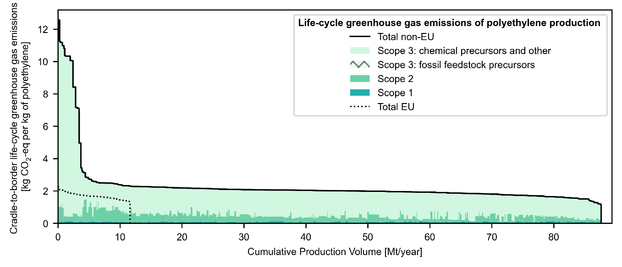
Figure S1: Cradle-to-border life-cycle greenhouse gas emissions of polyethylene facilities in- and outside the EU over their production volume in order of decreasing emissions. For non-EU producers, emissions are separated into “Scope 1" - direct emissions from the facility, "Scope 2" - energy-related supply-chain emissions, and "Scope 3" - remaining supply-chain emissions. Scope 3 emissions from fossil feedstock precursors are hatched, although no such emissions are present in this polyethylene emission profile.

S4.2 Life-cycle emissions of ethylene production
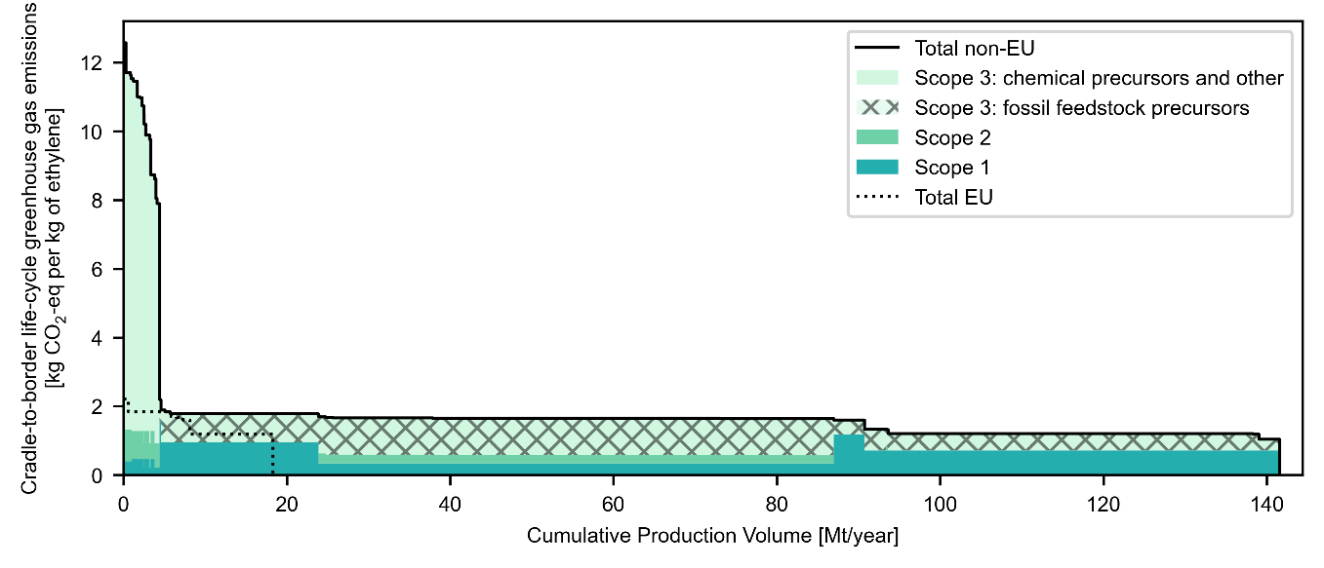
Figure S2: Cradle-to-border life-cycle greenhouse gas emissions of ethylene facilities in- and outside the EU over their production volume in order of decreasing emissions. For non-EU producers, emissions are separated into “Scope 1" - direct emissions from the facility, "Scope 2" - energy-related supply-chain emissions, and "Scope 3" - remaining supply-chain emissions. Scope 3 emissions from fossil feedstock precursors are hatched.
For the ethylene case study, our dataset consists of 545 ethylene facilities, showing a substantial variation in emissions, ranging by a factor of eight (Fig S2). The average life-cycle emissions of ethylene are higher for non-EU producers compared to EU producers, indicating differences in emission intensity. Among the non-EU facilities, approximately 3% are identified as emission-intensive outliers contributing 18% of total life-cycle emissions. No such outliers are observed among EU facilities. Similarly to polyethylene, scope 3 emissions constitute the largest share of life-cycle emissions for ethylene production (59%). However, the share of scope 3 emissions is smaller for ethylene compared to polyethylene. This difference can be attributed to ethylene’s position one step upstream in the supply chain from polyethylene, resulting in a shorter upstream supply chain and consequently smaller scope 3 emissions. Furthermore, scope 3 emissions are dominated by fossil feedstock and refinery product precursors. The contribution of scope 1 emissions is 33% for ethylene production on average, much higher than for polyethylene production. Many ethylene production processes are self-sustaining in terms of energy, leading to a lower relative importance of scope 2 emissions, which make up only 8% of the total life-cycle emissions.

S4.3 Embodied emissions in chemicals & feedstocks covered + average fallback design for polyethylene
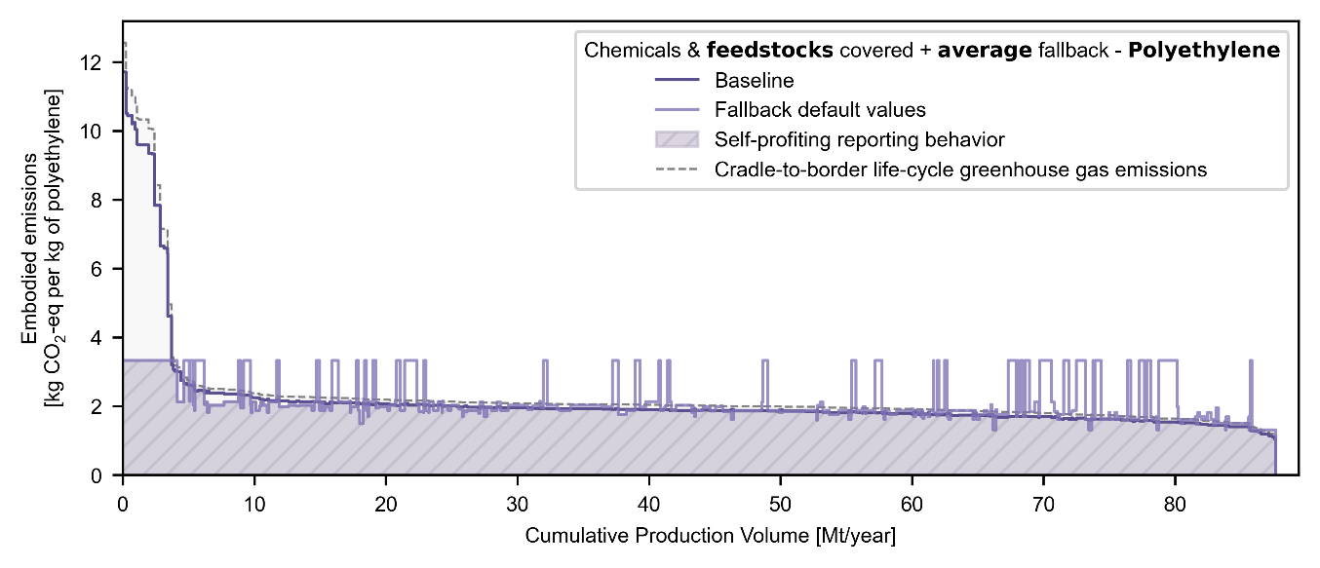
Figure S3: Embodied emissions of non-EU ethylene facilities calculated from cradle-to-border greenhouse gas emission data according to the chemicals & feedstocks covered + average fallback design. A perfect CBAM would cover cradle-to-border greenhouse gas emissions exactly. “Self-profiting reporting behavior” assumes that facilities supply baseline data only if it results in lower embodied emissions than the fallback value.

S4.4 Embodied emissions in chemicals covered + high fallback design
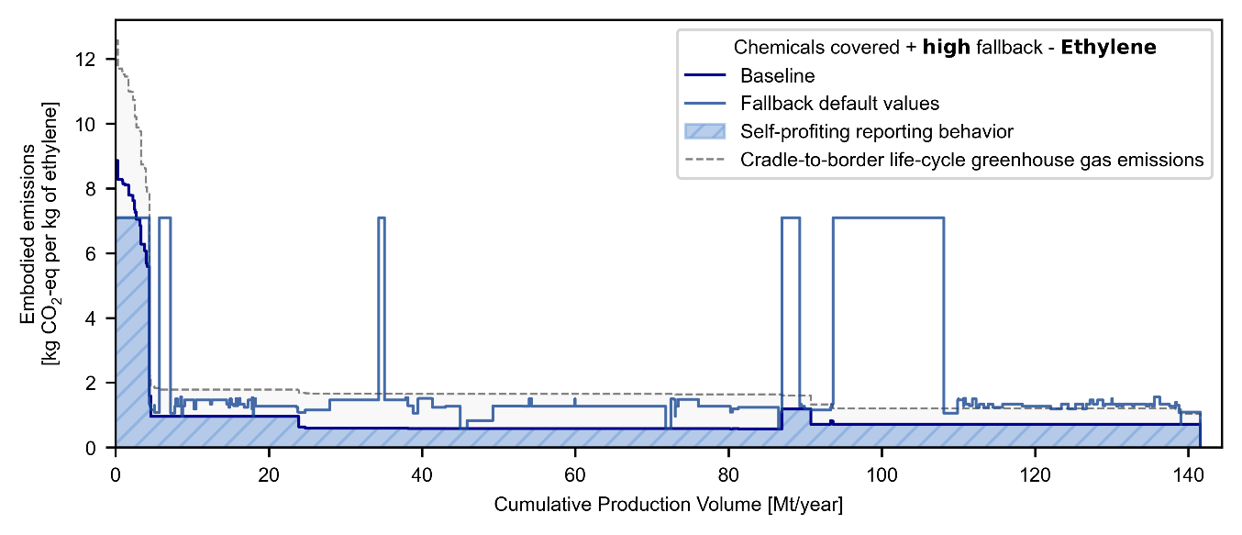
Figure S4: Embodied emissions of non-EU ethylene facilities calculated from cradle-to-border greenhouse gas emission data according to the chemicals covered + high fallback design. A perfect CBAM would cover cradle-to-border greenhouse gas emissions exactly. “Self-profiting reporting behavior” assumes that facilities supply baseline data only if it results in lower embodied emissions than the fallback value.
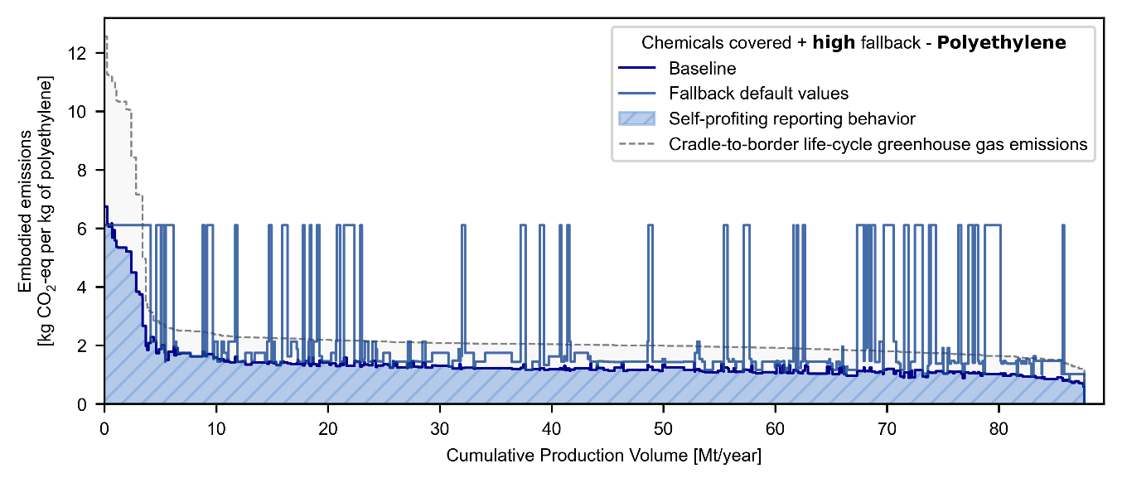
Figure S5: Embodied emissions of non-EU polyethylene facilities calculated from cradle-to-border greenhouse gas emission data according to the chemicals covered + high fallback design. A perfect CBAM would cover cradle-to-border greenhouse gas emissions exactly. “Self-profiting reporting behavior” assumes that facilities supply baseline data only if it results in lower embodied emissions than the fallback value.

S4.5 Embodied emissions in chemicals & feedstocks covered + high fallback design
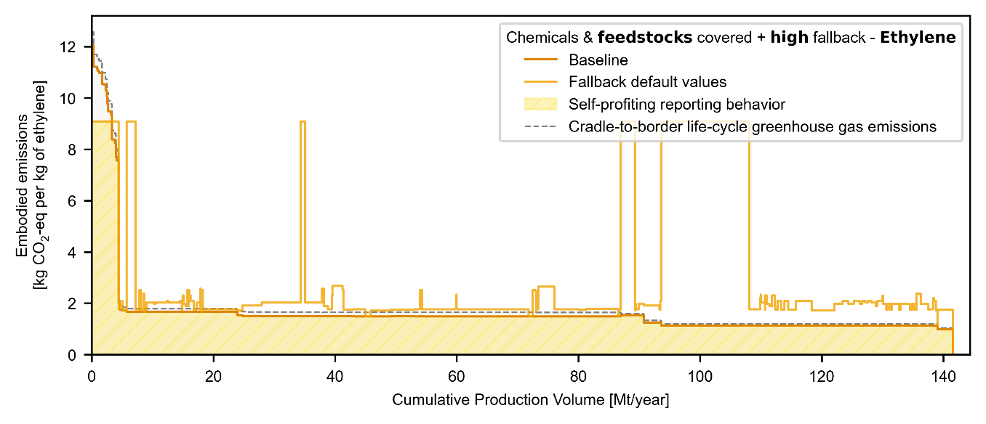
Figure S6: Embodied emissions of non-EU ethylene facilities calculated from cradle-to-border greenhouse gas emission data according to the chemicals & feedstocks covered + high fallback design. A perfect CBAM would cover cradle-to-border greenhouse gas emissions exactly. “Self-profiting reporting behavior” assumes that facilities supply baseline data only if it results in lower embodied emissions than the fallback value.

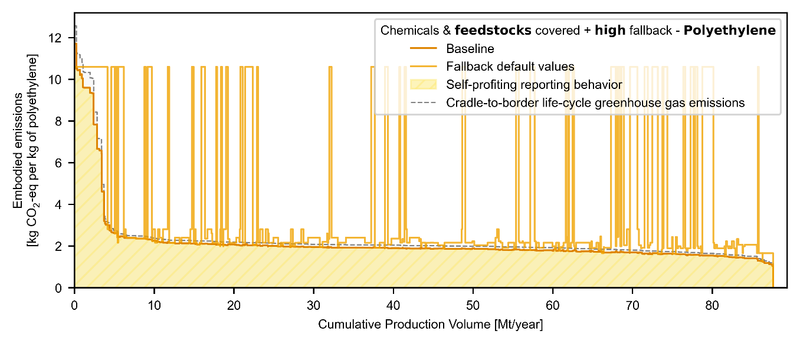
Figure S7: Embodied emissions of non-EU polyethylene facilities calculated from cradle-to-border greenhouse gas emission data according to the chemicals & feedstocks covered + high fallback design. A perfect CBAM would cover cradle-to-border greenhouse gas emissions exactly. “Self-profiting reporting behavior” assumes that facilities supply baseline data only if it results in lower embodied emissions than the fallback value.

S4.6 Emission coverage as a function of mark-up
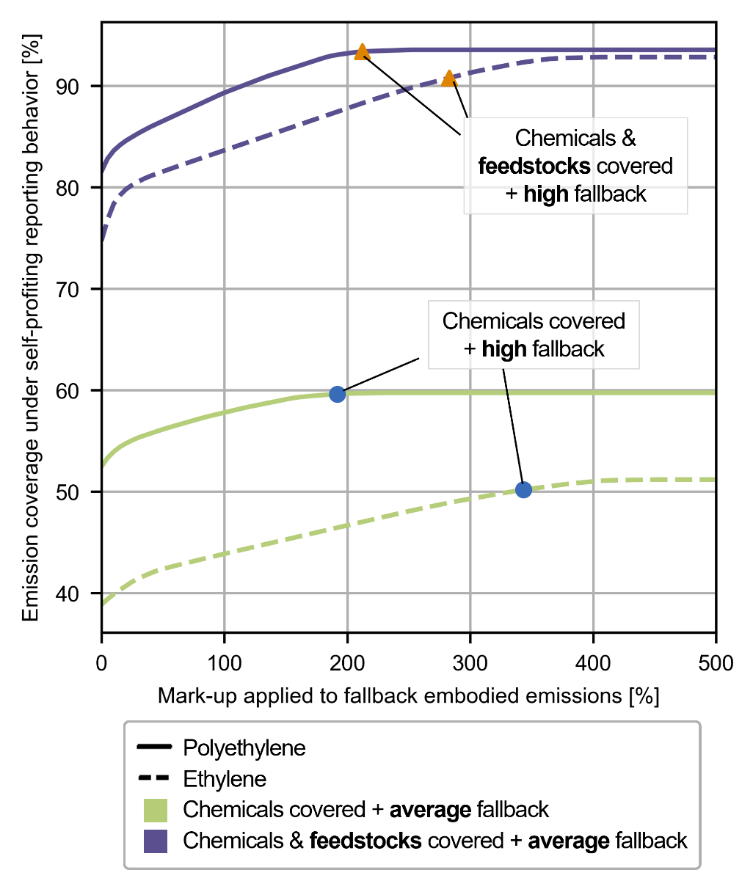
Figure S8: Emission coverage under self-profiting reporting behavior as a function of the mark-up applied to fallback values. With increasing mark-up, more facilities are incentivized to provide baseline embodied emissions data. Consequently, the self-profiting reporting behavior emission coverage approaches the baseline design emission coverage.

S5 References
1. Corrigendum to Commission Implementing Regulation (EU) 2021/1832 of 12 October 2021 amending Annex I to Council Regulation (EEC) No 2658/87 on the tariff and statistical nomenclature and on the Common Customs Tariff (2021).
2. Carbon border adjustment mechanism ***I Amendments adopted by the European Parliament on 22 June 2022 on the proposal for a regulation of the European Parliament and of the Council establishing a carbon border adjustment mechanismn(COM(2021)0564 - C9-0328/2021 - 2021/0214(COD)) (2022).

