Blocking copper transporter protein-dependent drug efflux with albumin-encapsulated Pt(IV) for synergistically enhanced chemo-immunotherapy
Man Fang^{1, 2, †}, Lei Cao^{2, 3, 4, 5, †}, Zhao Zhang⁶, Zhen Yu^{1, 2}, Yue Shen^{1, 2}, Jieqi Chen^{1, 2}, Juan Chen^{1, 2}, Zhaoqian Liu^{2, 3, 4}, Yingcai Meng^{1, 2}, Haihua Xiao⁷, Qiang Qu^{1, 2,} *, Ji-Ye Yin^{2, 3, 4, 5,} *, Xiang-Ping Li^{1, 2,} *
¹ Department of Pharmacy, Xiangya Hospital, Central South University, Changsha, Hunan, 410008, P. R. China
² National Clinical Research Center for Geriatric Disorders, Xiangya Hospital, Central South University, Changsha, 410008, P. R. China
³ Department of Clinical Pharmacology, Xiangya Hospital, Central South University, Changsha, 410008, P. R. China
⁴ Institute of Clinical Pharmacology, Hunan Key Laboratory of Pharmacogenetics, Central South University, Changsha, 410008, P. R. China
⁵ Engineering Research Center of Applied Technology of Pharmacogenomics, Ministry of Education, 110 Xiangya Road, Changsha, 410008, P. R. China
⁶ Central South University Xiangya Medical School, No. 172 Tongzipo Road, Yuelu District, Changsha, 410013, P. R. China
⁷ Beijing National Laboratory for Molecular Sciences, State Key Laboratory of Polymer Physics and Polymer Chemistry, Institute of Chemistry, Chinese Academy of Sciences, Beijing, 100190, P. R. China
* Corresponding author.
† Authors contributed equally to this work.
E-mail addresses: xylxping@csu.edu.cn (X. Li), yinjiye@csu.edu.cn (J. Yin), quqiang@csu.edu.cn (Q. Qu).

TABLE OF CONTENTS
Supplemental materials and methods 3
Scheme S1 5
Figure S1 6
Figure S2 7
Figure S3 8
Figure S4 9
Figure S5. 10
Figure S6. 11
Figure S7 12
Figure S8 13
Figure S9 14
Figure S10 15
Figure S11 16
Figure S12 17
Figure S13 18
Figure S14 20
Figure S15 21
Figure S16 22
Figure S17 23
Figure S18 24
Figure S19. 25
References 26

Supplemental materials and methods
1. Supplemental Materials
General instruments
Dynamic light scattering (DLS) was conducted by Malvern Zetasizer NanoZS90 (Malvern Instruments, Malvern, UK). Inductively Coupled Plasma (ICP) analysis was conducted by using Inductively Coupled Plasma Optical Emission Spectrometer (Agilent technologies 7800 series, U.S.A.). The morphology and size were measured by transmission electron microscope (Talos F200S, Thermo Fisher Scientific, MA, USA). Flow cytometry was conducted by DxP-Athena (Cytek, U.S.A.). Confocal laser scanning microscopy (CLSM) was accomplished by ZEISS LSM880. All OD values were recorded by Bio-Tek.
2. Methods
2.1. Synthesis of Pt(Ⅳ)
Pt(Ⅳ) was synthesized with the guidance of the previous study[1, 2]. A solution of H₂O₂ (36 mL, 30%) was added to cisplatin (1 g), and the resulting mixture was subjected to a 2-hour reaction in an oil bath maintained at 55 ℃. The reaction products were filtered and subsequently vacuum-dried. Subsequently, 10 mL of an anhydrous DMF solution and n-octanoic anhydride (814 mg) were added to the aforementioned products (334 mg). The Pt(IV) prodrug was then obtained through a process of sedimentation, filtration, and vacuum drying. The synthetic routes for Pt(Ⅳ) are illustrated in Scheme S1.
2.2. Cell uptake of HSA@Pt
The cellular uptake of nanoparticles was monitored with CLSM. Briefly, cover slides were placed in the bottom of each well of a 24-well plate. 1 × 10⁵ A549 cells in 1 mL media were added to each well and incubated at 37 °C for 12 h. Then the cells were treated with HSA@ Cy5.5 (5 μM Pt) for 0h, 1 h, 4 h, or 7 h, respectively. Following a cold PBS wash, the cells were fixed with paraformaldehyde, and cell nuclei were stained with DAPI. The cytoskeleton was stained with Actin, and images were subsequently collected with CLSM (DAPI, λex = 405 nm, λem = 460 nm; Cy5.5, λex = 673 nm, λem = 692 nm).
Flow cytometry was subsequently employed to examine the cellular internalization of nanoparticles. A549 cells were seeded in 12-well plates at a density of 3 × 10⁵ cells per well and allowed to incubate for 12 h. The cells were then treated with HSA@Cy5.5 for 0 h, 1 h, 4 h, or 7 h, respectively, and subsequently washed with PBS. The cells were then analyzed by FCM.
2.3. The intracellular uptake and apoptosis rate in 2D/3D tumor spheroids
A 1% agarose gel solution (50 μL) was added to each 96-well plate. A total of 1.5 × 10³ H1299 cells (200 μL) were added to each well. By the seventh day, the formation of cell spheres was largely complete. To analyze the cellular uptake of HSA@Pt, the 3D spheroids were treated with HSA@Cy5.5 for 12 h. Following a wash with cold PBS, the uptake of HSA@Pt by the spheroids was measured via CLSM. To assess apoptosis, the cells and spheroids were treated with PBS, TM, CisPt, Pt(IV), and HSA@Pt (10 μM Pt), or a combination with TM (100 μM) for 24 h. Following a wash with cold PBS, the cells and spheroids were stained with the Calcein AM/PI Cell Viability Kit, and images were collected with CLSM.

Scheme S1. Total synthesis route of Pt (IV).

Figure S1. ¹H NMR spectra of Pt(IV) in CDCl₃ at 298 K[2].

Figure S2. ¹C NMR spectra of Pt(IV) in CDCl₃ at 298 K[2].

Figure S3. Ineffective against cisplatin-resistant cell lines. A) Relative cell viabilities of MRC-5 and A549DDP cells with 48 h treatment of CisPt and Pt(Ⅳ) via CCK8 assay, respectively. B) Final colonies stained with crystal violet dye after different treatments for two weeks. C) Apoptosis via FCM in A549DDP cells treated with diverse Pt-containing drugs (10 μM Pt) for 24 h. D) Quantification of apoptotic ratio. n = 3. Data are presented as mean ± SD. Statistical significances between every two groups were calculated via one-way ANOVA. * p < 0.05, **p < 0.01, *** p < 0.001.

Figure S4. Related proteins expression levels of ATP7B in various cells (A549DDP and A549) by Western blot. Tubulin was used as the internal reference protein.

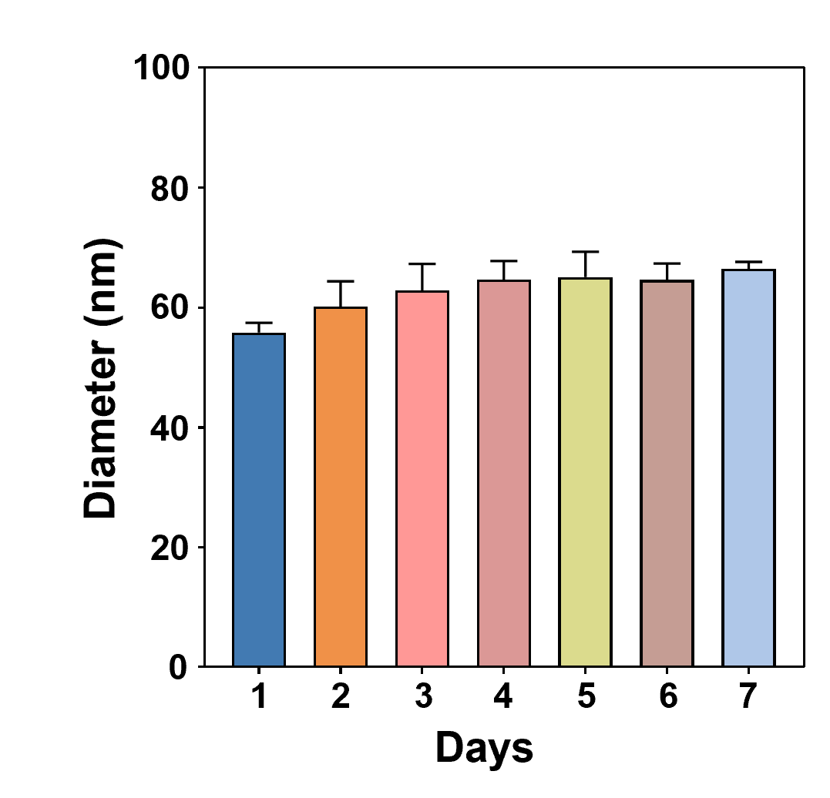

Figure S5. Stability (average diameter) of HSA@Pt within 7 days monitored by DLS. n = 3. Data are presented as mean ± SD.

Figure S6. Relative cell viabilities of A549, H1299, LLC and A549DDP cells with 48 h treatment of CisPt, Pt(Ⅳ) and HSA@Pt via CCK8 assay, respectively. n = 3. Data are presented as mean ± SD.

Figure S7. Apoptosis via FCM in A549 cells treated with diverse Pt-containing drugs (10 μM Pt), or combination with TM (100 μM) for 24 h.

Figure S8. The 3D spheroids CLSM images of H1299 cells stained with calcein-AM (green, viable) and PI (red, dead) after treatment with PBS, TM, CisPt, Pt(Ⅳ) and HSA@Pt (10 μM Pt), or combination with TM (100 μM) for 24 h. Scalar bar: 50 µm.

Figure S9. The corresponding quantification of Western blot. n = 3. Data are presented as mean ± SD. Statistical significances between every two groups were calculated via one-way ANOVA. *p < 0.05, **p < 0.01, ***p < 0.001.

Figure S10. Principal component analysis of all detectable metabolites in TM, CisPt, HSA@Pt+TM-treated or PBS control group.

Figure S11. A-C) The volcano plots of differentially expressed metabolites between two groups with various treatments. NO differentially expressed metabolites were denoted as Not Significant.

Figure S12. Dot plot depicting the top-15 KEGG enrichment pathways between A549 cells treated with HSA@Pt+TM and CisPt. The size of the dots corresponds to the enrichment ratio, and the color of the dots corresponds to the correlated p-value.

Figure S13. Bubble plot depicting the pathway analysis between A549 cells treated with HSA@Pt+TM and CisPt. The size of the dots corresponds to the enrichment ratio, and the color of the dots corresponds to the correlated p-value.

Figure S14. Biosafety evaluation of HSA@Pt combined with TM in vivo. A-E) Biochemical analysis of serum: A) alanine aminotransferase (ALT), B) aspartate aminotransferase (AST), C) alkaline phosphatase (ALP), D) Blood urea nitrogen (BUN), E) Serum creatinine (CRE). F) Representative masson staining images of various organs (heart, liver, spleen, lung and kidney) in different groups after 18 days of treatment. Scalar bar: 100 µm. n = 3. Data are presented as mean ± SD. Statistical significances between every two groups were calculated via one-way ANOVA. * p < 0.05, **p < 0.01, *** p < 0.001.

Figure S15. Gating strategies for flow cytometric analysis. A) The gating strategy of DCs maturation in within TDLNs from LLC tumor-bearing mice with various treatments, wherein B) matured DCs were denoted as the percentage of CD11c⁺ CD80⁺ CD86⁺ cells.

Figure S16. A) The gating strategy and the representative FCM analysis images of CD3⁺ CD8⁺ or CD3⁺ CD4⁺ T cells in spleen from LLC tumor-bearing mice with various treatments, which was denoted as B) the percentage of CD4⁺ or CD8⁺ T cells in the population of CD3⁺ T cells.

Figure S17. A) The gating strategy of DCs maturation in tumor sites from LLC tumor-bearing mice with various treatments, wherein B) matured DCs were denoted as the percentage of CD11c⁺ CD80⁺ CD86⁺ cells.

Figure S18. The gating strategy and the representative FCM analysis images of CD3⁺ CD8⁺ or CD3⁺ CD4⁺ T cells in tumor sites from LLC tumor-bearing mice with various treatments.

Figure S19. A) The gating strategy of TAM cells in tumor sites from LLC tumor-bearing mice with various treatments, wherein B) M1 TAM and M2 TAM were denoted as the percentage of F4/80⁺ CD80⁺ CD206⁻ cells and F4/80⁺ CD80⁻ CD206⁺, respectively.

References
1. Tian HX, Mei J, Cao L, Song J, Rong D, Fang M, Xu Z, Chen J, Tang J, Xiao H, et al: Disruption of Iron Homeostasis to Induce Ferroptosis with Albumin-Encapsulated Pt(IV) Nanodrug for the Treatment of Non-Small Cell Lung Cancer. Small 2023, 19:e2206688.
2. Ding F, Li F, Tang D, Wang B, Liu J, Mao X, Yin J, Xiao H, Wang J, Liu Z: Restoration of the Immunogenicity of Tumor Cells for Enhanced Cancer Therapy via Nanoparticle-Mediated Copper Chaperone Inhibition. Angew Chem Int Ed Engl 2022, 61:e202203546.

