Physiological Sources of Essential Lipids for Mycoplasma pneumoniae via Protein P116: Localization and Innovative Biotechnological Tools for Targeting Atherosclerotic Lesion
David Vizarraga^{1,*}, Marina Marcos^{2,*}, Noemi Rotllan^{3,4,*}, Jesús Martín¹, David Santos^{3,4}, Mercedes Camacho^{3,5}, Pablo Guerra⁶, Félix Pareja⁷, María Collantes^{8,9}, Wanlu Wu², Irene Rodríguez-Arce¹⁰, Luis Serrano^{10,11}, Jaume Piñol^{2, #}, Ignacio Fita^{1,#} and Joan Carles Escolà-Gil^{3,4,#}

Supplementary Figure 1: page 2
Supplementary Figure 2: page 4
Supplementary Figure 3 page 5
Supplementary Figure 4: page 6
Supplementary Figure 5: page 7
Supplementary Figure 6: page 8
Supplementary Table 1: page 9
Supplementary Table 2: page 10
Supplementary Table 3: page 12
Supplementary Table 4: page 34

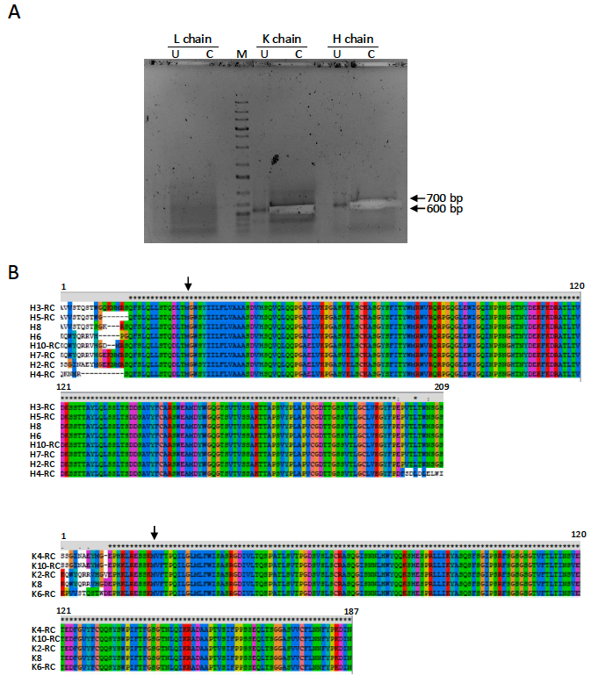
Supplementary figure 1: Sequence analysis of the coding cDNAs and amino acid sequences for the CDS of heavy and light chains in hybridoma cells producing the P116-mAb-3G9. (A) Agarose gel electrophoresis of RT-PCR products corresponding to the cDNAs of the heavy chain (H), kappa light chain (K), and lambda light chain (L). Lanes were loaded with 5 µL (U) or 45 µL (C) of the RT-PCR products. The C lanes from the K and H chain reactions were excised from the gel (indicated by arrows at ~700 bp and ~600 bp, respectively). The M lane contains the GeneRuler 1 kb Plus DNA Ladder (Thermo Fisher Scientific). (B) ClustalX alignment of the deduced amino acid sequences for the heavy chain (H3 to H10) and kappa light chain (K2, K4, K6, K8, and K10). "RC" indicates that the DNA sequence used for translation into amino acids was the reverse complement of the original sequence. Arrows indicate the first methionine (Met) residue in each alignment.
Supplementary figure 2: LDL and HDL composition. Both lipoproteins were isolated from human normolipidemic plasma at 100,000 g for 24 hours at densities of 1.019–1.063 and 1.063–1.21 g/mL, respectively. Lipids and apoB and apoA1 levels were determined. Values are expressed as lipid concentration per milligram of apoB or apoA1 (mmol/mg) and correspond to lipoprotein preparations isolated from three independent samples.
Supplementary figure 3: The transfer of unesterified cholesterol from LDL to P116W681A mutant is reduced. Relative transfer of radiolabeled unesterified cholesterol from LDL (0.5 mg/mL) to P116W681A mutant (0.25 mg/mL) for 90 minutes at 37°C.
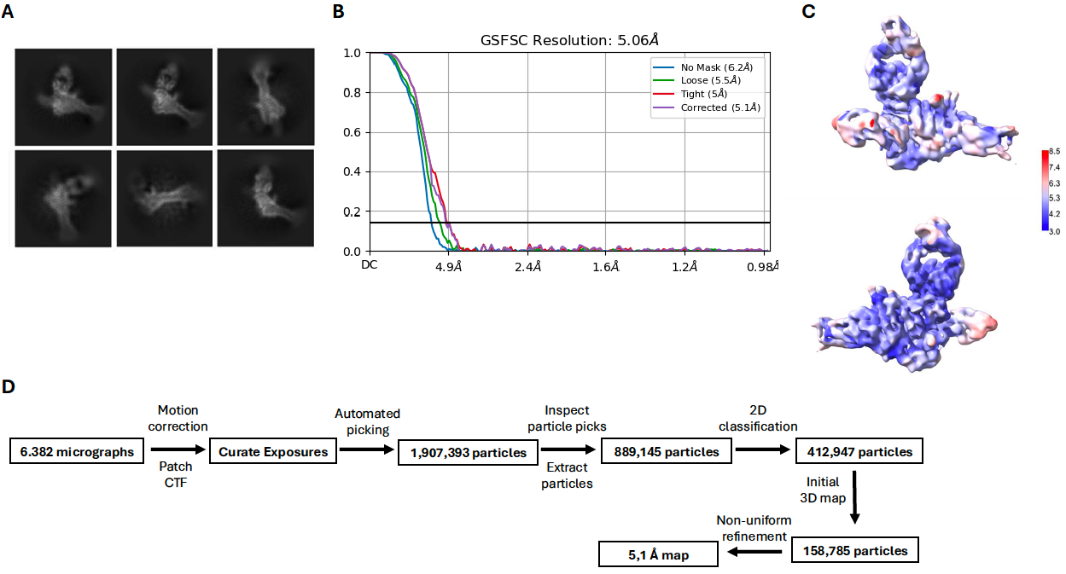
Supplementary Figure 4: Cryo-EM analysis of the P116-mAb-3G9 complex. (A) Representative 2D class averages of the P116-mAb-3G9 complex. (B) Fourier shell correlation (FSC) curve indicating a final resolution of 5.1 Å, based on the 0.143 cut-off criterion. (C) Local resolution estimation of the cryo-EM map. (D) Workflow schematic outlining the image processing steps for the P116-mAb-3G9 complex.
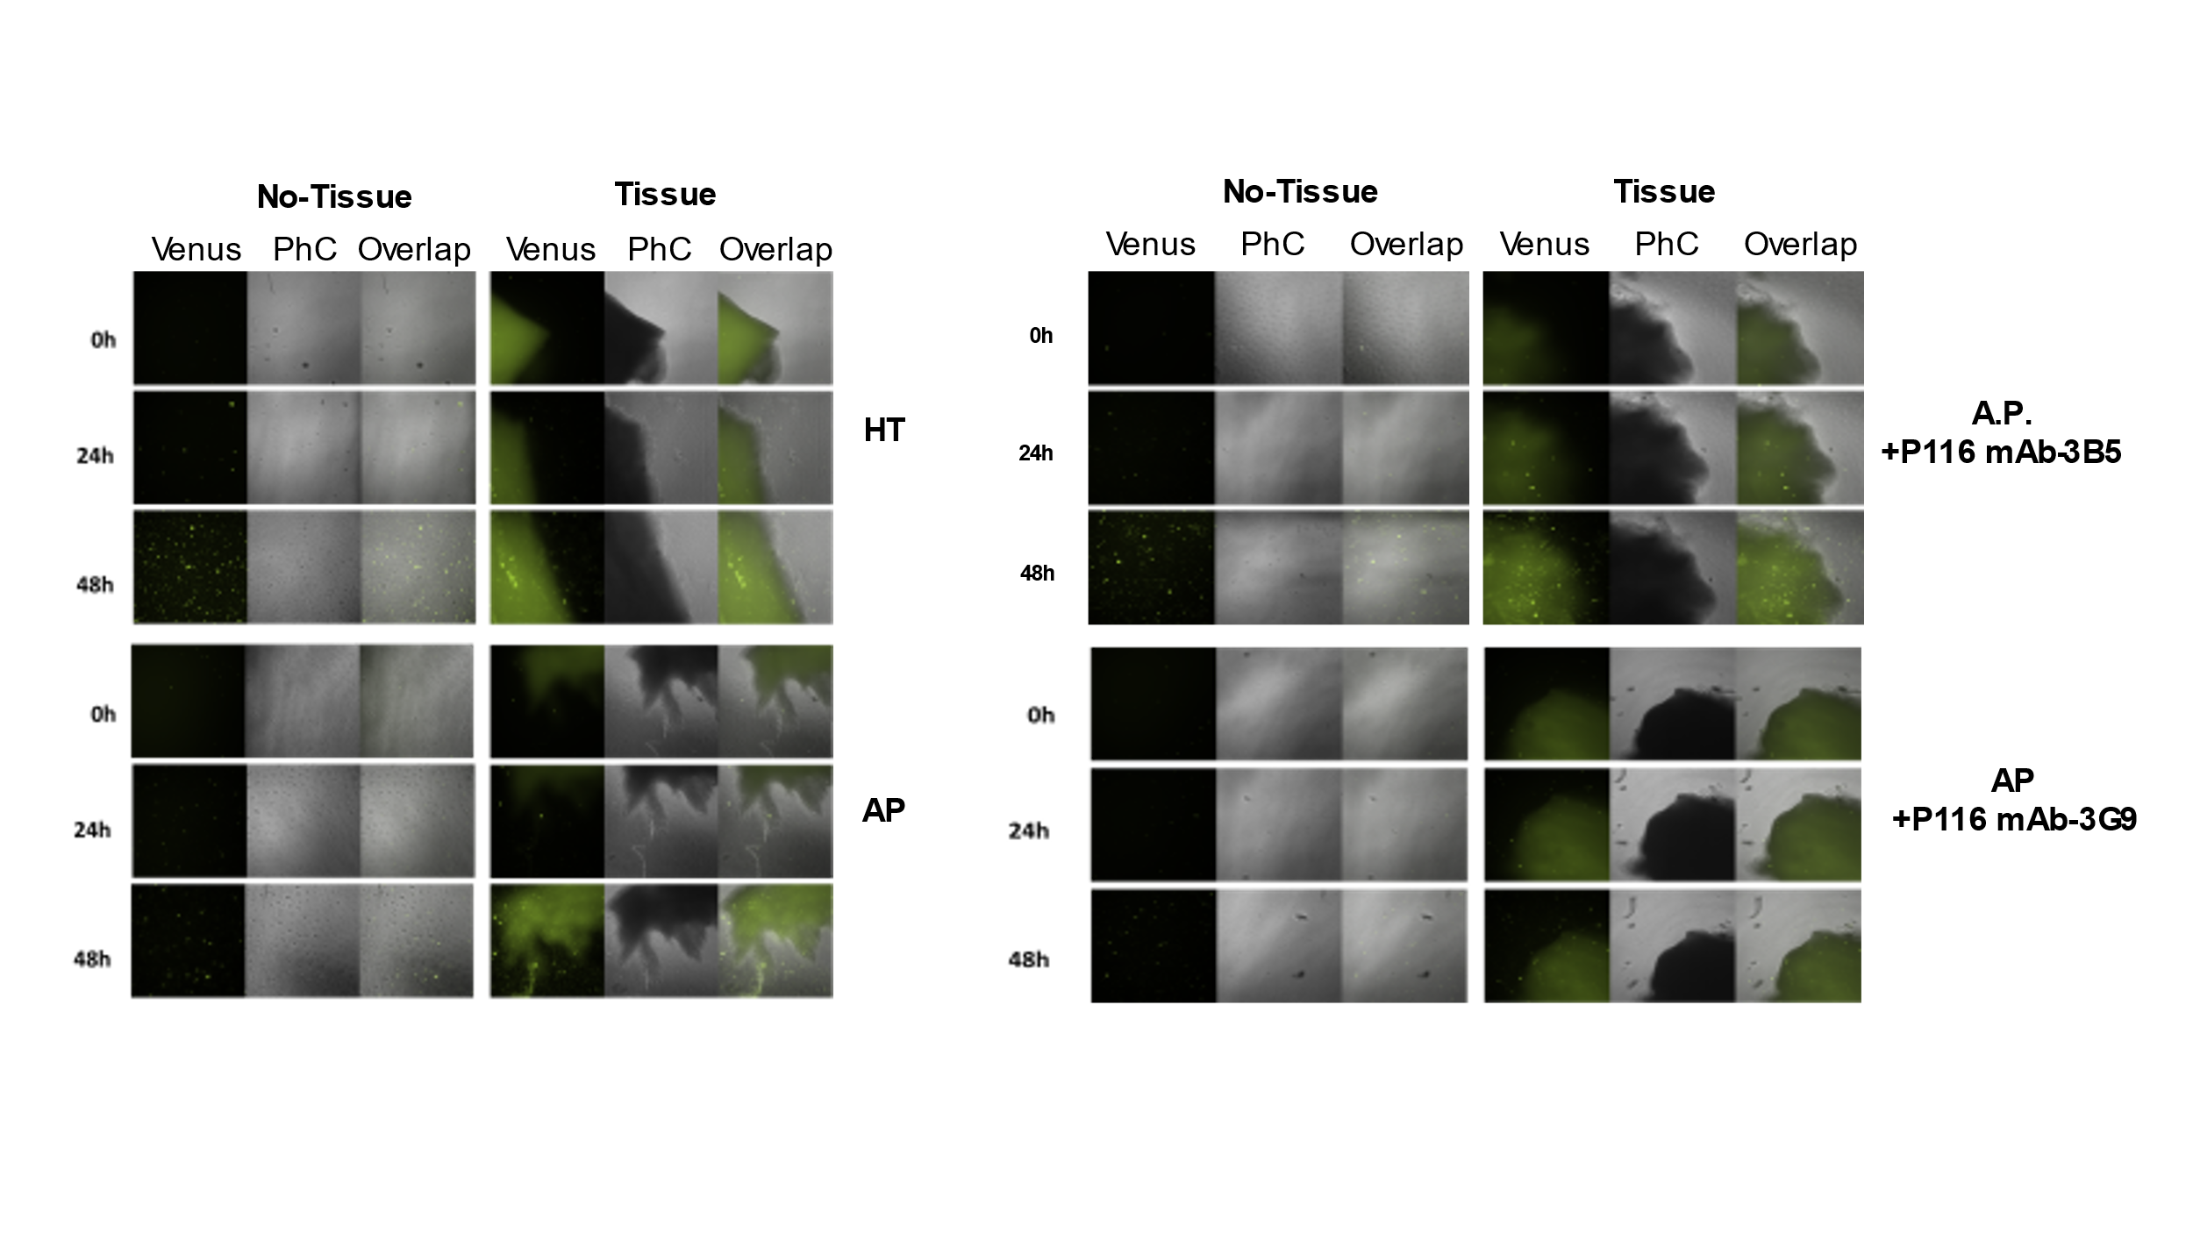Supplementary Figure 5: Monoclonal P116 Antibodies and Tropism of MPN to Human Atherosclerotic Plaques ex Vivo. Phase contrast (PhC) epifluorescence microscopy images of MPN cells grown in the presence of healthy human non-atherosclerotic tissue (HT) or human atherosclerotic plaque tissue (AP), before and after incubation with P116 mAb-3G9 or P116 mAb-3B5. Images were captured at different time points: 0h, 24h and 48h after inoculation with MPN Venus strain cells. The left panels display images from plate areas without tissue (No-Tissue), while the right panels show images from plate areas where tissue was deposited and monitored (Tissue).
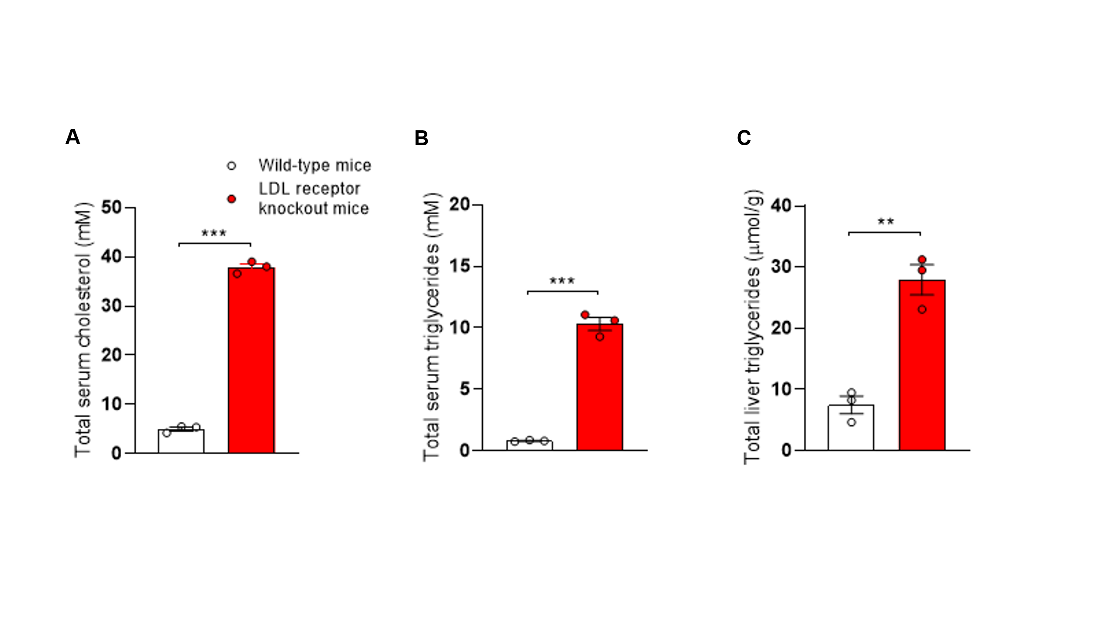Supplementary Figure 6: Increased levels of serum and liver lipids in LDL receptor knockout mice. Serum total cholesterol (A) and triglycerides (B), and liver triglycerides (C) in wild-type and LDL receptor knockout mice fed a Western-type diet for 8 weeks.
Statistics: An unpaired t-test was performed to compare the different parameters between the two groups. ** and *** are P≤0.01, and 0.001 vs. wild-type, respectively.

 | Platform 1 | Platform 2
Column type | UPLC BEH C18, 1.0 x  100 mm, 1.7 μm | UPLC BEH C18, 2.1 x 100  mm, 1.7 μm
Flow rate | 0.14 ml/min | 0.40 ml/min
Solvent A | H2O + 0.05% Formic Acid | H2O + ACN + 10mM  Ammonium Formate
Solvent B | ACN + 0.05% Formic Acid | ACN+ Isopropanol + 10mM Ammonium Formate
(%B), time | 0%, 0 min | 40%, 0 min
(%B), time | 50%, 2 min | 100%, 10 min
(%B), time | 100%, 13 min | 40%, 15 min
(%B), time | 0%, 18 min | 40%, 17 min
Column temperature | 40 °C | 60 °C
Injection volume | 2 μl | 3 μl
Source temperature | 120 °C | 120 °C
Nebulization N2 flow | 600 l / hour | 1000 l / hour
Nebulization N2 temperature | 350 °C | 500 °C
Cone N2 flow | 30 l / hour | 30 l / hour
Capillary voltage | 2.0 kV | 3.2 kV
Cone voltage | 50 V | 30 V
Supplementary Table 1. UHPLC-MS analysis methods

Supplementary Table 2.
Data collection and processing | P116-mAb
Magnification | 150000x
Voltage (kV) | 200
Electron exposure (e⁻/Å²) | 38.76
Defocus range (μm) | -1.8 to -2.8
Pixel size (Å) | 0.96
Symmetry imposed | C1
Initial particle images (nº) | 1.907.393
Final particle images (nº) | 412.947
Map Resolution | 5.06
FSC threshold | 0.143
Map resolution range (Å) | 3.0 to 8.5
Refinement statistcs
Initial model used | 8A9A (cryo-EM structure)
Model resolution (Å) | 6.8
FSC threshold | 0.5
Model resolution range (Å) | 2.0 to 6.8
Map sharpening B factor (Å² ) | -300
Model composition
Nonhydrogen atoms | 10018
Protein residues | 1278
N º Ligands | -
Water | -
B factor (Å² ) | 233.60
R.m.s deviations
Bond lengths (Å² ) | 0.003
Bond angles (º) | 0.760
Validation
MoltProbity score | 2.39
Clashscore | 19.57
Poor rotamer (%) | 0.16
Ramachandran plot
Favored (%) | 87.8
Allowed (%) | 12.0
Disallowed (%) | 0.2

Supplementary Table 3. Relative intensity of identified lipid compounds in P116 and P116 after being incubated with either HDL, LDL, or H1299 lung cells.
SUBCLASS | INDIVIDUAL NOTATION | P116 control | P116 control | P116 (tranfer from HDL) | P116 (tranfer from HDL) | P116 (tranfer from LDL) | P116 (tranfer from LDL) | P116 (tranfer from lung cell) | P116 (tranfer from lung cell)
Ceramides | Cer(d18:1/16:0) | 7 | 7 | 48 | 66 | 98 | 94 | 16 | 28
Ceramides | Cer(d18:1/22:0) |  |  | 73 | 68 | 81 | 85
Ceramides | Cer(d18:1/23:0) |  |  | 72 | 55 | 74 | 66
Ceramides | Cer(d18:1/24:0) |  |  | 159 | 157 | 213 | 205
Ceramides | Cer(d18:1/24:1)+Cer(d18:2/24:0) |  |  | 233 | 228 | 187 | 174 | 14 | 21
Ceramides | Cer(42:3) |  |  | 76 | 125 | 60 | 34
Cholesterol and derivatives | Cholesterol |  |  | 2780 | 2946 | 3350 | 3420 | 679 | 852
Cholesteryl Ester | ChoE(16:0) |  |  | 244 | 221 | 142 | 122
Cholesteryl Ester | ChoE(16:1) |  |  | 92 | 64 | 52 | 42
Cholesteryl Ester | ChoE(18:1) | 19 | 17 | 1906 | 1558 | 1172 | 987 | 49 | 52
Cholesteryl Ester | ChoE(18:2) | 82 | 102 | 12334 | 11213 | 7399 | 6830 | 89 | 97
Cholesteryl Ester | ChoE(18:3) |  |  | 863 | 728 | 345 | 285
Cholesteryl Ester | ChoE(20:2) | 6 | 11 | 78 | 65 | 34 | 32 | 5 | 7
Cholesteryl Ester | ChoE(20:3) |  |  | 757 | 674 | 354 | 325
Cholesteryl Ester | ChoE(20:4) | 21 | 25 | 10221 | 8800 | 3808 | 3367 | 44 | 46
Cholesteryl Ester | ChoE(20:5) |  |  | 1246 | 1001 | 379 | 259
Cholesteryl Ester | ChoE(22:4) |  |  | 73 | 59 | 26 | 22
Cholesteryl Ester | ChoE(22:5) |  |  | 116 | 92 | 41 | 35 | 8 | 8
Cholesteryl Ester | ChoE(22:6) |  |  | 2052 | 1844 | 725 | 851 | 18 | 26
Cholesteryl Ester | ChoE(18:0) |  |  | 691 | 614 | 345 | 306 | 30 | 46
Monohexosylceramides | CMH(d18:1/16:0) |  |  | 71 | 59 | 142 | 138 | 25 | 39
Monohexosylceramides | CMH(d18:1/22:0) |  |  | 93 | 74 | 48 | 57
Diacylglycerophosphocholine | PC(32:0) | 16 | 15 | 7531 | 7100 | 10722 | 10699 | 1031 | 1627
Diacylglycerophosphocholine | PC(32:1) |  |  | 10562 | 10292 | 11778 | 11663 | 2588 | 4100
Diacylglycerophosphocholine | PC(32:2) |  |  | 3652 | 3619 | 5925 | 5820 | 403 | 594
Diacylglycerophosphocholine | PC(34:0) | 239 | 214 | 2832 | 2542 | 2503 | 2299 | 394 | 509
Diacylglycerophosphocholine | PC(34:1) | 114 | 112 | 195331 | 189147 | 161075 | 159096 | 7734 | 12119
Diacylglycerophosphocholine | PC(34:2) | 238 | 257 | 326185 | 314850 | 317528 | 303326 | 3006 | 4645
Diacylglycerophosphocholine | PC(34:4) |  |  | 1102 | 1056 | 1582 | 1638
Diacylglycerophosphocholine | PC(36:1) | 21 | 16 | 48982 | 44396 | 31605 | 29219 | 991 | 1474
Diacylglycerophosphocholine | PC(36:2) | 129 | 115 | 246583 | 231695 | 183503 | 176803 | 4314 | 7262
Diacylglycerophosphocholine | PC(36:4) | 7 | 8 | 24773 | 23090 | 23020 | 21806 | 11 | 35
Diacylglycerophosphocholine | PC(36:4) | 69 | 78 | 191159 | 186175 | 151849 | 149858 | 363 | 536
Diacylglycerophosphocholine | PC(36:5) |  |  | 16239 | 16544 | 18543 | 17929 | 25 | 51
Diacylglycerophosphocholine | PC(36:6) |  |  | 426 | 398 | 681 | 626
Diacylglycerophosphocholine | PC(38:2) |  |  | 5272 | 4545 | 3133 | 2900 | 450 | 812
Diacylglycerophosphocholine | PC(38:3) | 13 | 14 | 46584 | 38010 | 28093 | 26383 | 97 | 125
Diacylglycerophosphocholine | PC(38:4) | 52 | 54 | 92983 | 85837 | 60467 | 58171 | 249 | 326
Diacylglycerophosphocholine | PC(38:5) |  |  | 35472 | 33310 | 24307 | 23451 | 516 | 744
Diacylglycerophosphocholine | PC(38:5) |  |  | 13802 | 12073 | 10469 | 9987
Diacylglycerophosphocholine | PC(38:6) |  |  | 9381 | 8980 | 9117 | 8576 | 48 | 68
Diacylglycerophosphocholine | PC(38:6) | 28 | 18 | 138807 | 128788 | 132990 | 130911 | 187 | 272
Diacylglycerophosphocholine | PC(40:4) |  |  | 2894 | 2737 | 1594 | 1532 | 18 | 30
Diacylglycerophosphocholine | PC(40:4) |  |  | 435 | 422 | 238 | 235 | 8 | 7
Diacylglycerophosphocholine | PC(40:5) |  |  | 3168 | 2935 | 1884 | 1810
Diacylglycerophosphocholine | PC(40:5) |  |  | 4695 | 4290 | 3181 | 3028 | 111 | 151
Diacylglycerophosphocholine | PC(40:6) | 10 | 11 | 33605 | 29695 | 23164 | 21569 | 87 | 142
Diacylglycerophosphocholine | PC(40:7) |  |  | 346 | 321 | 273 | 242 | 4 | 6
Diacylglycerophosphocholine | PC(40:7) |  |  | 7490 | 6842 | 6016 | 5763 | 132 | 214
Diacylglycerophosphocholine | PC(40:8) |  |  | 1358 | 1337 | 1386 | 1368
Diacylglycerophosphocholine | PC(42:8) |  |  | 254 | 236 | 174 | 166
Diacylglycerophosphocholine | PC(34:3) |  |  | 4836 | 4593 | 5744 | 5643 | 49 | 80
Diacylglycerophosphocholine | PC(34:3) |  |  | 1557 | 1526 | 1796 | 1710 | 17 | 25
Diacylglycerophosphocholine | PC(34:3) |  |  | 2923 | 2657 | 3530 | 3658
Diacylglycerophosphocholine | PC(36:3) | 22 | 21 | 49057 | 49507 | 34798 | 34278 | 383 | 578
Diacylglycerophosphocholine | PC(36:3) | 20 | 17 | 69399 | 67251 | 51591 | 51744 | 130 | 173
Diacylglycerophosphocholine | PC(36:5) |  |  | 1490 | 1264 | 1677 | 1530 | 63 | 75
Diacylglycerophosphocholine | PC(31:0) |  |  | 339 | 327 | 631 | 558 | 38 | 71
Diacylglycerophosphocholine | PC(28:0) |  |  | 103 | 112 | 343 | 340 | 114 | 150
Diacylglycerophosphocholine | PC(30:0) |  |  | 1452 | 1305 | 2419 | 2463 | 575 | 858
Diacylglycerophosphocholine | PC(30:1) |  |  | 195 | 187 | 402 | 364 | 287 | 474
Diacylglycerophosphocholine | PC(36:0) |  |  | 6664 | 6057 | 4343 | 3971 | 130 | 180
Diacylglycerophosphocholine | PC(40:0) | 77 | 68 | 115 | 120 | 104 | 23 | 98 | 77
Diacylglycerophosphocholine | PC(40:1) | 10 | 11 | 97 | 74 | 49 | 38 | 21 | 27
Oxidized Diacylglycerophosphocholine | PC(16:0/18:2-OH) |  |  | 2758 | 2617 | 1398 | 1090
Oxidized Diacylglycerophosphocholine | PC(16:0/18:2-OH) |  |  | 2641 | 2316 | 1468 | 1071
Oxidized Diacylglycerophosphocholine | PC(18:0/18:2-OH) |  |  | 1384 | 1261 | 487 | 393
Oxidized Diacylglycerophosphocholine | PC(18:0/18:2-OH) |  |  | 1226 | 1139 | 498 | 397
Oxidized Diacylglycerophosphocholine | PC(16:0/20:4-OH) |  |  | 874 | 839 | 363 | 348
Oxidized Diacylglycerophosphocholine | PC(16:0/20:4-OH) |  |  | 2799 | 2504 | 1212 | 1071
Oxidized Diacylglycerophosphocholine | PC(16:0/20:4-OH) |  |  | 2112 | 2035 | 1097 | 900
Oxidized Diacylglycerophosphocholine | PC(36:4-OH) |  |  | 794 | 691 | 363 | 288
Oxidized Diacylglycerophosphocholine | PC(18:0/20:4-OH) |  |  | 485 | 440 | 138 | 124
Oxidized Diacylglycerophosphocholine | PC(18:0/20:4-OH) |  |  | 1673 | 1373 | 549 | 428
Diacylglycerophosphoethanolamine | PE(34:1) | 81 | 76 | 8734 | 5159 | 13182 | 4848 | 60 | 117
Diacylglycerophosphocholine | PC(33:0) |  |  | 376 | 301 | 399 | 355 | 17 | 29
Diacylglycerophosphocholine | PC(33:1) |  |  | 3368 | 3032 | 3024 | 2931 | 177 | 285
Diacylglycerophosphocholine | PC(33:2) |  |  | 4387 | 4366 | 5591 | 5583 | 55 | 80
Diacylglycerophosphoethanolamine | PE(36:3) |  |  | 411 | 356 | 303 | 233 | 10 | 19
Diacylglycerophosphoethanolamine | PE(36:4) |  |  | 771 | 701 | 598 | 535 | 14 | 25
Diacylglycerophosphoethanolamine | PE(36:4) |  |  | 146 | 102 | 123 | 140
Diacylglycerophosphoethanolamine | PE(36:5) | 12 | 14 | 67 | 61 | 83 | 73 | 16 | 19
Diacylglycerophosphocholine | PC(35:1) |  |  | 1401 | 1381 | 894 | 798 | 41 | 48
Diacylglycerophosphocholine | PC(35:1) |  |  | 4046 | 3382 | 2625 | 2427 | 144 | 210
Diacylglycerophosphocholine | PC(35:2) |  |  | 2797 | 2757 | 2080 | 2087 | 131 | 211
Diacylglycerophosphocholine | PC(35:2) |  |  | 6989 | 6176 | 4925 | 4855
Diacylglycerophosphocholine | PC(35:3) |  |  | 551 | 529 | 470 | 490
Diacylglycerophosphocholine | PC(35:3) |  |  | 472 | 427 | 372 | 354
Diacylglycerophosphocholine | PC(35:4) |  |  | 1460 | 1329 | 1653 | 1627 | 7 | 5
Diacylglycerophosphoethanolamine | PE(38:4) |  |  | 1661 | 1465 | 910 | 801 | 10 | 27
Diacylglycerophosphoethanolamine | PE(38:5) |  |  | 449 | 451 | 292 | 265 | 31 | 89
Diacylglycerophosphoethanolamine | PE(38:6) |  |  | 1190 | 953 | 892 | 819
Diacylglycerophosphocholine | PC(37:2) |  |  | 208 | 152 | 96 | 99 | 45 | 75
Diacylglycerophosphocholine | PC(37:2) |  |  | 872 | 782 | 496 | 481
Diacylglycerophosphocholine | PC(37:3) |  |  | 644 | 623 | 410 | 380 | 9 | 7
Diacylglycerophosphocholine | PC(37:3) |  |  | 835 | 784 | 568 | 514
Diacylglycerophosphocholine | PC(37:4) |  |  | 1353 | 1322 | 910 | 891
Diacylglycerophosphocholine | PC(37:4) |  |  | 4140 | 4025 | 2936 | 3085 | 25 | 23
Diacylglycerophosphocholine | PC(37:5) |  |  | 678 | 622 | 656 | 617
Diacylglycerophosphoethanolamine | PE(40:6) |  |  | 556 | 445 | 342 | 295
Diacylglycerophosphocholine | PC(37:6) |  |  | 644 | 604 | 728 | 725
Diacylglycerophosphoethanolamine | PE(16:0/16:0) | 14 | 13 | 292 | 184 | 522 | 201 | 8 | 10
Diacylglycerophosphoethanolamine | PE(32:1) | 113 | 98 | 10794 | 6215 | 14245 | 5364 | 31 | 56
Diacylglycerophosphoethanolamine | PE(36:1) |  |  | 386 | 279 | 349 | 156 | 31 | 63
Diacylglycerophosphoinositol | PI(38:4) |  |  | 120 | 173 | 138 | 177
Diacylglycerophosphoinositol | PI(36:4) |  |  | 54 | 57 | 38 | 51
Diacylglycerophosphoinositol | PI(40:6) |  |  | 18 | 28 | 28 | 32
Diacylglycerols | DG(32:0) | 108 | 84 | 180 | 225 | 280 | 91 | 65 | 69
Diacylglycerols | DG(32:1) | 32 | 36 | 235 | 230 | 209 | 125 | 45 | 38
Diacylglycerols | DG(34:0) | 280 | 152 | 244 | 238 | 825 | 140 | 94 | 109
Diacylglycerols | DG(34:1) | 50 | 53 | 1096 | 984 | 505 | 416 | 99 | 79
Diacylglycerols | DG(34:2) |  |  | 547 | 511 | 334 | 240
Diacylglycerols | DG(36:2) | 36 | 17 | 1141 | 1126 | 552 | 475 | 60 | 70
Diacylglycerols | DG(36:3) |  |  | 636 | 601 | 343 | 338
Diacylglycerols | DG(36:4) |  |  | 48 | 54 | 31 | 36
Diacylglycerols | DG(30:0) | 18 | 19 | 59 | 65 | 60 | 35 | 21 | 18
Diacylglycerols | DG(36:1) |  |  | 114 | 151 | 48 | 30 | 18 | 18
Diacylglycerols | DG(38:5) |  |  | 84 | 98 | 55 | 58
1-ether, 2-acylglycerophosphocholine | PC(O-16:0/14:0) |  |  | 122 | 108 | 262 | 265 | 31 | 67
1-ether, 2-acylglycerophosphocholine | PC(O-16:0/16:0) |  |  | 2300 | 2000 | 2927 | 2717 | 209 | 302
1-ether, 2-acylglycerophosphocholine | PC(P-16:0/16:0) |  |  | 1935 | 1619 | 1879 | 1808 | 54 | 85
1-ether, 2-acylglycerophosphocholine | PC(O-34:0) |  |  | 336 | 275 | 289 | 272 | 29 | 53
1-ether, 2-acylglycerophosphocholine | PC(O-34:1) |  |  | 9446 | 8327 | 7179 | 6848 | 573 | 916
1-ether, 2-acylglycerophosphocholine | PC(O-16:0/18:2) | 6 | 4 | 7055 | 5831 | 5706 | 5437 | 6 | 13
1-ether, 2-acylglycerophosphocholine | PC(P-16:0/18:1) |  |  | 5352 | 4872 | 3398 | 3252 | 82 | 152
1-ether, 2-acylglycerophosphocholine | PC(P-16:0/18:2) |  |  | 10220 | 9193 | 7643 | 7075
1-ether, 2-acylglycerophosphocholine | PC(O-18:1/18:1) |  |  | 1770 | 1418 | 981 | 937 | 101 | 164
1-ether, 2-acylglycerophosphocholine | PC(O-18:0/18:2) |  |  | 1179 | 914 | 741 | 697 | 1 | 1
1-ether, 2-acylglycerophosphocholine | PC(O-18:1/18:2) |  |  | 3922 | 3403 | 2502 | 2357 | 7 | 16
1-ether, 2-acylglycerophosphocholine | PC(O-16:0/20:3) |  |  | 894 | 928 | 744 | 754
1-ether, 2-acylglycerophosphocholine | PC(P-36:2) |  |  | 3174 | 2777 | 1775 | 1680 | 36 | 50
1-ether, 2-acylglycerophosphocholine | PC(O-16:0/20:4) | 7 | 9 | 18918 | 17054 | 14867 | 13954 | 81 | 123
1-ether, 2-acylglycerophosphocholine | PC(P-16:0/20:3) |  |  | 1152 | 1090 | 755 | 724
1-ether, 2-acylglycerophosphocholine | PC(P-16:0/20:4) |  |  | 14037 | 12869 | 9830 | 9862 | 52 | 82
1-ether, 2-acylglycerophosphocholine | PC(O-38:4) |  |  | 968 | 896 | 634 | 590 | 17 | 32
1-ether, 2-acylglycerophosphocholine | PC(O-16:0/22:4) |  |  | 1978 | 1888 | 1349 | 1246 | 12 | 13
1-ether, 2-acylglycerophosphocholine | PC(O-18:0/20:4) |  |  | 7591 | 6797 | 4696 | 4295 | 22 | 24
1-ether, 2-acylglycerophosphocholine | PC(18:1e/20:3) |  |  | 246 | 195 | 120 | 121
1-ether, 2-acylglycerophosphocholine | PC(O-38:5) |  |  | 21858 | 19863 | 14606 | 13753 | 174 | 269
1-ether, 2-acylglycerophosphocholine | PC(P-18:0/20:4) | 12 | 9 | 669 | 649 | 429 | 390 | 35 | 73
1-ether, 2-acylglycerophosphocholine | PC(P-18:0/20:4) |  |  | 3054 | 2576 | 1902 | 1670 | 7 | 15
1-ether, 2-acylglycerophosphocholine | PC(O-18:2/20:4) |  |  | 1389 | 1408 | 1265 | 1247 | 17 | 38
1-ether, 2-acylglycerophosphocholine | PC(P-16:0/22:6) |  |  | 2057 | 1865 | 1613 | 1423 | 22 | 28
1-ether, 2-acylglycerophosphocholine | PC(O-18:0/22:4) |  |  | 448 | 363 | 263 | 219
1-ether, 2-acylglycerophosphocholine | PC(O-20:0/20:4) |  |  | 1079 | 949 | 555 | 504 | 10 | 6
1-ether, 2-acylglycerophosphocholine | PC(O-18:1/22:4) |  |  | 1116 | 918 | 651 | 595
1-ether, 2-acylglycerophosphocholine | PC(O-40:5) |  |  | 2147 | 1840 | 1236 | 1087
1-ether, 2-acylglycerophosphocholine | PC(O-22:1/20:4) |  |  | 1973 | 1758 | 1007 | 992 | 4 | 12
1-ether, 2-acylglycerophosphocholine | PC(O-42:6) |  |  | 681 | 576 | 373 | 345
1-ether, 2-acylglycerophosphocholine | PC(O-22:0/20:4) | 3 | 2 | 674 | 620 | 316 | 314 | 3 | 9
1-ether, 2-acylglycerophosphocholine | PC(O-24:1/20:4) |  |  | 2595 | 2325 | 1334 | 1244 | 9 | 16
1-ether, 2-acylglycerophosphoethanolamine | PE(O-16:0/18:1) |  |  | 158 | 143 | 81 | 97 | 26 | 67
1-ether, 2-acylglycerophosphoethanolamine | PE(P-16:0/18:2) |  |  | 346 | 310 | 222 | 220
1-ether, 2-acylglycerophosphoethanolamine | PE(P-18:0/18:1) |  |  | 144 | 124 | 61 | 53 | 8 | 19
1-ether, 2-acylglycerophosphoethanolamine | PE(P-16:0/20:4) |  |  | 1429 | 1223 | 839 | 768 | 49 | 87
1-ether, 2-acylglycerophosphoethanolamine | PE(P-18:0/20:4) |  |  | 1669 | 1418 | 817 | 690 | 6 | 19
1-ether, 2-acylglycerophosphoethanolamine | PE(P-18:1/20:4) |  |  | 1186 | 1027 | 583 | 546 | 38 | 97
1-ether, 2-acylglycerophosphoethanolamine | PE(P-18:1/20:4) |  |  | 117 | 107 | 75 | 65
1-ether, 2-acylglycerophosphoethanolamine | PE(P-16:0/22:6) |  |  | 923 | 763 | 628 | 528 | 23 | 45
1-ether, 2-acylglycerophosphocholine | PC(P-17:0/20:4) |  |  | 349 | 306 | 215 | 204
1-ether, 2-acylglycerophosphocholine | PC(P-17:0/20:4) |  |  | 625 | 557 | 392 | 368
1-ether, 2-acylglycerophosphoethanolamine | PE(P-18:0/18:2) |  |  | 445 | 378 | 253 | 221
1-ether, 2-acylglycerophosphoethanolamine | PE(16:1e/20:5) |  |  | 138 | 129 | 69 | 72
1-ether, 2-acylglycerophosphoethanolamine | PE(18:1e/22:6) |  |  | 739 | 618 | 356 | 376
1-ether, 2-acylglycerophosphoethanolamine | PE(18:2e/22:6) |  |  | 558 | 492 | 335 | 310 | 14 | 36
Monoacylglycerols | MG(16:0/0:0/0:0) | 1033 | 367 | 753 | 399 | 1702 | 308 | 149 | 142
Monoacylglycerols | MG(18:0/0:0/0:0) | 1190 | 443 | 759 | 411 | 2269 | 349 | 61 | 63
Monoacylglycerols | MG(18:1(9Z)/0:0/0:0) |  |  | 58 | 69 | 86 | 58
Sphingomyelin | SM(d18:0/14:0) |  |  | 115 | 124 | 745 | 723 | 17 | 28
Sphingomyelin | SM(d18:0/15:0) |  |  | 28 | 37 | 93 | 95
Sphingomyelin | SM(d18:0/16:0) |  |  | 1819 | 1627 | 5188 | 4918 | 142 | 219
Sphingomyelin | SM(d18:0/18:0) |  |  | 341 | 302 | 612 | 591 | 8 | 6
Sphingomyelin | SM(d18:0/22:0) |  |  | 226 | 189 | 233 | 208
Sphingomyelin | SM(d18:1/12:0) |  |  | 209 | 192 | 744 | 722 | 36 | 56
Sphingomyelin | SM(32:1) |  |  | 5704 | 5437 | 33924 | 33493 | 298 | 439
Sphingomyelin | SM(33:1) |  |  | 3003 | 2975 | 14967 | 14394 | 81 | 124
Sphingomyelin | SM(d18:1/16:0) | 47 | 53 | 61021 | 57812 | 168304 | 166541 | 1233 | 1890
Sphingomyelin | SM(d18:2/16:0) |  |  | 14342 | 13695 | 51941 | 52449 | 282 | 437
Sphingomyelin | SM(d18:1/17:0) |  |  | 1229 | 1054 | 2356 | 2221 | 16 | 22
Sphingomyelin | SM(d18:1/18:0) |  |  | 7164 | 6666 | 11127 | 11402 | 70 | 96
Sphingomyelin | SM(36:2) |  |  | 7527 | 6914 | 12087 | 11516 | 19 | 29
Sphingomyelin | SM(38:1) |  |  | 7124 | 6182 | 6918 | 6514 | 22 | 17
Sphingomyelin | SM(d18:2/20:0) |  |  | 3720 | 3314 | 3784 | 3531
Sphingomyelin | SM(39:1) |  |  | 2955 | 2544 | 2207 | 2129
Sphingomyelin | SM(d18:1/22:0) |  |  | 13293 | 11865 | 10884 | 10564 | 53 | 72
Sphingomyelin | SM(d16:1/24:1) |  |  | 3946 | 3699 | 3588 | 3015 | 30 | 38
Sphingomyelin | SM(d18:2/22:0) |  |  | 11330 | 9289 | 7672 | 7675 | 17 | 25
Sphingomyelin | SM(d18:1/23:0) |  |  | 7894 | 7178 | 6369 | 6072 | 23 | 37
Sphingomyelin | SM(d18:1/23:1) |  |  | 2859 | 2560 | 2199 | 2067 | 21 | 37
Sphingomyelin | SM(d18:2/23:0) |  |  | 4380 | 3660 | 2786 | 2636
Sphingomyelin | SM(d18:1/24:1) + SM(d18:2/24:0) |  |  | 39440 | 33461 | 29254 | 27326 | 276 | 418
Sphingomyelin | SM(42:3) |  |  | 21358 | 19346 | 15114 | 14478 | 65 | 98
Sphingomyelin | SM(d18:2/14:0) |  |  | 643 | 551 | 1780 | 1647 | 91 | 111
Sphingomyelin | SM(42:1) |  |  | 8399 | 7150 | 6174 | 5954 | 52 | 76
Sphingomyelin | SM(d18:1/25:0) |  |  | 211 | 164 | 132 | 121
Sphingomyelin | SM(43:1) |  |  | 241 | 201 | 138 | 152
Sphingomyelin | SM(43:2) |  |  | 800 | 652 | 554 | 502
Sphingomyelin | SM(38:0) |  |  | 158 | 123 | 162 | 163
Sphingomyelin | SM(31:1) |  |  | 96 | 95 | 499 | 460 | 22 | 29
Triacylglycerols | TG(51:0) | 206 | 201 | 475 | 435 | 314 | 203 | 211 | 176
Triacylglycerols | TG(42:0) | 45 | 49 | 96 | 79 | 73 | 72 | 46 | 29
Triacylglycerols | TG(44:0) | 319 | 317 | 708 | 652 | 490 | 388 | 348 | 304
Triacylglycerols | TG(44:1) | 159 | 130 | 340 | 343 | 244 | 179 | 166 | 127
Triacylglycerols | TG(44:2) | 32 | 29 | 81 | 78 | 44 | 45 | 37 | 22
Triacylglycerols | TG(45:0) | 398 | 355 | 1100 | 979 | 741 | 501 | 404 | 324
Triacylglycerols | TG(46:0) | 670 | 668 | 1697 | 1691 | 1393 | 1013 | 786 | 610
Triacylglycerols | TG(46:1) | 613 | 508 | 1717 | 1653 | 1088 | 766 | 630 | 473
Triacylglycerols | TG(46:2) | 234 | 211 | 585 | 647 | 372 | 240 | 238 | 196
Triacylglycerols | TG(46:3) | 42 | 38 | 94 | 116 | 74 | 52 | 59 | 38
Triacylglycerols | TG(47:0) | 714 | 683 | 1634 | 1484 | 1213 | 744 | 757 | 610
Triacylglycerols | TG(43:0) | 93 | 71 | 242 | 194 | 159 | 76 | 103 | 82
Triacylglycerols | TG(43:1) | 77 | 57 | 122 | 130 | 86 | 51 | 71 | 43
Triacylglycerols | TG(45:2) | 123 | 110 | 208 | 220 | 168 | 94 | 124 | 103
Triacylglycerols | TG(46:3) | 57 | 50 | 112 | 137 | 72 | 51 | 52 | 38
Triacylglycerols | TG(47:1) | 679 | 635 | 1854 | 1924 | 1314 | 843 | 780 | 576
Triacylglycerols | TG(48:0) | 1115 | 1142 | 2467 | 2514 | 2175 | 1618 | 1318 | 1103
Triacylglycerols | TG(52:4) |  |  | 59 | 47 | 32 | 24
Triacylglycerols | TG(55:0) | 243 | 260 | 492 | 446 | 407 | 229 | 277 | 205
Triacylglycerols | TG(55:1) | 159 | 156 | 352 | 331 | 255 | 160 | 179 | 119
Triacylglycerols | TG(55:2) | 99 | 66 | 203 | 182 | 136 | 80 | 105 | 75
Triacylglycerols | TG(55:3) | 41 | 29 | 132 | 109 | 105 | 68 | 59 | 52
Triacylglycerols | TG(48:2) | 589 | 517 | 2991 | 2973 | 1582 | 1057 | 640 | 535
Triacylglycerols | TG(48:3) | 223 | 166 | 686 | 713 | 356 | 253 | 191 | 162
Triacylglycerols | TG(49:0) | 502 | 513 | 1226 | 1129 | 886 | 574 | 573 | 443
Triacylglycerols | TG(49:1) | 771 | 678 | 2153 | 2031 | 1388 | 886 | 818 | 609
Triacylglycerols | TG(49:2) | 566 | 499 | 1738 | 1846 | 1189 | 787 | 611 | 475
Triacylglycerols | TG(49:3) | 223 | 185 | 508 | 605 | 369 | 233 | 229 | 188
Triacylglycerols | TG(50:0) | 579 | 654 | 1252 | 1566 | 1047 | 800 | 635 | 586
Triacylglycerols | TG(50:1) | 889 | 737 | 9688 | 9348 | 5319 | 4314 | 1191 | 1190
Triacylglycerols | TG(50:2) | 816 | 712 | 12801 | 12242 | 6051 | 5174 | 1131 | 1151
Triacylglycerols | TG(50:3) | 342 | 280 | 5676 | 5304 | 2073 | 1669 | 429 | 337
Triacylglycerols | TG(50:4) |  |  | 662 | 597 | 177 | 142
Triacylglycerols | TG(51:1) | 351 | 317 | 1170 | 986 | 762 | 479 | 382 | 312
Triacylglycerols | TG(51:2) | 437 | 405 | 2322 | 2128 | 1206 | 870 | 476 | 391
Triacylglycerols | TG(51:3) | 192 | 186 | 1279 | 1278 | 624 | 463 | 231 | 168
Triacylglycerols | TG(51:4) | 40 | 50 | 293 | 289 | 147 | 109 | 43 | 34
Triacylglycerols | TG(52:0) | 416 | 412 | 665 | 911 | 540 | 463 | 382 | 358
Triacylglycerols | TG(52:1) | 382 | 345 | 2998 | 2842 | 1752 | 1457 | 523 | 527
Triacylglycerols | TG(52:2) | 1308 | 1012 | 52915 | 51170 | 23027 | 21374 | 2105 | 2565
Triacylglycerols | TG(52:3) | 676 | 620 | 48290 | 43724 | 19835 | 17853 | 918 | 1031
Triacylglycerols | TG(52:4) | 121 | 135 | 15188 | 13132 | 5093 | 4218 | 143 | 125
Triacylglycerols | TG(52:5) |  |  | 1975 | 1755 | 663 | 571
Triacylglycerols | TG(53:0) | 164 | 153 | 331 | 291 | 235 | 164 | 173 | 112
Triacylglycerols | TG(53:1) | 137 | 92 | 357 | 331 | 252 | 168 | 147 | 109
Triacylglycerols | TG(53:2) | 152 | 156 | 1282 | 959 | 682 | 521 | 200 | 172
Triacylglycerols | TG(53:3) | 130 | 115 | 1313 | 1202 | 607 | 499 | 159 | 131
Triacylglycerols | TG(54:0) | 269 | 293 | 513 | 572 | 467 | 281 | 294 | 242
Triacylglycerols | TG(54:1) | 283 | 240 | 857 | 724 | 572 | 427 | 339 | 284
Triacylglycerols | TG(54:2) | 435 | 307 | 5159 | 4891 | 2796 | 2336 | 656 | 773
Triacylglycerols | TG(54:3) | 1218 | 637 | 20957 | 21709 | 10137 | 9340 | 1508 | 1650
Triacylglycerols | TG(54:4) | 366 | 258 | 15146 | 14341 | 7108 | 6523 | 355 | 316
Triacylglycerols | TG(54:5) | 169 | 137 | 6704 | 6316 | 2430 | 2077 | 176 | 100
Triacylglycerols | TG(54:5) |  |  | 1625 | 1372 | 689 | 574 | 8 | 11
Triacylglycerols | TG(54:6) | 80 | 72 | 1329 | 1198 | 422 | 329 | 95 | 69
Triacylglycerols | TG(54:6) |  |  | 920 | 746 | 318 | 291
Triacylglycerols | TG(54:7) | 21 | 23 | 120 | 112 | 40 | 30 | 25 | 20
Triacylglycerols | TG(54:7) |  |  | 88 | 68 | 30 | 33
Triacylglycerols | TG(56:0) | 296 | 277 | 569 | 517 | 431 | 253 | 327 | 230
Triacylglycerols | TG(56:1) | 270 | 219 | 562 | 538 | 422 | 234 | 283 | 244
Triacylglycerols | TG(56:2) | 177 | 129 | 391 | 451 | 330 | 214 | 213 | 216
Triacylglycerols | TG(56:3) | 59 | 31 | 496 | 514 | 350 | 268 | 215 | 297
Triacylglycerols | TG(56:5) |  |  | 1139 | 963 | 535 | 464
Triacylglycerols | TG(56:6) |  |  | 2998 | 2513 | 1408 | 1262
Triacylglycerols | TG(56:7) |  |  | 849 | 720 | 367 | 356
Triacylglycerols | TG(56:7) |  |  | 963 | 828 | 443 | 403 | 20 | 16
Triacylglycerols | TG(56:8) |  |  | 143 | 109 | 46 | 41
Triacylglycerols | TG(56:8) |  |  | 439 | 368 | 185 | 157
Triacylglycerols | TG(58:1) | 226 | 210 | 439 | 445 | 374 | 216 | 275 | 210
Triacylglycerols | TG(58:2) | 195 | 146 | 331 | 409 | 259 | 175 | 240 | 219
Triacylglycerols | TG(58:3) | 26 | 25 | 73 | 107 | 79 | 40 | 74 | 98
Triacylglycerols | TG(58:8) |  |  | 443 | 375 | 282 | 281 | 9 | 15
Triacylglycerols | TG(58:9) |  |  | 289 | 245 | 158 | 131
Triacylglycerols | TG(58:10) |  |  | 92 | 83 | 46 | 38
Triacylglycerols | TG(59:1) | 165 | 157 | 289 | 288 | 227 | 124 | 181 | 127
Triacylglycerols | TG(60:1) | 102 | 84 | 202 | 194 | 138 | 93 | 117 | 95
Triacylglycerols | TG(60:2) | 131 | 82 | 227 | 267 | 199 | 114 | 185 | 170
Triacylglycerols | TG(42:1) | 27 | 22 | 54 | 47 | 30 | 34 | 18 | 18
Triacylglycerols | TG(53:4) |  |  | 436 | 379 | 148 | 112
Triacylglycerols | TG(45:1) | 383 | 333 | 733 | 786 | 537 | 348 | 413 | 342
Acylcarnitines | AC(18:1n-9) |  |  | 1 | 1 | 2 | 2 | 1 | 2
Saturated fatty acids | 16:0 | 67 | 53 | 91 | 120 | 164 | 161 | 142 | 130
Monounsaturated fatty acids |  | 1 | 1 | 1 | 2 | 2 | 1 | 1 | 1
Saturated fatty acids | 18:0 | 72 | 58 | 82 | 100 | 126 | 119 | 114 | 109
Monounsaturated fatty acids | 18:1n-9 | 13 | 12 | 40 | 40 | 44 | 40 | 40 | 52
Polyunsaturated fatty acids | 18:2n-6 | 3 | 2 | 7 | 7 | 17 | 11 | 4 | 4
Monounsaturated fatty acids | 20:1n-6 |  |  |  | 2 | 1 | 1 | 3 | 4
Polyunsaturated fatty acids | 20:3n-3 |  |  | 2 | 1 | 3 | 3 | 1 | 2
Polyunsaturated fatty acids | 20:4n-6 |  | 1 | 14 | 7 | 29 | 29 | 11 | 17
Polyunsaturated fatty acids | 20:5n-3 |  |  |  |  | 2 | 2 | 1 | 2
Polyunsaturated fatty acids | 22:4n-6 |  |  | 1 | 1 | 1 | 1 | 2 | 3
Polyunsaturated fatty acids | 22:5n-3 |  |  | 1 | 1 | 1 | 2 | 3 | 5
Polyunsaturated fatty acids | 22:6n-3 |  |  | 6 | 4 | 15 | 14 | 11 | 16
Saturated fatty acids | 20:0 | 2 | 1 | 2 | 3 | 2 | 3 | 3 | 2
Hydroxy-octadecadienoic acids | 9-HODE + 13-HODE |  |  | 3 | 2 | 7 | 6
1-Monoacylglycerophosphocholine | PC(14:0/0:0) | 3 | 3 | 4 | 4 | 7 | 6 | 6 | 6
2-Monoacylglycerophosphocholine | PC(0:0/14:0) | 0 | 0 | 1 | 1 | 1 | 1 | 1 | 1
1-Monoacylglycerophosphocholine | PC(15:0/0:0) | 2 | 3 | 5 | 9 | 15 | 13 | 4 | 5
2-Monoacylglycerophosphocholine | PC(0:0/15:0) |  |  | 0 | 1 | 1 | 1 | 1 | 1
1-Monoacylglycerophosphocholine | PC(16:0/0:0) | 12 | 20 | 1049 | 1541 | 2396 | 2266 | 241 | 259
2-Monoacylglycerophosphocholine | PC(0:0/16:0) | 2 | 5 | 107 | 221 | 343 | 336 | 28 | 32
2-Monoacylglycerophosphocholine | PC(0:0/16:1) |  |  | 1 | 1 | 1 | 1 | 3 | 3
1-Monoacylglycerophosphocholine | PC(16:1/0:0) |  |  | 1 | 3 | 3 | 2 | 16 | 16
2-Monoacylglycerophosphocholine | PC(0:0/18:0) | 1 | 2 | 153 | 168 | 337 | 320 | 39 | 56
1-Monoacylglycerophosphocholine | PC(18:0/0:0) | 8 | 13 | 1296 | 1338 | 2342 | 2246 | 397 | 494
2-Monoacylglycerophosphocholine | PC(0:0/18:1) |  | 1 | 53 | 67 | 71 | 65 | 26 | 34
1-Monoacylglycerophosphocholine | PC(18:1/0:0) | 2 | 4 | 400 | 571 | 656 | 614 | 220 | 274
1-Monoacylglycerophosphocholine | PC(18:1/0:0) |  |  | 16 | 18 | 34 | 32
2-Monoacylglycerophosphocholine | PC(0:0/18:2) | 1 | 2 | 44 | 52 | 48 | 45 | 2 | 2
1-Monoacylglycerophosphocholine | PC(18:2/0:0) | 3 | 5 | 51 | 158 | 172 | 159 | 8 | 8
1-Monoacylglycerophosphocholine | PC(18:2/0:0) |  |  | 1 | 1 | 1 | 1 | 2 | 2
1-Monoacylglycerophosphocholine | PC(20:0/0:0) |  |  | 11 | 10 | 27 | 25 | 12 | 16
2-Monoacylglycerophosphocholine | PC(0:0/20:1) |  |  | 2 | 2 | 3 | 2 | 4 | 5
1-Monoacylglycerophosphocholine | PC(20:1/0:0) |  |  | 24 | 22 | 34 | 31 | 29 | 41
2-Monoacylglycerophosphocholine | PC(0:0/20:2) |  |  | 2 | 2 | 3 | 3 | 0 | 0
1-Monoacylglycerophosphocholine | PC(20:2/0:0) |  |  | 11 | 11 | 18 | 17 | 2 | 3
2-Monoacylglycerophosphocholine | PC(0:0/20:3) | 0 | 0 | 8 | 8 | 8 | 7
1-Monoacylglycerophosphocholine | PC(20:3/0:0) |  |  | 18 | 28 | 33 | 31 | 5 | 6
2-Monoacylglycerophosphocholine | PC(0:0/20:4) | 9 | 16 | 32 | 33 | 27 | 23 | 3 | 3
1-Monoacylglycerophosphocholine | PC(20:4/0:0) | 2 | 3 | 40 | 64 | 53 | 50 | 10 | 10
2-Monoacylglycerophosphocholine | PC(0:0/22:4) |  |  | 2 | 1 | 2 | 1
1-Monoacylglycerophosphocholine | PC(22:4/0:0) |  |  | 4 | 4 | 5 | 5 | 4 | 5
2-Monoacylglycerophosphocholine | PC(0:0/22:5) |  |  | 2 | 2 | 2 | 2 | 1 | 1
1-Monoacylglycerophosphocholine | PC(22:5/0:0) |  |  | 4 | 4 | 7 | 6 | 7 | 8
1-Monoacylglycerophosphocholine | PC(22:5/0:0) |  |  | 2 | 2 | 3 | 3 | 1 | 1
2-Monoacylglycerophosphocholine | PC(0:0/22:6) |  |  | 9 | 8 | 9 | 8
1-Monoacylglycerophosphocholine | PC(22:6/0:0) |  |  | 21 | 26 | 28 | 26 | 8 | 8
1-Monoacylglycerophosphocholine | PC(17:0/0:0) |  |  | 30 | 36 | 68 | 65 | 12 | 12
2-Monoacylglycerophosphocholine | PC(0:0/17:0) |  |  | 6 | 7 | 14 | 13
1-Monoacylglycerophosphocholine | PC(19:0/0:0) |  |  | 7 | 7 | 16 | 15 | 10 | 12
Monoacylglycerophosphocholine | LPC(22:0) |  |  | 3 | 3 | 8 | 8 | 2 | 3
Monoacylglycerophosphocholine | LPC(22:1) |  |  | 2 | 2 | 4 | 4 | 3 | 5
1-Monoacylglycerophosphoethanolamine | PE(14:0/0:0) |  |  | 2 | 1 | 2 | 1
2-Monoacylglycerophosphoethanolamine | PE(0:0/16:0) |  |  | 4 | 4 | 8 | 6 | 1 | 2
1-Monoacylglycerophosphoethanolamine | PE(16:0/0:0) | 6 | 6 | 32 | 32 | 71 | 51 | 4 | 6
2-Monoacylglycerophosphoethanolamine |  | 1 | 1 | 4 | 2 | 5 | 3
2-Monoacylglycerophosphoethanolamine | PE(0:0/18:0) |  |  | 6 | 6 | 12 | 13 | 1 | 3
1-Monoacylglycerophosphoethanolamine | PE(18:0/0:0) |  |  | 52 | 51 | 119 | 110 | 12 | 19
1-Monoacylglycerophosphoethanolamine | PE(18:1/0:0) | 5 | 5 | 53 | 47 | 71 | 47 | 18 | 35
2-Monoacylglycerophosphoethanolamine | PE(0:0/18:2) |  |  | 5 | 5 | 4 | 4
1-Monoacylglycerophosphoethanolamine | PE(18:2/0:0) |  |  | 4 | 10 | 7 | 7
2-Monoacylglycerophosphoethanolamine | PE(0:0/20:4) | 1 | 1 | 17 | 15 | 12 | 10 | 5 | 9
1-Monoacylglycerophosphoethanolamine | PE(20:4/0:0) |  |  | 9 | 14 | 6 | 7 | 4 | 7
1-Monoacylglycerophosphoethanolamine | PE(22:4/0:0) |  |  | 1 | 1 | 1 | 1 | 2 | 3
Monoacylglycerophosphoethanolamine |  |  |  | 1 | 1 | 1 | 1 | 1 | 2
Monoacylglycerophosphoethanolamine |  |  |  | 1 | 1 | 1 | 1 | 1 | 2
2-Monoacylglycerophosphoethanolamine | PE(0:0/22:6) |  |  | 8 | 8 | 6 | 5 | 2 | 4
1-Monoacylglycerophosphoethanolamine | PE(22:6/0:0) |  |  | 11 | 11 | 5 | 5 | 3 | 6
Monoacylglycerophosphoinositol | LPI(16:0) |  |  | 2 | 2 | 3 | 3 |  | 12
Monoacylglycerophosphoinositol | LPI(18:0) |  |  | 2 | 2 | 4 | 3 |  | 4
Monoacylglycerophosphoinositol | LPI(18:0) | 2 | 3 | 27 | 28 | 40 | 35 | 2 | 39
Monoacylglycerophosphoinositol | LPI(18:1) |  |  | 4 | 5 | 6 | 5 |  | 32
Monoacylglycerophosphoinositol | LPI(20:4) | 0 | 1 | 4 | 5 | 6 | 5 | 1 | 8
Monoacylglycerophosphoinositol | LPI(20:4) |  |  | 1 | 2 | 1 | 1 |  | 1
1-Monoetherglycerophosphocholine | PC(O-16:0/0:0) |  |  | 29 | 28 | 65 | 61 | 13 | 20
1-Monoetherglycerophosphocholine | PC(P-16:0/0:0) |  |  | 26 | 25 | 44 | 37 | 9 | 13
1-Monoetherglycerophosphocholine | PC(O-18:0/0:0) |  |  | 13 | 13 | 35 | 32 | 6 | 9
1-Monoetherglycerophosphocholine | PC(O-18:1/0:0) | 1 | 5 | 38 | 39 | 58 | 48 | 15 | 23
1-Monoetherglycerophosphocholine | PC(P-18:0/0:0) |  |  | 7 | 7 | 13 | 12 | 5 | 6
1-Monoetherglycerophosphocholine | PC(P-18:1/0:0) |  |  | 4 | 4 | 5 | 4 | 3 | 4
1-Monoetherglycerophosphocholine | PC(O-20:0/0:0) |  |  | 2 | 3 | 7 | 7 | 6 | 9
1-Monoetherglycerophosphocholine | PC(O-20:1/0:0) |  |  | 3 | 3 | 5 | 5 | 1 | 1
1-Monoetherglycerophosphocholine | PC(O-22:1/0:0) |  |  | 5 | 5 | 12 | 11 | 1 | 1
1-Monoetherglycerophosphocholine | PC(O-22:0/0:0) |  |  | 3 | 4 | 12 | 11 | 6 | 8
1-Monoetherglycerophosphocholine | PC(O-24:1/0:0) |  |  | 13 | 16 | 40 | 38 | 1 | 2
1-Monoetherglycerophosphocholine | PC(O-24:2/0:0) |  |  | 3 | 3 | 9 | 7
1-Monoetherglycerophosphoethanolamine | PE(O-16:0/0:0) |  |  | 2 | 2 | 4 | 4 | 2 | 3
1-Monoetherglycerophosphoethanolamine | PE(P-16:1/0:0) |  |  | 10 | 10 | 16 | 13 | 9 | 19
1-Monoetherglycerophosphoethanolamine | PE(P-18:0/0:0) |  |  | 17 | 17 | 36 | 33 | 7 | 12
1-Monoetherglycerophosphoethanolamine | PE(P-18:1/0:0) |  |  | 7 | 7 | 8 | 6 | 8 | 18
1-Monoetherglycerophosphoethanolamine | PE(P-20:0/0:0) |  |  | 1 | 2 | 4 | 3 | 3 | 5
N-acyl ethanolamines |  |  |  |  |  |  |  | 2 | 2
Blank spaces in the table indicate that the lipid species was not detected.

Supplementary Table 4. Distribution of human antibody reactivity in the ELISA against different P116 constructs.

Reactivity was classified as follows: negative (optical density at 450 nm < 0.1) and positive (optical density at 450 nm ≥ 0.1). The number and percentage of subjects reacting to the different constructs are indicated. A chi-square test was used to compare the categorical data between groups (P≤0.001).
Antigen | Negative | Positive
P116 246-818 IgG | 7 (28%) | 18 (72%)
P116 30-957 IgG | 0 (0%) | 25 (100%)
P116 30-845 IgG | 0 (0%) | 25 (100%)

