Supplementary material for
Instability-Induced Crystal Self-Assembly in Film-Substrate System for the Construction of Large-Area Micro- and Nano-Chiral Structures
Fushuai Wangª, Quanzi Yuan^{b,c*}, Xinghua Shi^{a,c*}
ª Laboratory of Theoretical and Computational Nanoscience, National Center for Nanoscience and Technology, Chinese Academy of Sciences, Beijing 100190, People’s Republic of China
^{b} State Key Laboratory of Nonlinear Mechanics, Institute of Mechanics, Chinese Academy of Sciences, Beijing 100190, People’s Republic of China
^{c} University of Chinese Academy of Sciences, Beijing 100049, People’s Republic of China

AUTHOR INFORMATION
Corresponding Authors
Prof. Dr. Quanzi Yuan
Tel: 86-10-8254 3979
State Key Laboratory of Nonlinear Mechanics (LNM)
Institute of Mechanics, Chinese Academy of Sciences
No. 15, Beisihuanxi Road, Beijing, China, 100190
E-mail: yuanquanzi@lnm.imech.ac.cn
Prof. Dr. Xinghua Shi
Tel: 86-10-8254 4313
Laboratory of Theoretical and Computational Nanoscience
National Center for Nanoscience and Technology, Chinese Academy of Sciences
No. 11, Beiyitiao Alley, Beijing, China, 100190
E-mail: shixh@nanoctr.cn

In the Supplementary material, we give the details of the additional experiments. The contents are arranged as follows:
- Experimental process of IICSA (Movie S1).
- Transition process from lamella to fiber (Movie S2).
- PIV results within the ibu-film (Movie S3).
- The molecular structure of ibuprofen (Figure S1).
- Variation of the average relative gray value of the interference colors on the ibu-film surface with time (Figure S2).
- Experimental model for measuring ibu-film thickness (Figure S3).
- Fractal dimension of the self-assembly structure. (Figure S4).
- Scaling relationship between surface tension and concentration (Figure S5).
- Self-assembly structure before and after contact angle testing (Figure S6).
- Surface roughness measurement of the PS substrate (Figure S7).

Fig. S1. The molecular structure of ibuprofen, where gray, white, and red spheres represent carbon, hydrogen, and oxygen atoms, respectively.

Fig. S2. The variation of the average relative gray value of the interference colors on the ibu-film surface with time, with both of them being dimensionless.

Fig. S3. Experimental model for measuring ibu-film thickness using optical interference fringe method. Scale bar:

Fig. S4. The fractal dimension of the self-assembly structure corresponding to different initial ibuprofen concentrations.

Fig. S5. The relationship between the surface tension of the ibu-film and the initial ibuprofen concentration in a log-log plot, where the red line represents a scale of 0.13.

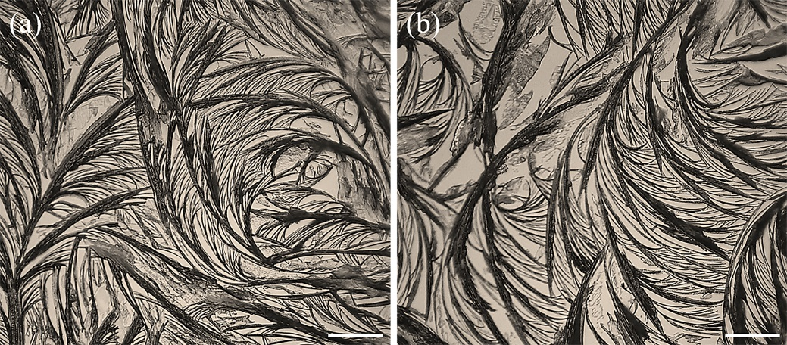
Fig. S6. Characterization of the self-assembly structure before (a) and after (b) contact angle testing. Scale bar:

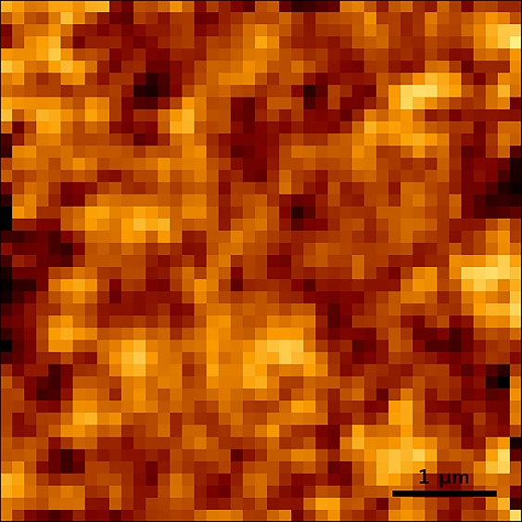
Fig. S7. Surface roughness measurement of the PS substrate, with a root-mean-square roughness of approximately 1.6 nm.

