The characterization of size-controlled nanocrystalline cellulose from soy hulls with ultrasonic assisted extraction

Kejin Yu, Lina Yang*, Siyu Zhang, Ning Zhang, He Liu*
College of Food Science and Technology, Bohai University. Jinzhou, Liaoning, 121013, China.

*Corresponding Author:
Professor Lina Yang, College of Food Science and Technology, Bohai University, 19 Keji Road, Songshan New Region, Jinzhou, Liaoning, 121013, P.R. China. E-mail: yangln10@lzu.edu.cn; Tel: +86 15804164170
Professor He Liu, College of Food Science and Engineering, Bohai University. 19 Keji Road, Songshan New Region, Jinzhou, Liaoning 121013, P.R. China. E-mail: liuhe2069@163.com. Tel: +86 13464319258

- Experiment section
  - Materials
Sodium nitrate, Potassium bisulfate, Sodium azide and Trifluoroacetic acid was purchased from Sinopharm Group Chemical reagent Co., Ltd. (Tianjin, China). Acetonitrile, Chloroform and Propylene glycol methyl ether propionate was purchased from Aladdin Biochemical Technology Co., Ltd. (Shanghai, China).
  - Determination of molecular weight and monosaccharide composition
The molecular weight of SHNC were determined using the method reported by (Tian, Gruppen, & Schols, 2015) with several improvements. The molecular weight of SHNC was determined by gel chromatograph (1260 Infinity II, Agilent, USA). Specifically, an appropriate amount of sample was weighed and dissolved with a mobile phase, configured into a solution with a concentration of 1.5 mg/mL, and then filtered with a 0.22 μm microporous filter membrane and tested on the machine. The molecular weight Mp, Mn, Mw and Mz of the sample were calculated by fitting the viscosity and peak time of the sample with GPC software. Technical support was provided by Shiyanjia Lab (Zhengzhou, China, www.shiyanjia.com).
  - Particle size distribution
The particle size of all SHNC solutions were measured with a particle size analyzer (NanoBrook 90Plus, Brookhaven, USA) after diluting the sample solution 10 times (1 %, w/v). The parameters were set as follows: scattering angle 90°, laser wavelength 640 nm, temperature 37℃, particle refractive index 1.59, and water solvent refractive index 1.33. Each experiment was repeated three times.
  - Zeta potential detection
The surface charge of all SHNC solutions was determined with Zeta-Potentiometric analyzer (Nano ZS90, Malvern, UK) after diluting the sample solution by 10 times (1 %, w/v). Prior to the test, about 0.5 mL of diluted solution was placed in a quartz colorimetric dish and then equilibrated in the instrument for 60 s. Each experiment was repeated three times.
  - Interface tension and pressure measurements
The interfacial tension (γ) and interfacial pressure (π) of SHNC at air/water interface were investigated using a video optical contact angle instrument (OCA20, Dataphysics, Germany). The γ and π of SHNC was determined using the method reported by (Li, Arranz, Guri, & Corredig, 2017) with several improvements. Briefly, the sample syringe (inner diameter, 2 mm) automatically forms a 16 μL volume of droplets at the tip, which is suspended on the surface of the comparator containing the same sample. Cover with a thin film to reduce the impact of moisture volatilization on measurement results. According to Laplace-Young equation, the interfacial tension at the air/water interface was measured within 180 min. The air/water interface pressure (π, mN/m) was calculated with the following equation:
$$π=γ_{0}-γ (1)$$
where γ₀ (mN/m) and γ (mN/m) were the interfacial tensions at the air/water interface for the air-distilled water (86.972 mN/m) and the SHNC. Each experiment was repeated three times.
  - UV–visible transmission
A 0.1 % suspension of SHNC was added to a quartz cuvette, and the transmittance was measured using a UV spectrophotometer (Caryl, Agilent, USA) in the range of 200–800 nm. Each experiment was repeated five times
2. Result section
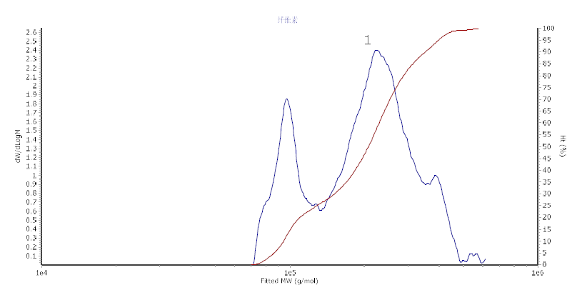
Fig. S1. Molecular weight distribution of SHNC
References
Li, Y., Arranz, E., Guri, A., & Corredig, M. (2017). Mucus interactions with liposomes encapsulating bioactives: Interfacial tensiometry and cellular uptake on Caco-2 and cocultures of Caco-2/HT29-MTX. Food research international, 92, 128-137.
Tian, L., Gruppen, H., & Schols, H. A. (2015). Characterization of (Glucurono) arabinoxylans from oats using enzymatic fingerprinting. Journal of agricultural and food chemistry, 63(50), 10822-10830.

