A Synthetic Probiotic Engineered for Colorectal Cancer Therapy Modulates Gut Microbiota

Yusook Chung^{1,2}, Yongku Ryu¹, Byung Chull An¹, Yeo-Sang Yoon¹, Oksik Choi¹, Tai Yeub Kim¹, Jae Kyung Yoon², Jun Young Ahn¹, Ho Jin Park¹, Soon-Kyeong Kwon^{2,3}, Jihyun F. Kim^{2,†}, and Myung Jun Chung^{1,†}

¹R&D Center, Cell Biotech, Co., Ltd., 50 Aegibong-ro 409beon-gil, Gaegok-ri, Wolgot-myeon, Gimpo-si, Gyeonggi-do 10003, Republic of Korea; ²Department of Systems Biology, Division of Life Sciences, and Institute for Life Science and Biotechnology, Yonsei University, 50 Yonsei-ro, Seodaemun-gu, Seoul 03722, Republic of Korea; ³Division of Life Science, Gyeongsang National University, 501 Jinju-daero, Jinju-si, Gyeongsangnam-do 52828, Republic of Korea

*Corresponding authors:
Myung Jun Chung; phone: +82-31-987-6205, fax: +82-31-987-6216, e-mail: ceo@cellbiotech.com
Jihyun F. Kim; phone: +82-2-2123-5561, fax: +82-2-312-5657, e-mail: jfk1@yonsei.ac.kr

SUPPLEMENTARY FIGURE LEGENDS

Supplementary Figure 1 Construction and validation of the alr knockout mutant and alr complementation strain.
(A) General scheme of the alr complementation system construction. (B) Confirmation of the alr knockout mutant and alr complemented strains cultured in MRS media with or without d-Ala. (C) Genotyping of the alr gene in the wild-type and alr knockout mutant strains. (D) Comparison of the secreted form of P8 between wild-type and alr knockout mutant strains. Recombinant form of P8.

Supplementary Figure 2 Measurement of tumor weights and immunodetection of cell cycle pathway factors in the DLD-1 xenograft mouse model
(A) Tumor weights measured at week 6. Mice (n = 10 in each group) were subcutaneously inoculated with 2×10⁶ DLD-1 cells in the rear right flank and then received 0.9% saline (control), 60 mg/kg body weight gemcitabine (dFdC; intraperitoneal injection, twice a week), 1×10¹⁰ CFU/head P. pentosaceus alr (pCBT24-2-alr) (PP*; oral administration, five times a week), or 1×10¹⁰ CFU/head P. pentosaceus alr (pCBT24-2-PK-p8-PK-p8-alr) (PP*-P8; oral administration, five times a week). ***P < 0.001 (B) Immunodetection of cell cycle regulatory factors in untreated control, PP*, and PP*-P8.

Supplementary Figure 3 Kaplan-Meier survival curve in mice following group.
Survival proportions was plotted using a Kaplan-Meier survival curve of the AOM/DSS mouse model during the whole experimental period.

Supplementary Figure 4 Principal coordinate analysis based on the Bray-Curtis dissimilarity.
Each dot indicates a single sample and each group is shown in a different color. P-values correspond to the results of permutational multivariate analysis of variance. Day 0 and Day 5 samples were included in the all stages to observe longitudinal sample dissimilarity. P-values correspond to the results from permutational multivariate analysis of variance.

Supplementary Figure 5 Cladogram of LEfSe analysis between 5-FU and PP*-P8.
Taxonomic cladogram results from linear discriminant analysis (LDA) effect size. Red, taxa enriched in PP*; green, taxa enriched in PP*-P8.

Supplementary Figure 6 LEfSe analysis using individual OTU.
Linear discriminant analysis effect size of samples after the last DSS administration using individual operational taxonomical units (OTUs) to compare specific taxa with of the same level (genus). 5-FU, fluorouracil; PP*, P. pentosaceus alr (pCBT24-2-alr); PP*-P8, P. pentosaceus alr (pCBT24-2-PK-p8-PK-p8-alr).

SUPPLEMENTARY FIGURES

Figure S1

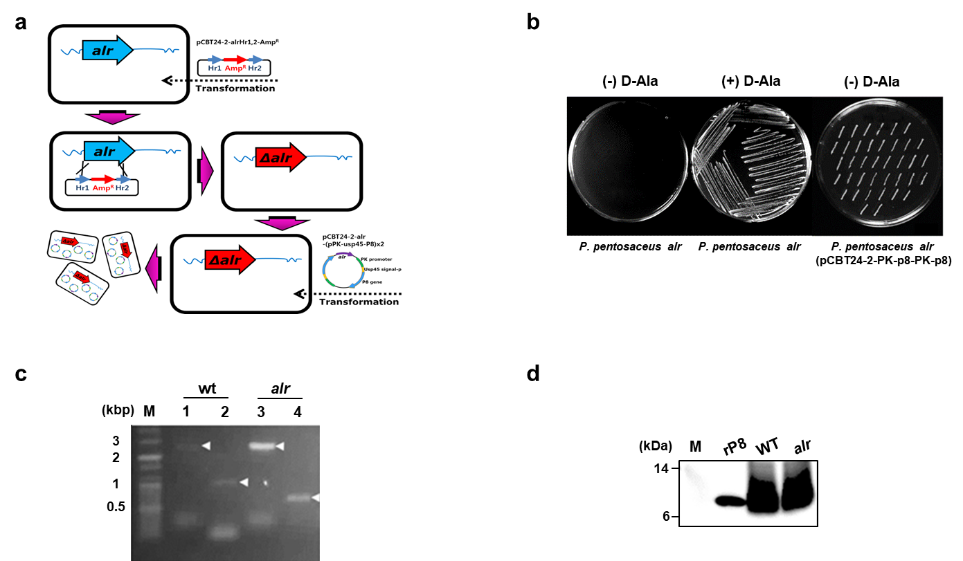

Figure S2

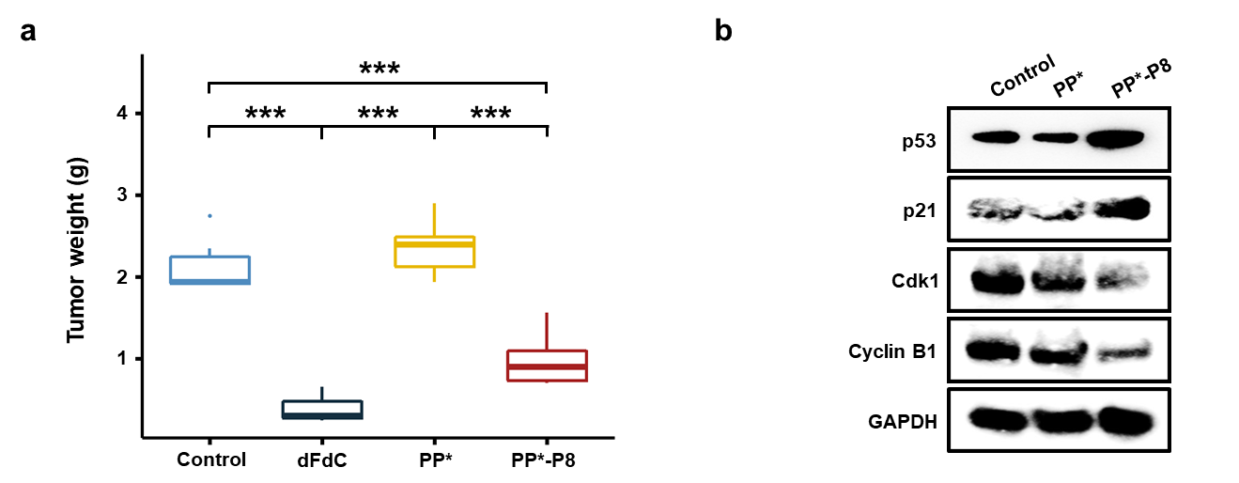

Figure S3

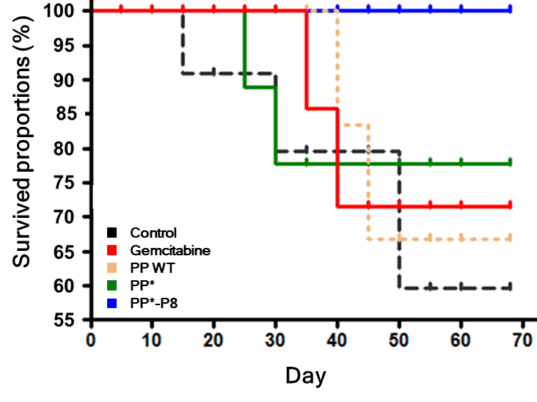

Figure S4

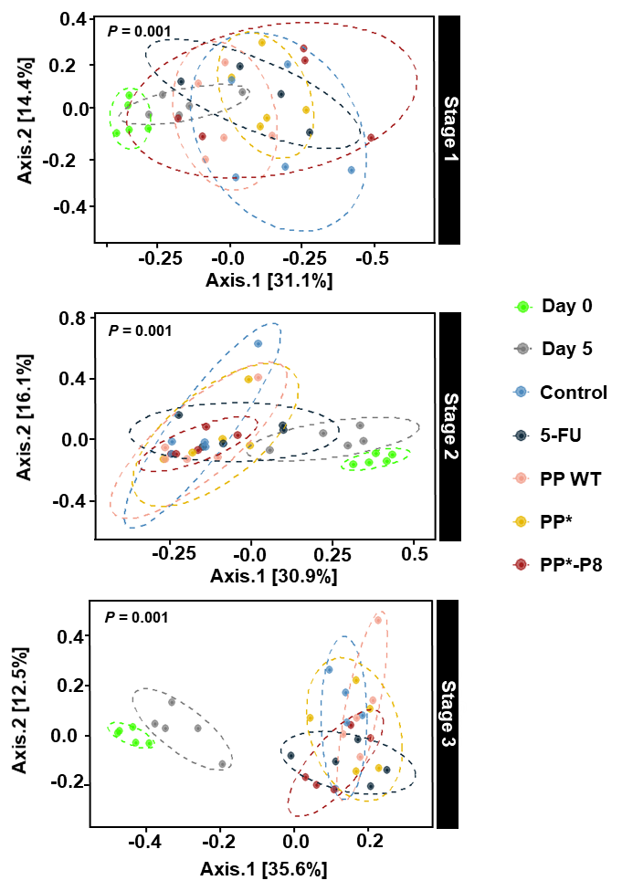

Figure S5

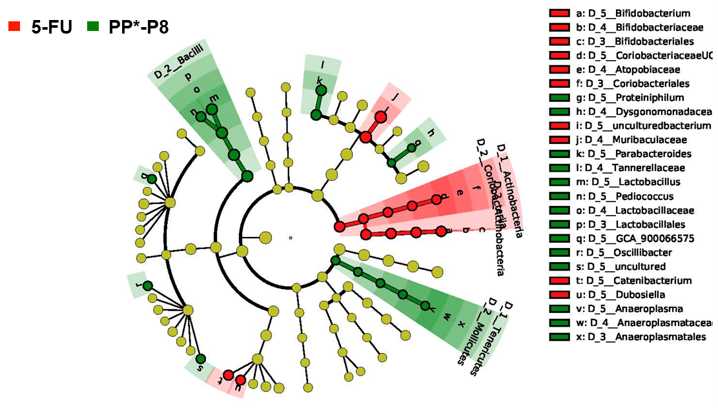

Figure S6

