Supplementary Figures
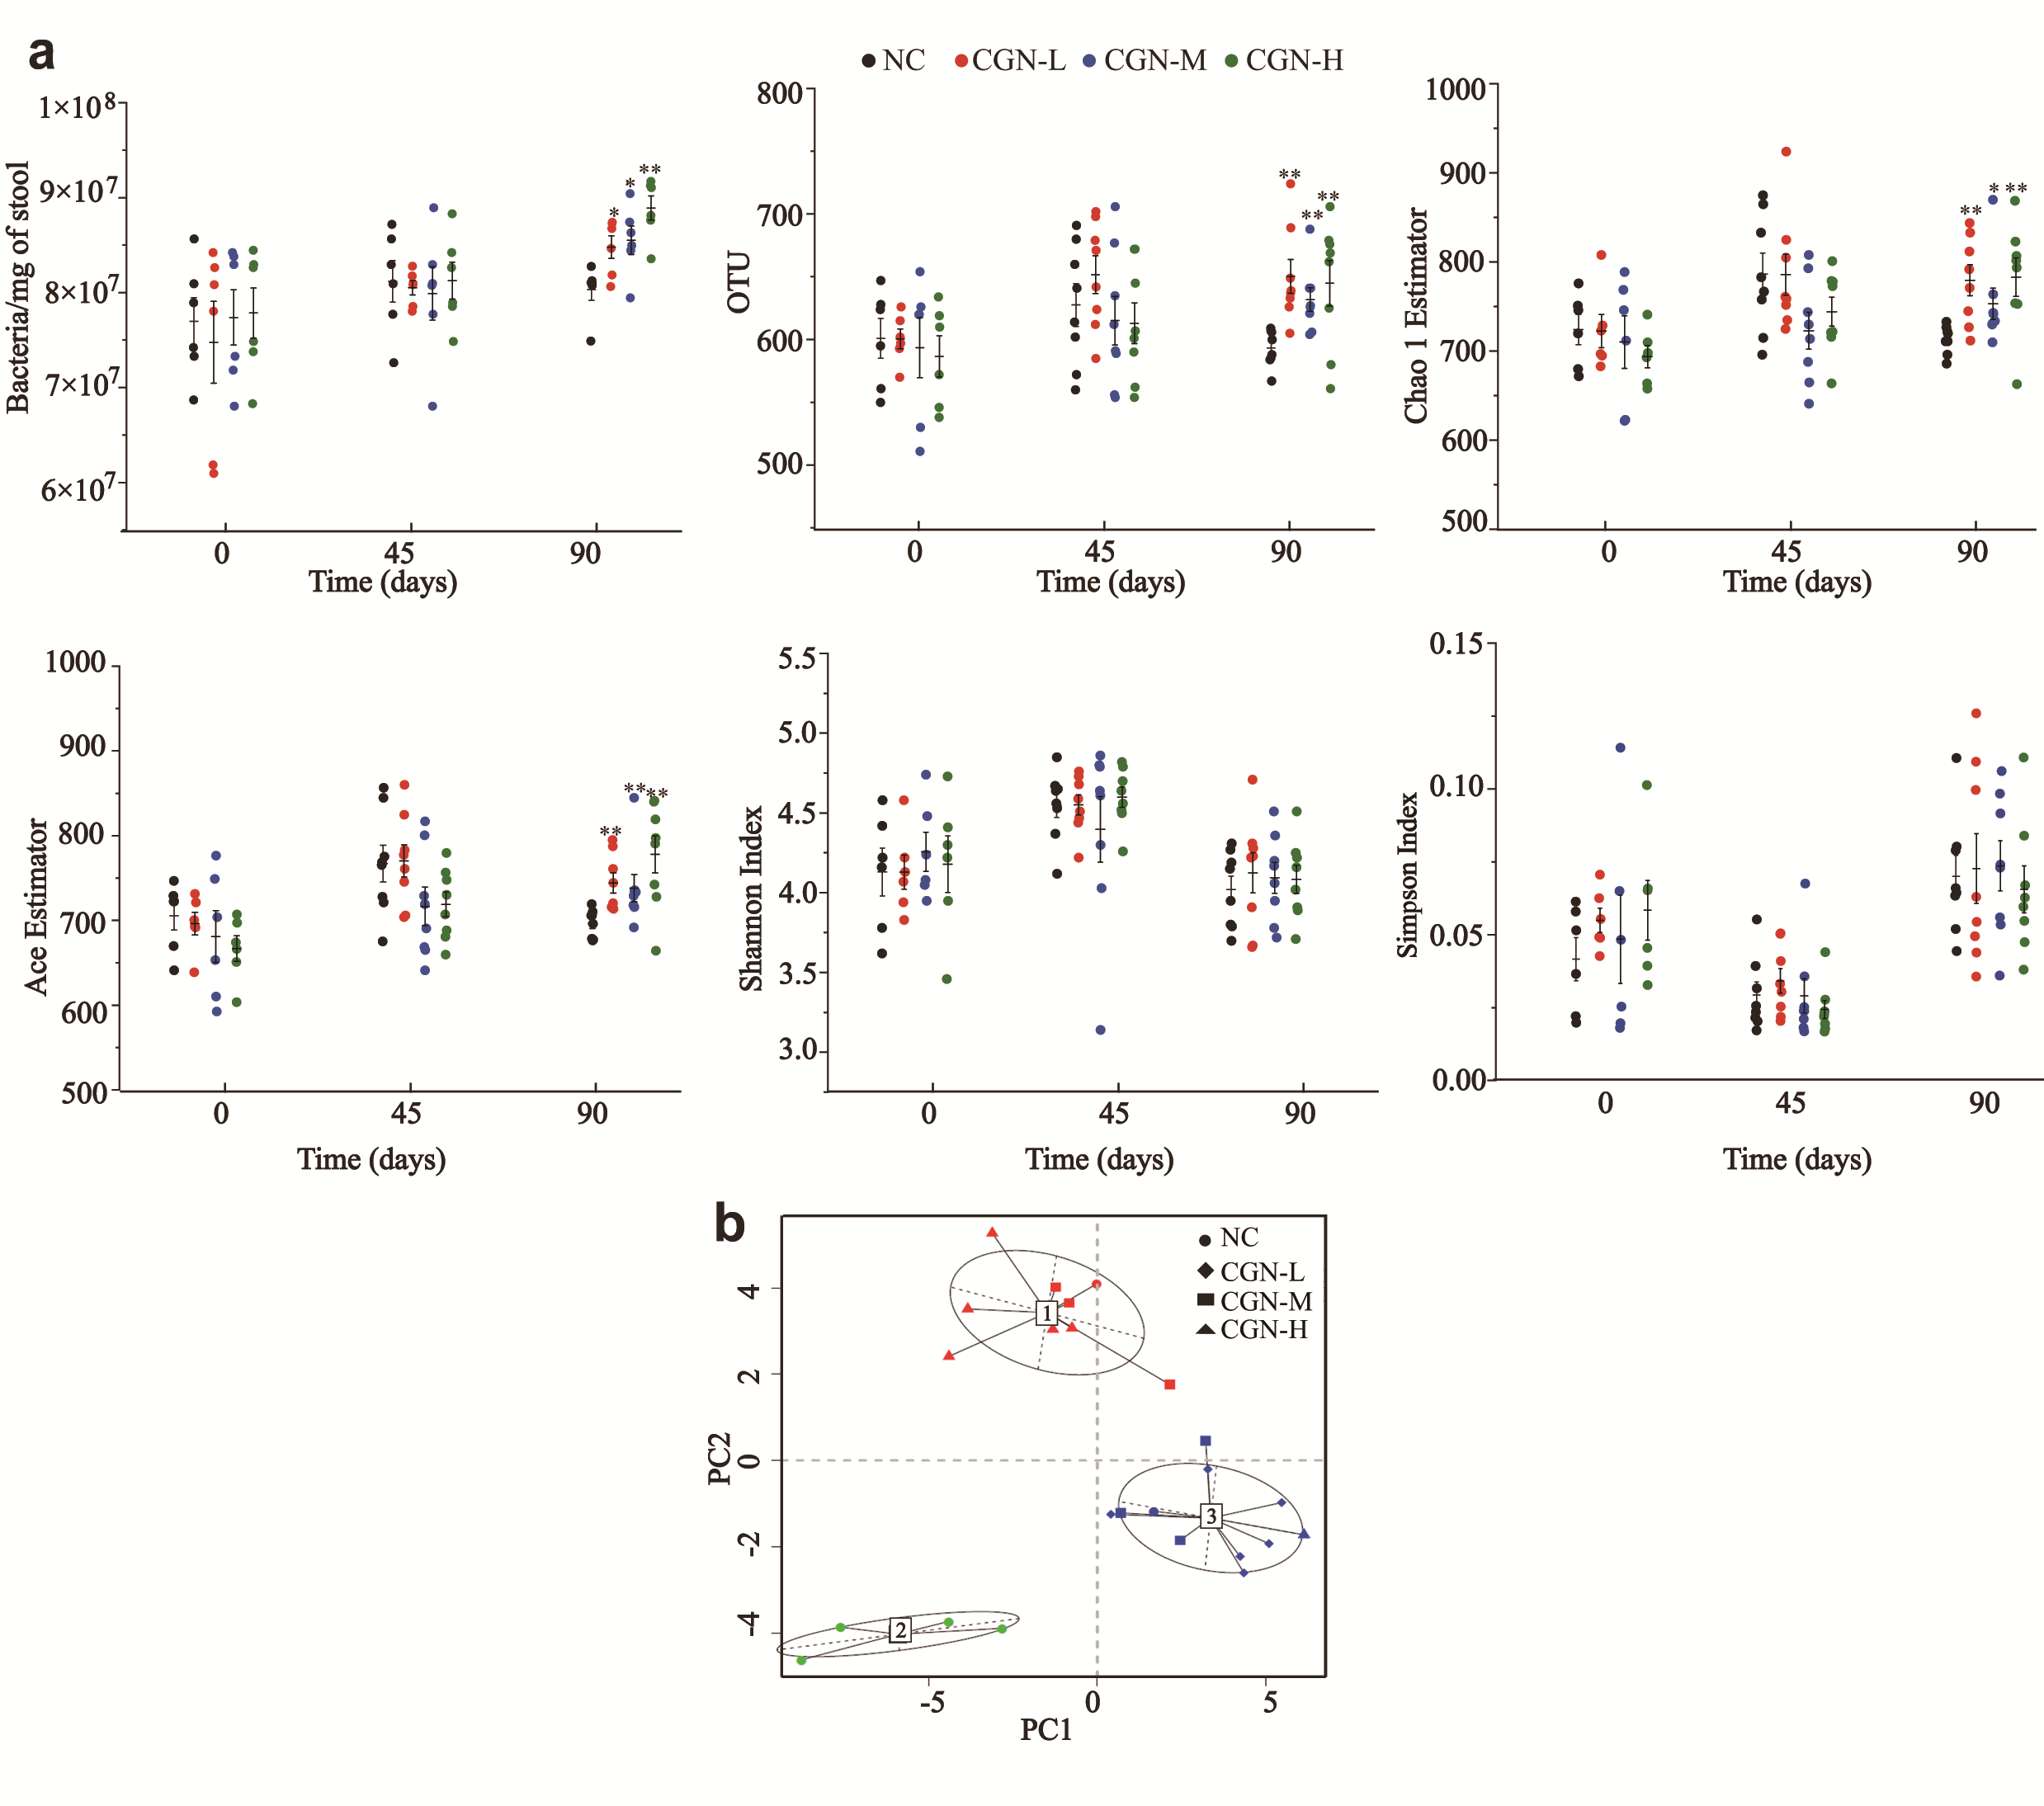
Supplementary Figure 1. Changes in global gut microbiota after κ-CGN treatment.
(a). Total bacterial load in stool and α-diversity estimated by OTU, Ace, Chao 1, Simpson, and Shannon indices. *P < 0.05, **P < 0.01, compared with the NC group. (b). Clustering of gut microbiota into enterotypes at the genus level using Jensen–Shannon distance. The first three principal components were clustered.
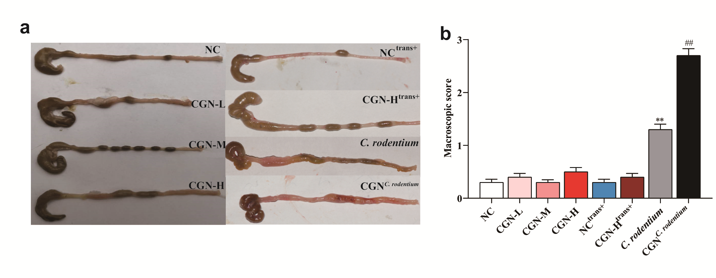
Supplementary Figure 2. The impact of 𝜅-CGN on colon damage induced by administration of Citrobacter rodentium.
(a). Gut morphology. (b). Colon damage scores. **P < 0.01, compared with the NC group. ##P < 0.01, compared with the C. rodentium group.

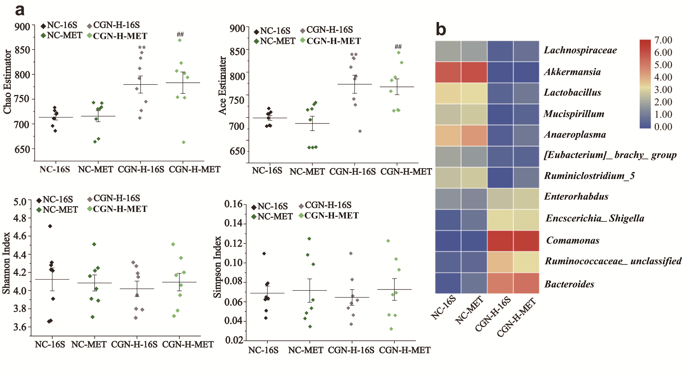Supplementary Figure 3. Changes in gut microbiota after κ-CGN treatment by 16S rRNA and metagenomic analysis.
(a). α-Diversity estimated by Chao 1, Ace, Shannon, and Simpson indices. 16S: 16S rRNA; MET: metagenomic data. **P < 0.01, compared with the NC-16S group, ##P < 0.01, compared with the NC-MET group. (b). Heatmap of relative abundance of individual genera after CGN-H treatment.

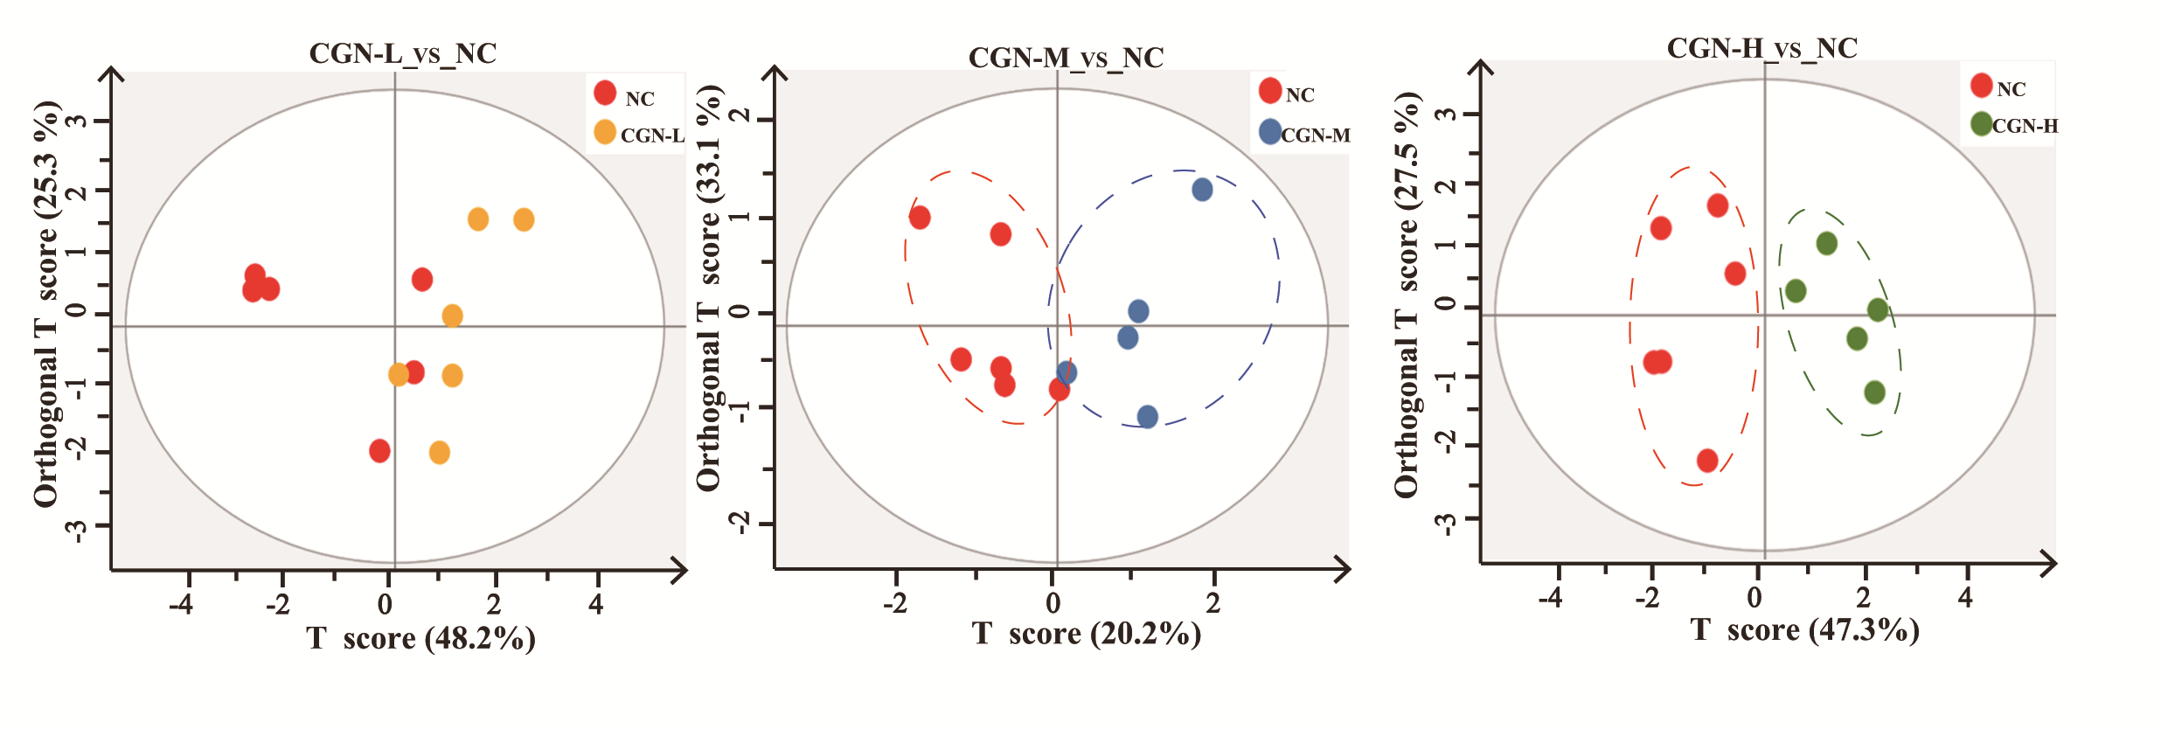Supplementary Figure 4. OPLS-DA score plots of fecal SCFAs of NC and κ-CGN intervention groups.

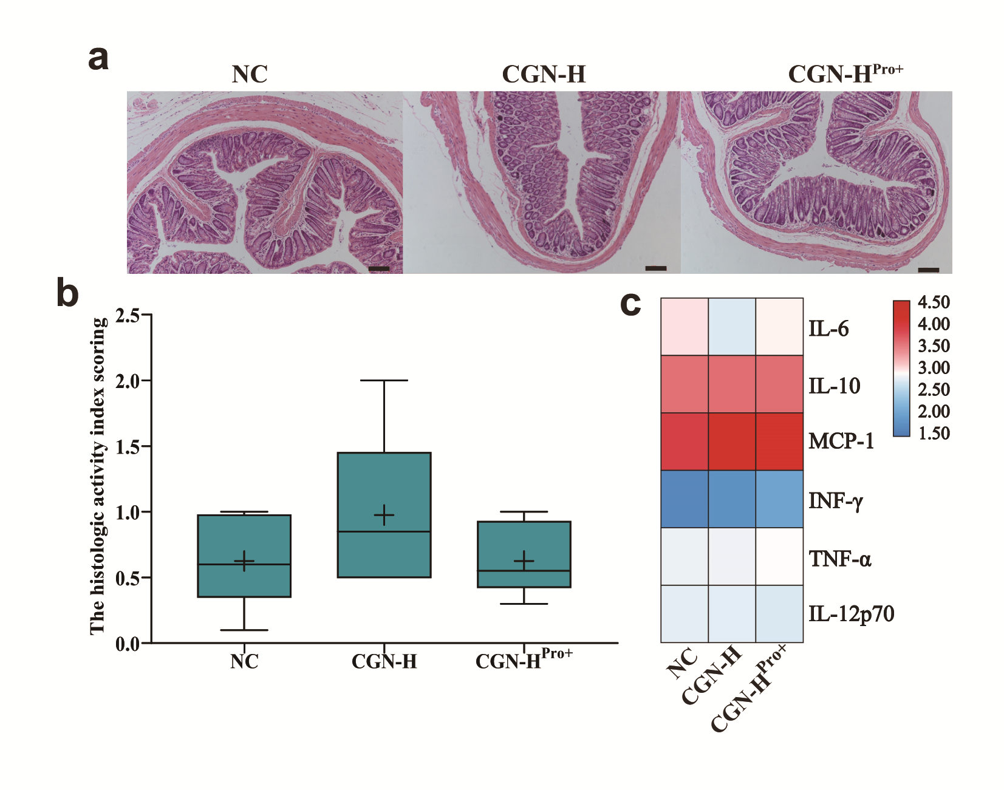Supplementary Figure 5. The impact of 𝜅-CGN and probiotics on histological changes in the colon and inflammatory cytokines.
(a). The H&E staining of the colon. Bar = 100 μm. Pictures are representatives of 10 biological replicates. (b). The histologic activity scores of mice colons. (c). Heatmap of the levels of the inflammatory cytokines (pg/mL).
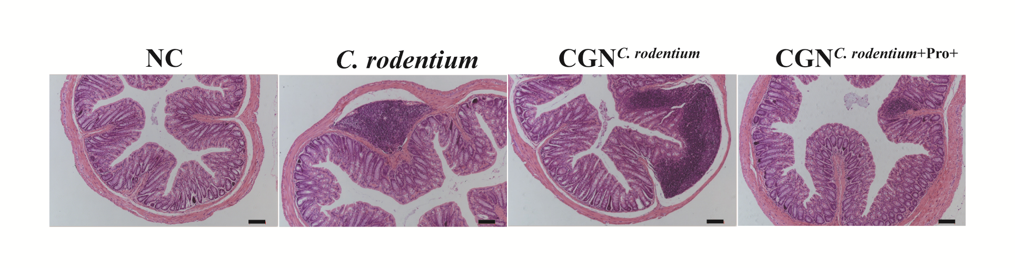
Supplementary Figure 6. H&E staining of mouse colons by treatment. Bar = 100 μm.

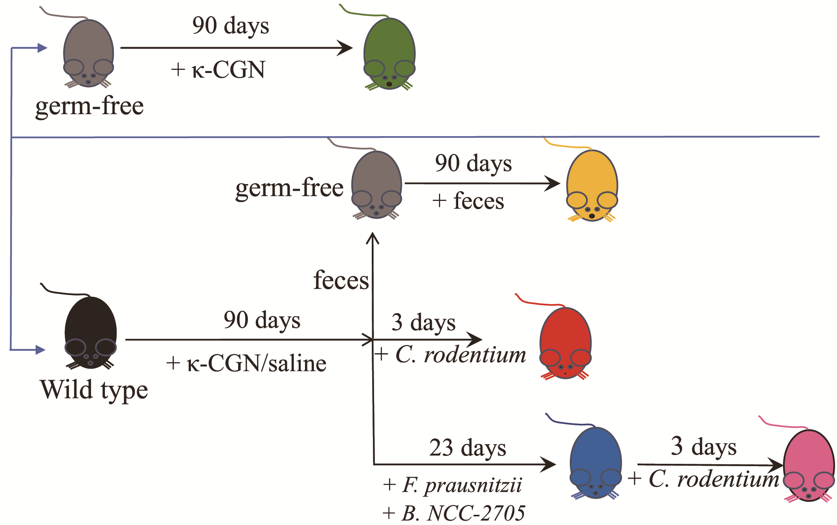
Supplementary Figure 7. Schematic of experiment illustrating the timeline of feeding, fecal bacteria transplantation, probiotic treatment, and Citrobacter rodentium-induced colitis model strategies.
Supplementary Tables
Supplementary Table 1. Mean relative abundance fold changes of individual genera/family in κ-CGN vs. NC
 | CGN-L |  |  |  | CGN-M |  |  | CGN-H
 | Fold change |  | SEM | p | Fold change | SEM | p | Fold change | SEM | p
Lactobacillus | 0.72 | 0.03 |  | 0.05 | 0.59 | 0.06 | 0.01 | 0.32 | 0.09 | <0.01
Ruminiclostridium_5 | 0.24 | <0.01 |  | 0.01 | 0.15 | <0.01 | 0.05 | 0.25 | <0.01 | 0.01
Ruminiclostridium | 3.36 | <0.01 |  | <0.01 | 1.70 | <0.01 | 0.29 | 0.53 | <0.01 | 0.15
Rikenella | 4.20 | <0.01 |  | 0.02 | 5.53 | <0.01 | 0.03 | 6.03 | <0.01 | 0.02
Parasutterella | 1.07 | <0.01 |  | 0.89 | 3.17 | <0.01 | 0.05 | 4.85 | <0.01 | 0.04
Mucispirillum | 0.30 | 0.01 |  | 0.02 | 0.10 | <0.01 | 0.04 | 0.12 | <0.01 | 0.01
Lachnospiraceae | 0.85 | <0.01 |  | 0.03 | 0.35 | <0.01 | 0.01 | 0.29 | <0.01 | 0.01
Ruminococcaceae_unclassified | 3.11 | <0.01 |  | 0.03 | 3.29 | <0.01 | 0.02 | 4.32 | <0.01 | 0.02
Lactobacillales_unclassified | 3.15 | <0.01 |  | 0.03 | 3.55 | <0.01 | 0.03 | 1.38 | <0.01 | 0.56
Bacteroides | 1.53 | 0.03 |  | 0.05 | 4.76 | 0.06 | 0.02 | 8.27 | 0.01 | <0.01
Gastranaerophilales_norank | 3.70 | <0.01 |  | 0.07 | 4.40 | <0.01 | 0.01 | 5.90 | <0.01 | 0.03
[Eubacterium]_ brachy_group | 2.13 | <0.01 |  | 0.02 | 2.37 | <0.01 | 0.04 | 0.21 | <0.01 | 0.02
Aerococcus | 1.48 | <0.01 |  | 0.09 | 2.31 | <0.01 | 0.02 | 3.20 | <0.01 | 0.01
Escherichia-Shigella | 1.81 | <0.01 |  | 0.03 | 3.73 | <0.01 | 0.01 | 5.10 | <0.01 | 0.01
Enterorhabdus | 2.44 | <0.01 |  | 0.09 | 4.95 | <0.01 | 0.02 | 6.37 | <0.01 | 0.44
Comamonas | 5.04 | <0.01 |  | 0.02 | 5.05 | <0.01 | 0.14 | 5.03 | <0.01 | 0.17
Anaeroplasma | 0.27 | <0.01 |  | 0.02 | 0.31 | <0.01 | 0.03 | 0.21 | <0.01 | 0.02
Akkermansia | 0.09 | <0.01 |  | <0.01 | <0.01 | <0.01 | <0.01 | <0.01 | <0.01 | <0.01
[Ruminococcus]_torques_group | 0.51 | <0.01 |  | <0.01 | 0.38 | <0.01 | <0.01 | <0.01 | <0.01 | <0.01
Rhodospirillaceae | 1.12 | <0.01 |  | 0.35 | 1.60 | 0.03 | 0.02 | 6.40 | 0.65 | <0.01
Others | 0.98 | 0.97 |  | 0.99 | 1.11 | 0.93 | 0.97 | 0.93 | 0.07 | 0.96

Supplementary Table 2. Mean relative abundance fold changes of individual genera in κ-CGN^{trans+} vs. NC
 | CGN-L^{trans+} |  |  |  | CGN-M^{trans+} |  |  | CGN-H^{trans+}
 | Fold change |  | SEM | p | Fold change | SEM | p | Fold change | SEM | p
Lactobacillus | 0.69 | 0.15 |  | 0.03 | 0.60 | 0.12 | 0.05 | 0.49 | 0.12 | 0.03
Ruminiclostridium_5 | 0.35 | <0.01 |  | 0.02 | 0.14 | <0.01 | 0.05 | 0.33 | <0.01 | 0.01
Ruminiclostridium | 0.87 | <0.01 |  | 0.83 | 0.06 | <0.01 | 0.08 | 1.11 | <0.01 | 0.89
Rikenella | 1.66 | <0.01 |  | 0.21 | 1.29 | <0.01 | 0.35 | 2.64 | <0.01 | 0.07
Parasutterella | 1.66 | <0.01 |  | 0.39 | 0.65 | <0.01 | 0.59 | 0.85 | <0.01 | 0.84
Mucispirillum | 0.17 | 0.01 |  | 0.02 | 0.18 | <0.01 | 0.02 | 0.15 | <0.01 | 0.01
Lachnospiraceae | 0.73 | <0.01 |  | 0.04 | 0.28 | <0.01 | 0.01 | 0.19 | <0.01 | 0.01
Ruminococcaceae_unclassified | 4.22 | 0.01 |  | 0.02 | 4.37 | 0.01 | 0.02 | 5.03 | <0.01 | 0.02
Lactobacillales_unclassified | 0.63 | 0.01 |  | 0.51 | 0.81 | 0.01 | 0.73 | 2.35 | 0.02 | 0.16
Bacteroides | 1.62 | 0.11 |  | 0.50 | 4.22 | 0.16 | 0.05 | 9.11 | 0.32 | 0.01
Gastranaerophilales_norank | 3.21 | <0.01 |  | 0.02 | 4.65 | <0.01 | 0.04 | 5.49 | <0.01 | 0.04
[Eubacterium]_ brachy_group | 0.27 | <0.01 |  | 0.05 | 0.23 | <0.01 | 0.02 | 0.22 | <0.01 | 0.02
Aerococcus | 1.21 | <0.01 |  | 0.14 | 2.01 | <0.01 | 0.04 | 3.00 | <0.01 | 0.01
Escherichia-Shigella | 1.21 | <0.01 |  | 0.04 | 3.02 | <0.01 | 0.03 | 5.23 | <0.01 | 0.04
Enterorhabdus | 1.53 | <0.01 |  | 0.23 | 3.80 | <0.01 | 0.05 | 6.66 | <0.01 | 0.01
Comamonas | 5.31 | <0.01 |  | 0.01 | 5.35 | <0.01 | 0.15 | 5.33 | <0.01 | 0.07
Anaeroplasma | 0.34 | <0.01 |  | 0.03 | 0.22 | <0.01 | 0.01 | 0.23 | 0.01 | 0.02
Akkermansia | 0.22 | 0.02 |  | 0.01 | 0.16 | 0.04 | 0.02 | 0.11 | 0.03 | 0.02
[Ruminococcus]_torques_group | 0.42 | <0.01 |  | <0.01 | 0.23 | <0.01 | <0.01 | <0.01 | <0.01 | <0.01
Others | 0.96 | 0.99 |  | 0.99 | 1.13 | 0.95 | 0.96 | 0.97 | 0.03 | 0.94

Supplementary Table 3. Mean relative abundance fold changes of individual genera in κ-CGN-H vs. NC for 16S rRNA vs. metagenomic data
 | CGN-H-16S/NC-16S |  |  | CGN-H-MET/NC-MET
 | Fold change | SEM | p | Fold change | SEM | p
Lachnospiraceae | 0.29 | <0.01 | 0.01 | 0.26 | 0.06 | 0.02
Akkermansia | <0.01 | <0.01 | <0.01 | 0.01 | <0.01 | <0.01
Lactobacillus | 0.32 | 0.09 | <0.01 | 0.11 | <0.01 | 0.03
Mucispirillum | 0.12 | <0.01 | 0.01 | 0.05 | <0.01 | 0.02
Anaeroplasma | 0.21 | <0.01 | 0.02 | 0.27 | <0.01 | 0.03
[Eubacterium]_brachy_group | 0.21 | <0.01 | 0.02 | 0.13 | 0.01 | 0.02
Ruminiclostridium_5 | 0.25 | <0.01 | 0.01 | 0.56 | <0.01 | <0.01
Enterorhabdus | 6.37 | <0.01 | 0.44 | 6.43 | 0.39 | 0.03
Escherichia-Shigella | 5.10 | <0.01 | 0.01 | 8.92 | 0.03 | 0.04
Comamonas | 5.03 | <0.01 | 0.03 | 8.37 | <0.01 | <0.01
Ruminococcaceae_unclassified | 4.32 | <0.01 | 0.02 | 4.12 | 1.58 | 0.02
Bacteroides | 8.27 | 0.01 | <0.01 | 9.34 | <0.01 | <0.01
Others | 0.95 | 0.05 | 0.96 | 0.98 | 0.99 | 0.99
This table includes the top 12 genera that were significantly different in either metagenomics or 16S data.

Supplementary Table 4. Changes in bacterial abundance based on genome metagenomic data
 | NC | CGN-H |  | Fold change | p
Bacteroides_nordii | 0.000394667 |  | 0.00706059 | 17.89 | <0.01
Bacteroides_thetaiotaomicron | 0.009023835 |  | 0.19265887 | 21.35 | <0.01
[Ruminococcus]_torques | 0.000140978 |  | 0.00001973 | 0.14 | <0.01
Lachnospiraceae_bacterium_10 | 0.000805794 |  | 0.00005642 | 0.07 | <0.01
Bacteroides_intestinihominis | 0.007592390 |  | 0.02619374 | 3.45 | 0.03
Parabacteroides_merdae | 0.001043594 |  | 0.00106446 | 1.02 | 0.17
Faecalibacterium prausnitzii | 0.000365224 |  | 0.00033235 | 0.91 | 0.21
Firmicutes_bacterium_CAG:41 | 0.000277863 |  | 0.00027508 | 0.99 | 0.74
Bacteroides_caccae | 0.002168219 |  | 0.02901077 | 13.38 | <0.01
Bacteroides_ovatus | 0.000188865 |  | 0.00478773 | 25.35 | <0.01
Prevotella_buccae | 0.000893466 |  | 0.00083092 | 0.93 | 0.68
This table include species that were significantly different in metagenomics data.

Supplementary Table 5. Mean relative abundance fold changes of CGN-H/NC and CGN^{Pro+}/ CGN-H of individual genera
 | CGN-H/NC |  |  | CGN^{Pro+}/ CGN-H
 | Fold change | SEM | p | Fold change | SEM | p
Lachnospiraceae | 0.29 | <0.01 | 0.01 | 9.34 | 1.24 | 0.05
Akkermansia | <0.01 | <0.01 | <0.01 | 7.25 | 1.06 | 0.03
Lactobacillus | 0.32 | 0.09 | <0.01 | 4.33 | 0.71 | 0.02
Mucispirillum | 0.12 | <0.01 | 0.01 | 6.21 | 0.63 | 0.03
Anaeroplasma | 0.21 | <0.01 | 0.02 | 3.58 | 0.21 | 0.02
[Eubacterium]_brachy_group | 0.21 | <0.01 | 0.02 | 13.11 | 1.76 | <0.01
Ruminiclostridium_5 | 0.25 | <0.01 | 0.01 | 3.61 | 0.26 | 0.01
Enterorhabdus | 6.37 | <0.01 | 0.44 | 3.18 | 0.14 | 0.02
Escherichia-Shigella | 5.10 | <0.01 | 0.01 | 2.37 | 0.21 | 0.03
Comamonas | 5.03 | <0.01 | 0.03 | 2.70 | 0.36 | 0.05
Clostridium | 3.21 | <0.01 | 0.05 | 1.42 | 0.07 | 0.02
Alistipes | 2.72 | <0.01 | 0.04 | 1.16 | 0.10 | 0.04
Desulfovibrio | 9.58 | 1.35 | 0.04 | 2.64 | 0.33 | 0.03
Faecalibacterium | 0.64 | <0.01 | 0.21 | 14.39 | 2.42 | <0.01
Bifidobacterium | 0.59 | <0.01 | 0.13 | 18.34 | 2.51 | <0.01
Others | 0.98 | 0.99 | 0.99 | 1.13 | 0.97 | 0.98
This table include top 15 genera that were significantly different in 16S data.

Supplementary Table 6. Mouse feed content
Component | Content | Component | Content | Component | Content
Vitamin A | ≥7000 IU | Sodium (Na) | ≥2 g | Protein | ≥180 g
Vitamin D | ≥800 IU | Potassium (K) | ≥5 g | Fat | ≥40 g
Vitamin E | ≥61 IU | Magnesium (Mg) | ≥2 g | Fibrin | ≥50 g
Vitamin K | ≥3 mg | Copper (Cu) | ≥10 mg | Lysine | ≥8.2 g
Vitamin B1 | ≥8 mg | Iron (Fe) | ≥100 mg | Cystine | ≥5.3 g
Vitamin B2 | ≥10 mg | Zinc (Zn) | ≥30 mg | Arginine | ≥9.9 g
Vitamin B6 | ≥6 mg | Manganese (Mn) | ≥75 mg | Tryptophan | ≥1.9 g
Vitamin B12 | ≥0.02 mg | Iodine (I) | ≥0.5 mg | Histidine | ≥4.0 g
Biotin | ≥0.1 mg | Selenium (Se) | 0.1–0.2 mg | Phenylalanine | ≥11.0 g
Niacin | ≥45 mg | Calcium (Ca) | 10–18 g | Threonine | ≥6.5 g
Pantothenic | ≥17 mg | Phosphorus (P) | 6–12 g | Leucine | ≥14.4 g
Folate | ≥4 mg | Water | ≤100 g | Isoleucine | ≥7.0 g
Choline | ≥125 mg | Crude ash | ≤80 g | Valine | ≥8.4 g

Supplementary Table 7. Macroscopic evaluation of the gut
Score | Histological changes | Percentage of tissue damaged
0 | Normal | None
1 | Erythema only | <20%
2 | Erythema, slight edema, and small erosions | 21–40%
3 | Two or more bleeding ulcers, and/or inflammation, and/or moderate adhesions | 41–60%
4 | Severe ulceration, and/or stenosis with dilations, and/or severe adhesions | >61%

Supplementary Table 8. The histology activity index scoring system for inflammation-associated histological changes in the colon
Score | Infiltrate | Extent of inflammatory infiltrate | Goblet cell mucin depletion | Mucosal thickness
0 | Normal/physiologic | None | None | Normal
1 | Minimal elevation | Single or rare, scattered foci | Minimal | Minimal, focal thickening
2 | Expanded within or beyond lamina propria | Patchy, moderately abundant | Moderate | Moderate, multifocal thickening
3 | Crypt abscesses or submucosal involvement | Extensive | Extensive | Extensive
4 | Inflammatory crypt destruction with erosion of the mucosa | N/A | N/A | N/A

