Effects of maize/soybean intercropping on soil nitrogen mineralization and fungal communities
Yalin Liu^{1, 2}, Yuanyuan Fan¹, Yakov Kuzyakov^{3, 4, 5}, Jie Dai¹, Chaochun Zhang¹*, Chunjie Li¹*
¹ State Key Laboratory of Nutrient Use and Management (SKL-NUM), College of Resources and Environmental Science, National Academy of Agriculture Green Development, China Agricultural University, Beijing 100193, China
² Centre for Crop Systems Analysis, Wageningen University, P.O. Box 430, 6700 AK, Wageningen, the Netherlands
³ Department of Soil Science of Temperate Ecosystems, University of Göttingen, Göttingen, Germany
⁴ Peoples Friendship University of Russia (RUDN University), 117198 Moscow, Russia
⁵ Institute of Environmental Sciences, Kazan Federal University, 420049 Kazan, Russia
Table S1 Two-way ANOVA testing the effect of cropping system (CS, monoculture and intercropping), N input and their interactions on N mineralization, enzyme activities and fungal community composition

Treatments | Net mineral N content  (mg N kg⁻¹) | Net NH₄⁺ content  (mg N kg⁻¹) | Net NO₃⁻ content  (mg N kg⁻¹) | Urease  (U g⁻¹ soil h⁻¹) | Protease  (U g⁻¹ soil h⁻¹) |  | Chao1 richness | Shannon diversity
CS | 0.01 | 0.002 | 0.38 | 0.77 | 0.002 |  | 0.87 | < 0.001
N | 0.49 | 0.004 | 0.11 | 0.89 | 0.52 |  | 0.21 | 0.04
CS*N | 0.003 | 0.006 | 0.09 | 0.45 |  | 0.007 | 0.25 | 0.22

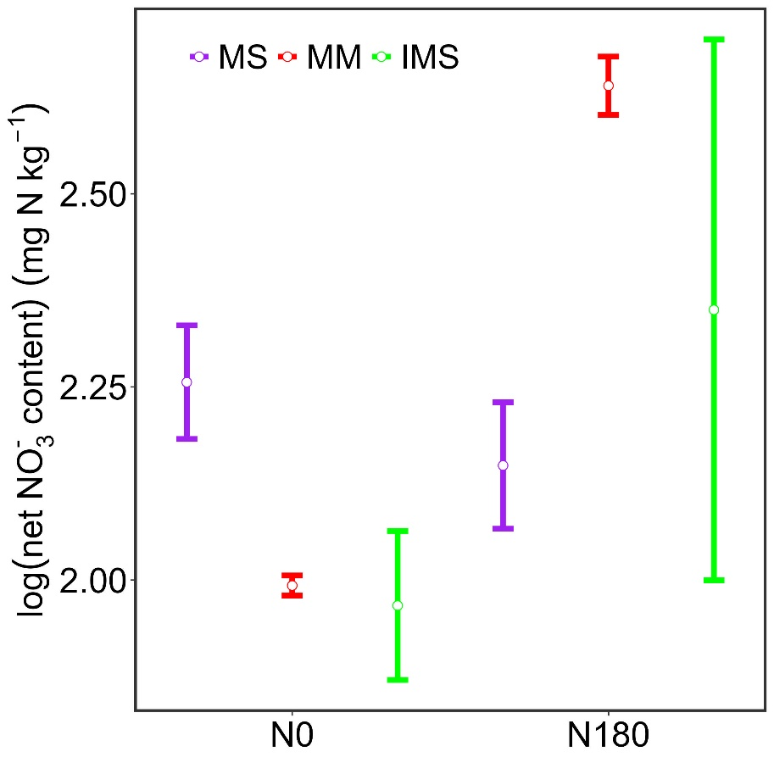
Fig. S1 Net NO₃⁻ content in different treatments. MS: monocultured soybean, MM: monocultured maize, IMS: maize/soybean intercropping. N0: no N input, N180: 180 kg N ha⁻¹ input.

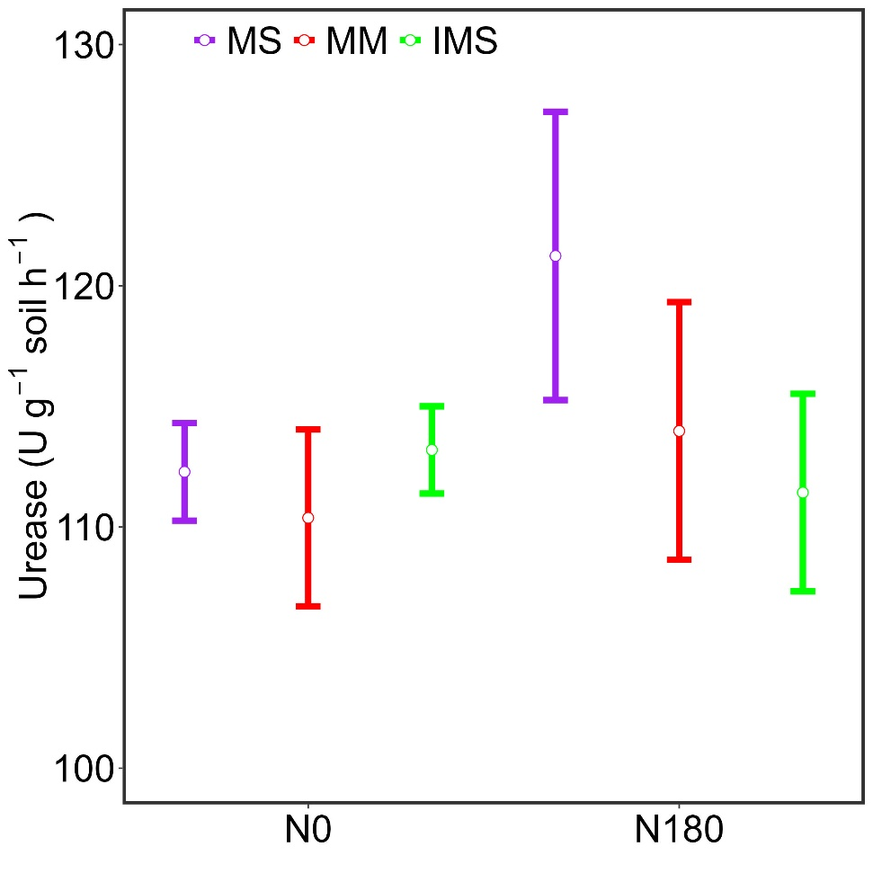
Figure S2 Urease activity in different treatments. MS: monocultured soybean, MM: monocultured maize, IMS: maize/soybean intercropping. N0: no N input, N180: 180 kg N ha⁻¹ input.

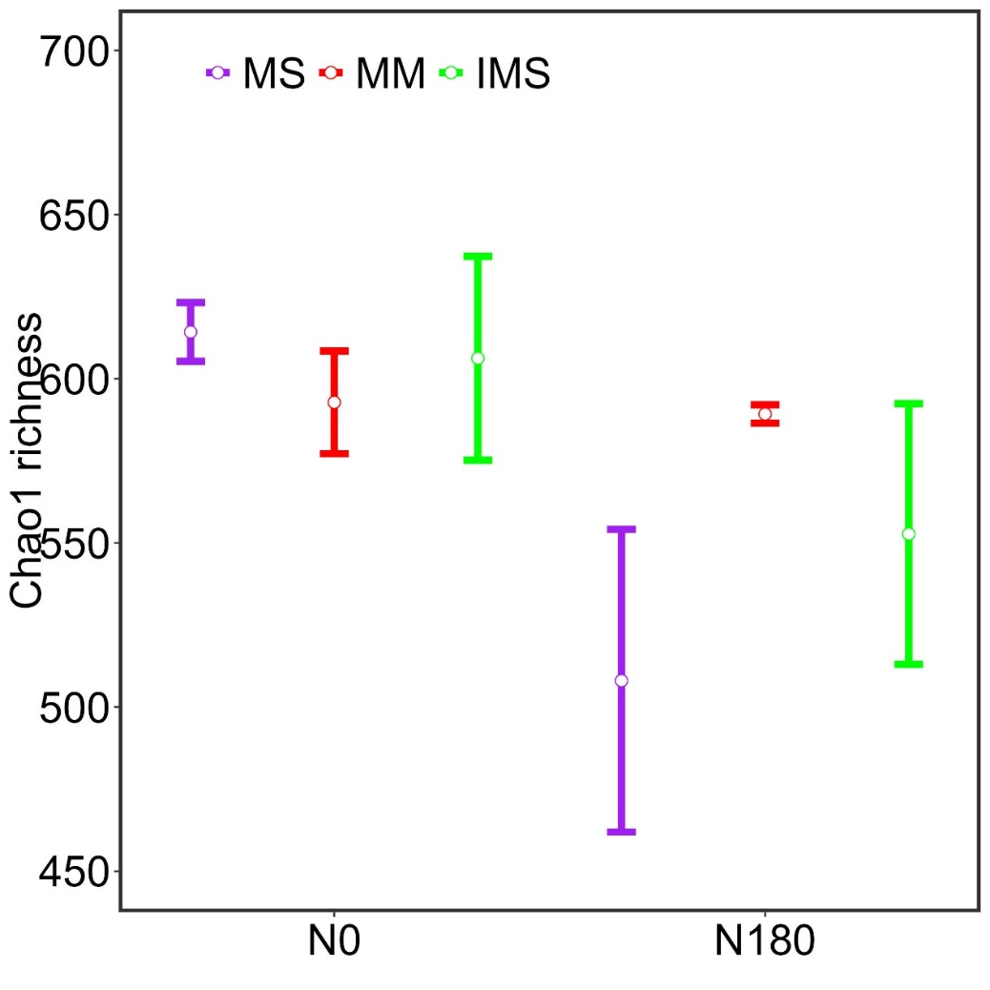
Figure S3 Chao1 richness in different treatments. MS: monocultured soybean, MM: monocultured maize, IMS: maize/soybean intercropping. N0: no N input, N180: 180 kg N ha⁻¹ input.
Figure S4 The relationship between the relative abundance of fungal communities (Ascomycota, Mortierellomycota, Glomeromycota) and the net mineral N content, net${\text{ NO}}_{\text{3}}^{\text{-}}$and${\text{NH}}_{\text{4}}^{\text{+}}$content in different crop systems. N0: no N input, N180: 180 kg N ha⁻¹ input.

