Appendix A
Table A1: General information about respondents
1. What is your academic qualification?
□ Bachelor |  | □Graduation |  |  | □ Ph.D. candidate |  |  |  |  |  |  | □ Ph.D.
2. What is your field of study? ……………..
3. Years of professional work experience:
□ <5 | □ 5~10 |  | □ 11~15 |  |  |  |  |  | □16~20 |  |  |  | □20 <
4. What is your current position?
5. Which Industry/ segmentations have you been working?
□ AEC/construction |  | □ IT/ Technology industry |  |  |  | □ Start Ups: PropTech, FinTech, ConTech
 |  |  |  | Very Poor |  |  | Poor | Medium Poor |  | Fair | Medium Good |  |  | Good | Very Good
 |  |  |  | (1) |  |  | (2) | (3) |  | (4) | (5) |  |  | (6) | (7)
6. Your general knowledge of Distributed Ledger Technology (DLT)/Blockchain |  |  |  | □ |  |  | □ | □ |  | □ | □ |  |  | □ |  | □
7. Your general knowledge of other emerging technologies (i.e., AI, ML, IoT, BIM) |  |  |  | □ |  |  | □ | □ |  | □ | □ |  |  | □ |  | □
8. According to Questions 6,7, Do you have a similar professional experience?
8.1. Distributed Ledger Technology (DLT)/Blockchain |  |  |  |  | □ Yes |  |  |  |  |  |  | □ No
8.2. Emerging technologies |  |  |  |  | □ Yes |  |  |  |  |  |  | □ No

Appendix A (Continue)
Considering the fact that DLT can contribute to sustainability, how much the following ATTRIBUTES are important? Please sort the following SUSTAINABILITY ATTRIBUTES from 1 to 30.
Table A2: Sustainability attributes and DLT’s contribution
Rank | Sustainability attributes | DLT’s contribution | References
 | PS. Project Sustainability
 | PS1. Product impacts | DLT tracks the lifecycle and servicing of the product. | R1, R2, R3, R5, R7, R10
 | PS2. Process impacts | DLT controls the safety, effectiveness, efficiency, and fairness of the project processes. | R1, R3, R4, R5, R6, R7, R10
 | SC. Social Sustainability
 | SC1. Human resource management | DLT can be used throughout the acquisition and development of human resources within an organization. | R1, R3, R10
 | SC2. Local competence development | DLT is a driving force to empower local resources, knowledge, and skills necessitated for technology adoption. | R1, R2, R6, R9
 | SC3. Health and safety | DLT Ensures the health and safety of the end-users by providing traceable and reliable data of products. | R1, R3, R5, R7, R8, R10
 | SC4. Community support and involvement | Collaboration among stakeholders will be increased through distributed ledgers. | R1, R2, R6, R8
 | SC5. Public policy and compliance | DLT revolutionized regulatory compliance that accelerates complying with laws and regulations using smart contracts. | R1, R2, R5, R7
 | SC6. Product and service labeling | DLT helps customers to obtain necessary information about ethical, sustainable, and green products and services. | R1, R5, R7, R9
 | SC7. Flexibleble and innovative marketplace | DLT brings itself new market opportunities by promoting new products and services. | R1, R2, R3, R4, R6, R7, R8
 | SC8. Customer care | DLT protects customer information and their financial transactions and provides personalized services accordingly. | R1, R2, R3, R4, R7, R9
 | SC9. Age-appropriate and voluntary labor | This technology monitors fairness, non-discrimination, and equal opportunity for labors. | R1, R3
 | SC10. Supply chain management and procurement | DLT integrates supply chain flows (products, financial, and information) in an automated, secure, and transparent manner | R11
 | SC11. Transparency, anti-corruption, and anti-counterfeiting | DLT minimizes the risk of corruption and fraudulent activities by transparent information stored on the distributed ledgers. | R1, R3, R4, R5, R7, R9
 | SC12. Fair operation and honest competition | Market players can easily monitor any anti-competitive behaviors and moral hazards using DLT. | R1, R2, R3, R4, R5
 | EN- Environmental Sustainability
 | EN1. Local procurement | DLT enables local and small suppliers to deliver their products and digital services in minimum time, cost, and transportation. | R1, R2, R6, R8, R9
 | EN2. Digital communication | This technology can be leverage for communications and information-sharing among stakeholders. | R1, R3, R5, R8, R9
 | EN3. Logistic and transportation | DLT enables the digital exchange of value within the P2P networks, which reduces unnecessary physical transportation and travel-related resources. | R1, R2, R3, R9, R10
 | EN4. Energy and materials consumption | This technology provides real-time data throughout the demand, supply, and consumption of energy and materials. | R1, R2, R3, R6, R7, R8, R9, R10
 | EN5. Greenhouse gas emissions | Green certificates can be issued for activities based on historical information on greenhouse gas emissions. | R1, R2, R3, R5, R6, R7, R8, R10
 | EN6. Contamination, pollution, and waste | Automated services and real-time control reduces pollution and wastes significantly. | R1, R2, R3, R5, R6, R7, R9, R10
 | EN7-Natural resource management | DLT revolutionizes the way natural resources (i.e., water) are managed. It can digitalize supply, demand, and displacement of resources (i.e., water). | R1, R3
 | EN8- Renewable and green energy | One potential use-case of DLT is distributed energy system (DES) to produce and distribute clean energy. | R1, R2, R3, R6, R8
 | EC- Economic Sustainability
 | EC1. Modeling and simulation | Stored data can be utilized in organizational decision-making and business operations. | R1, R4, R6
 | EC2. Financial benefits | DLT improves cash liquidity and enables near-zero transaction fees. | R1, R3, R4, R6, R7, R8, R10
 | EC3. Return on investment (ROI) | Decentralized financial system and streamline investment evaluation in the long run | R1, R8
 | EC4. Benefit-Cost Ratio | The value-added and benefits of DLT adoption is higher than the cost of development and implementation | R1, R2, R4, R5, R7, R9, R10
 | EC5. Strategic value | Employing emerging technologies, like DLT, improves brand and business core values | R1, R4, R7
 | EC6. Innovative business models | DLT offers new business models for new services and new products. | R1, R2, R3, R7, R8, R9
 | EC7. Local economic growth | DLT impacts the nearby businesses and local community. It enables access to resources/ services and improved living standards. | R1, R3, R6
 | EC8. Circular economy | The continual reuse, repair, and recycling practices in a closed-loop economic system | R1, R2, R3, R5, R7, R9, R10
R1 (GPM Global, 2019; Silvius et al., 2012), R2 (Esmaeilian et al., 2020), R3 (Bai et al., 2020), R4 (De Giovanni, 2020), R5 (Kouhizadeh et al., 2021; Saberi et al., 2018), R6 (Petri et al., 2020), R7 (Farooque et al., 2020; Zhang et al., 2020), R8 (Bürer et al., 2019), R9 (Nandi et al., 2020), R10 (Kumar et al., 2021), R11 (Hofmann et al., 2018).

Appendix A (Continue)
It seems that solving barriers to DLT implementation causes sustainability in the construction industry. Please, sort the following alternatives for each SUSTAINABILITY ATTRIBUTE based on procedures.
Table A3: List of barriers and challenges
 | PS1 | PS2 | SC1 | SC2 | SC3 | SC4 | SC5 | SC6 | SC7 | SC8 | SC9 | SC10 | SC11 | SC12 | EN1 | EN2 | EN3 | EN4 | EN5 | EN6 | EN7 | EN8 | EC1 | EC2 | EC3 | EC4 | EC5 | EC6 | EC7 | EC8
Barriers to DLT implementation at the project level
P1. Abuse and fraud
P2. Manual processes and traditional practices
P3. Irreversibility and immutability of the process
P4. Authenticity, consistency, and legitimacy of data
P5. Infrastructure for data management
P6. Contractual standards |  |  |  |  |  |  | Note! Sort alternatives from 1 to 11 based on their importance for each sustainability attribute.
P7. Multiple chains and private systems
P8. Fragmentation and complexity of activities
P9. Scalability problems
P10. Low accountability control
P11. Financing models and debt instrument
Barriers to DLT implementation in Organization
O1. Organizational considerations
O2. New business model
O3. Shared governance
O4. Financial constraints and cost of adoption
O5. Uncertain return of investment (ROI)
O6. Digital representation of real-world objects
O7. Negative perception and insufficient understanding |  |  |  | Note! Sort alternatives from 1 to 11 based on their importance for each sustainability attribute.
O8. Scarcity in multidisciplinary experts and developers |  |  |  |  |  |  | Note! Sort alternatives from 1 to 13.
O9. Legacy systems
O10. System robustness and full technology stack
O11. Lack of advanced applications and archetypes
O12. Wide rollout and large-scale technology adoption
O13. Compatibility and inoperability
Barriers to DLT implementation in Market/Industry
M1. Network effects
M2. Lack of customers’ demand, interest, and tendency |  |  |  |  |  |  |  |  | Note! Sort alternatives from 1 to 8.
M3. Low usability
M4. Limited access to lesson-learned and practices
M5. Technical guidelines and standards
M6. Lack of insurance mechanism
M7. Technological state of the construction industry
M8. Market competition and heavily regulated segmentations
Barriers to DLT implementation in PESTEL macro-environment
E1. Technology accessibility
E2. Lack of governments’ support
E3. Volatility of cryptocurrency and fluctuating exchange rate
E4. R&D projects and higher training programs |  |  |  |  |  |  |  | Note! Sort alternatives from 1 to 9.
E5. Lack of incentive and encouragement programs
E6. High energy consumption
E7. Legal issues
E8. Compliance requirements
E9. Taxation and reporting

Appendix B
Table B: List of Experts involved in survey
Experts ID | Academic qualification | Field of study | Experience in construction engineering or project management |  |  | Knowledge of DLT/blockchain | Experience in DLT implementation | Experience and knowledge in other emerging technologies (not mandatory) | Overall score
Experts ID | Academic qualification | Field of study | Years of experience | Current Position | Industry/segmentations
E1 | Ph.D. candidate | Project management and construction engineering | 8 | Project coordinator and scholar | Construction: Project Financing | Very Good | Design Specification and Sprint Plan for business use-cases | BIM | 18
E2 | Graduation | Project management and construction engineering | 18 | Project manager | Construction: building and real estate | Satisfactory | Academic Research | BIM, drones, and 3-D printing | 15
E3 | Ph.D. candidate | Electrical engineering (control systems) (Prince II certified) | 5 | Technologist and scholar | PropTech, ConTech, and Fintech | Good | Developing and technical supporting | Oracles, sensors, clouding, big data, AI, and ML | 14
E4 | Ph.D. | Computer engineering | 25 | Project manager | PropTech, ConTech, and Regtech | Excellent | Whole PLC (Scaling and commercialization) | - | 22
E5 | Ph.D. candidate | Engineering management (PMP Certified) | 11 | Project manager | PropTech, ConTech, and Fintech | Good | Feasibility study and applied research | - | 14
E6 | Graduation | Project management and construction engineering | 20 | Portfolio manager | Construction: building and real estate | Good | Academic Research | BIM | 16
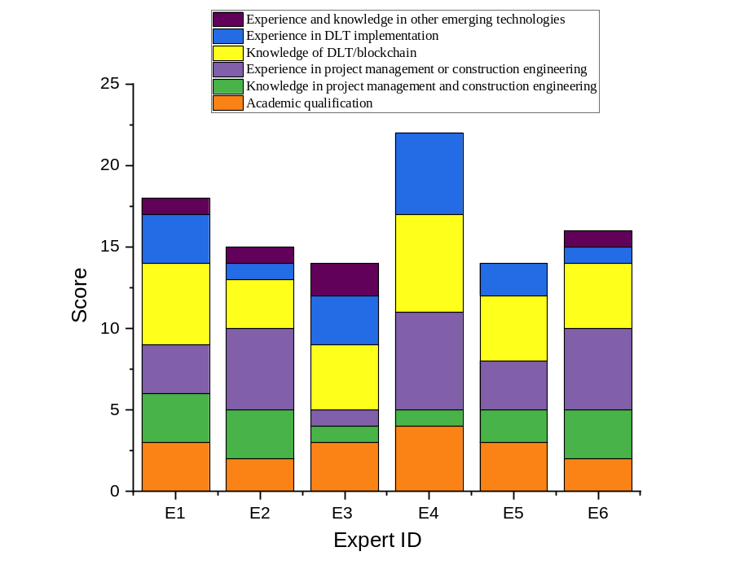
Figure B: Comparison of exporters’ competencies

