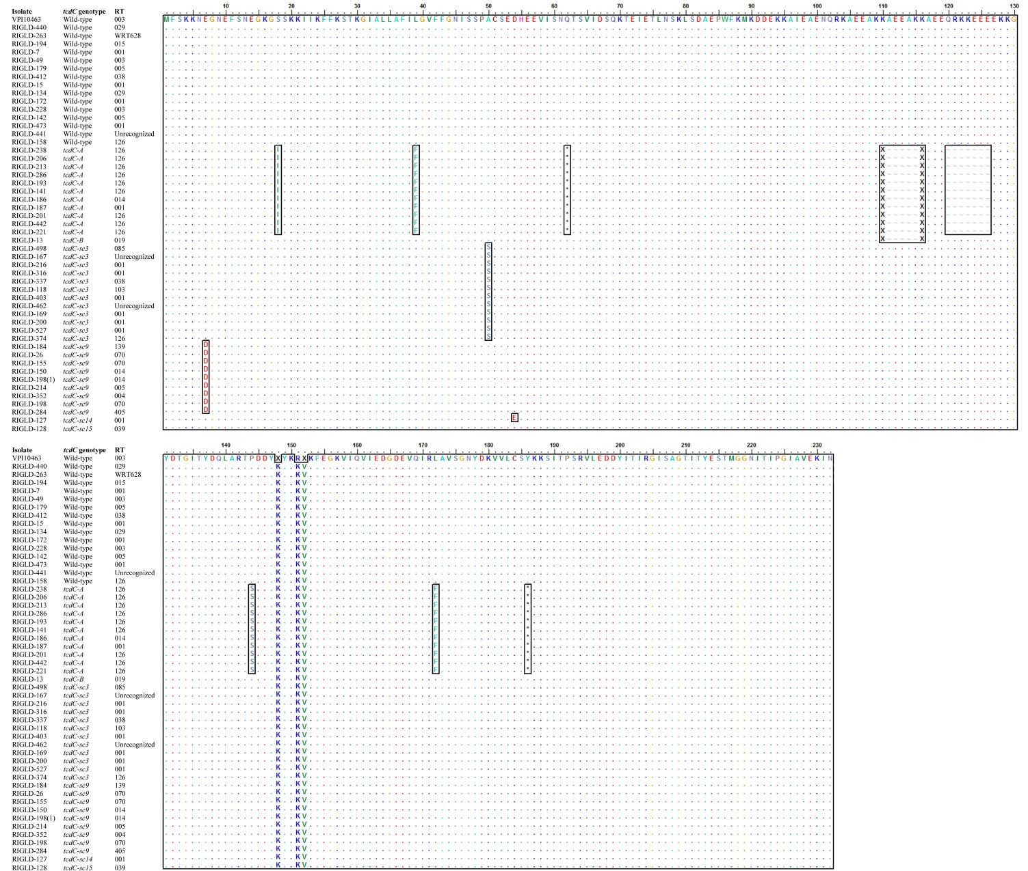
Figure S1. Amino acid sequence alignment of TcdC in tcdA⁺B⁺ C. difficile isolates (n = 50) as compared with C. difficile reference strain VPI10463.

