Supplementary material

Supplementary Figure 1: Population of lung cells in the control and CSE-emphysema model by scRNA-seq
- Identification of five cellular population in lung cells
- Abundance distribution according to cellular population.

Supplementary Figure 2: Pulmonary function of mice.
Data are expressed as mean ± SEM. P values were determined using one-way ANOVA. n = 10 mice per group.

Supplementary WB original image
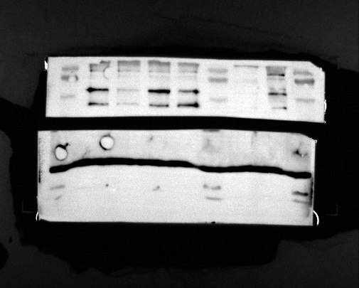
ALDH3A1

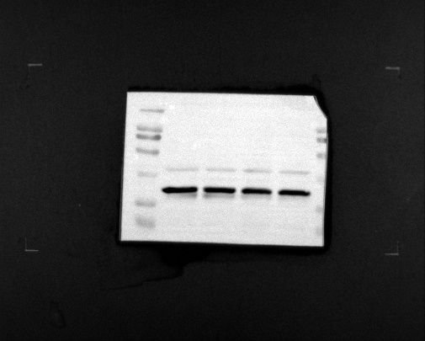
GAPDH

