Supplementary data for
Enhanced oral delivery of paclitaxel via a folate decorated zein nanoparticles across intestinal organoid and in vivo models
Ahmed Somaida ^{1┼}, Ahmed M. Abdelsalam ^{1,2┼*}, Shaimaa M. Khedr ³, Ahmed M. Mohamed ², Imran Tariq ^{1,4}, Noor Almohsen ⁵, Orchid Ashraf ⁵, Michael Keusgen ⁵, Shaaban K. Osman ², Majid M. Al-Sawahli ⁶, Dandan Zhao ⁷, Thomas Worzfeld ⁷ , and Udo Bakowsky ¹
¹ Department of Pharmaceutics and Biopharmaceutics, University of Marburg, Robert-Koch Strasse 4, 35037 Marburg, Germany.
² Department of Pharmaceutics and Pharmaceutical Technology, Faculty of Pharmacy, Al-Azhar University, Assiut 71524, Egypt.
³ Pharmaceutical and Fermentation Industries Development Center (PFIDC), City of Scientific Research and Technology Applications (SRTA-City), New Borg El Arab, Alexandria, 21111, Egypt.
⁴ Punjab University College of Pharmacy, University of the Punjab, 54000 Lahore, Pakistan.
⁵ Department of Pharmaceutical Chemistry, University of Marburg, Marbacher Weg 10, 35032 Marburg, Germany.
⁶ Department of Pharmaceutics, College of Pharmacy, The Islamic University, Najaf, Iraq.
⁷ Institute of Pharmacology, University of Marburg, Marburg, Germany.

┼ These authors equally contributed to this work.
* Correspondence author: ahm.abdelsalam87@azhar.edu.eg

Chemical synthesis of folate labeled zein.

The overall synthesis steps are shown in Fig S1 and were adopted from previously published work as follows [1,2]:
1.1. Synthesis of active folic acid (Folic acid succinimidyl ester).
NHS active folic acid was synthesized using NHS/DCC coupling chemistry. In a degassed 10 ml solution of DMSO, 1 g (2.26 mM) of folic acid was dissolved completely. DCC (0.931 g, 4.52 mM, 2 equivalents) and NHS (0.52 g, 4.52 mM, 2 equivalents) were added. Following the addition of 0.5 ml of TEA, the reaction mixture was stirred under a nitrogen atmosphere for 24 hours in the dark. The byproduct, Dicyclohexyl urea, was removed by filtration, and the filtrate was precipitated using a cold diethyl ether/acetone mixture (70:30 v/v). The resulted NHS-activated folic acid ester product was washed with ethanol and diethyl ether, then dried in a desiccator under reduced pressure. FT-IR as well as H1NMR spectroscopy confirmed the successful formation of the active acid.
1.2. Synthesis of Carboxyl-PEG-FA Conjugate.
In a 25 ml round-bottom flask, the heterofunctional PEG (COOH-PEG-NH₂, 5.311 kDa, 0.1 g, 17 mM) was dissolved completely in 3 ml of dry DMSO under a nitrogen atmosphere. Active folic acid (0.021 g, 2 molar equivalents) and 200 µl of dry triethylamine were then added. The reaction was stirred under nitrogen in the dark for 48 hours. Upon completion, the reaction mixture was added to cold diethyl ether to precipitate both the folic acid and the FA-PEG conjugate. The resulting residue was filtered, dissolved in dichloromethane, and washed in a separating funnel with 50 ml of 0.1 M carbonate buffer (pH 9.2) and deionized water to remove any unreacted folic acid. The organic phase was dried with anhydrous magnesium sulfate, filtered, and the pale-yellow solution was evaporated using a rotary evaporator, redissolved in dichloromethane, and precipitated into cold diethyl ether. The final PEG-FA conjugate was filtered through Whatman filter paper, dried in a desiccator, and characterized using FT-IR and H1NMR spectroscopy to confirm successful synthesis.
1.3. Synthesis of Z-PEG-FA conjugate.
To activate the carboxyl group of carboxyl-PEG-folate, 0.08 g of the compound was dissolved in 20 ml of nitrogen-purged methylene chloride. DCC (0.007 g, 2 equivalents) and NHS (0.004 g, 2 equivalents) were then added to the solution. The reaction was stirred under nitrogen for 48 hours. Following the reaction, by-products were removed by filtration, and the filtrate was evaporated using rotary evaporator, yielding the active folic-PEG-NHS ester as a pale-yellow residue. The residue was then dissolved in 3 ml of nitrogen-purged DMSO followed by the addition of 0.1 g of yellow zein and 200 µl of dry triethylamine. The mixture was stirred under nitrogen for 72 hours. The mixture was dialyzed against distilled water for 48 hours using dialysis tubing (12–14 kDa), with water replaced every 6 hours to ensure complete removal of unreacted PEG and DMSO. The dialyzed colloidal Z-PEG-FA product was freeze-dried to yield a fluffy zein powder, which was further characterized using FT-IR and H1NMR spectroscopy.
1.4. FT-IR Spectroscopy.
Infrared spectra were obtained using a Bruker α-alpha FT-IR spectrometer (Bruker Optic GmbH, Ettlingen, Germany), which featured a diamond crystal for attenuated total reflectance (ATR) measurements. Solid samples were applied directly onto the diamond crystal, then held in place with a pressure arm to ensure optimal contact. Spectral data were recorded over a range of 4000 cm⁻¹ down to 400 cm⁻¹ using the spectrometer’s integrated software.
1.5. H1NMR spectroscopy.
Proton NMR (¹H NMR) spectra were acquired using a JEOL ECX-400 Nuclear Magnetic Resonance spectrometer (JEOL, Japan) with an automated tuning sample head. Samples were prepared by dissolving an accurately measured quantity of the compound in a suitable NMR solvent, like CDCl₃ or DMSO-d₆. The resulting solutions were then placed in NMR tubes for analysis.
1.6. UV-Spectroscopy
UV spectra of free folic acid (in 0.2 M carbonate buffer), Z-PEG, and the Z-PEG-FA (both in 90% EtOH) were acquired via UV-Spectrophotometer (Thermo Fisher Scientific, Finland). Recordings were caught at ambient temperature (25OC), and the data were extracted and analyzed by Origin Lab software (MA, USA).

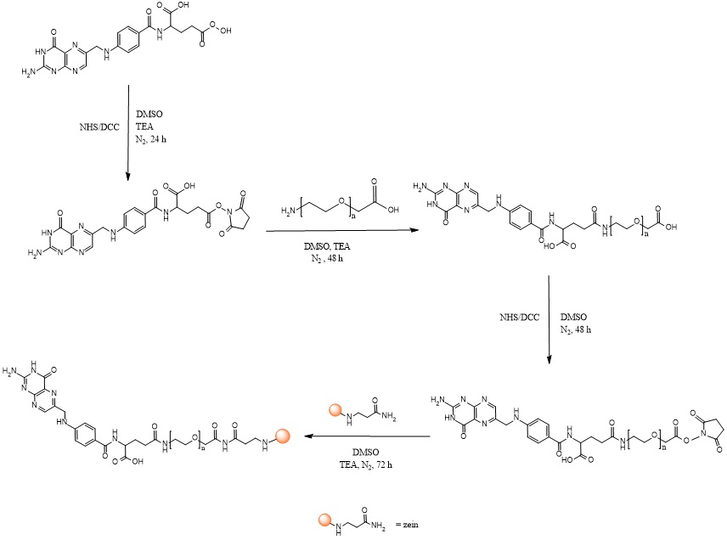
Figure S1. Chemical synthesis of PEGylated zein functionalized with folic acid

The HPLC calibration of paclitaxel in ethanol
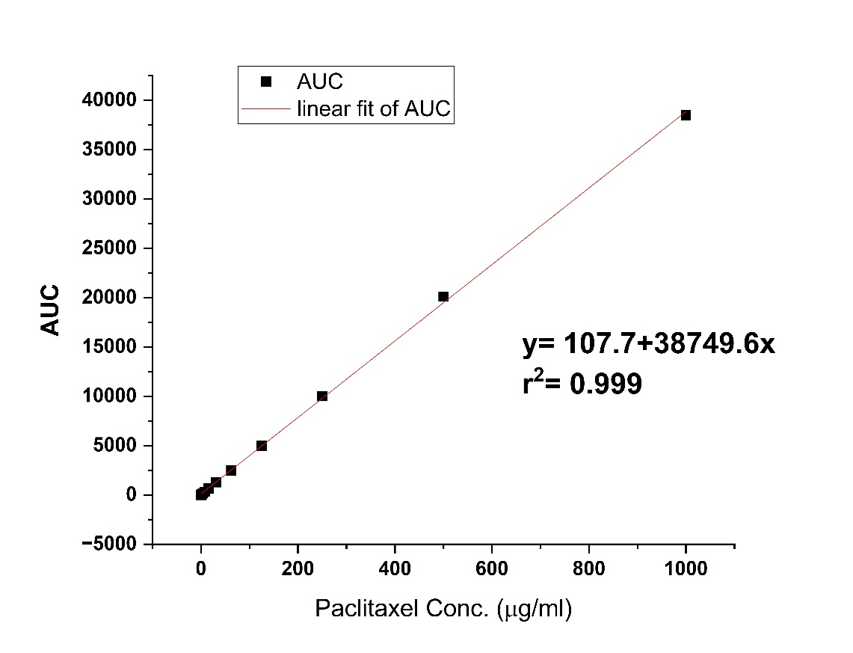
Figure S2. The HPLC calibration of paclitaxel in Ethanol generated at concentration range (0 – 1000 ug/ml ) of pure paclitaxel.

Chemical synthesis of fluorescent folic acid conjugate and its uptake pattern in 2D Hela cells

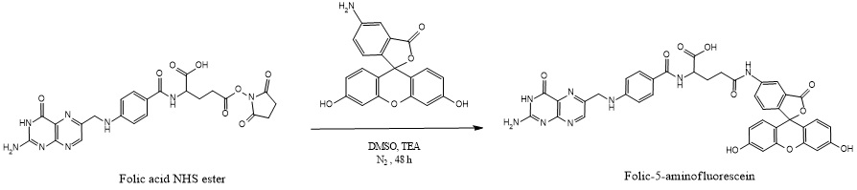
Figure S3. Synthesis of the green-fluorescent Folic acid conjugated 5-aminofluorescein
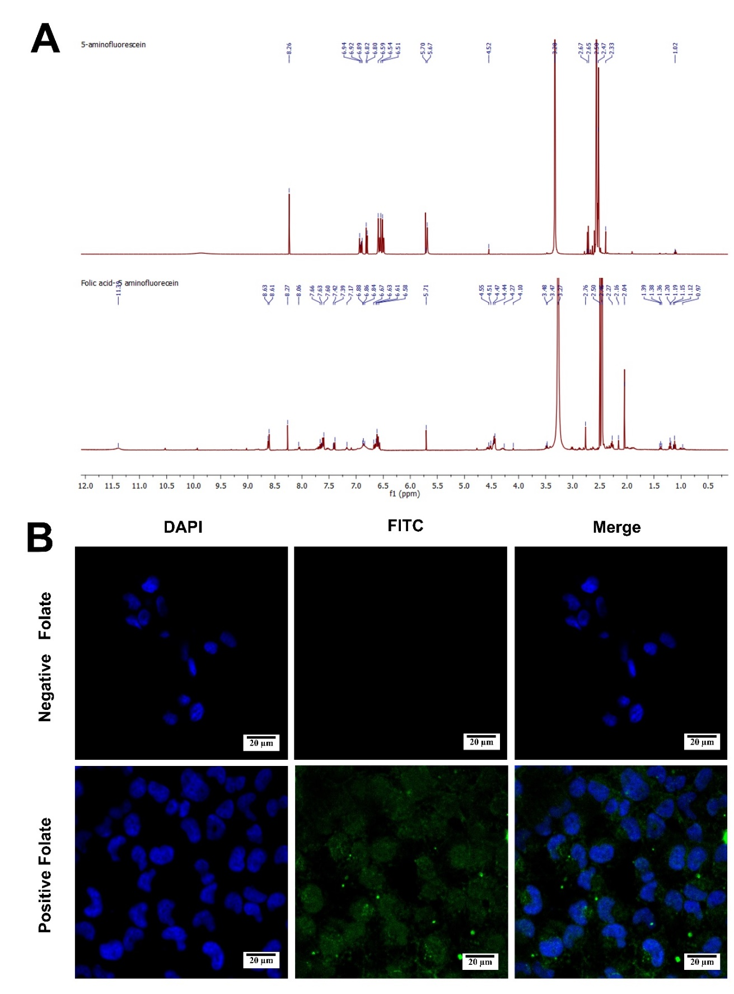
Figure S4. The H¹NMR spectra of 5-aminofluorescine and folic acid conjugated 5-aminofluorescein (A) and cellular uptake of the folate conjugated 5-aminofluorescein in folate-positive Hela cells as proof of the presence of folate receptors in the tested cells prior to the cultivation of multicellular spheroids.
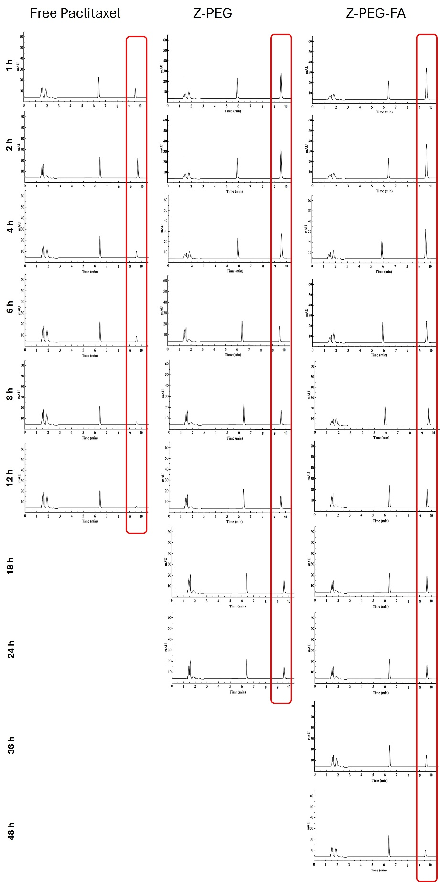
Figure S5: the HPLC chromatograms developed from Rabbit’s withdrawn plasma for groups treated with free paclitaxel, Z-PEG, and Z-PEG-FA

References.
1. Abdelsalam AM, Somaida A, Ambreen G, Ayoub AM, Tariq I, Engelhardt K, et al. Surface tailored zein as a novel delivery system for hypericin: Application in photodynamic therapy. Mater Sci Eng C [Internet]. 2021;129:112420. Available from: https://doi.org/10.1016/j.msec.2021.112420
2. Mohamed AMA. Novel protein-based nanomaterial for active targeted drug delivery to human hepatocyte carcinoma cells [Internet]. Philipps-Universität Marburg; 2023. Available from: https://archiv.ub.uni-marburg.de/diss/z2023/0244

