Supplementary Material

Neoadjuvant Imatinib in recurrent/metastatic gastrointestinal stromal tumors: A systematic review and meta-analysis of proportions

Medical Oncology

Niki Stavrou¹, Nikolaos Memos², Charalampos Filippatos¹, Flora Zagouri¹, Maria Gavriatopoulou¹, Ioannis Ntanasis-Stathopoulos¹

Affiliations: ¹Department of Clinical Therapeutics, Alexandra Hospital, School of Medicine, National and Kapodistrian University of Athens, Athens, Greece
²Surgical Department, Aretaieio Hospital, School of Medicine, National and Kapodistrian University of Athens, Athens, Greece

Corresponding author: Niki Stavrou; ORCID: 0000-0001-7578-3001; ndstav@med.uoa.gr; ndstavrou@gmail.com

Table 1 Descriptive table

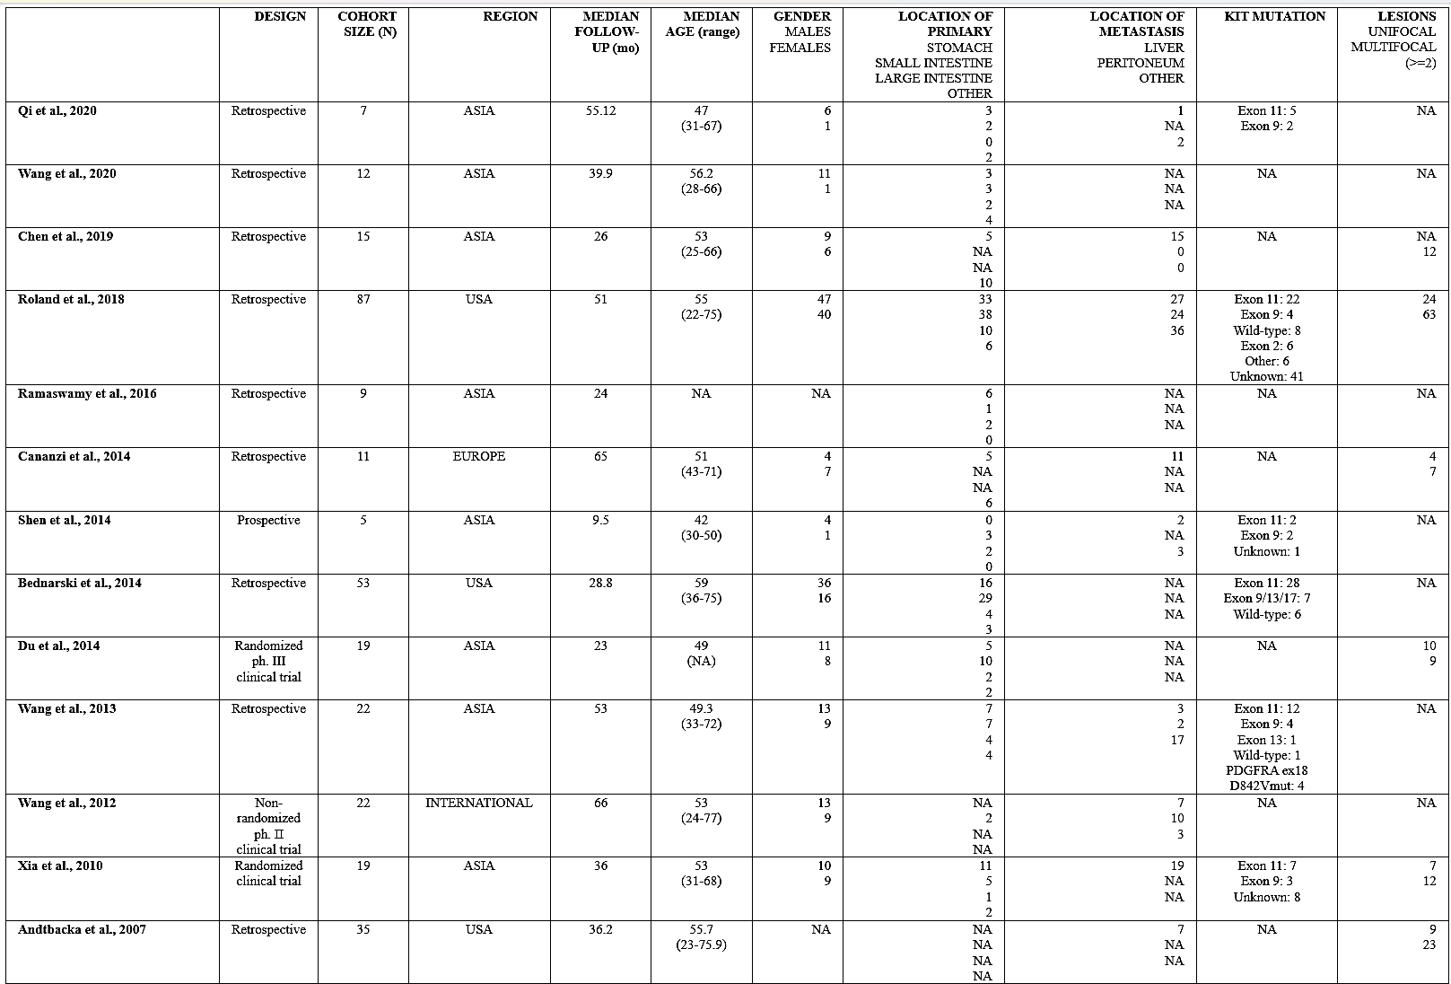
Figure 1 Meta-analysis of 2-year PFS rates, subgroup analysis by design

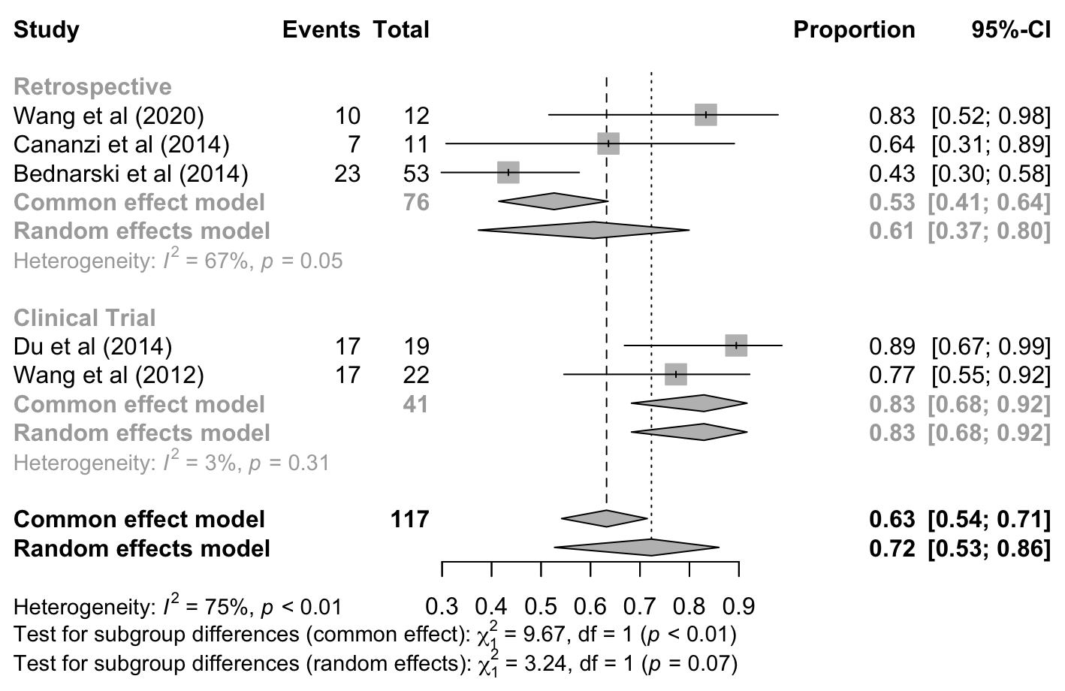

Figure 2 Meta-analysis of 2-year PFS rates, subgroup analysis by region
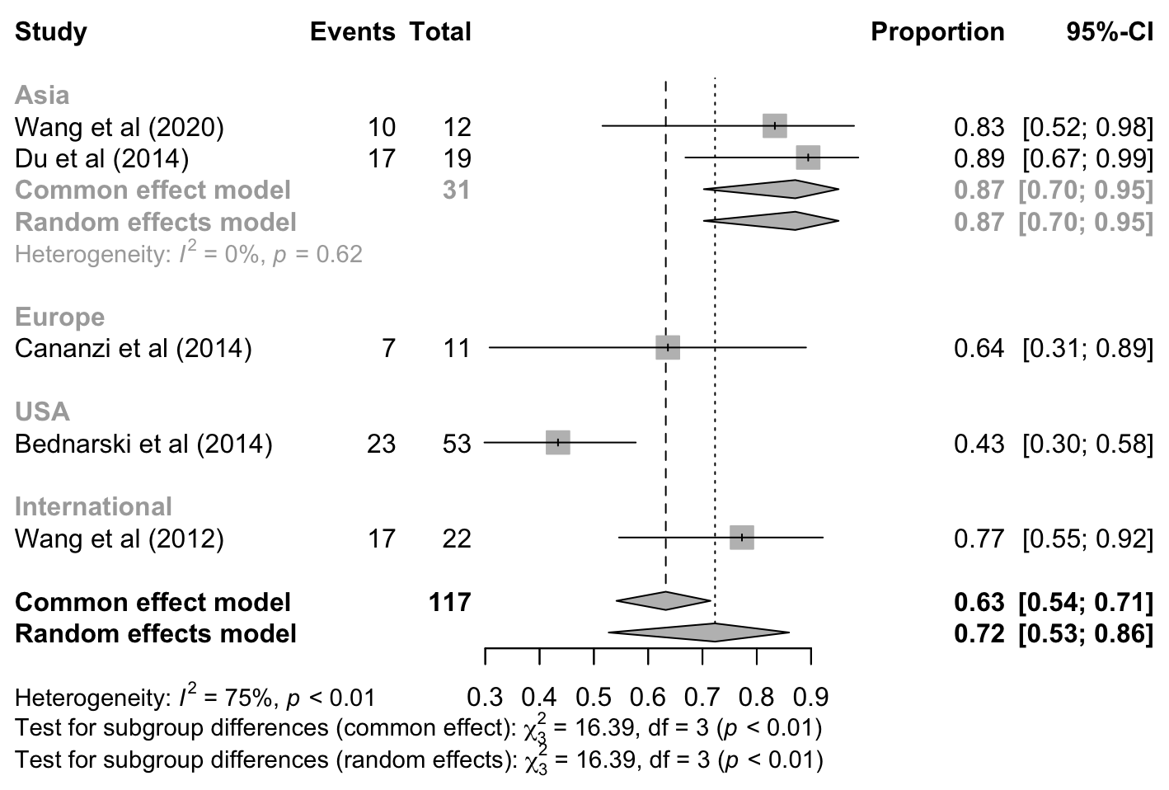

Figure 3 Meta-analysis of 2-year OS rates, subgroup analysis by design
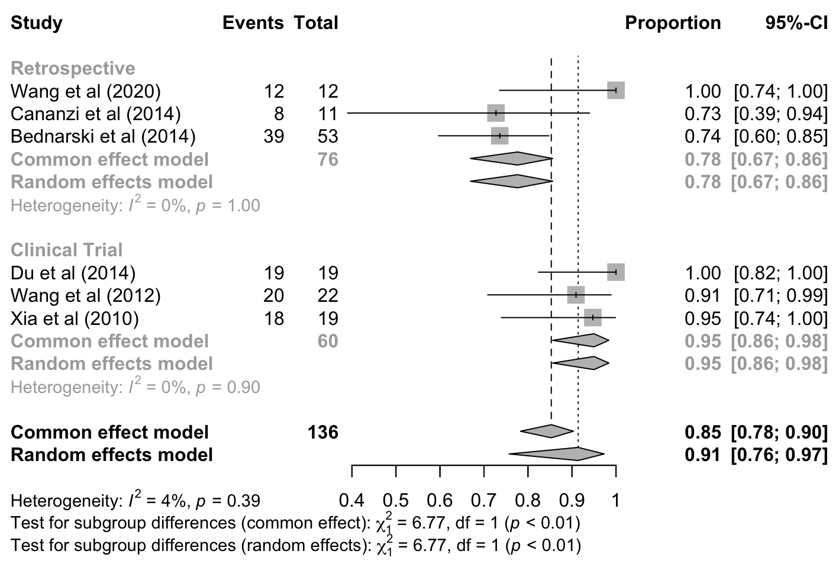

Figure 4 Meta-analysis of 2-year OS rates, subgroup analysis by region

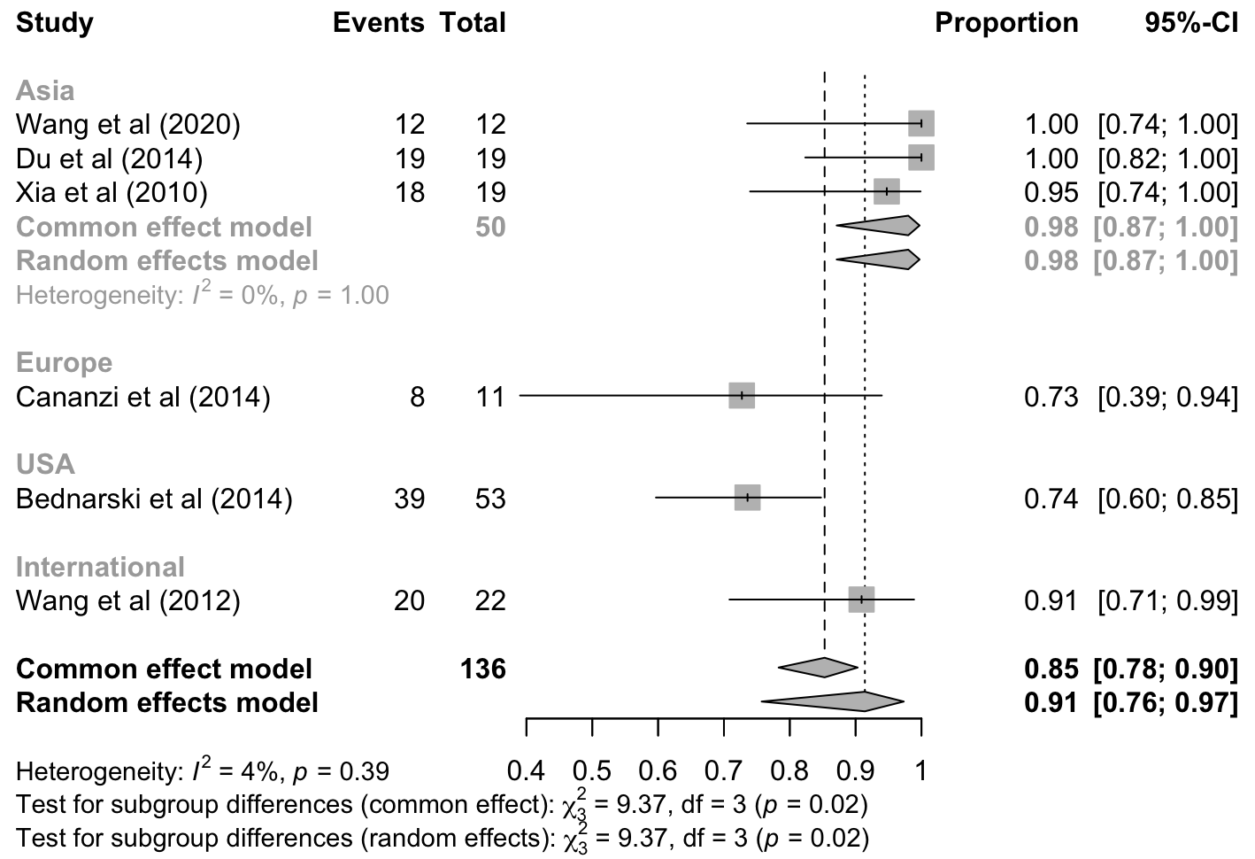
Figure 5 Meta-analysis of 5-year OS rates, subgroup analysis by design

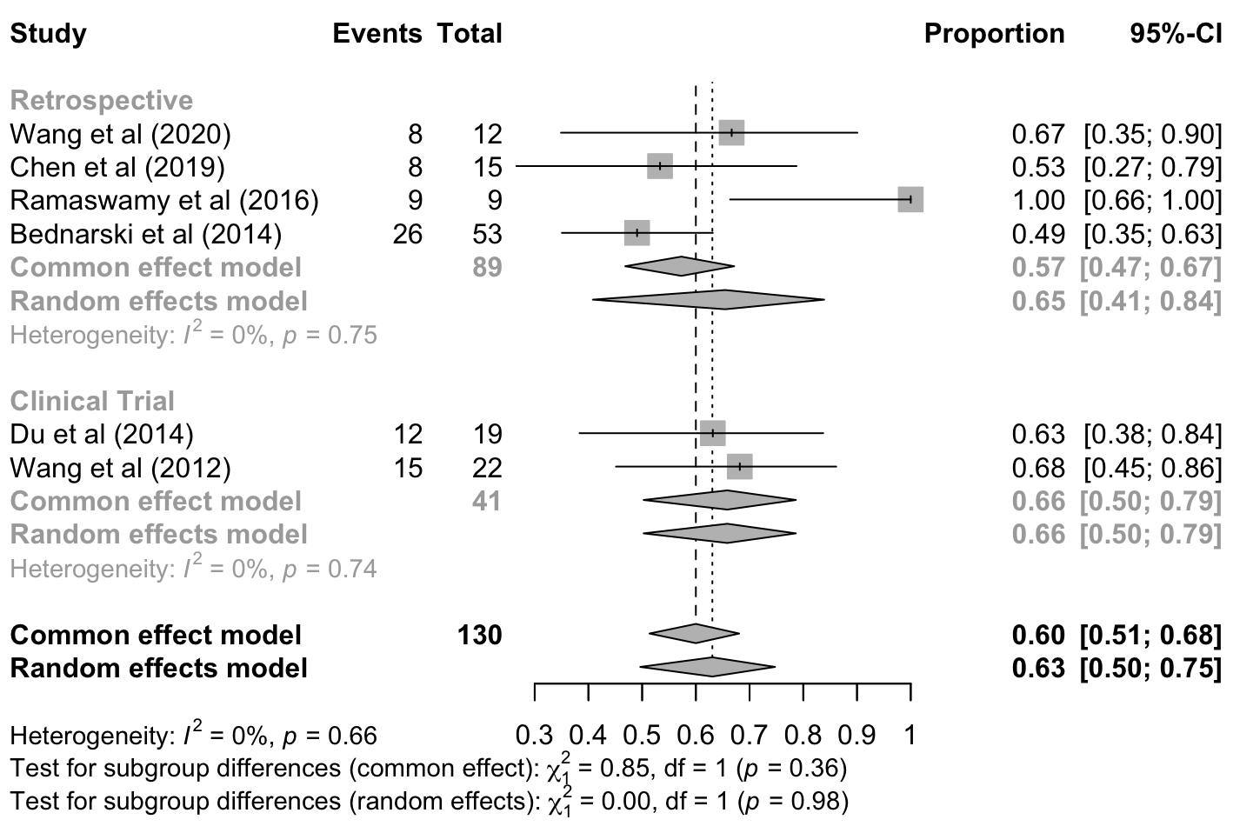

Figure 6 Meta-analysis of 5-year OS rates, subgroup analysis by region

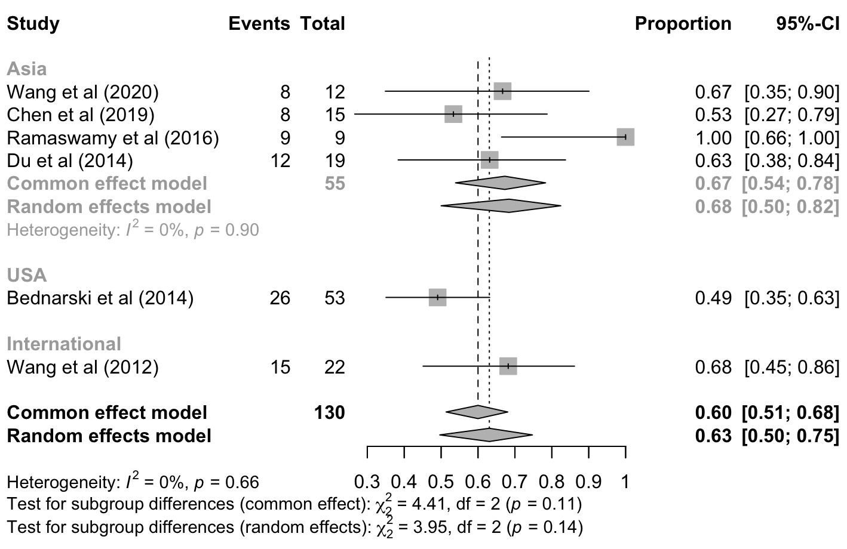

Figure 7 Meta-analysis of R0 resection proportions, subgroup analysis by design

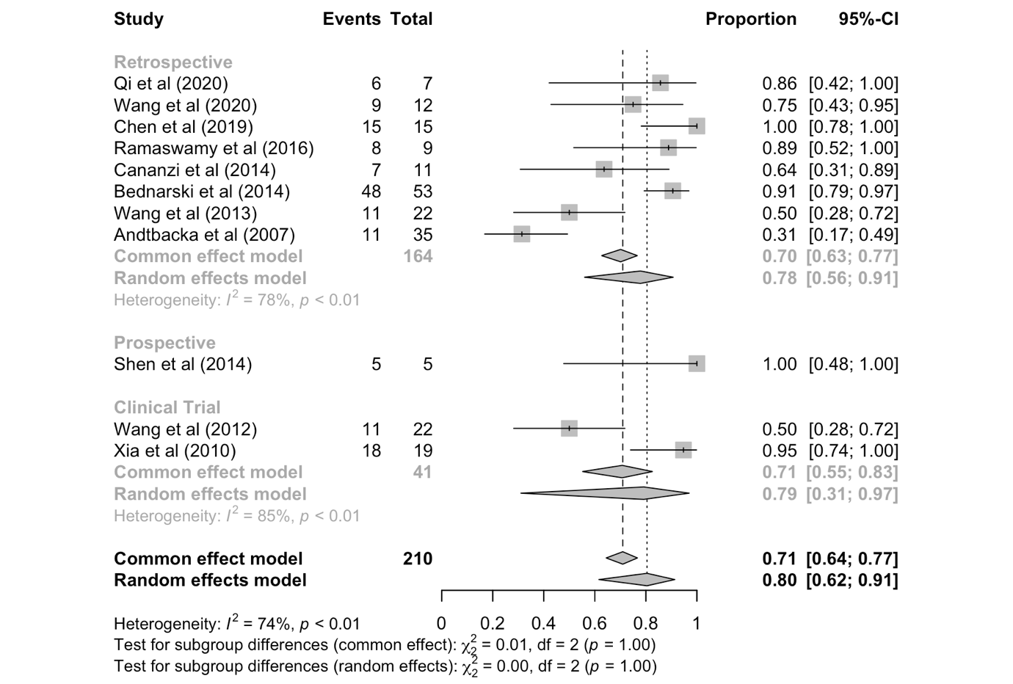

Figure 8 Meta-analysis of R0 resection proportions, subgroup analysis by region

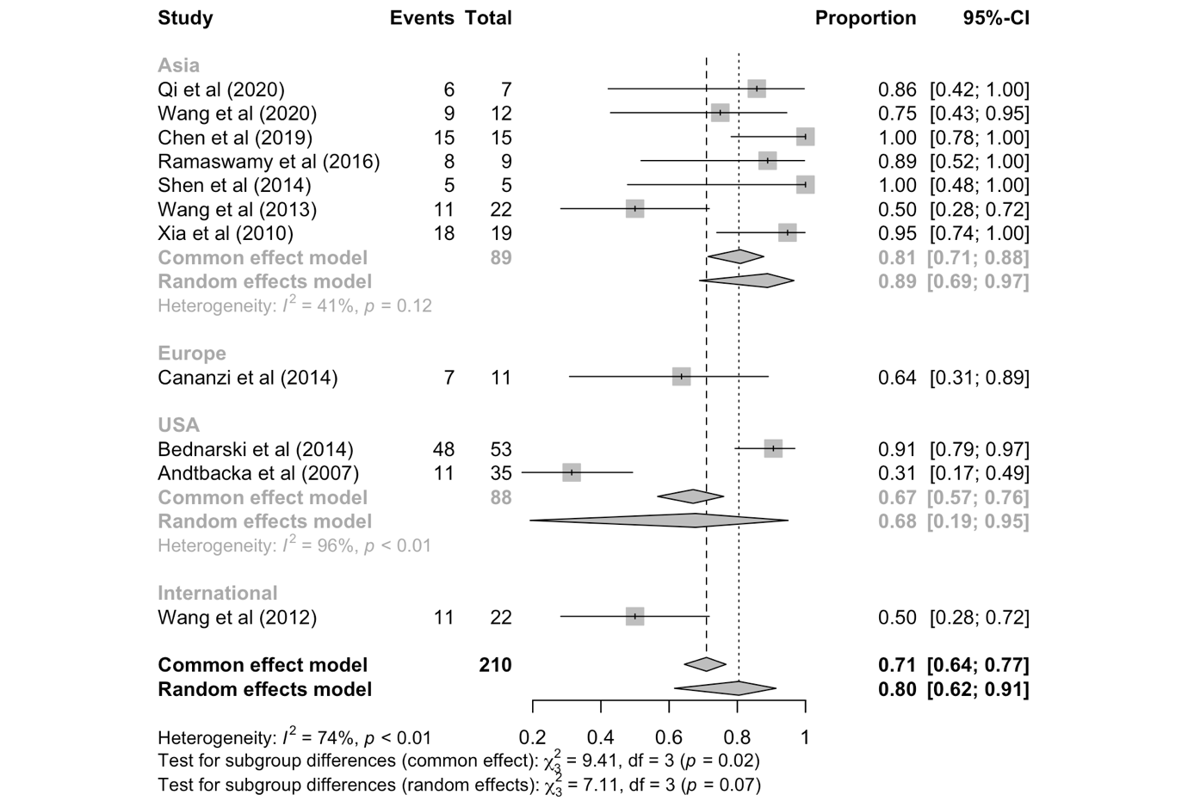
Figure 9 Meta-analysis of R1 resection proportions

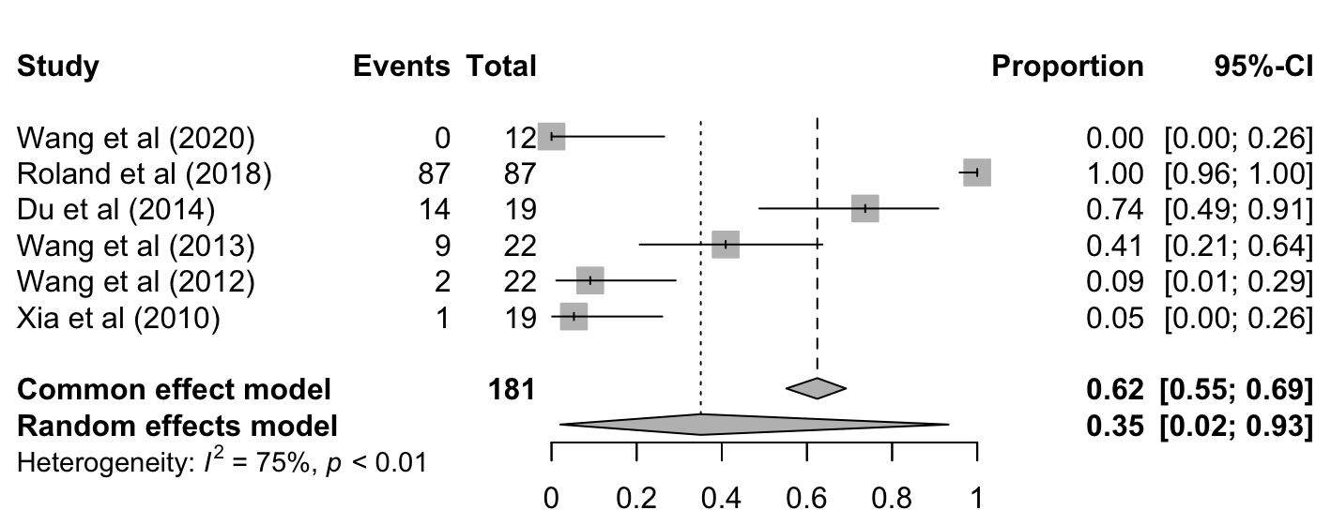

Figure 10 Meta-analysis of R1 resection proportions, subgroup analysis by design

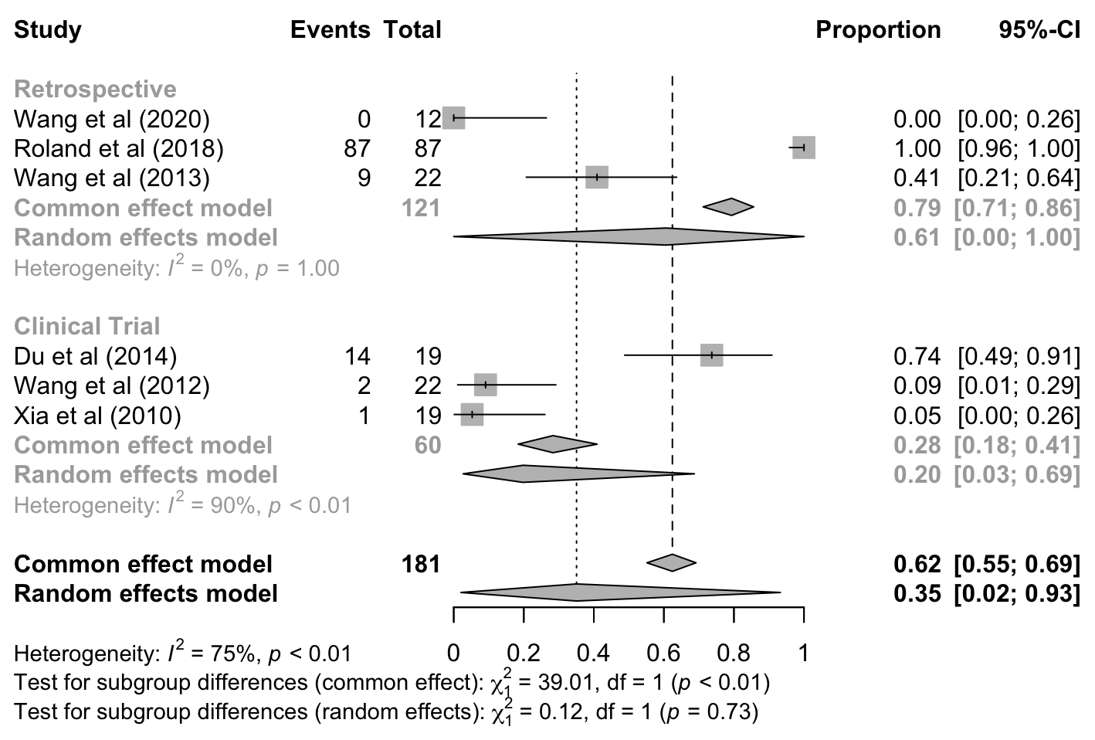

Figure 11 Meta-analysis of R1 resection proportions, subgroup analysis by region

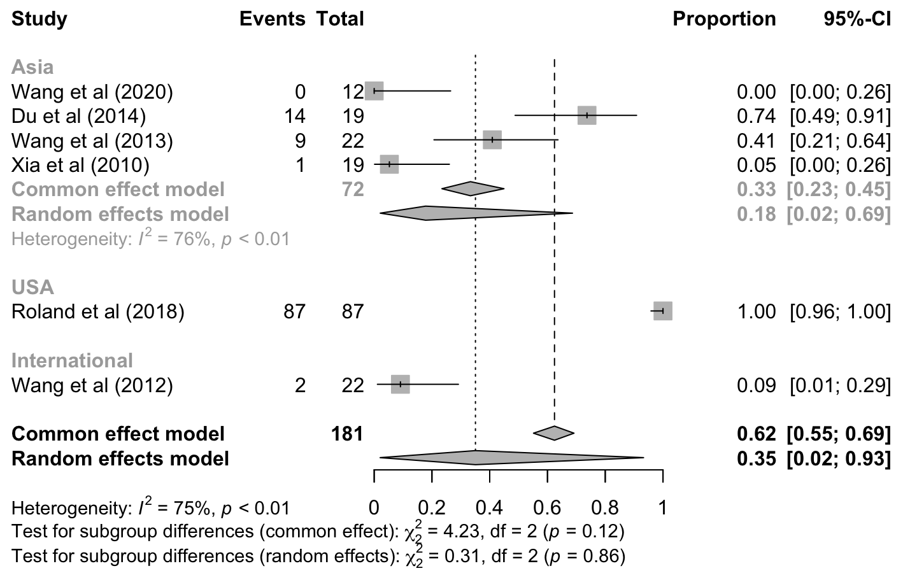

Figure 12 Meta-analysis of R0 resection proportions
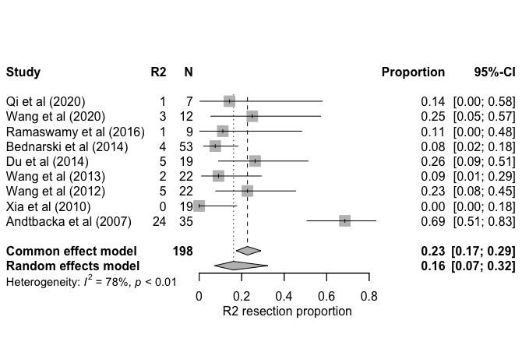

Figure 13 Meta-analysis of R2 resection proportions, subgroup analysis by design

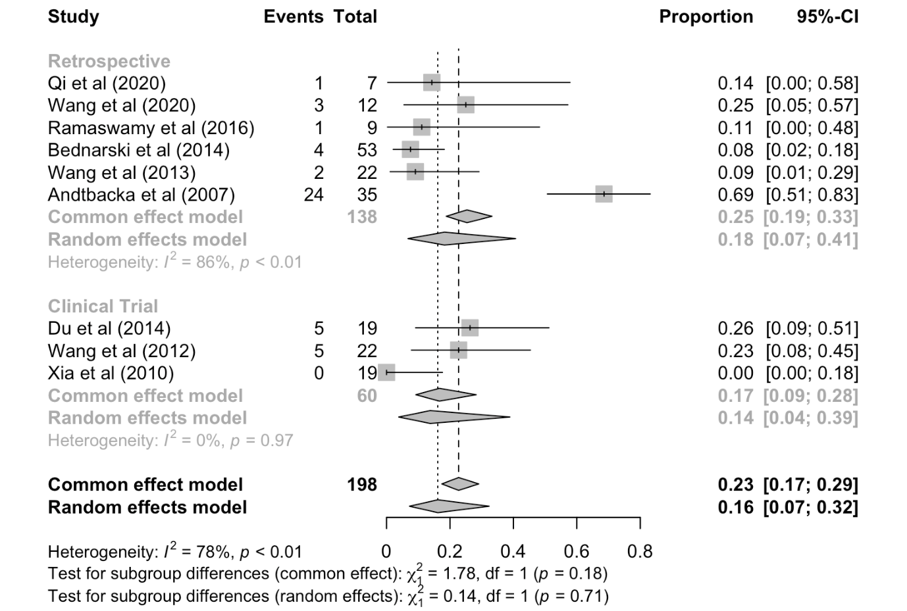

Figure 14 Meta-analysis of R2 resection proportions, subgroup analysis by region
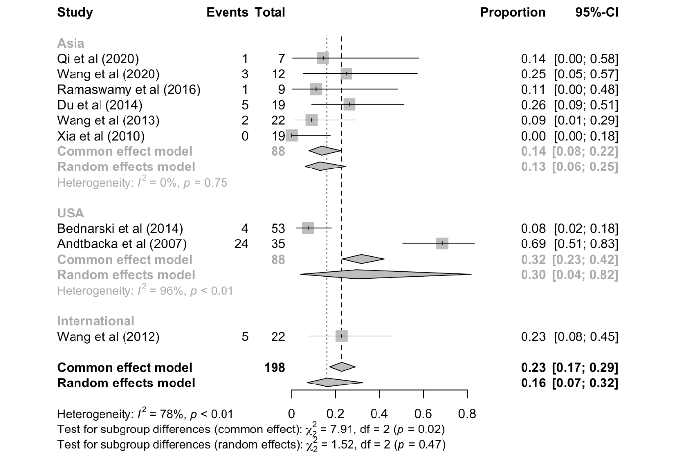
Table 2 Meta-regression results for R0 resection proportions

Variable | Estimate (Logit scale) | p-value
Age (median) | -0.07 | 0.456
# of patients | -0.02 | 0.491
% of males | 0.02 | 0.191
Preoperative IM duration (months, median) | -0.03 | 0.514
% of Radiological PR | 3.92 | <0.001***

