SUPPLEMENTARY INFORMATION

A Single-vector CRISPR/Cas9 System for Genome Editing and Heterologous Enzyme Secretion in Saccharomyces cerevisiae: A Case Study on Pectate Lyase for Coffee Mucilage Removal

La Ho Truc Lam^{1,2}, Nguyen Huynh Ha Nhi^{1,2}, Vo Thi Hoang Lan^{1,2}, Nguyen Van Hau^{1,2}, Nguyen Hieu Nghia^{1,2}*

¹Department of Molecular and Environmental Biotechnology, Faculty of Biology and Biotechnology, University of Science, Ho Chi Minh City, Vietnam
²Vietnam National University, Ho Chi Minh City, Vietnam
^{(*)}: corresponding author: nghnghia@hcmus.edu.vn

Figure S1. Schematic diagram of vectors p427-TEF (A), pBluescript II SK(+) (B), and p427-gfp (C)
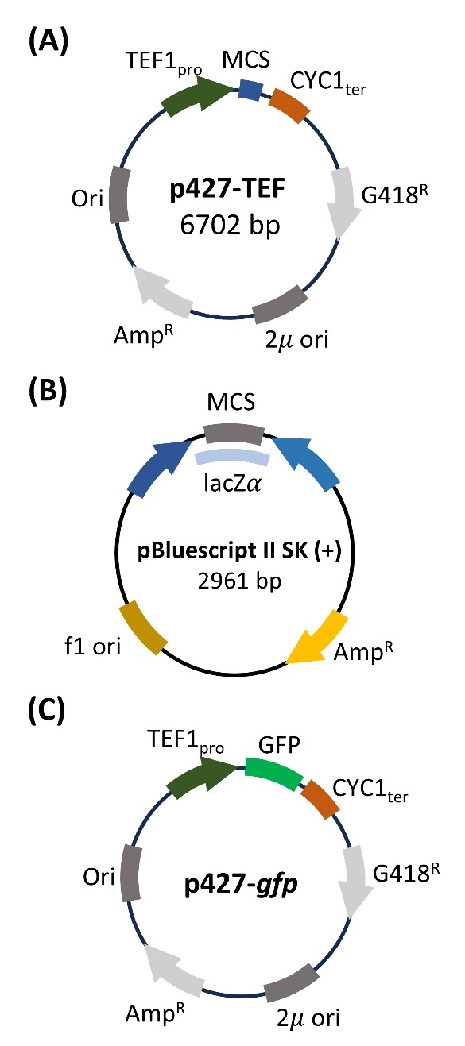

Figure S2. Analysis of the PL expression of S. cerevisiae BY4743/p427-pecA by SDS‒PAGE. S₁ shows the protein sample after concentration, and S₂ shows the protein sample before concentration from S. cerevisiae BY4743/p427-pecA. (M) Protein ladder.
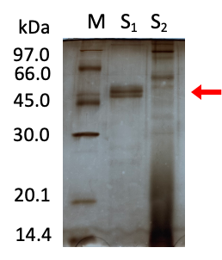

Figure S3. Screening E. coli colonies harboring the p427-Cas9 vector. (A) Schematic representation of primer pairs used for screening E. coli colonies harboring the p427-Cas9 vector. (B) Verification of the presence of the Cas gene in E. coli colonies by PCR with the Cas9-F2/R2 primers. Lane (1) is the negative control; lane (2) is the positive control. Lanes (3‒5) show the PCR products of three colonies.
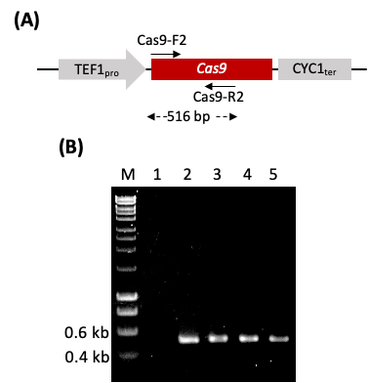

Figure S4. Verification of pBlueHA-gfp. (A) Schematic representation of the gfp cassette fused with two homology arms in the donor vector pBlueHA-gfp. (B) Verification of the presence of HA-gfp presence in E. coli colonies by PCR using the LHA-F/R primer set. Lane (1) is the negative control; lane (2) is the positive control. Lanes (3‒5) show the PCR products of three colonies. (C) PCR analysis for verification of the HA-gfp structure using the LHA-F/CYC1-R primers (lanes 1‒3), TEF1-F1/RHA-R primers (lanes 4‒6) and LHA-F/RHA-R primers (lanes 7‒9). Lanes (1), (4), and (7) are negative controls, and lanes (2, 3), (5, 6), and (8, 9) show the amplification of two isolated vectors with the corresponding primer sets. (M) denotes the 1-kb DNA ladder.
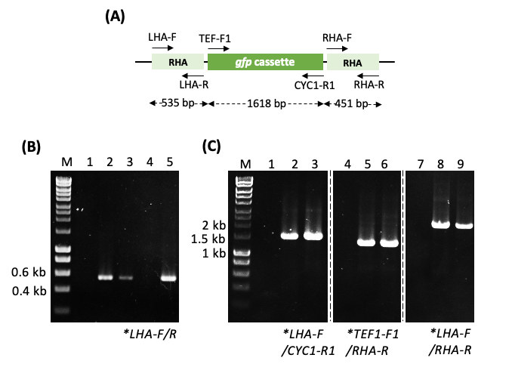
*Primer sequences:
CYC1-R1: CTTTTCGGTTAGAGCGGATG,
LHA-F: ACCGCGGTGGCGGCCGCGATATCTAGGGTTTCTGTGTGG,
LHA-R: GAGCGCAATGGATACAATTCTTTAC,
RHA-F: GTGAAGAGAGAGCTTAAGCAAAGAC,
RHA-R: AGGGCGAATTGGGTACCGATATCCAACTGGGCCGGTAACC

Figure S5. Analysis of GFP expression in three S. cerevisiae clones of BY4743::gfp by SDS‒PAGE and Western blotting with a specific anti-GFP antibody.
Lanes of BY4743 are the negative control from the intracellular protein sample of the S. cerevisiae BY4743 wild-type strain; lanes of BY4743/p427-GFP represent the positive control of the intracellular protein sample of S. cerevisiae BY4743 harboring the p427-GFP vector; lanes of BY4743::gfp (1‒3) show the intracellular protein sample of S. cerevisiae BY4743::gfp after the removal of the p427-Cas9-gRNA vector. (M) Protein ladder.
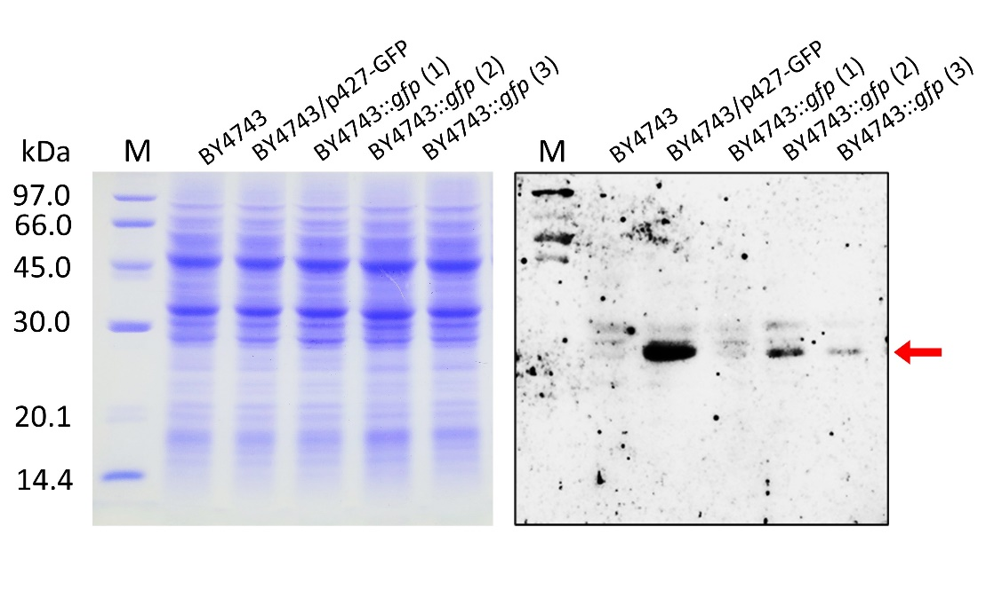

Figure S6. Verification of pBlueHA-pecA
(A) Schematic representation of the primer pairs used for screening and verification of the pBlueHA-pecA vector. (B) Verification of the pBlueHA-pecA vector structure by PCR using the primer sets pecA-F/R and pecA-F/RHA-R2. Lanes (1) and (8) are negative controls; lane (2) is a positive control. Lanes (3‒7) and (9‒13) show the amplification of five isolated vectors with the corresponding primer sets. (M) denotes the 1-kb DNA ladder.
Sequence of RHA-R2: AAGCTCTCTCTTCACCTAGTTCTAGAGCGGCCGCAGATCT
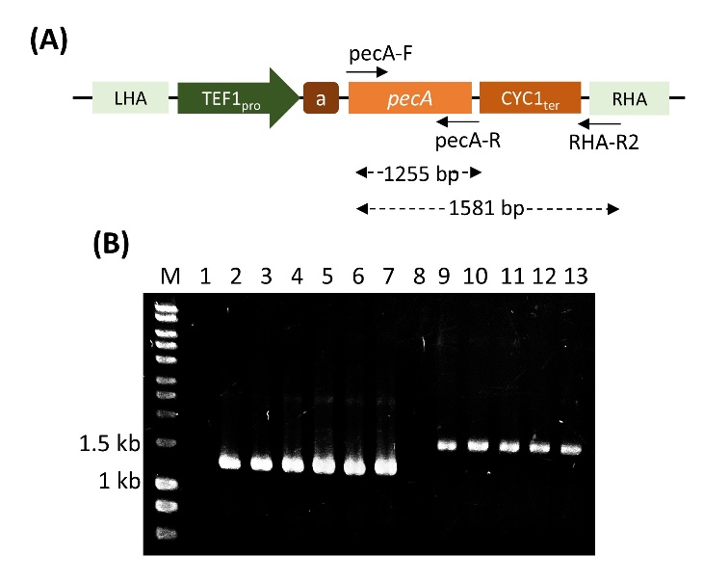

Table S1. Integration efficiency of various CRISPR/Cas9 systems in S. cerevisiae

S. cerevisiae strain | Cas9 protein expression system |  |  |  |  | gRNA expression system |  |  |  | Editing efficiency | Ref.
S. cerevisiae strain | Pro | Ter | Marker | Ori |  | Pro | Ter | Marker | Ori | Editing efficiency | Ref.
BY4733 (n) | TEF1 | CYC1 | TRP1 | CEN/ARS |  | SNR52 | SUP4 | URA3 | 2μ | 99% | (Dicarlo et al., 2013)
CEN.PK113-7D (n)  Ethanol Red (2n) | TEF1/ ADH1 | - | kanMX | CEN/ARS |  | SNR52 | SUP4 | natMX | 2μ | 65-78% | (Stovicek et al., 2017)
Y1H (n) | GAP | ADH1 | LEU2 | 2µ |  | SNR52 | SUP4 | LEU2 | 2µ | 91.4-100% | (Xue et al., 2018)
JM (n) | TEF1 | ADH2 | kanMX | 2µ |  | SNR52 | SUP4 | kanMX | 2µ | - | (Guo et al., 2021)
BY4743 (2n) | TEF1 | CYC1 | kanMX | 2µ |  | SNR52 | SUP4 | kanMX | 2µ | 70-100% | This study

Table S2. Comparison of pectate lyase (PL) production in various hosts
Host cell | Cultue conditions | PL production  (U/mL) | Ref.
S. cerevisiae^{(a)} | 100-mL flask culture | ~ 0.003 | This study
P. pastoris GS115 | 5-L fermentor  (Methanol induction) | 100 | (Zhuge et al., 2008)
P. pastoris GS115 | 25-mL flask culture  (Methanol induction) | 102.6 | (Zhang et al., 2013)
B. subtilis PB1 | 50-mL flask culture | 19.5 | (Zhou et al., 2017)
^{(a)} PL activity was measured at 540 nm (OD₅₄₀) and converted to activity units using a standard curve of D-galacturonic acid (MW: 194.139 g/mol) in the concentration range of 0–1000 μg/mL. The standard curve equation was Y = 0.0009X – 0.1653 (R² = 0.9949), where X represents OD₅₄₀ and Y denotes the D-galacturonic acid concentration. One unit of PL activity was defined as the amount of enzyme required to release 1.0 μmol of reducing sugars per minute under experimental conditions at 42°C.

