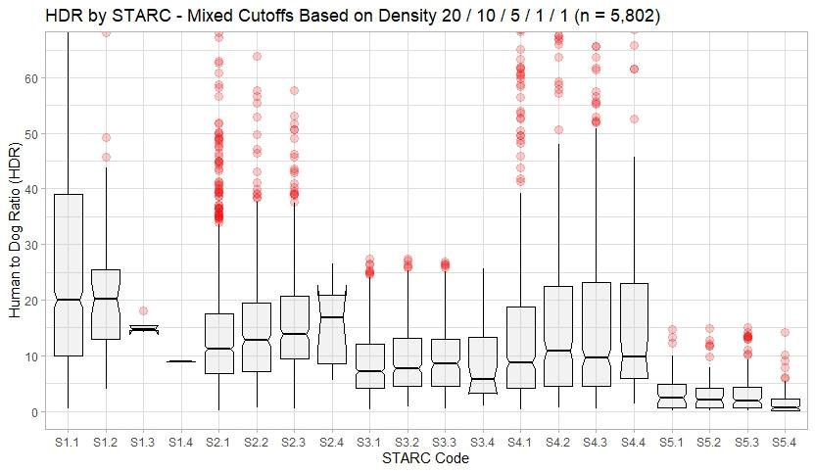
Figure S1: From 2015 – 2019, 63 dog population surveys were conducted across a broad spectrum of communities in Haiti. Surveys included door-to-door and field-based observation studies. Lincoln-Petersen with the Wallace free-roaming dog adjustment were applied (26). Communities were characterized based on population density and road connectivity, as described in the methods section. Human-to-Dog ratios were obtained from this survey data and median and quartile values were obtained. This data, found in supplemental file, was then used to estimate the free roaming dog population used in this analysis.

