Supplementary Figures

Figure A1. Transcriptomic Signatures of T Cell Differentiated States and Type II Interferon Signaling. This heatmap illustrates the expression levels of gene markers characterizing each differentiated state, with red indicating expression or upregulation and blue representing downregulated markers.

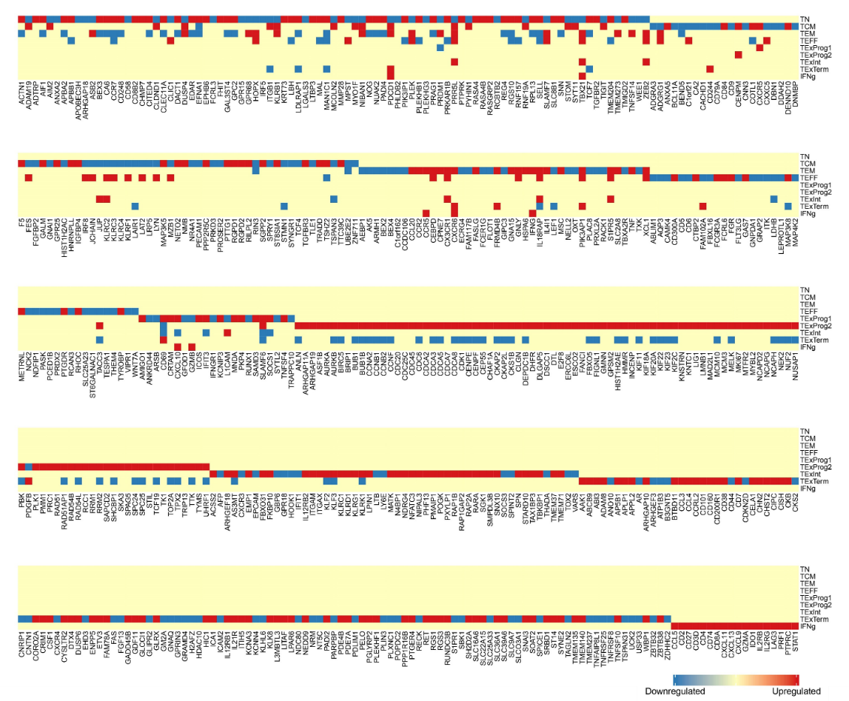

Figure A2. Relative T cell state proportion differences assessed using scProportionTest; red dots indicate statistically significant results (FDR < 0.05 and absolute log2 fold change > 0.58), with larger log2 fold changes reflecting a higher proportion of cells in responders and lower in non-responders.

