Supplementary Information
The RNA N⁶-Methyladenosine Methylome Coordinates Long Non-Coding RNAs to Mediate Cancer Drug Resistance by Activating PI3K Signaling
Yanhong Tan, Changli Zhou, Sicheng Bian, Huiqin Bian, Yanan Ren, Wencke Walter, Jiuxia Pang, Tao Cheng, Hongwei Wang, Yuchao Yang, Wenzheng Guo, Lingli Zhang, Aref Al-Kali, Mark R. Litzow, Xiaonan Han, Jianhua Yu, Rendong Yang, Gang Huang, Gregor Hoermann, William Tse, Shujun Liu

Inventory of Supplemental Information

Supplemental Figures and Legends
- Figure S1, Related to Figure 1
- Figure S2, Related to Figure 2
- Figure S3, Related to Figure 4
- Figure S4, Related to Figure 5
- Figure S5, Related to Figure 6
- Figure S6, Related to Figure 6
- Figure S7
- Figure S8
- Figure S9
- Figure S10

Supplemental Tables
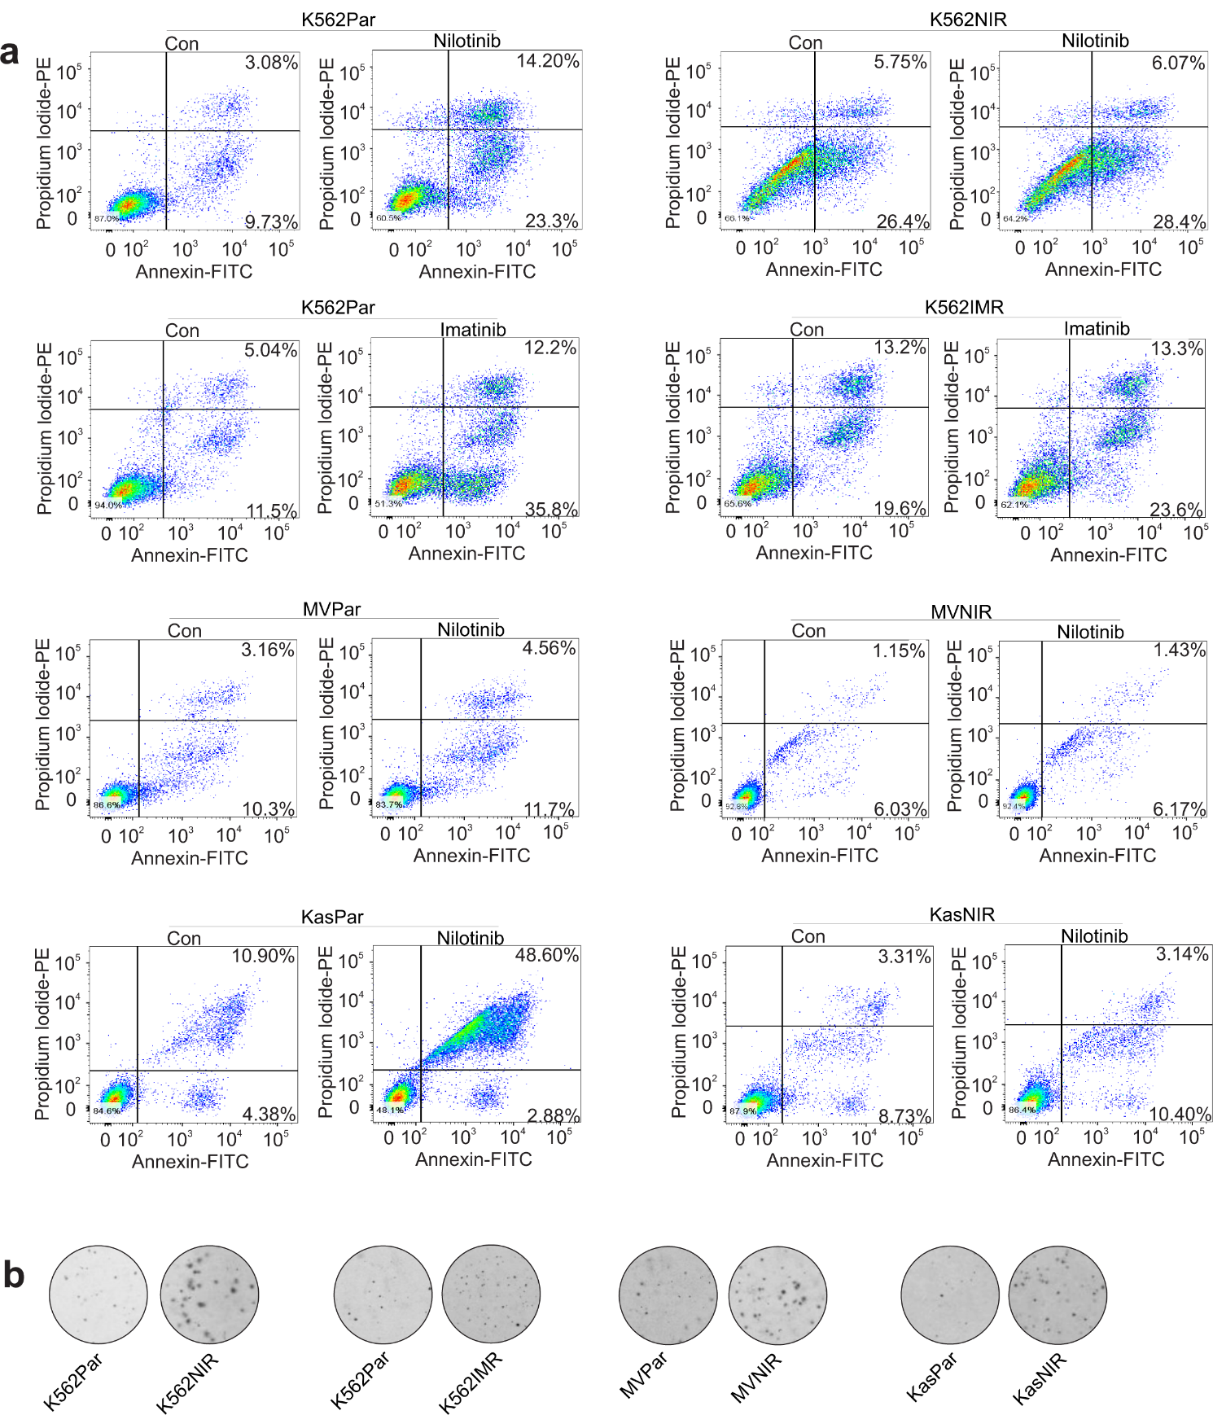

Figure S1. Characterization of TKI resistant cells. (a) Flow cytometry assays in parental and resistant cells treated with 1 µM nilotinib or imatinib for 72 h. Data represent three independent experiments. (b) Colony forming assays for parental and resistant cells. Data represent two independent experiments with three duplicates. Par, parental control; Con, control; NIR, nilotinib resistance; IMR, imatinib resistance; Kas, Kasumi-1; MV, MV-4-11.

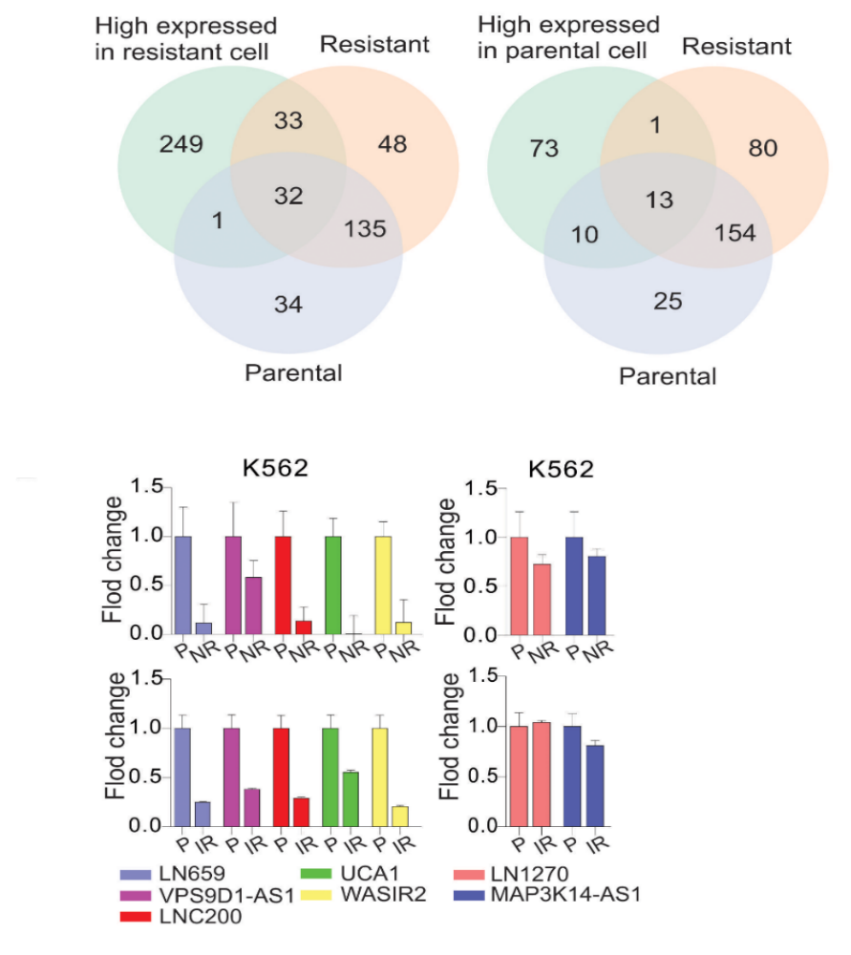
a

b

Figure S2. Analysis of lncRNA-associated m⁶A peak and account. (a) Venn diagram illustrating the number of overlapped lncRNAs highly expressed in resistant or parental cells with m⁶A-associated lncRNAs. (b) qPCR of total RNA for the expression of indicated lncRNAs in parental and resistant K562 cells. P, parental control; NR, nilotinib resistance; IR, imatinib resistance.

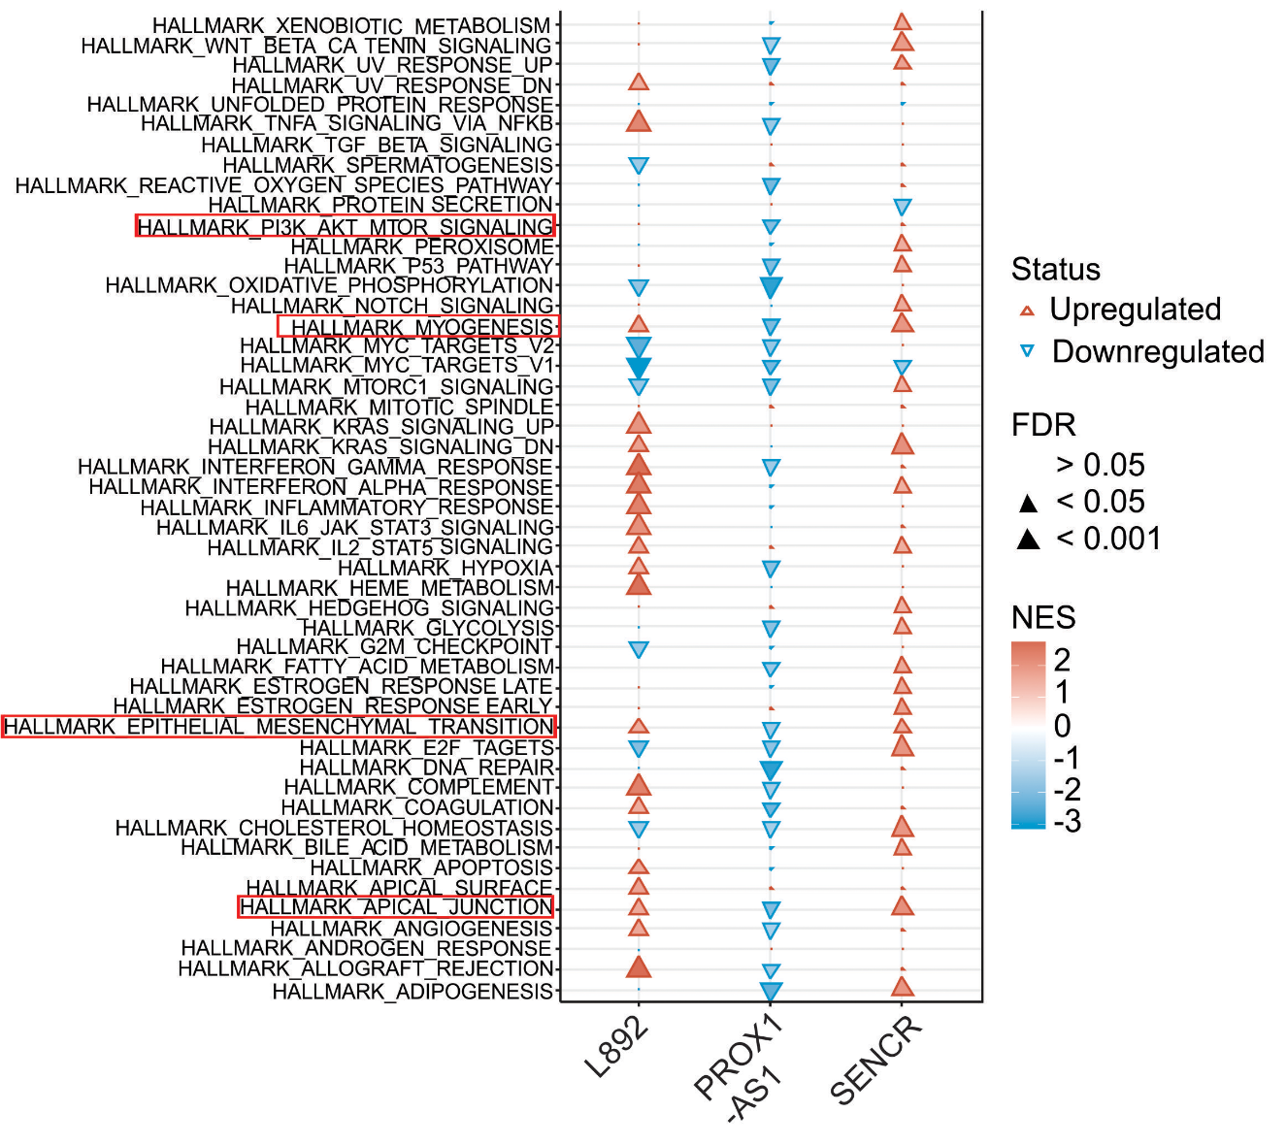
Figure S3. Pathways associated with upregulated lncRNAs. The correlation of expression between each lncRNA and other genes is used for GSEA pre-rank analysis. Hallmark gene sets are used for pathway analysis; NES stands for Normalized Enrichment Score, the higher the score, the more positive enriched in that pathway; The lower the score, the more negative enriched. FDR ≤0.05, pathways are significantly enriched; FDR > 0.05, not significantly enriched.
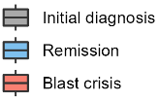
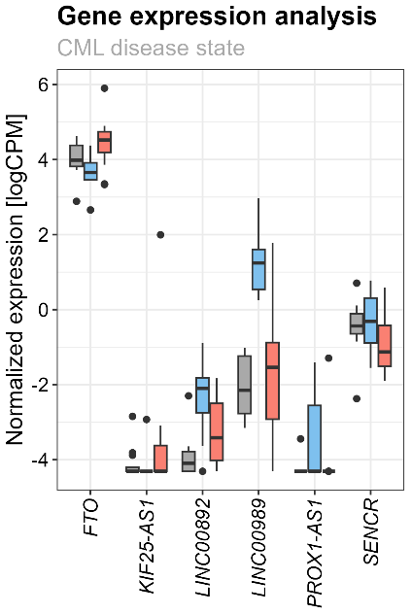
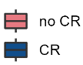
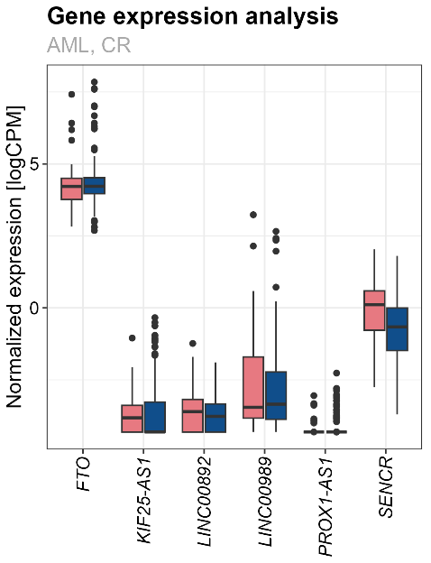
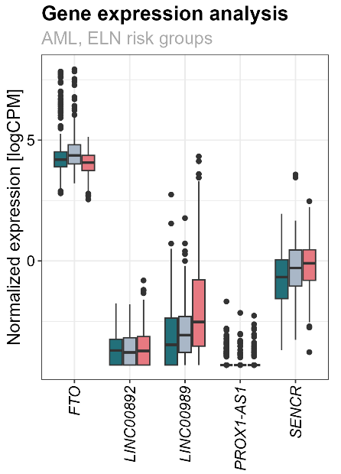
a b c
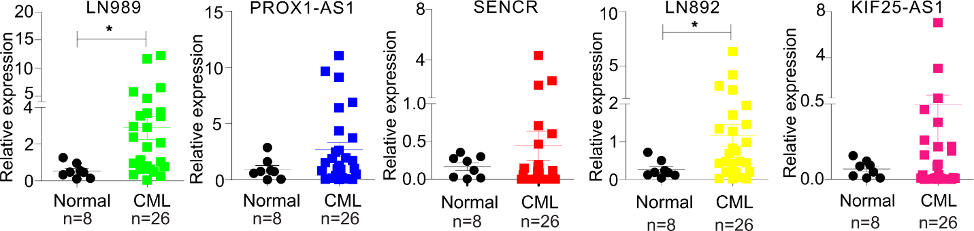
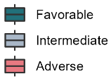
d

Figure S4. Expression of FTO and lncRNAs in AML and CML patients. a-b, Analysis of gene expression profiling in patient cells collected at diagnosis. AML patients (n = 774) were stratified according to ELN risk group (a) and the achievement of complete remission after induction therapy (b). c, Matched samples from CML patients (n = 12) were analyzed at initial diagnosis of chronic phase CML, in hematologic remission, and at progression to blast phase CML. d, qPCR for lncRNA expression in CML patients (n = 26) and normal donors (n = 8). *P < 0.05.

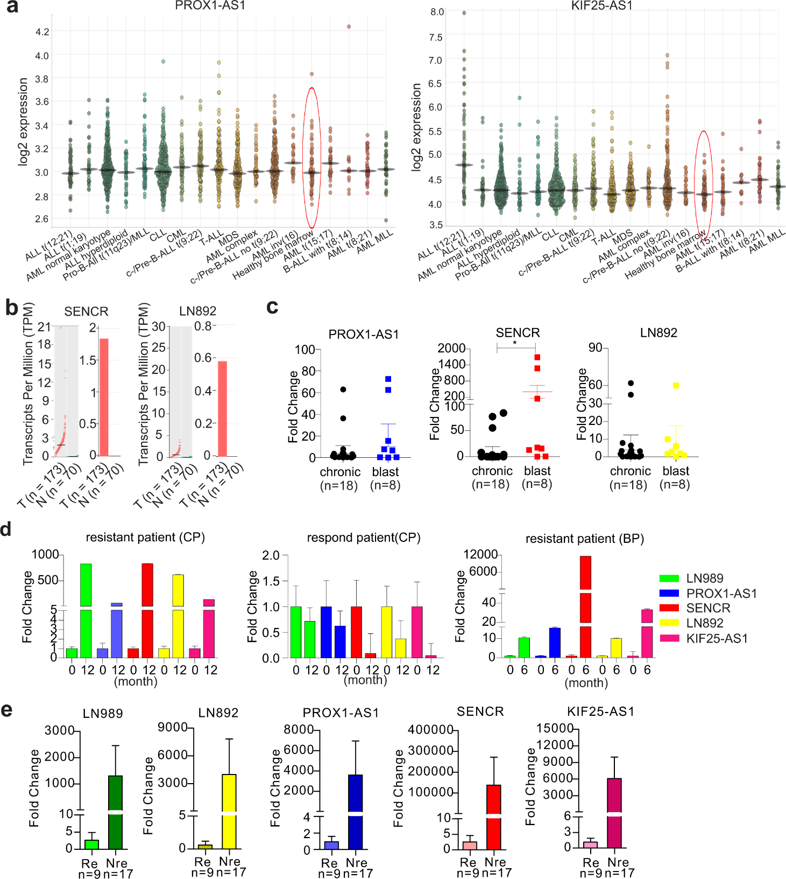

Figure S5. LncRNAs are upregulated in leukemia patients. (a,b) Public dataset analysis for the expression of indicated lncRNAs using online tools BloodSpot (Leukemia MILE Study) (a) or GEPIA (b). The images were generated by these tools. The red circles in (a) indicate lncRNA expression in normal donors. Note, in GEPIA analysis, Dot plot: The gene expression profile across all tumor samples and paired normal tissues; each dots represent expression of samples. Bar plot: The gene expression profile across all tumor samples and paired normal tissues. The height of bar represents the median expression of certain tumor type or normal tissue. (c) Expression of PROX1-AS1, SENCR and LN892 in chronic (n = 18) and blast crisis (n = 8) CML patients using ABL as an internal control. (d) Expression of lncRNAs in CML-CP patients with TKI respond and resistant respectively, and in individual CML-BP patient with TKI resistant. (e) qPCR for lncRNA expression of LN989, LN892, PROX1-AS1, SENCR and KIF25-AS1 in responder (n = 9) and inadequate responders (n = 17) CML patients using 18S as an internal control. T, tumor; N, normal; Re, responder; Nre, non-responder; CP, chronic phase; BP, blast phase.

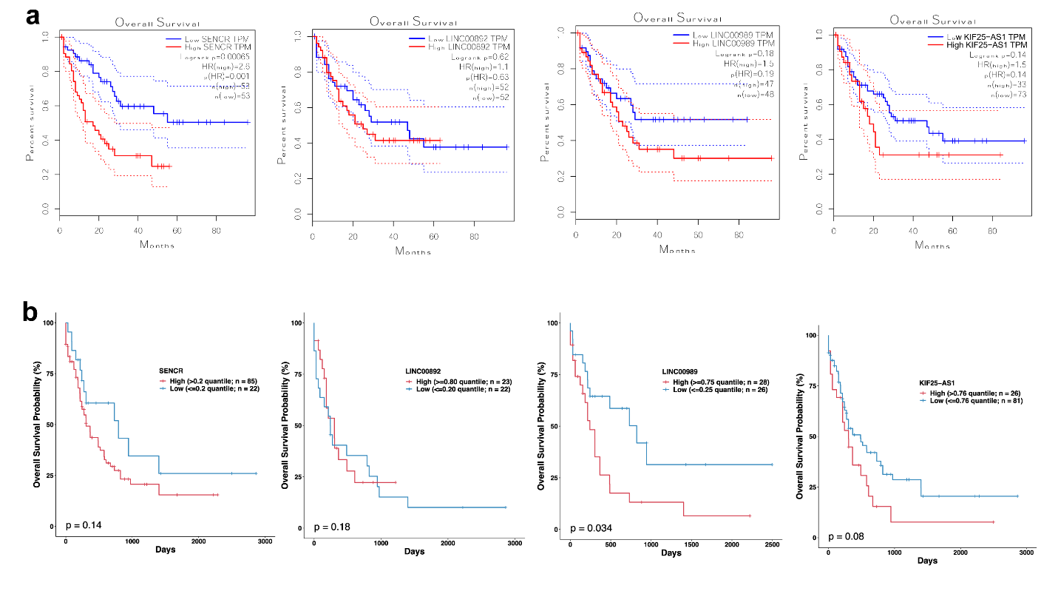
Figure S6. Upregulation of lncRNAs predicts unfavorable outcomes in AML patients. The association of lncRNA expression with overall survival (OS) in TCGA LAML (leukemia) dataset analyzed by the Kaplan–Meier estimate (n = 200). (a) The plots were made by using a database which provides LAML expression and clinical information for analysis. (b) The plots were generated by using TCGA LAML data. Log-rank test; the quantiles/percentiles were indicated in the plots.

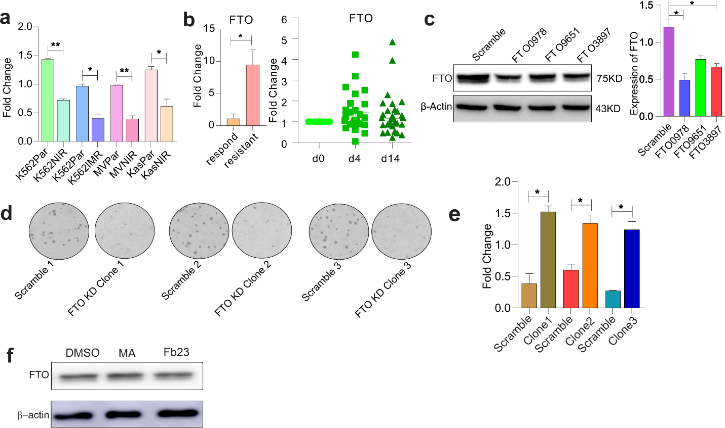
Figure S7. FTO regulates lncRNA expression. (a) Quantification of dotblotting reported in Fig. 4a. (b) qPCR for FTO expression in CML (n = 16) and AML (n = 32) patients receiving nilotinib or imatinib therapy. (c) K562 parental cells were infected by different FTO shRNA viruses and selected by 1 µg/ml puromycin for 5 days. Western blot was used to measure FTO protein expression. The figures were made by cropping the large gel or blot images. Graph shows the quantification of Western blot band intensities. (d) K562 resistant cells were infected by FTO shRNA virus TRCN0000180978 and subjected to colony-forming assays. Data represent two independent experiments with three duplicates. (e) Quantification of dotblotting reported in Fig. 4e. (f) Western blotting for FTO protein expression in K562 resistant cells treated with FTO inhibitors for 6 hours. The figures were made by cropping the large gel or blot images. Data represent 3 independent experiments. *p < 0.05, **p < 0.01.

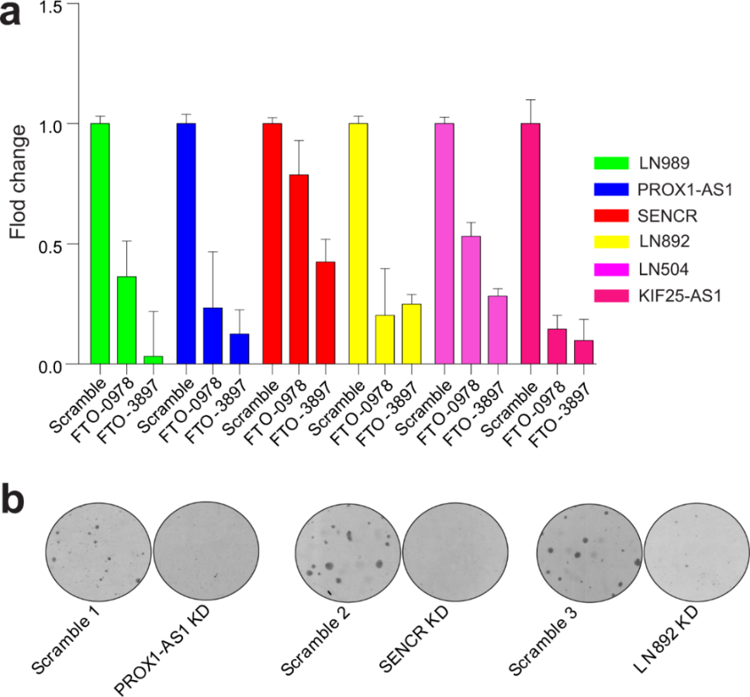

Figure S8. The effects of FTO knockdown in K562 parental cells. (a) qPCR for lncRNA expression in K562 parental cells with FTO knockdown by 2 shRNA virus infection. (b) The colony-forming assays in K562 nilotinib resistant clones with PROX1-AS1, SENCR and LN892 knockdown. In colony assays, data represent two independent experiments with four duplicates.

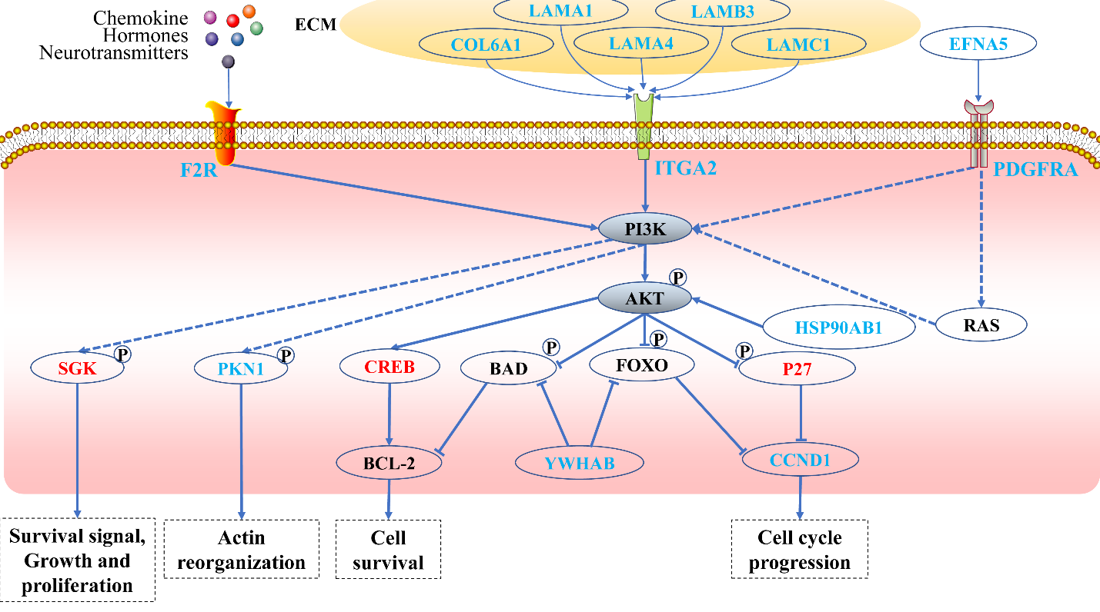
Figure S9. The PI3K pathway network. Using DAVID 6.8 for functional annotation, KEGG data for differentially expressed genes in SENCR-knockdown cells identified the PI3K as a major downstream effector pathway. Red genes are the significantly up-regulated genes in SENCR-knockdown cells, the blue genes are the significantly down-regulation genes in SENCR-knockdown cells.

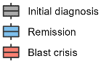
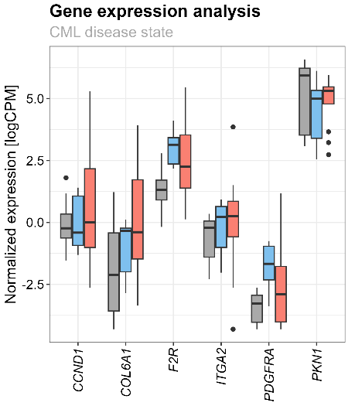
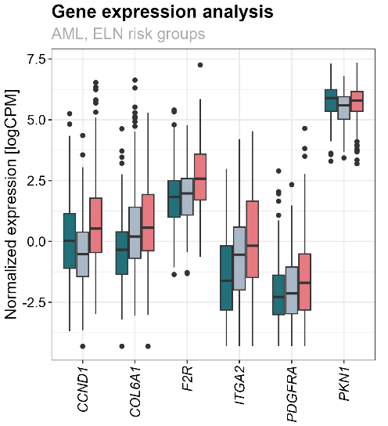
a b c
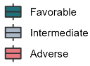
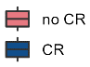
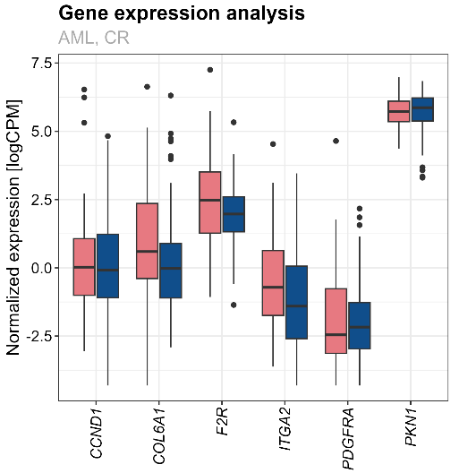
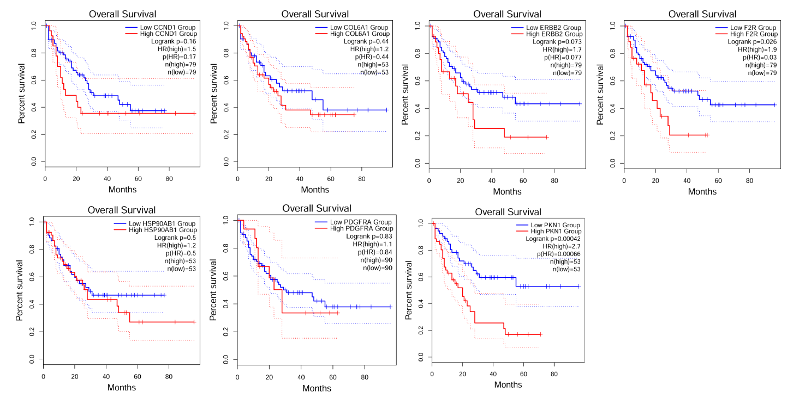
d

Figure S10. Upregulation of PI3K downstream mediators predicts unfavorable outcomes in leukemia patients at a diagnosis and after induction of TKI therapies. a-b Analysis of gene expression profiling in patient cells collected at diagnosis. AML patients (n = 774) were stratified according to ELN risk group (a) and the achievement of complete remission after induction therapy (b). c, Matched samples from CML patients (n = 12) were analyzed at initial diagnosis of chronic phase CML, in hematologic remission, and at progression to blast phase CML. d, The association between the expression of PI3K downstream mediators with overall survival (OS) in public dataset analyzed by the Kaplan–Meier estimate using online tool GEPIA.

Supplementary Table 1. Differentially expressed lncRNAs in resistant and parental K562 cells.

Supplementary Table 2. Up- and down-regulated lncRNAs that are associated with m⁶A peaks. DElncRNAs_resistance_m⁶A is a subset of DElncRNAs_resistance that overlapped lncRNAs with m⁶A peaks in resistance file); DElncRNAs_parental_m⁶A is a subset of DElncRNAs_parental that overlapped lncRNAs with m⁶A peaks in parental file.

Supplementary Table 3 Characteristics of 40 CML patients with TKI treatment
Supplementary Table 4 Up- and down-regulated genes in SENCR knockdown cells.
Supplementary Table 5 Lists of functional pathways identified by DAVID 6.8 for functional annotation. Functional pathways that involve ≥9 genes and p value <0.05 are listed.
Supplementary Table 6 Lists of antibodies used in the experiments
Supplementary Table 7 Sequence of primers used in the experiments

Supplementary Table 3 Characteristics of 40 CML patients with TKI treatment

Variables |  | Good response  (n = 15) | Inadequate response  (n = 25)
Age (years)
Median |  | 46 | 39
Range |  | 15-65 | 15-69
Sex
Female (N,%) |  | 10 (66.7% ) | 10 (40.0%)
Male (N,%) |  | 5 (33.3%) | 15 (60.0%)
Phase
Chronic phase (N,%) |  | 15 (100%) | 16 (62.5%)
Blast phase (N,%) |  | 0 (0.0%) | 9 (37.5%)
WBC (× 10⁹/L) |  | 178.0 | 210.6
PLT (× 10⁹/L) |  | 534.3 | 373.3
Hb (g/L) |  | 104.7 | 112.8
Bone marrow blasts (%) |  | 2.1 | 1.7
BCR::ABL1 transcripts
 | BCR::ABL1 e14a2 or e13/a2 (P210) transcripts (N, %) | 14 (93.3%) | 24 (96.0%)
 | BCR::ABL1 e1a2 (P190) transcripts (N, %) | 0 (0.0%) | 0 (0.0%)
BCR::ABL1 e14a2 or e13/a2 (P210) transcripts + BCR::ABL1 e1a2 (P190) transcripts (N, %) |  | 1 (6.7%) | 1 (4.0%)
Chromosome
Ph (N, %) |  | 15 (100%) | 24 (96.0%)
ACA (N, %) |  | 0 (0.0%) | 1 (4.0%)
TKIs
Imatinib (N, %) |  | 7 (46.7% ) | 4 (16.0%)
Nilotinib (N, %) |  | 3 (20.0% ) | 10 (40.0%)
Imatinib + Nilotinib (N, %) |  | 5 (33.3% ) | 11 (44.0%)
ABL mutation
T315I (N, %) |  | 0 (0.0%) | 2 (8.3%)
Others (N, %) |  | 0 (0.0%) | 2 (8.3%)

Supplementary Table 6 Antibodies used in the experiments
Antibody | Application | Company | Catalog No. | Source | Dilution
FTO | Western blot | AdipoGen | AG-20A-0064 | Mouse | 1:2000
STAT5 | Western blot | Cell Signaling | 9363 | Rabbit | 1:1000
p-STAT5 | Western blot | Cell Signaling | 9351 | Rabbit | 1:1000
KIT | Western blot | Cell Signaling | 3074 | Rabbit | 1:500
p-KIT | Western blot | Cell Signaling | 3391 | Rabbit | 1:500
FLT3 | Western blot | Cell Signaling | 3462 | Rabbit | 1:500
p-FLT3 | Western blot | Cell Signaling | 3464 | Rabbit | 1:500
BCR | Western blot | Cell Signaling | 3902 | Rabbit | 1:500
p-ABL | Western blot | Cell Signaling | 2865 | Rabbit | 1:500
WTAP | Western blot | Abcam | ab195380 | Rabbit | 1:2000
PKN1 | Western blot | Santa Cruz | Sc-393344 | Mouse | 1:1000
F2R | Western blot | Thermo Fisher | 35-2200 | Mouse | 1:1000
cyclin D1 | Western blot | abcom | Ab16663 | Rabbit | 1:1000
β-actin | Western blot | Santa Cruz | sc-47778 | Mouse | 1:1000
goat anti-rabbit IgG | Western blot | Cell Signaling | 7074S |  | 1:10000
horse anti-mouse IgG | Western blot | Cell Signaling | 7076S |  | 1:10000
rabbit anti-goat IgG | Western blot | Invitrogen | 31402 |  | 1:10000
m⁶A | Dot blot | Synaptic Systems | #202003 | Rabbit | 1:1000

Supplementary Table 7. Sequence of primers used in the experiments
 | Name |  | Oligo sequences (5’ to 3’)
qPCR | LINC00989  ( NR_038826.1) | forward | ACACCGCCAGAAATTCCCTT
qPCR | LINC00989  ( NR_038826.1) | reverse | GCCCGTAGGCTAGCTGATTC
qPCR | SENCR  (NR_038908.1) | forward | CCGTCTCTCCGCATTCTCC
qPCR | SENCR  (NR_038908.1) | reverse | TTACCTTGTCCACGCTCTCC
qPCR | PROX1-AS1  (NR_037850.2) | forward | CAAAGGGGCTCACAGGACTT
qPCR | PROX1-AS1  (NR_037850.2) | reverse | GAAAGTGCCCCTGTTGGTCT
qPCR | LINC00892  ( NR_038461.1) | forward | TCCGAGAGGCAGCTTGATTC
qPCR | LINC00892  ( NR_038461.1) | reverse | TAGCGGCAGAGCTGAGAGTA
qPCR | LINC00504 F1  ( NR_126435.1) | forward | GGGAACTCTGGCCAAGCTAA
qPCR | LINC00504 F1  ( NR_126435.1) | reverse | GCAGCCTCCAGGGTTAATCA
qPCR | KIF25-AS1  ( NR_103750.1) | forward | CGTCATCAGCCTCAAATGCC
qPCR | KIF25-AS1  ( NR_103750.1) | reverse | CACTCATCGCCACATCACCT
qPCR | LINC01270  ( NR_034124.1) | forward | CTTGTCTGCTTTTGGAGCCG
qPCR | LINC01270  ( NR_034124.1) | reverse | TGGAGAGTCTGAGACAGCGT
qPCR | MAP3K14  ( NR_024435.2 ) | forward | ACACCGCAGGTATCAGTAGC
qPCR | MAP3K14  ( NR_024435.2 ) | reverse | TGGGAGCTCTTGAGTTGGTG
qPCR | LINC00659  ( NR_046224.1) | forward | CTTGGGATCAGCCGAGCTTT
qPCR | LINC00659  ( NR_046224.1) | reverse | TTCCTTCGAGTCACTGAGATGC
qPCR | VPS9D1-AS1  ( NR_036480.1) | forward | GTCGGCTCTACCACTGTTACT
qPCR | VPS9D1-AS1  ( NR_036480.1) | reverse | AGCACGTCCTTGTCTCTGTA
qPCR | LINC00200  ( NR_015376.2) | forward | TGTGCTCCGTACATCACACC
qPCR | LINC00200  ( NR_015376.2) | reverse | GCGGAAGGTTTTCCATGCAG
qPCR | UCA1  ( NR_015379.3) | forward | ATGCACCCTAGACCCGAAAC
qPCR | UCA1  ( NR_015379.3) | reverse | CTCCGGACTGCTTCAAGTGT
qPCR | WASIR2  ( NR_130735.1) | forward | TCCGCGATGAGGACATCTCT
qPCR | WASIR2  ( NR_130735.1) | reverse | TTCCTCCTCCTTTCCCCGTA
qPCR | 18S  ( M10098.1) | forward | ACAGGATTGACAGATTGA
qPCR | 18S  ( M10098.1) | reverse | TATCGGAATTAACCAGACA
qPCR | FTO  (NM_001363894.1 ) | forward | TTCACCAGCATAGTATAGTT
qPCR | FTO  (NM_001363894.1 ) | reverse | AGTCTCCAATGTCATCAG
qPCR | GAPDH  (NM_002046.4) | forward | CTCTGCTCCTCCTGTTCGAC
qPCR | GAPDH  (NM_002046.4) | reverse | GCCCAATACGACCAAATCC
qPCR | ABL  (NM_X16416) | forward | GGTACTCCATGGCTGACGAGAT
qPCR | ABL  (NM_X16416) | reverse | GAGTTCATGACCTACGGGAACCT
qPCR | CyclinD1  ( NM_053056.3) | forward | ATCAAGTGTGACCCGGACTG
qPCR | CyclinD1  ( NM_053056.3) | reverse | CTTGGGGTCCATGTTCTGCT
qPCR | ITGA2  ( NM_002203.4) | forward | CAACATGAGCCTCGGCTTGA
qPCR | ITGA2  ( NM_002203.4) | reverse | CACAGAGGACCACATGTGAGAA
qPCR | COL6A1  ( NM_001848.3) | forward | CATCAGCCAGACCATCGACA
qPCR | COL6A1  ( NM_001848.3) | reverse | ATTCGAAGGAGCAGCACACT
qPCR | PDGFRA  ( NM_006206.6) | forward | TGCGGAATAACATCGGAGGA
qPCR | PDGFRA  ( NM_006206.6) | reverse | GATTAGGCTCAGCCCTGTGA
qPCR | PKN1  ( NM_213560.3) | forward | GAGCAGGAGCTGGAGAGTG
qPCR | PKN1  ( NM_213560.3) | reverse | GCTGCTGCTGTACCCCG
qPCR | F2R  ( NM_001992.5) | forward | CCCGCAGGCCAGAATCAAAA
qPCR | F2R  ( NM_001992.5) | reverse | TCATTGGGGTTCCTGAGAAGAA
qPCR | HSP90AB1  ( NM_001271969.1) | forward | CCACTTGGCAGTCAAGCACT
qPCR | HSP90AB1  ( NM_001271969.1) | reverse | GGAGCCCGACGAGGAATAAA
Cloning | SENCR16 |  | GTTTAAGCAGTGTGGAGATAT
Cloning | SENCR785 |  | CAGAGGAGATCCAAGTCAATT
Cloning | SENCR1238 |  | CCCACTGGAATTATTCAATAT
Cloning | PROX1-AS1-7 |  | GAGGCTGGGAGCAGAAATAAT
Cloning | PROX1-AS1-3299 |  | CAGCAGATTTACGGCAAATAT
Cloning | PROX1-AS1-1277 |  | CAGCAGCTGTCGTGCTAATAA
Cloning | LN892-370 |  | CTCAGCACCTGGCTCACATTA
Cloning | LN892-619 |  | GGGTGTATAACACACATAATT
Cloning | LN892-576 |  | CTTTGCATTGAACACTTTAAA

