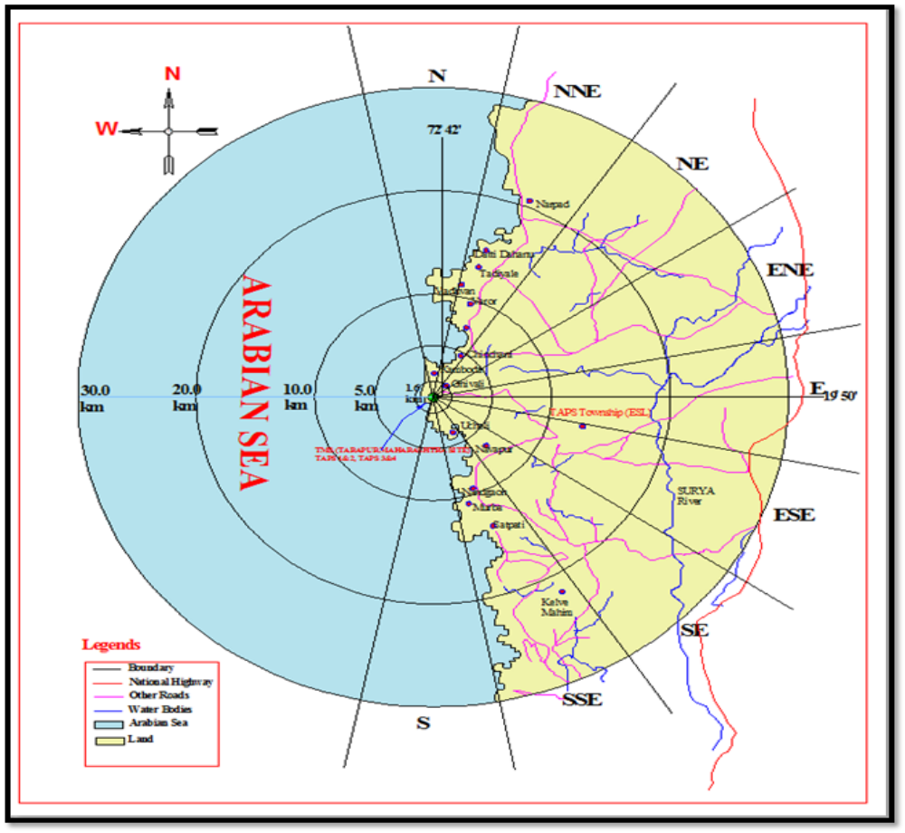
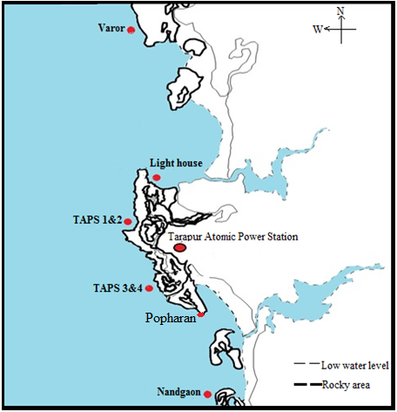
S Fig. 1 Study area
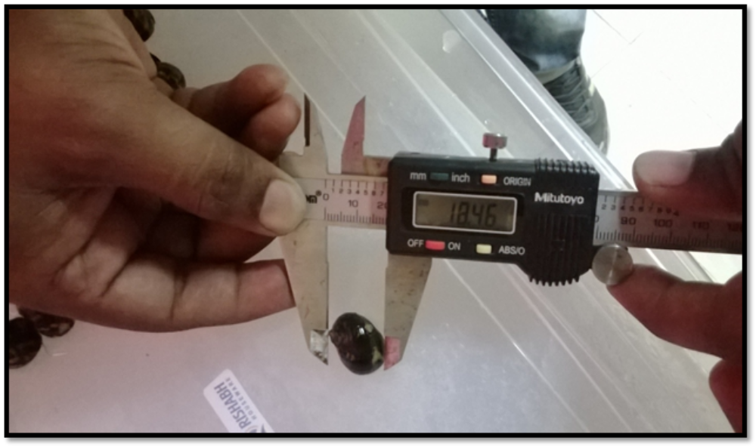
(Study animal of Nerita oryzarum)
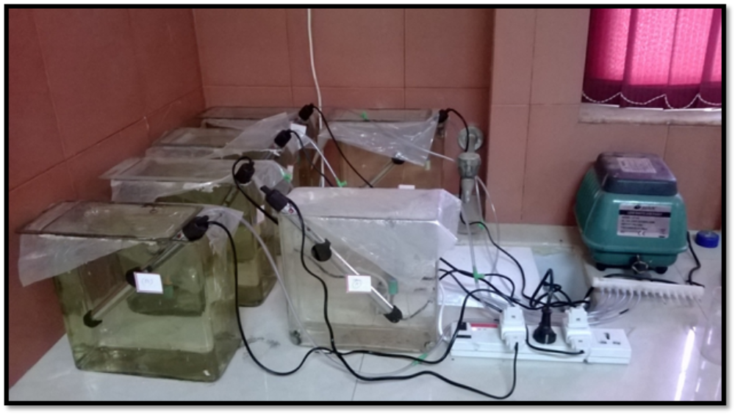
S Fig.2 Experimental set-up of diiferent temperature

S Table 1: GPS positioning and importance of sampling locations with location code
Sampling location / code | GPS position | Importance of location
TAPS 1 & 2  (NW-I) | N -19⁰50.003’  E -72⁰39.139’ | Intertidal area near to intake channel (Northside)
Lighthouse  (NW-II) | N -19⁰50’32.1”  E -72⁰39’21.6” | Intertidal area at the discharge channel of TAPS 1 & 2 (Northside)
Varror  (NW-III) | N -19⁰54’32.4”  E -72⁰40’35.6” | Reference location, at the distance of 8.00 km from the discharge channel of TAPS 1&2 (Northside)
TAPS 3 & 4  (SW-I) | N -19⁰49.533’  E -72⁰39.557’ | Intertidal area near to intake channel (Southside)
Popharan  (SW-II) | N – 19⁰50.638”  E – 72⁰40.651” | Intertidal area at the discharge channel of TAPS 3 & 4 (Southside)
Nandgaon  (SW-III) | N -19⁰45’09.0”  E -72⁰41’19.2” | Reference location, at the distance of 8.00 km from the discharge channel of TAPS 3& 4 (Southside)

S Table 2: Levels of different antioxidant enzyme activity at different locations during different seasons
Season /  Locations | N I | N II |  | N III |  | S I | S II | S III
Lipid peroxidation (LPO)
Monsoon | 1.06 ± 0.02^{c} | 1.57 ± 0.14^{d} |  | 0.88 ± 0.04^{d} |  | 1.12 ± 0.16^{c} | 1.11 ± 0.14^{b} | 0.89 ± 0.05^{d}
Postmonsoon | 0.42 ± 0.03ª | 0.47 ± 0.05ª |  | 0.34 ± 0.10ª |  | 0.41 ± 0.08ª | 0.89 ± 0.06^{a,b} | 0.20 ± 0.03ª
Premonsoon | 1.03 ± 0.02^{c} | 1.04 ± 0.12^{c} |  | 0.78 ± 0.07^{c,d} |  | 0.91 ± 0.05^{b,c} | 1.88 ± 0.12^{c} | 0.87 ± 0.05^{c,d}
Catalase (CAT)
Monsoon | 0.4 ± 0.12ª | 0.52 ± 0.11^{a,b} |  | 0.33 ± 0.09^{b,c} |  | 0.52 ± 0.11^{a,b} | 0.60 ± 0.06ª | 0.25 ± 0.11^{a,b}
Post-monsoon | 0.46 ± 0.12ª | 0.54 ± 0.12^{a,b} |  | 0.17 ± 0.08^{a,b} |  | 0.36 ± 0.1ª | 0.50 ± 0.11ª | 0.08 ± 0.003ª
Pre-monsoon | 0.79 ± 0.08^{b} | 0.65 ± 0.02^{b} |  | 0.49 ± 0.08^{c} |  | 0.65 ± 0.05^{b} | 1.52 ± 0.14^{c} | 0.71 ± 0.07^{c}
Superoxide Dismutase (SOD)
Monsoon | 8.14 ± 0.48^{c} | 10.2 ± 0.73^{c} |  | 4.16 ± 0.38ª |  | 12.23 ± 0.7^{d} | 16.71 ± 0.57^{d} | 6.18 ± 0.6^{a,b,c}
Postmonsoon | 0.46 ± 0.58ª | 4.87 ± 0.32ª |  | 3.49 ± 0.3ª |  | 5.52 ± 0.38^{a,b} | 10.92 ± 0.52^{b,c} | 4.68 ± 0.25ª
Premonsoon | 10.24 ± 0.43^{d} | 9.14 ± 0.76^{c} |  | 5.47 ± 0.38^{b} |  | 11.3 ± 0.28^{d} | 22.57 ± 0.89e | 7.41 ± 0.71^{c}
Glutathione peroxidase (GPx)
Monsoon | 1.08 ± 0.06^{d} | 1.39 ± 0.1^{c} |  | 1 ± 0.1^{c,d} |  | 1.26 ± 0.13^{c} | 1.17 ± 0.13^{b} | 1.1 ± 0.1^{c}
Post-monsoon | 0.51 ± 0.1^{a,b} | 0.46 ± 0.1ª |  | 0.54 ± 0.04^{a,b} |  | 0.62 ± 0.1ª | 0.72 ± 0.1ª | 0.34 ± 0.03ª
Pre-monsoon | 1.1 ± 0.2^{d} | 1.02 ± 0.13^{b} |  | 1.1 ± 0.1^{d} |  | 1.15 ± 0.2^{c} | 1.98 ± 0.2^{c} | 0.69 ± 0.1^{b}
Glutathione-S- transferase (GST)
Monsoon | 14.44 ± 0.48^{c} |  | 12.89 ± 0.43^{b} |  | 12.12 ± 0.4^{a,b} | 14.24 ± 0.33^{c} | 14.75 ± 0.4^{a,b} | 13.7 ± 0.53^{c,d}
Post-monsoon | 12.31 ± 0.41ª |  | 10.92 ± 0.35ª |  | 11.33± 0.5ª | 11.81 ± 0.6ª | 13.23 ± 0.4ª | 10.52 ± 0.4ª
Pre-monsoon | 14.18 ± 0.25^{b,c} |  | 13.89 ± 0.43^{b,c} |  | 13.1 ± 0.4^{b,c} | 13.1 ± 0.6^{a,b,c} | 17.22 ± 0.63^{c} | 12.89 ± 0.47^{b,c}

