Sildenafil Promotes Osteogenic Differentiation of Human Mesenchymal Stem Cells and Inhibits Bone Loss by Affecting the TGF-β Signaling Pathway
Supplementary Material

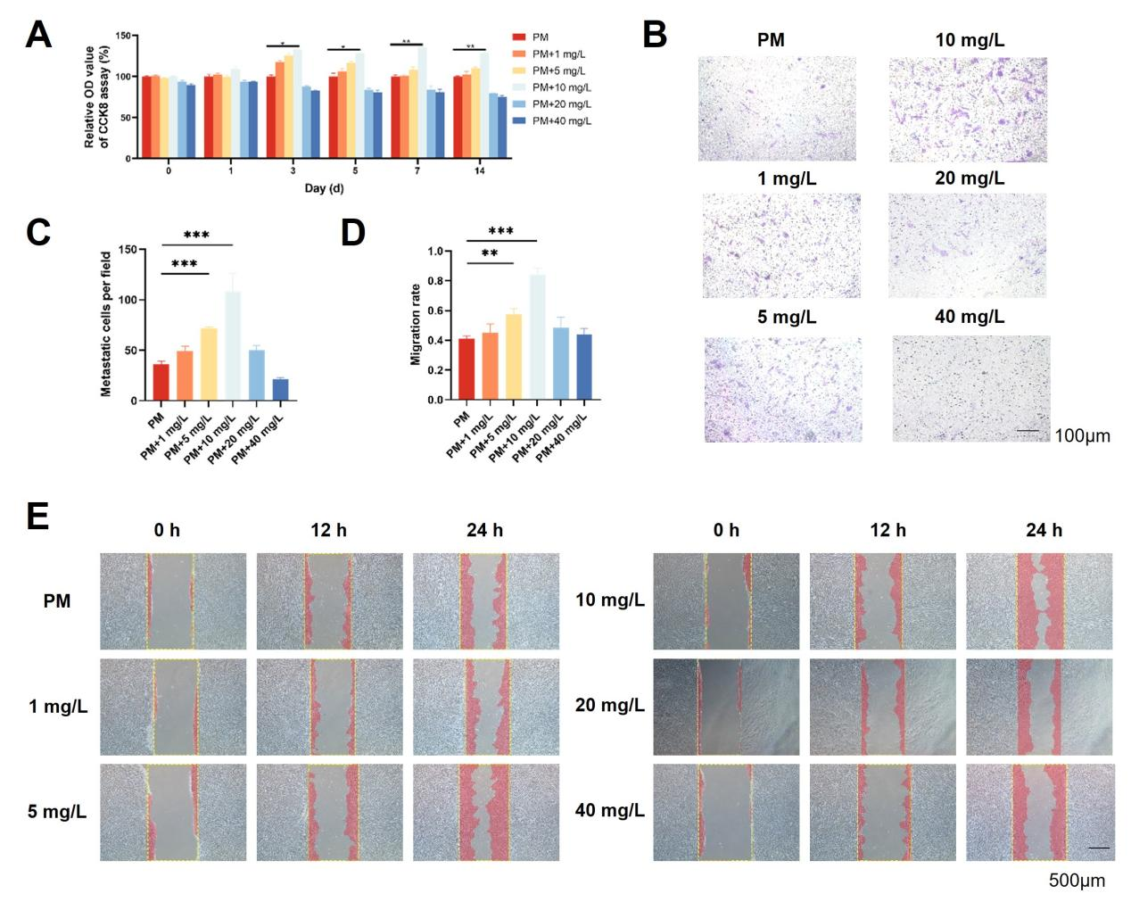
Figure. S1. Low concentrations of sildenafil enhanced the proliferation and migration of hASCs in vitro. A. hASCs growth curve derived using the CCK-8 assay; B, C. The transwell assay was employed to investigate how sildenafil at different concentrations affected hASCs migration; D, E. The morphologies and quantitative analyses of the scratch assay migration areas used to explore the effects of sildenafil at different concentrations on hASCs migration.
The data are means ± standard deviations. *p < 0.05, **p < 0.01, and ***p < 0.001 compared to the PM group. N ≥ 3. Transwell assay image [scale bar]: 100 μm. Scratch assay image [scale bar]: 500 μm. hASCs, human adipose-derived mesenchymal stem cells.

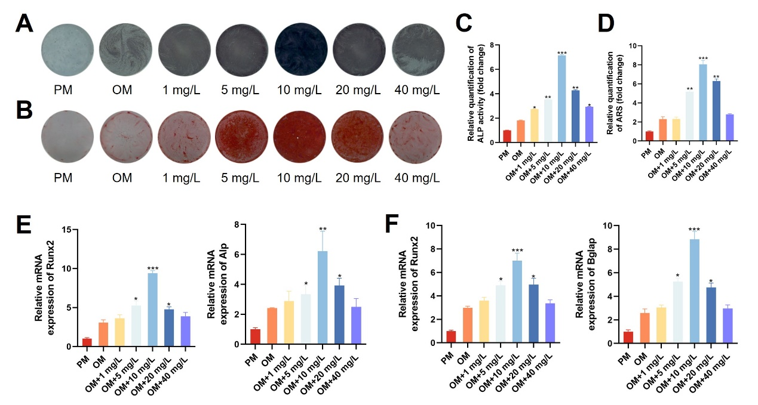

Figure. S2. Low concentrations of sildenafil enhanced osteogenic differentiation of hASCs in vitro. A. ALP staining revealing the effects of sildenafil at different concentrations on the osteogenic differentiation of hASCs; B. ARS staining revealing the effects of sildenafil at different concentrations on the osteogenic differentiation of hASCs; C. Quantification of ALP staining; D. Quantification of ARS staining; E. The relative levels of mRNAs encoding RUNX2 and ALP in hASCs as revealed by qRT-PCR after 7 days of osteogenic induction; F. The relative levels of mRNAs encoding RUNX2 and BGLAP in hASCs after 14 days of osteogenic induction.
The data are means ± standard deviations. *p < 0.05, **p < 0.01, and ***p < 0.001 compared to the OM group. hASCs, human adipose-derived mesenchymal stem cells; ALP, alkaline phosphatase; ARS, alizarin red S; RUNX2, runt-related transcription factor 2; BGLAP, bone gamma-carboxyglutamate protein; qRT-PCR, quantitative real-time reverse transcription polymerase chain reaction; OM, osteogenic medium.

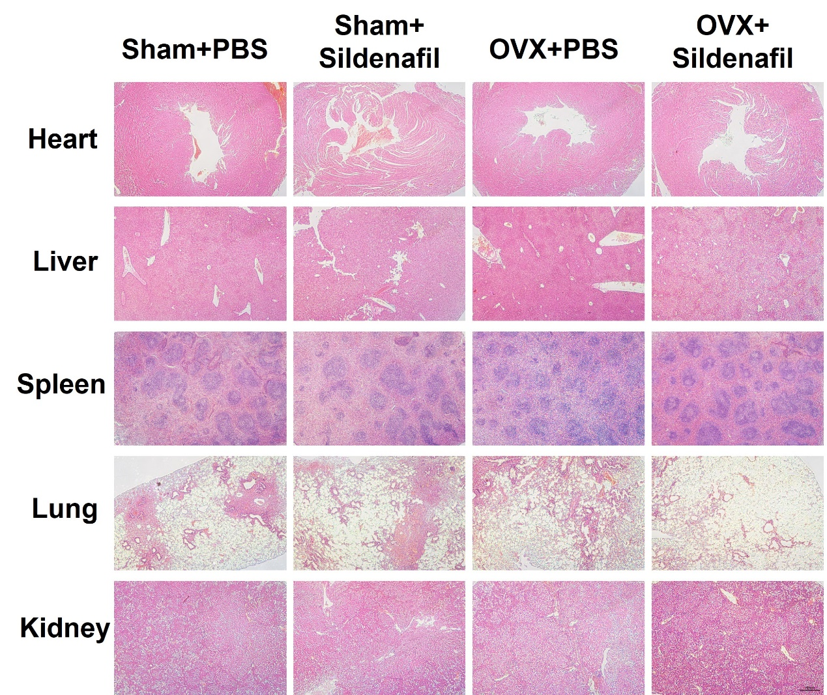
Figure. S3. No toxicity was apparent in the viscera of OVX mice injected with sildenafil. H&E staining of heart, liver, spleen, lung, and kidney tissues of OVX mice. H&E staining image [scale bar]: 500 μm. OVX, ovariectomized; H&E, hematoxylin and eosin.

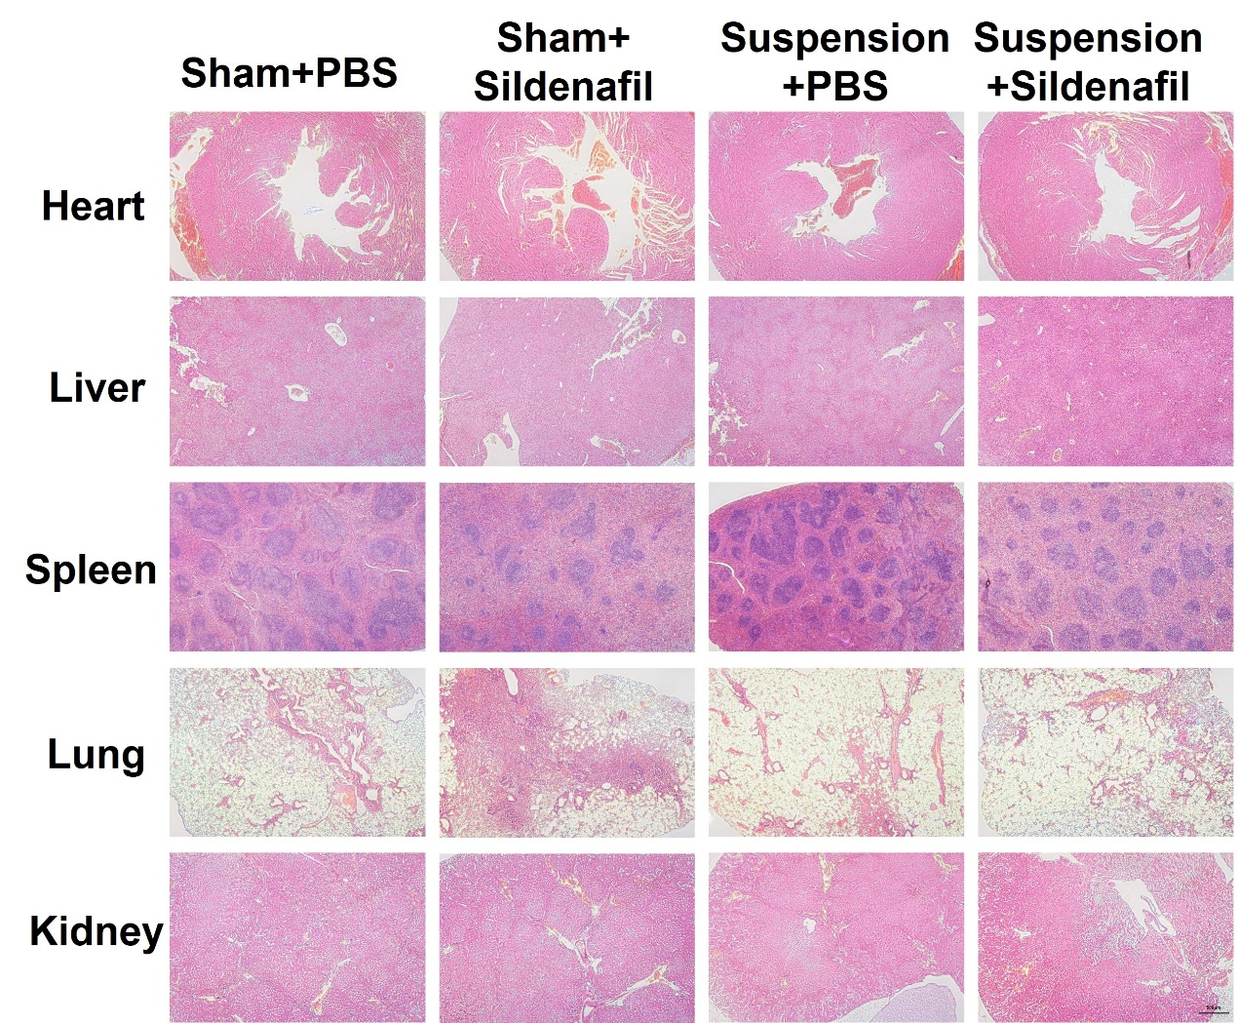
Figure. S4. No toxicity was apparent in the viscera of TS mice injected with sildenafil. H&E staining of heart, liver, spleen, lung, and kidney tissues of TS mice. H&E staining image [scale bar]: 500 μm. TS, tail-suspended; H&E, hematoxylin and eosin.

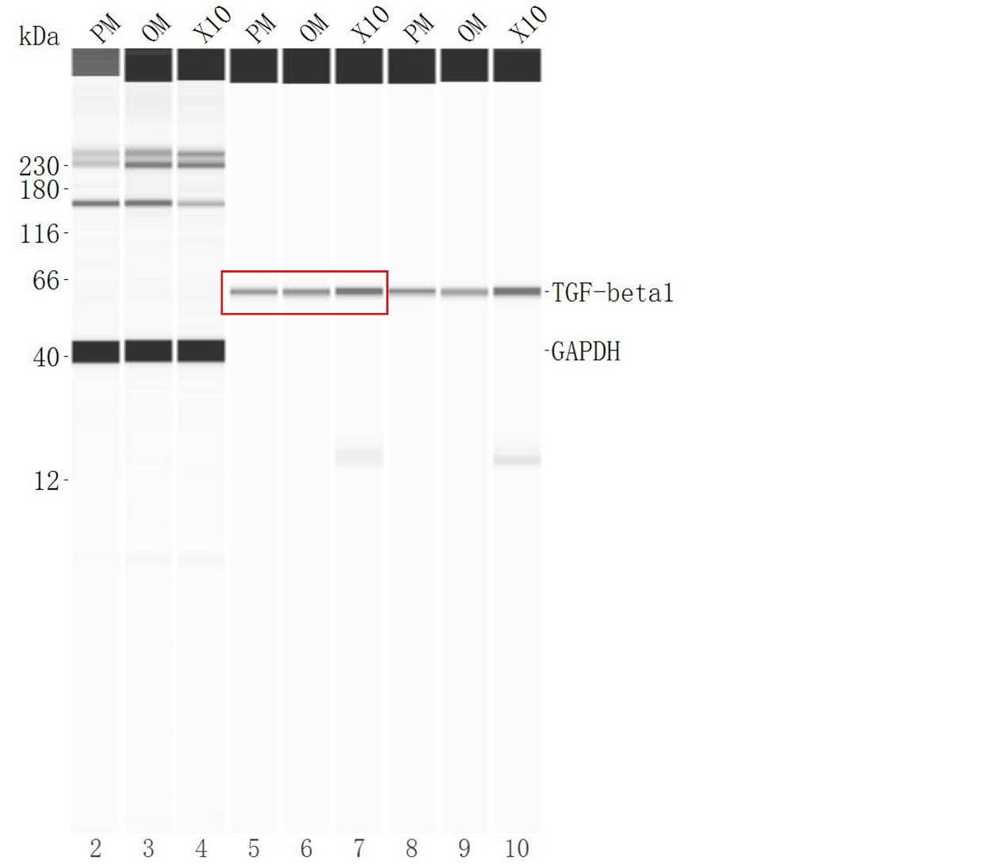
Figure. S5. Full-length blots of TGF-β1. The cropped regions in the original image are highlighted with red boxes. TGF-β1, transforming growth factor-β1.

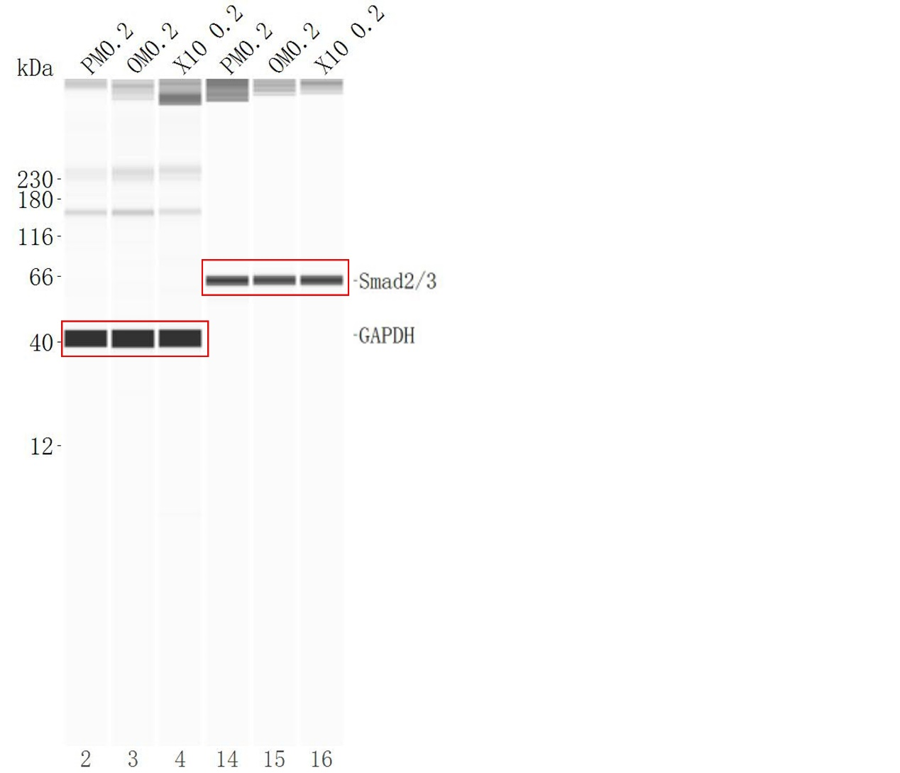
Figure. S6. Full-length blots of Smad2/3. The cropped regions in the original image are highlighted with red boxes.

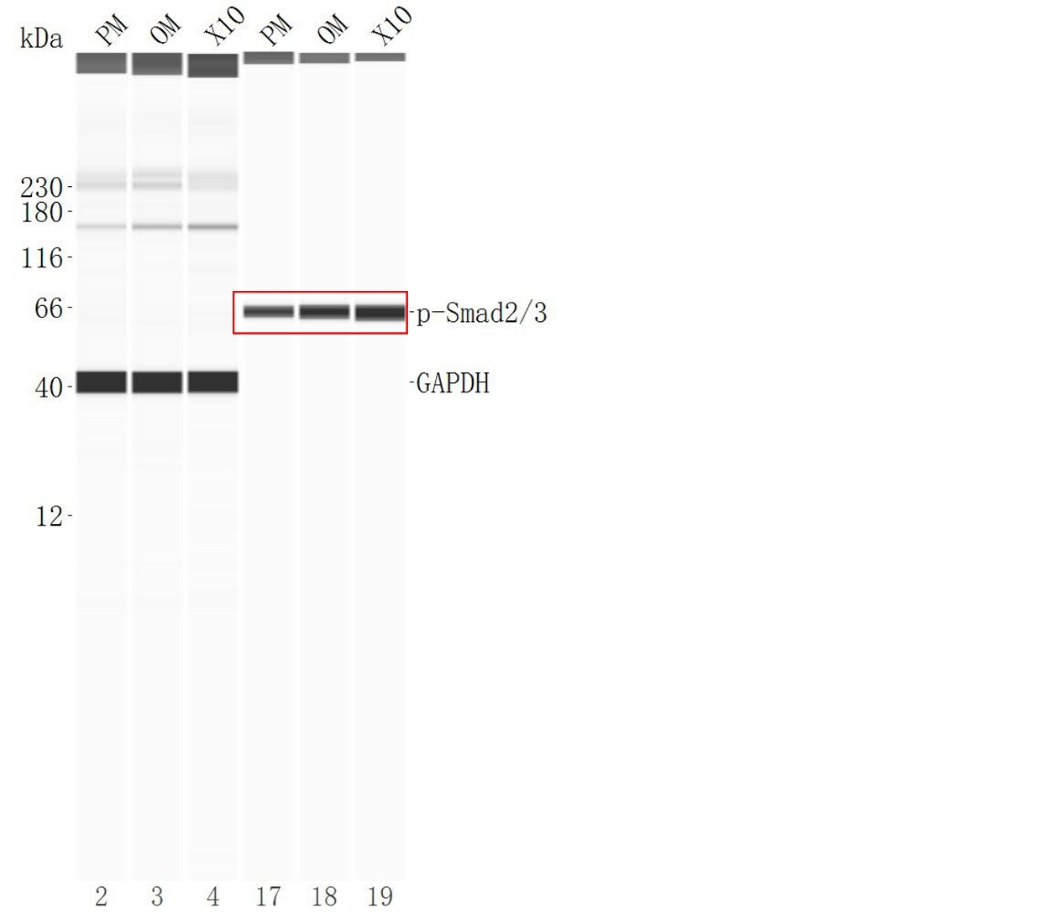
Figure. S7. Full-length blots of p-Smad2/3. The cropped regions in the original image are highlighted with red boxes.

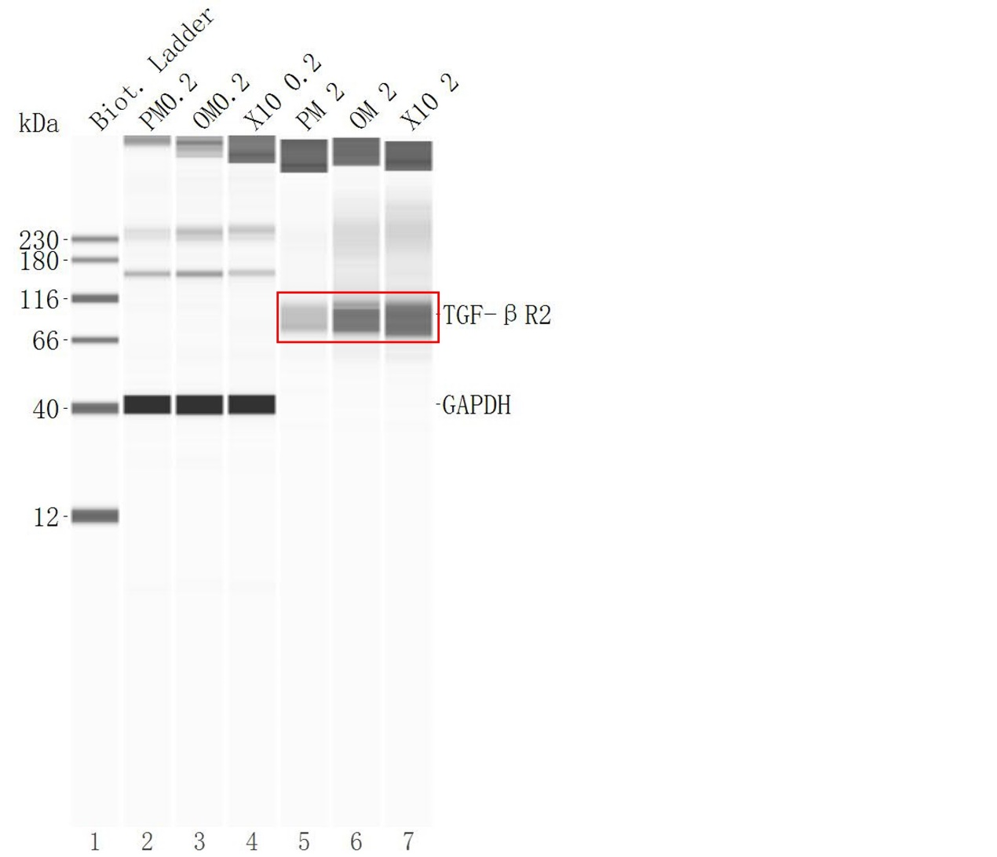
Figure. S8. Full-length blots of TGF-βR2. The cropped regions in the original image are highlighted with red boxes. TGF-βR2, transforming growth factor-β type ⅠⅠ receptor.

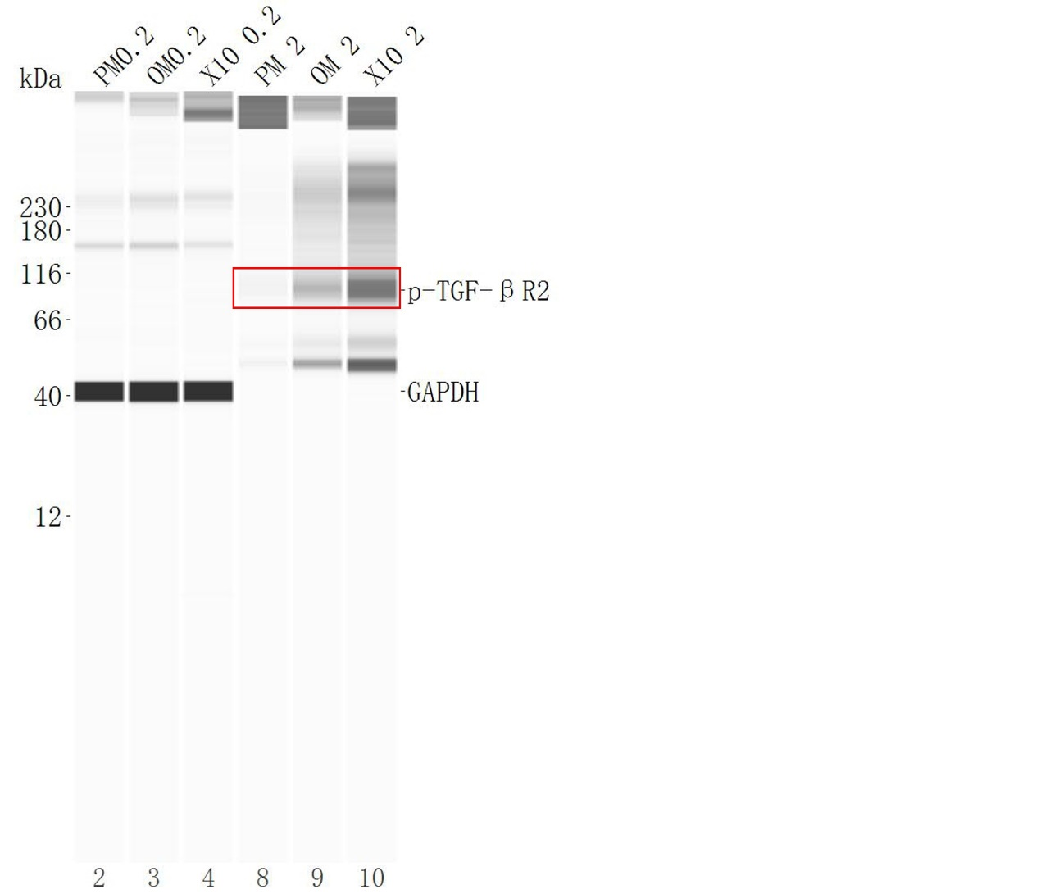
Figure. S9. Full-length blots of p-TGF-βR2. The cropped regions in the original image are highlighted with red boxes. p-TGF-βR2, phospho- transforming growth factor-β type ⅠⅠ receptor.

