Table S1 Response surface design test protocol and results
No. | A: ethanol  concentration  (%) | B: extraction time  (min) | C: liquid-material ratio  (mL/g) | D: extraction times | Y₁: Yields of  coptisine  (mg) | Y₂: Yields of corydaline (mg) | Y₃: Yields of berberine  (mg) | Y₄: Yields of palmatine  (mg) | Y₅: Yields of berberine chloride  (mg) | Y₆: Yields of dehydrocorydaline  (mg)
1 | 70 | 50 | 40 | 3 | 1.4759 | 0.2915 | 0.7727 | 0.7846 | 0.0992 | 3.4060
2 | 70 | 50 | 50 | 2 | 1.6699 | 0.4406 | 0.8111 | 1.1648 | 0.1267 | 4.0069
3 | 60 | 60 | 50 | 2 | 1.4213 | 0.3959 | 0.7776 | 0.8866 | 0.1007 | 3.1333
4 | 80 | 40 | 50 | 2 | 1.0920 | 0.2876 | 0.6094 | 0.7719 | 0.0736 | 2.7012
5 | 70 | 60 | 40 | 2 | 1.4123 | 0.3913 | 0.7936 | 0.8274 | 0.0977 | 3.5606
6 | 70 | 40 | 50 | 3 | 1.4383 | 0.3267 | 0.7789 | 0.8770 | 0.0934 | 3.5540
7 | 70 | 40 | 40 | 2 | 1.3739 | 0.3083 | 0.7608 | 0.8704 | 0.0900 | 3.3283
8 | 70 | 50 | 50 | 2 | 1.7103 | 0.4150 | 0.9358 | 1.1657 | 0.1250 | 3.8057
9 | 70 | 50 | 50 | 2 | 1.6065 | 0.4083 | 0.8022 | 0.9987 | 0.1770 | 3.6540
10 | 80 | 60 | 50 | 2 | 1.3200 | 0.3101 | 0.6959 | 0.8873 | 0.0877 | 3.0454
11 | 70 | 60 | 50 | 3 | 1.4983 | 0.3164 | 0.7217 | 0.8955 | 0.0923 | 3.5221
12 | 70 | 50 | 40 | 1 | 0.8965 | 0.1874 | 0.5004 | 0.6522 | 0.0624 | 2.2554
13 | 80 | 50 | 50 | 1 | 0.9089 | 0.2338 | 0.4914 | 0.6355 | 0.0648 | 2.2202
14 | 70 | 60 | 50 | 1 | 1.0623 | 0.2416 | 0.6287 | 0.7995 | 0.0847 | 2.8270
15 | 80 | 50 | 50 | 3 | 1.4910 | 0.3643 | 0.7836 | 0.8579 | 0.1003 | 3.0356
16 | 70 | 50 | 60 | 1 | 0.9900 | 0.2279 | 0.5643 | 0.7228 | 0.0670 | 2.5783
17 | 60 | 40 | 50 | 2 | 1.2906 | 0.3440 | 0.6853 | 0.7820 | 0.0862 | 3.2463
18 | 80 | 50 | 60 | 2 | 1.3840 | 0.3368 | 0.7465 | 0.9383 | 0.0862 | 3.2269
19 | 70 | 50 | 50 | 2 | 1.6451 | 0.4115 | 0.8113 | 1.0121 | 0.1239 | 3.9768
20 | 60 | 50 | 50 | 3 | 1.4419 | 0.3536 | 0.7314 | 0.7941 | 0.0994 | 3.2471
21 | 70 | 40 | 60 | 2 | 0.9448 | 0.2588 | 0.4455 | 0.4697 | 0.0938 | 2.0413
22 | 70 | 50 | 60 | 3 | 1.3555 | 0.3588 | 0.7074 | 0.7675 | 0.0900 | 3.1183
23 | 60 | 50 | 50 | 1 | 1.1661 | 0.3042 | 0.6175 | 0.6801 | 0.0887 | 2.8200
24 | 70 | 60 | 60 | 2 | 1.1122 | 0.2684 | 0.6274 | 0.6701 | 0.0695 | 2.7103
25 | 70 | 40 | 50 | 1 | 1.1459 | 0.3446 | 0.5997 | 0.6483 | 0.0849 | 2.7065
26 | 60 | 50 | 60 | 2 | 1.4333 | 0.3664 | 0.7854 | 0.8304 | 0.0964 | 3.4449
27 | 60 | 50 | 40 | 2 | 1.2227 | 0.3809 | 0.6627 | 0.6935 | 0.0872 | 3.3564
28 | 80 | 50 | 40 | 2 | 1.0934 | 0.2629 | 0.5857 | 0.7404 | 0.0561 | 2.6974
29 | 70 | 50 | 50 | 2 | 1.5778 | 0.4000 | 0.8765 | 1.0867 | 0.1119 | 3.5965

Table S2 Results of analysis of variance of coptisine response surface multiple regression model
Source | Sum of Squares | df | Mean Square | F-value | P-value
Model | 1.31 | 14 | 0.0939 | 5.40 | 0.0016**
A-ethanol concentration | 0.0393 | 1 | 0.0393 | 2.26 | 0.1549
B- extraction time ratio | 0.0244 | 1 | 0.0244 | 1.40 | 0.2560
C- liquid-material | 0.0054 | 1 | 0.0054 | 0.3115 | 0.5856
D- extraction times | 0.5339 | 1 | 0.5339 | 30.72 | < 0.0001**
AB | 0.0024 | 1 | 0.0024 | 0.1362 | 0.7176
AC | 0.0016 | 1 | 0.0016 | 0.0921 | 0.7660
AD | 0.0235 | 1 | 0.0235 | 1.35 | 0.2648
BC | 0.0042 | 1 | 0.0042 | 0.2394 | 0.6322
BD | 0.0052 | 1 | 0.0052 | 0.2966 | 0.5946
CD | 0.0114 | 1 | 0.0114 | 0.6581 | 0.4308
A² | 0.1694 | 1 | 0.1694 | 9.75 | 0.0075**
B² | 0.2120 | 1 | 0.2120 | 12.20 | 0.0036**
C² | 0.3520 | 1 | 0.3520 | 20.25 | 0.0005**
D² | 0.2886 | 1 | 0.2886 | 16.60 | 0.0011**
Residual | 0.2433 | 14 | 0.0174
Lack of Fit | 0.2325 | 10 | 0.0232 | 8.58 | 0.0264
Pure Error | 0.0108 | 4 | 0.0027

Table S3 Results of analysis of variance of corydaline response surface multiple regression model
Source | Sum of Squares | df | Mean Square | F-value | P-value
Model | 0.0924 | 14 | 0.0066 | 3.57 | 0.0117*
A-ethanol concentration | 0.0102 | 1 | 0.0102 | 5.50 | 0.0342*
B- extraction time | 0.0002 | 1 | 0.0002 | 0.1299 | 0.7239
C- liquid-material ratio | 2.253E-06 | 1 | 2.253E-06 | 0.0012 | 0.9727
D- extraction times | 0.0185 | 1 | 0.0185 | 10.03 | 0.0069**
AB | 0.0002 | 1 | 0.0002 | 0.1168 | 0.7376
AC | 0.0020 | 1 | 0.0020 | 1.06 | 0.3215
AD | 0.0016 | 1 | 0.0016 | 0.8889 | 0.3618
BC | 0.0013 | 1 | 0.0013 | 0.7281 | 0.4079
BD | 0.0021 | 1 | 0.0021 | 1.16 | 0.2994
CD | 0.0002 | 1 | 0.0002 | 0.0971 | 0.7600
A² | 0.0044 | 1 | 0.0044 | 2.35 | 0.1473
B² | 0.0127 | 1 | 0.0127 | 6.87 | 0.0202*
C² | 0.0262 | 1 | 0.0262 | 14.16 | 0.0021**
D² | 0.0361 | 1 | 0.0361 | 19.52 | 0.0006**
Residual | 0.0259 | 14 | 0.0018
Lack of Fit | 0.0250 | 10 | 0.0025 | 10.65 | 0.0178
Pure Error | 0.0009 | 4 | 0.0002

Table S4 Results of analysis of variance of berberine response surface multiple regression model
Source | Sum of Squares | df | Mean Square | F-value | P-value
Model | 0.2812 | 14 | 0.0201 | 2.67 | 0.0382*
A-ethanol concentration | 0.0101 | 1 | 0.0101 | 1.34 | 0.2669
B- extraction time | 0.0111 | 1 | 0.0111 | 1.48 | 0.2441
C- liquid-material ratio | 0.0033 | 1 | 0.0033 | 0.4406 | 0.5176
D- extraction times | 0.0997 | 1 | 0.0997 | 13.25 | 0.0027**
AB | 8.410E-06 | 1 | 8.410E-06 | 0.0011 | 0.9738
AC | 0.0004 | 1 | 0.0004 | 0.0483 | 0.8293
AD | 0.0079 | 1 | 0.0079 | 1.06 | 0.3214
BC | 0.0056 | 1 | 0.0056 | 0.7390 | 0.4045
BD | 0.0019 | 1 | 0.0019 | 0.2470 | 0.6269
CD | 0.0042 | 1 | 0.0042 | 0.5549 | 0.4686
A² | 0.0335 | 1 | 0.0335 | 4.45 | 0.0533
B² | 0.0393 | 1 | 0.0393 | 5.23 | 0.0383*
C² | 0.0640 | 1 | 0.0640 | 8.52 | 0.0112*
D² | 0.0732 | 1 | 0.0732 | 9.73 | 0.0075**
Residual | 0.1053 | 14 | 0.0075
Lack of Fit | 0.0920 | 10 | 0.0092 | 2.76 | 0.1700
Pure Error | 0.0133 | 4 | 0.0033

Table S5 Results of analysis of variance of palmatine response surface multiple regression model
Source | Sum of Squares | df | Mean Square | F-value | P-value
Model | 0.5472 | 14 | 0.0391 | 3.34 | 0.0155*
A-ethanol concentration | 0.0023 | 1 | 0.0023 | 0.1931 | 0.6670
B- extraction time | 0.0249 | 1 | 0.0249 | 2.13 | 0.1662
C- liquid-material ratio | 0.0024 | 1 | 0.0024 | 0.2053 | 0.6574
D- extraction times | 0.0585 | 1 | 0.0585 | 5.01 | 0.0420*
AB | 0.0000 | 1 | 0.0000 | 0.0025 | 0.9609
AC | 0.0009 | 1 | 0.0009 | 0.0796 | 0.7820
AD | 0.0029 | 1 | 0.0029 | 0.2513 | 0.6240
BC | 0.0148 | 1 | 0.0148 | 1.27 | 0.2793
BD | 0.0044 | 1 | 0.0044 | 0.3766 | 0.5493
CD | 0.0019 | 1 | 0.0019 | 0.1645 | 0.6912
A² | 0.1024 | 1 | 0.1024 | 8.76 | 0.0103*
B² | 0.1266 | 1 | 0.1266 | 10.83 | 0.0054**
C² | 0.2391 | 1 | 0.2391 | 20.46 | 0.0005**
D² | 0.1954 | 1 | 0.1954 | 16.71 | 0.0011**
Residual | 0.1637 | 14 | 0.0117
Lack of Fit | 0.1380 | 10 | 0.0138 | 2.15 | 0.2393
Pure Error | 0.0256 | 4 | 0.0064

Table S6 Results of analysis of variance of berberine chloride response surface multiple regression model
Source | Sum of Squares | df | Mean Square | F-value | P-value
Model | 0.0120 | 14 | 0.0009 | 3.20 | 0.0186*
A-ethanol concentration | 0.0007 | 1 | 0.0007 | 2.51 | 0.1352
B- extraction time | 9.541E-06 | 1 | 9.541E-06 | 0.0356 | 0.8530
C- liquid-material ratio | 8.841E-06 | 1 | 8.841E-06 | 0.0330 | 0.8585
D- extraction times | 0.0012 | 1 | 0.0012 | 4.64 | 0.0492*
AB | 4.000E-08 | 1 | 4.000E-08 | 0.0001 | 0.9904
AC | 0.0001 | 1 | 0.0001 | 0.4075 | 0.5335
AD | 0.0002 | 1 | 0.0002 | 0.5738 | 0.4613
BC | 0.0003 | 1 | 0.0003 | 0.9554 | 0.3449
BD | 2.025E-07 | 1 | 2.025E-07 | 0.0008 | 0.9785
CD | 0.0000 | 1 | 0.0000 | 0.1777 | 0.6798
A² | 0.0036 | 1 | 0.0036 | 13.42 | 0.0026**
B² | 0.0026 | 1 | 0.0026 | 9.82 | 0.0073**
C² | 0.0049 | 1 | 0.0049 | 18.33 | 0.0008**
D² | 0.0036 | 1 | 0.0036 | 13.45 | 0.0025**
Residual | 0.0038 | 14 | 0.0003
Lack of Fit | 0.0012 | 10 | 0.0001 | 0.1844 | 0.9862
Pure Error | 0.0026 | 4 | 0.0006

Table S7 Results of analysis of variance of dehydrocorydaline response surface multiple regression model
Source | Sum of Squares | df | Mean Square | F-value | P-value
Model | 5.56 | 14 | 0.3973 | 3.26 | 0.0173*
A-ethanol concentration | 0.4490 | 1 | 0.4490 | 3.68 | 0.0756
B- extraction time | 0.1243 | 1 | 0.1243 | 1.02 | 0.3299
C- liquid-material ratio | 0.1835 | 1 | 0.1835 | 1.50 | 0.2401
D- extraction times | 1.67 | 1 | 1.67 | 13.69 | 0.0024**
AB | 0.0523 | 1 | 0.0523 | 0.4285 | 0.5233
AC | 0.0486 | 1 | 0.0486 | 0.3987 | 0.5380
AD | 0.0377 | 1 | 0.0377 | 0.3091 | 0.5870
BC | 0.0477 | 1 | 0.0477 | 0.3909 | 0.5419
BD | 0.0058 | 1 | 0.0058 | 0.0476 | 0.8304
CD | 0.0932 | 1 | 0.0932 | 0.7643 | 0.3967
A² | 0.9030 | 1 | 0.9030 | 7.40 | 0.0166*
B² | 0.7851 | 1 | 0.7851 | 6.44 | 0.0237*
C² | 1.20 | 1 | 1.20 | 9.81 | 0.0074**
D² | 1.52 | 1 | 1.52 | 12.44 | 0.0034**
Residual | 1.71 | 14 | 0.1220
Lack of Fit | 1.57 | 10 | 0.1571 | 4.60 | 0.0772
Pure Error | 0.1365 | 4 | 0.0341

Table S8 Standardization of response surface design results
No. | A: ethanol  concentration  (%) | B: extraction time  (min) | C: liquid-material ratio  (mL/g) | D: extraction times | Y₁: Yields of  coptisine | Y₂: Yields of corydaline | Y₃: Yields of berberine | Y₄: Yields of palmatine | Y₅: Yields of berberine chloride | Y₆: Yields of dehydrocorydaline
1 | 70 | 50 | 40 | 3 | 1.0000 | 1.0000 | 1.0000 | 1.0000 | 1.0000 | 1.0000
2 | 70 | 50 | 50 | 2 | 1.1314 | 1.5115 | 1.0497 | 1.4846 | 1.2772 | 1.1764
3 | 60 | 60 | 50 | 2 | 0.9630 | 1.3581 | 1.0063 | 1.1300 | 1.0151 | 0.9199
4 | 80 | 40 | 50 | 2 | 0.7399 | 0.9866 | 0.7887 | 0.9838 | 0.7419 | 0.7931
5 | 70 | 60 | 40 | 2 | 0.9569 | 1.3424 | 1.0270 | 1.0546 | 0.9849 | 1.0454
6 | 70 | 40 | 50 | 3 | 0.9745 | 1.1208 | 1.0080 | 1.1178 | 0.9415 | 1.0435
7 | 70 | 40 | 40 | 2 | 0.9309 | 1.0576 | 0.9846 | 1.1094 | 0.9073 | 0.9772
8 | 70 | 50 | 50 | 2 | 1.1588 | 1.4237 | 1.2111 | 1.4857 | 1.2601 | 1.1174
9 | 70 | 50 | 50 | 2 | 1.0885 | 1.4007 | 1.0382 | 1.2729 | 1.7843 | 1.0728
10 | 80 | 60 | 50 | 2 | 0.8944 | 1.0638 | 0.9006 | 1.1309 | 0.8841 | 0.8941
11 | 70 | 60 | 50 | 3 | 1.0152 | 1.0854 | 0.9340 | 1.1413 | 0.9304 | 1.0341
12 | 70 | 50 | 40 | 1 | 0.6074 | 0.6429 | 0.6476 | 0.8313 | 0.6290 | 0.6622
13 | 80 | 50 | 50 | 1 | 0.6158 | 0.8021 | 0.6360 | 0.8100 | 0.6532 | 0.6518
14 | 70 | 60 | 50 | 1 | 0.7198 | 0.8288 | 0.8136 | 1.0190 | 0.8538 | 0.8300
15 | 80 | 50 | 50 | 3 | 1.0102 | 1.2497 | 1.0141 | 1.0934 | 1.0111 | 0.8913
16 | 70 | 50 | 60 | 1 | 0.6708 | 0.7818 | 0.7303 | 0.9212 | 0.6754 | 0.7570
17 | 60 | 40 | 50 | 2 | 0.8744 | 1.1801 | 0.8869 | 0.9967 | 0.8690 | 0.9531
18 | 80 | 50 | 60 | 2 | 0.9377 | 1.1554 | 0.9661 | 1.1959 | 0.8690 | 0.9474
19 | 70 | 50 | 50 | 2 | 1.1146 | 1.4117 | 1.0500 | 1.2900 | 1.2490 | 1.1676
20 | 60 | 50 | 50 | 3 | 0.9770 | 1.2130 | 0.9466 | 1.0121 | 1.0020 | 0.9533
21 | 70 | 40 | 60 | 2 | 0.6402 | 0.8878 | 0.5765 | 0.5986 | 0.9456 | 0.5993
22 | 70 | 50 | 60 | 3 | 0.9184 | 1.2309 | 0.9155 | 0.9782 | 0.9073 | 0.9155
23 | 60 | 50 | 50 | 1 | 0.7901 | 1.0436 | 0.7991 | 0.8668 | 0.8942 | 0.8280
24 | 70 | 60 | 60 | 2 | 0.7536 | 0.9208 | 0.8120 | 0.8541 | 0.7006 | 0.7957
25 | 70 | 40 | 50 | 1 | 0.7764 | 1.1822 | 0.7761 | 0.8263 | 0.8558 | 0.7946
26 | 60 | 50 | 60 | 2 | 0.9711 | 1.2569 | 1.0164 | 1.0584 | 0.9718 | 1.0114
27 | 60 | 50 | 40 | 2 | 0.8284 | 1.3067 | 0.8576 | 0.8839 | 0.8790 | 0.9854
28 | 80 | 50 | 40 | 2 | 0.7408 | 0.9019 | 0.7580 | 0.9437 | 0.5655 | 0.7920
29 | 70 | 50 | 50 | 2 | 1.0690 | 1.3722 | 1.1343 | 1.3850 | 1.1280 | 1.0559

Figure S1 SASA (c1-c6) and Rg (d1-d6) by kinetic simulations of active compouds from C. yanhusuo were butted with acetylcholinesterase.
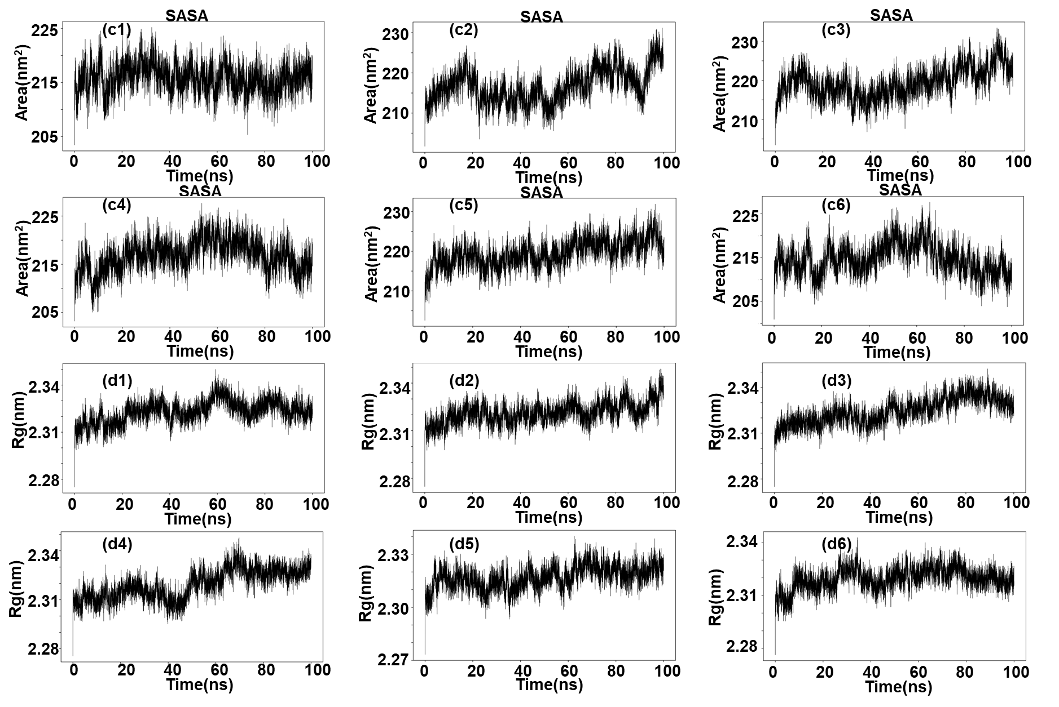

Figure S2 Hbond number (e1-e6) and gibbs energy landscape (f1-f6) by kinetic simulations of active compouds from C. yanhusuo were butted with acetylcholinesterase.
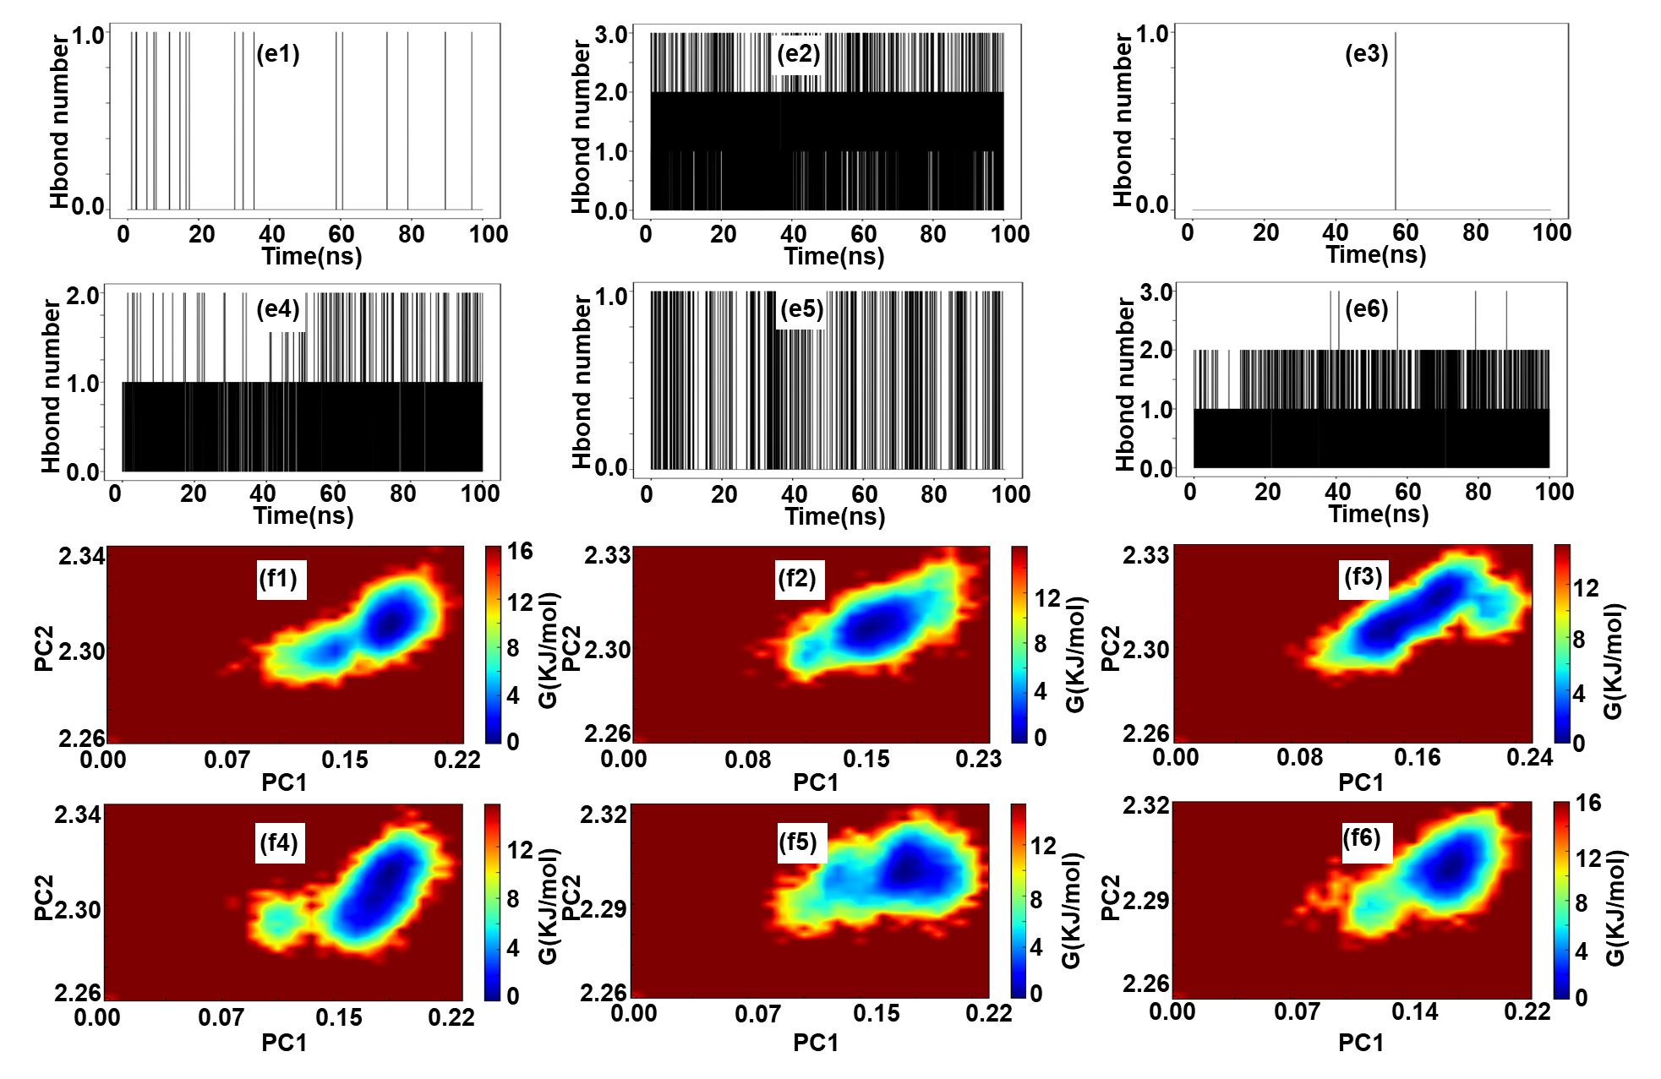

Figure S3 (A) Drug-active ingredient-target-AD network diagram; (B) Drug-active ingredient-target-AD network diagram. (Target Degree value greater than 4); (C) Interaction network between active ingredients of Corydalis yanhusuo and AD target proteins (protein-protein interaction, PPI); (D) Visual diagram of core target screening

