Supplementary Information to:

A constellation of mud volcanoes originated from a buried Arctic mega-slide, Southwestern Barents Sea

Claudio Argentino,¹ Rune Mattingsdal,² Tor Eidvin³, Sverre Ekrene Ohm⁴, Giuliana Panieri¹

¹ Department of Geosciences, UiT The Arctic University of Norway, NO-9037 Tromsø, Norway
² Norwegian Offshore Directorate, NO-9406 Harstad, Norway.
³ Retired from the Norwegian Offshore Directorate, NO-4003 Stavanger, Norway.
⁴ Department of Energy Resources, University of Stavanger, 4021 Stavanger, Norway

* Corresponding Author: Claudio Argentino claudio.argentino@uit.no

Supplementary Fig.1: n-Alkanes chromatograms
Supplementary Fig.2: Hopanes chromatograms and maturity proxies
Supplementary Fig.3: Steranes chromatograms and paleo-depositional proxies
Supplementary Fig.4: Pristane (Pr)/n-C17 vs Phytane (Ph)/n-C18 diagram

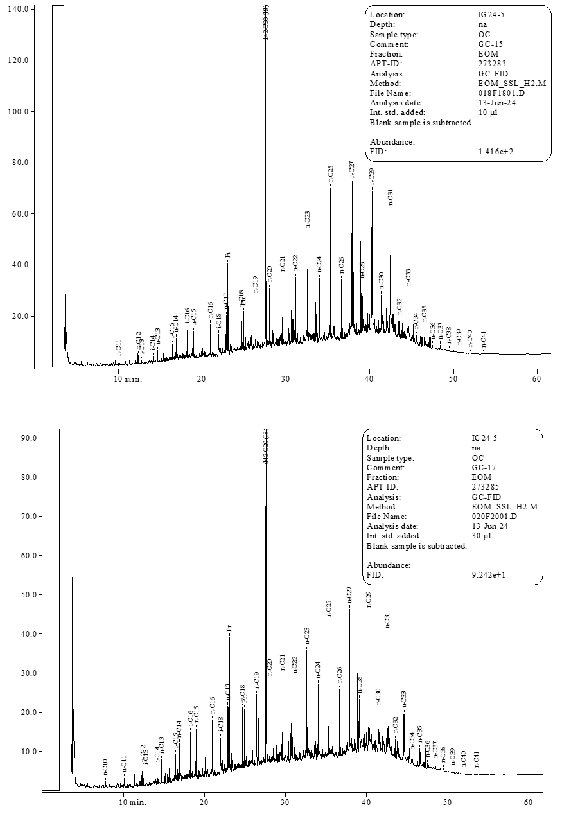
UCM
UCM
Supplementary Fig.1: Extract gas chromatograms showing n-alkanes distribution in sediment samples from gravity cores GC-15 and GC-17, collected from Kefeus and Kusken mud volcanoes, respectively. Both gas chromatograms displays and odd/even n-alkane dominance in the n-C₂₃ to n-C₃₃ range and the presence of unresolved complex mixture (UCM). The relatively high concentration of iso-alkanes relative to n-alkanes in the front end of the chromatograms and the UCM indicate biodegradation.
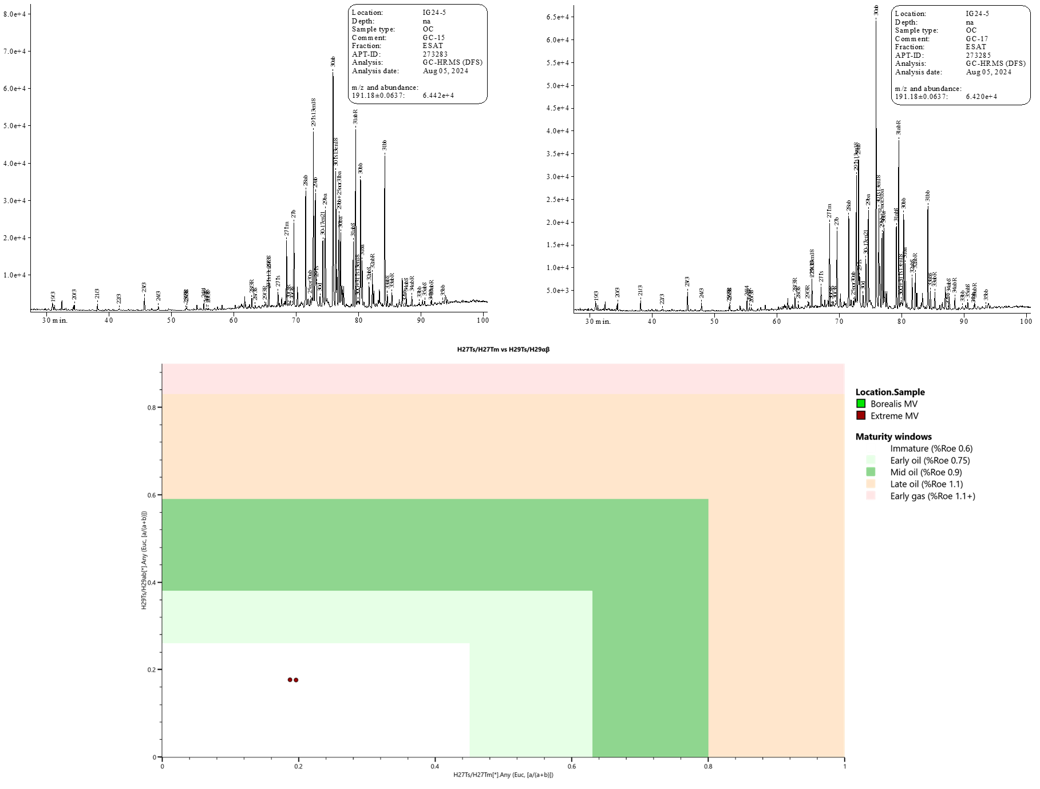
Early gas (%Roe 1.1+)
Mid oil (%Roe 0.9)
Late oil (%Roe 1.1)
Early oil (%Roe 0.75)
Immature (%Roe 0.6)
H29Ts/H29ab
1.0
0.8
0.6
0.4
0.2
0.0
0.0
0.2
0.4
0.6
0.8
H27Ts/H27Tm

Supplementary Fig.2: Hopanes distribution in the m/z 191 fragmentograms (top figures) and extrapolated hopane ratios H29Ts/H29ab vs H27Ts/H27Tm areused for assessing the degree of matury of organic matter sourcing the extracts¹ (bottom figure). Hopanes derives from the degradation of hopanoids, which are biomarkers found in bacteria, algae, and higher plants. Structural changes occurring during the thermal maturation of organic matter can be quantified through specific hopane ratios^{2,3}. Overall, hopanes in the Polaris samples suggest an immature source for the oil.

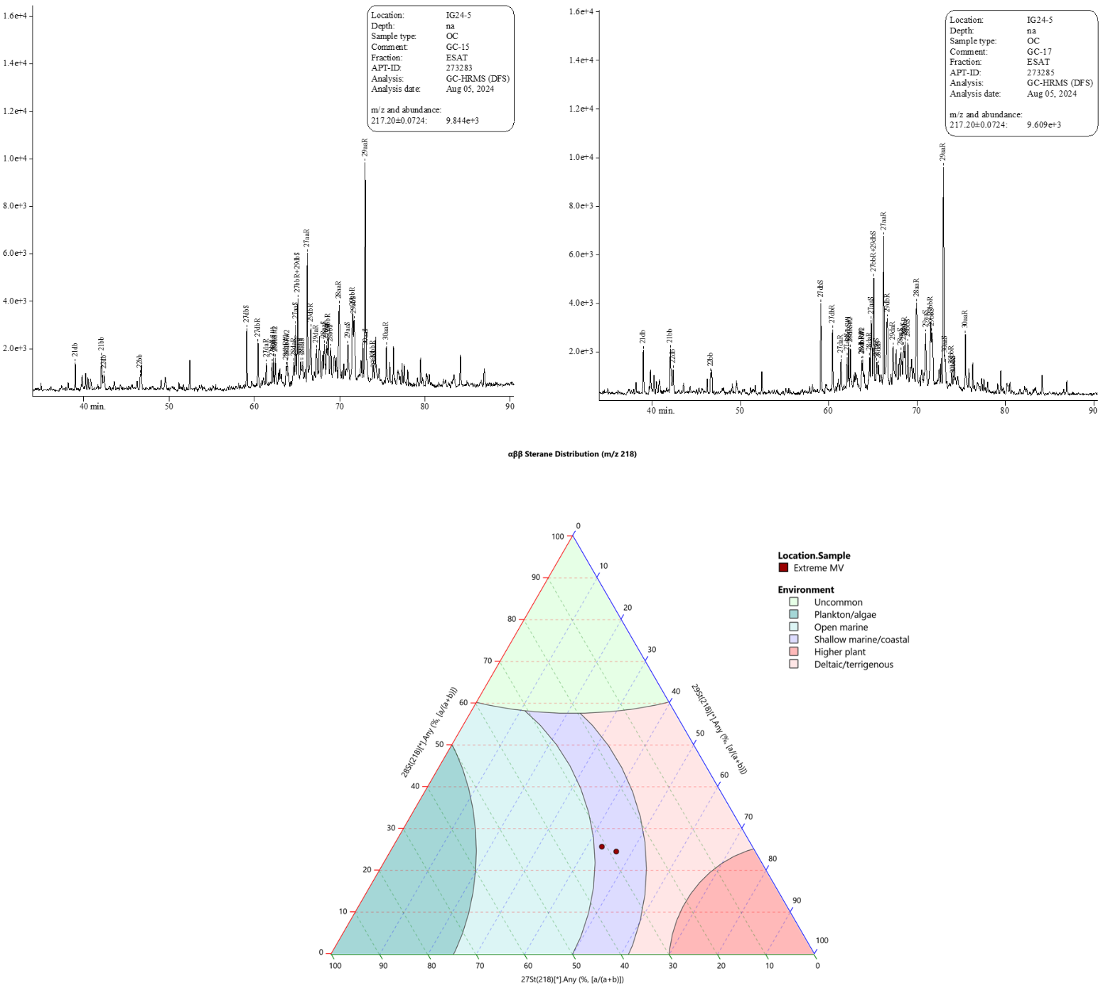
%C₂₉
%C₂₇
%C₂₈
αββ Sterane distribution (m/z 218)
Supplementary Fig.3: Sterane distribution in the m/z 217 fragmentograms (top figures) and extrapolated sterane ternary diagram of the percentage of C₂₇, C₂₈, and C₂₉ steranes obtained from the m/z 218 fragmentograms (bottom diagram). Steranes are derived from steroids contained in eukaryotic organisms such as algae and higher plants. Steranes can be used for interpreting the paleo-depositional environments (modified after Huang and Meinschein⁴) (bottom figure). The steranes in Polaris samples indicate a shallow marine/coastal environment source for the oil.
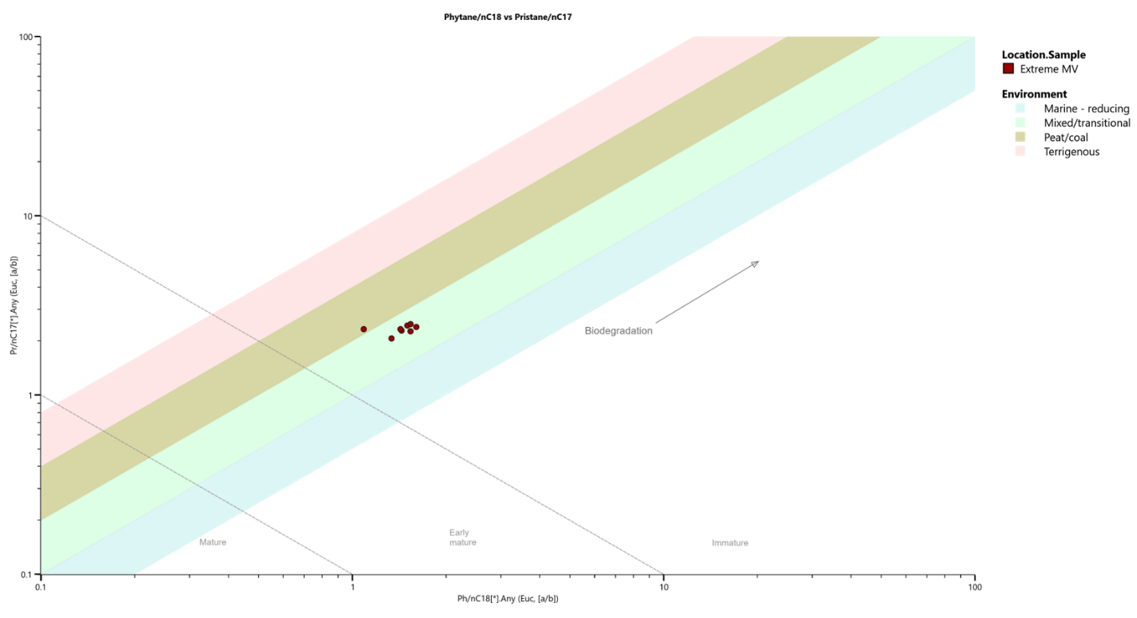
Mature
Immature
Early mature
Biodegradation
Terrigenous
Peat-coal
Mixed-transitional
Marine-reducing
Pr/n-C₁₇
0.1
1
10
100
100
10
1
Ph/n-C₁₈
0.1

Supplementary Fig.4: Pristane (Pr)/n-C₁₇ vs Phytane (Ph)/n-C₁₈ diagram used for assessing the depositional environment, redox conditions, and source of organic matter (modified after Lijmbach⁵). Polaris samples fall in the fields of immature, mixed/transitional marine environment and suggest ongoing biodegradation.

References
1. Lerch, B., Karlsen, D. A., Matapour, Z., Seland, R. & Backer-Owe, K. Organic geochemistry of barents sea petroleum: Thermal maturity and alteration and mixing processes in oils and condensates. Journal of Petroleum Geology 39, 125–148 (2016).
2. J. Michael Moldowan (2), Wolfgang K. Relationship Between Petroleum Composition and Depositional Environment of Petroleum Source Rocks. Bulletin 69, (1985).
3. Dembick-Jr., H. ­ Petroleum ­ Geochemistry for Exploration and Production. (2017).
4. Huang, W.-Y. & Meinschein, W. G. Sterols as ecological indicators. Geochimica et Cosmochimica Acta 43, 739–745 (1979).
5. Lijmbach, W. On the origin of petroleum. in Proceedings of the 9th World Petroleum Congress (Applied Science Publishers, London, 1975).

