Supplementary Figures

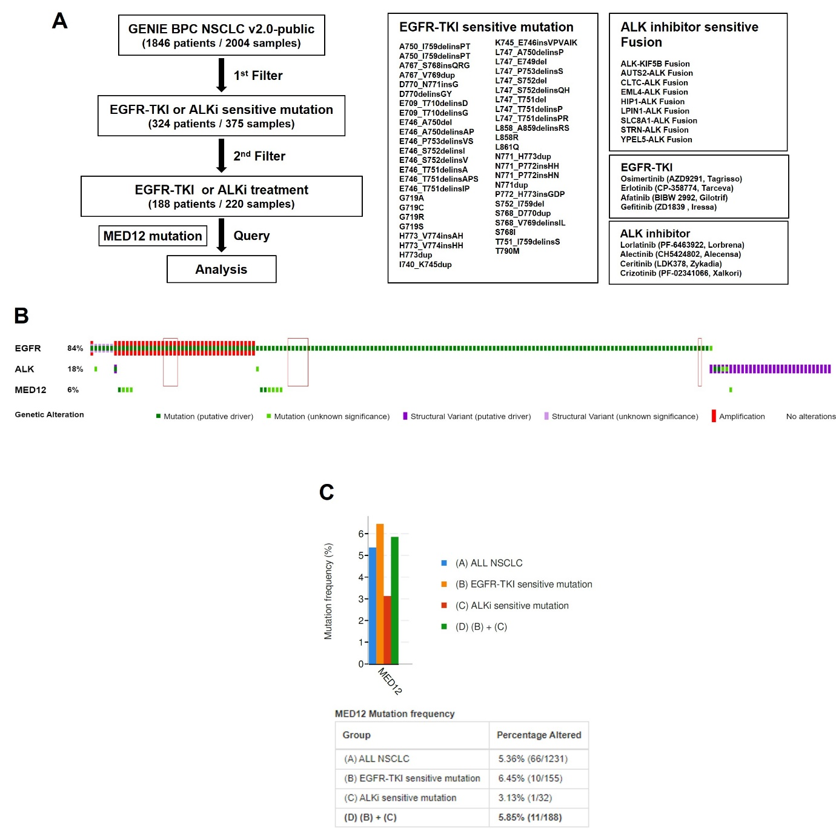
Supplementary Figure 1. The MED12-mutant NSCLC patients harboring RTK, such as ALK or EGFR, sensitive mutations show poor prognosis for RTK inhibitors.
(A) Patient cohort selection process using the GENIE BPC NSCLC v2.0-public database. (B) Oncoprint showing distribution of patients in the selected cohort based on EGFR, ALK and MED12 mutation status. (C) MED12 mutation frequency within both EGFR-TKI and ALKi sensitive mutation groups.

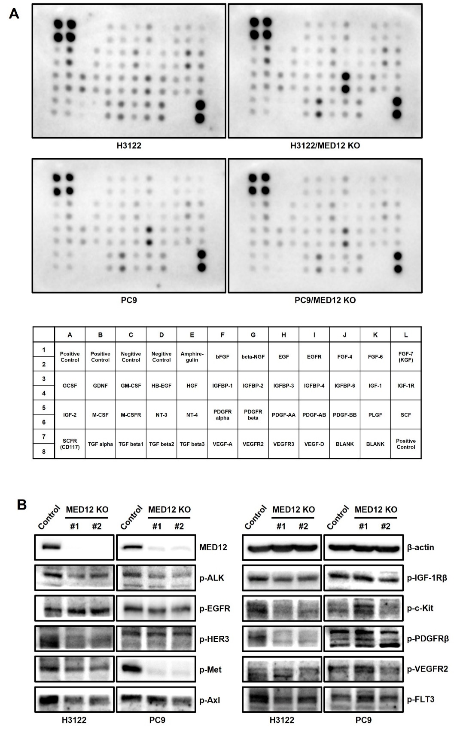
Supplementary Figure 2. Analysis of growth factors and RTK receptors in MED12 knock-out cell lines.
(A) Human Growth Factor Array Result. Culture media from MED12 knock-out cells (H3122 and PC9 cell lines), as well as their respective parental cell lines, were collected after 48 hours of incubation. (B) Western blot analysis for RTK activation in the parental (H3122 and PC9) and MED12 KO (H3122/MED12 KO and PC9/MED12 KO) cell lines.
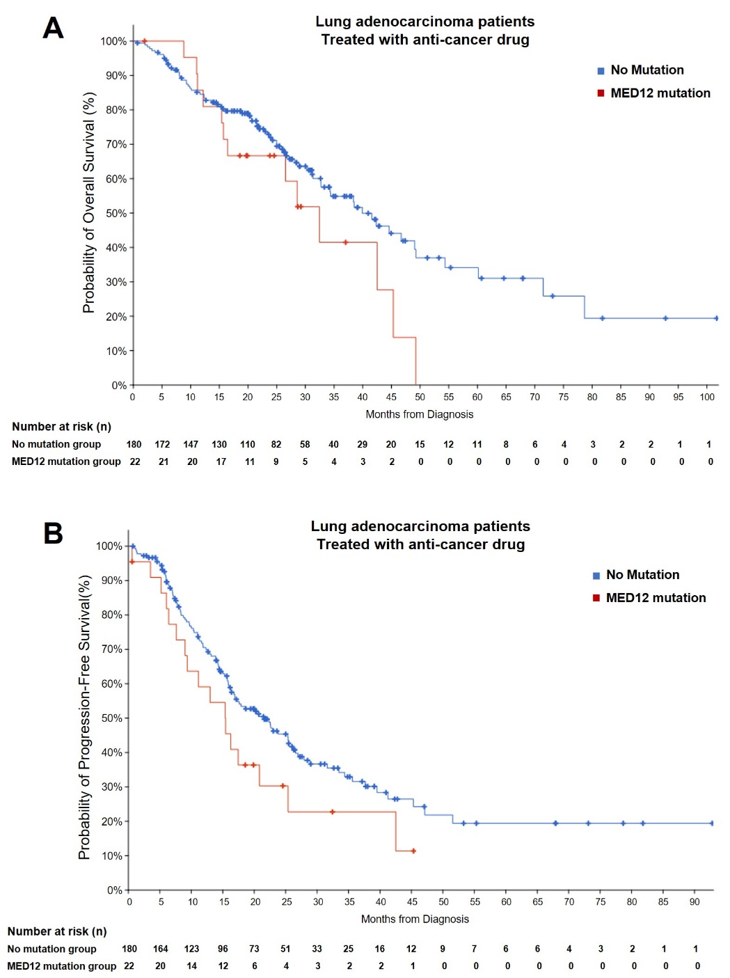
Supplementary Figure 3. Analysis of survival endpoints in the lung adenocarcinoma patients from TCGA PanCancer Atlas dataset.
(A) Overall survival according to the presence or absence of MED12 mutation. (Left: No
filtered patients, HR=1.643, p-value=0.0268; Right: anti-cancer drug treated patients,
HR=1.621, p-value=0.103) (B) Progression-free survival according to the presence or absence of MED12 mutation. (Left: No filtered patients, HR=1.502, p-value=0.0589; Right: anti-cancer drug treated patients, HR=1.521, p-value=0.106)

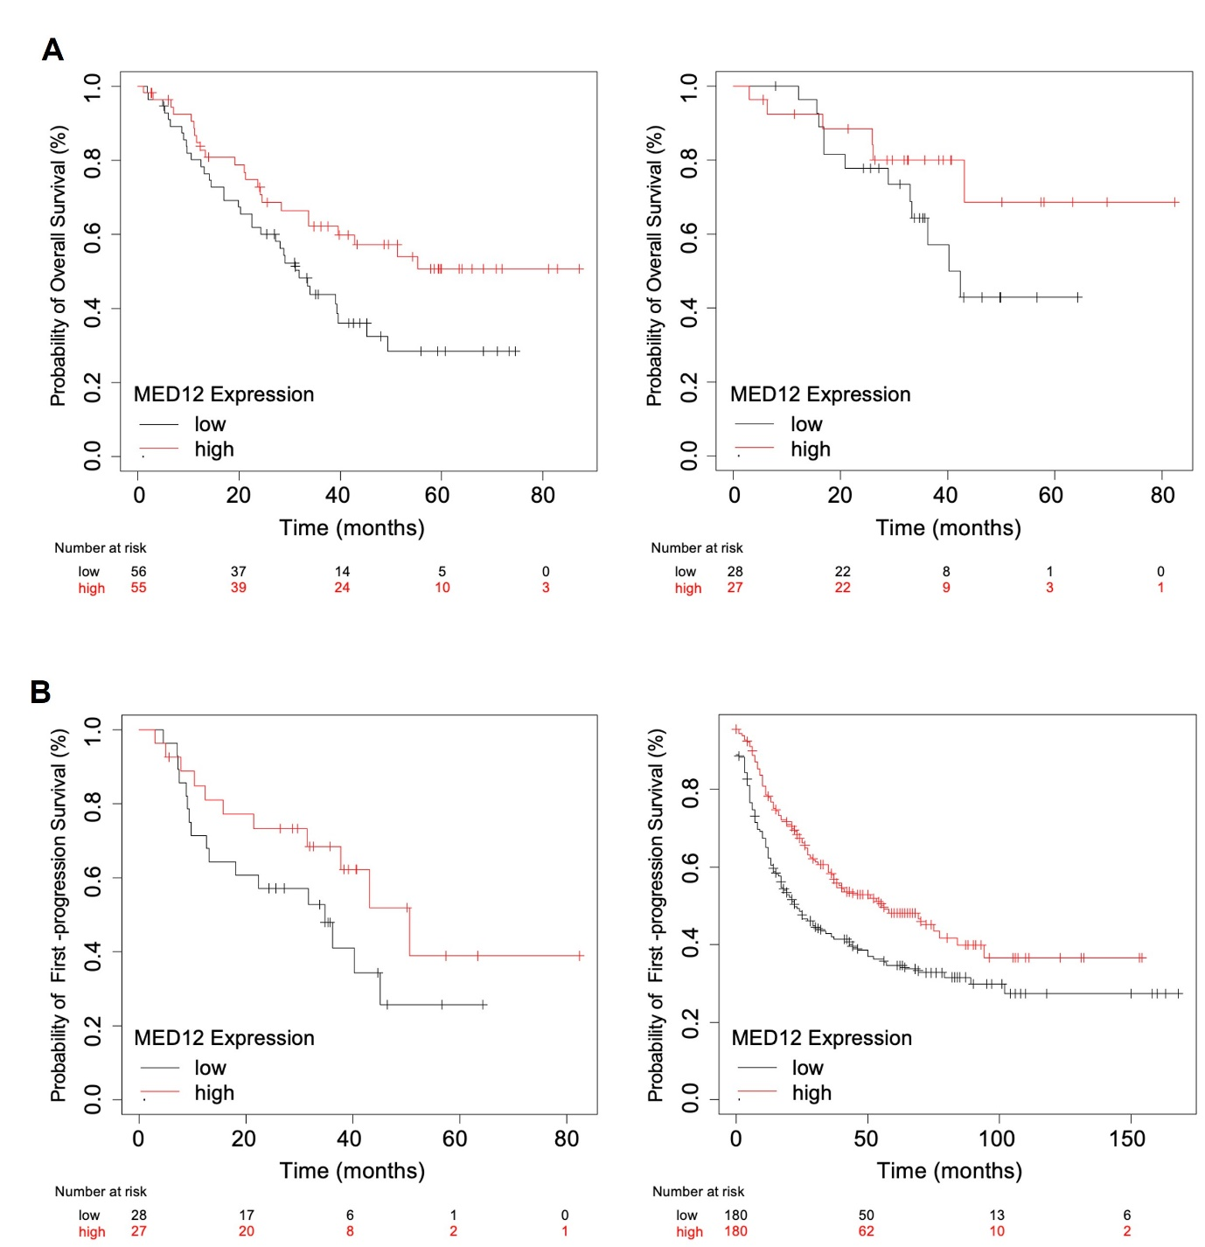
Supplementary Figure 4. Analysis of survival endpoints in the NSCLC patients from Gene Expression Omnibus (GEO) dataset.
(A) Overall survival according to the MED12 mRNA expression level. (Left: GSE3141 dataset,
Probe ID=211342_x_at, HR=1.786, p-value=0.031; Right: GSE29013 dataset, Probe ID=203506_s_at, HR=1.961, p-value=0.17) (B) First-progression survival according the MED12 mRNA expression level. (Left: GSE29013 dataset, Probe ID=203506_s_at, HR=1.754, p-value=0.15; Right: GSE68465, Probe ID=211342_x_at, HR=1.538, p-value=0.002

