Extended Data Figures For

Unidirectional Electric Field Enables Reversible Ferroelectric Domain Engineering
Xingan Jiang¹, Muzhi Li², Yuanyuan Cui³, Xiao Wu⁴, Zunyi Deng³, Xiangping Zhang^{3,5}, Jianming Deng⁶, Xiaolei Wang⁷, Dongdong Zhang¹, Xiangdong Yang¹, Zhuoyin Peng², Zhao Liang^{1,†}, Xueyun Wang^{3,†} and Weiyou Yang^{1,†}
¹Institute of Micro/Nano Materials and Devices, Ningbo University of Technology, Ningbo City, 315211, P. R. China
²School of Energy and Power Engineering, Changsha University of Science & Technology, Changsha, 410014, P. R. China.
³School of Aerospace Engineering, Beijing Institute of Technology, Beijing, 100081, P. R. China.
⁴College of Materials Science and Engineering, Fuzhou University, Fuzhou 350108, P. R. China.
⁵Department of Materials Science and Engineering, Southern University of Science and Technology, Shenzhen, Guangdong, 518055, P. R. China.
⁶Guangdong Provincial Key Laboratory of Electronic Functional Materials and Devices, Huizhou University, Huizhou, Guangdong, 516001, P. R. China.
⁷School of Physics and Optoelectronic Engineering, Beijing University of Technology, Beijing 100124, P. R. China.
†Corresponding Authors Emails: walleliang@hnu.edu.cn; xueyun@bit.edu.cn; weiyouyang@tsinghua.org.cn
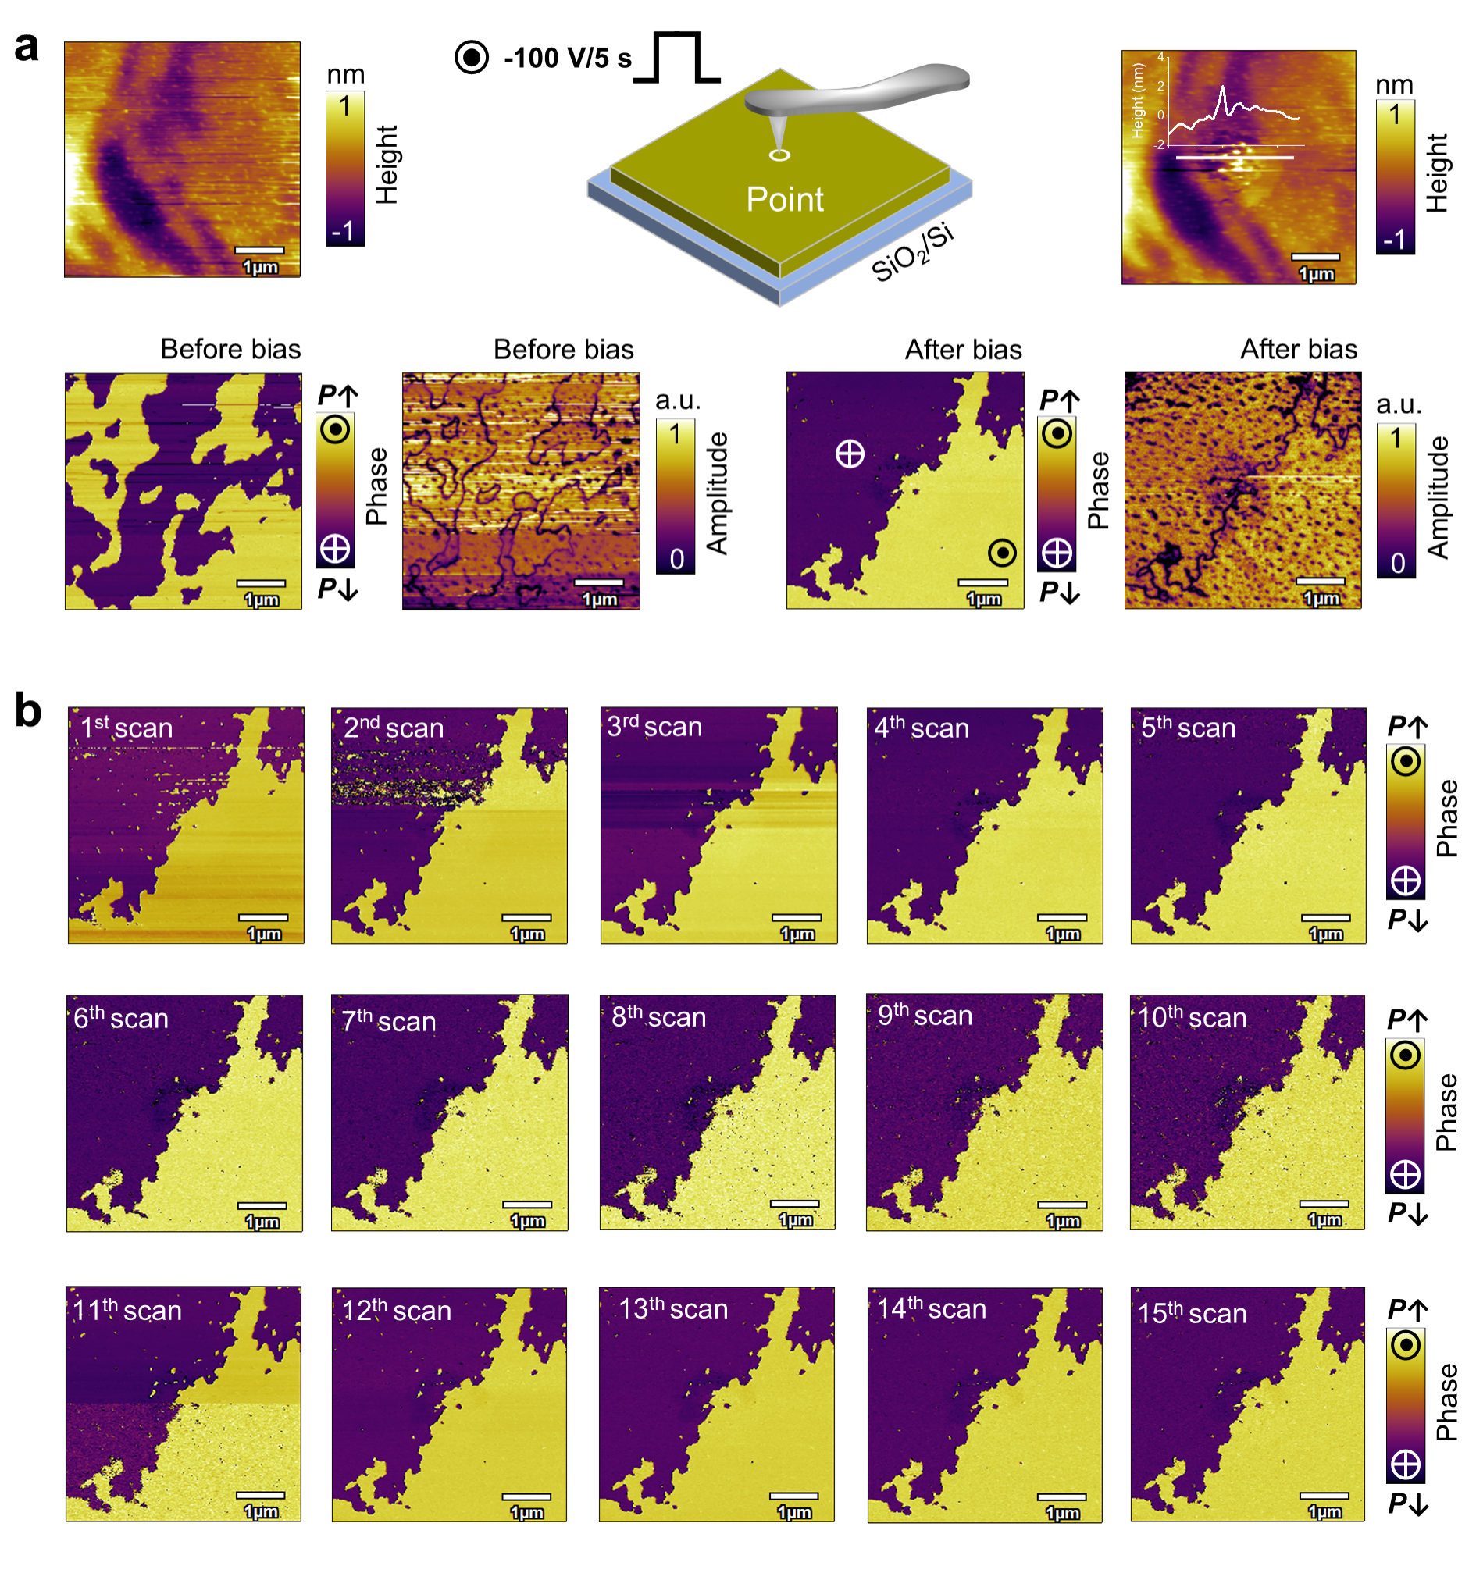
Extended Data Fig. 1 | Stability of the switched ferroelectric domains after the bias withdrawal. a The surface topography and ferroelectric domain changes before and after applying bias (-100 V, 5 s). The bias is applied at a central point location while maintaining an open circuit. b The stability of the switched domains monitored by ultrafast scan imaging. Bias (-100 V, 5 s) is applied through a conductive tip, then immediately removed, followed by continuously scanning quickly (~26 s per image) to monitor the domains.

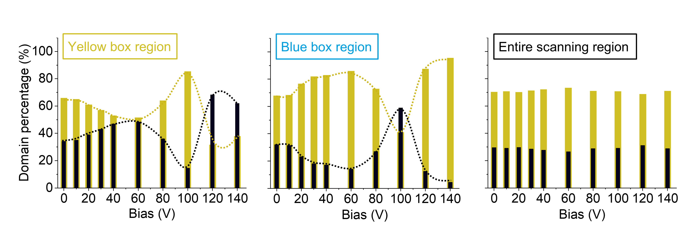
Extended Data Fig. 2 | The domain percentages after applying unidirectional electric fields with progressively increased magnitude. The domain percentages of purple-black domains (P↓) and yellow domains (P↑) are extracted in the yellow, blue box regions, as well as the entire scanning area in Fig. 3c under different bias magnitude.

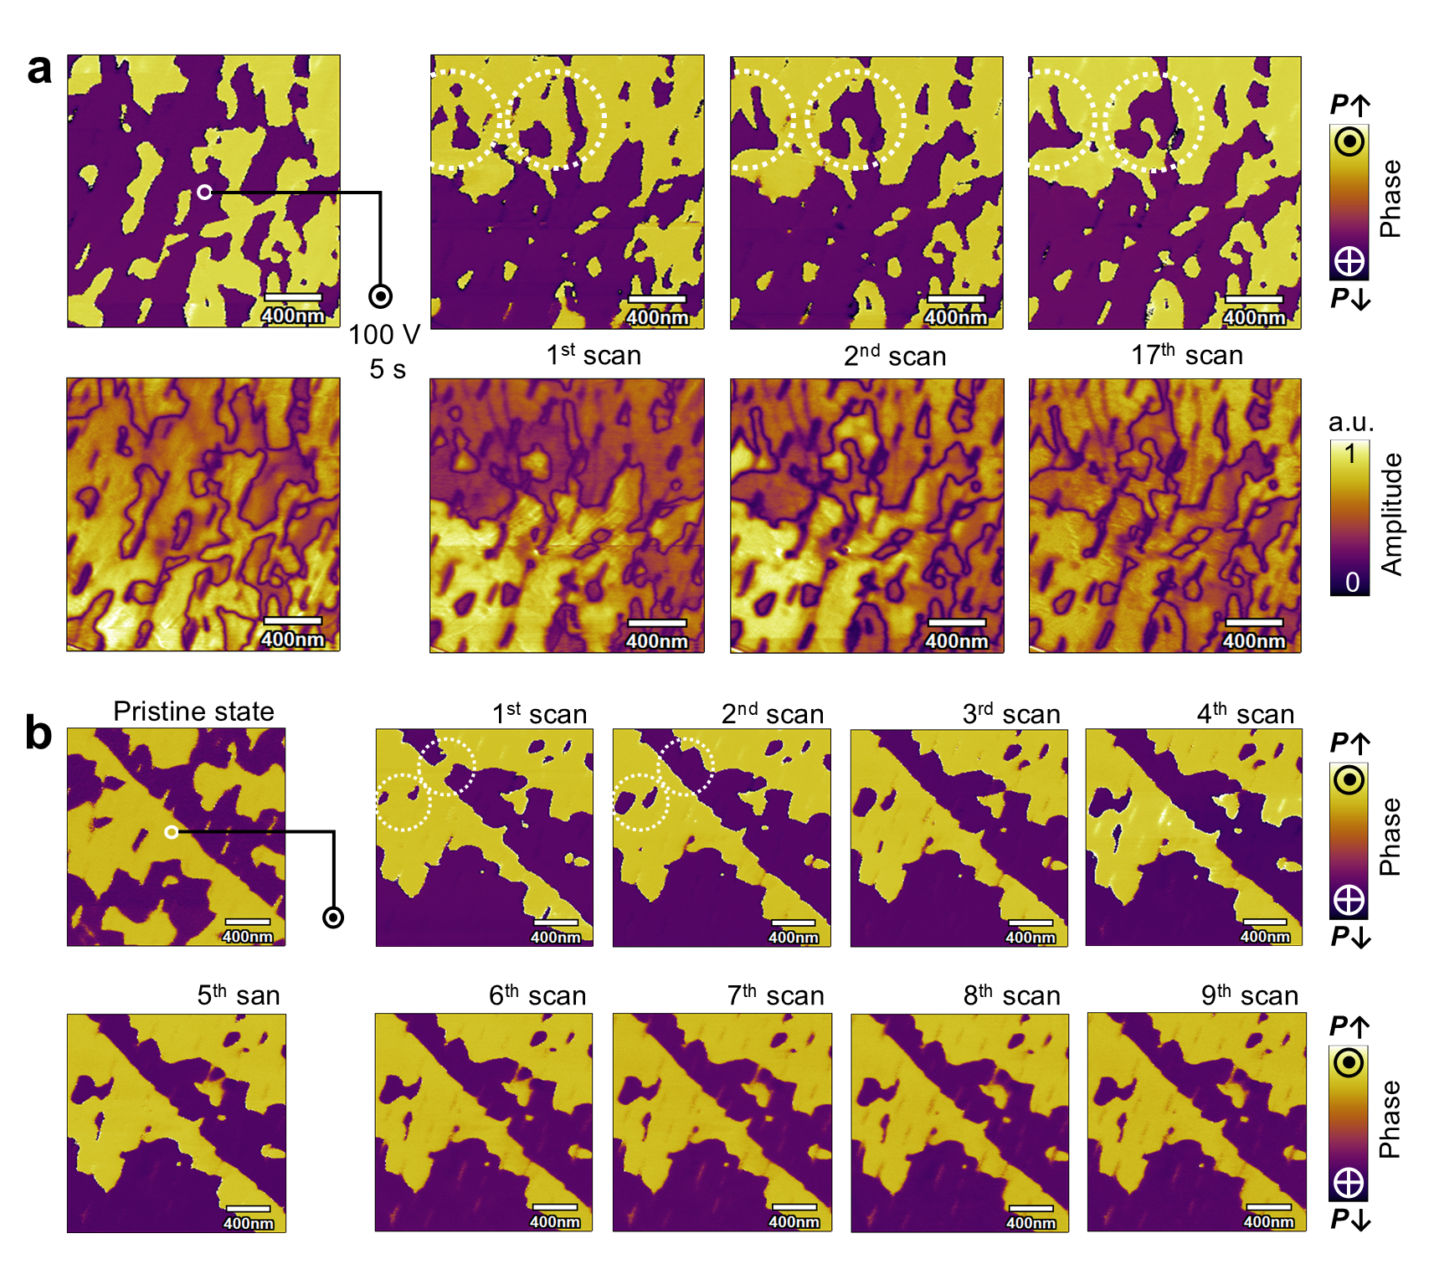
Extended Data Fig. 3 | Relaxation behaviors of electrically switched ferroelectric domains after the electric field withdrawal. a Bias (-100 V, 5 s) is applied at the central point location, then immediately removed, followed by continuously scanning quickly (~26 s per image for panel a) and (~52 s per image for panel b) to monitor their relaxation of switched domains. A small portion of switched domains are rapidly relaxed to their original shape in a minute after the electric field withdrawal. However, the majority of switched ferroelectric domains are stabilized.

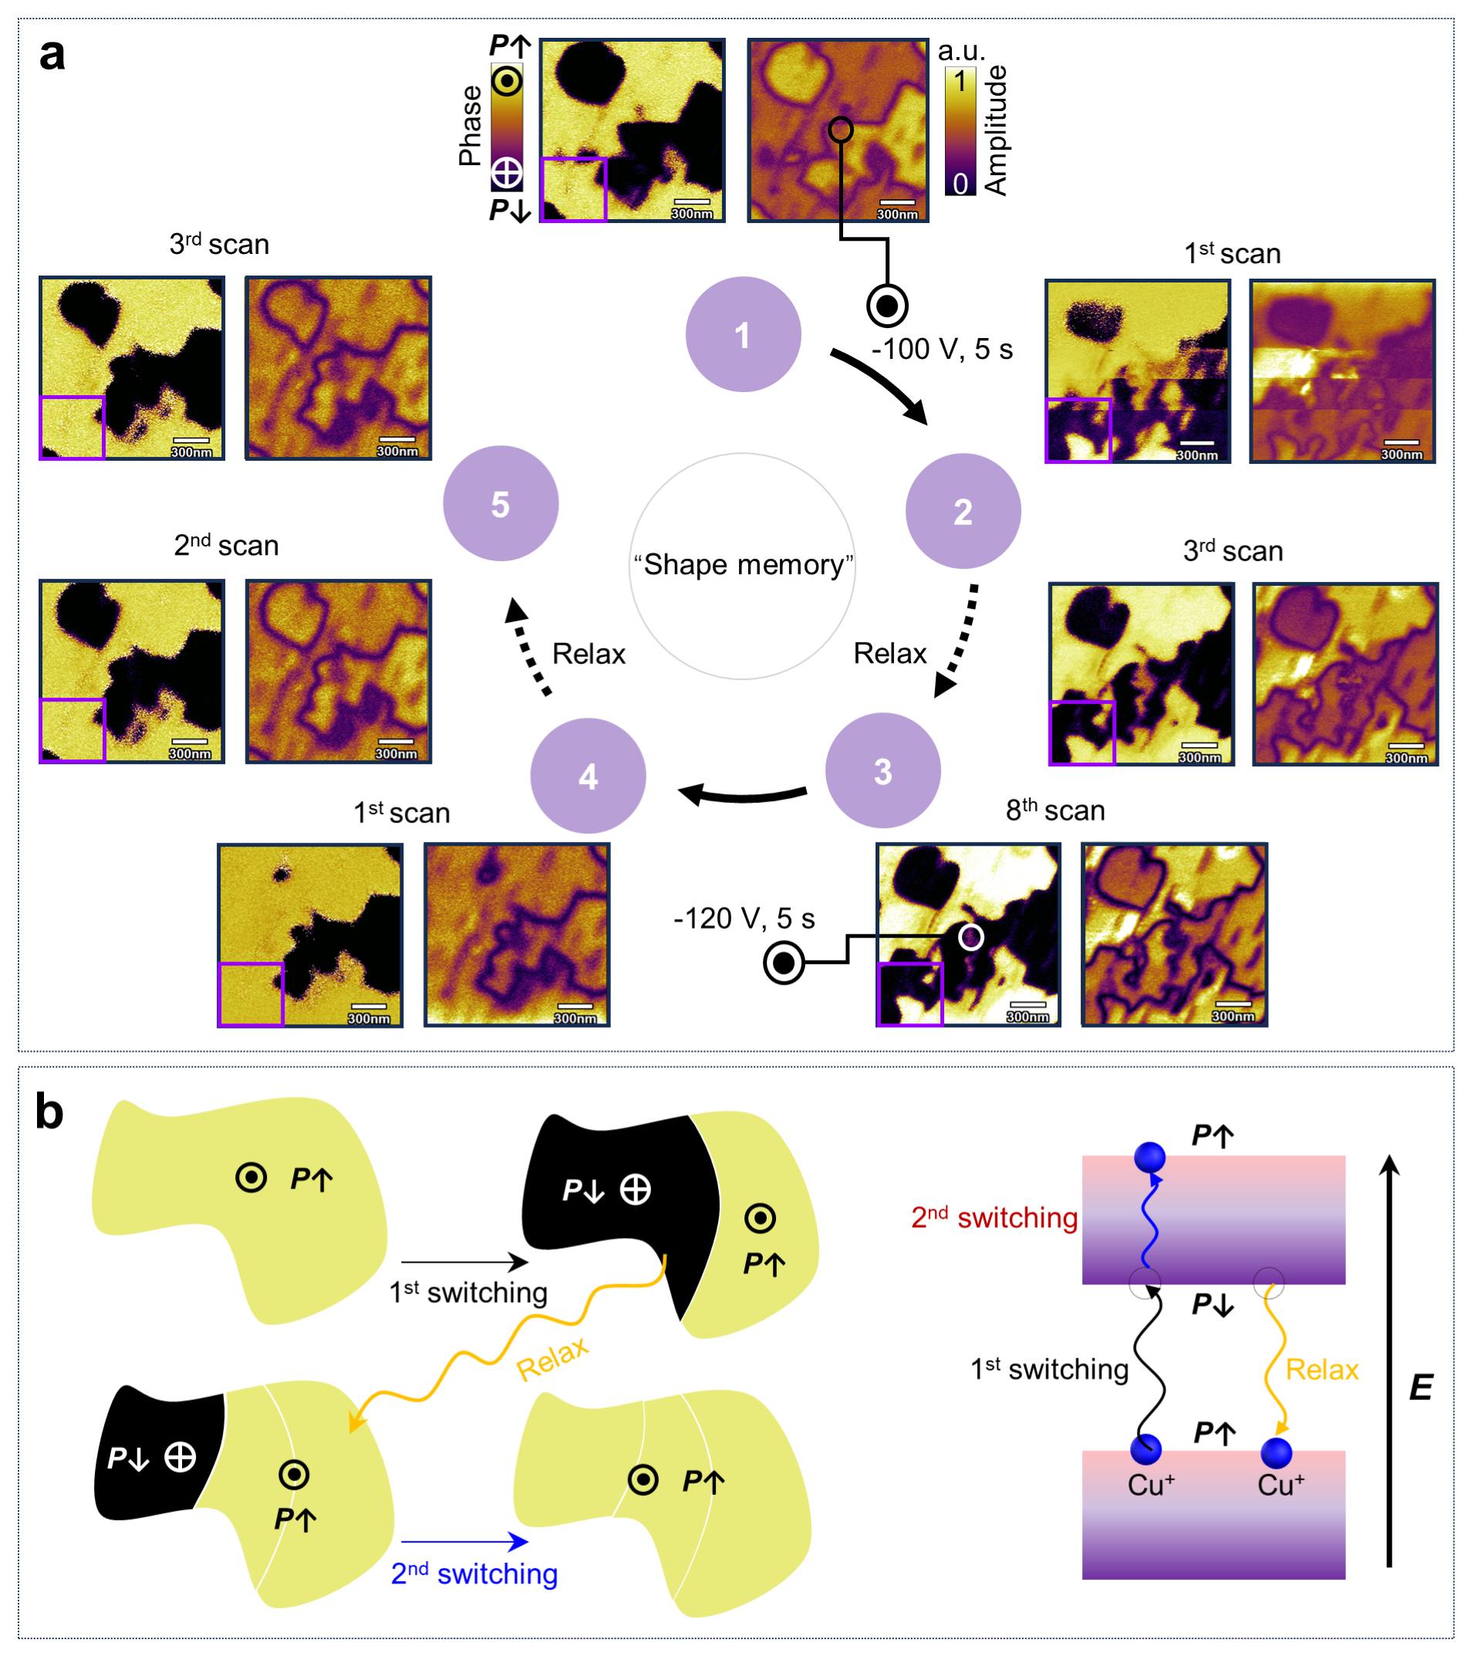
Extended Data Fig. 4 | The “shape memory” behaviors of ferroelectric domains. a “Shape memory” effect of switched domains during a cyclic switching. In the purple box region, the ferroelectric domains exhibit a “shape memory” effect, disappearing and reappearing with recoverable shape effect during a cyclic switching. b The schematic of domain switching behavior and Cu ions migration dynamics within the layers or across the vdW gap during a cyclic switching.

