Supplementary Information For

Unidirectional Electric Field Enables Reversible Ferroelectric Domain Engineering
Xingan Jiang¹, Muzhi Li², Yuanyuan Cui³, Xiao Wu⁴, Zunyi Deng³, Xiangping Zhang^{3,5}, Jianming Deng⁶, Xiaolei Wang⁷, Dongdong Zhang¹, Xiangdong Yang¹, Zhuoyin Peng², Zhao Liang^{1,†}, Xueyun Wang^{3,†} and Weiyou Yang^{1,†}
¹Institute of Micro/Nano Materials and Devices, Ningbo University of Technology, Ningbo City, 315211, P. R. China
²School of Energy and Power Engineering, Changsha University of Science & Technology, Changsha, 410014, P. R. China.
³School of Aerospace Engineering, Beijing Institute of Technology, Beijing, 100081, P. R. China.
⁴College of Materials Science and Engineering, Fuzhou University, Fuzhou 350108, P. R. China.
⁵Department of Materials Science and Engineering, Southern University of Science and Technology, Shenzhen, Guangdong, 518055, P. R. China.
⁶Guangdong Provincial Key Laboratory of Electronic Functional Materials and Devices, Huizhou University, Huizhou, Guangdong, 516001, P. R. China.
⁷School of Physics and Optoelectronic Engineering, Beijing University of Technology, Beijing 100124, P. R. China.
†Corresponding Authors Emails: walleliang@hnu.edu.cn; xueyun@bit.edu.cn; weiyouyang@tsinghua.org.cn

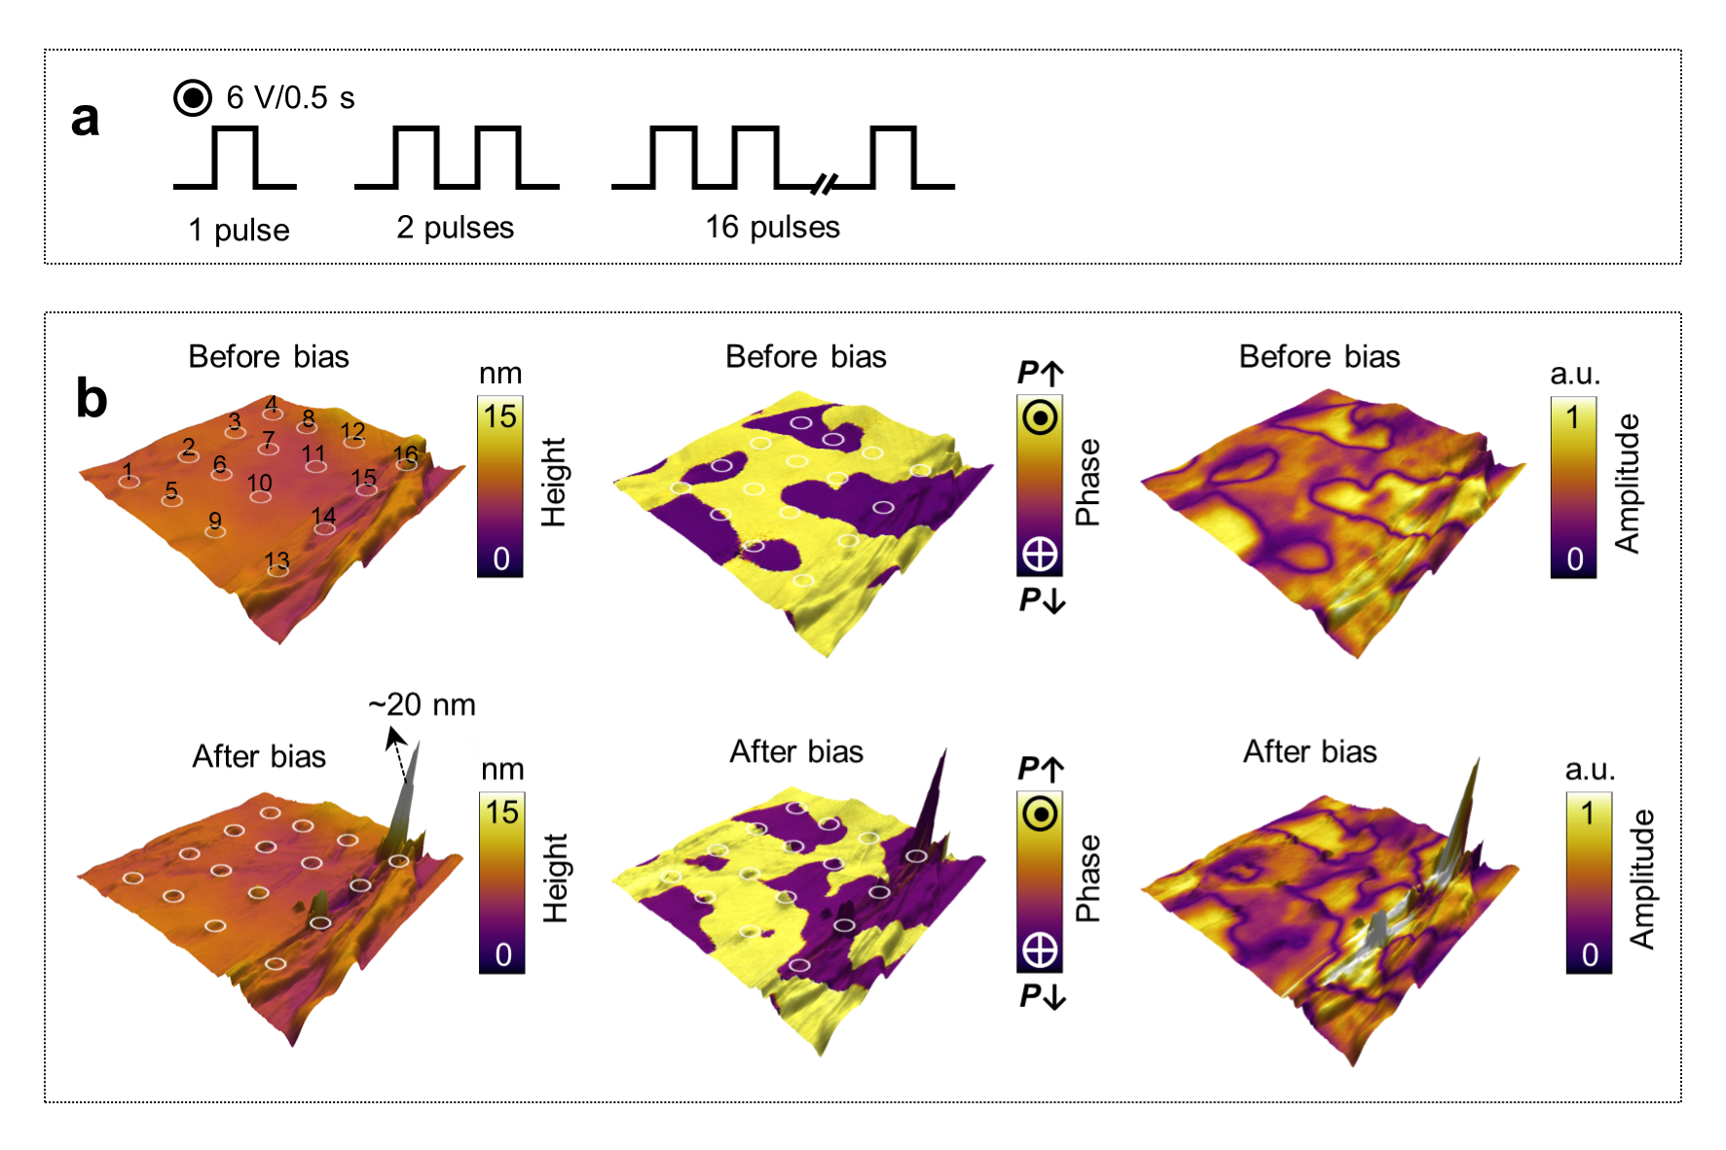
Supplementary Fig. 1. The ferroelectric domain switching and the topographical protrusions under an electric field using a conductive tip. a The applied tip bias with increased numbers of bias pulses (6 V, 0.5 s). b The domain switching behavior and the topographical protrusion at different locations across 6×6 grid points with gradually increased bias pulse numbers. By overlaying the phase and amplitude of ferroelectric domains onto the topography, 3D image can be displayed with PFM and topographical information together.

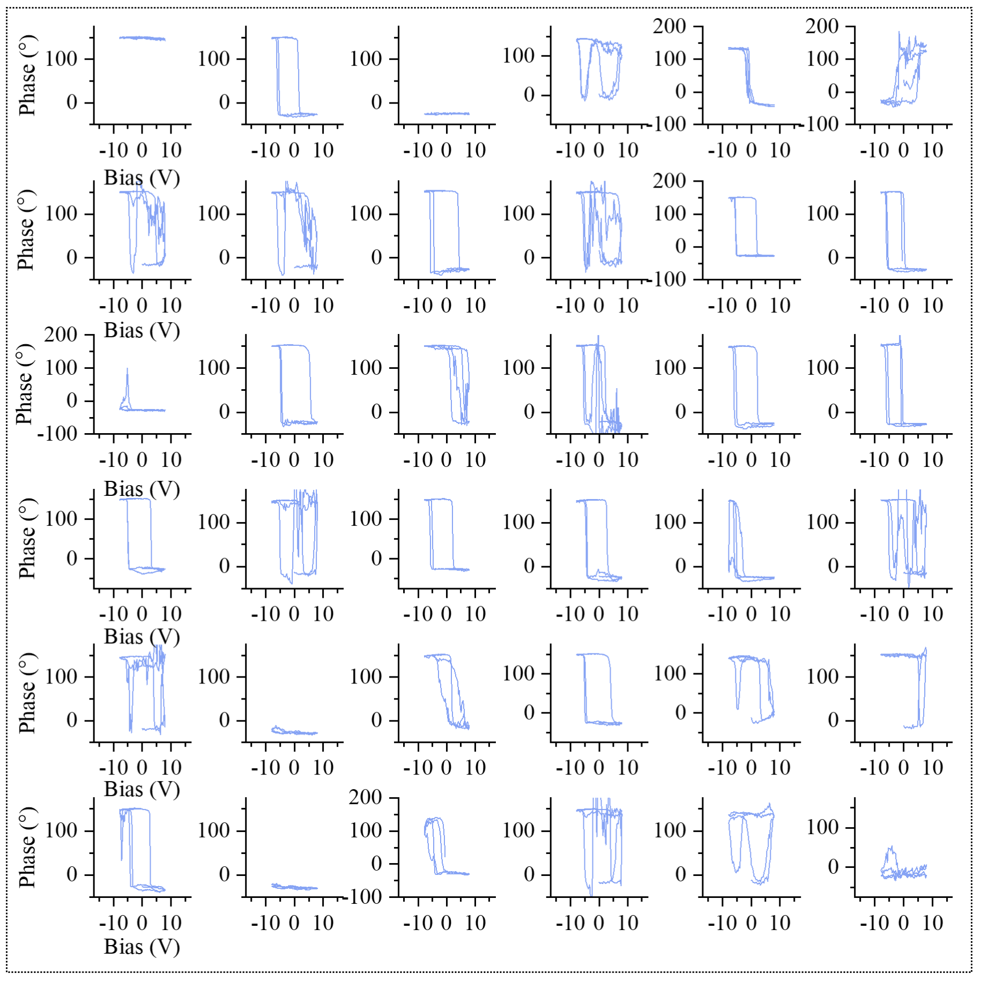
Supplementary Fig. 2. Polarization switching curves measured by switching spectroscopy PFM (SS-PFM) across 6×6 grid points. The testing bias window is ±8 V, and the time duration for each loop is 1 s, respectively.

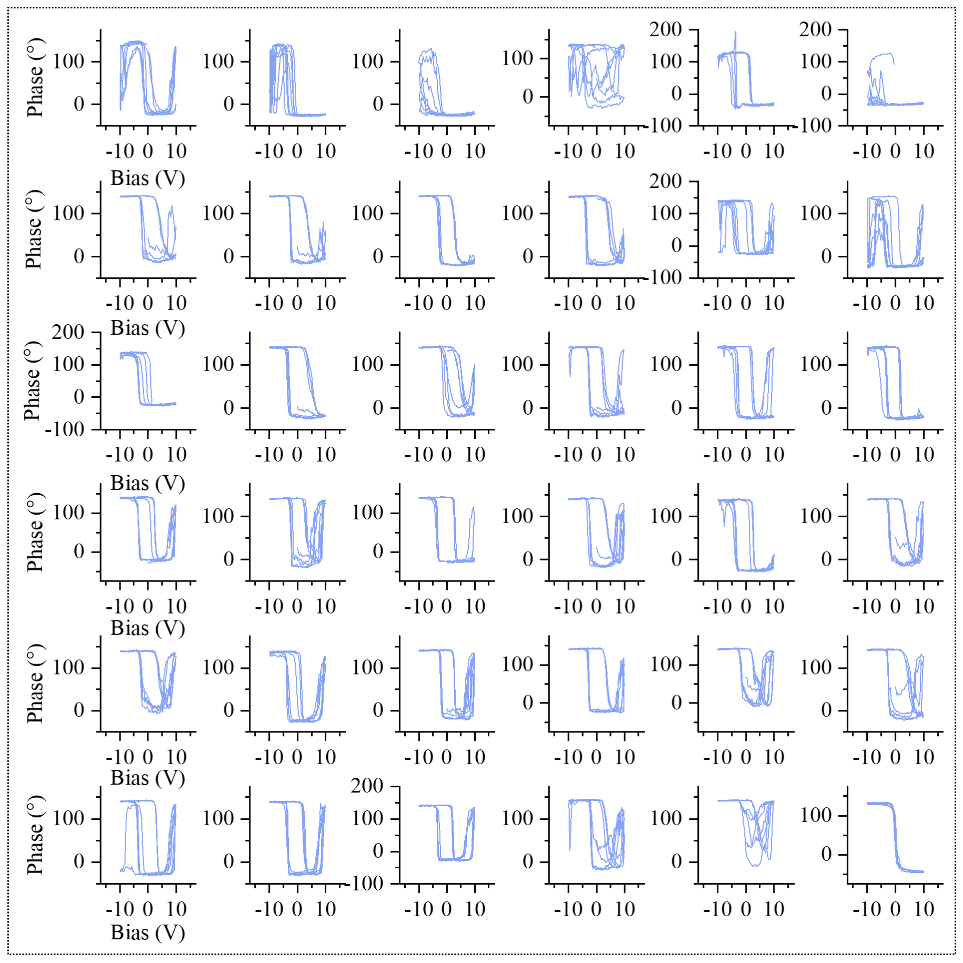
Supplementary Fig. 3. Polarization switching curves measured by switching spectroscopy PFM (SS-PFM) across 6×6 grid points. The testing bias window is ±10 V, and the time duration for each loop is 1 s, respectively.

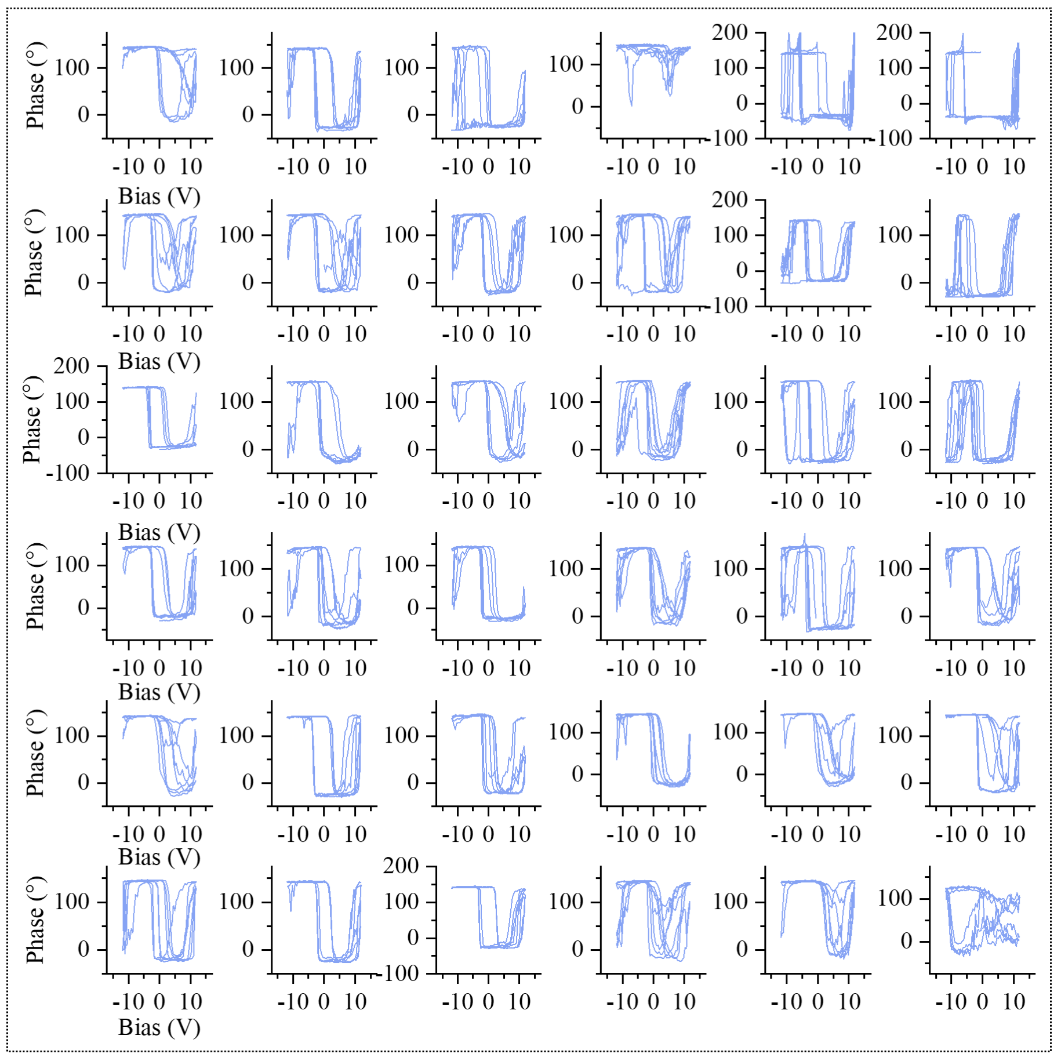
Supplementary Fig. 4. Polarization switching curves measured by switching spectroscopy PFM (SS-PFM) across 6×6 grid points. The testing bias window is ±12 V, and the time duration for each loop is 1 s, respectively.

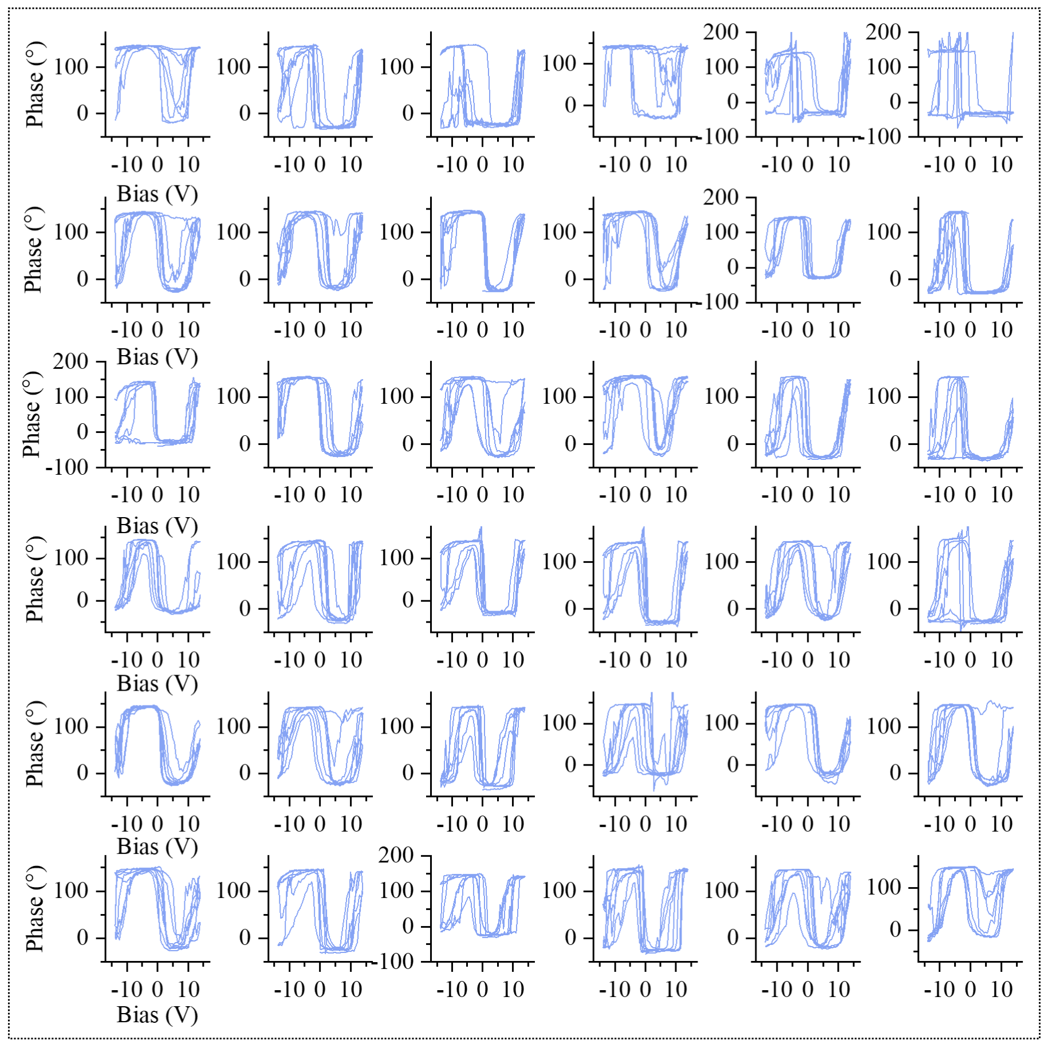
Supplementary Fig. 5. Polarization switching curves measured by switching spectroscopy PFM (SS-PFM) across 6×6 grid points. The testing bias window is ±14 V, and the time duration for each loop is 1 s, respectively.

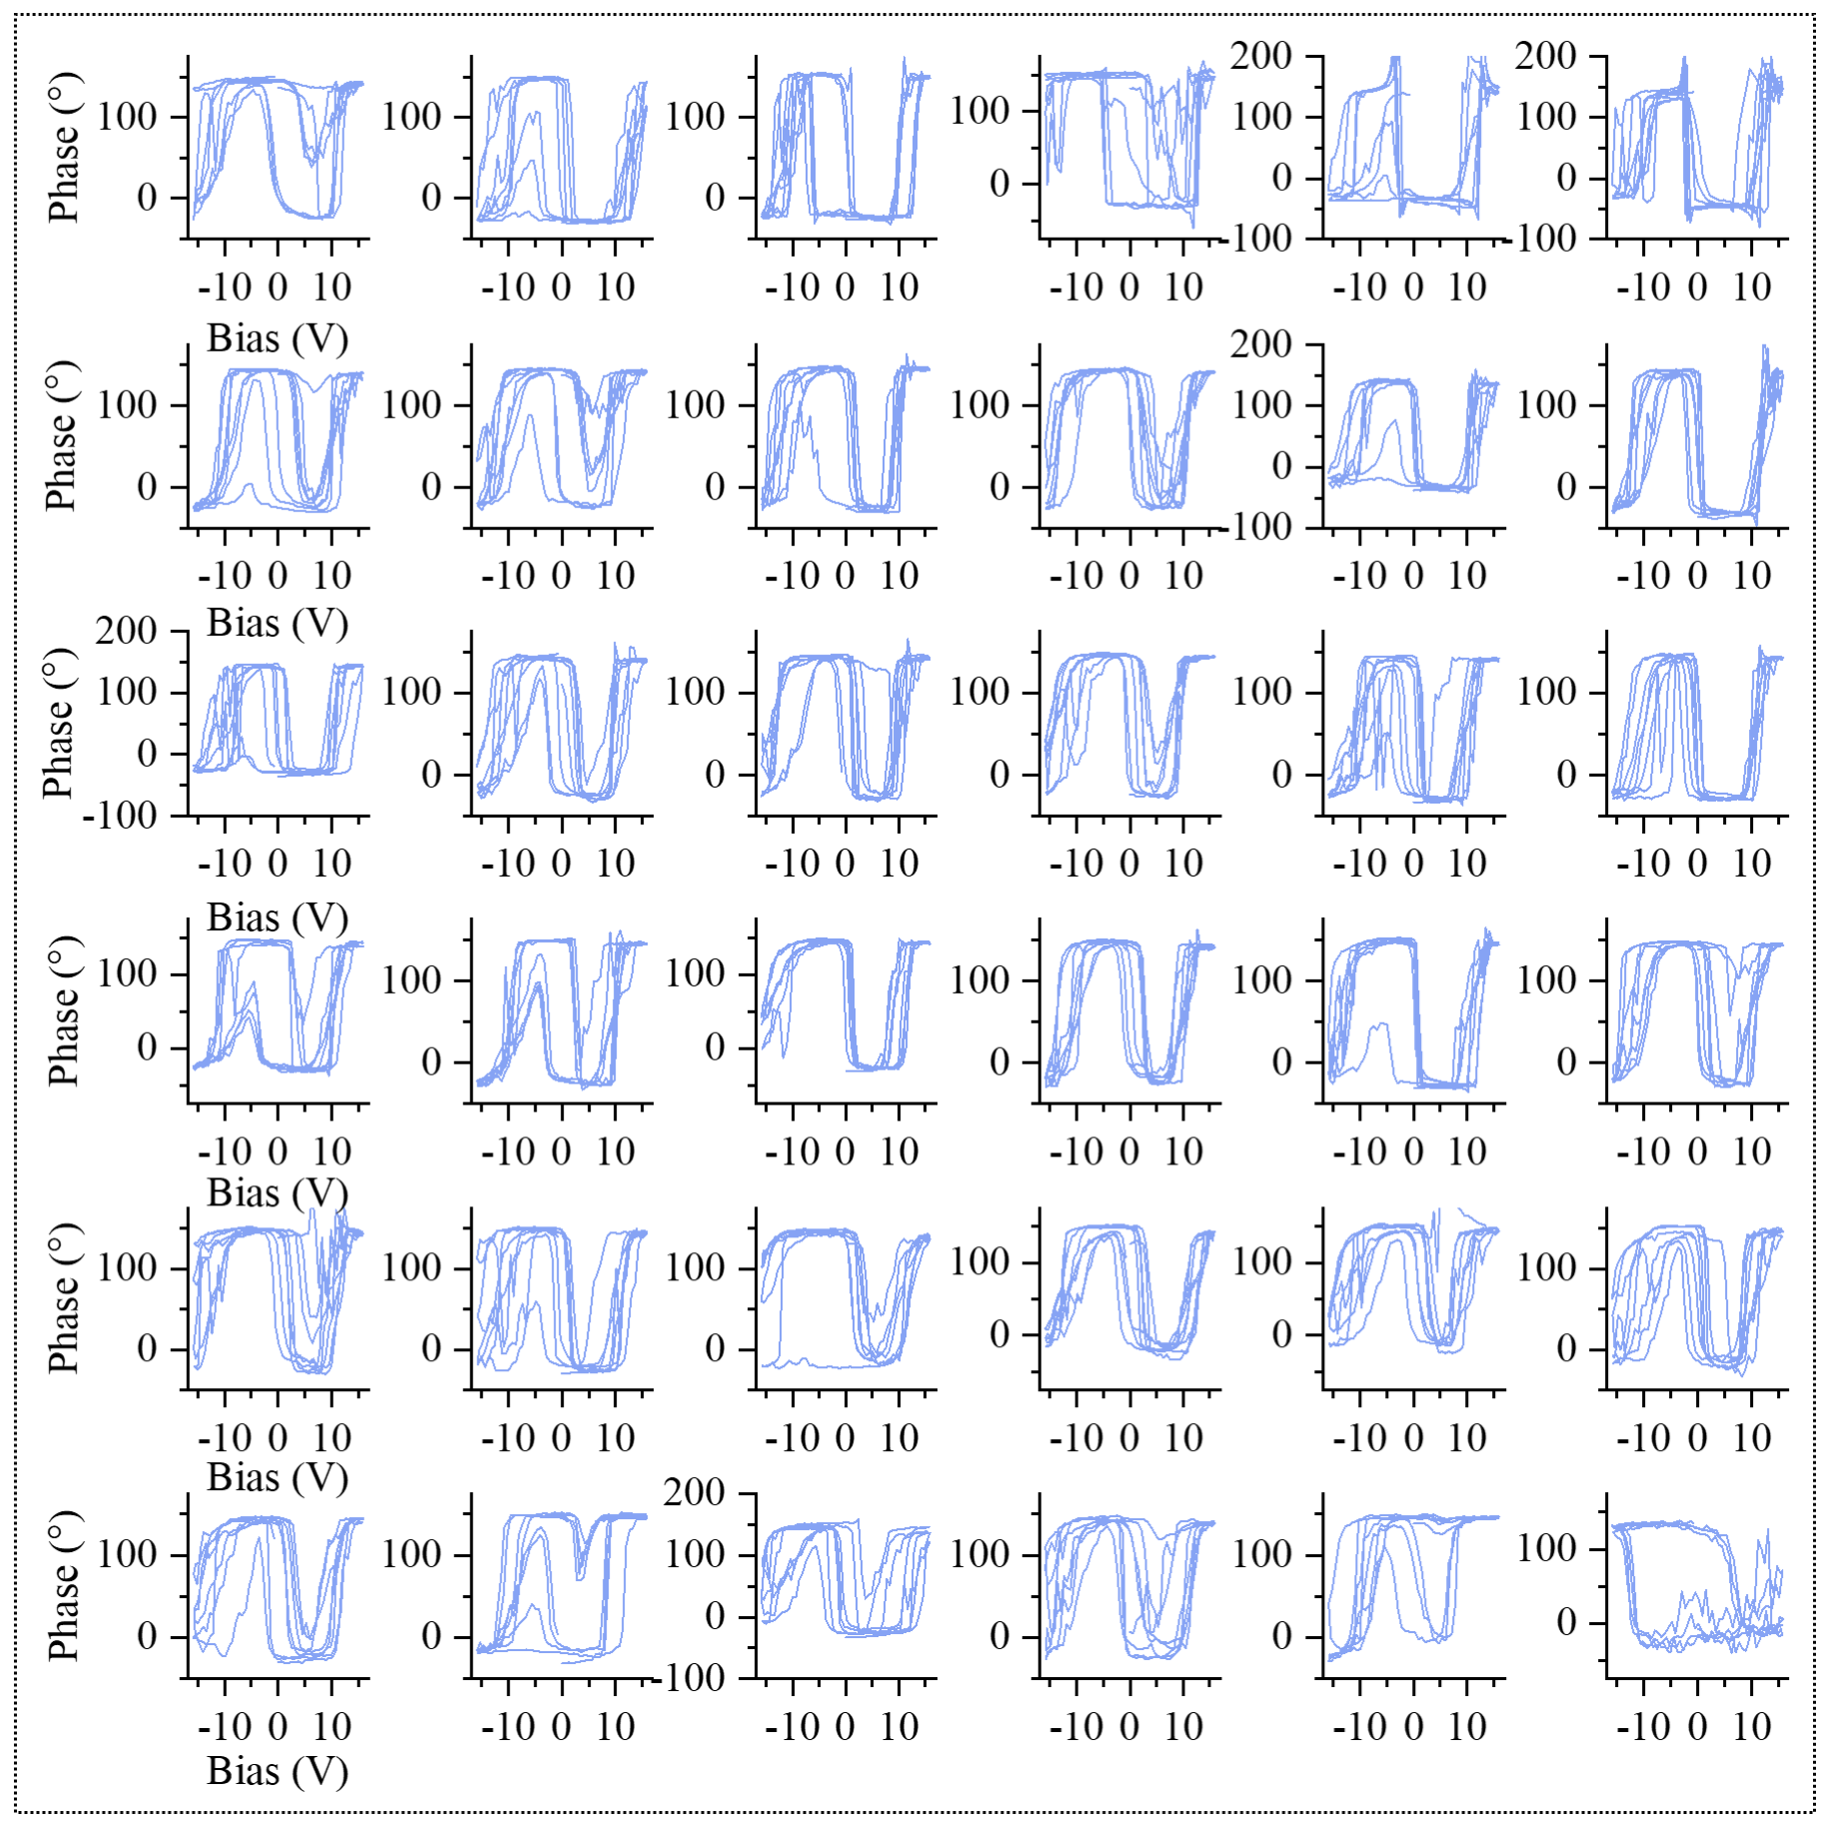
Supplementary Fig. 6. Polarization switching curves measured by switching spectroscopy PFM (SS-PFM) across 6×6 grid points. The testing bias window is ±16 V, and the time duration for each loop is 1 s, respectively.

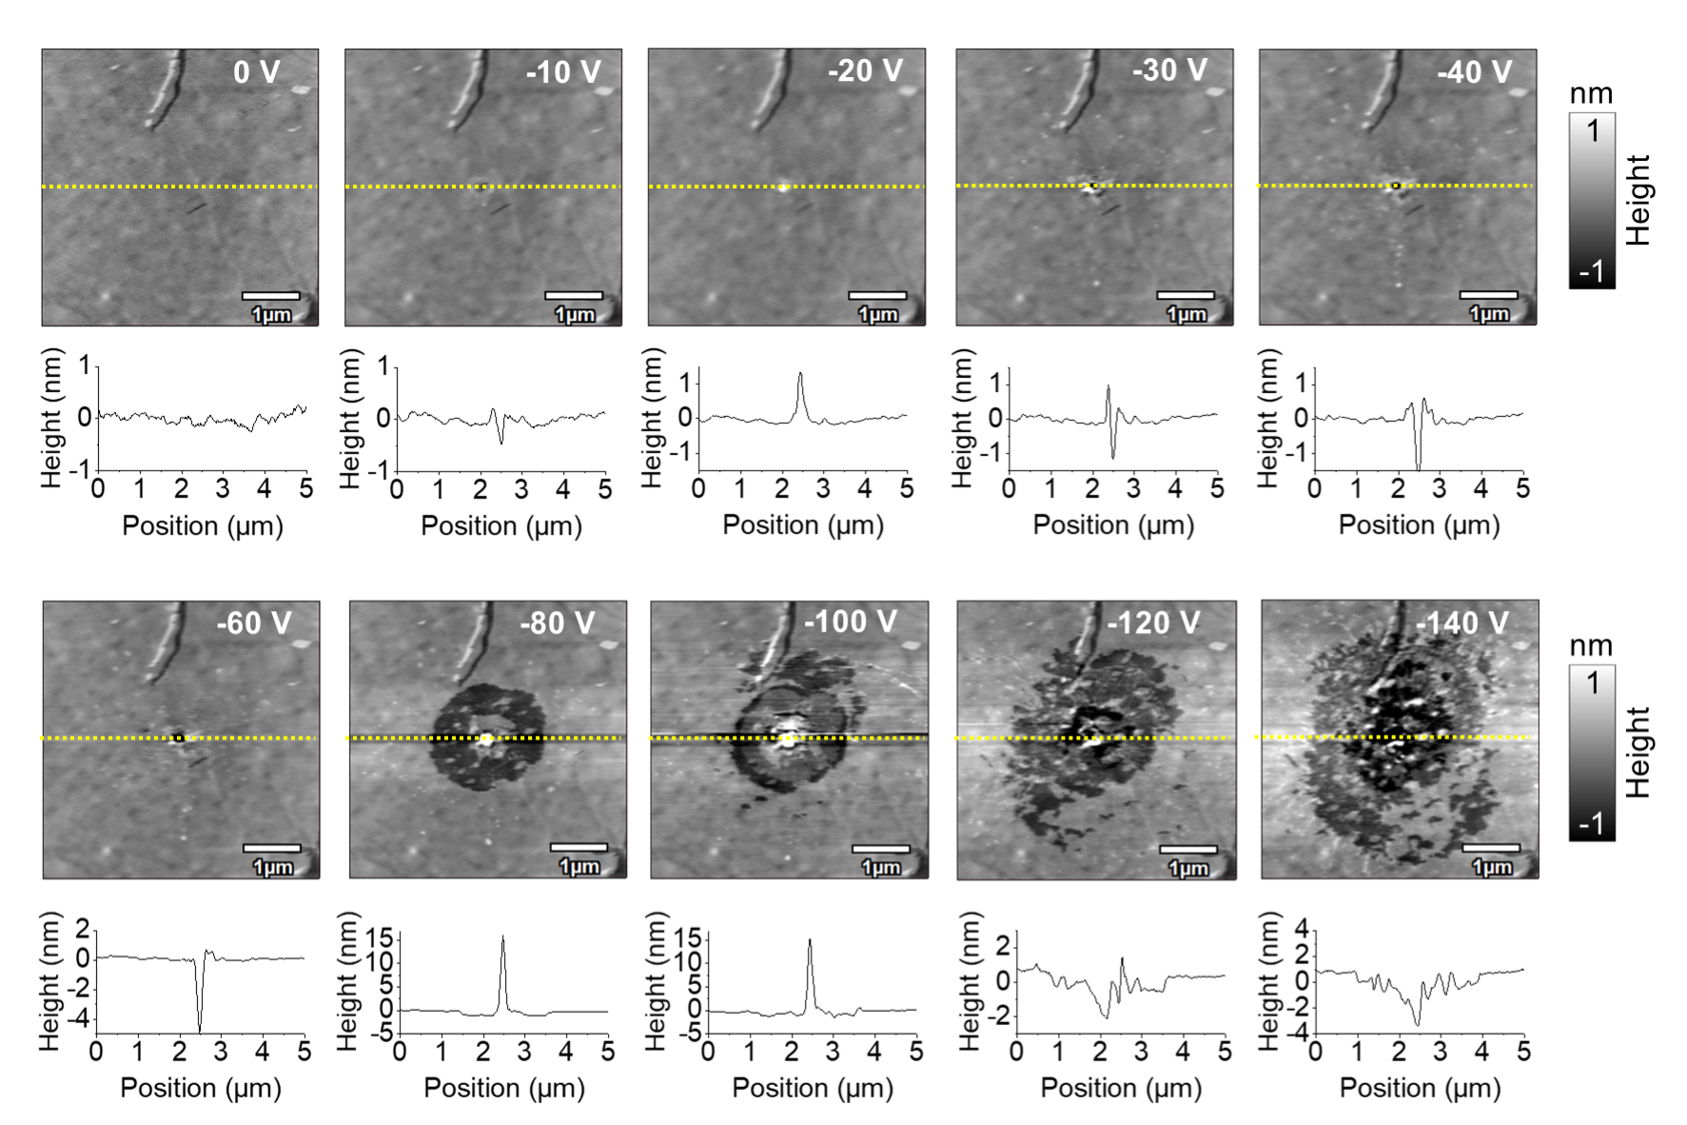
Supplementary Fig. 7. Surface topography and the line profiles before and after applying the unidirectional bias. The bias is applied in the central point location for 5 s and varies from -10 V to -140 V (E↑, ⊙).

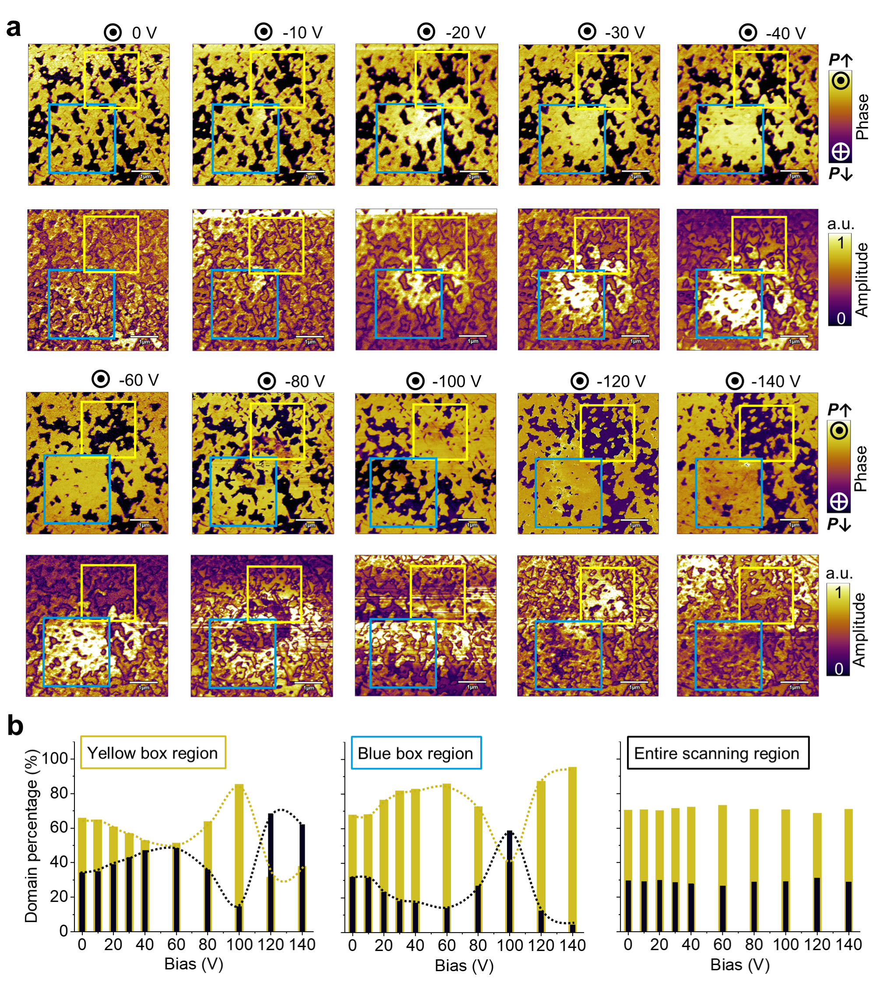
Supplementary Fig. 8. Controlled domains engineering with alternative switching after applying unidirectional electric fields with progressively increased magnitude. a The phase and amplitude image under different bias magnitude. b Statistical domain percentages of purple-black domains (P↓) and yellow domains (P↑) in the yellow, blue box regions, as well as the entire scanning area under different bias magnitude. The bias is applied at the central point location, and varies from -10 V to -140 V (E↑, ⊙) for 5 s.

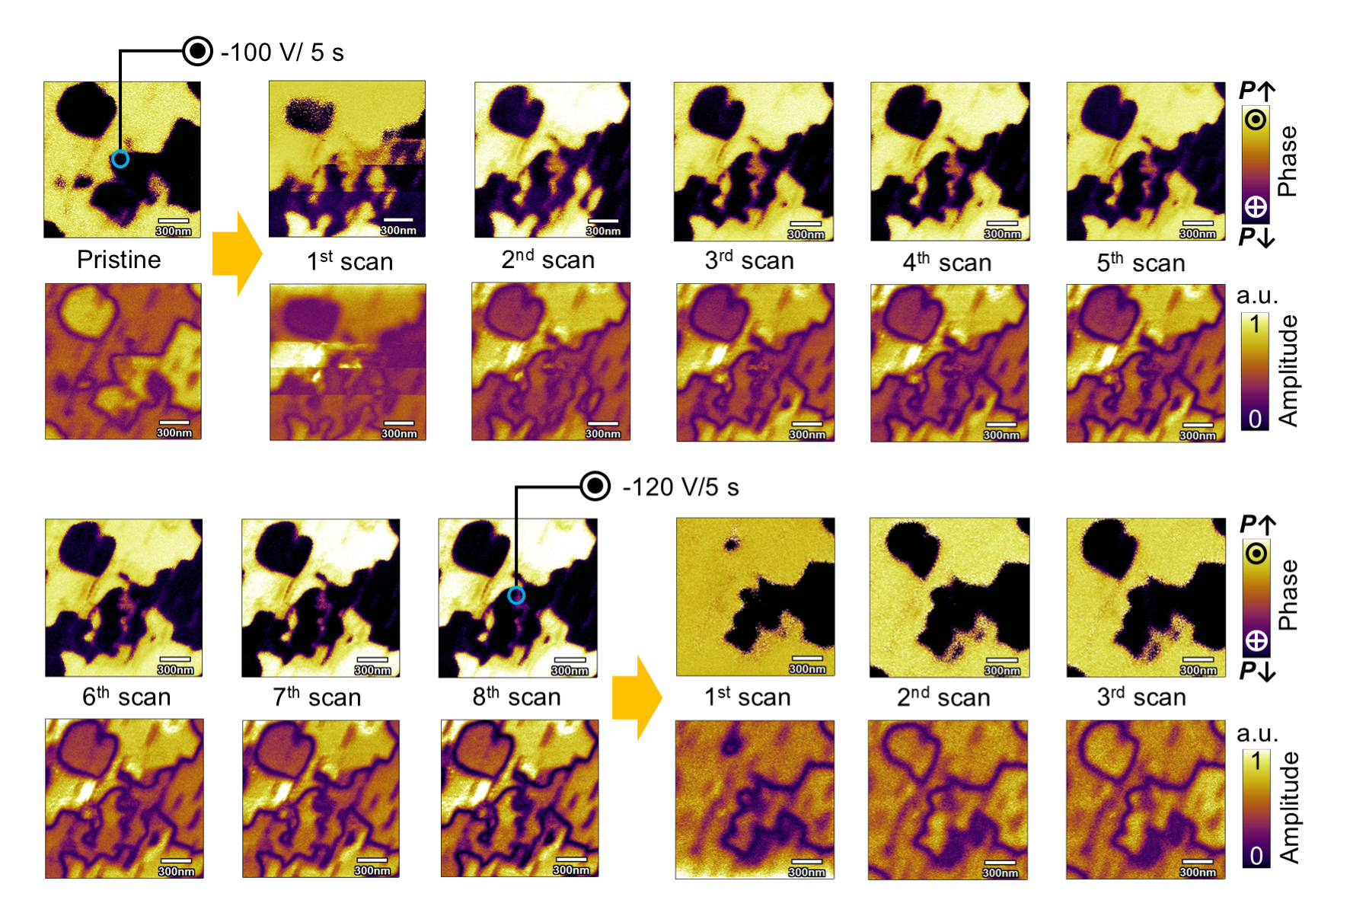
Supplementary Fig. 9. “Shape memory” effect of electrically switched ferroelectric domains. In such case, a bias (-100 V, 5 s) is applied at the central point location, then immediately withdrawn, followed by continuously scanning quickly (~26 s per image) to monitor the relaxation of switched domains. Until the switched ferroelectric domains are stabilized, we continue to apply bias (-100 V, 5 s), then immediately withdraw the bias, and continuously scan quickly (~26 s per image) to monitor the relaxation of switched domains.

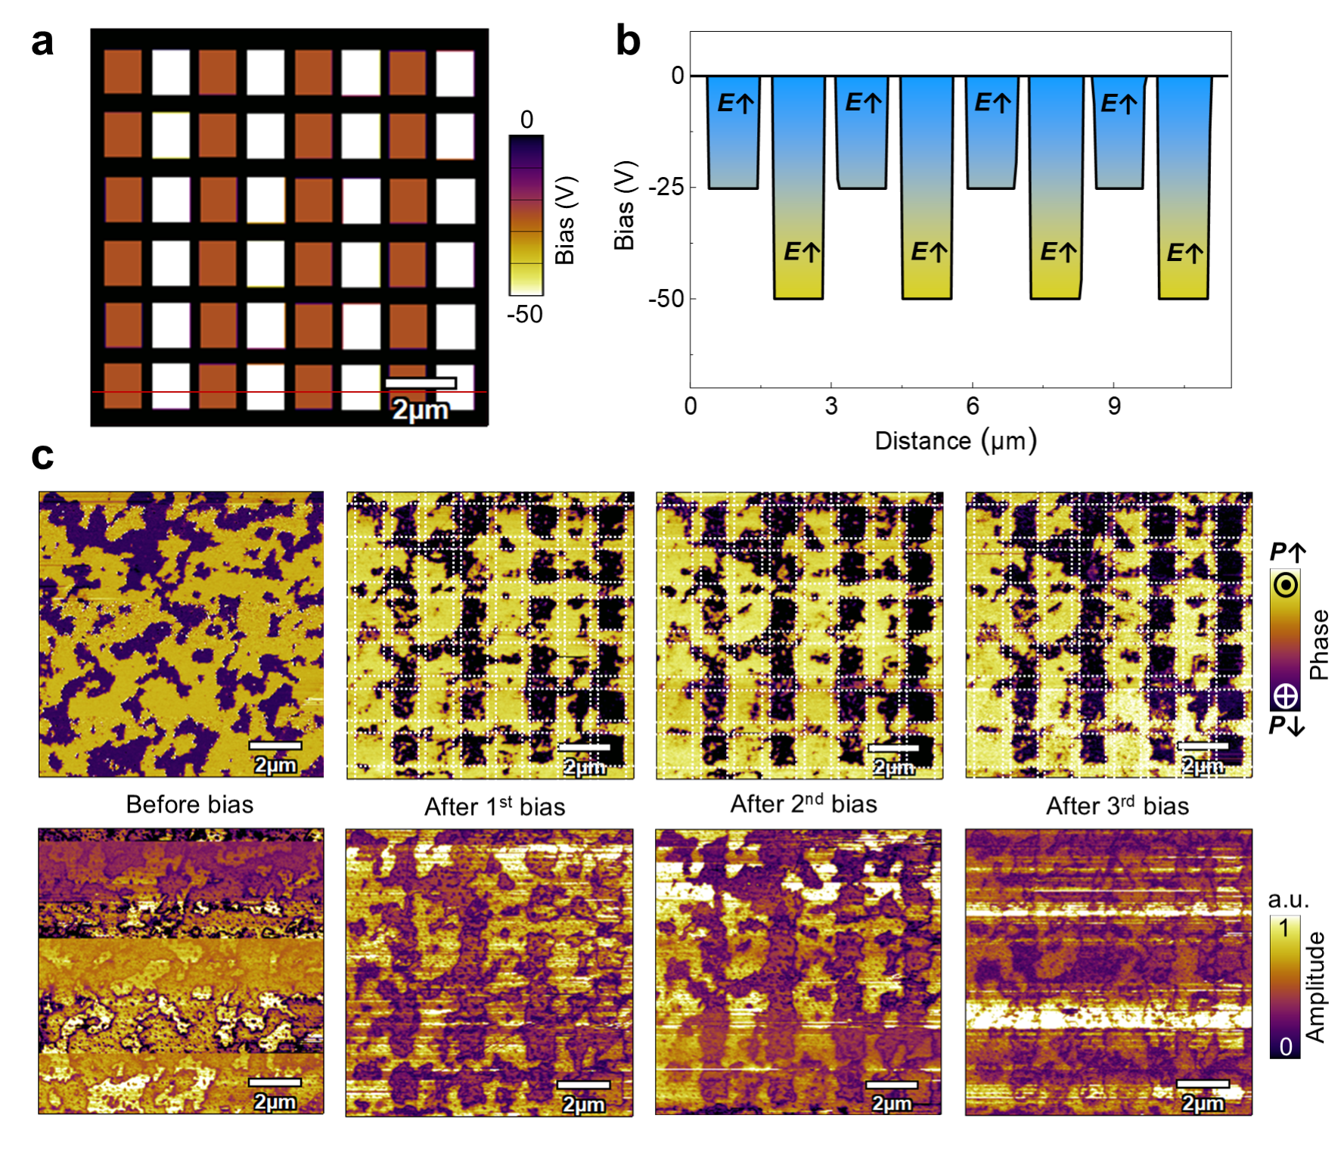
Supplementary Fig. 10. Electrical “writing” of grid-patterned ferroelectric domains under unidirectional electric fields. a-b Applied bias for electrically “writing” the ferroelectric domain, under alternating fields of -25 V (E↑, ⊙) and -50 V (E↑, ⊙). c The achieved grid-patterned ferroelectric domains by multiple electrical “writing” operations.

