Supplementary material
Inhibiting DPP4 activity protects hiPSC-derived steatotic HLCs by supporting fatty acid and purine metabolism and dampening inflammation
List of authors: Christiane Loerch¹, Wasco Wruck¹, Julian, Reiss¹, James Adjaye^{1,2}, Nina Graffmann¹
¹Institute for Stem Cell Research and Regenerative Medicine, Medical Faculty and University Hospital Düsseldorf, Heinrich Heine University, Düsseldorf, Germany
³University College London, EGA Institute for Women`s Health, Zayed Center for Research into Rare Diseases in Children (ZGR), London, United Kingdom

Table of contents
Supplementary Methods 2
Next generation sequencing and analysis of deep sequencing data 2
Microscopic imaging data 2
Supplementary Figures 3
Fig. S1 Cell morphology during the differentiation stages of cell lines Cntrl 1, Cntrl 2, Stea 1 and Stea 2. 3
Fig. S2 Characterization of HLC differentiation. 4
Fig. S3 OA-induction of Lipid droplets. 6
Fig. S4 Released proteins after OA treatment. 7
Fig. S5 Global transcriptome analysis of HLCs treated with OA with and without VILDA. 8
Fig. S6 Gene expression of steatosis markers in HLCs treated with OA w and w/o VILDA. 9
Fig. S7 Pearson’s correlation heatmap analysis upon OA w and w/o VILDA. 10
Fig. S8 Global transcriptome analysis of mock-treated HLCs with and without VILDA. 11
Fig. S9 Uncropped full-length western blot membranes. 12
Supplementary Tables 14
Table S1: List of Primers 14
Table S2: List of Antibodies 15
References 15

Supplementary Methods

Next generation sequencing and analysis of deep sequencing data

The HISAT2 (version 2.1.0) software(1) was employed to align the fastq files received from the BMFZ core facility against the GRCh38 genome. Parameter optimizations(2) were applied resulting in the command:
hisat2 -p 7 -N 1 -L 20 -i S,1,0.5 -D 25 -R 5 --mp 1,0 --sp 3,0 -x hisatindex/grch38_r109 -U input.fastq.gz -S output.sam
Via SAMtools software(3) the resulting BAM files were sorted by coordinates. Read counts per gene obtained with the subread (1.6.1) featurecounts software(4) using the ENSEMBL annotation file Homo_sapiens.GRCh38.109.gtf and parameters –t exon –g gene_id. Within the R/Bioconductor environment data was normalized with the voom(5) algorithm from the limma package(6) filtering genes, which were expressed with CPM (counts per million) > 1 in at least one sample. Venn diagrams were drawn with the VennDiagram package(7) based on genes considered expressed when there were more than 5 reads. Differential expression was determined by a p-value < 0.05 from the limma test and a fold change greater than 1.5 for genes expressed at least in one condition. The complete correlation table and gene lists for OA/mock experiments can be found in the supplementary table 1. The complete correlation table and gene lists for OA w and w/o VILDA experiments can be found in the supplementary table 2.

Microscopic imaging data
Make and model of microscope: Zeiss, LSM 700 microscope
Type, magnification, and numerical aperture of the objective lenses: LD Plan-Neofluar 20x/0.4 and Plan-Apochromat 40x/1.4 Oil DIC (UV)VIS-IR
Temperature: 20-22 °C
Imaging medium: Phosphate-buffered saline (PBS) w/o magnesium and calcium, 1x Fluoromount-G W DAPI (Biozol, Cat. Number: SBA-0100-20)
Fluorochromes: Alexa Fluor 488 Dye, Alexa Fluor 594 Dye, Alexa Fluor 555 Dye, Alexa Fluor 647 Dye, Hoechst 33342
Camera make and model: Zeiss, AxioCam MRM
Acquisition software: Zeiss, ZEN2012 (blue edition), Version 6.1.7601 for fluorescence microscopy and ZEN2011 SP3 (black edition), Version 8,1,6,484 for confocal microscopy. Images were processed using ZEN software, Version 3.10.103.00000,

Supplementary Figures
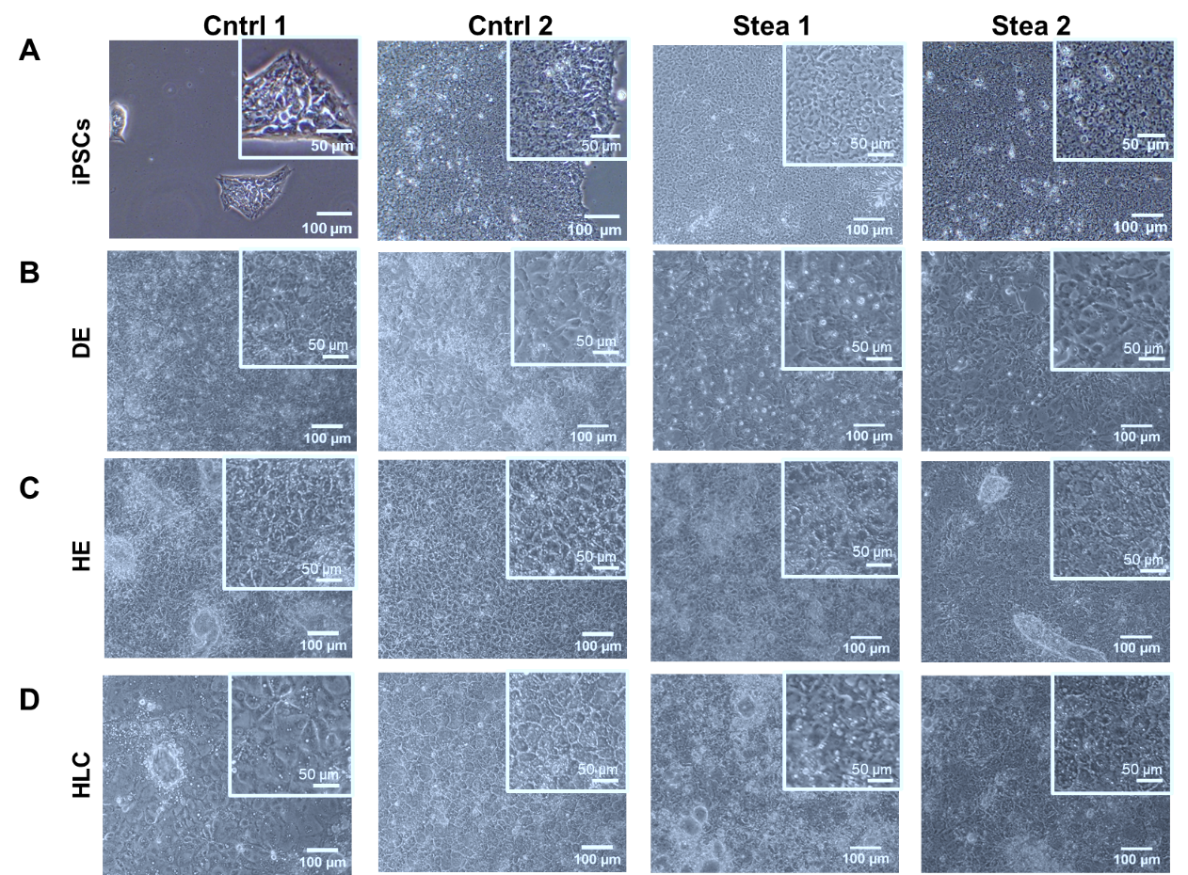
Fig. S1 Cell morphology during the differentiation stages of cell lines Cntrl 1, Cntrl 2, Stea 1 and Stea 2. Scale bars represent 100 µm and 50 µm in the zoom-in. (A) induced pluripotent stem cells (iPSCs). (B) Definitive endoderm (DE). (C) Hepatic endoderm (HE). (D) Hepatocyte-like cells (HLCs).
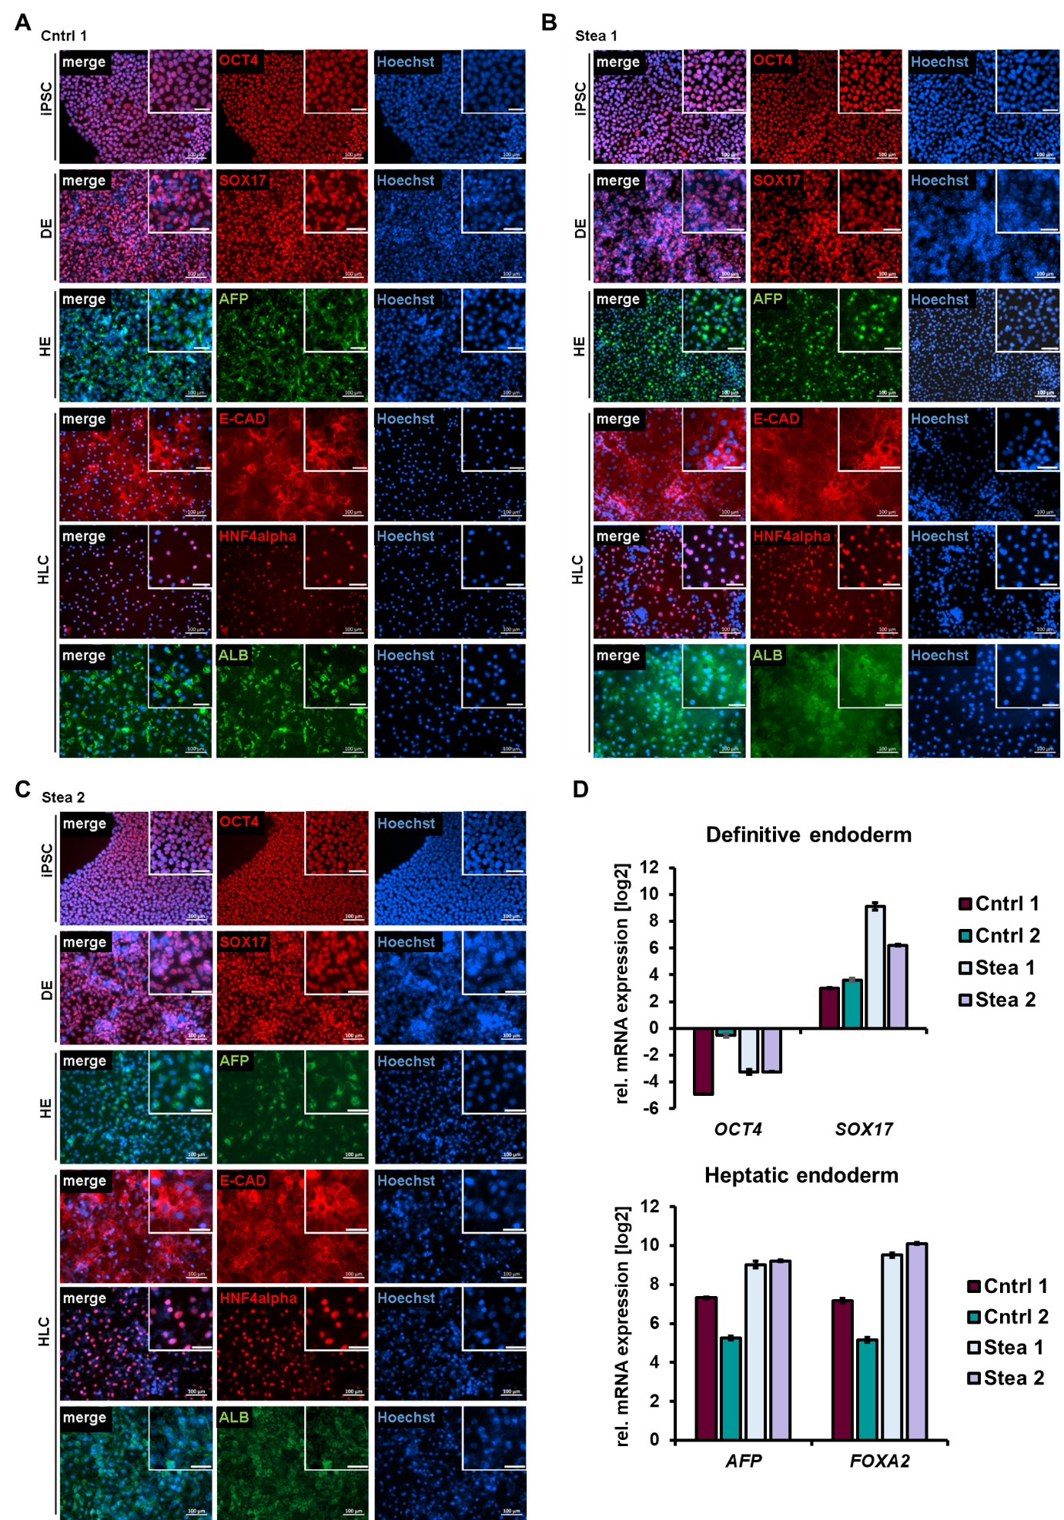
Fig. S2 Characterization of HLC differentiation. (A-C) Representative immunocytochemistry of cell line Cntrl 1, Stea 1 and Stea 2 of differentiation stages showing respective markers OCT4 in induced pluripotent stem cells (iPSCs), SOX17 in Definitive Endoderm (DE) and AFP in Hepatic Endoderm (HE). For hepatocyte-like cells (HLCs), the epithelial marker E-CAD, HNF4alpha and ALB are shown. (D) Gene expression of HLCs derived from four cell lines. Shown are means of three technical replicates (n=1) ± SE of OCT4 and SOX17 in DE and AFP and FOXA2 in HE in comparison to iPSC-stage (n=1).
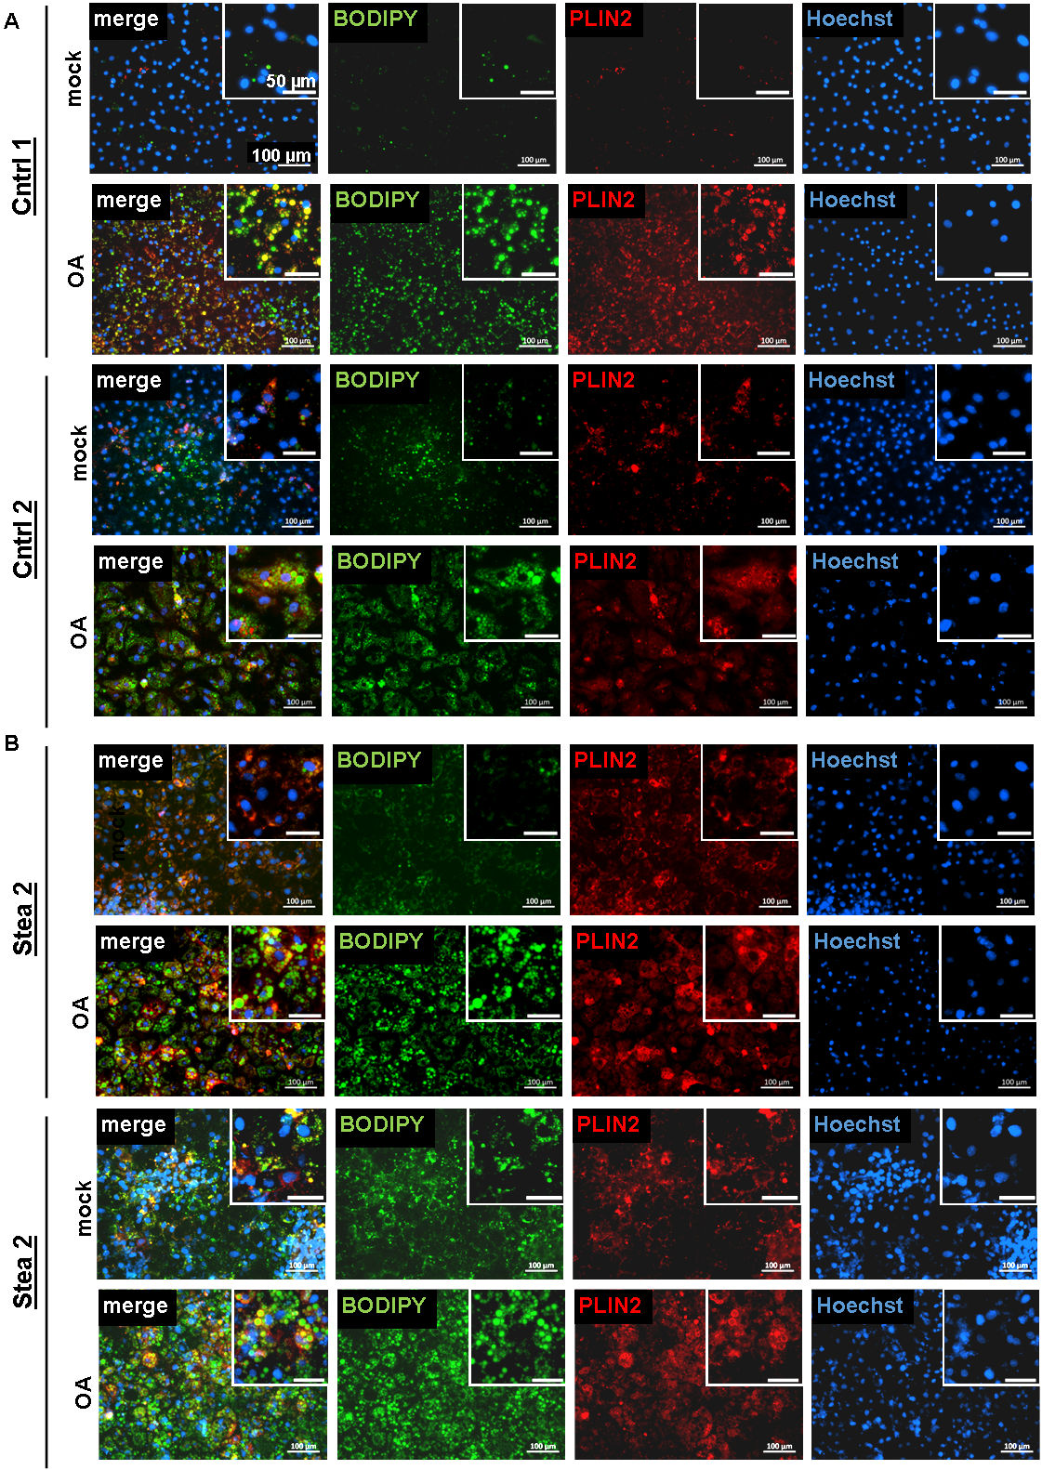
Fig. S3 OA-induction of Lipid droplets. (A/B) Representative immunofluorescence and BODIPY493/503 staining of HLCs of Cntrl 1, Cntrl 2 Stea 1 and Stea 2 HLCs treated with 400 µM OA (OA) and respective control (mock) for 7 days. PLIN2 is shown in red, fatty acids are stained in green, scale bars represent 100 µm in the original image and 50 µm in the zoom-in.
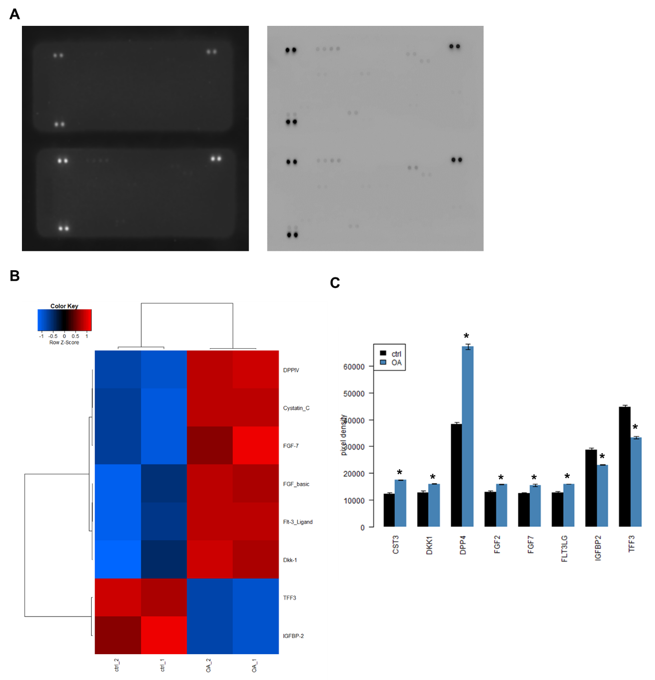
Fig. S4 Released proteins after OA treatment. Cntrl 1 HLCs were treated with OA for 7 days and the supernatant was analyzed for secreted proteins. (A) Array membranes, incubated with pooled supernatant of three biological replicates from mock (upper)- or OA (lower) treated Cntrl 1 HLCs. (B) Heatmap indicating significantly regulated proteins after analysis of the captured proteins on the membranes in technical duplicates. (C) Histogram of the detected chemiluminescence signal in pixel density for captured proteins under mock (ctrl) and OA treatment (* p-value < 0.05).
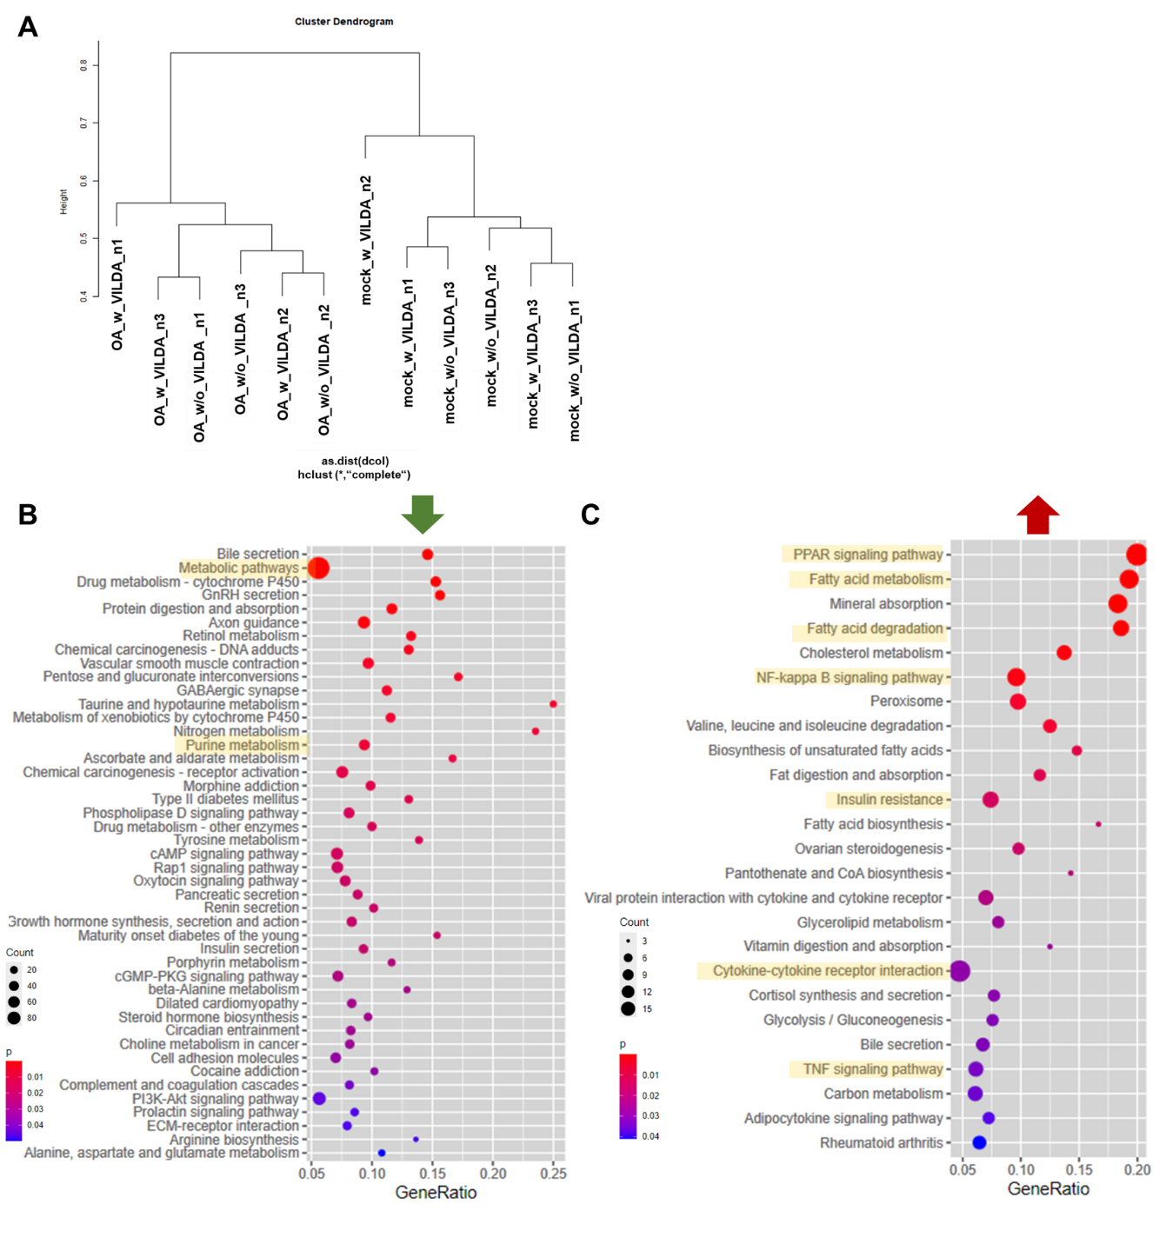
Fig. S5 Global transcriptome analysis of HLCs treated with OA with and without VILDA. (A) Hierarchical cluster dendrogram of global transcriptomic changes upon OA (mock or OA) with and without VILDA (w or w/o VILDA) treatment of HLCs derived from cell lines Cntrl 1 in three biological replicates (n=3). (B) KEGG-associated pathway analysis of significantly downregulated genes upon OA w/o VILDA in comparison to mock w/o VILDA treatment. (C) KEGG-associated pathway analysis of significantly upregulated genes upon OA w/o VILDA in comparison to mock w/o VILDA treatment.
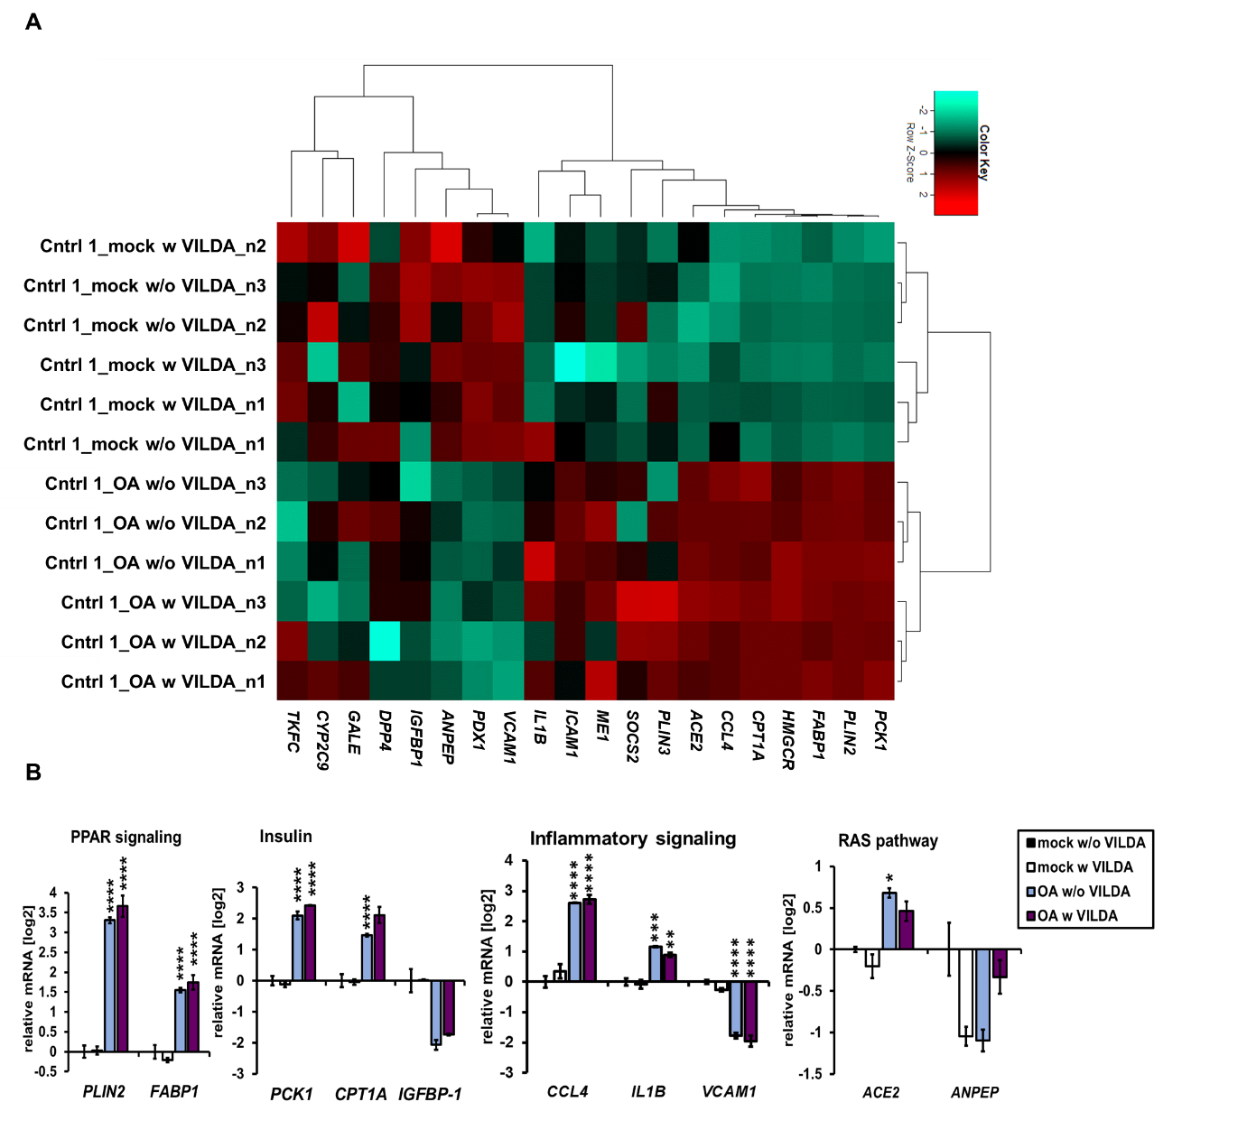
Fig. S6 Gene expression of steatosis markers in HLCs treated with OA w and w/o VILDA. (A) Heatmap analysis of steatosis associated genes. (B) Gene expression of PLIN2, FABP1, PCK1, CPT1A, IGFBP1, CCL4, IL1B, VCAM1, ACE2and ANPEP, shown as means of three biological replicates (n=3 ±SD), normalized to mock w/o VILDA. Ordinary two-way ANOVA, followed by Tukey`s multiple comparison test was performed to calculate significances (*p < 0.05, **p < 0.01, ***p < 0.001 in comparison to mock w/o VILDA).
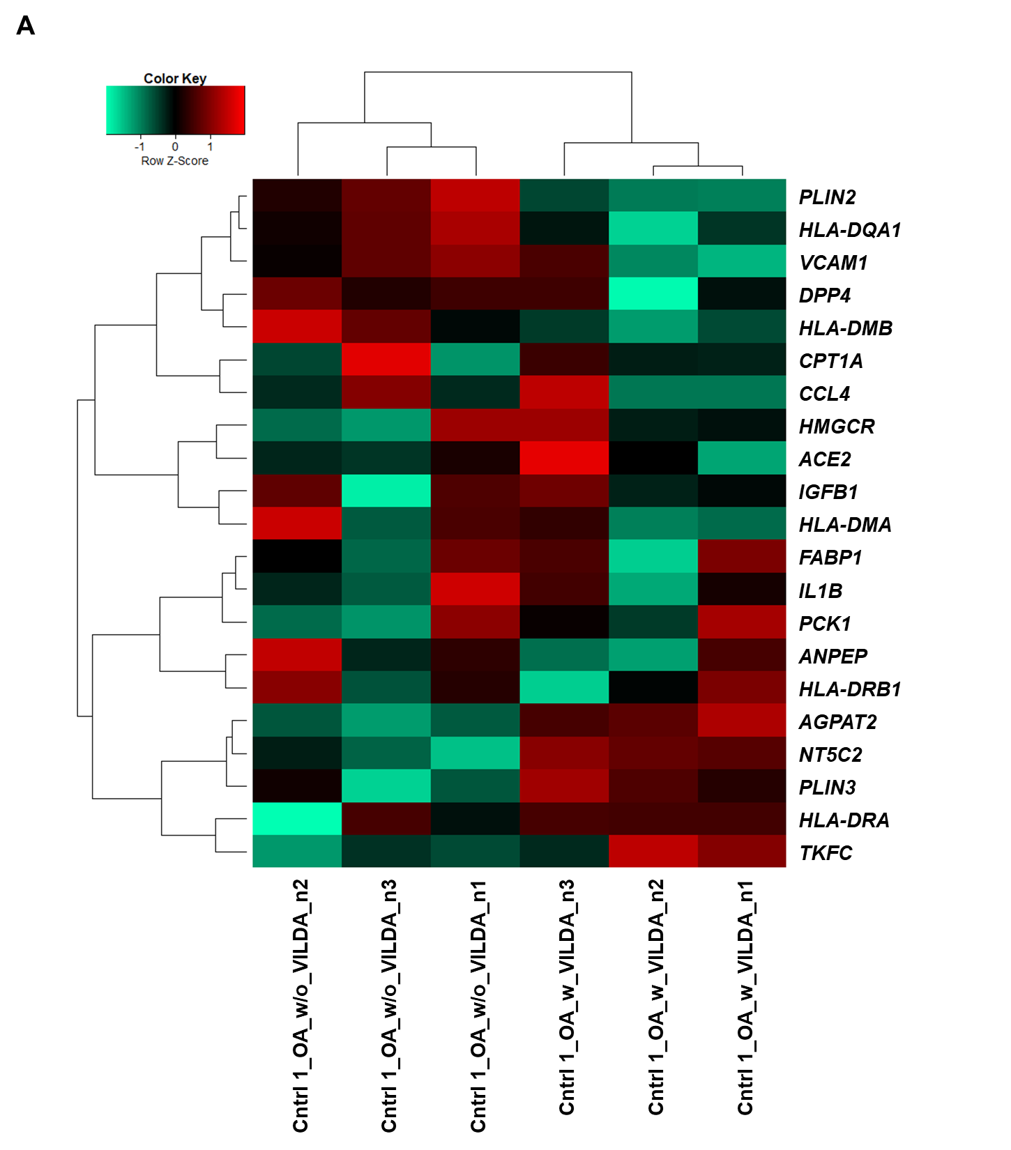
Fig. S7 Pearson’s correlation heatmap analysis upon OA w and w/o VILDA. (A) Pearson’s correlation heatmap analysis of genes involved in KEGG-associated pathways of purine metabolism (TKFC, NT5C2), fatty acid metabolism (FABP1, PLIN3, AGPAT2), inflammatory bowel disease, asthma and maturity onset diabetes of the young (HLA-DQA1, HLA-DMB).
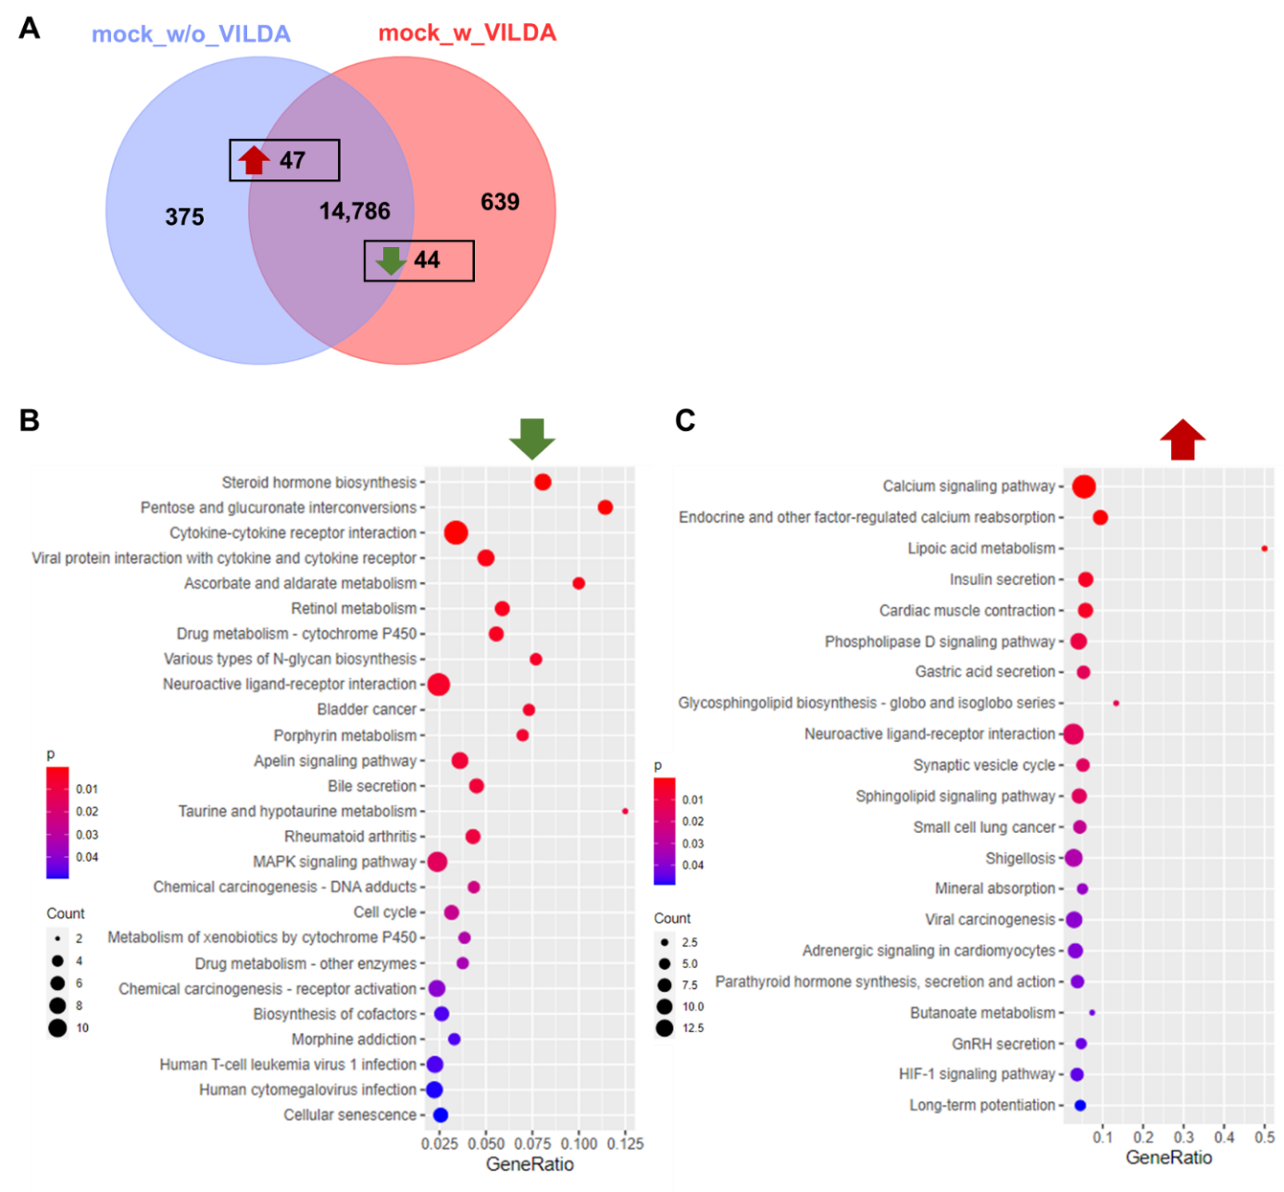
Fig. S8 Global transcriptome analysis of mock-treated HLCs with and without VILDA. (A) Venn diagram of expressed genes upon mock treatment, indicating 14,786 commonly expressed genes. 375 and 639 genes were exclusively expressed w/o or w VILDA, respectively. Among the exclusive and common gene sets, 47 genes were significantly up-, while 44 genes were significantly downregulated upon VILDA. (B) KEGG-associated pathway analysis of downregulated gene expression in HLCs treated with mock w and w/o VILDA. (C) KEGG-associated pathway analysis of upregulated gene expression in HLCs treated with mock w and w/o VILDA.
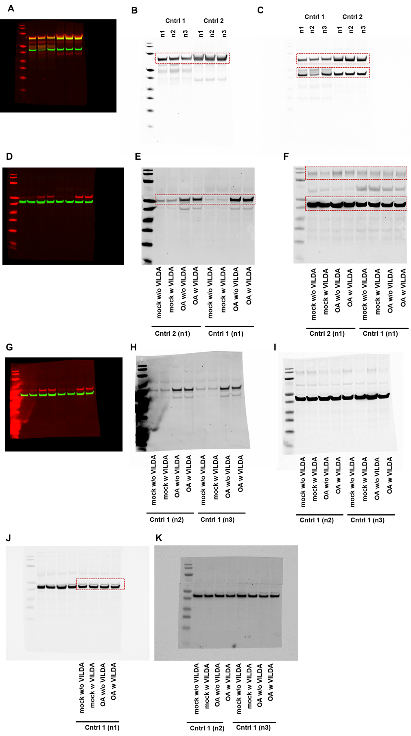

Fig. S9 Uncropped full-length western blot membranes.
(A-C) WB analysis of HLC differentiation, Fig. 1C. (A) composite membrane detected in 680RD and 800RD channels. (B) AFP staining (1:2000 overnight, at 4 °C) and detection with IRDye 680RD goat anti-Rabbit (Licor) 1:10000, 1 h at RT. (C) ALB (1:5000 overnight, 4 °C) and bActin (1:5000, 4 °C) staining, detected with IRDye 800RD goat anti-Mouse (Licor) (1:10000, 1 h, RT). Dotted lines indicate the cropping. (D-F) Uncropped WB membrane for Fig. 5B: Analysis of HLCs treated with OA w and w/o VILDA n1. (D) Composite membrane detected in 680RD and 800RD channels. (E) PLIN2 staining (1:2000 overnight, at 4 °C) and detection with IRDye 680RD goat anti-Rabbit (Licor) 1:10000, 1 h at RT. (F) DPP4 (1:5000 overnight, 4 °C) and bActin (1:5000, 4 °C) staining, detected with IRDye 800RD goat anti-Mouse (Licor) (1:10000, 1 h, RT). Dotted lines indicate the cropping. (G-I) Full-length WB membrane for Fig. 5C: Analysis of Cntrl 1 HLCs treated with OA w and w/o VILDA n2 and n3. (G) Composite membrane detected in 680RD and 800RD channels. (H) PLIN2 staining (1:2000 overnight, at 4 °C) and detection with IRDye 680RD goat anti-Rabbit (Licor) 1:10000, 1 h at RT. (I) DPP4 (1:5000 overnight, 4 °C) and bActin (1:5000, 4 °C) staining, detected with IRDye 800RD goat anti-Mouse (Licor) (1:10000, 1 h, RT). (J-K): Uncropped WB membrane for Fig. 6G: Analysis of HLCs treated with OA w and w/o VILDA. PLIN3 Staining (1:5000 overnight, at 4 °C) and detection with IRDye 800RD goat anti-Mouse (Licor) (1:10000, 1 h, RT).

Supplementary Tables

Table S1: List of Primers
Primers
Gene | Sequence
* | Forward 5`-3` | Reverse 5`-3`
AFP | AGCAGCTTGGTGGTGGATGA | CCTGAGCTTGGCACAGATCCT
AGPAT2 | GGGGCGTCTTCTTCATCA | TTGAGGTTCTCCCTGACCAT
Albumin | AGCTGTTATGGATGATTTCGCAG | CCTCGGCAAAGCAGGTCTC
ANPEP | TGAGCTGTTTGACGCCATCT | GCCCTGCTTGAATACGTCCT
CCL4 | GCTAGTAGCTGCCTTCTGCT | CCACAAAGTTGCCAGGAAGC
CPT1A | CCTACCACGGGTGGATGTTC | CAACATGGGTTTTCGGCCTG
CYP2D6 | TTCCTGCCTTTCTCAGCAGG | GCACAAAGCTCATAGGGGGA
CYP3A4 | GTGACTTTGCCCATTGTTTAGAAAG | CAGGCGTGAGCCACTGTG
DPP4 | GTTCTTCTGGGACTGCTGGG | GCTGTAGCATCATCTGTGCCT
FABP1 | ATCGTGCAGAATGGGAAGCA | CCCCTGTCATTGTCTCCAGC
FOXA2 | TTCAGGCCCGGCTAACTCTG | CCTTGCGTCTCTGCAACACC
HLA-DMA | GGGTTTCCTATCGCTGAAGTG | CCAATAGGCAATTGCTGTGTA
IGFBP1 | ACCATCACTTGCCCAGAGTT | AGGAGCAGTACCAGCCAGAC
IL1B | TGTACCTGTCCTGCGTGTTG | ACTGGGCAGACTCAAATTCCA
OCT4 | AGTTTGTGCCAGGGTTTTTG | ACTTCACCTTCCCTCCAACC
PCK1 | GGGAGTCTCCGGAAGGTGTT | CATGGCAAAGGGGTCATGC
PLIN2 | GCTGAGCACATTGAGTCACG | TGGTACACCTTGGATGTTGG
RPLP0 | TCGACAATGGCAGCATCTAC | ATCCGTCTCCACAGACAAGG
sHLA-DMB | CGGCCACCATCTGTGCAAGT | CCAGTCCCGAACGATGGGCT
sHLA-DQA1 | GAAGGAGACTGCCTGGCG | CATGATGTTCAAGTTGTGTTTTGC
sHLA-DRB1 | ACCCAAGCGTGACAAGCCCT | CCCGACTCCACTCAGCATCTTG
SOX17 | ACGTGTACTACGGCGCGATG | CTGGTGCTGGTGCTGGTGTT
VCAM1 | CGAACCCAAACAAAGGCAGAGTA | GAGGAAGGGCTGACCAAGACG

Table S2: List of Antibodies
Use: |  |  |  | Western Blot |  | Immunocytochemistry
Antibody | Host species | Manufacturer | Catalog number | Dilution | Diluent/ Blocking | Dilution | Diluent/Blocking
Albumin (ALB) | mouse | Sigma | A6684-.2ml | 1:5000 | 5 % Milk TBS-T | 1:100 | 10 % goat serum
Alpha-fetoprotein (AFP) | rabbit | Sigma | HPA023600 | 1:2000 | 5 % Milk TBS-T | 1:300 | 3 % BSA
Angiotensin converting enzyme 2 (ACE2) | goat | R&D Systems | AF933 | 1:5000 | 5 % Milk TBS-T | NA | NA
beta-Actin | mouse | Cell Signaling Technologies | 3700S | 1:5000 | 5 % Milk TBS-T | NA | NA
Dipeptidyl peptidase 4 (DPP4) | mouse | Proteintech | 68383-1-Ig | 1:5000 | 5 % Milk TBS-T | 1:100 | 3 % BSA
E-Cadherin (ECAD) | goat | Cell Signaling Technologies | 3195 | NA | NA | 1:100 | 3 % BSA
Hepatocyte nuclear factor 4alpha (HNF4a) | rabbit | Abcam | 92378 | NA | NA | 1:250 | 3 % BSA
Octamer-binding transcription factor 4 (OCT4) | rabbit | Cell Signaling technologies | 2840S | NA | NA | 1:400 | 3 % BSA
Perilipin-2 (PLIN2) | rabbit | Proteintech | 15294-1-AP | 1:2000 | 5 % Milk TBS-T | 1:200 | 3 % BSA
Perilipin-3/TP47 (PLIN3) | mouse | Proteintech | 66523-1-Ig | 1:5000 | 5 % Milk TBS-T | NA | NA
Sry box transcription factor 17 (SOX17) | goat | R&D Systems | AF1924 | NA | NA | 1:50 | 3 % BSA
IRDye680RD Goat anti-Rabbit | goat | Licor | 925-68070 | 1:10,000 | 5 % Milk TBS-T | NA | NA
IRDye800RD  Goat-anti-Mouse | goat | Licor | 925-68071 | 1:10,000 | 5 % Milk TBS-T | NA | NA
Alexa 594 gt anti ms IgG (H+L) | goat | Life technologies | A10521 | NA | NA | 1:500 | 3 % BSA
Alexa647 gt anti-Rabbit IgG (H+L) | goat | Life technologies | A32733 | NA | NA | 1:500 | 3 % BSA
Alexa488 gt anti-Rabbit IgG (H+L | goat | Life technologies | A11008 | NA | NA | 1:500 | 3 % BSA
Alexa555 dk anti-Goat IgG | donkey | Life technologies | A32816 | NA | NA | 1:500 | 3 % BSA

References
1. Kim D, Langmead B, Salzberg SL. HISAT: a fast spliced aligner with low memory requirements. Nat Methods 2015;12:357-360.
2. Baruzzo G, Hayer KE, Kim EJ, Di Camillo B, FitzGerald GA, Grant GR. Simulation-based comprehensive benchmarking of RNA-seq aligners. Nat Methods 2017;14:135-139.
3. Li H, Handsaker B, Wysoker A, Fennell T, Ruan J, Homer N, Marth G, et al. The Sequence Alignment/Map format and SAMtools. Bioinformatics 2009;25:2078-2079.
4. Liao Y, Smyth GK, Shi W. featureCounts: an efficient general purpose program for assigning sequence reads to genomic features. Bioinformatics 2014;30:923-930.
5. Law CW, Chen Y, Shi W, Smyth GK. voom: Precision weights unlock linear model analysis tools for RNA-seq read counts. Genome Biol 2014;15:R29.
6. Smyth GK. Linear models and empirical bayes methods for assessing differential expression in microarray experiments. Stat Appl Genet Mol Biol 2004;3:Article3.
7. Chen H, Boutros PC. VennDiagram: a package for the generation of highly-customizable Venn and Euler diagrams in R. BMC Bioinformatics 2011;12:35.

