Using Gypsum-modified Biochar to Adsorb Phosphate from Water: Adsorption Performance and Mechanism

Guanli Xu, Di Wu*, Xiang Ao

College of Earth and Planetary Science Sciences, Chengdu University of Technology, Chengdu, 610059, P.R. China.
∗Corresponding author. E-mail address: asumio1994@gmail.com.

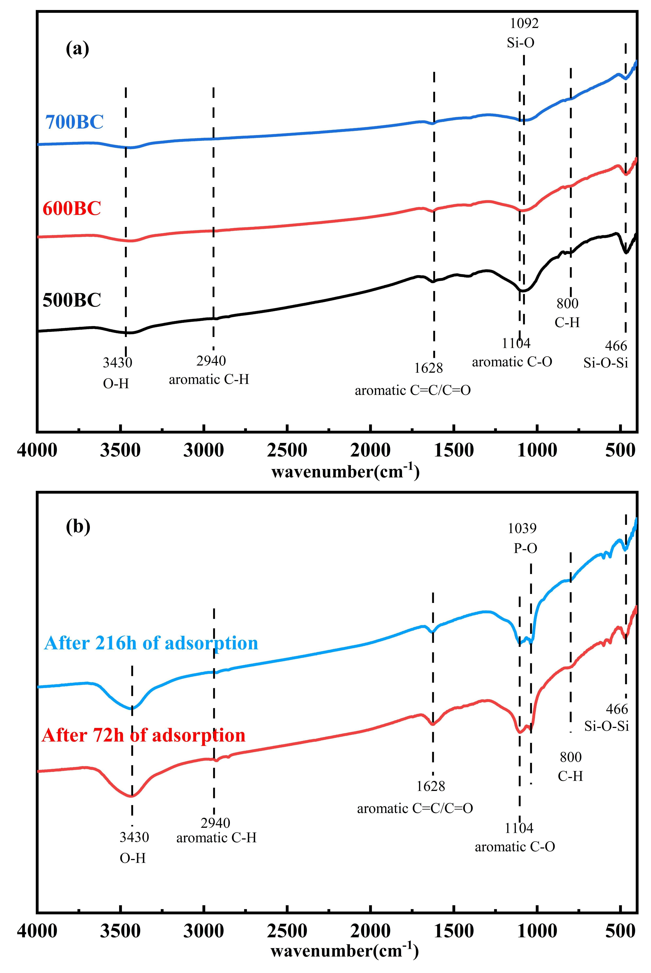
Fig. S1. FTIR Spectra of (a) 700BC, 600BC and 500BC and (b) 700GBC after adsorption for 72 and 216 h.

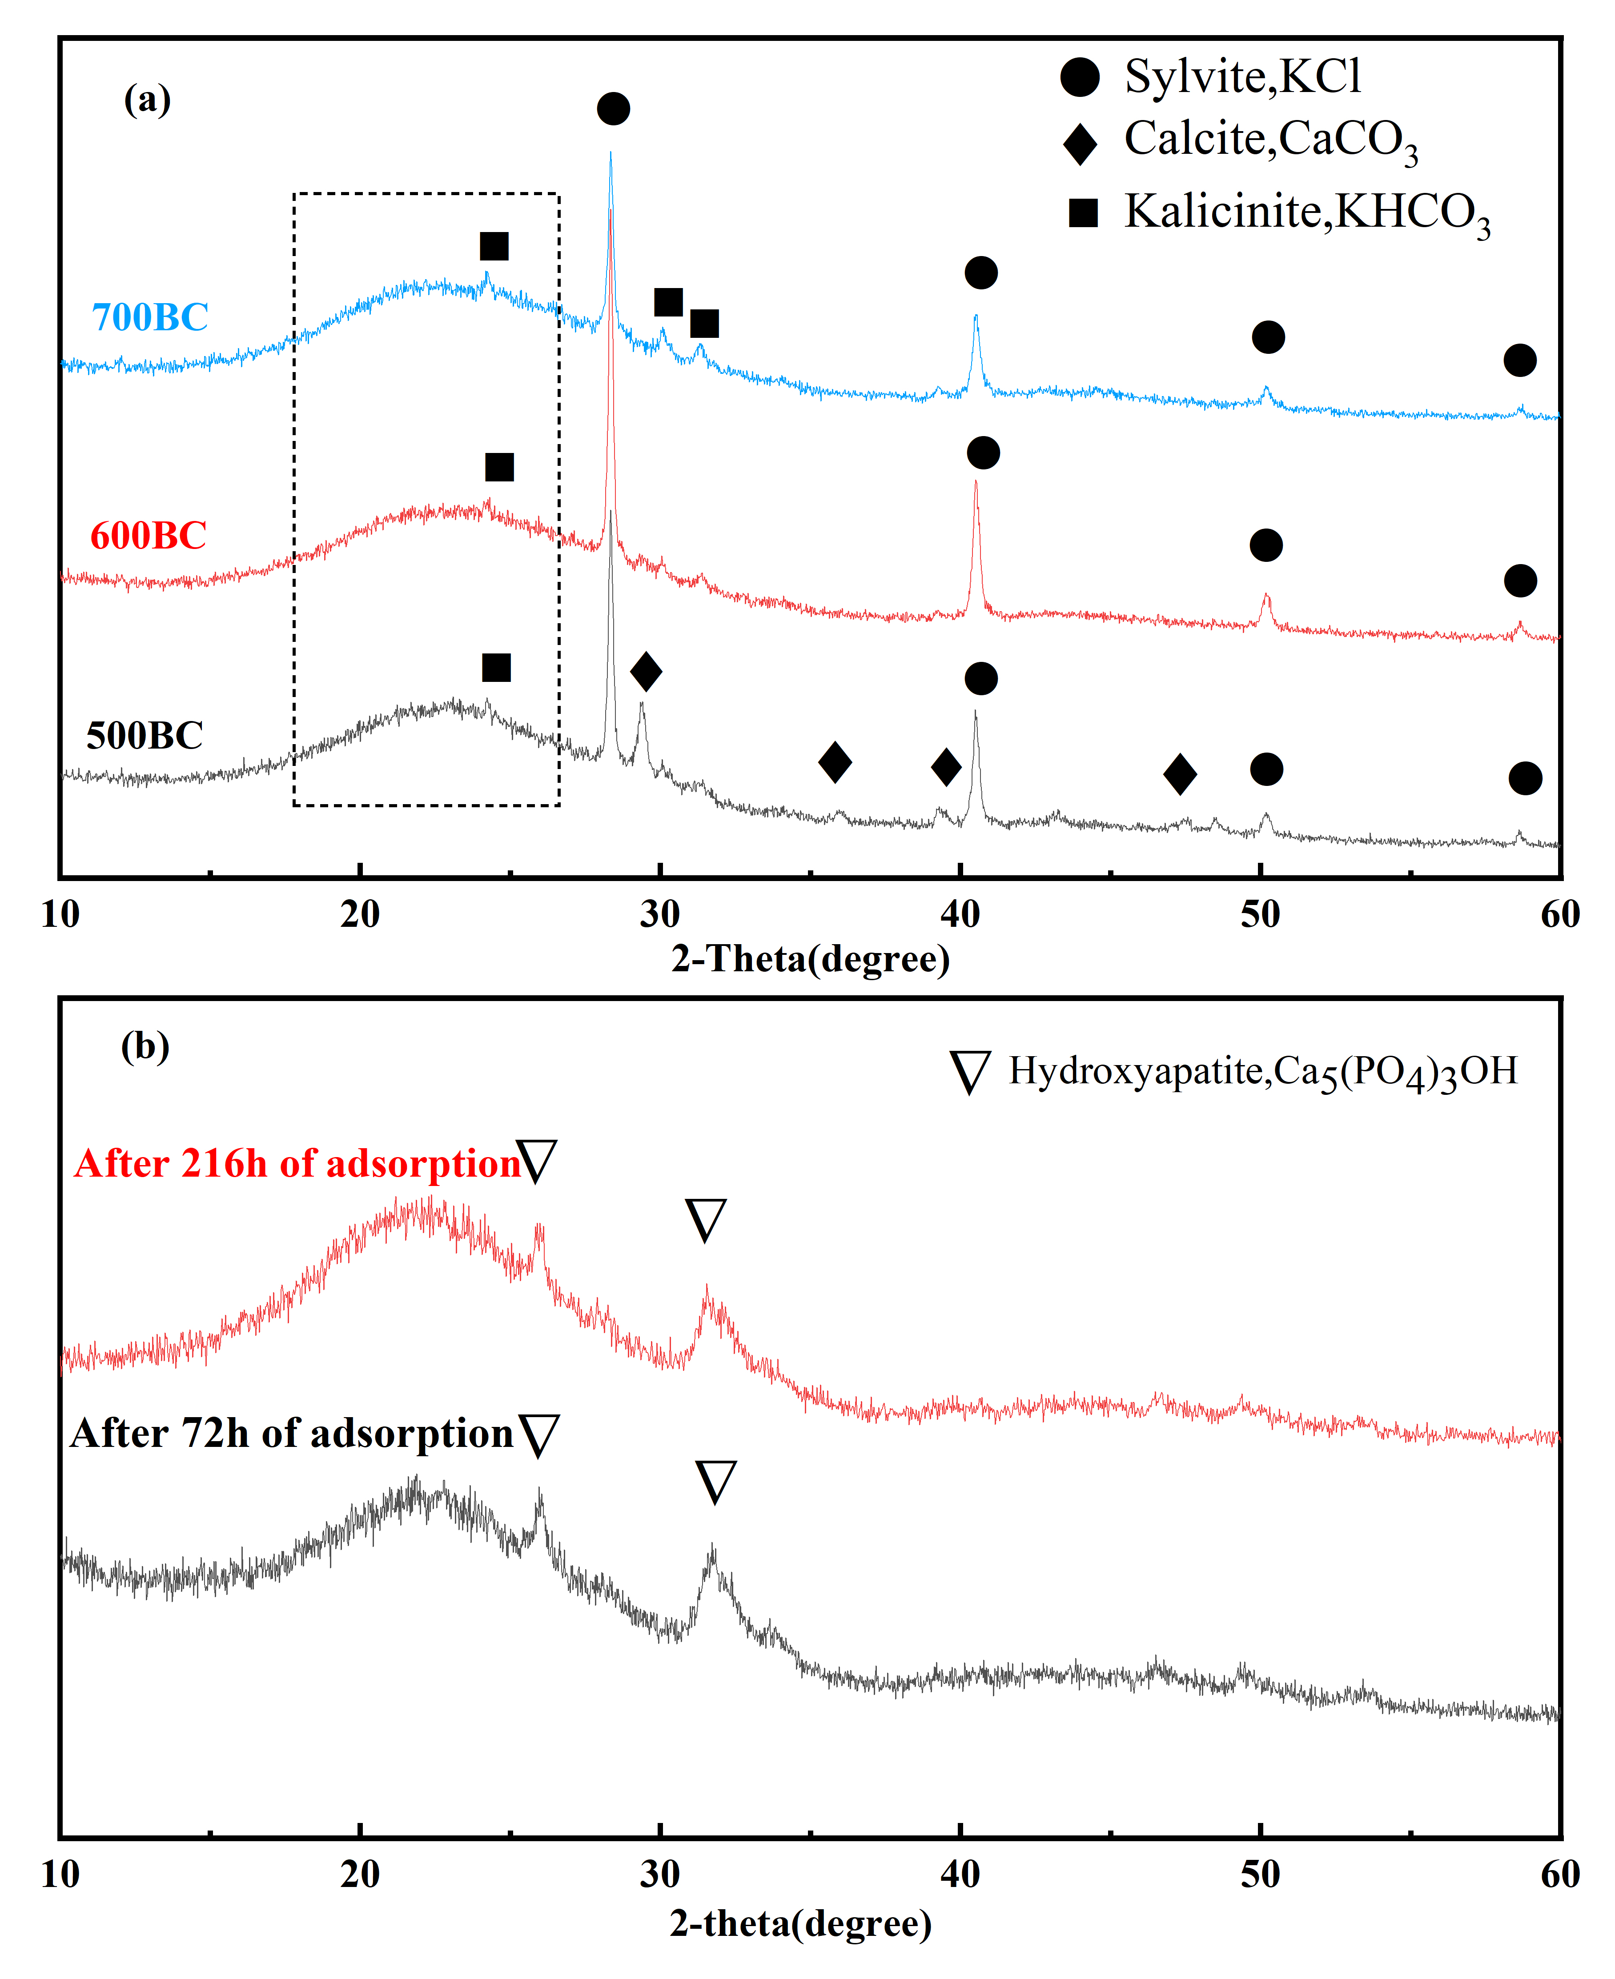
Fig. S2. XRD spectra of (a) 700BC, 600BC and 500BC and (b) 700GBC after adsorption for 216 and 72 h

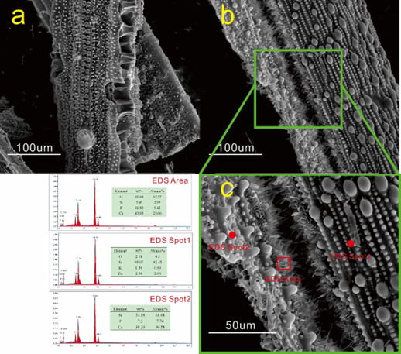
Fig. S3. SEM images of 700BC before adsorption and (b) 700GBC after adsorption. (c) SEM and EDS images of GBC after adsorption.

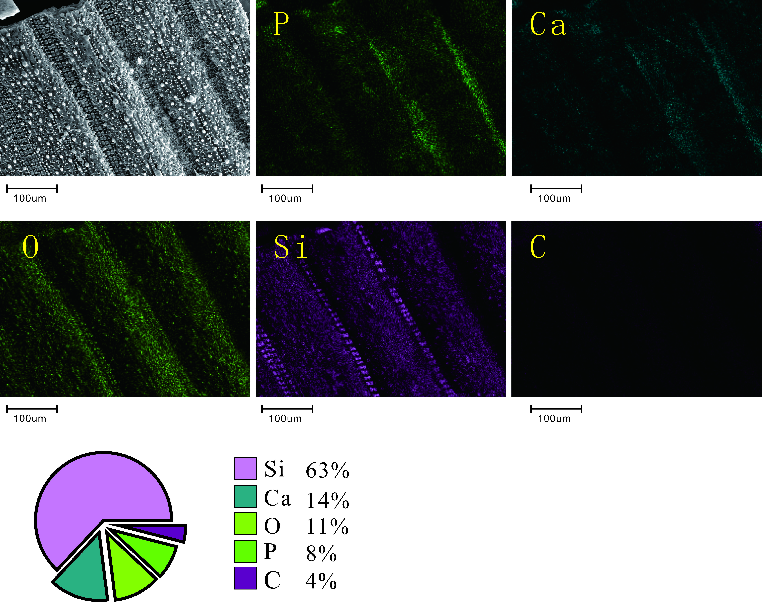
Fig. S4. SEM elemental mapping of 700GBC after adsorption.

