Supplementary information for the manuscript entitled:

CRY1 fuels resistance to T cell-based immunotherapy in NANOG^{high} cancers

Se Jin Oh et al.

Supplementary Figure 1. Diagram depicting the schedule of in vivo treatment.
Supplementary Figure 2. MHC class I expression are unaffected by CRY1 in PD-1 blockade-resistant tumor cells.
Supplementary Figure 3. CRY1 plays a crucial role in NANOG-driven immune-refractory properties.
Supplementary Figure 4. NANOG represses the expression of E3 ligases.
Supplementary Figure 5. Efficiency of siRNAs targeting APC3 or TRIM17.
Supplementary Fig. 6. CRY1 regulates the expression of effector molecules that induces immune-refractory phenotypes in NANOGhigh tumor cells.
Supplementary Fig. 7. CRY1 inhibition sensitizes innate immunotherapy-resistant tumors to PD-1 blockade.
Supplementary Fig. 8. CRY1 inhibition enhances anti-tumor response to adoptive T cell therapy.
Supplementary Fig. 9. Gating strategy for identification of apoptotic tumor cells by CTL-mediated killing.
Supplementary Fig. 10. Uncropped blot images.

Supplementary Figures and Figure legends
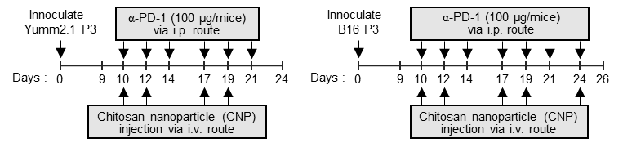
Supplementary Fig. 1. Diagram depicting the schedule of in vivo treatment. Schematic of the therapy regiment in C57BL/6 mice implanted with PD-1 blockade-resistant tumor cells were treated with indicated reagents.

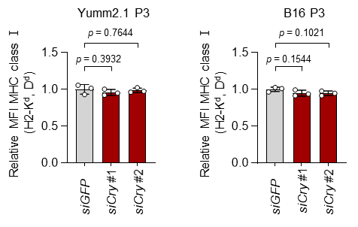
Supplementary Fig. 2. MHC class I expression are unaffected by CRY1 in PD-1 blockade-resistant tumor cells. The MHC class I expression on PD-1 blockade-resistant tumor cells transfected with siRNA-targeting GFP or Cry1 was measured by flow cytometry. All experiments were performed in triplicate. The p-values were calculated using one-way ANOVA. Data represent the mean ±SD. Source data are provided as a Source Data file.

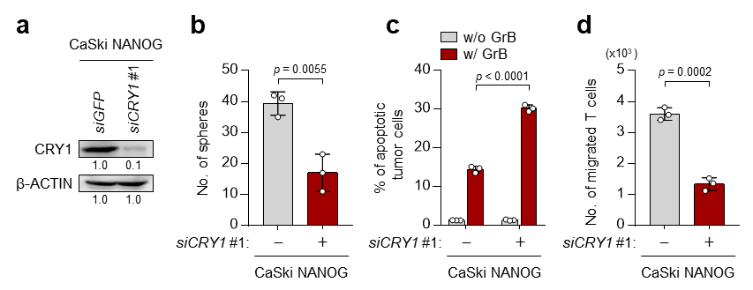
Supplementary Fig. 3. CRY1 plays a crucial role in NANOG-driven immune-refractory properties. a-d CaSki NANOG cells were transfected with siRNA-targeting GFP or CRY1. a Levels of indicated proteins determined by Western blot. β-actin was included as an internal loading control. Numbers below blot images indicate the expression as measured by fold change. b Sphere-forming capacity of the cells in low-density suspension culture. c Flow cytometry analysis of the frequency of apoptotic (active caspase-3⁺) cells after intracellular delivery of GrB for 4 h. d Transwell-based T cell chemotaxis assay by using siGFP- of siCRY #1-transfected tumor cells-derived conditioned media. All experiments were performed in triplicate. The p-values were calculated using two-tailed Student’s t test. (b and d), or two-way ANOVA (c). Data represent the mean ±SD. Source data are provided as a Source Data file.

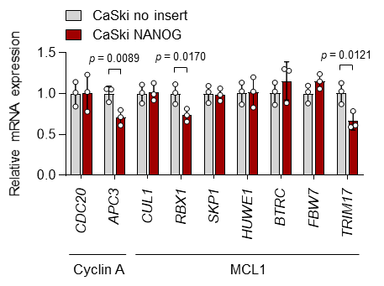
Supplementary Fig. 4. NANOG represses the expression of E3 ligases. mRNA levels of indicated genes in CaSki no insert and CaSki NANOG cells determined by qRT-PCR. This experiment was performed in triplicate. The p-values were calculated using two-tailed Student’s t test. Data represent the mean ±SD. Source data are provided as a Source Data file.

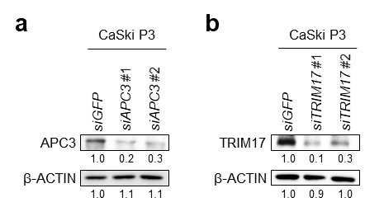
Supplementary Fig. 5. Efficiency of siRNAs targeting APC3 or TRIM17. a and b Levels of the APC3 (a) or TRIM17 (b) protein in CaSki P3 cells transfected with indicated siRNAs determined by Western blot. β-actin was included as an internal loading control. Numbers below blot images indicate the expression as measured by fold change. This experiment was performed in triplicate.

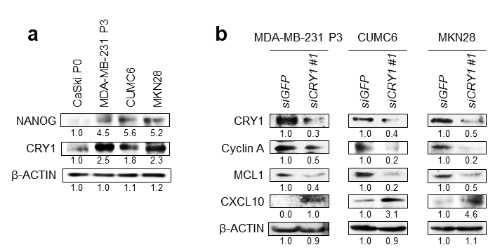
Supplementary Fig. 6. CRY1 regulates the expression of effector molecules that induces immune-refractory phenotypes in NANOG^{high} tumor cells. a The levels of NANOG and CRY1 proteins determined by Western blot. b Relative levels of indicated proteins in indicated tumor cells transfected with siRNA-targeting GFP or CRY1 were measured by Western blot. β-actin was included as an internal loading control. Numbers below blot images indicate the expression as measured by fold change. All experiment was performed in triplicate.

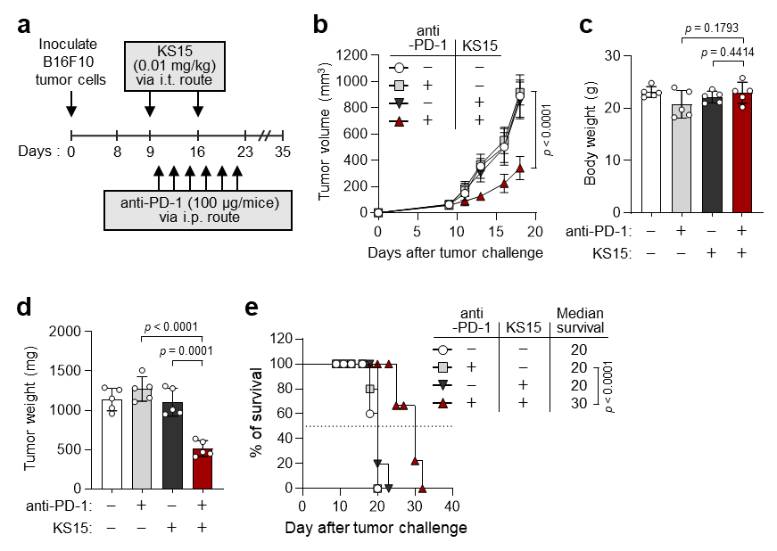
Supplementary Fig. 7. CRY1 inhibition sensitizes innate immunotherapy-resistant tumors to PD-1 blockade. a Schematic of the therapy regiment for C57BL/6 mice implanted with B16F10 tumor cells were treated with indicated reagents. b Tumor growth, c the mouse body weight, d tumor mass at 18 days after challenge, and e survival of mice. For in vivo experiments, five mice from each group were used. Results in the graphs represent 3 independent experiments performed in triplicate. The p-values were calculated using one-way ANOVA (c and d), two-way ANOVA (b), or Gehan-Breslow-wilcoxon test (e). Data represent the mean ±SD. Source data are provided as a Source Data file.

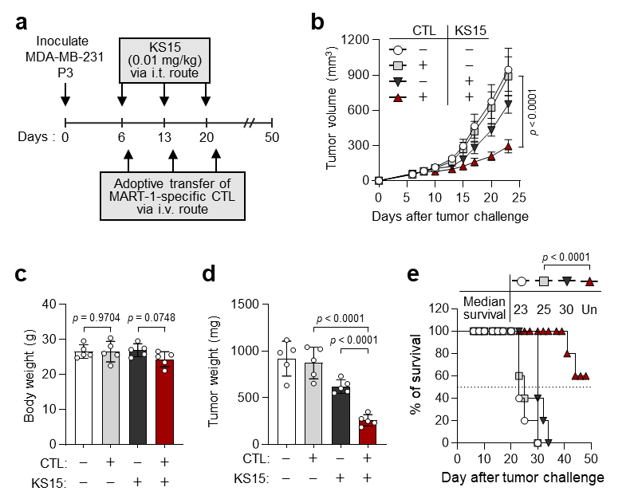
Supplementary Fig. 8. CRY1 inhibition enhances anti-tumor response to adoptive T cell therapy. a Schematic of the therapy regimen in NOD-SCID mice implanted with MDA-MB-231 P3 cells. b-e The tumor growth (b), the mouse body weight (c), the tumor mass at 23 days after challenge (d), and the survival (e) of MDA-MB-231 P3 tumor cells-bearing mice administrated with vehicle or KS15, with or without MART-1 specific CTL. For in vivo experiments, five mice from each group were used. Results in the graphs represent 3 independent experiments performed in triplicate. The p-values were calculated using one-way ANOVA (c and d), two-way ANOVA (b), or Gehan-Breslow-wilcoxon test (e) are indicated. Data represent the mean ±SD. Source data are provided as a Source Data file.

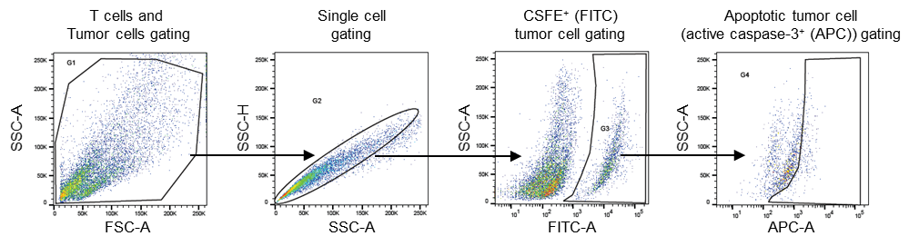
Supplementary Fig. 9. Gating strategy for identification of apoptotic tumor cells by CTL-mediated killing. Representative flow cytometry analysis showing the gating strategy. T cells and tumor cells population was initially gated based on the FSC-A and SSC-A, and single cells were gated based on SSC-A and SSC-H. After then, CFSE⁺ tumor cells were gated in the plot CFSF (FITC). Finally, the CSFE⁺ and active caspase-3⁺ population was measured in the active caspase-3⁺ (APC).

Supplementary Fig. 10. Uncropped blot images.
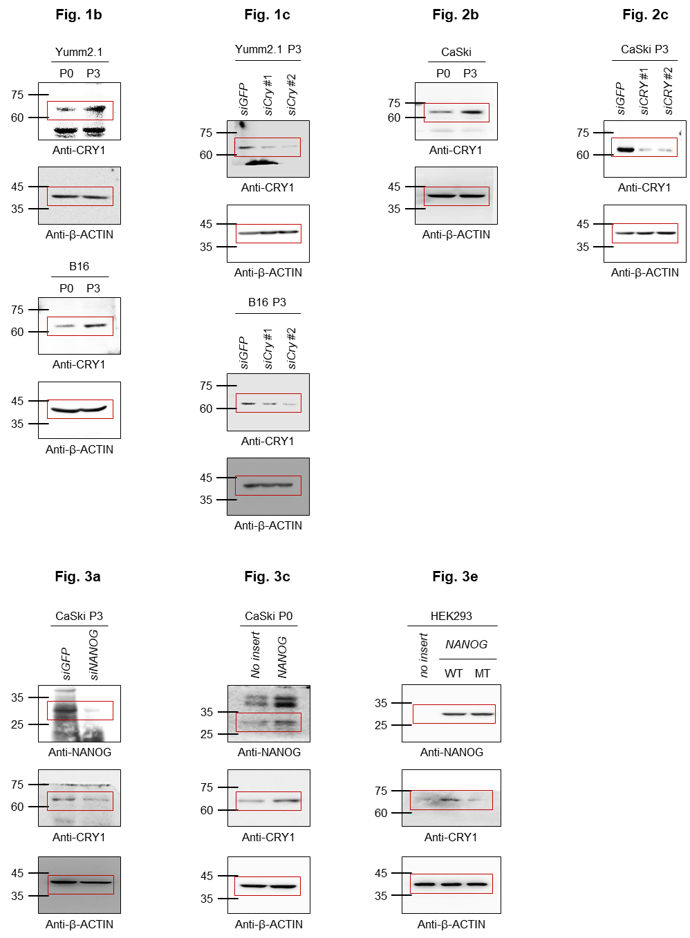

Supplementary Fig. 10. Uncropped blot images (continued).
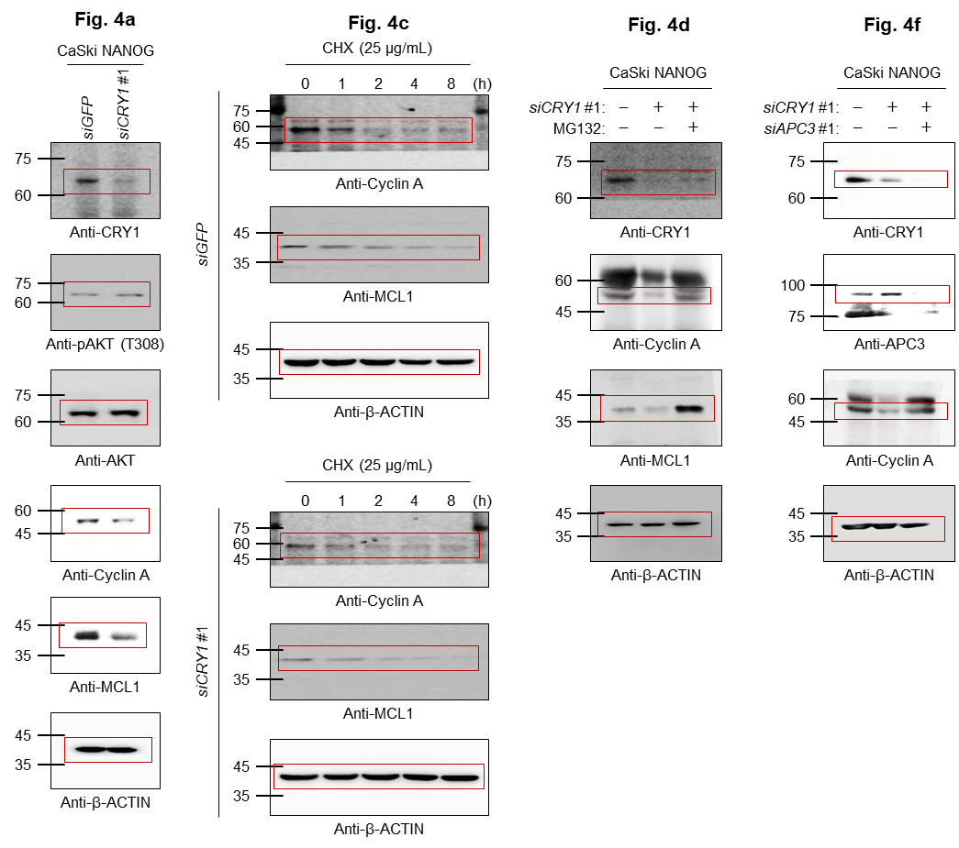

Supplementary Fig. 10. Uncropped blot images (continued).
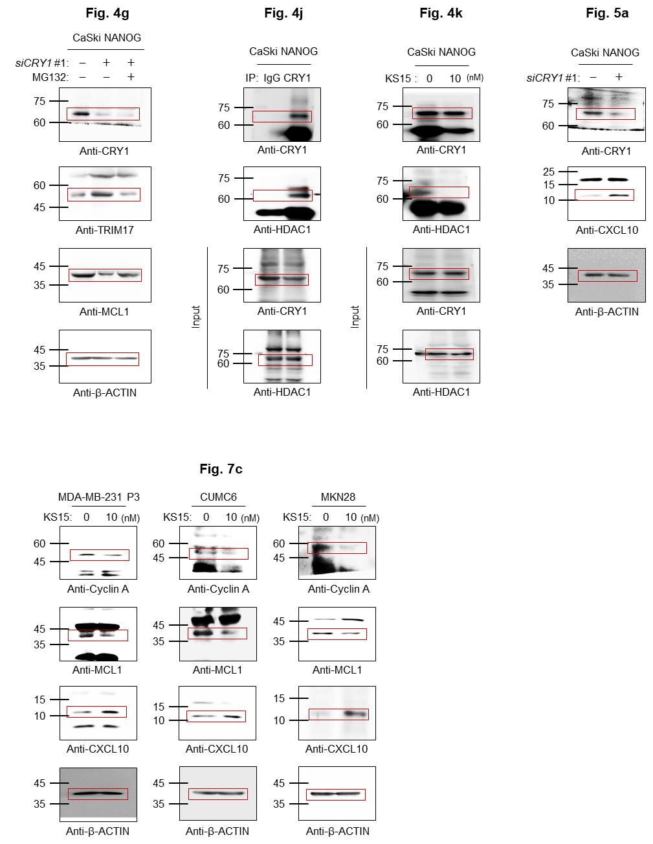

Supplementary Fig. 10. Uncropped blot images (continued).
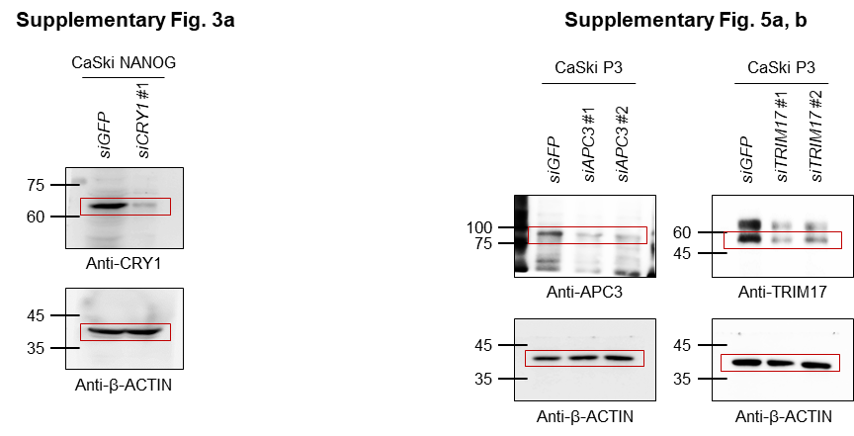

Supplementary Fig. 10. Uncropped blot images (continued).
