Luminescent Nanofibers for Human Skin Textures Photocopying
Tian Tian^{1,5}, Huixuan Han^{1,5}, Xinyi Lin^{1,5}, Hui Kang¹, Meifang Yang¹, Zihao Chen¹, Chao Wu², Yuansheng Jiang¹, Wenguang Li¹, Xueqing Chang¹, Qin Xu¹, Yizhou Zhang³, Yu-Xin Chen^{*4}, Gangfeng Ouyang⁴, Huan Pang^{*1}
¹ Institute of Innovation Materials and Energy, School of Chemistry and Chemical Engineering, Yangzhou University, Yangzhou, 225002, P. R. China.
² Department of Neurology, the First Affiliated Hospital, Sun Yat-sen University, Guangdong Provincial Key Laboratory of Diagnosis and Treatment of Major Neurological Diseases, National Key Clinical Department and Key Discipline of Neurology, Guangzhou, 510080, P.R. China.
³ Institute of Advanced Materials and Flexible Electronics (IAMFE), School of Chemistry and Materials Science, Nanjing University of Information Science and Technology, Nanjing, 210044 P. R. China.
⁴ GBRCE for Functional Molecular Engineering, Instrumental Analysis & Research Center, School of Chemical Engineering and Technology, Sun Yat-sen University, Guangzhou, 510275, P. R. China.
Email: chenyx46@mail.sysu.edu.cn
Email: huanpangchem@hotmail.com
⁵ These authors contributed equally: Tian Tian, Huixuan Han, Xinyi Lin.
Inventory of Supplementary Information
Supplementary Fig. 1. Hydrophilicity and hydrophobicity of the TPU and polystyrene nanofiber. …………………………………………………………………………….8
Supplementary Fig. 2. a Image of a real finger. b. Overlay of the fingerprint luminescence image obtained via NFIT and the real fingerprint image…..……………………………………………………………………………...9
Supplementary Fig. 3. Similarity between real fingers and fluorescent fingerprints by CsPbBr3@HPβCD fibers………………….………………………………………....10
Supplementary Table 1. Quantitative comparison of pore spacing between real fingerprint and NFIT imaging………………………………………………………..11
Supplementary Fig. 4 Summary images of NFIT Level 3 fingerprint imaging alongside currently representative reported Level 3 fingerprint imaging technique………………………………………………………………………..…....12
Supplementary Fig. 5. Comparison of three fingerprint imaging methods.. 13
Supplementary Table 2. The dosage of organic solution used in the electrospinning process………………………………………………………………………………..14
Supplementary Table 3. ICP-MS of Pb element in different samples……………….15
Supplementary Fig. 6. SEM images of CsPbBr₃@HPβCD fibers at various magnification. 16
Supplementary Fig. 7. EDS mapping of CsPbBr₃@HPβCD fibers, scalebar: 1 μm. 17
Supplementary Fig. 8. SEM images and HRTEM images of LFP before and after electrospinning. 18
Supplementary Fig. 9. EDS mapping of the fingerprint residues without CsPbBr₃@HPβCD fibers. 19
Supplementary Fig. 10. EDS mapping of electrospun CsPbBr₃@HPβCD fibers on LFP. 20
Supplementary Fig. 11. EDS mapping of electrospun CsPbBr₃@HPβCD fibers on the sweat pore of LFP. 21
Supplementary Fig. 12. EDS mapping of electrospun CsPbBr₃@HPβCD fibers at the central of LFP, the scalebar: 200 μm. Red arrows indicate the aggregated regions of NaCl. 22
Supplementary Fig. 13. EDS mapping of CsPbBr₃@HPβCD fibers after spraying with sodium chloride aqueous solution. 23
Supplementary Fig. 14. TEM image of CsPbBr₃@HPβCD fibers after spraying with NaCl aqueous solution.. 24
Supplementary Fig. 15. Luminescence imaging on a forged fingerprint by NFIT. 25
Supplementary Fig. 16. The photo parameter of the fingerprint image with NFIT. 26
Supplementary Fig. 17. PL intensity comparison of CsPbBr₃ fibers with or without HPβCD. 27
Supplementary Fig. 18. HRTEM image of CsPbBr₃ fibers without HPβCD. 28
Supplementary Fig. 19. XRD patterns of CsPbBr₃@HPβCD nanocrystals and CsPbBr₃@HPβCD fibers. 29
Supplementary Fig. 20. Spectral characterization of CsPbBr₃ and CsPbBr₃ @HPβCD fibers in response to fingerprint residue components………………………………………………………….………………..30
Supplementary Fig. 21. PL images of (a) CsPbBr₃@HPβCD fibers and (b) CsPbBr₃@HPβCD/NaCl fibers under 365 nm UV light. 31
Supplementary Fig. 22. PL spectra of CsPbBr₃ fibers and CsPbBr₃@HPβCD fibers with the addition of chloride at different mass ratios. 32
Supplementary Fig. 23. PL spectra of CsPbBr₃ fibers and CsPbBr₃@HPβCD fibers with the addition of organic compounds at different mass ratios. 33
Supplementary Fig. 24. PL spectra of CsPbBr₃ fibers and CsPbBr₃@HPβCD fibers with the addition of glucose at different mass ratios. 34
Supplementary Fig. 25. PL spectra of CsPbBr₃@HPβCD fibers with the addition of chloride at different mass ratios. 35
Supplementary Table 4. The PL parameters of CsPbBr₃@HPβCD fibers with the addition of NaCl. 36
Supplementary Table 5. The PL parameters of CsPbBr₃@HPβCD fibers with the addition of MgCl₂. 37
Supplementary Table 6. The PL parameters of CsPbBr₃@HPβCD fibers with the addition of KCl. 38
Supplementary Fig. 26. PL spectra of CsPbBr₃@HPβCD fibers with the addition of glucose at different mass ratios.. 39
Supplementary Table 7. The PL parameters of CsPbBr₃@HPβCD fibers with the addition of glucose. 40
Supplementary Table 8. The PL parameters of CsPbBr₃@HPβCD fibers with the addition of laurostearin. 41
Supplementary Table 9. The PL parameters of CsPbBr₃@HPβCD fibers with the addition of urea. 42
Supplementary Fig. 27. PL spectra of CsPbBr₃@HPβCD fibers with the addition of squalene at different mass ratios.. 43
Supplementary Table 10. The PL parameters of CsPbBr₃@HPβCD fibers with the addition of squalene. 44
Supplementary Table 11. The PL parameters of CsPbBr₃@HPβCD fibers with the addition of uric acid. 45
Supplementary Table 12. The PL parameters of CsPbBr₃@HPβCD fibers with the addition of ascorbic acid. 46
Supplementary Table 13. Summary of the PL peak shifts of CsPbBr₃@HPβCD fibers in responding to different components. 47
Supplementary Table 14. Summary of PL lifetimes of CsPbBr₃@HPβCD fibers upon the addition of various components. 48
Supplementary Fig. 28. Cs 3d XPS spectra of CsPbBr₃ fibers with the addition of various components. 49
Supplementary Fig. 29. Pb 4f XPS spectra of CsPbBr₃ fibers with the addition of various components. 50
Supplementary Fig. 30. Br 3d XPS spectra of CsPbBr₃ fibers with the addition of various components. 51
Supplementary Fig. 31. Br 3d XPS spectra of CsPbBr₃@HPβCD fibers with the addition of various components. 52
Supplementary Table 15. The Pb peak shifts in XPS spectra of CsPbBr₃@HPβCD introduced by different components. 53
Supplementary Table 16. The Br peak shifts in XPS spectra of CsPbBr₃ @HPβCD introduced by different components. 54
Supplementary Table 17. ¹H-NMR shifts of each component relative to HPβCD. 55
Supplementary Fig. 32. ¹H-NMR spectra of the interaction among (a,c) CsPbBr₃, HPβCD with chlorides addition; (b,d) CsPbBr₃, HPβCD with glucose addition. 56
Supplementary Table 18. 1H-NMR shifts of components relative to organic………………………………………………………………………………..57
Supplementary Table 19. The simulated band gaps of CsPbBr₃ with NaCl introduction. 58
Supplementary Table 20. The simulated band gaps of CsPbBr₃ with KCl introduction. 59
Supplementary Table 21. The simulated band gaps of CsPbBr₃ with MgCl₂ introduction. 60
Supplementary Table 22. The simulated adsorption energy of CsPbBr₃ with chloride introduction. 61
Supplementary Fig. 33. PL spectra of influence of CsPbBr₃@HPβCD, CsPbBr₃@K-βCD, and CsPbBr₃@Cl-βCD fiber.. 62
Supplementary Fig. 34. Temperature-dependence PL spectra. 63
Supplementary Fig. 35. Temperature-dependent PL intensity relationship of CsPbBr₃@HPβCD and CsPbBr₃@HPβCD/NaCl fibers. 64
Supplementary Fig. 36. Arrhenius plot of integrated PL intensity as a function of the reciprocal temperature (1/T) of CsPbBr_{3,} CsPbBr₃@HPβCD and CsPbBr₃ @HPβCD/glucose fibers. 65
Supplementary Fig. 37. PL mapping images of CsPbBr₃@HPβCD fiber. 66
Supplementary Table 23. Reference in situ PL lifetime for CsPbBr₃ @HPβCD fibers with or without fingerprint residue components. 67
Supplementary Fig. 38. Reference in situ PL lifetime for CsPbBr₃@ HPβCD fibers with or without fingerprint residue components. 68
Supplementary Fig. 39. Luminescence imaging of LFPs on tinfoil by NFIT.. 69
Supplementary Fig. 40. Luminescence imaging of LFPs on iron by NFIT. 70
Supplementary Fig. 41. Luminescence imaging of LFPs on glass by NFIT. 71
Supplementary Fig. 42. Imaging of LFPs on various substrates by NFIT.. 72
Supplementary Fig. 43. Fingerprint imaging by CsPbBr₃@HPβCD fibers at the weight of (a) 1 kg; (b) 2 kg; (c) 3 kg; (d) 4 kg and (e) 5 kg. 73
Supplementary Fig. 44. The sweat pore distribution at the weight of (a) 1 kg; (b) 2 kg; (c) 3 kg; (d) 4 kg and (e) 5 kg. 74
Supplementary Fig. 45. The timelines of fingerprint extraction by CsPbBr₃ @HPβCD fibers. (a)-(e) the extraction day from 0-41 days 75
Supplementary Fig. 46. The timelines of entire fingerprint extraction by NFIT. (full fingers) …………………………………………………………………………...…..76
Supplementary Fig. 47. Stability tracking of CsPbBr₃@HPβCD fibers. (a-o) From 1 day to 126 days. 77
Supplementary Fig. 48. Stability of CsPbBr₃@HPβCD fibers. 78
Supplementary Fig. 49. The palm imaged with CsPbBr₃@HPβCD fibers. 79
Supplementary Fig. 50. STR analysis of DNA in a blood sample on LFP without electrospun CsPbBr₃@HPβCD fibers. 80
Supplementary Fig. 51. STR analysis of DNA from a blood sample on LFP with electrospun CsPbBr₃@HPβCD fibers. 81
Supplementary Fig. 52. The setup of fingerprint extraction device. 82
Supplementary Fig. 53. Portable device for NFIT and the integrated data processing program. 83
Supplementary Fig. 54. NFIT integrated system for extracting grayscale values from multiple regions of the fingerprint image at the same extraction points (5000 points). 84
Supplementary Fig. 55. Fingerprint analysis program for instant transformation of data from 2D charts into 3D models………………………………………………….85
Supplementary Fig. 56. Fingerprint extraction and 3D image generation based on integrated NIFT system.. 86
Supplementary Fig. 57. Fingerprint extraction and 3D image generation based on integrated NIFT system.. 87
Supplementary Fig. 58. 3D construction of sweat pore by NFIT system……………88
Supplementary Fig. 59. 3D construction of lines of fingerprint by NFIT system…...89
Supplementary Fig. 60. Fingerprint system for 3D fingerprint construction and mirror inversion processing. 90
Supplementary Table 24. Summary of fingerprint feature visualization technology. 91
Supplementary Table 25. Cost evaluation of the NFIT system………………………92
Supplementary Fig. 61. NFIT system for 3D plam construction. 94

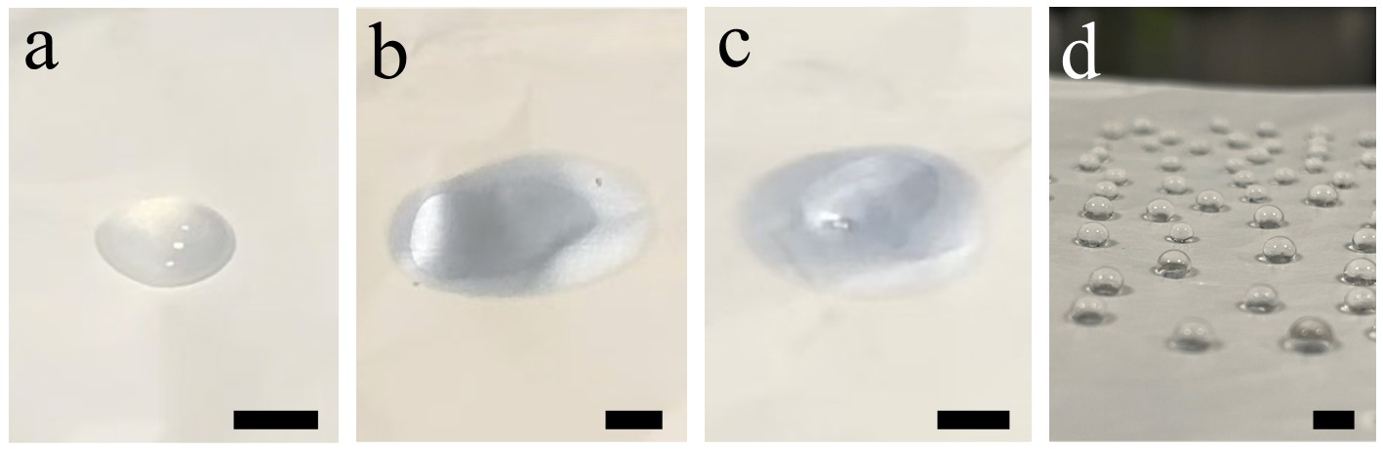

Supplementary Fig. 1. Hydrophilicity and hydrophobicity of the TPU and polystyrene nanofiber. (a) the image of dropping water, (b) oil (squalene), and (c) water and oil mixture (1:1, v/v) on TPU nanofiber, (d) the image of dropping water on PS nanofibers, scale bar: 1 cm.

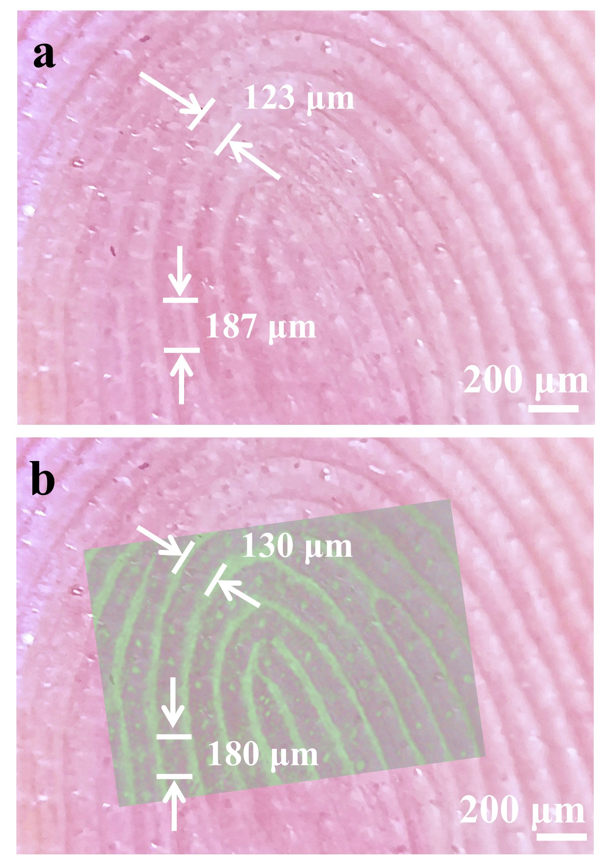
Supplementary Fig. 2. a Image of a real finger. b. Overlay of the fingerprint luminescence image obtained via NFIT and the real fingerprint image.

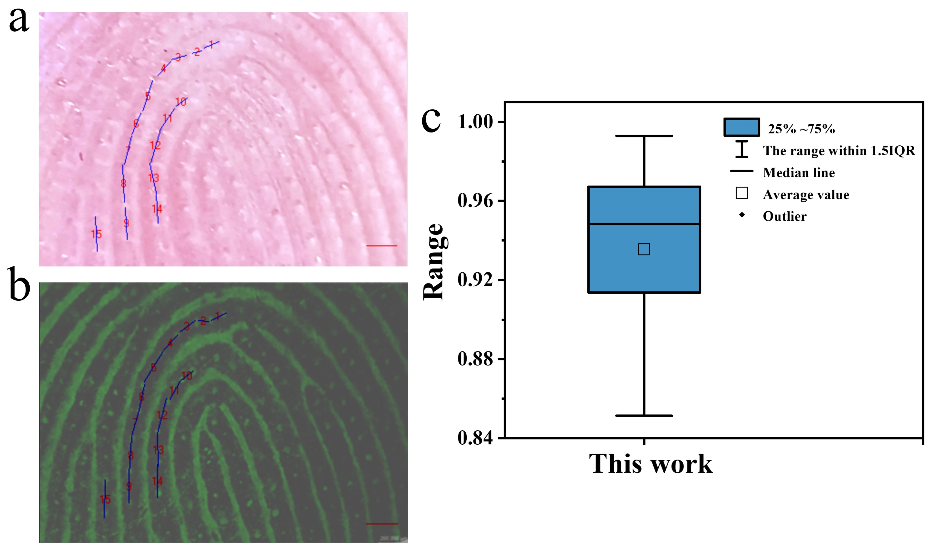
Supplementary Fig. 3. Similarity between real fingers and fluorescent fingerprints by CsPbBr₃@HPβCD fibers.

Notes: To determine the accuracy of our material in replicating real fingerprints, we measured multiple sweat pore spacings on both real fingers and the imaged fingerprints, and calculated the average similarity of these spacings.
Supplementary Table 1. Quantitative comparison of pore spacing between real fingerprint and NFIT imaging.
Sample | d_{(Real finger)} (μm) | d _{(NFIT fingerprint)} (μm) | RDR | Similarity  (%)
1 | 108.21 | 107.44 | 0.0071 | 99.29
2 | 67.09 | 68.81 | 0.0253 | 97.47
3 | 104.27 | 122.47 | 0.1605 | 83.95
4 | 129.3 | 133.68 | 0.0333 | 96.67
5 | 211.02 | 229.01 | 0.0818 | 91.82
6 | 153.5 | 164.25 | 0.0677 | 93.23
7 | 194.8 | 167.01 | 0.1536 | 84.64
8 | 248.38 | 235.83 | 0.0518 | 94.82
9 | 212.99 | 206.52 | 0.0308 | 96.92
10 | 96.63 | 101.89 | 0.0530 | 94.70
11 | 157.08 | 138.62 | 0.1249 | 87.51
12 | 233.62 | 225.36 | 0.0360 | 96.40
13 | 199.24 | 218.07 | 0.0902 | 90.98
14 | 201.19 | 212.26 | 0.0535 | 94.65
15 | 230.69 | 241.01 | 0.0438 | 95.62
Overall Similarity±S.D. |  |  |  | （93.24±4.6）%
Notes: $RDR=\frac{1}{n}\sum_{i=1}^{n}{\frac{\left|d_{real finger, i}-d_{ NFIT fingerprint, i})\right|}{\frac{d_{real finger, i}+d_{NFIT fingerprint, i}}{2}}}$ (1)
$Similarity=\left(1-RDR\right)×100\%$ (2)
S. D. stands for standard deviation.
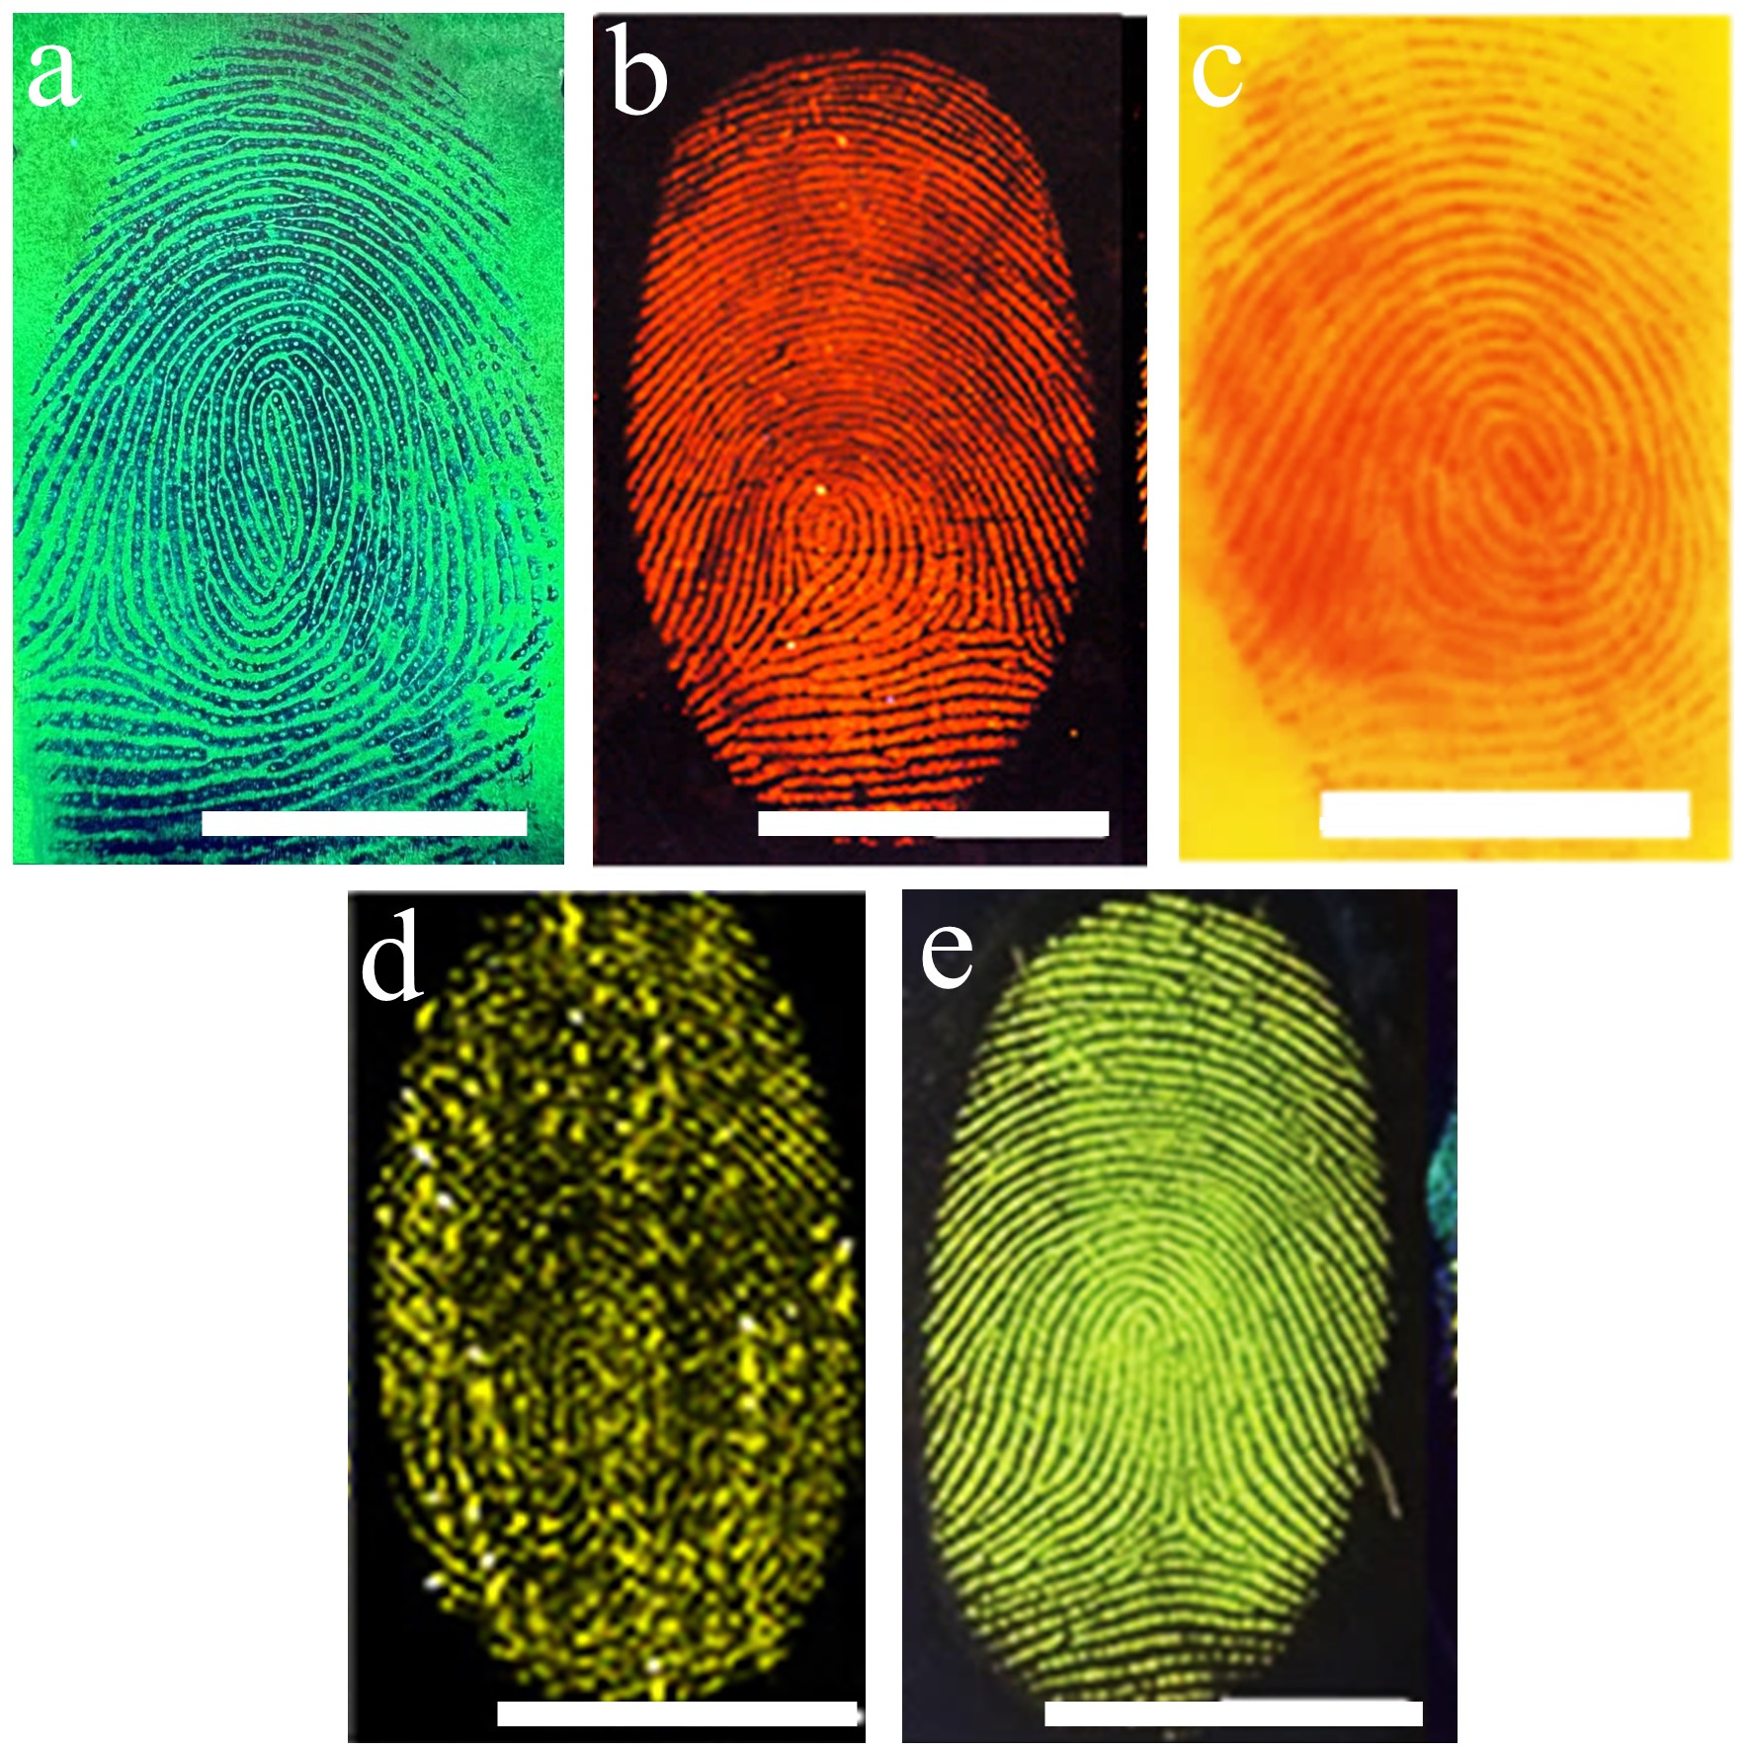
Supplementary Fig. 4. Summary images of NFIT Level 3 fingerprint imaging alongside currently representative reported Level 3 fingerprint imaging technique. a NFIT Level 3 fingerprint imaging method. b AIE property of TPA-1OH LFPS imaging method. [Ref. 16], c a sweat-responsive covalent organic framework ﬁlm LFPS imaging method. [Ref. 19], d de novo green fluorescent protein chromophore-based probes LFPS imaging method. [Ref. 23] e color-tunable AIE pincer complexes LFPS imaging method. [ Ref. 24], scalebar: 1 cm.
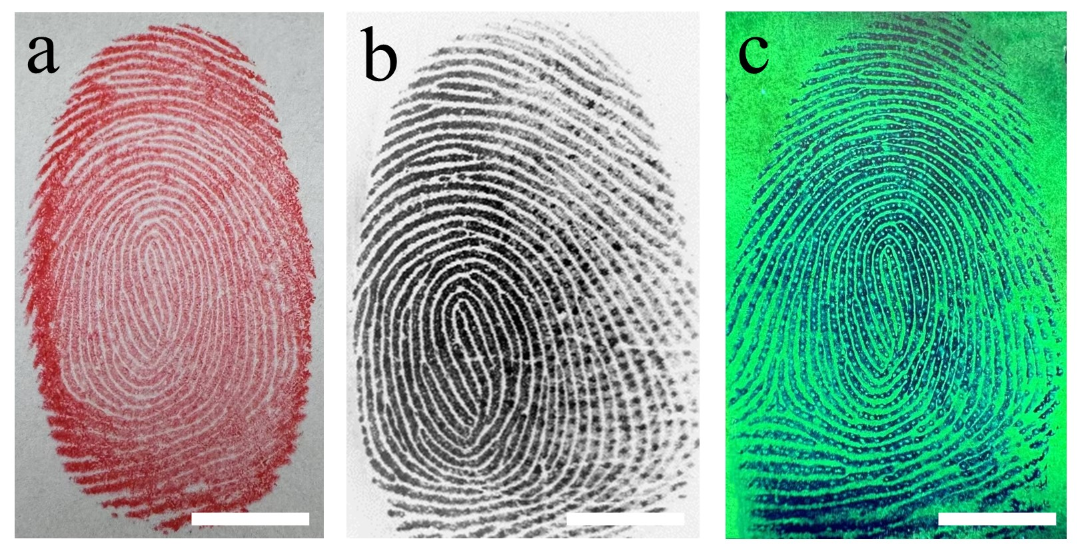

Supplementary Fig. 5. Comparison of three fingerprint imaging methods. (a) the fingerprint imaging by traditional ink-based fingerprinting (b) the fingerprint imaging by commercial capacitive fingerprint sensors, purchased from Shenzhen Entropy Electronic Technology Co., LTD. (Live 10r) (c) CsPbBr₃@HPβCD nanofiber-based imaging by electrospinning, scalebar: 1 cm.

Supplementary Table 2. The exposure dose of organic solvent during the electrospinning process.
 | For ca. 1200 fingerprints (4800 cm²) | For single fingerprint imaging (ca. 4 cm²) | Per-unit area (cm²)
DMF | 5.25 mL | 4 μL | 1 μL
DMSO | 0.25 mL | 0.48 μL | 0.14 μL
Total | 5.5 mL | 4.48 μL | 1.14 μL

Supplementary Table 3. Quantification of Pb leakage in imaged fingerprints by ICP-MS.
Samples | Pb content in the leachates of an imaged fingerprint (mg/L) | WHO Standard for Pb in drinking water (mg/L)
1 | 0.0017 | 0.01
2 | 0.0033 | 0.01
3 | 0.0044 | 0.01
Average | 0.0031 | 0.01
Notes: WHO refers to World Health Organization.

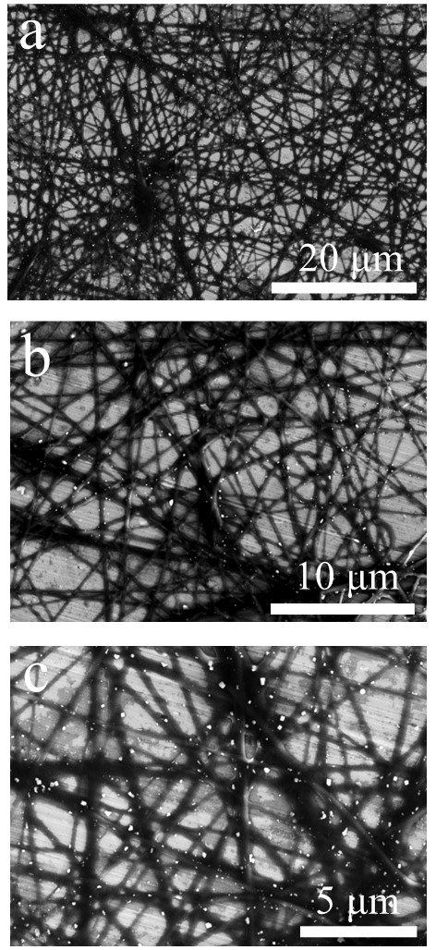

Supplementary Fig. 6. SEM images of CsPbBr₃@HPβCD fibers at various magnification.

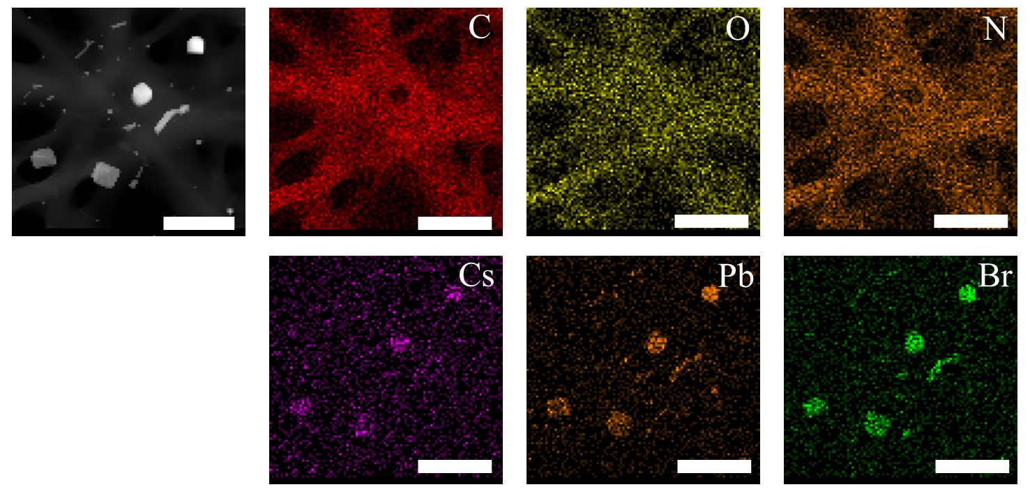

Supplementary Fig. 7. EDS mapping of CsPbBr₃@HPβCD fibers, scalebar: 1 μm.
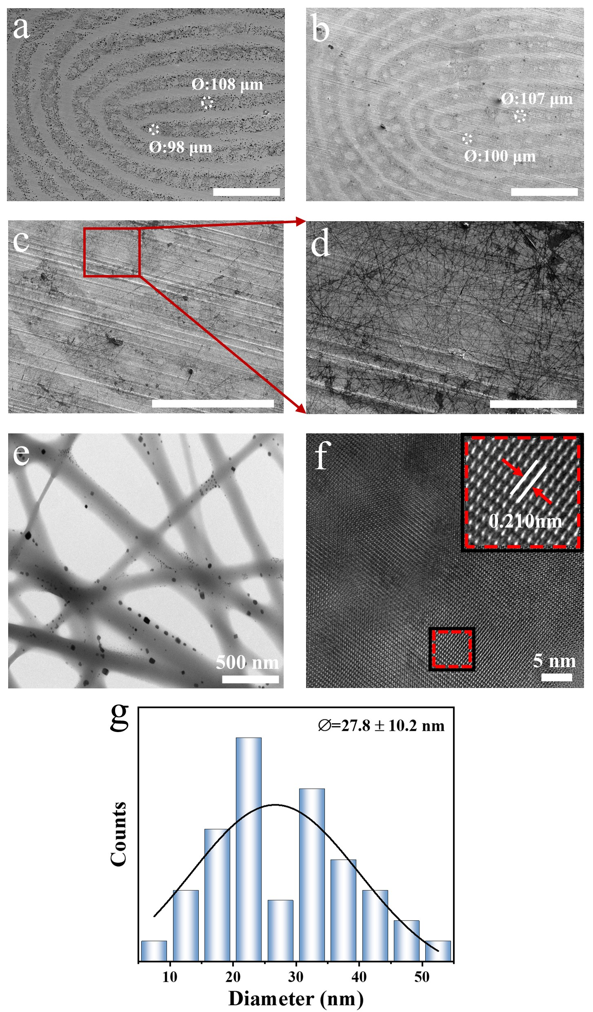

Supplementary Fig. 8. SEM images and HRTEM images of LFP before and after electrospinning. (a) SEM image of real fingerprint, scale bar: 1 mm. (b)-(d) SEM images of the LFP with CsPbBr₃@HPβCD fibers at (b) 30×, scale bar: 1 mm, (c) 110×, scale bar: 500 μm and (d) 400×, scale bar: 100 μm. (e) HRTEM image after electrospinning on LFP with CsPbBr₃@HPβCD fibers. (f) Magnified HRTEM image of CsPbBr₃@HPβCD. (g) The diameter distribution chart of CsPbBr₃@HPβCD.

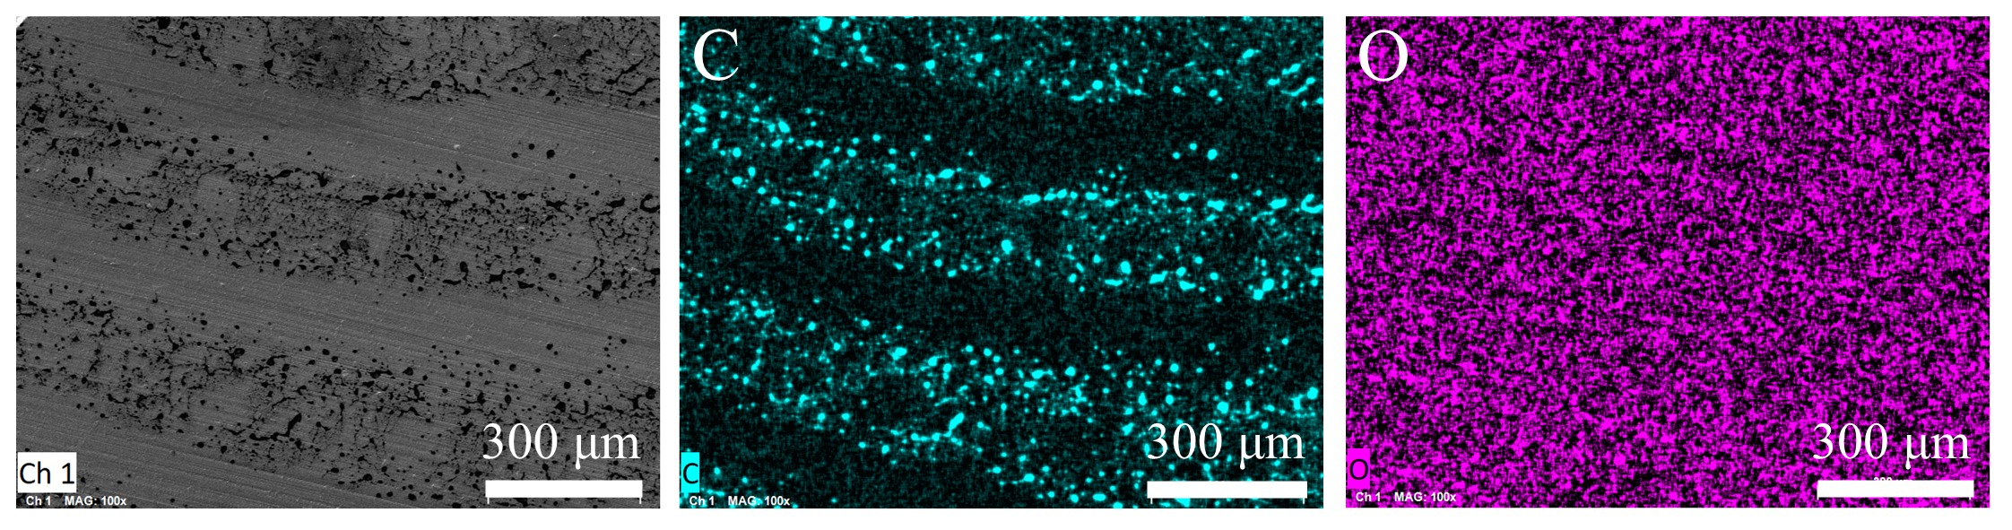

Supplementary Fig. 9. EDS mapping of the fingerprint residues without CsPbBr₃@HPβCD fibers.

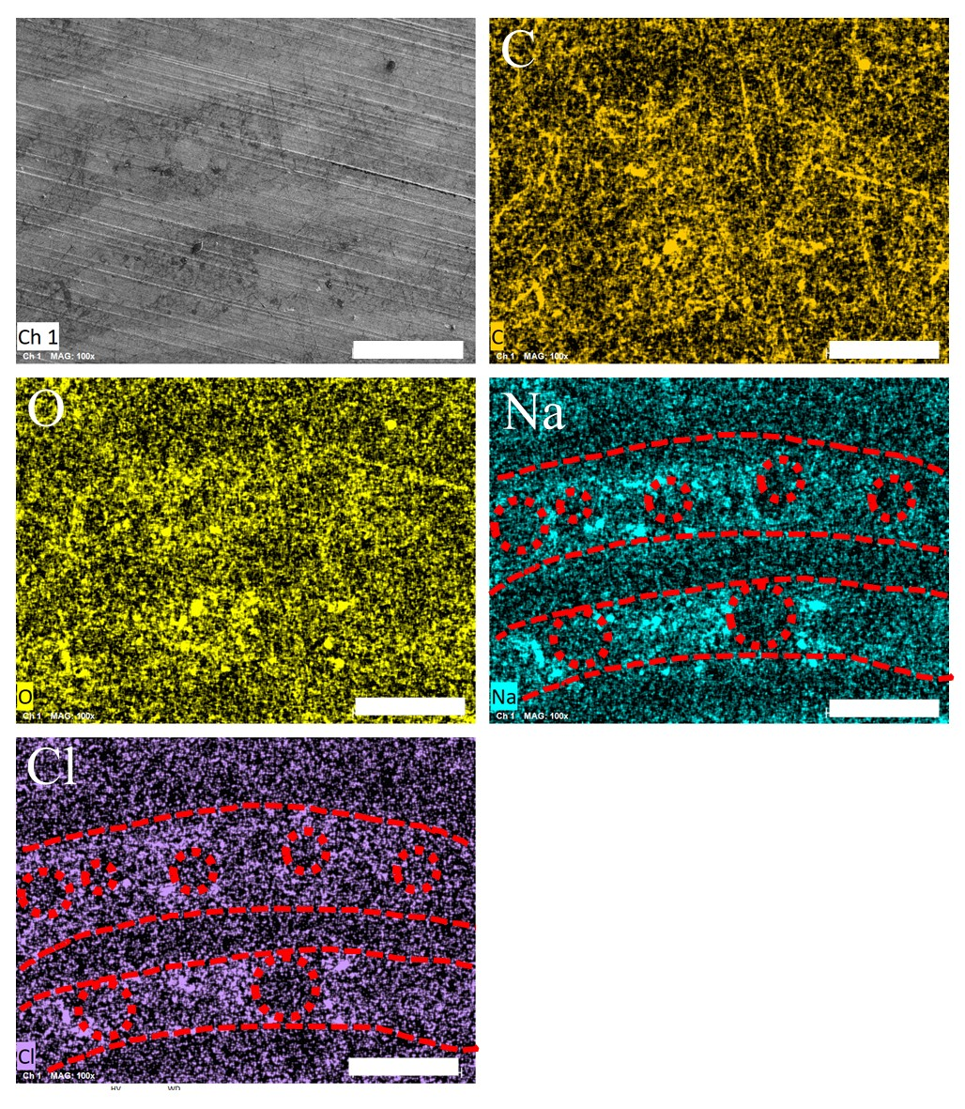

Supplementary Fig. 10. EDS mapping of electrospun CsPbBr₃@HPβCD fibers on LFP, scalebar: 300 μm.
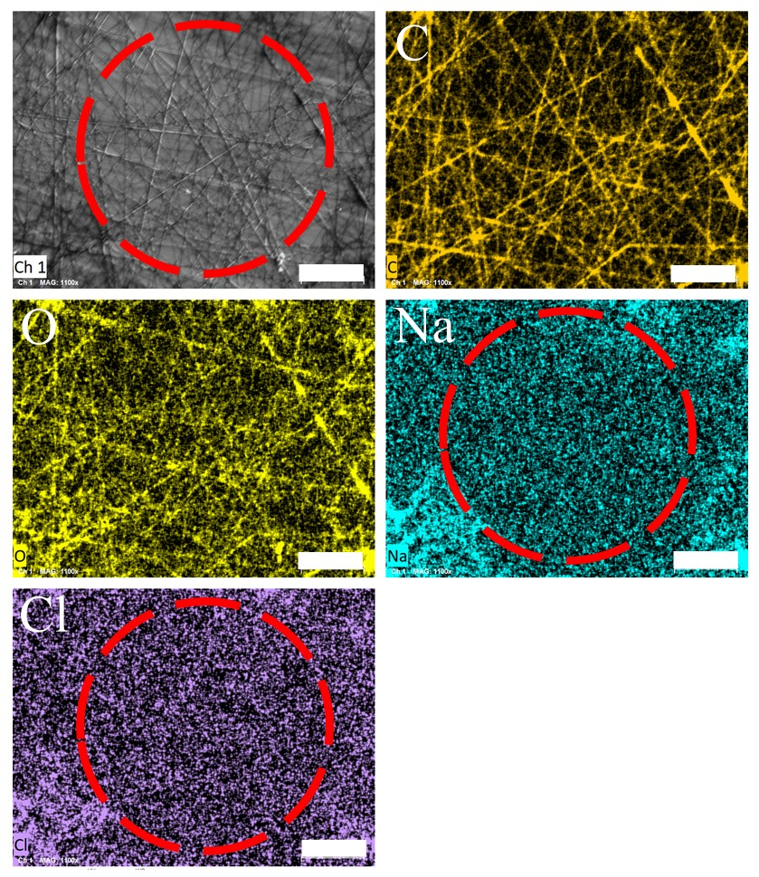

Supplementary Fig. 11. EDS mapping of electrospun CsPbBr₃@HPβCD fibers on the sweat pore of LFP, the scalebar: 20 μm. The red circle indicates the position of a sweat pore.

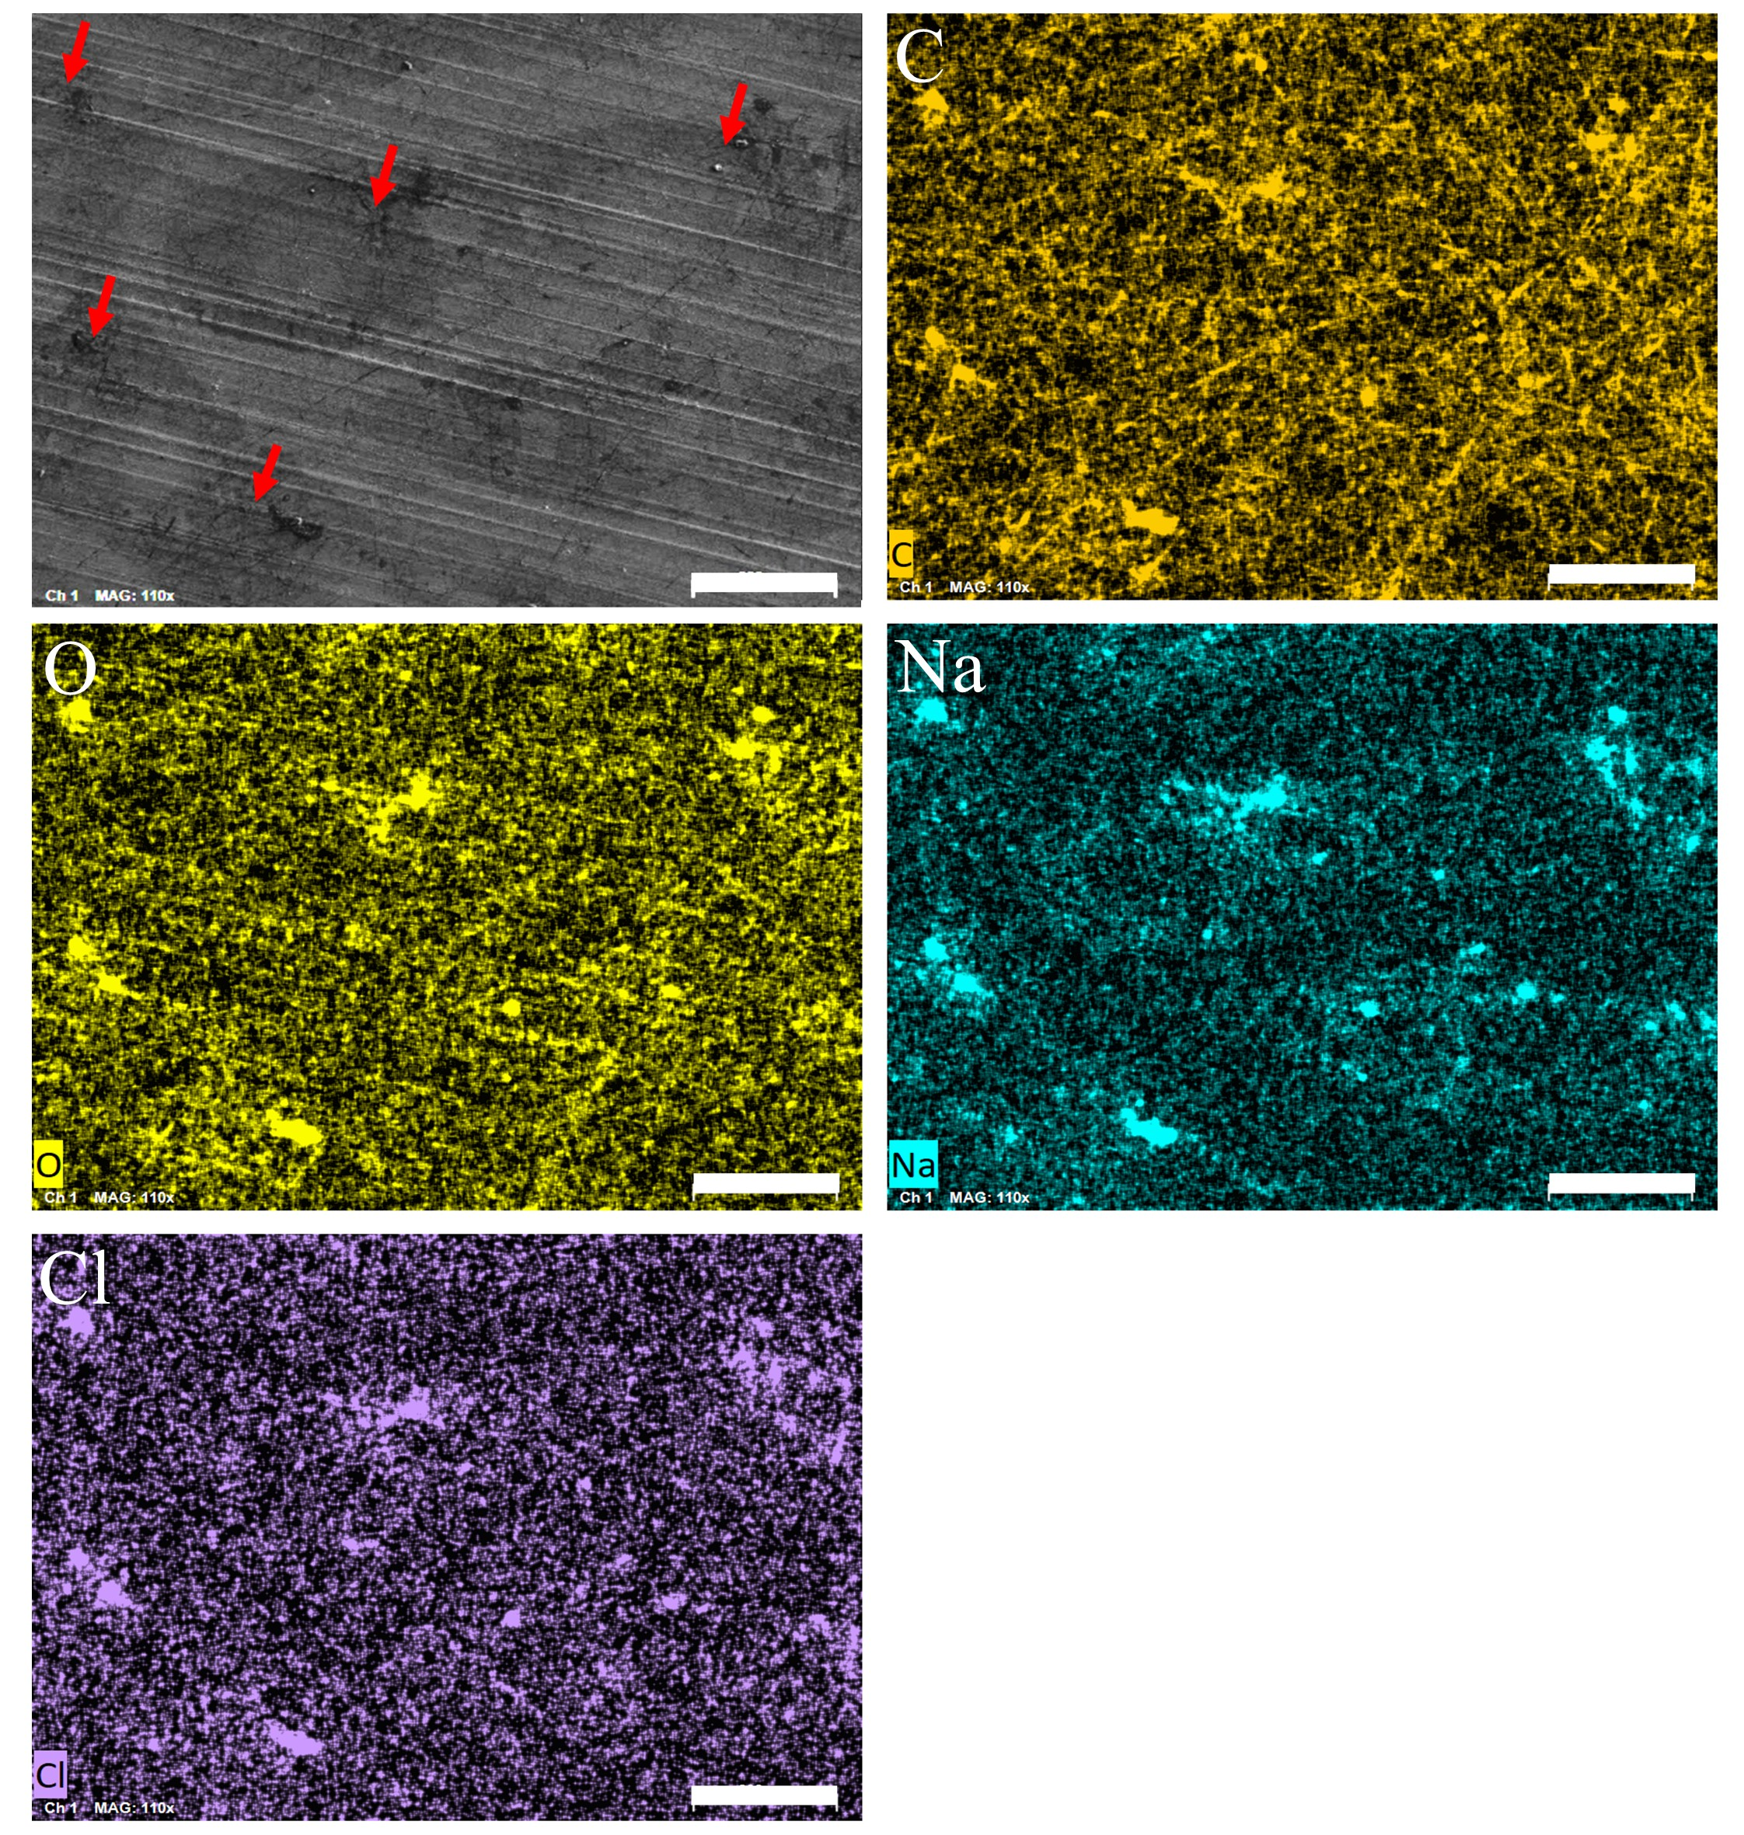

Supplementary Fig. 12. EDS mapping of electrospun CsPbBr₃@HPβCD fibers at the central of LFP, the scalebar: 200 μm. Red arrows indicate the aggregated regions of NaCl.

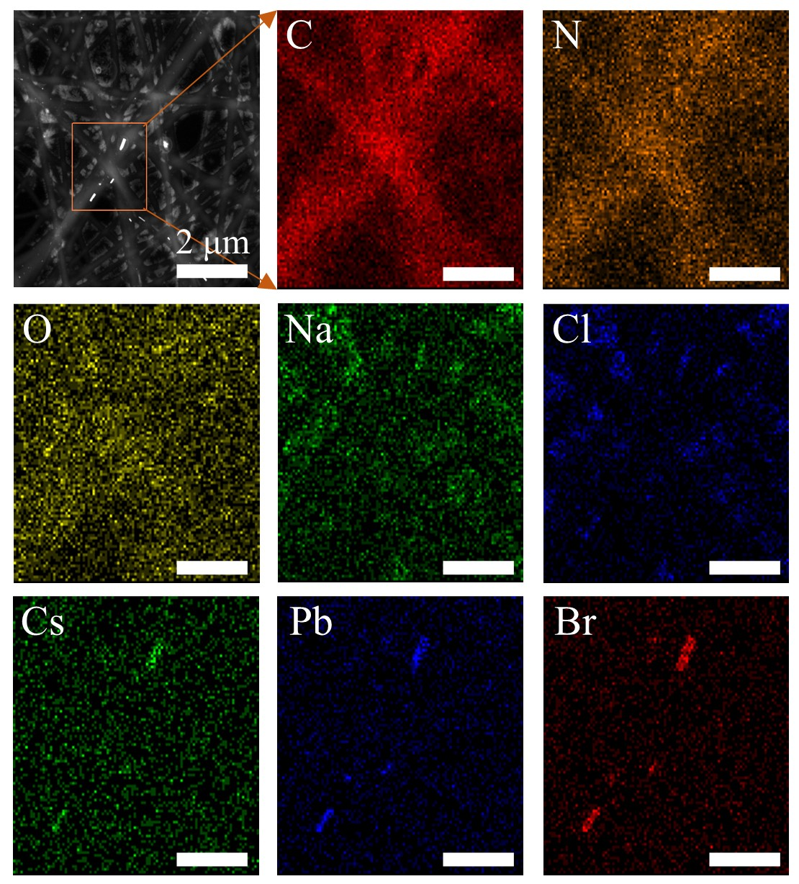

Supplementary Fig. 13. EDS mapping of CsPbBr₃@HPβCD fibers after spraying with sodium chloride aqueous solution, scalebar: 1 μm.

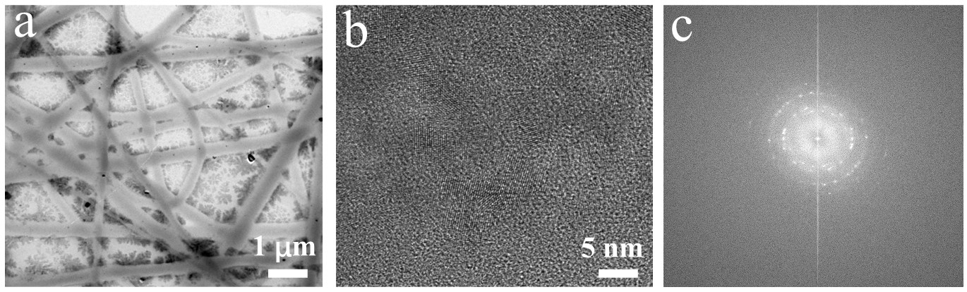

Supplementary Fig. 14. TEM image of CsPbBr₃@HPβCD fibers after spraying with NaCl aqueous solution. (a) CsPbBr₃@HPβCD fibers with NaCl aqueous solution. (b) The corresponding HRTEM image and (c) its corresponding fast Fourier transformation image.

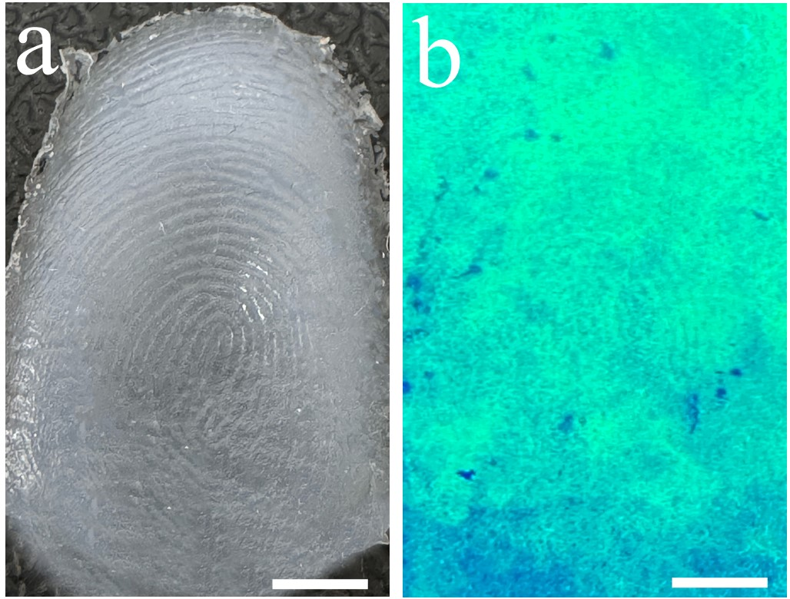

Supplementary Fig. 15. Luminescence imaging on a forged fingerprint by NFIT. (a) A fake fingerprint made of silicone mold. (b) The fake fingerprint imaging by NFIT, scalebar:500 μm.

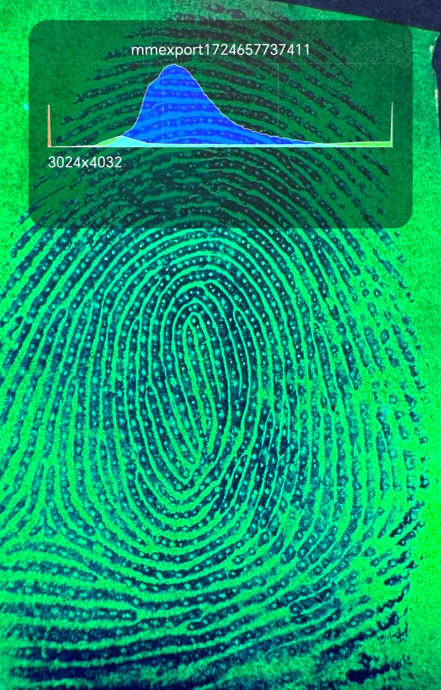

Supplementary Fig. 16. The photo parameter of the fingerprint image with NFIT.

Notes: Horizontal pixel density is calculated as the image width in pixels divided by the width of the display in inches: 3024 pixels / 5.77 inches = 524 dpi. Vertical pixel density is determined by dividing the image height in pixels by the height of the display in inches: 4032 pixels / 2.78 inches = ~1450 dpi.
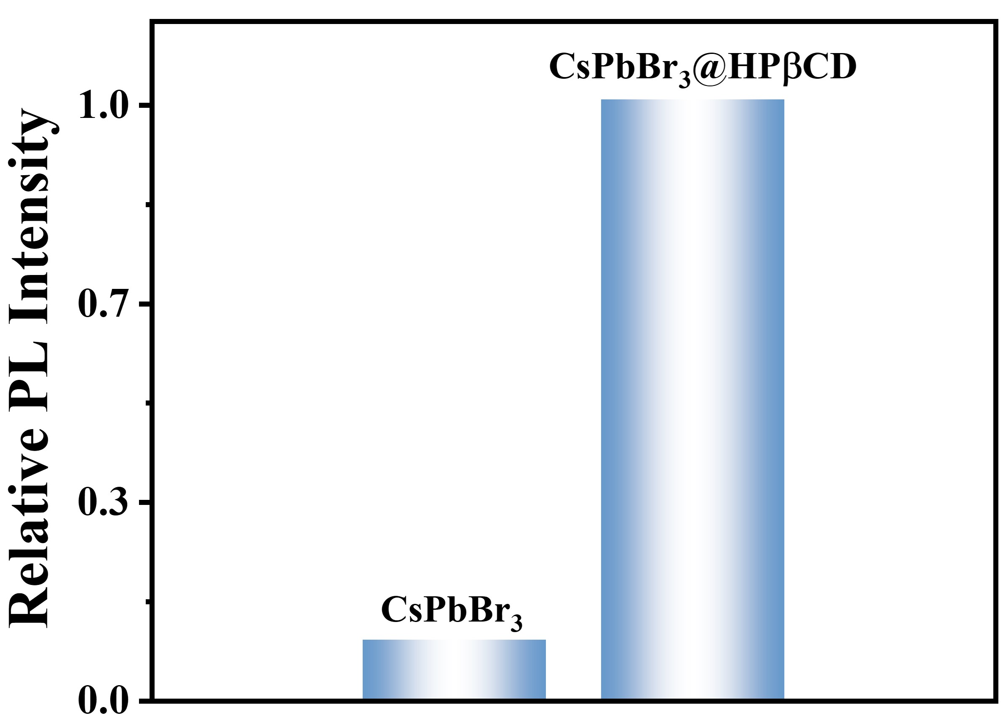

Supplementary Fig. 17. PL intensity comparison of CsPbBr₃ fibers with or without HPβCD.

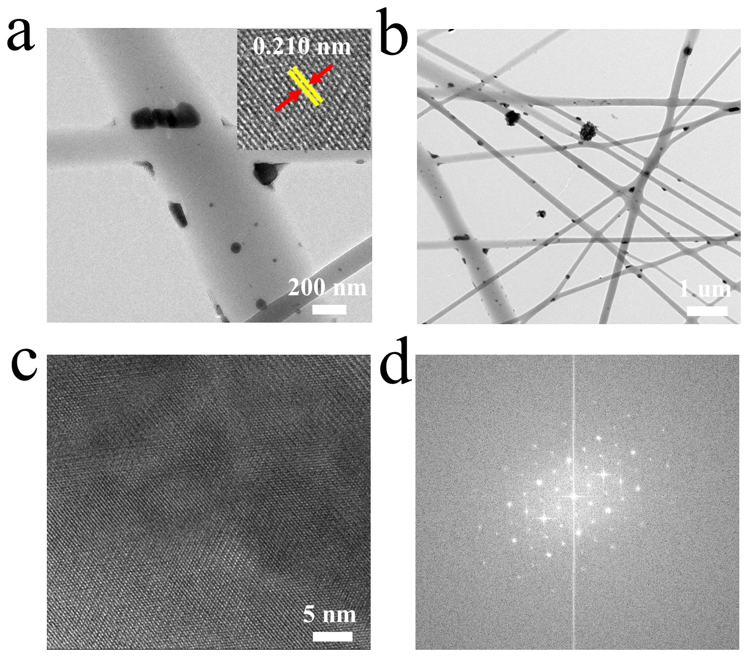

Supplementary Fig. 18. HRTEM image of CsPbBr₃ fibers without HPβCD.

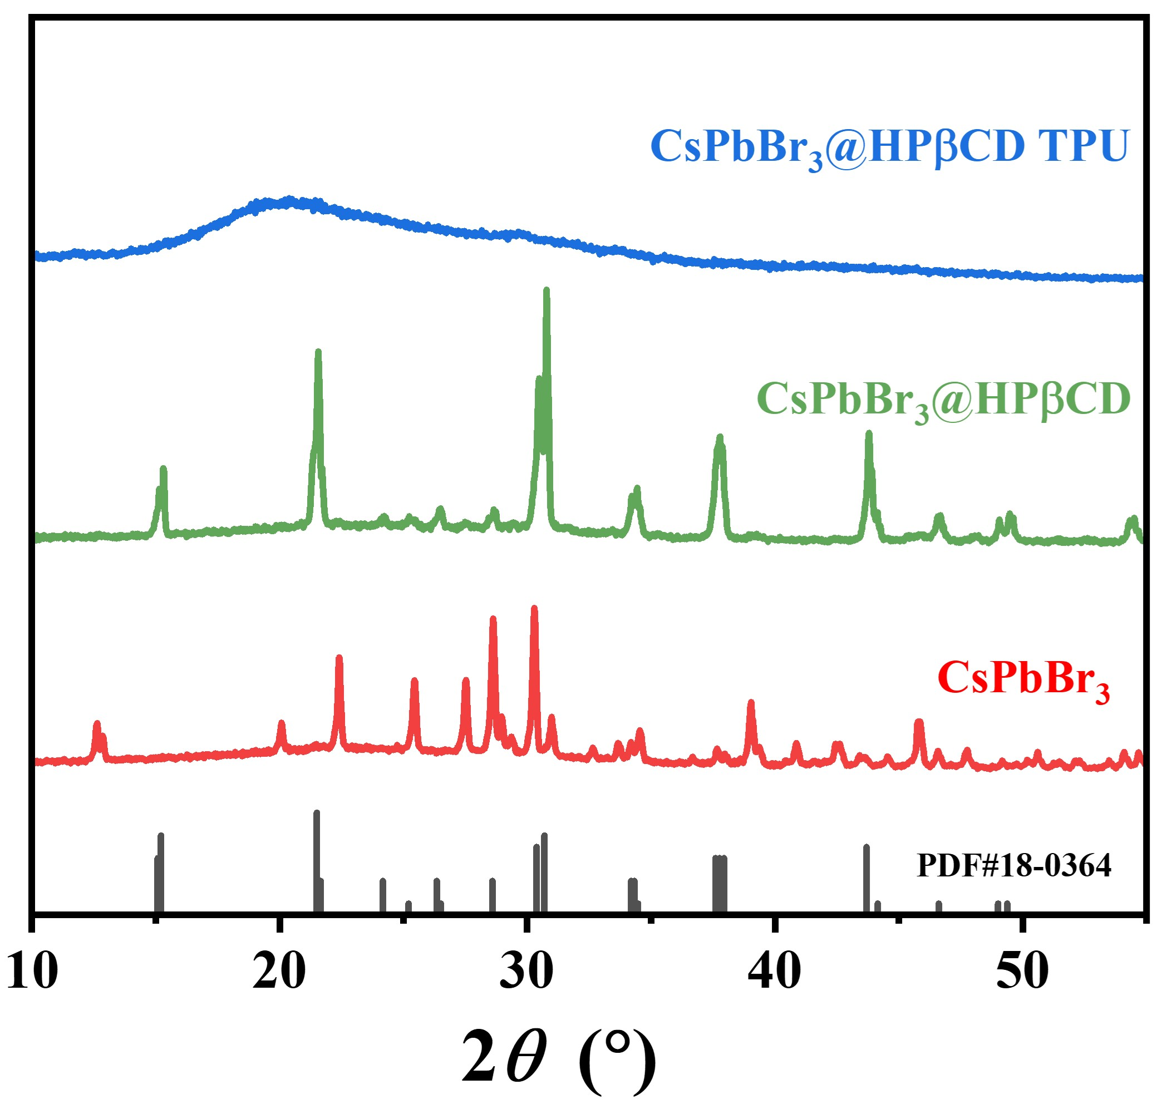

Supplementary Fig. 19. XRD patterns of CsPbBr₃@HPβCD nanocrystals and CsPbBr₃@HPβCD fibers.

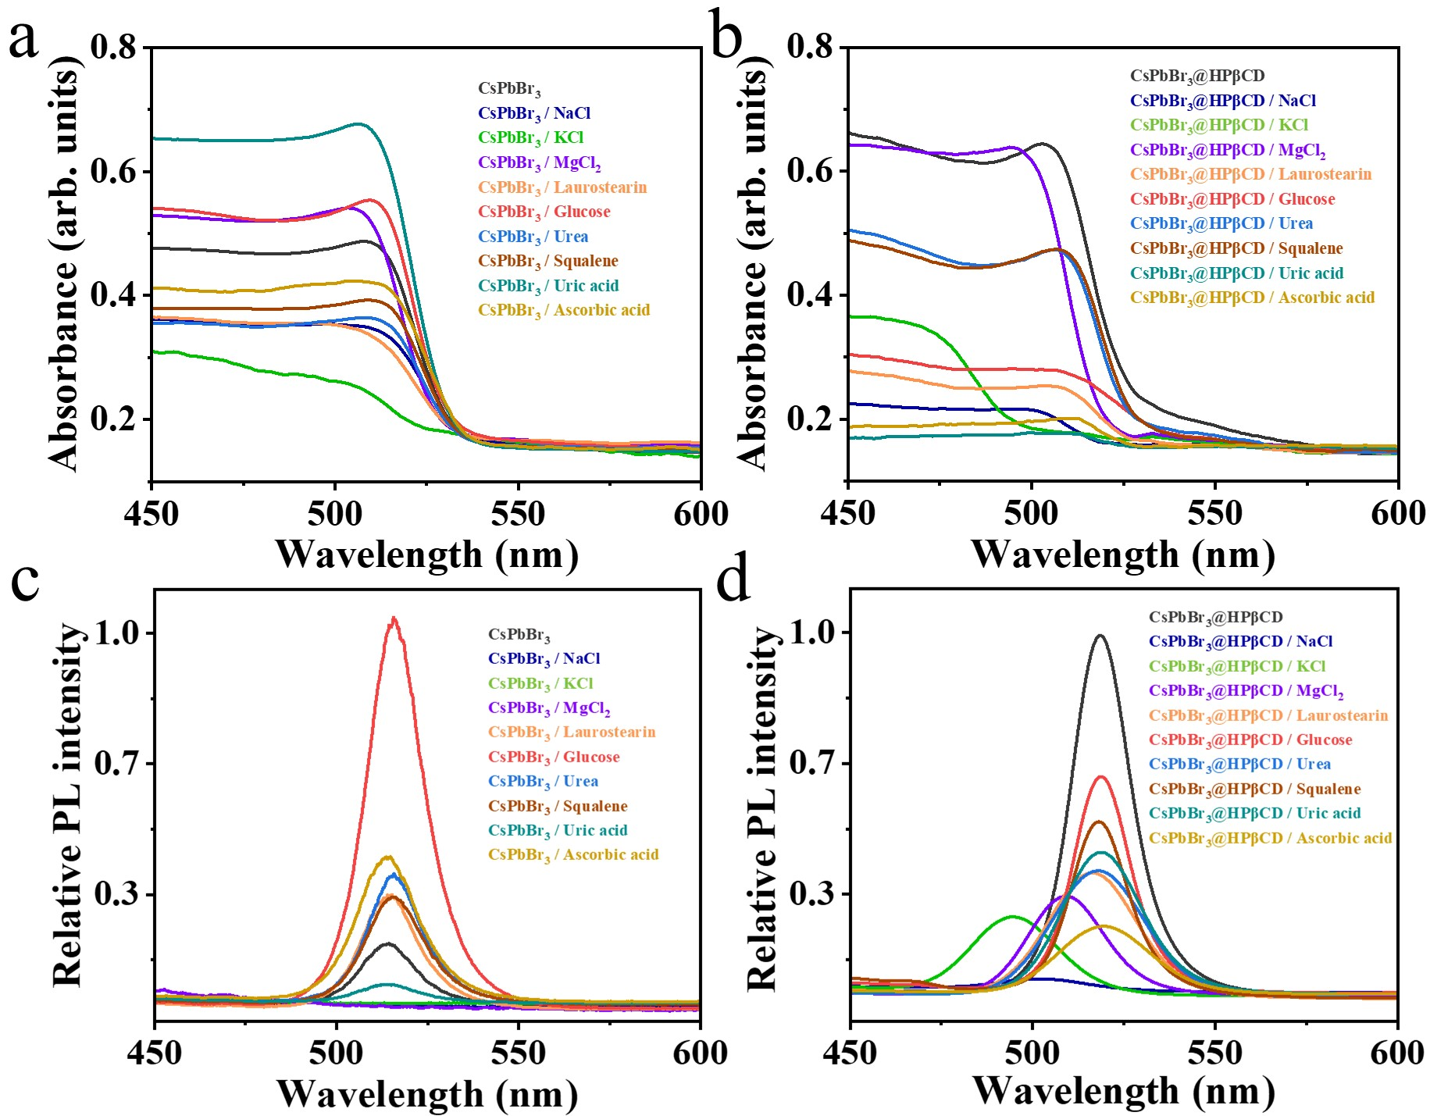
Supplementary Fig. 20. Spectral characterization of CsPbBr₃ and CsPbBr₃@HPβCD fibers in response to fingerprint residue components. a-b UV-Vis absorption spectra of (a) CsPbBr₃ fibers and (b) CsPbBr₃@HPβCD fibers exposed to representative components. c-d PL spectra of (c) CsPbBr₃ fibers and (d) CsPbBr₃@HPβCD fibers exposed to representative components.

Note: The ultraviolet-visible absorption (UV-Vis) spectra indicate that the addition of various components has little effect on the bandgap of the CsPbBr₃ fibers without HPβCD (Supplementary Figs. 20a). However, in the presence of HPβCD, the bandgap of the CsPbBr₃@HPβCD fibers is affected to varying degrees by these components (Supplementary Figs. 20b). The NaCl, KCl, and MgCl₂ induce a significant blueshift, with the absorption edge shifting from 525.9 nm to 517.5 nm, 495.2 nm, and 518.2 nm. Organic compounds such as glucose, laurostearin, and squalene also induce a slight blueshift. Adding NaCl, KCl, and MgCl₂ at the same concentration leads to a significant blueshift in the PL emission peak, from 518.6 nm to 500.1 nm, 493.5 nm and 508.2 nm, respectively.
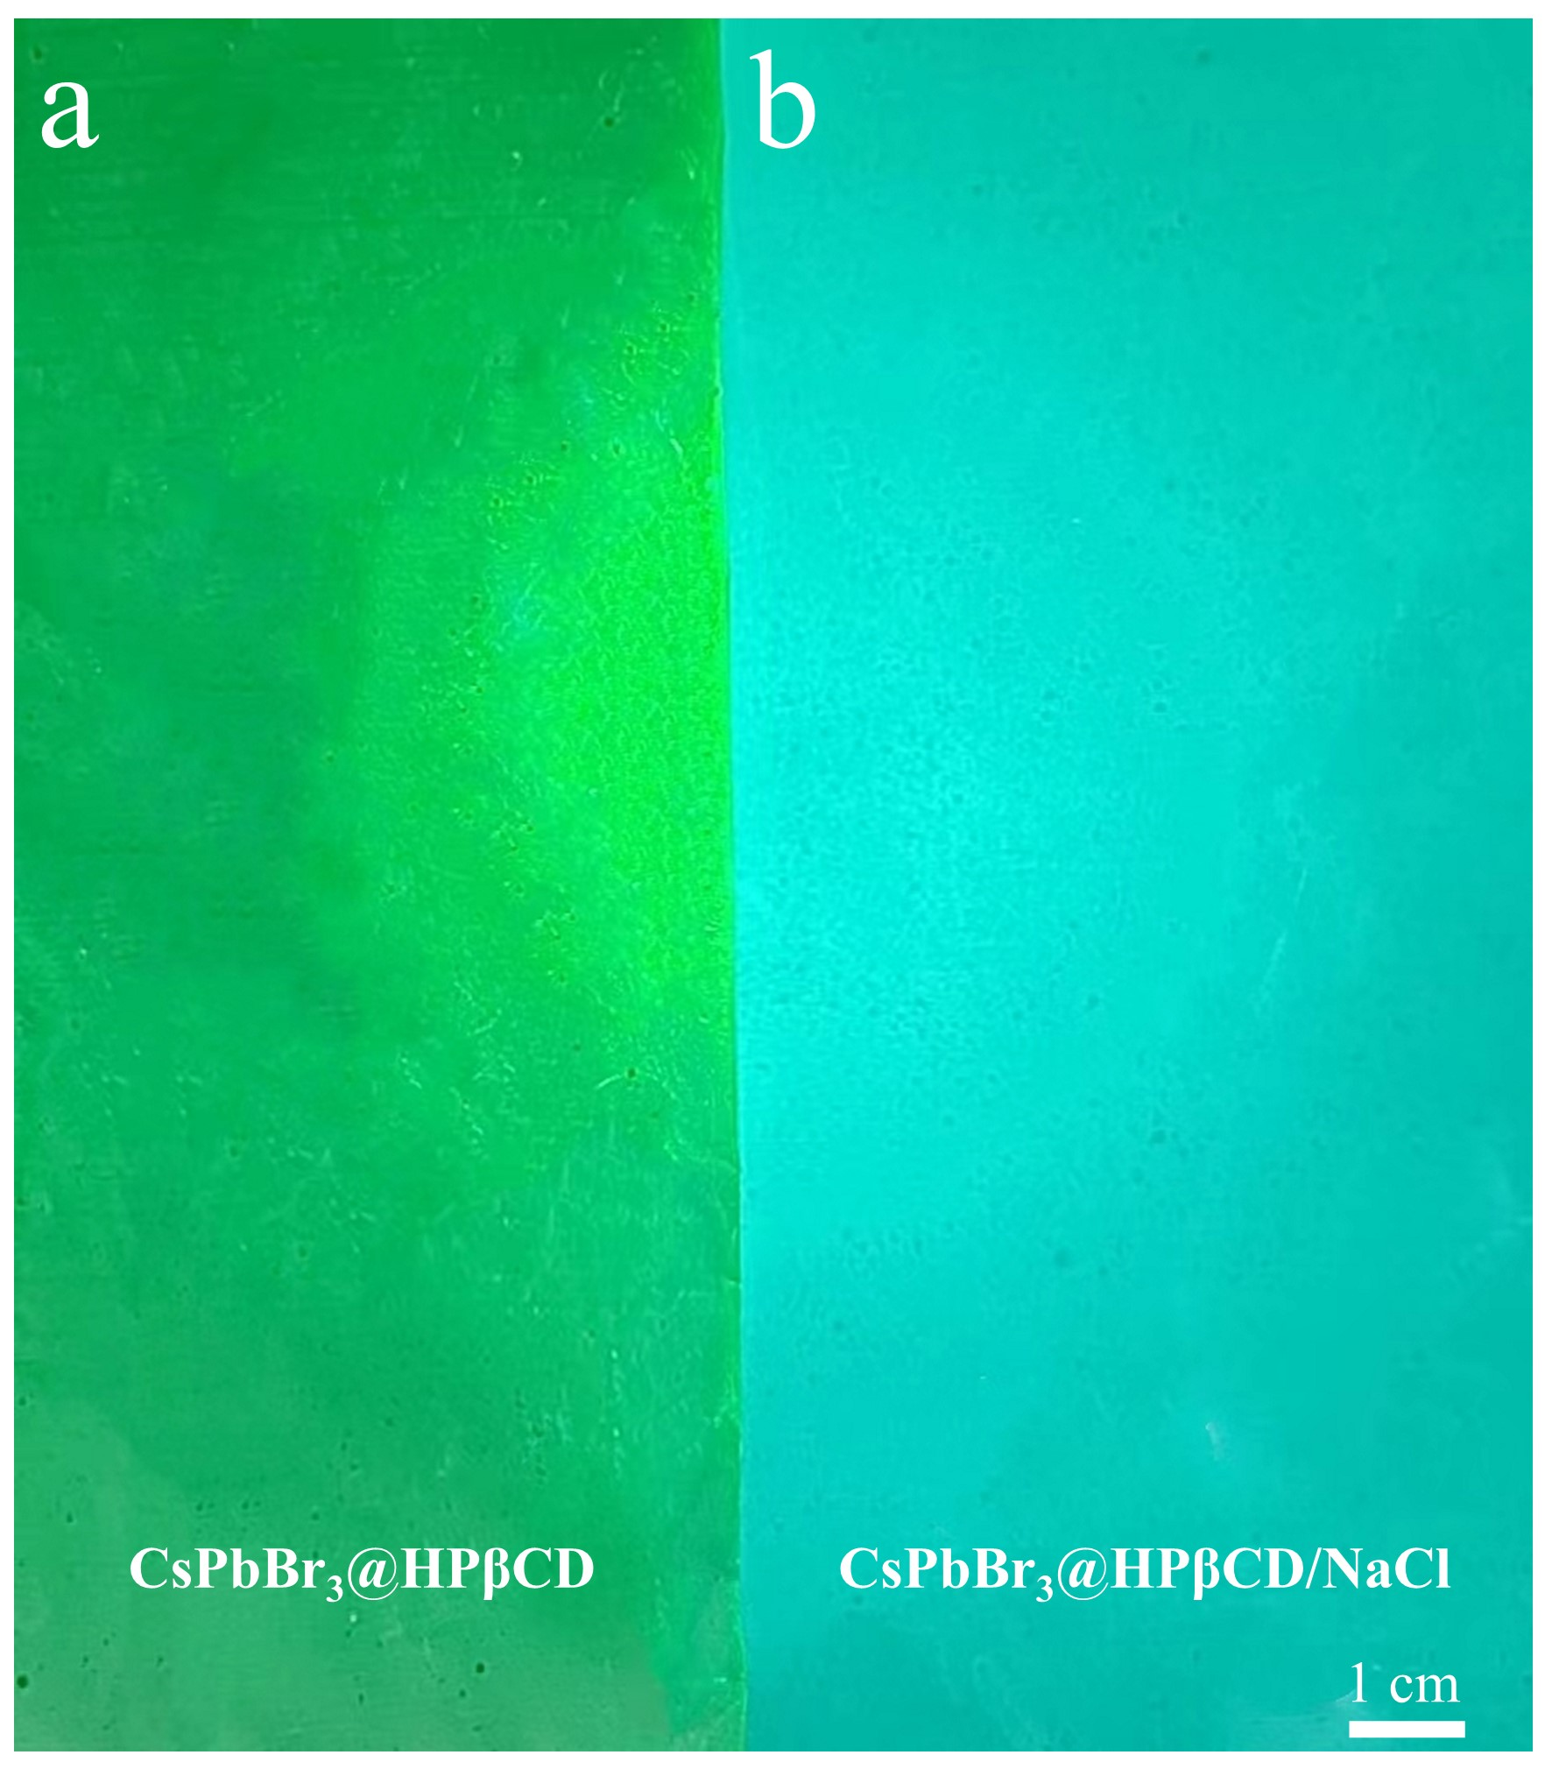

Supplementary Fig. 21. PL images of (a) CsPbBr₃@HPβCD fibers and (b) CsPbBr₃@HPβCD/NaCl fibers under 365 nm UV light.
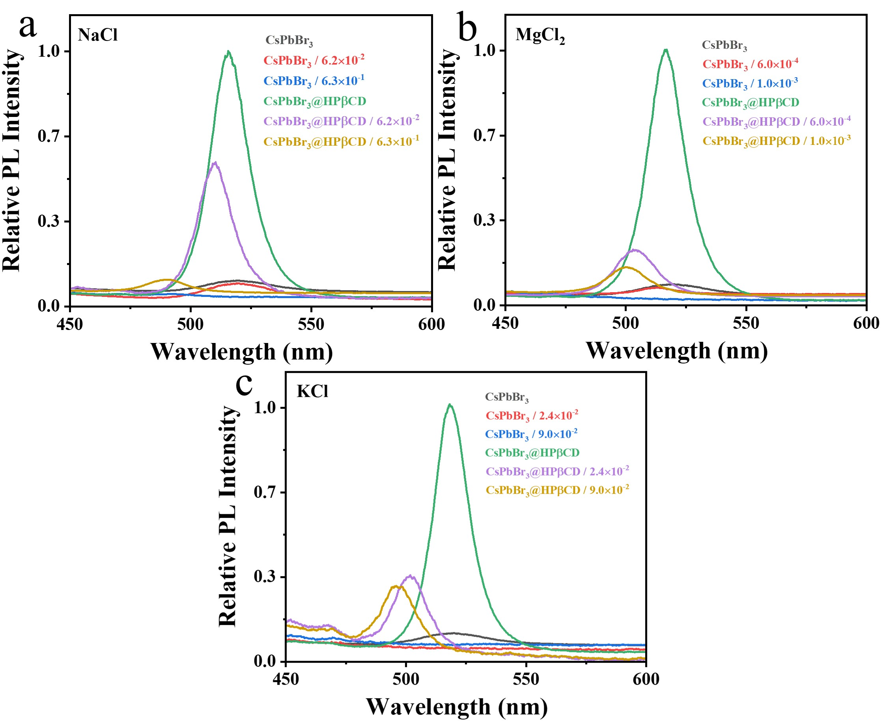

Supplementary Fig. 22. PL spectra of CsPbBr₃ fibers and CsPbBr₃@HPβCD fibers with the addition of chloride at different mass ratios. (a) NaCl, (b) MgCl₂, (c) KCl.

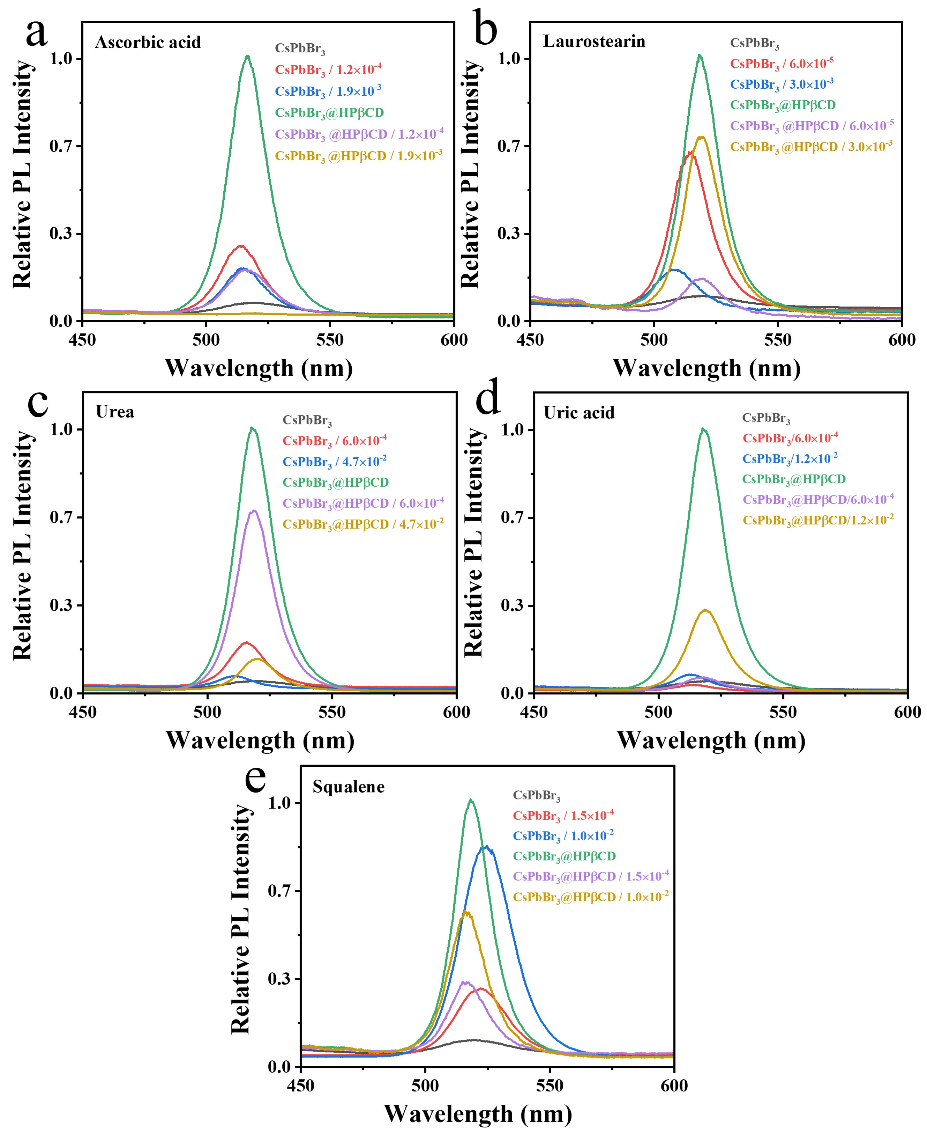

Supplementary Fig. 23. PL spectra of CsPbBr₃ fibers and CsPbBr₃@HPβCD fibers with the addition of organic compounds at different mass ratios. (a) Ascorbic acid, (b) Laurostearin, (c) urea, (d) uric acid, (e) squalene.

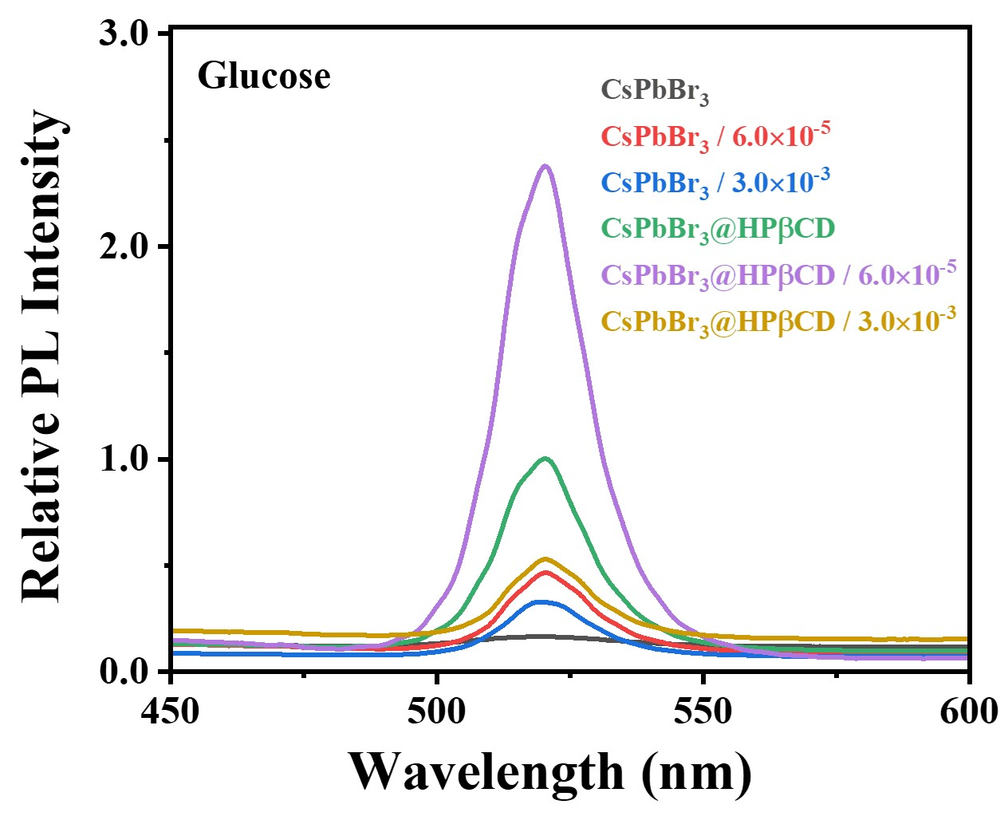

Supplementary Fig. 24. PL spectra of CsPbBr₃ fibers and CsPbBr₃@HPβCD fibers with the addition of glucose at different mass ratios.

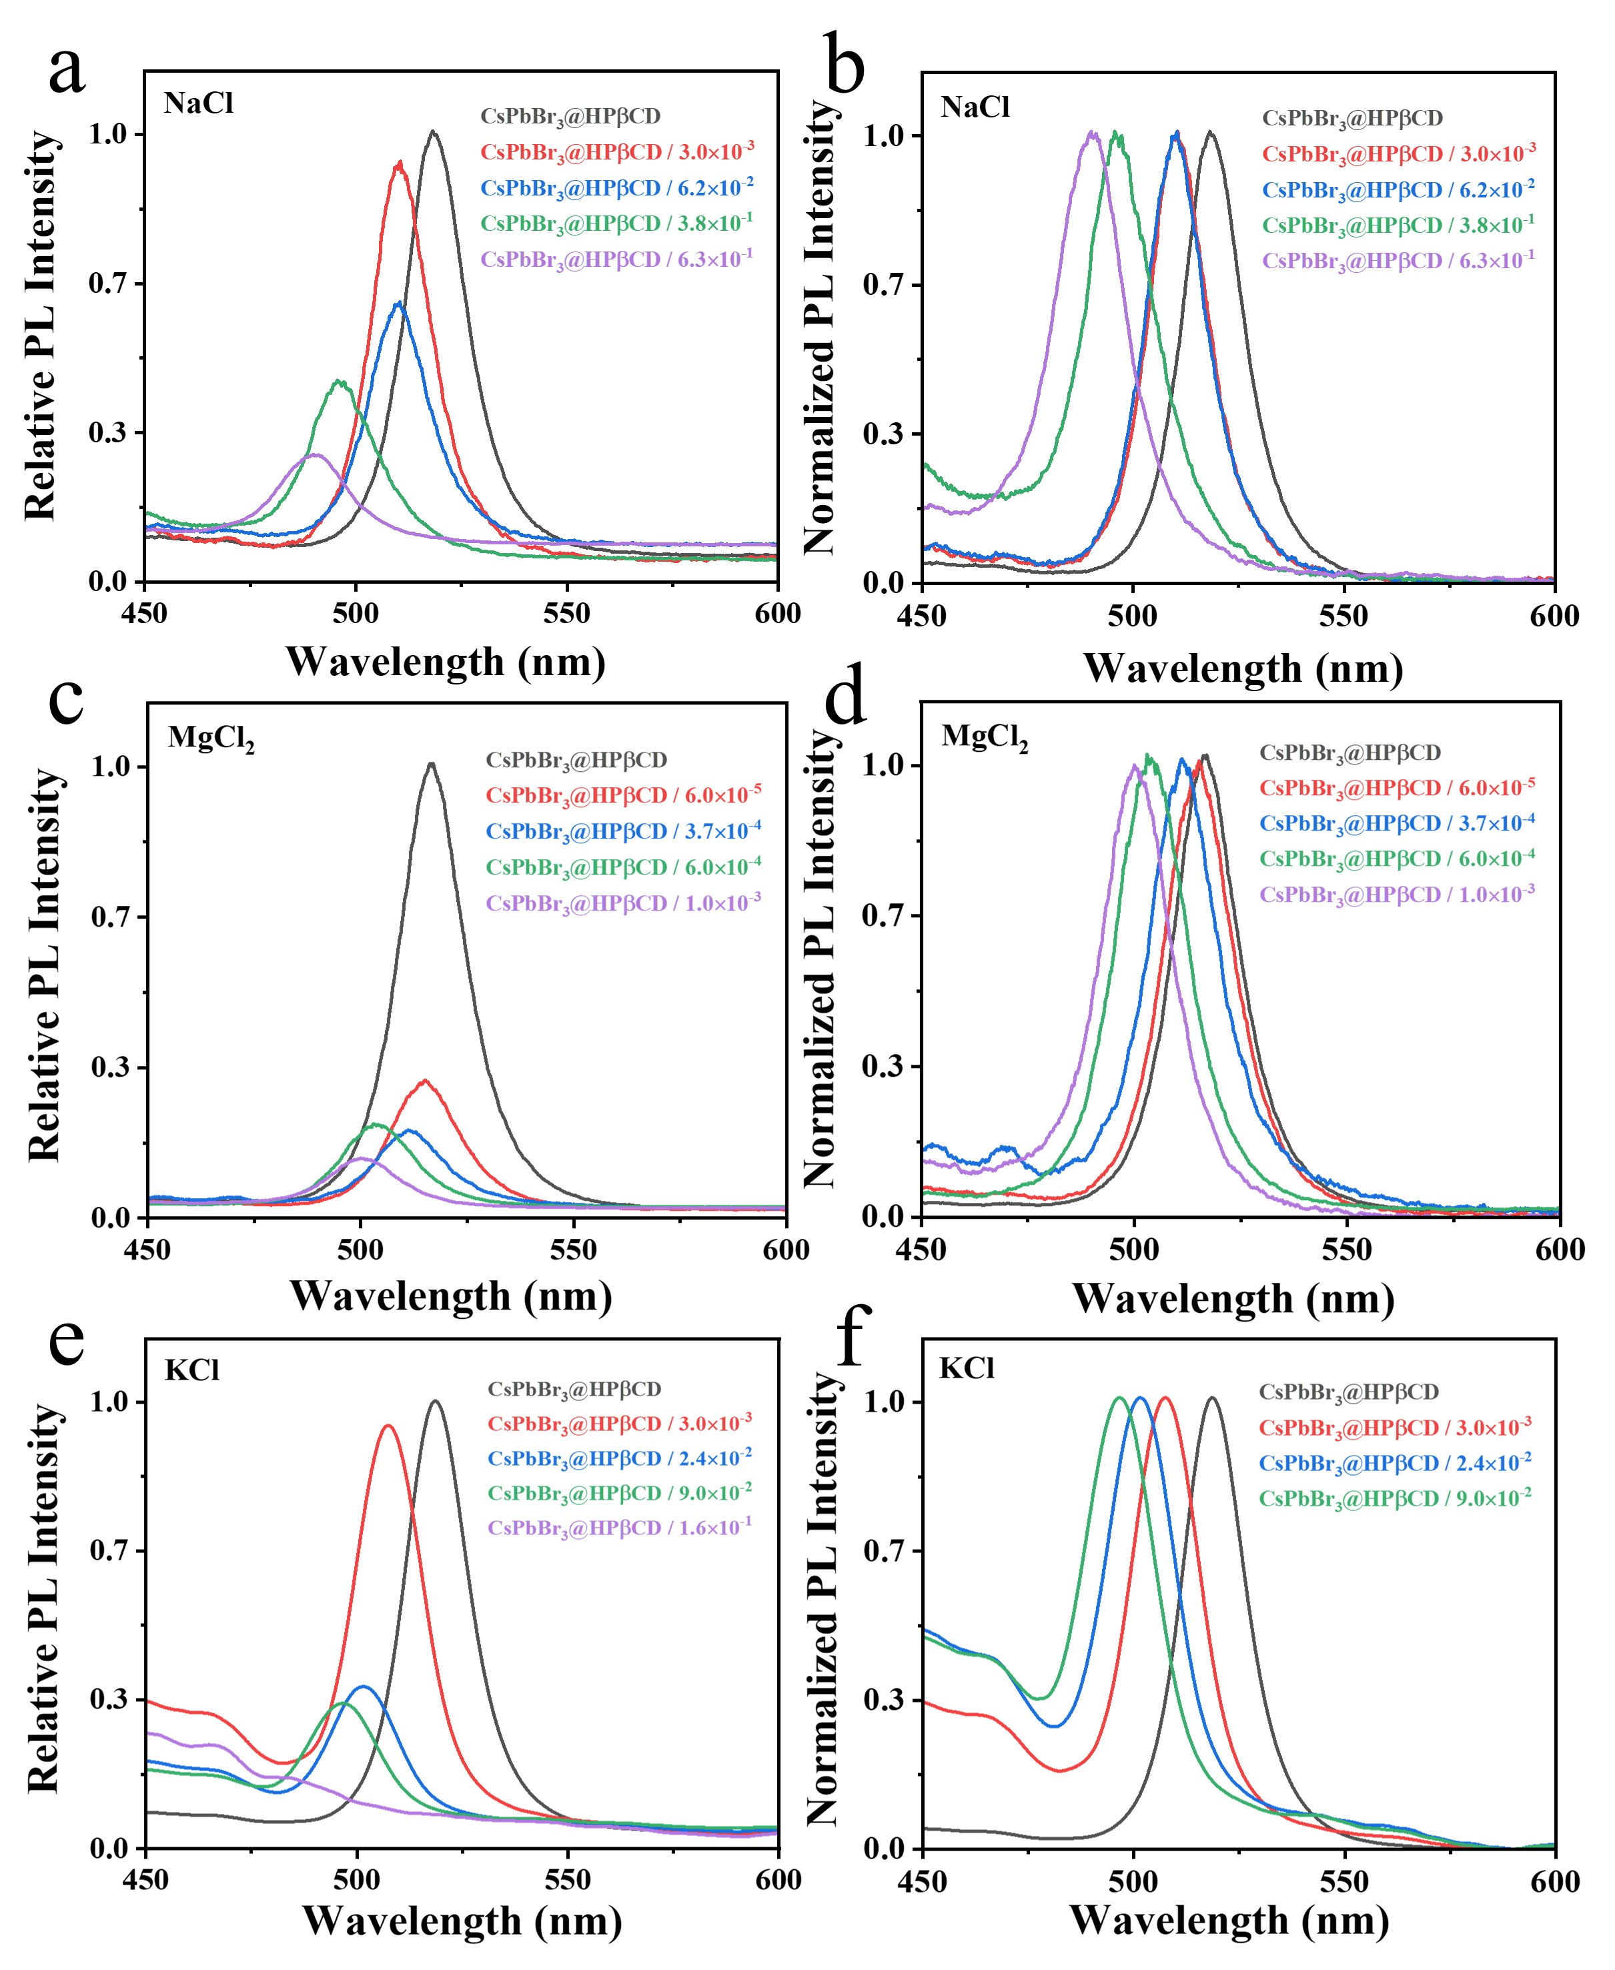

Supplementary Fig. 25. PL spectra of CsPbBr₃@HPβCD fibers with the addition of chloride at different mass ratios. (a, c, e) PL spectra, (b, d, f) normalized PL spectra of (a, c, e), (a-b) NaCl, (c-d) MgCl₂, (e-f) KCl.

Supplementary Table 4. The PL parameters of CsPbBr₃@HPβCD fibers with the addition of NaCl.

Mass ratio  (NaCl : CsPbBr₃@HPβCD) | Relative PL intensity | Peak wavelength  (nm) | Peak wavelength shift  (nm)
0 | 1.00 | 518.5 | /
3.0×10⁻³ | 0.92 | 509.2 | -9.3
6.2×10⁻² | 0.61 | 508.8 | -9.8
3.8×10⁻¹ | 0.44 | 495 | -23.5
6.3×10⁻¹ | 0.28 | 488 | -30.5

Supplementary Table 5. The PL parameters of CsPbBr₃@HPβCD fibers with the addition of MgCl₂.
Mass ratio  (MgCl₂ : CsPbBr₃@HPβCD) |  | Relative PL intensity | Peak wavelength  (nm) |  | Peak wavelength shift  (nm)
0 | 1.00 |  |  | 517.2 |  | /
6.0×10⁻⁵ | 0.30 |  |  | 514.9 |  | -2.3
3.7×10⁻⁴ | 0.20 |  |  | 509.5 |  | -7.7
6.0×10⁻⁴ | 0.18 |  |  | 500.8 |  | -16.4
1.0×10⁻³ | 0.12 |  |  | 497.3 |  | -19.9

Supplementary Table 6. The PL parameters of CsPbBr₃@HPβCD fibers with the addition of KCl.
Mass ratio  (KCl : CsPbBr₃@HPβCD) | Relative PL intensity | Peak wavelength  (nm) |  | Peak wavelength shift  (nm)
0 | 1.00 |  | 519.4 |  | /
3.0×10⁻³ | 0.94 |  | 506.5 |  | -12.9
2.4×10⁻² | 0.36 |  | 498.6 |  | -20.8
9.0×10⁻² | 0.32 |  | 493.8 |  | -25.6
1.6×10⁻¹ | N.D. |  | N.D. |  | N.D.
N.D. refers to not detected.

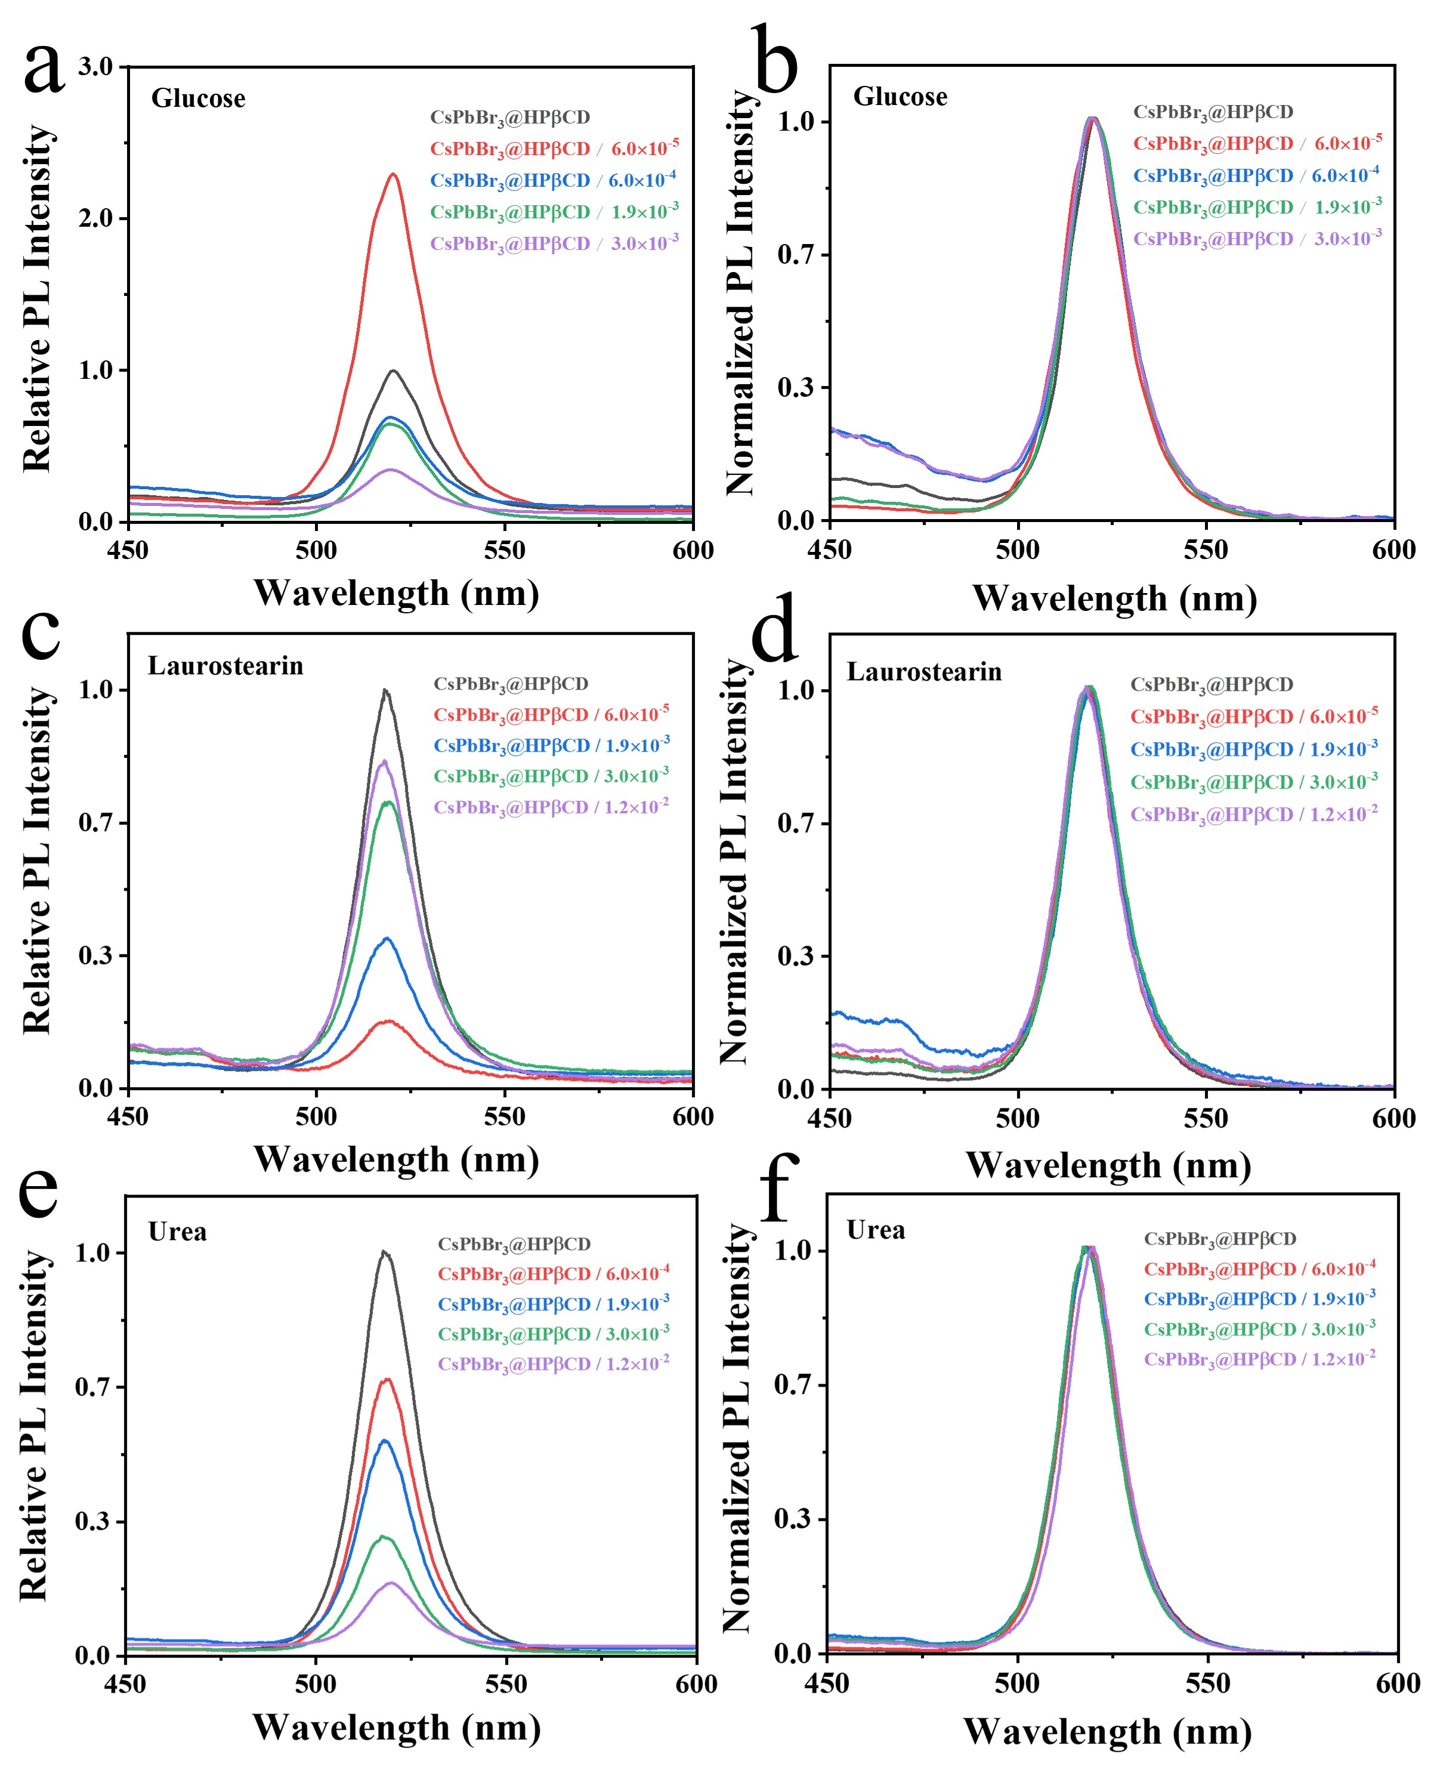

Supplementary Fig. 26. PL spectra of CsPbBr₃@HPβCD fibers with the addition of glucose at different mass ratios. (a, c, e) PL spectra, (b, d, f) normalized PL spectra of (a, c, e), (a-b) glucose, (c-d) laurostearin, (e-f) urea.

Supplementary Table 7. The PL parameters of CsPbBr₃@HPβCD fibers with the addition of glucose.
Mass ratio  (Glucose : CsPbBr₃@HPβCD) | Relative PL intensity | Peak wavelength (nm) | Peak wavelength shift  (nm)
0 | 1.00 | 520.3 | /
6.0×10⁻⁵ | 2.28 | 520.3 | 0
6.0×10⁻⁴ | 0.70 | 520.3 | 0
1.9×10⁻³ | 0.64 | 520.3 | 0
3.0×10⁻³ | 0.31 | 520.1 | -0.2

Supplementary Table 8. The PL parameters of CsPbBr₃@HPβCD fibers with the addition of laurostearin.
Mass ratio  (Laurostearin : CsPbBr₃@HPβCD) |  | Relative PL intensity | Peak wavelength  (nm) |  |  | Peak wavelength shift  (nm)
0 | 1.00 |  |  | 518.3 | /
6.0×10⁻⁵ | 0.17 |  |  | 518.8 | +0.5
1.9×10⁻³ | 0.36 |  |  | 518 6 | +0.3
3.0×10⁻³ | 0.71 |  |  | 518.5 | +0.2
1.2×10⁻² | 0.78 |  |  | 518.3 | 0

Supplementary Table 9. The PL parameters of CsPbBr₃@HPβCD fibers with the addition of urea.
Mass ratio  (Urea : CsPbBr₃@HPβCD) | Relative PL intensity | Peak wavelength  (nm) | Peak wavelength shift  (nm)
0 | 1.00 | 518.2 | /
6.0×10⁻⁴ | 0.68 | 518.3 | +0.1
1.9×10⁻³ | 0.53 | 518.3 | +0.1
3.0×10⁻³ | 0.29 | 518.3 | +0.1
1.2×10⁻² | 0.16 | 518.7 | +0.5

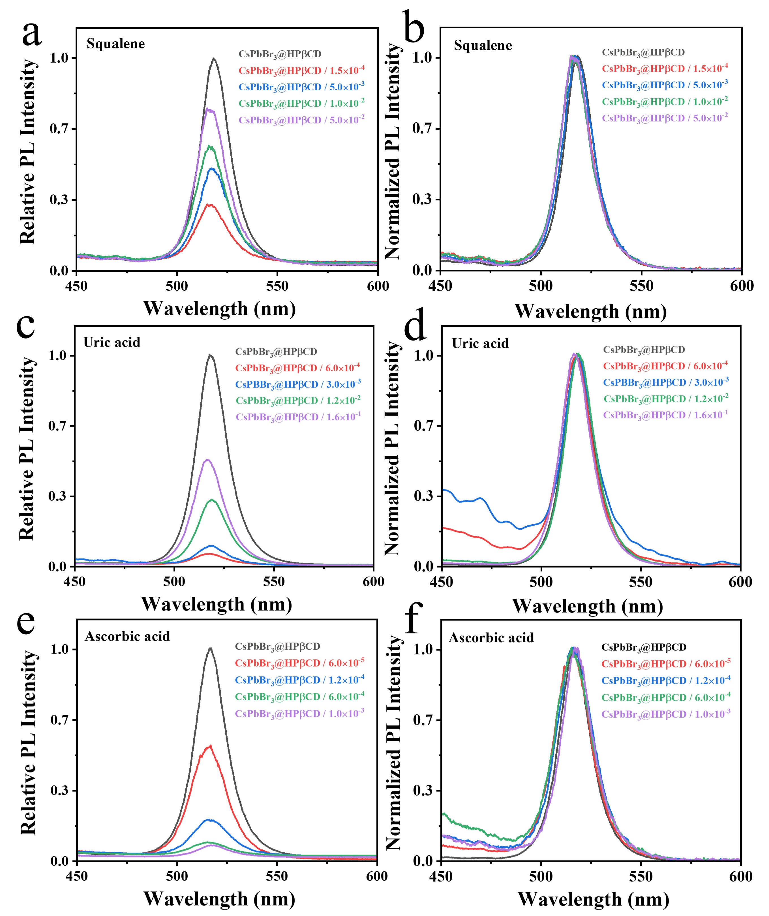

Supplementary Fig. 27. PL spectra of CsPbBr₃@HPβCD fibers with the addition of squalene at different mass ratios. (a, c, e) PL spectra, (b, d, f) normalized PL spectra of (a, c, e), (a-b) squalene, (c-d) uric acid, (e-f) Ascorbic acid.

Supplementary Table 10. The PL parameters of CsPbBr₃@HPβCD fibers with the addition of squalene.
Mass ratio  (Squalene : CsPbBr₃@HPβCD) | Relative PL intensity | Peak wavelength  (nm) | Peak wavelength shift  (nm)
0 | 1.00 | 518 2 | /
1.5×10⁻⁴ | 0.30 | 518.3 | +0.1
5.0×10⁻³ | 0.47 | 518.3 | +0.1
1.0×10⁻² | 0.57 | 518.2 | 0
5.0×10⁻² | 0.75 | 518.1 | -0.1

Supplementary Table 11. The PL parameters of CsPbBr₃@HPβCD fibers with the addition of uric acid.
Mass ratio  (Uric acid : CsPbBr₃@HPβCD) | Relative PL intensity | Peak wavelength  (nm) | Peak wavelength shift  (nm)
0 | 1.00 | 518.5 | /
6.0×10⁻⁴ | 0.06 | 518.5 | 0
3.0×10⁻³ | 0.13 | 518.5 | 0
1.2×10⁻² | 0.31 | 518.5 | 0
1.6×10⁻¹ | 0.53 | 518.3 | -0.2

Supplementary Table 12. The PL parameters of CsPbBr₃@HPβCD fibers with the addition of ascorbic acid.
Mass ratio  (ascorbic acid: CsPbBr₃@HPβCD) | Relative PL intensity | Peak wavelength  (nm) | Peak wavelength shift  (nm)
0 | 1.00 | 517.4 | /
6.0×10⁻⁵ | 0.53 | 517.3 | -0.1
1.2×10⁻⁴ | 0.19 | 517.4 | 0
6.0×10⁻⁴ | 0.09 | 517.4 | 0
1.0×10⁻³ | 0.08 | 517.6 | +0.2

Supplementary Table 13. Summary of the PL peak shifts of CsPbBr₃@HPβCD fibers in responding to different components.
NaCl | PL peak  (nm) | 488 |  | 495 |  | 508.8 |  | 509.2
NaCl | Mass ratio | 6.3×10⁻¹ |  | 3.8×10⁻¹ |  | 6.2×10⁻² |  | 3.0×10⁻³
KCl | PL peak  (nm) | N.D. |  | 493.8 |  | 498.6 |  | 506.5
KCl | Mass ratio | 1.6×10⁻¹ |  | 9.0×10⁻² |  | 2.4×10⁻² |  | 3.0×10⁻³
MgCl₂ | PL peak  (nm) | 497.3 |  | 500.8 |  | 509.5 |  | 514.9
MgCl₂ | Mass ratio | 1.0×10⁻³ |  | 6.0×10⁻⁴ |  | 3.7×10⁻⁴ |  | 6.0×10⁻⁵
Laurostearin | PL peak  (nm) | 518.3 |  | 518.5 |  | 518.6 |  | 518.8
Laurostearin | Mass ratio | 1.2×10⁻² |  | 3.0×10⁻³ |  | 1.9×10⁻³ |  | 6.0×10⁻⁵
Urea | PL peak  (nm) | 518.7 |  | 518.3 |  | 518.3 |  | 518.3
Urea | Mass ratio | 1.2×10⁻² |  | 3.0×10⁻³ |  | 1.9×10⁻³ |  | 6.0×10⁻⁴
Glucose | PL peak  (nm) | 520.1 |  | 520.3 |  | 520.3 |  | 520.3
Glucose | Mass ratio | 3.0×10⁻³ |  | 1.9×10⁻³ |  | 6.0×10⁻⁴ |  | 6.0×10⁻⁵
Squalane | PL peak  (nm) | 518.1 | 518.2 |  | 518.3 |  | 518.3
Squalane | Mass ratio | 5.0×10⁻² | 1.0×10⁻² |  | 5.0×10⁻³ |  | 1.5×10⁻⁴
Uric acid | PL peak  (nm) | 518.3 |  | 518.5 |  | 518.5 |  | 518.5
Uric acid | Mass ratio | 1.6×10⁻¹ |  | 1.2×10⁻² |  | 3.0×10⁻³ |  | 6.0×10⁻⁴
Ascorbic acid | PL peak  (nm) | 517.6 |  | 517.4 |  | 517.4 |  | 517.3
Ascorbic acid | Mass ratio | 1.0×10⁻³ |  | 6.0×10⁻⁴ |  | 1.2×10⁻⁴ |  | 6.0×10⁻⁵
N.D. refers to not detected.

Supplementary Table 14. Summary of PL lifetimes of CsPbBr₃@HPβCD fibers upon the addition of various components.
*The average lifetime (τ_{av}) can be calculated as the function (1-1):
 | τ₁  (ns) | A₁  % | τ₂  (ns) | A₂  % | τ₃  (ns) | A₃  % | τ_{av}*  (ns)
CsPbBr₃@HPβCD | 31.68 | 26.45 | 145.92 | 54.32 | 685.87 | 19.23 | 219.55
Glucose | 30.13 | 25.19 | 185.48 | 50.85 | 967.48 | 23.95 | 333.67
KCl | 16.93 | 28.02 | 94.52 | 54.88 | 501.61 | 17.1 | 142.39
Urea | 17.04 | 33.91 | 94.69 | 51.97 | 584.9 | 14.12 | 137.55
NaCl | 16.22 | 32.07 | 89.58 | 50.19 | 485.5 | 17.74 | 136. 28
Urea Acid | 18.35 | 33.12 | 94.14 | 51.42 | 459.71 | 15.46 | 124.53
Ascorbic acid | 10.84 | 30.1 | 61.33 | 53.69 | 305.46 | 16.21 | 85.71
MgCl₂ | 11.53 | 34.05 | 55.27 | 49.43 | 288.08 | 16.51 | 78.82
Laurostearin | 12.12 | 36.08 | 78.23 | 41.79 | 494.8 | 22.12 | 146.5
Squalene | 13.10 | 41.31 | 99.93 | 41.16 | 594.1 | 17.53 | 150.7

$τ_{average}=τ_{1}×A_{1}+τ_{2}×A_{2}+τ_{3}×A_{3}$ (3)
where τ₁, τ₂ and τ₃ are the triexponential fitted lifetime. A₁, A₂ and A₃ are the relative percentages of τ₁, τ₂ and τ₃, respectively. τ_{av} is the average lifetime.

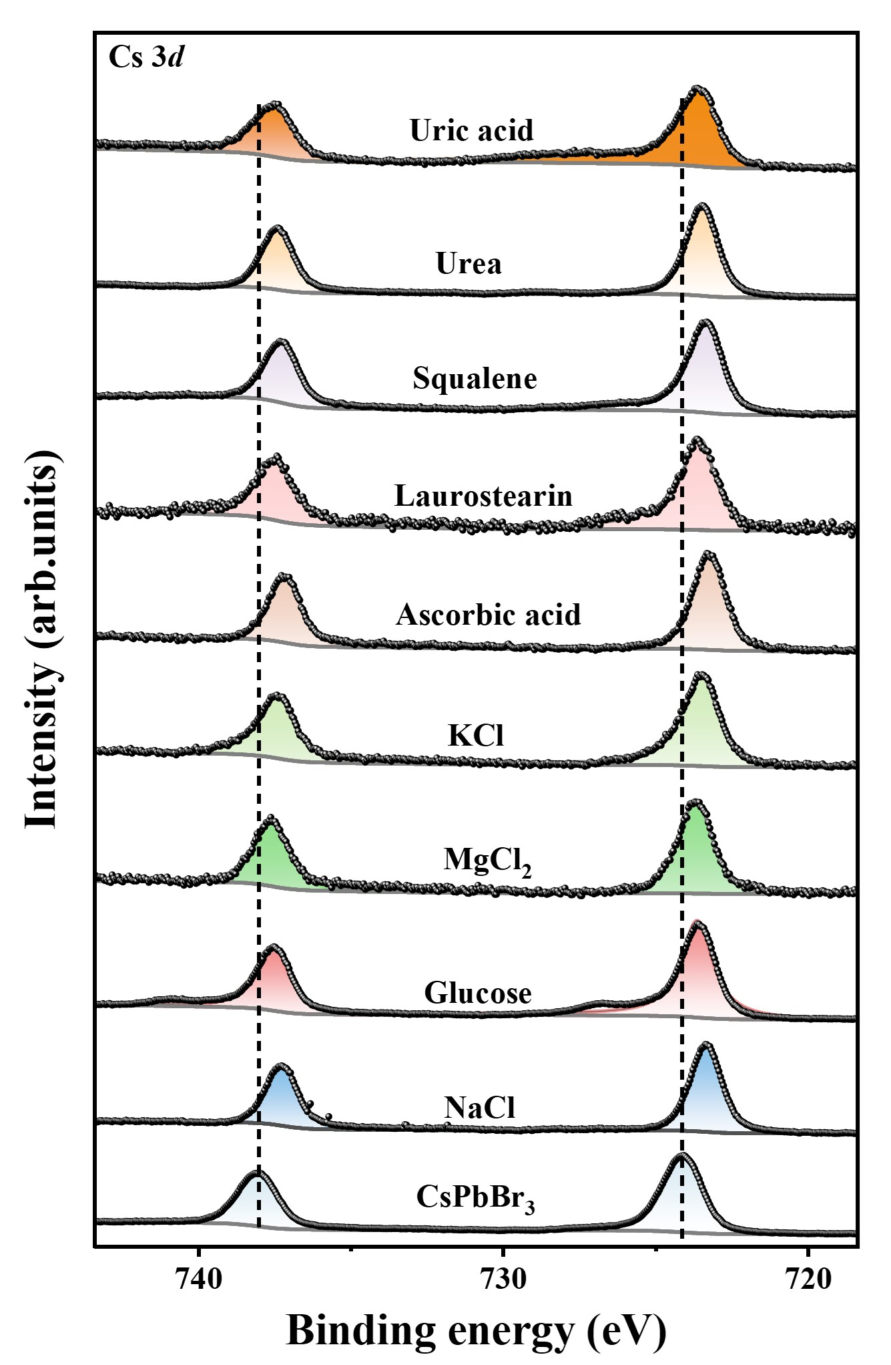

Supplementary Fig. 28. Cs 3d XPS spectra of CsPbBr₃ fibers with the addition of various components.

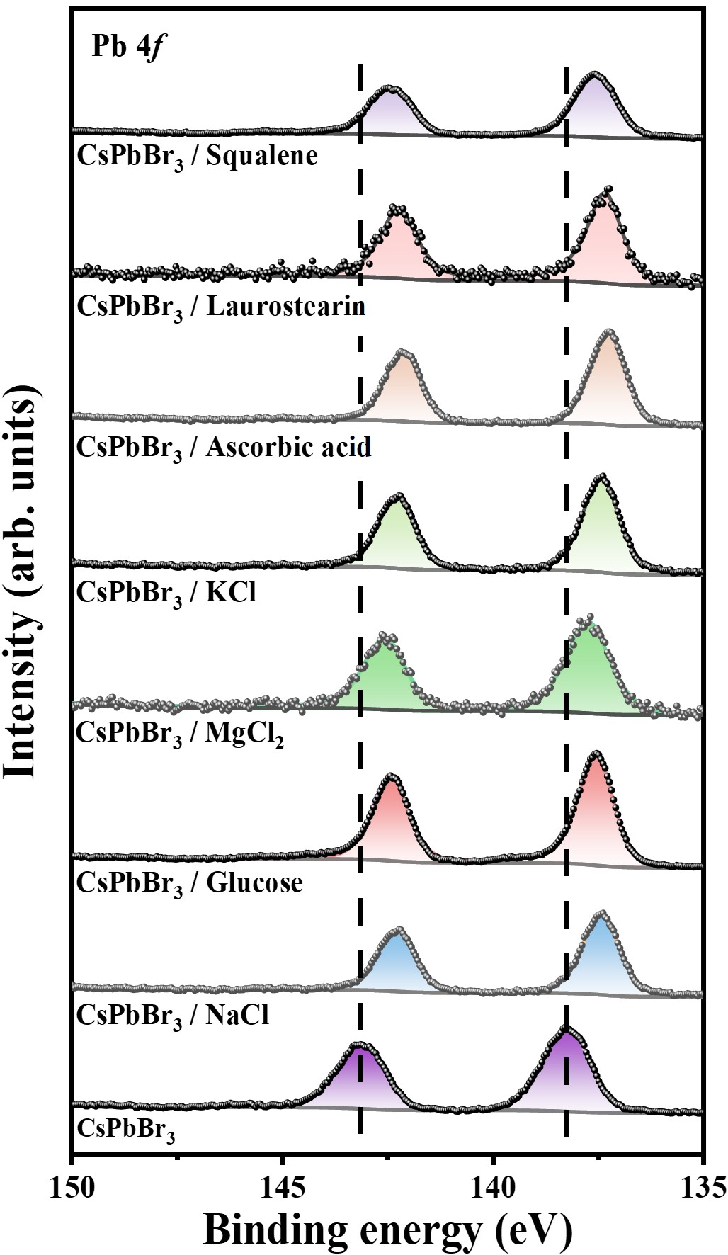

Supplementary Fig. 29. Pb 4f XPS spectra of CsPbBr₃ fibers with the addition of various components.

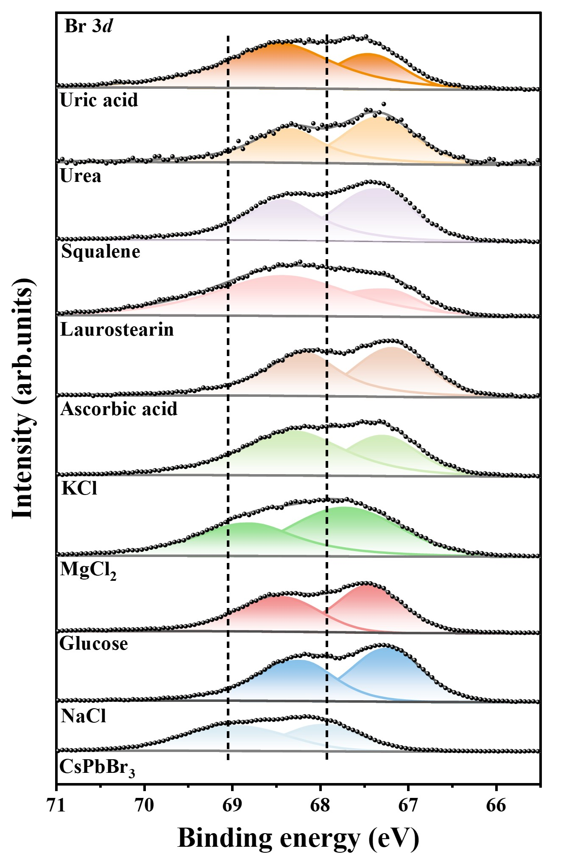

Supplementary Fig. 30. Br 3d XPS spectra of CsPbBr₃ fibers with the addition of various components.

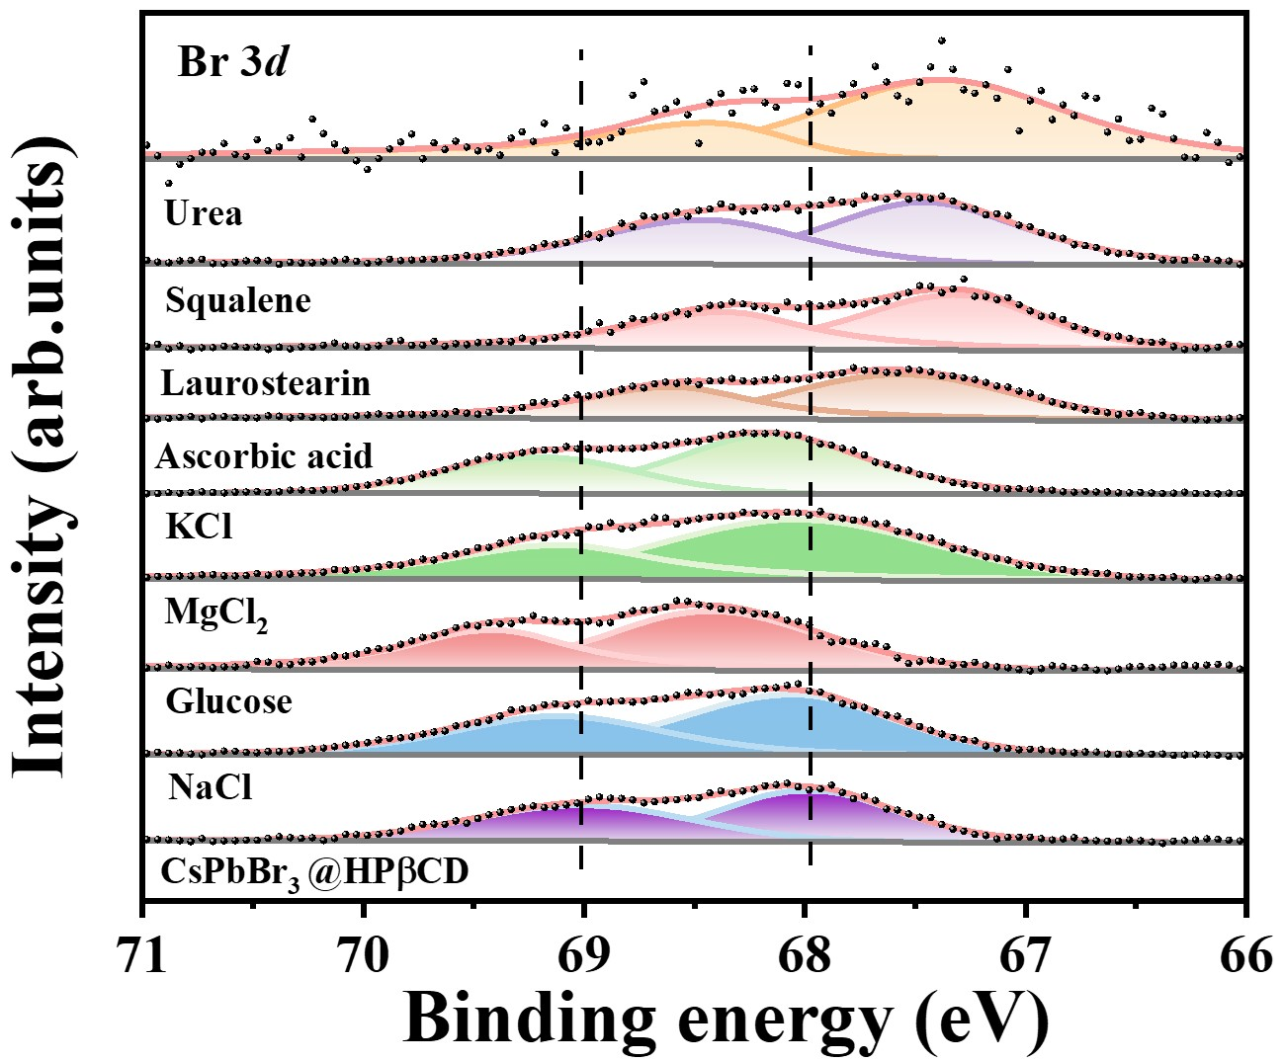

Supplementary Fig. 31. Br 3d XPS spectra of CsPbBr₃@HPβCD fibers with the addition of various components.

Supplementary Table 15. The Pb peak shifts in XPS spectra of CsPbBr₃@HPβCD introduced by different components.
Introduced component | Peak shift of Pb 4f_{5/2} (eV) | Peak shift of Pb 4f_{7/2} (eV)
NaCl | +0.42 | +0.38
MgCl₂ | +0.26 | +0.28
KCl | +0.15 | +0.12
Glucose | +0.40 | +0.38
Ascorbic acid | -0.40 | -0.42
Laurostearin | -0.50 | -0.52
Squalene | -0.40 | -0.42

Supplementary Table 16. The Br peak shifts in XPS spectra of CsPbBr₃ @HPβCD introduced by different components.
Introduced component | Peak shift of Br 3d_{3/2} (eV) | Peak shift of Br 3d_{5/2} (eV)
NaCl | +0.14 | +0.02
MgCl₂ | +0.16 | +0.02
KCl | +0.23 | +0.20
Glucose | +0.42 | +0.44
Ascorbic acid | -0.50 | -0.37
Laurostearin | -0.70 | -0.64
Squalene | -0.67 | -0.45
Urea | -0.72 | -0.58

Supplementary Table 17. ¹H-NMR shifts of each component relative to HPβCD.

Sample | Chemical shifts of HPβCD’s protons
Sample | H1 | H2 | H3 | H4 | H5 | H6 | H7 | H8
HPβCD | 5.534 | 4.698 | 4.492 | 3.740 | 3.608 | 3.553 | 3.301 | 3.217
CsPbBr₃@HPβCD | 5.511 | 4.675 | 4.495 | 3.717 | 3.588 | 3.527 | 3.230 | 3.217
CsPbBr₃@HPβCD/ NaCl | N.D. | 4.731 | 4.548 | 3.738 | 3.620 | 3.558 | N.D. | 3.157
CsPbBr₃@HPβCD /KCl | 5.507 | 4.680 | 4.508 | 3.714 | 3.585 | 3.521 | 3.303 | 3.208
CsPbBr₃@HPβCD/MgCl₂ | 5.534 | 4.618 | 4.560 | 3.682 | 3.569 | 3.508 | 3.255 | 3.163
Glucose + HPβCD | 5.519 | 4.669 | 4.463 | 3.749 | 3.616 | 3.559 | N.D. | 3.222
Glucose + CsPbBr₃@HPβCD | N.D. | 4.681 | 4.482 | 3.740 | 3.610 | 3.553 | N.D. | 3.220
N.D. refers to not detected.
Notes: The H4 and H6 protons are located inside the cavity, while the remaining protons are situated on the exterior.

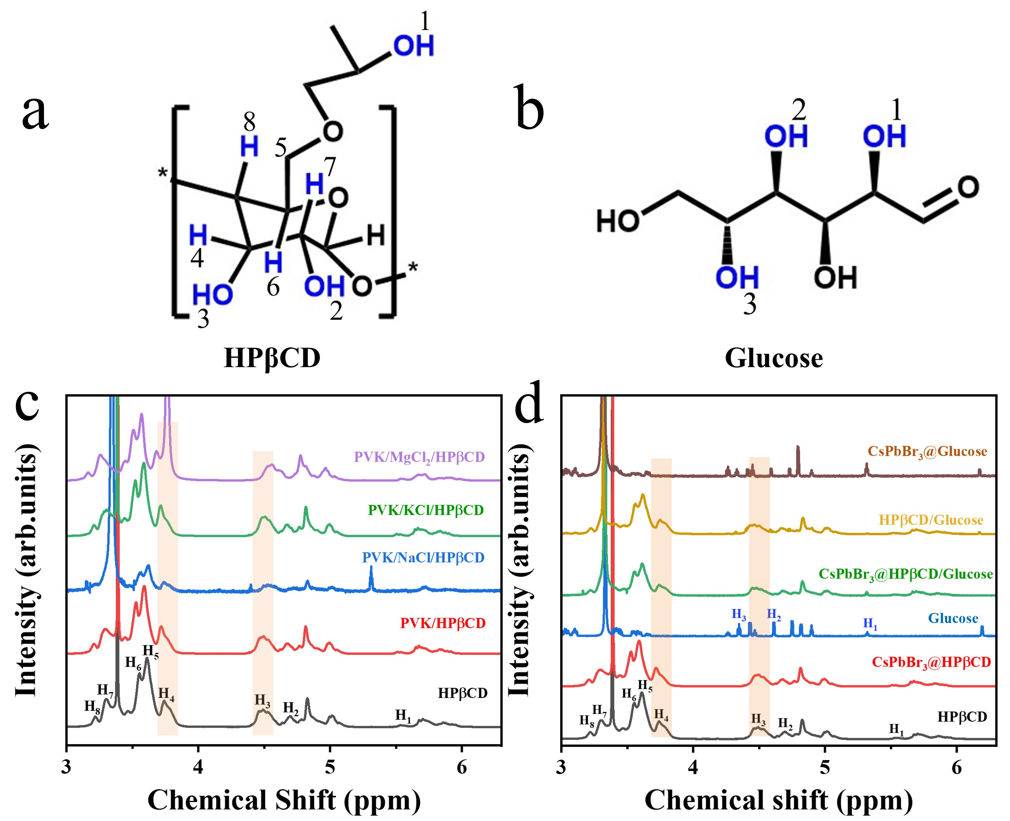

Supplementary Fig. 32. ¹H-NMR spectra of the interaction among (a,c) CsPbBr₃, HPβCD with chlorides addition; (b,d) CsPbBr₃, HPβCD with glucose addition.

Note: The addition of chloride salts (NaCl, KCl, and MgCl₂) to CsPbBr₃@HPβCD results in distinct shifts in the exterior protons of HPβCD. For example, upon NaCl introduction, the exterior protons, H2 and H3 show downfield shifts of 0.056 and 0.053 ppm, respectively, exhibiting greater chemical shifts than the interior protons H4 and H6. For glucose, which is the monomer of unmodified HPβCD, we observe intriguing experimental phenomena. ¹H-NMR analysis reveals a 0.029 ppm upfield shift for the exterior protons H2 and H3 of HPβCD upon glucose addition, suggesting hydrogen bonding interactions on the outer surface.

Supplementary Table 18. ¹H-NMR shifts of components relative to organic.
Sample | Chemical shift of glucose’s protons
Sample | H1 | H2 | H3
Glucose | 5.329 | 4.616 | 4.357
Glucose + HPβCD | 5.330 | 4.591 | 4.333
Glucose + HPβCD + CsPbBr₃ | 5.325 | N.D. | N.D.
N. D. refers to Not detected.

Supplementary Table 19. The simulated band gaps of CsPbBr₃ with NaCl introduction.
Serial name | Mode of substitution | Crystal form | Bandgap (eV)
NaCl-CsPbBr₃-1 | Na doping of Cs; Cl doping of Br | 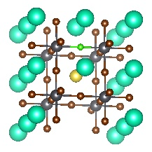 | 1.30301
NaCl-CsPbBr₃-2 | 2 Na doping of 2 Cs; Cl doping of Br | 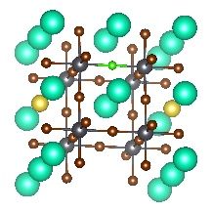 | 1.30255
NaCl-CsPbBr₃-3 | Na doping of Pb; Cl doping of Br | 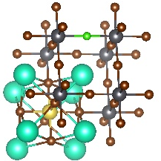 | 2.24274
NaCl-CsPbBr₃-4 | Na doping of Pb; Cl doping of Br | 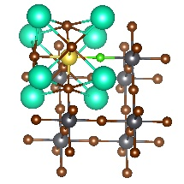 | 2.23006
The highlighted simulation is the closest band gap to the experimental result.
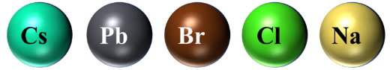

Supplementary Table 20. The simulated band gaps of CsPbBr₃ with KCl introduction.
Serial name | Mode of substitution | Crystal form | Bandgap  (eV)
KCl-CsPbBr₃-1 | K doping of Cs; Cl doping of Br | 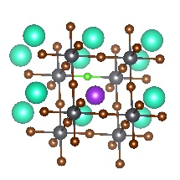 | 1.31215
KCl-CsPbBr₃-2 | 2 K doping of 2 Cs; Cl doping of Br | 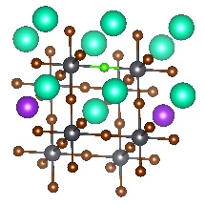 | 1.29909
KCl-CsPbBr₃-3 | K doping of Pb; Cl doping of Br | 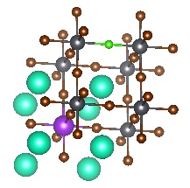 | 2.21372
KCl-CsPbBr₃-4 | K doping of Pb; Cl doping of Br | 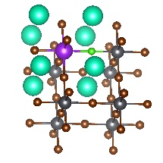 | 2.22328
The highlighted simulation is the closest band gap to the experimental result.


Supplementary Table 21. The simulated band gaps of CsPbBr₃ with MgCl₂ introduction.
Serial name | Mode of substitution | Crystal form | Bandgap  (eV)
MgCl₂-CsPbBr₃-1 | Mg doping of Pb; Cl doping of Br | 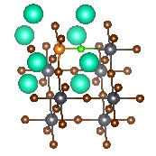 | 1.40074
MgCl₂-CsPbBr₃-2 | Mg doping of Pb; Cl doping of Br (Mg and Cl are far apart) | 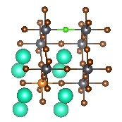 | 1.4301
MgCl₂-CsPbBr₃-3 | Mg doping of Cs; Cl doping of Br; theoretically nonexistent | 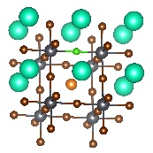 | 0
MgCl₂-CsPbBr₃-4 | 2 Mg doping of Cs; Cl doping of Br; theoretically nonexistent | 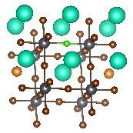 | 0
MgCl₂-CsPbBr₃-5 | Theoretically nonexistent | 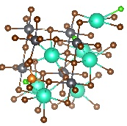 | 0
MgCl₂-CsPbBr₃-6 | Theoretically nonexistent | 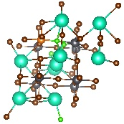 | 0
MgCl₂-CsPbBr₃-7 | Theoretically nonexistent | 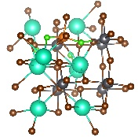 | 0
The highlighted simulation is the closest band gap to the experimental result.
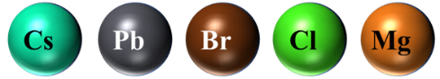

Supplementary Table 22. The simulated adsorption energy of CsPbBr₃ with chloride introduction.
Serial name | Crystal form | Adsorption energy
CsPbBr₃+KCl | 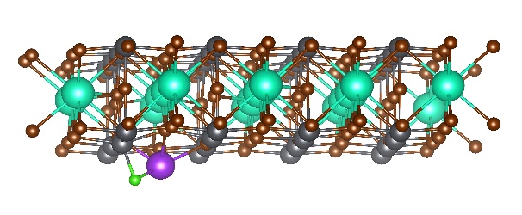 | -6.64 eV
CsPbBr₃+MgCl₂ | 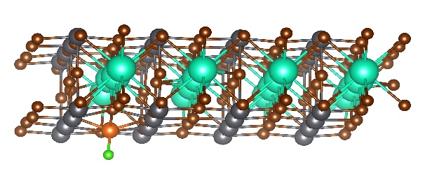 | -6.01 eV
CsPbBr₃+NaCl | 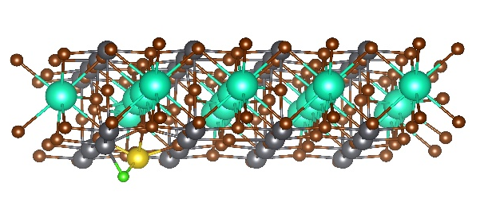 | -6.42 eV

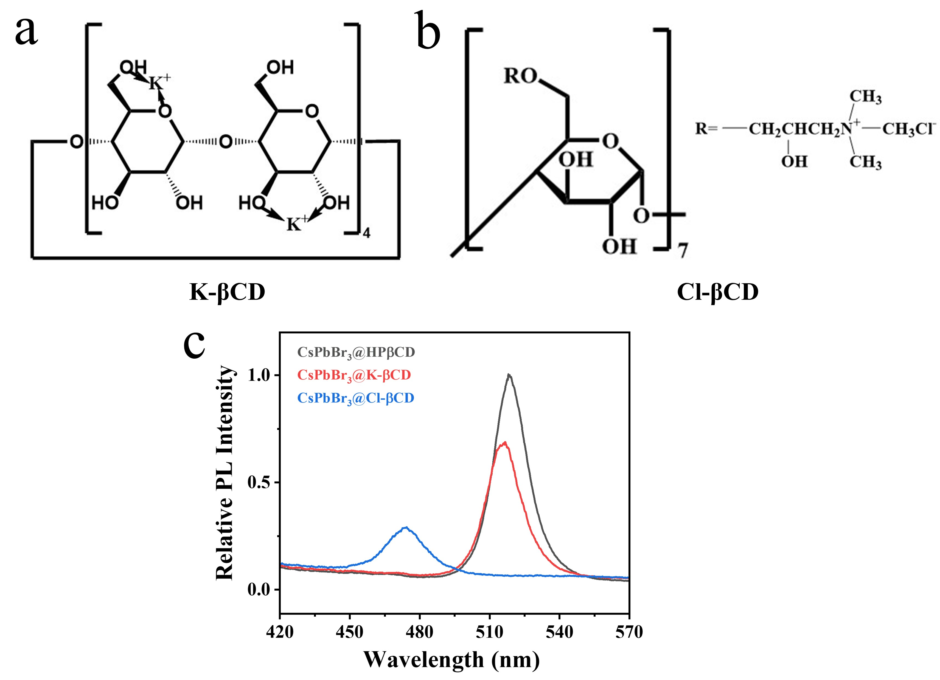

Supplementary Fig. 33. PL spectra of influence of CsPbBr₃@HPβCD, CsPbBr₃@K-βCD, and CsPbBr₃@Cl-βCD fiber. The structure formula of (a) K-βCD and (b) Cl-βCD. (c) PL spectra of CsPbBr₃@HPβCD, CsPbBr₃@K-βCD, and CsPbBr₃@Cl-βCD fibers.

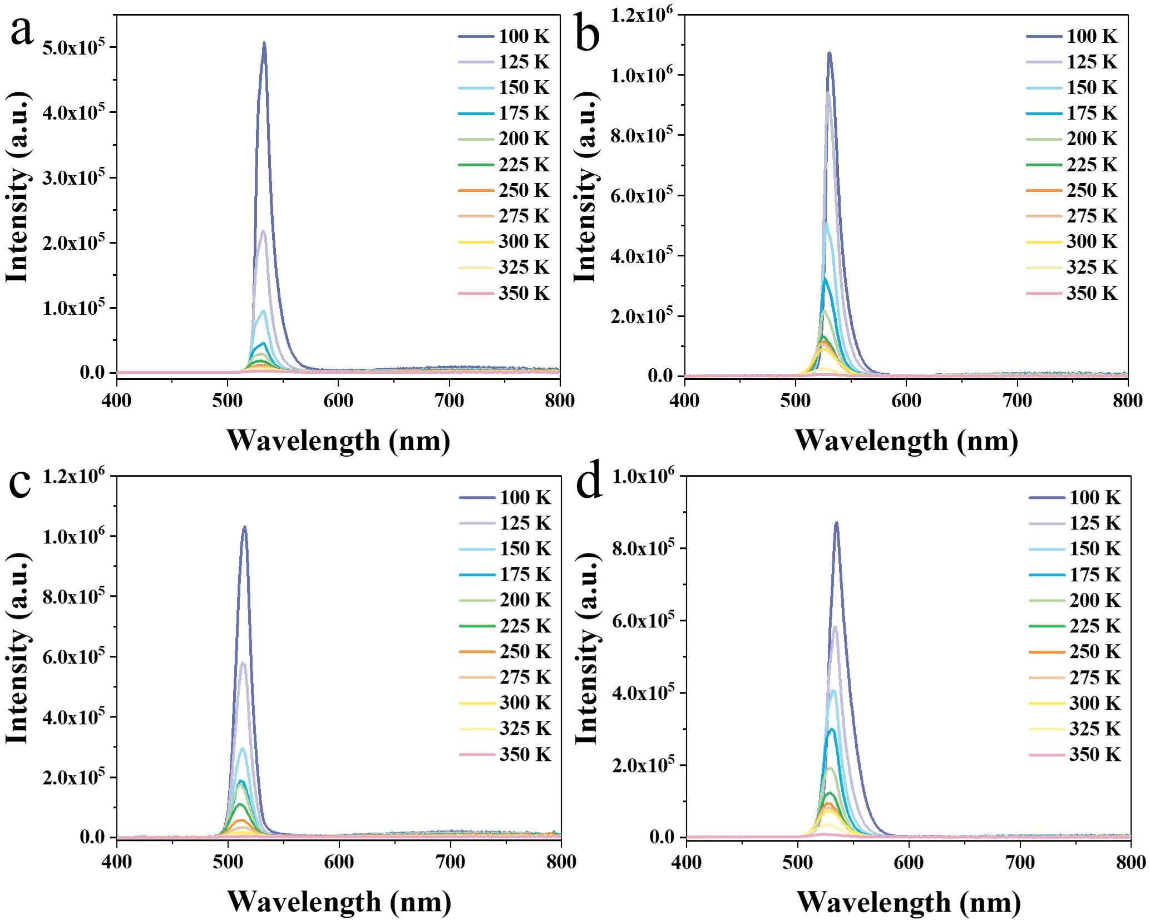

Supplementary Fig. 34. Temperature-dependence PL spectra. (a) CsPbBr₃ fibers, (b) CsPbBr₃@HPβCD fibers, (c) CsPbBr₃@HPβCD/NaCl fibers and (d) CsPbBr₃@HPβCD/ glucose fibers.

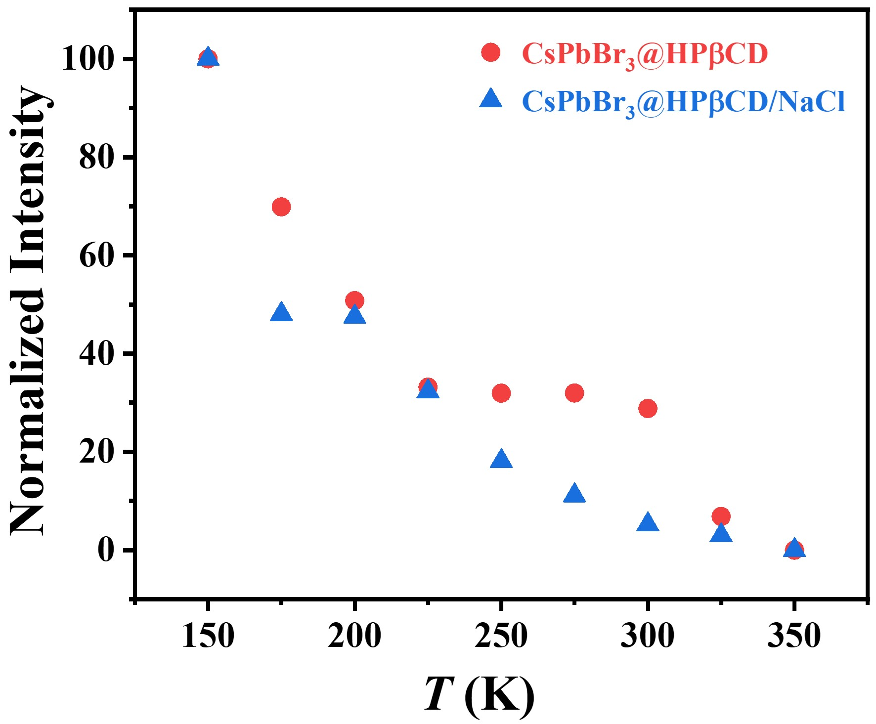

Supplementary Fig. 35. Temperature-dependent PL intensity relationship of CsPbBr₃@HPβCD and CsPbBr₃@HPβCD/NaCl fibers.

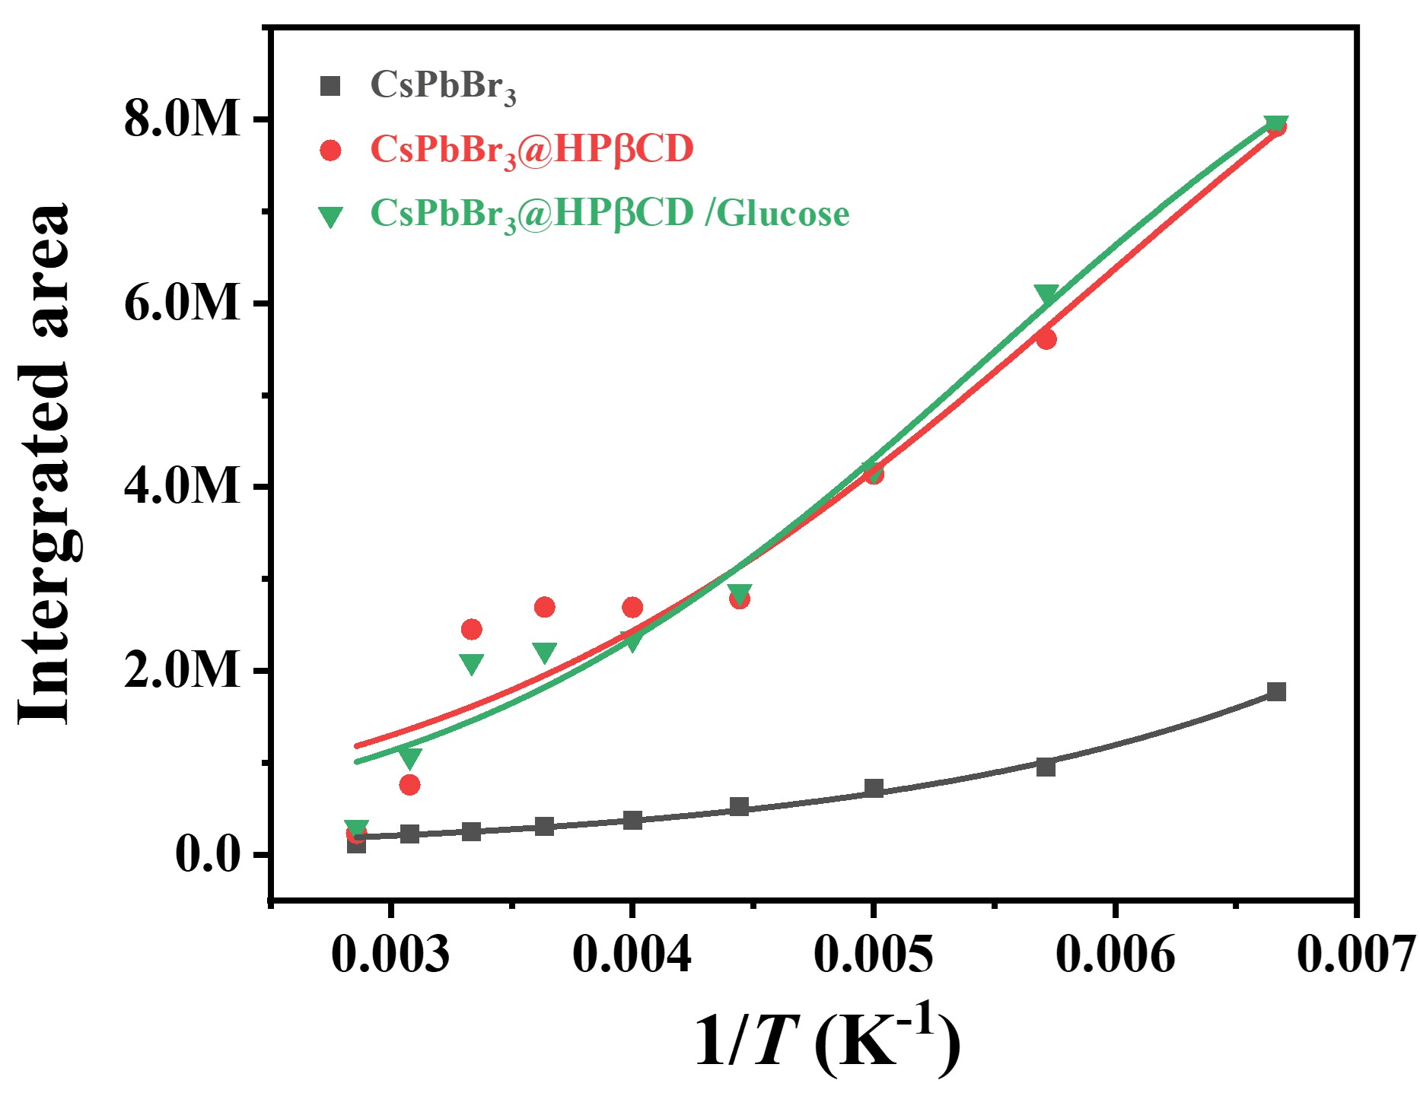

Supplementary Fig. 36. Arrhenius plot of integrated PL intensity as a function of the reciprocal temperature (1/T) of CsPbBr_{3,} CsPbBr₃@HPβCD and CsPbBr₃@HPβCD/glucose fibers.

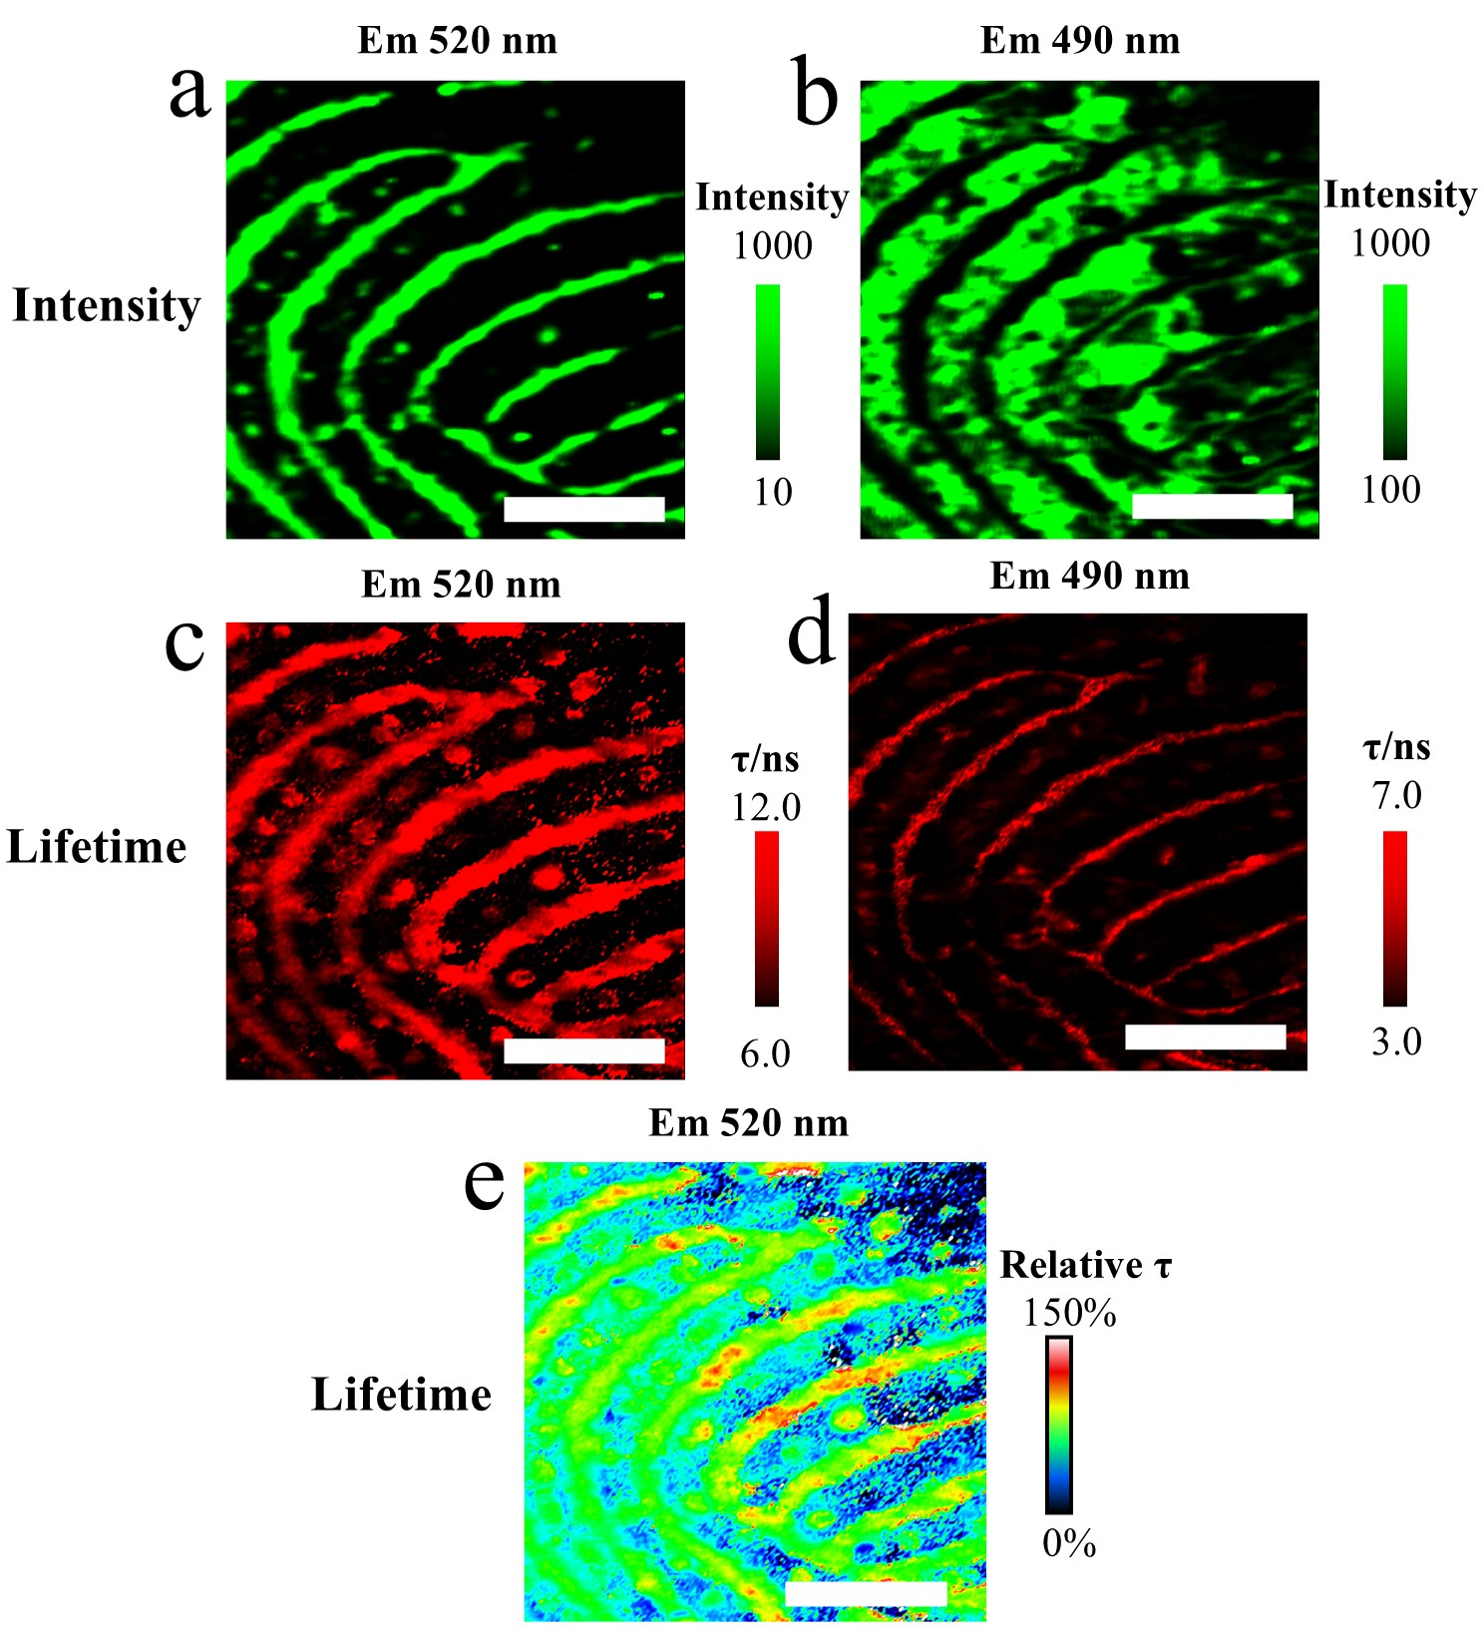

Supplementary Fig. 37. PL mapping images of CsPbBr₃@HPβCD fiber. Peak intensity mapping at (a) 520 nm and (b) 490 nm. Lifetime mapping at (c) 520 nm and (d) 490 nm. Scale bar: 1 mm. (e) the relative lifetime distribution. The lifetime of CsPbBr₃@HPβCD fiber as 100% (see Supplementary Table 23), scale bar: 1 mm.

Note: FLIM captures the lifetimes in localized microregions. Owing to the small laser spot size and the need to optimize the FLIM acquisition efficiency by reducing the overall mapping time, the duration per point is limited to a few seconds. As a result, the lifetimes measured by FLIM are shorter (Supplementary Table 23). Despite the differences in the specific lifetime values obtained by the two methods, the trends of longer or shorter lifetimes are consistent (Supplementary Fig. 38).

Supplementary Table 23. Reference in situ PL lifetime for CsPbBr₃ @HPβCD fibers with or without fingerprint residue components.
Components | τ / ns | S. D.
CsPbBr₃@HPβCD | 14.1 | 3.5
CsPbBr₃@HPβCD/NaCl | 11.4 | 2.1
CsPbBr₃@HPβCD/MgCl₂ | 10.0 | 2.7
CsPbBr₃@HPβCD/KCl | 10.4 | 3.2
CsPbBr₃@HPβCD/Glucose | 33.9 | 8.5
CsPbBr₃@HPβCD/Ascorbic acid | 8.1 | 3.6
CsPbBr₃@HPβCD/Urea | 7.9 | 1.6
CsPbBr₃@HPβCD/Uric acid | 6.2 | 1.9
CsPbBr₃@HPβCD/Laurostearin | 11.6 | 2.8
CsPbBr₃@HPβCD/Squalene | 12.8 | 1.6
S.D. stands for standard deviation, n = 3.

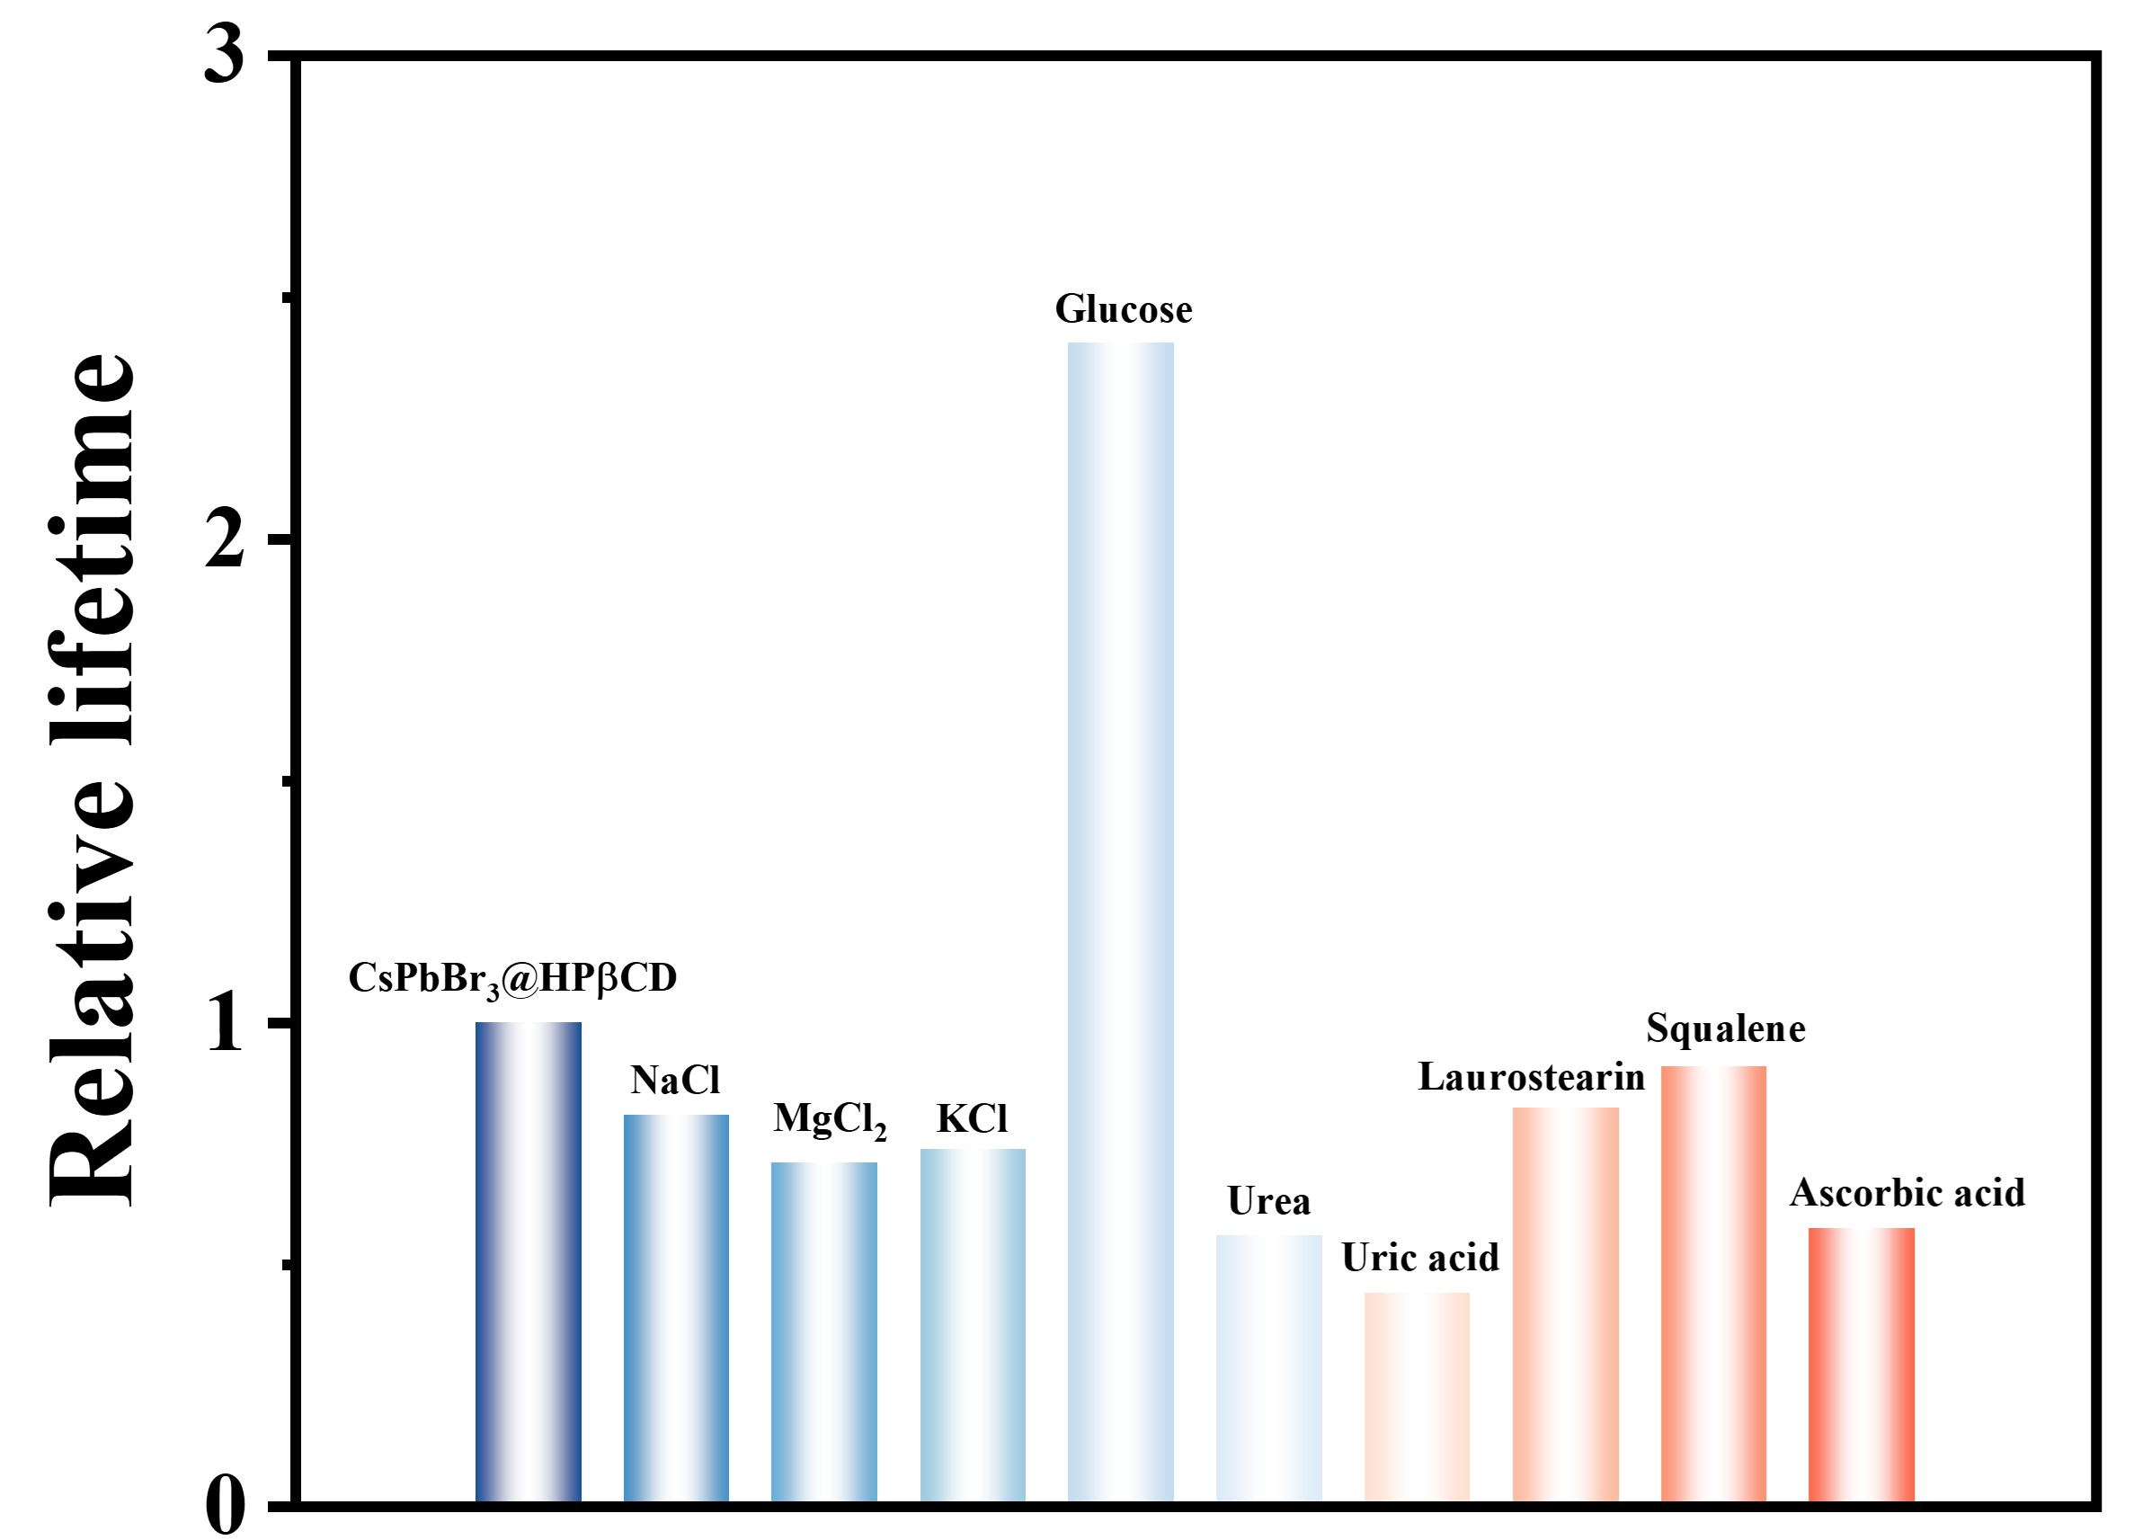

Supplementary Fig. 38. Reference in situ PL lifetime for CsPbBr₃@HPβCD fibers with or without fingerprint residue components.

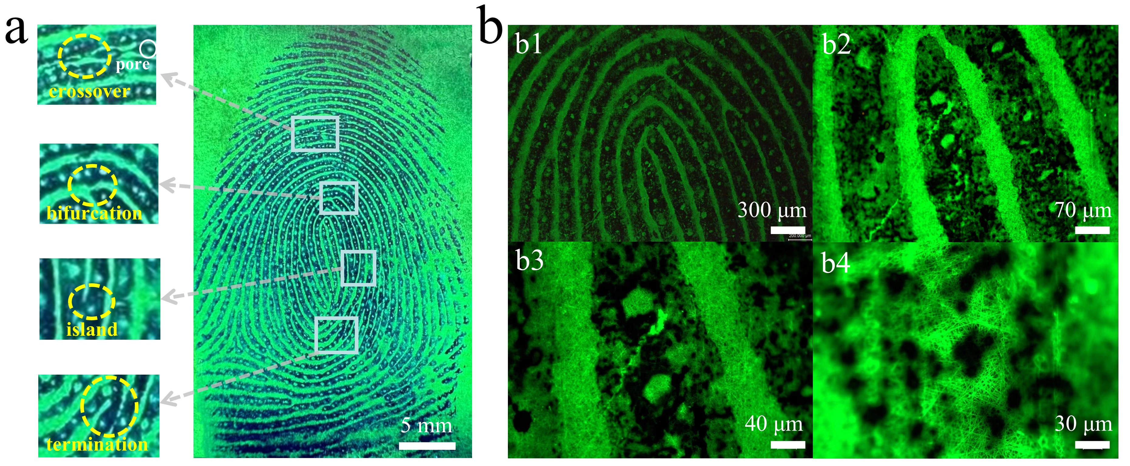

Supplementary Fig. 39. Luminescence imaging of LFPs on tinfoil by NFIT. (a) The characteristics of Level 3 fingerprints (b) Magnified luminescence images under 365 nm UV light.

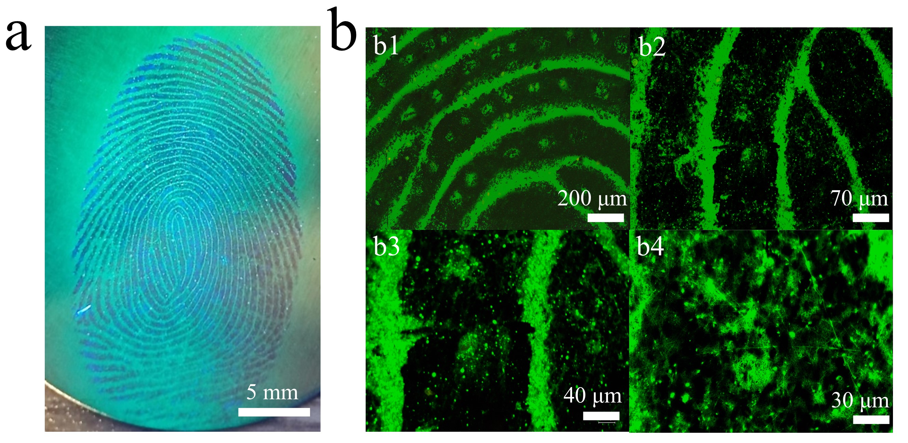

Supplementary Fig. 40. Luminescence imaging of LFPs on iron by NFIT. (a) Level 3 fingerprint imaging. (b) Magnified luminescence images under UV light.

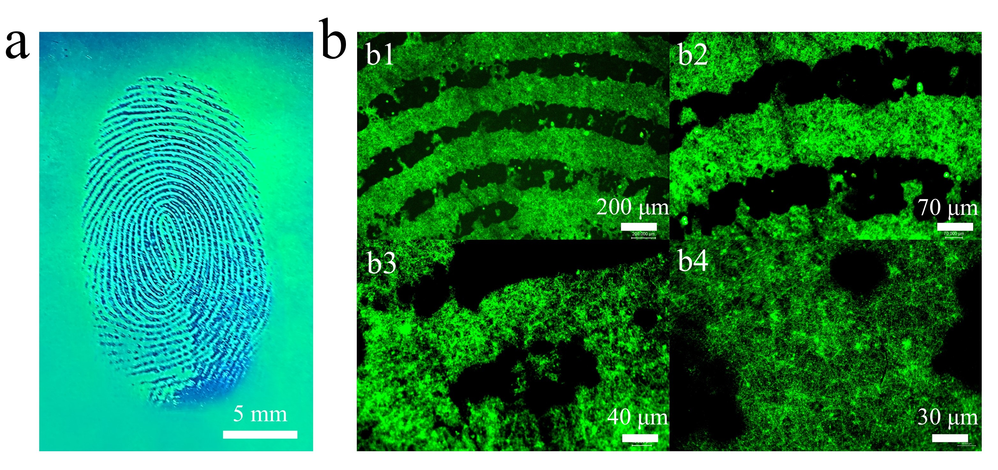

Supplementary Fig. 41. Luminescence imaging of LFPs on glass by NFIT. (a) Level 3 fingerprint imaging. (b) Magnified luminescence images under UV light.

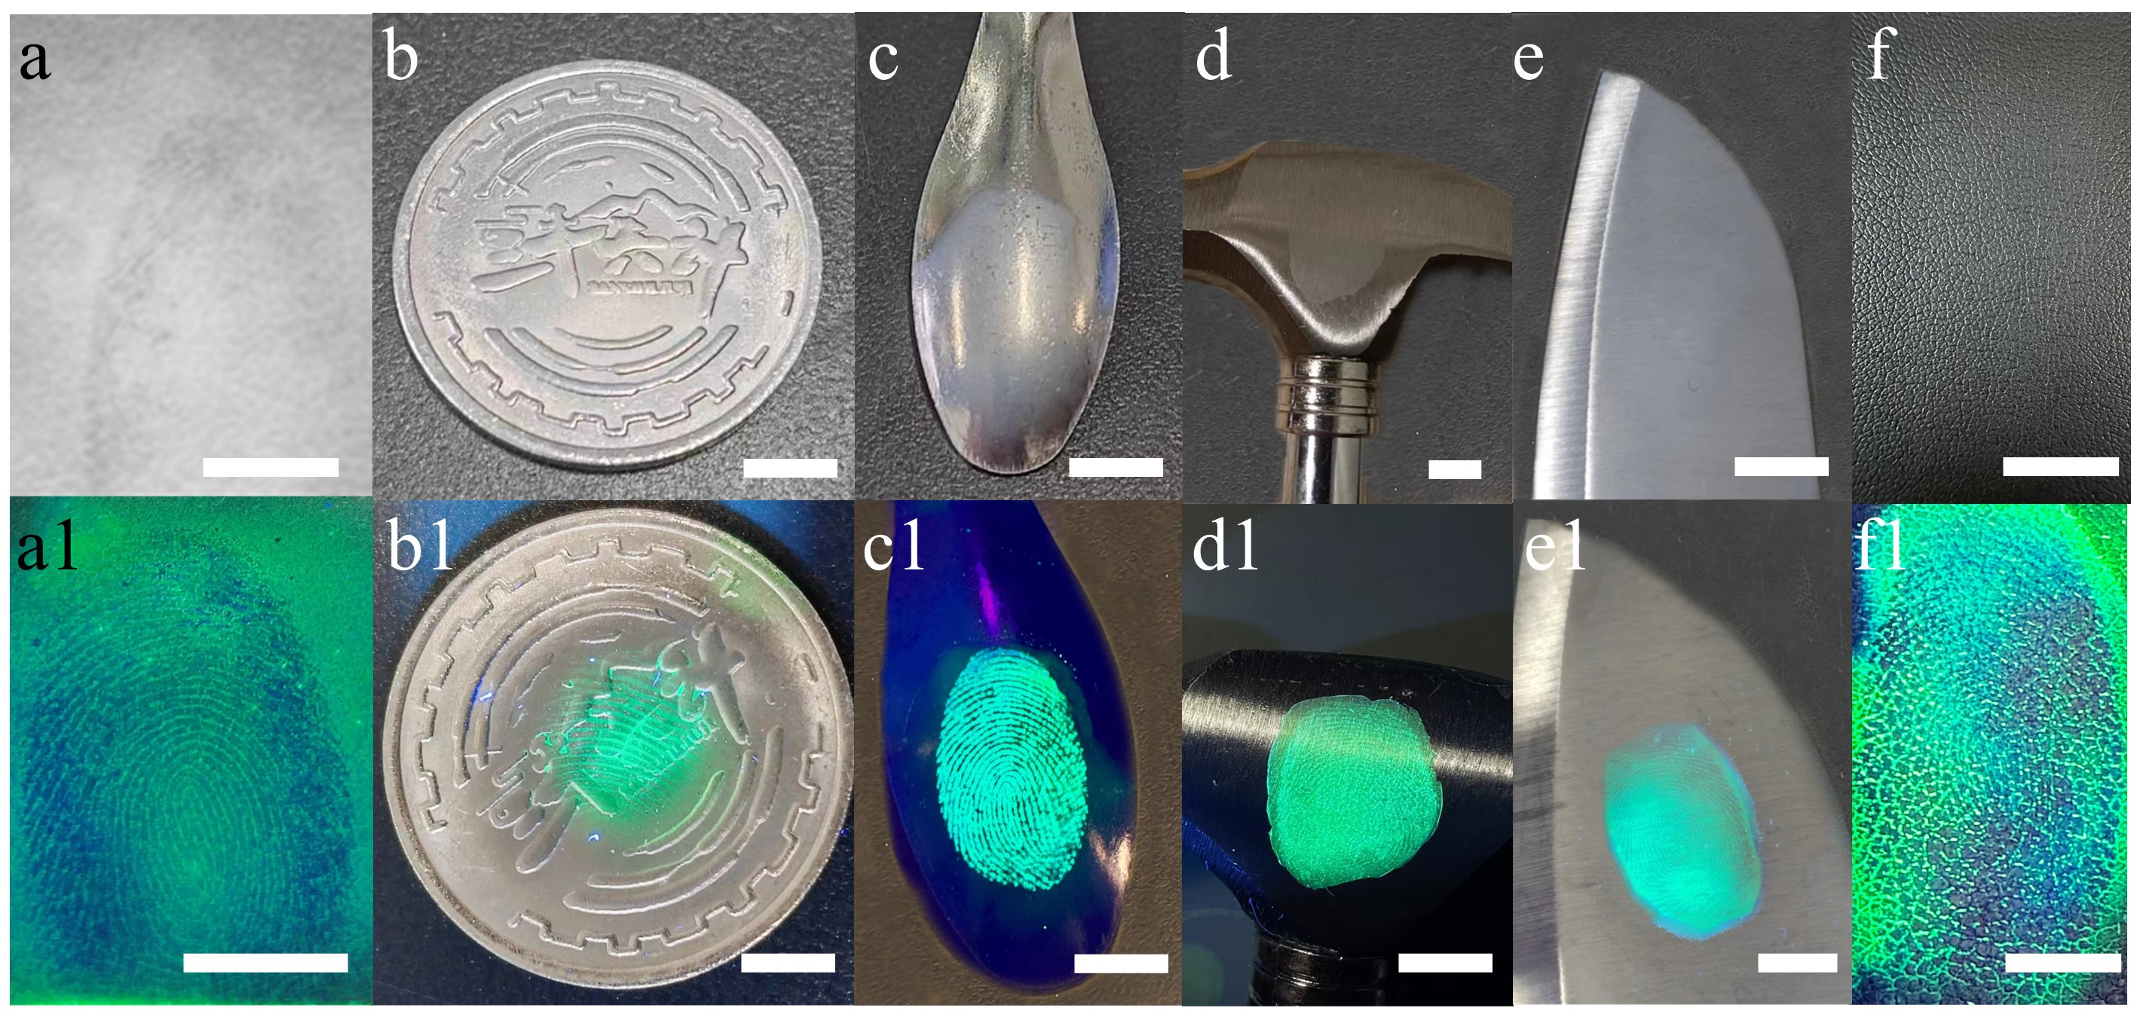

Supplementary Fig. 42. Imaging of LFPs on various substrates by NFIT. (a) wooden desk (b) coin (c) spoon (d) hammer (e) knife under indoor light (f) leather, and (a1-f1) under 365nm UV light, scale bar: 1 cm.

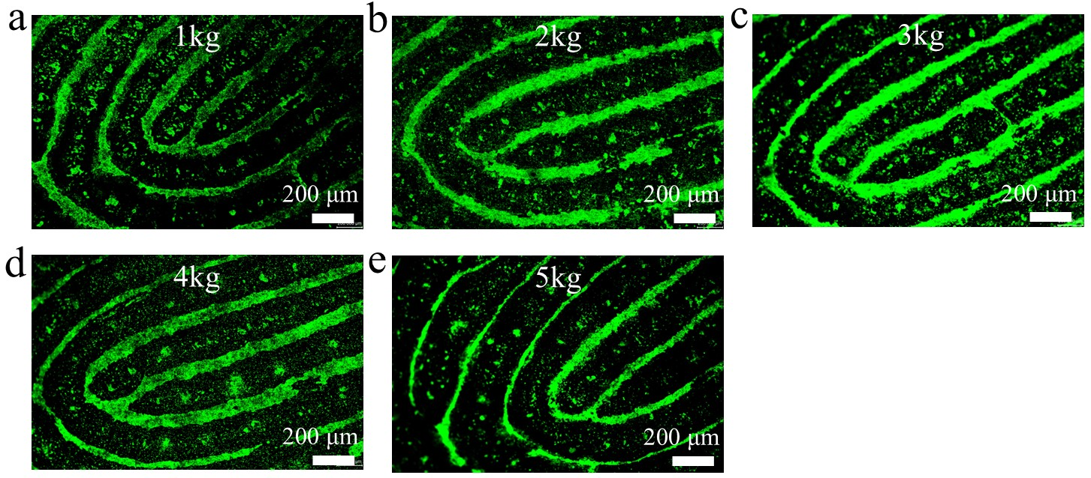

Supplementary Fig. 43. Fingerprint imaging by CsPbBr₃@HPβCD fibers at the weight of (a) 1 kg; (b) 2 kg; (c) 3 kg; (d) 4 kg and (e) 5 kg.

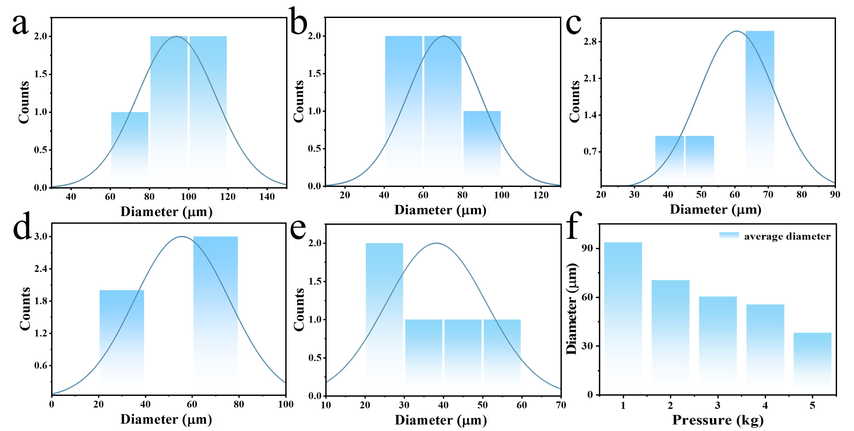

Supplementary Fig. 44. The sweat pore distribution at the weight of (a) 1 kg; (b) 2 kg; (c) 3 kg; (d) 4 kg and (e) 5 kg. (f) Bar graph of different pressure versus pore diameters.

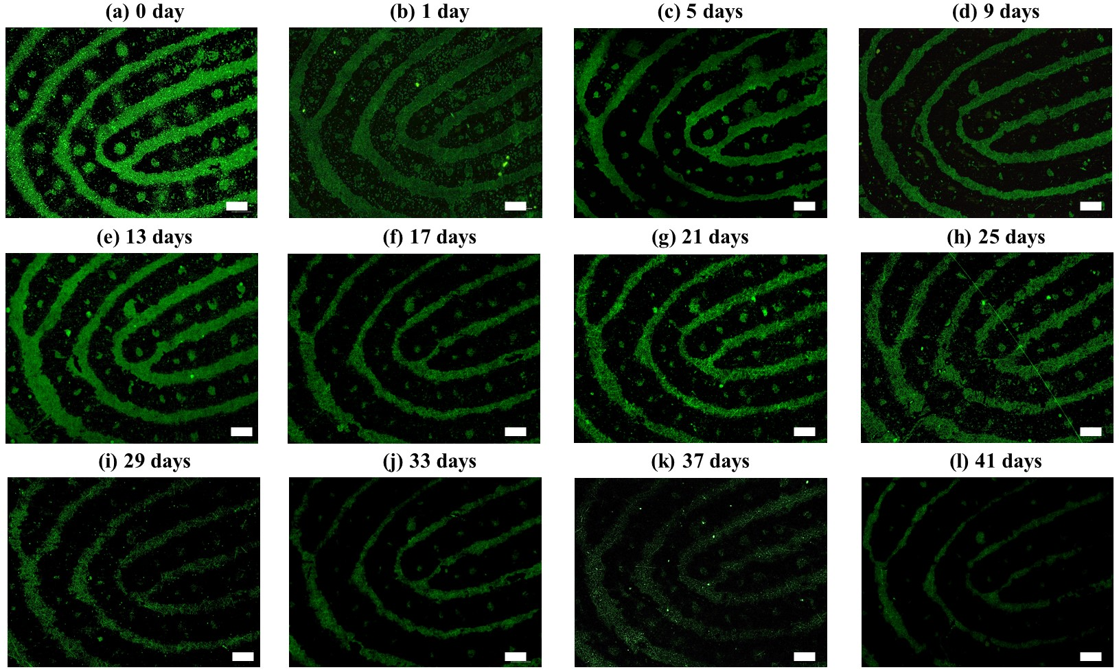

Supplementary Fig. 45. The timelines of aged fingerprint extraction by CsPbBr₃@HPβCD fibers. (a)-(e) the extraction day from 0-41 days, scale bar: 200 μm.

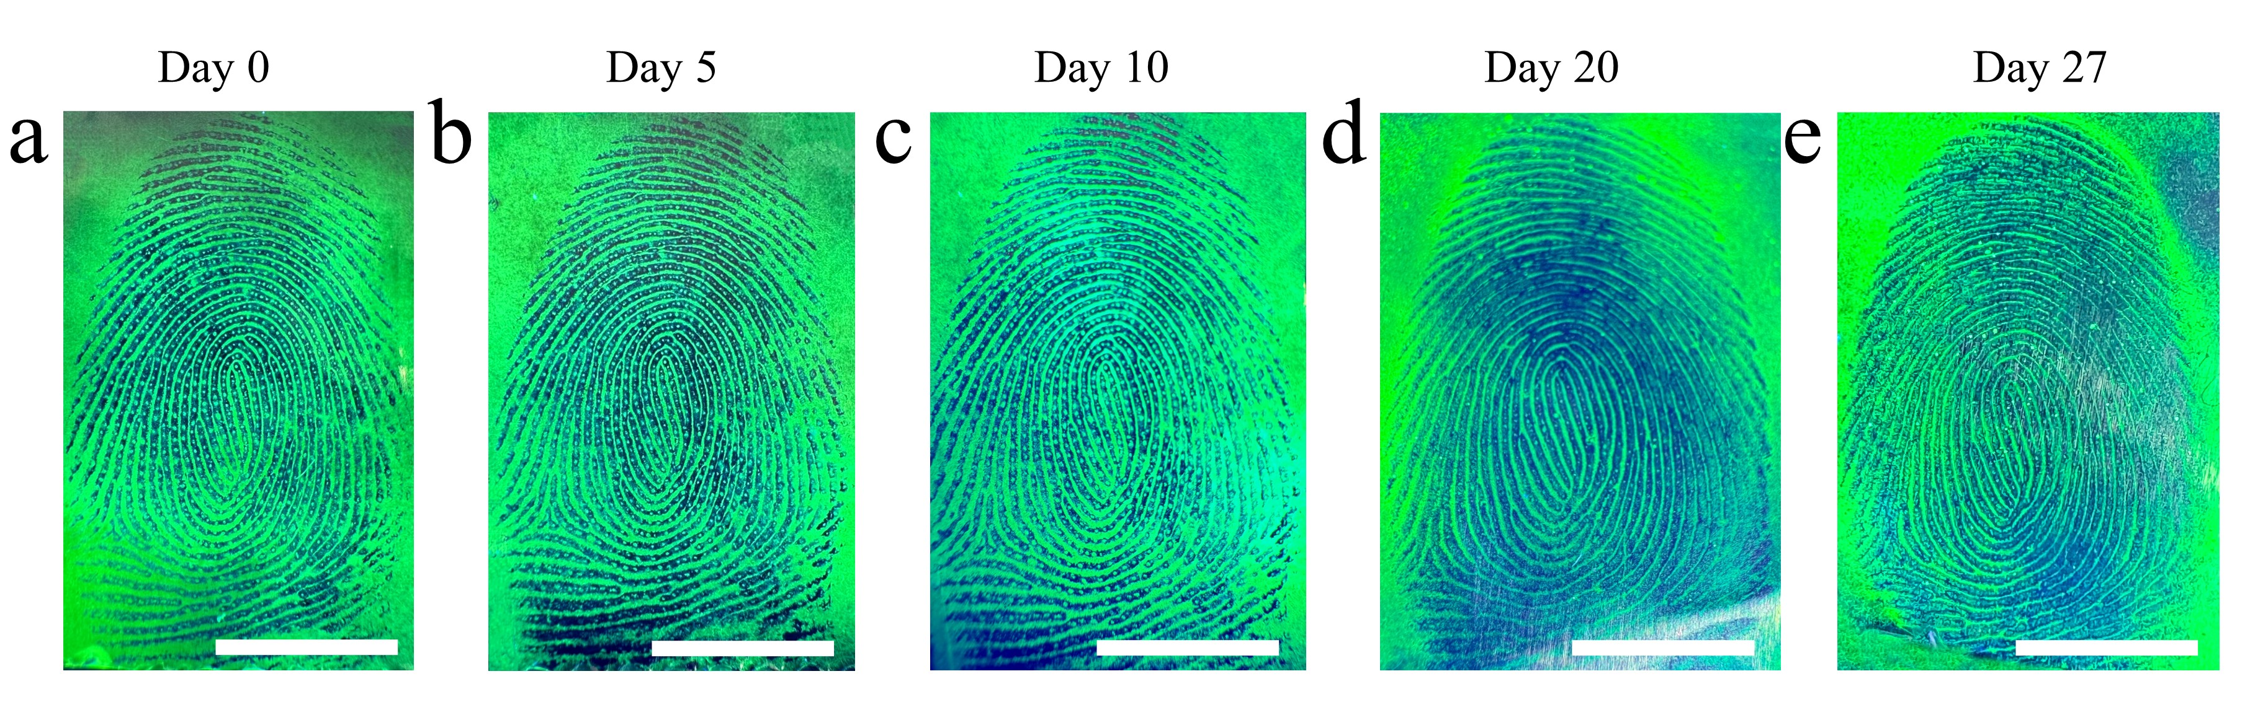
Supplementary Fig. 46. The timeline of aged fingerprint extraction by NFIT (full fingerprint), (a)-(e) the extraction day from 0-27 days, scalebar: 1 cm.
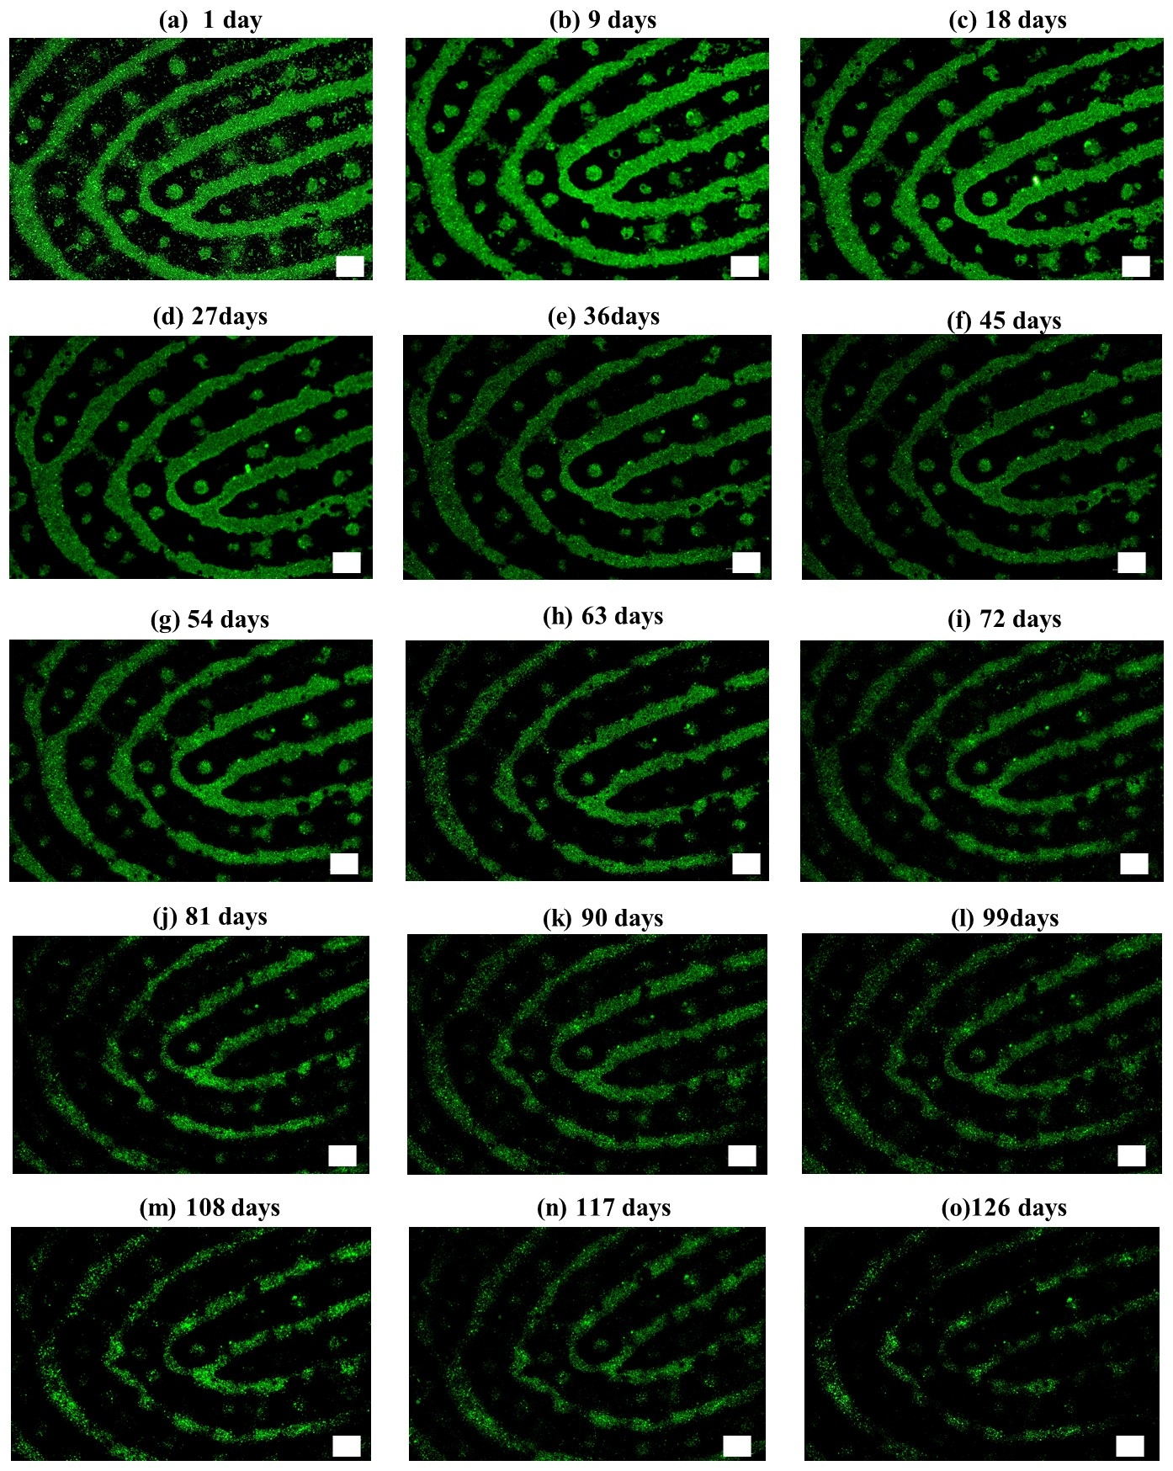

Supplementary Fig. 47. Stability tracking of CsPbBr₃@HPβCD fibers. (a-o) From 1 day to 126 days. scale bar: 200 μm.
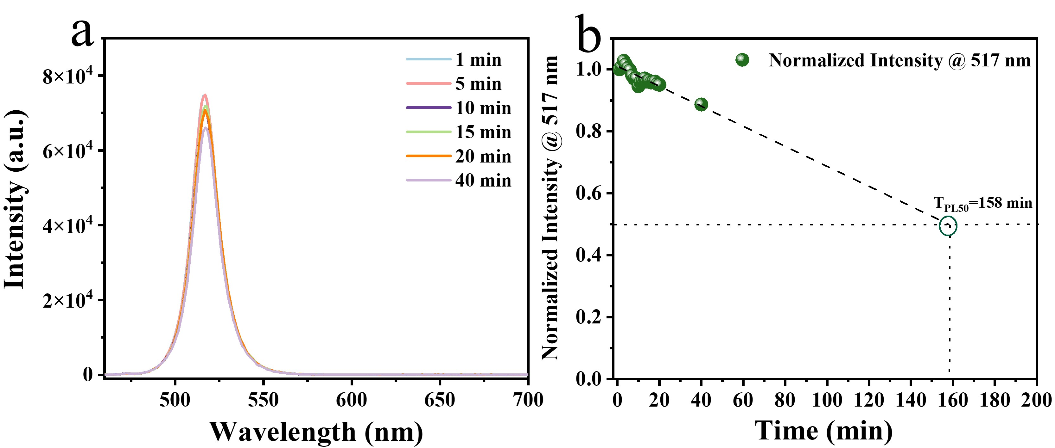

Supplementary Fig. 48. Stability of CsPbBr₃@HPβCD fibers. (a) The PL spectra of CsPbBr₃@HPβCD fibers were continuously irradiated by laser for 1 min to 40 min. Stability of the PL image of CsPbBr₃@HPβCD fibers under laser irradiation (b) The simulated PL₅₀ intensity of CsPbBr₃@HPβCD fibers are irradiated by laser.

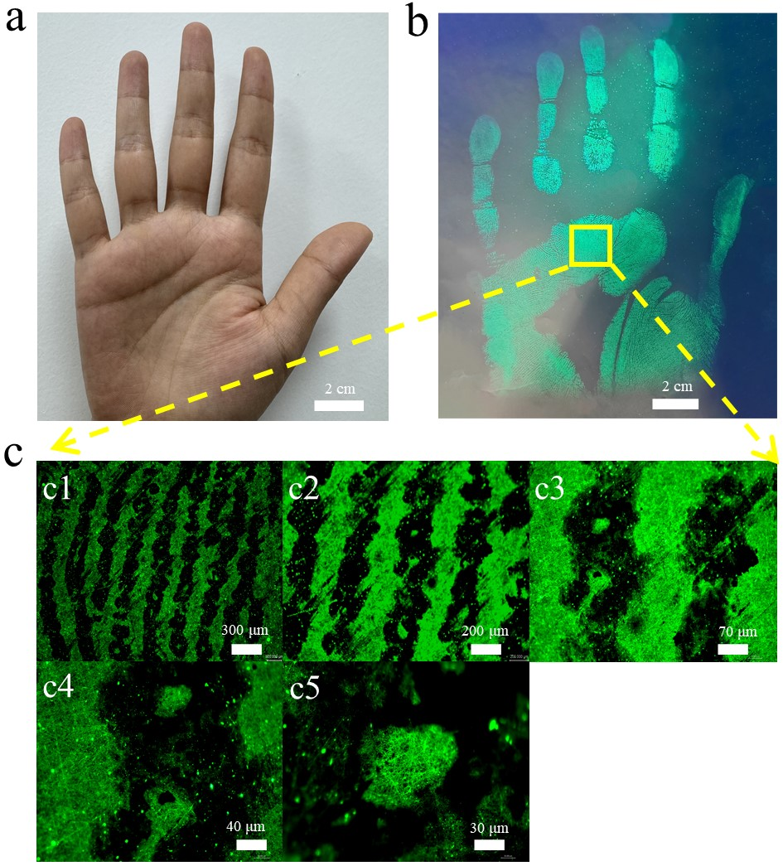

Supplementary Fig. 49. The palm imaged with CsPbBr₃@HPβCD fibers. (a) Real palm image (b) The palm imaging by CsPbBr₃@HPβCD fibers. (c) The local magnified luminescence images under UV light.

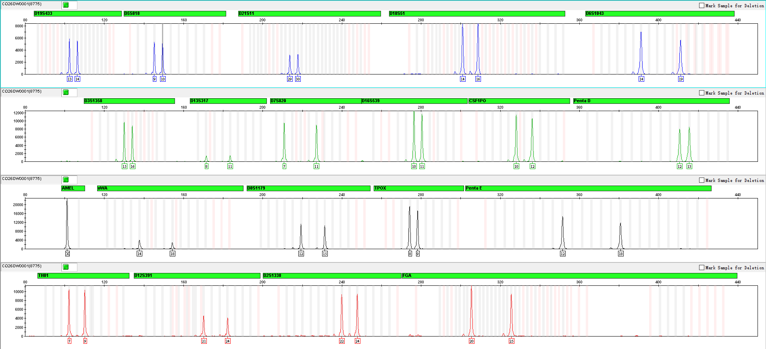

Supplementary Fig. 50. STR analysis of DNA in a blood sample on LFP without electrospun CsPbBr₃@HPβCD fibers.
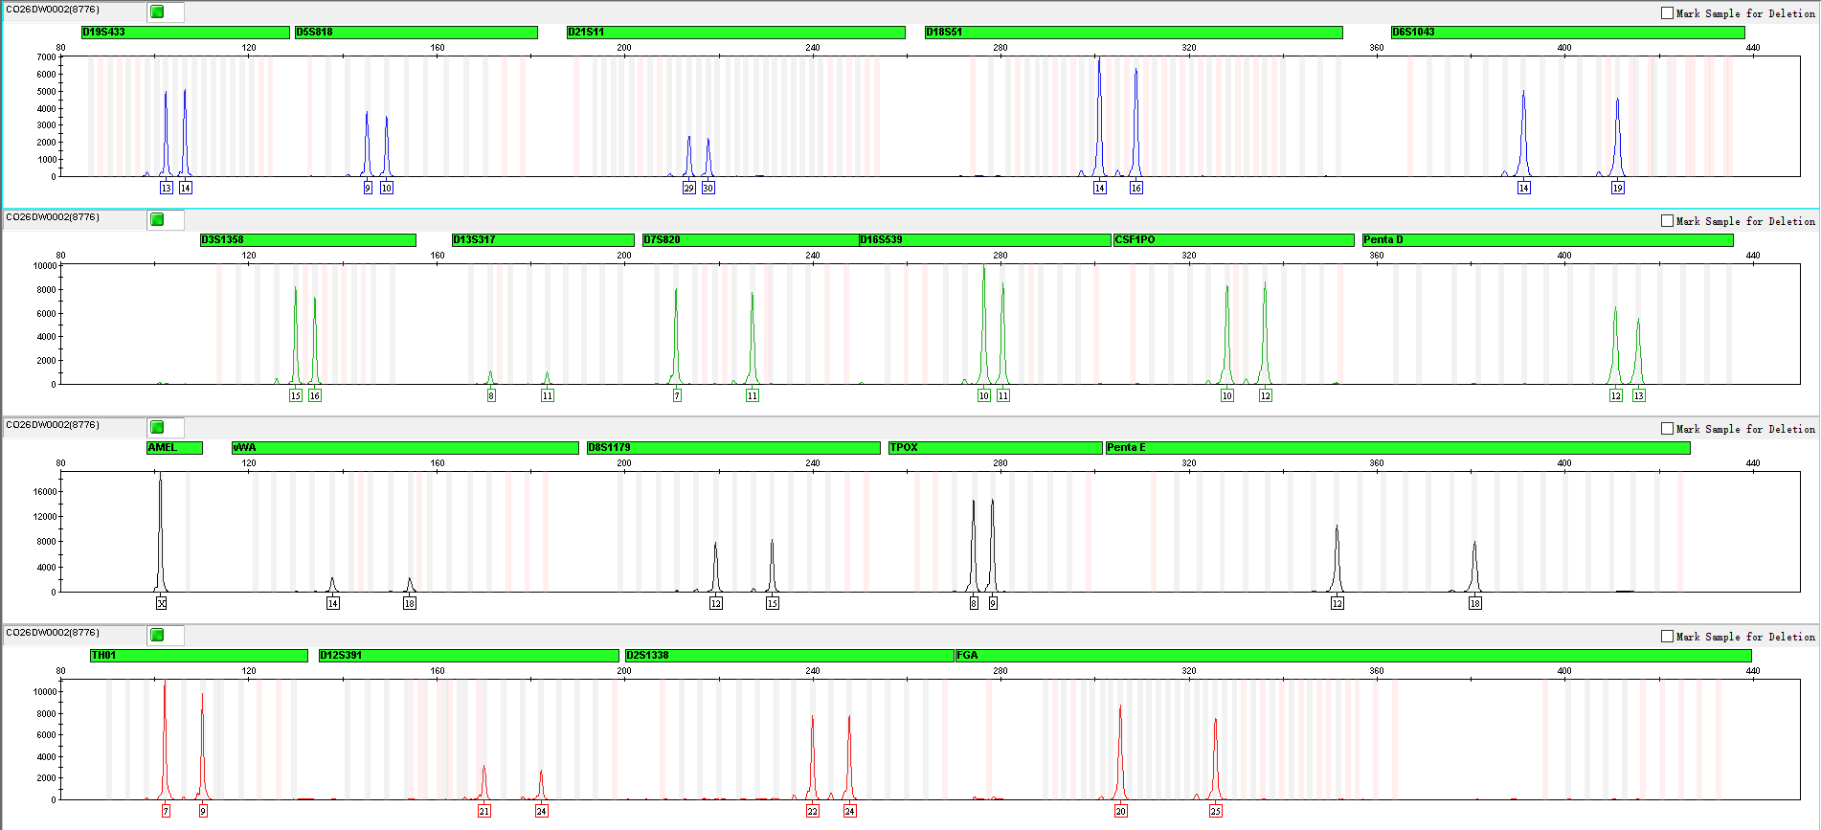

Supplementary Fig. 51. STR analysis of DNA from a blood sample on LFP with electrospun CsPbBr₃@HPβCD fibers.
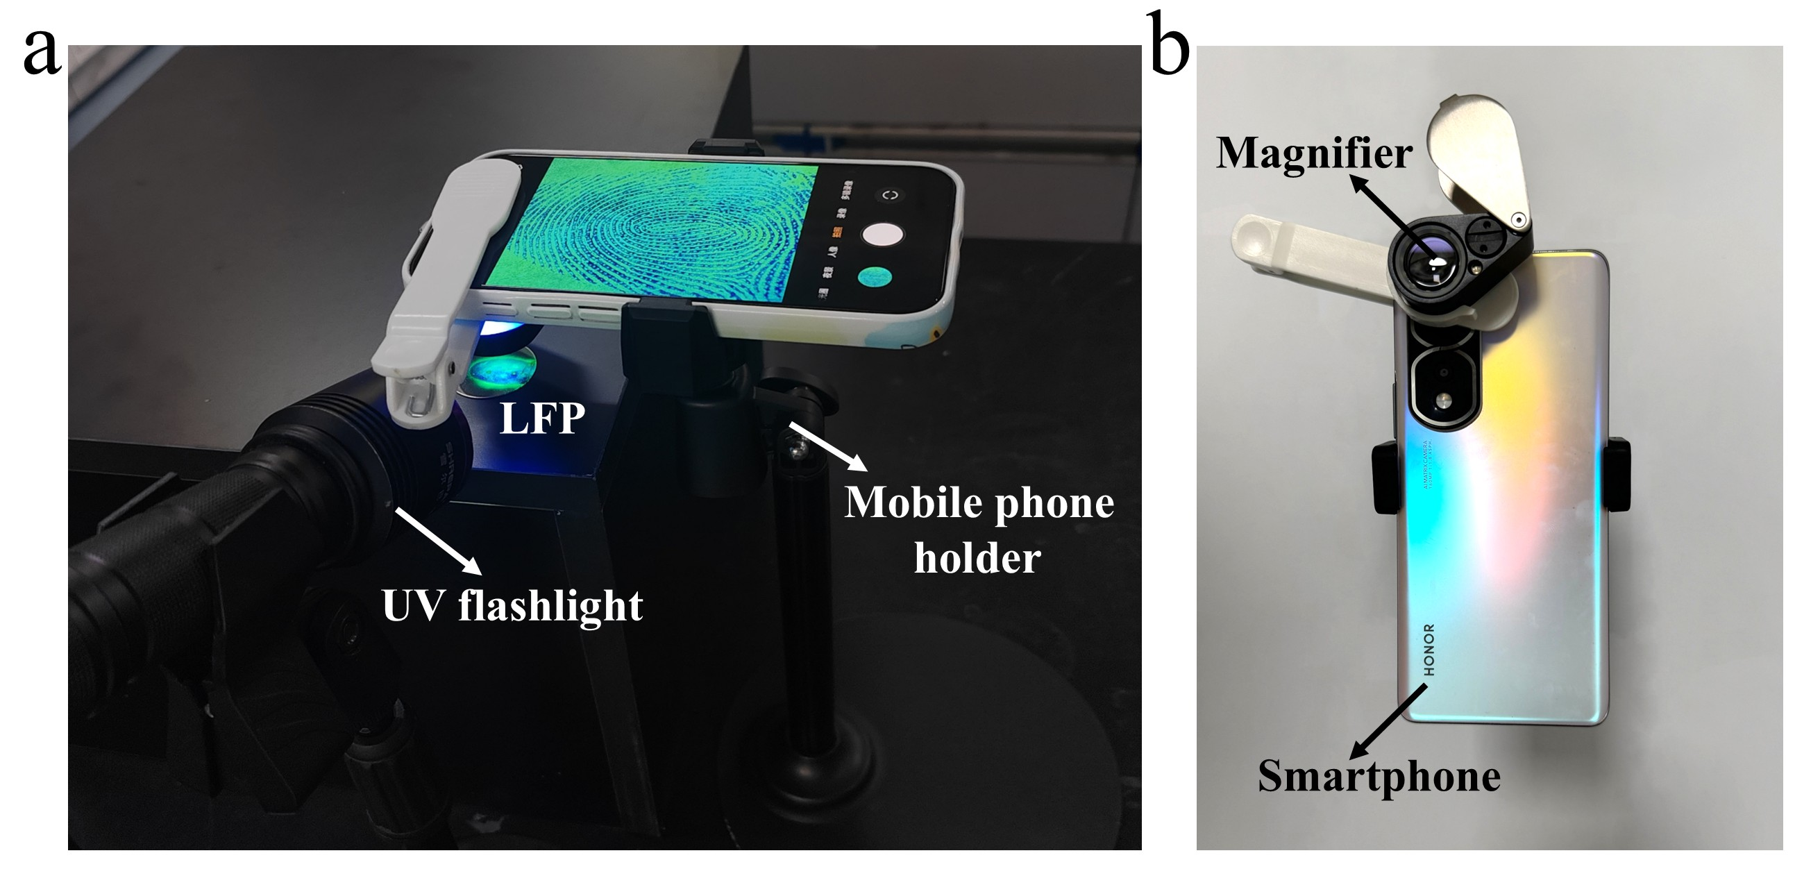

Supplementary Fig. 52. The setup of the fingerprint extraction device.

Notes: The handheld electrospinning device is used to generate CsPbBr₃@HPβCD nanofibers, the UV flashlight is used to excite the fingerprint luminescence images, the smartphone is equipped with a low-magnification (10×) magnifier for capture of images, while the mobile phone holder is used to fix the smartphone to obtain a stable image.

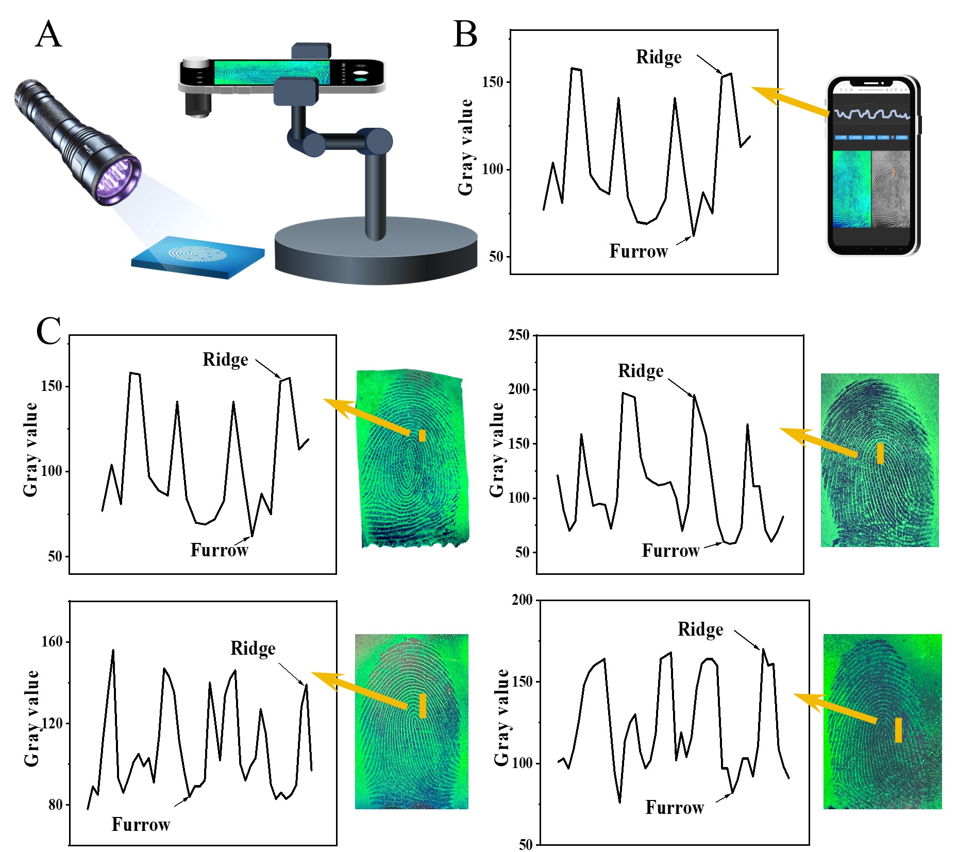

Supplementary Fig. 53. Portable device for NFIT and the integrated data processing program.

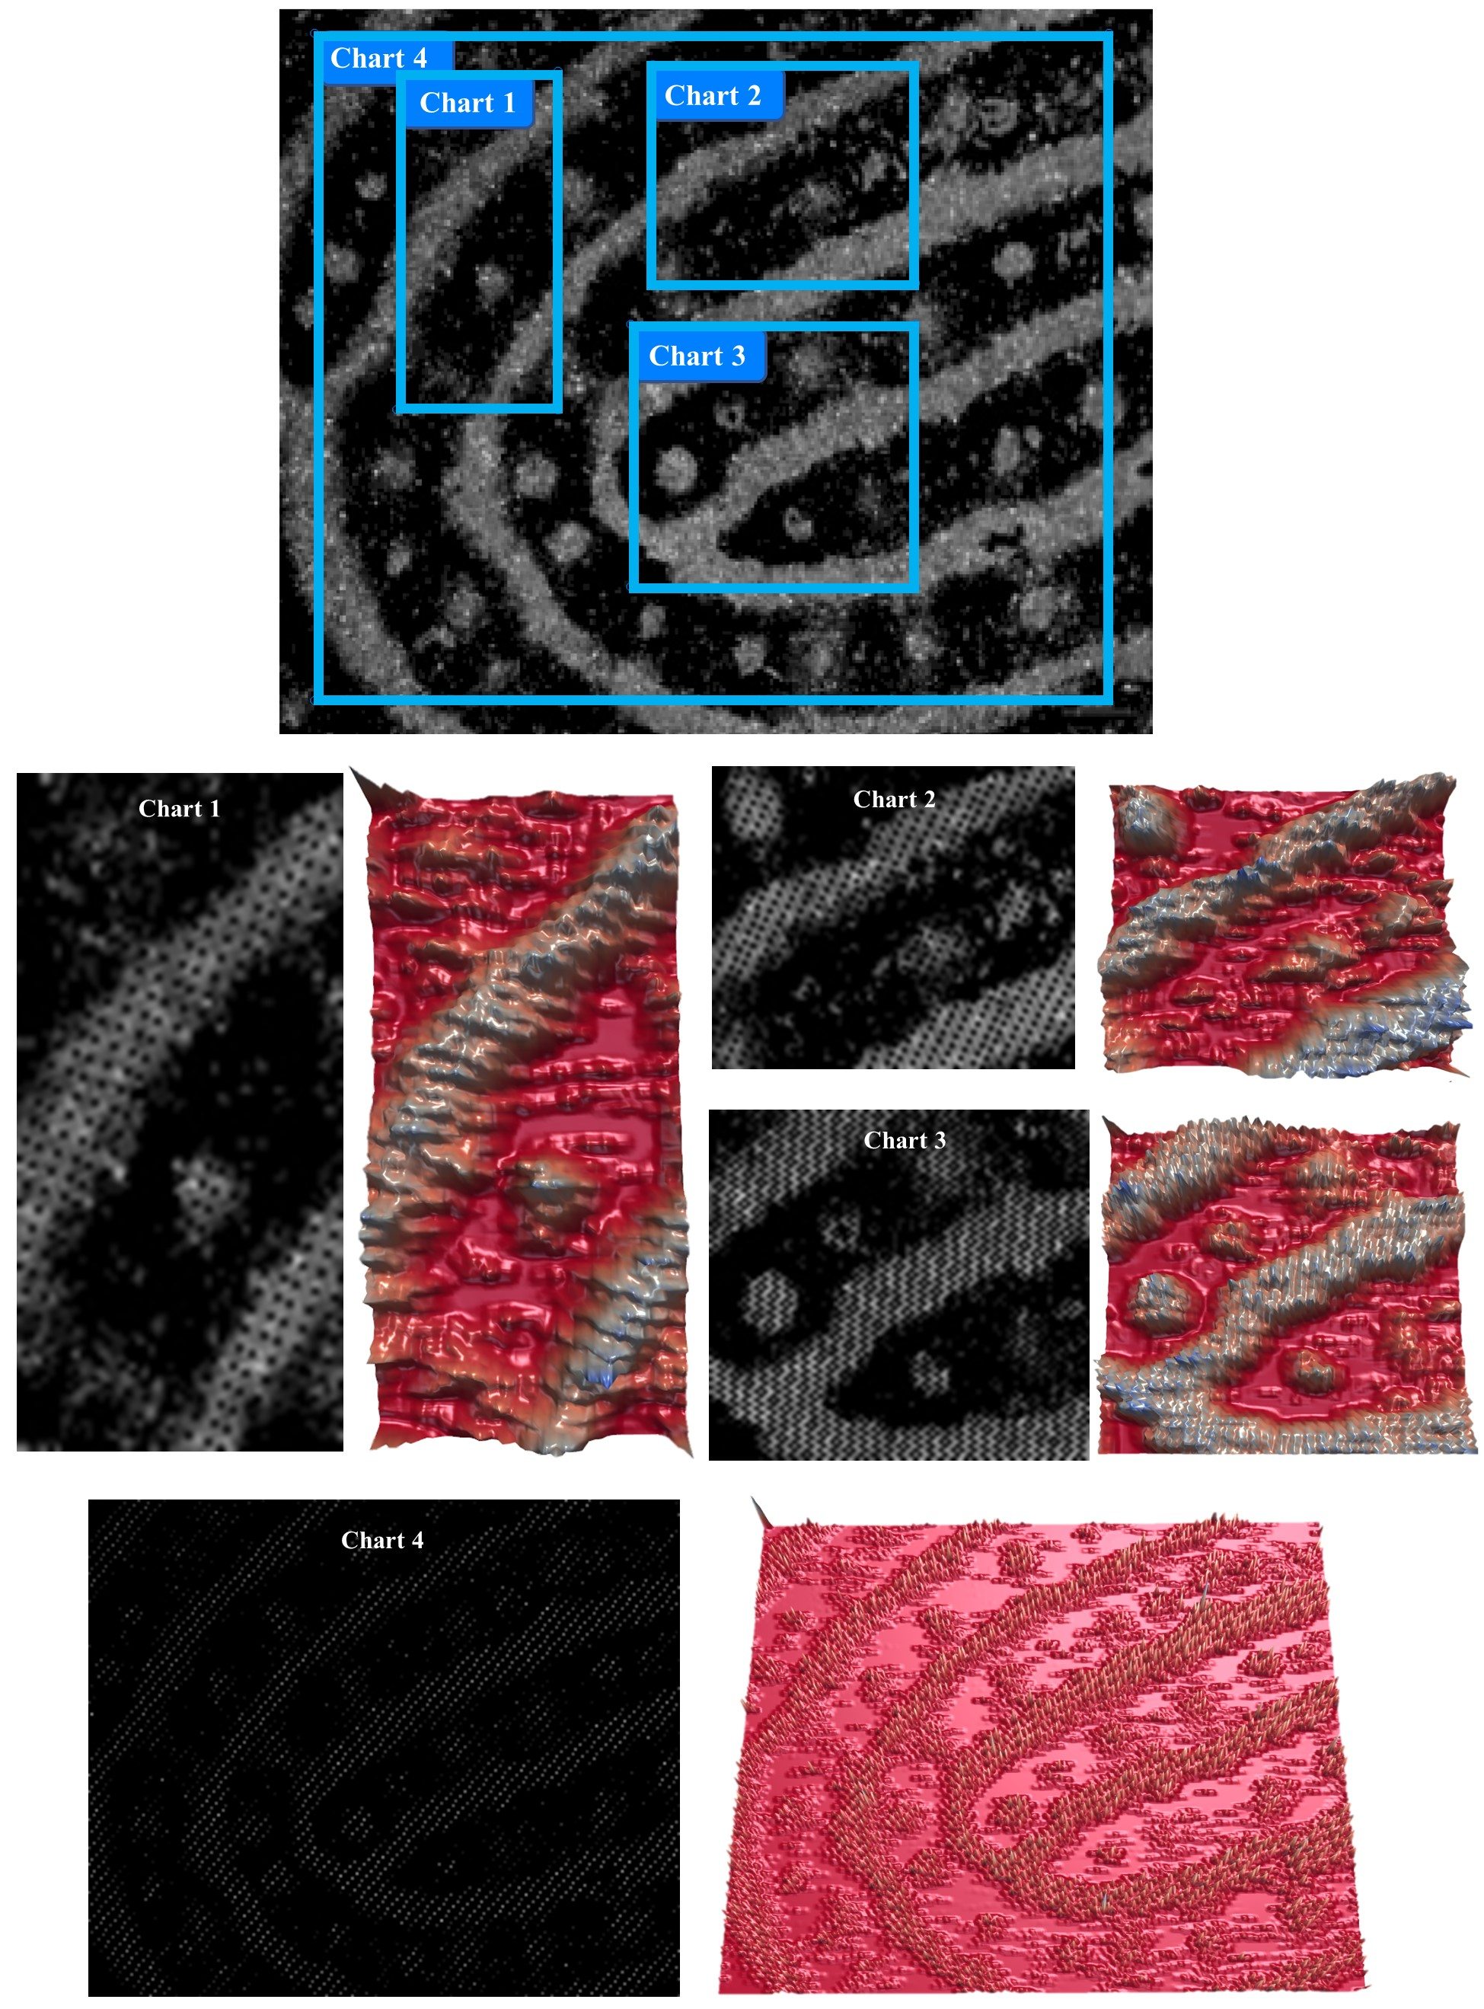

Supplementary Fig. 54. NFIT integrated system for extracting grayscale values from multiple regions of the fingerprint image at the same extraction points (5000 points).

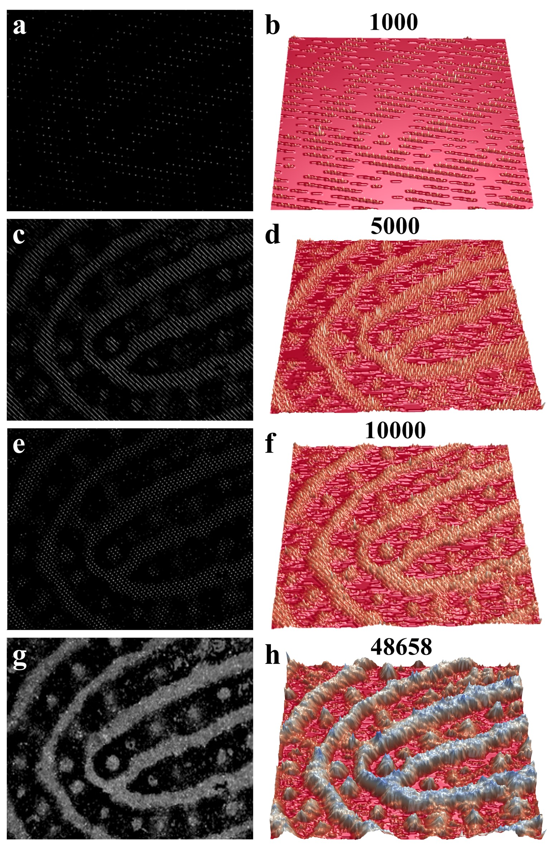

Supplementary Fig. 55. Fingerprint analysis program for instant transformation of data from 2D charts into 3D models.(a), (c), (e) and (g), 2D images converted from 2D charts using 1000, 5000, 10000 and 48000 pixels, respectively. (b), (d), (f) and (h) the reconstructed models corresponding to (a), (c), (e) and (g), respectively.

Note: For example, 2D images of Level 3 fingerprint features from the same region were extracted using 1000, 5000, 10000, or the maximum number of pixels. The data illustrate that an increase in the number of pixels results in progressively clearer fingerprint images.
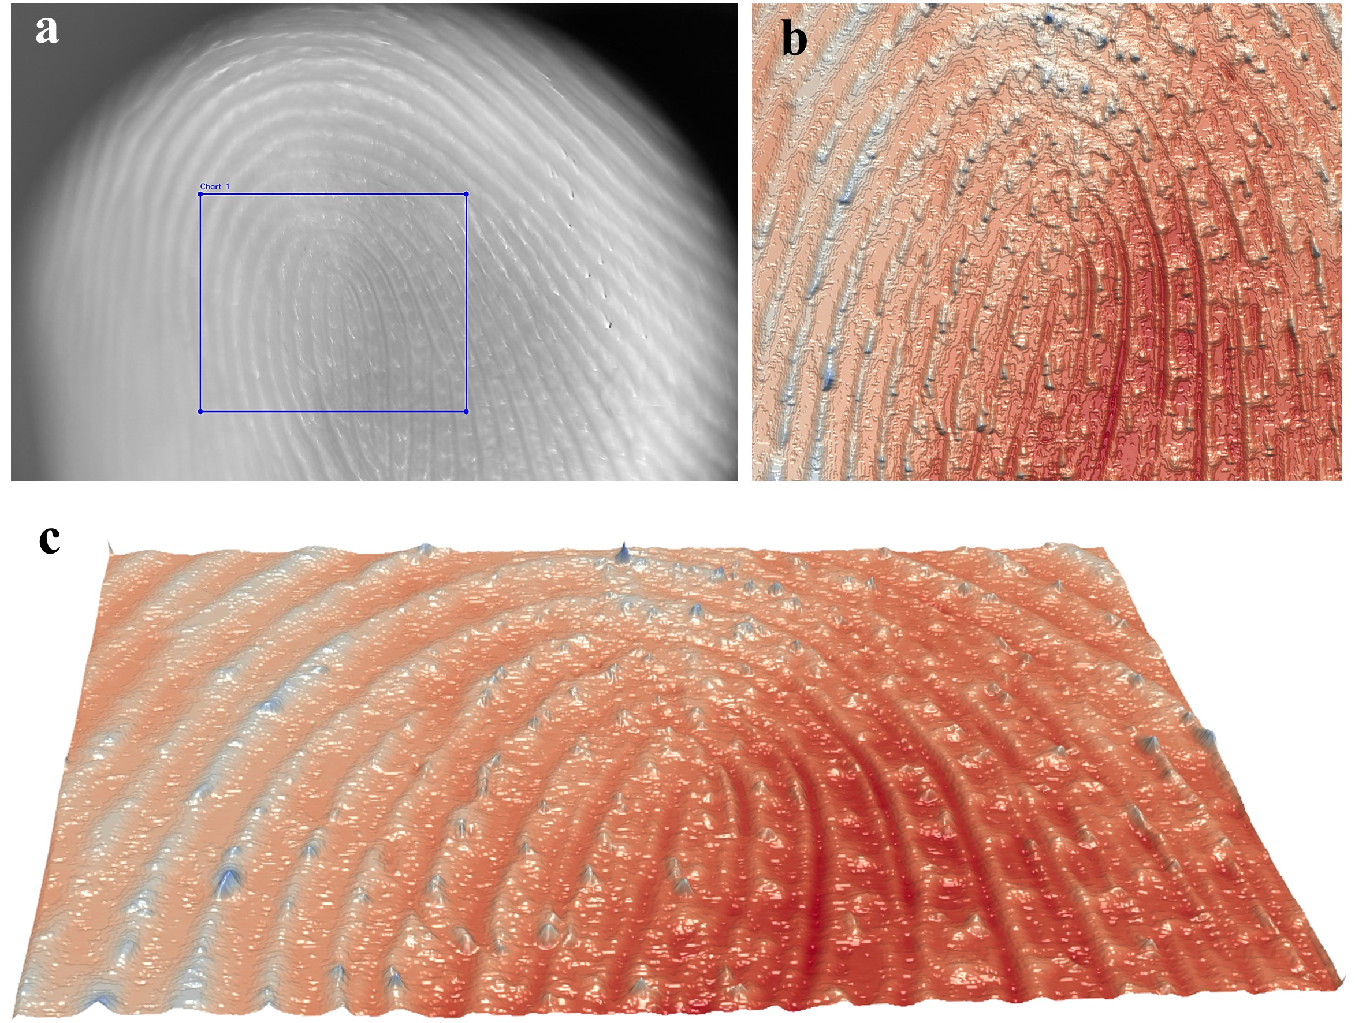

Supplementary Fig. 56. Fingerprint extraction and 3D image generation based on integrated NIFT system. (a) the photograph of a real fingerprint. (b-c) the generated 3D images by the system.

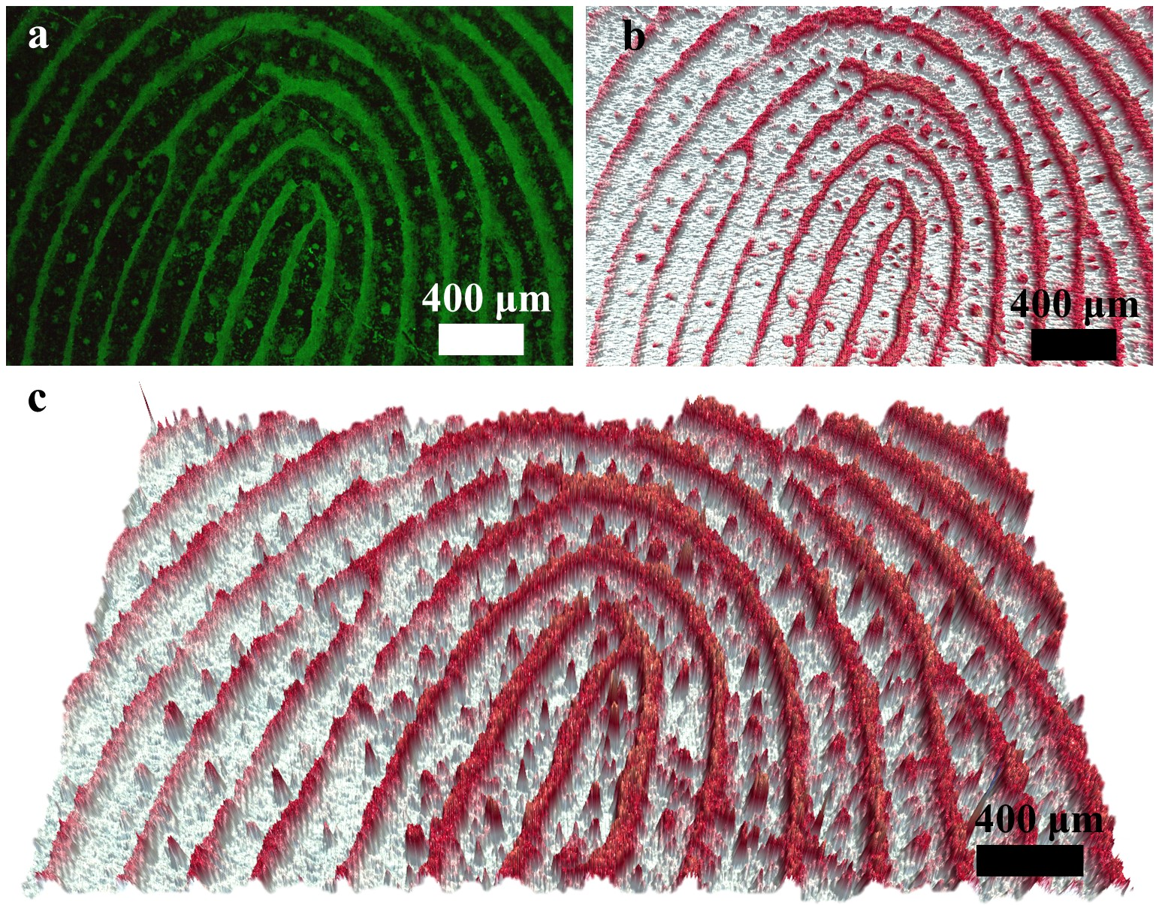

Supplementary Fig. 57. Fingerprint extraction and 3D image generation based on integrated NIFT system. (a) The luminescent fingerprint images. (b-c) the generated 3D images by the system.

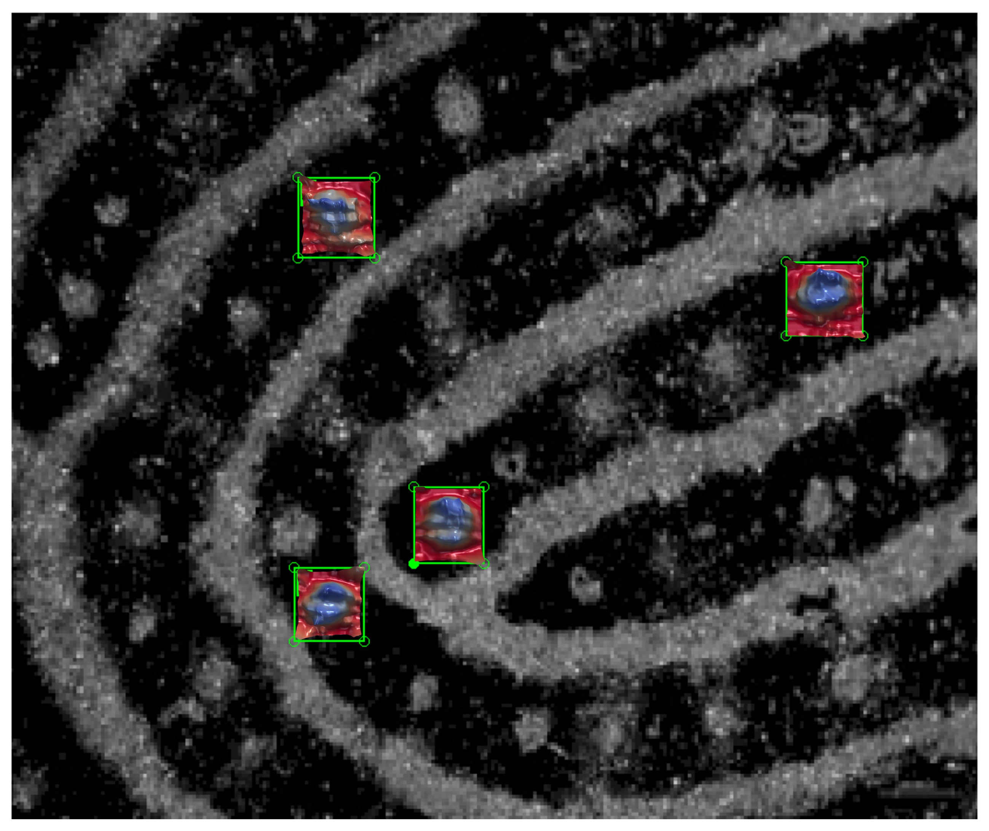
Supplementary Fig. 58. 3D construction of sweat pore by NFIT system.
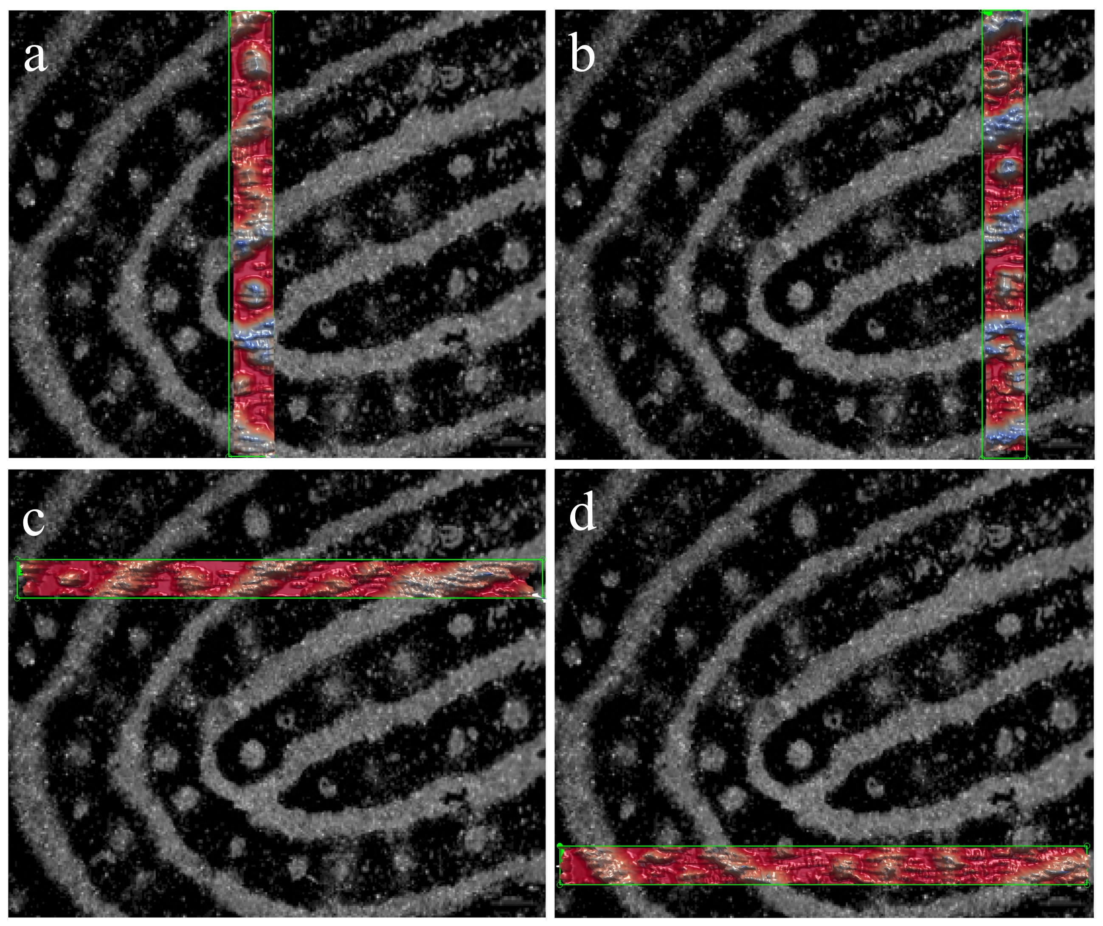
Supplementary Fig. 59. 3D construction of lines of fingerprint by NFIT system.

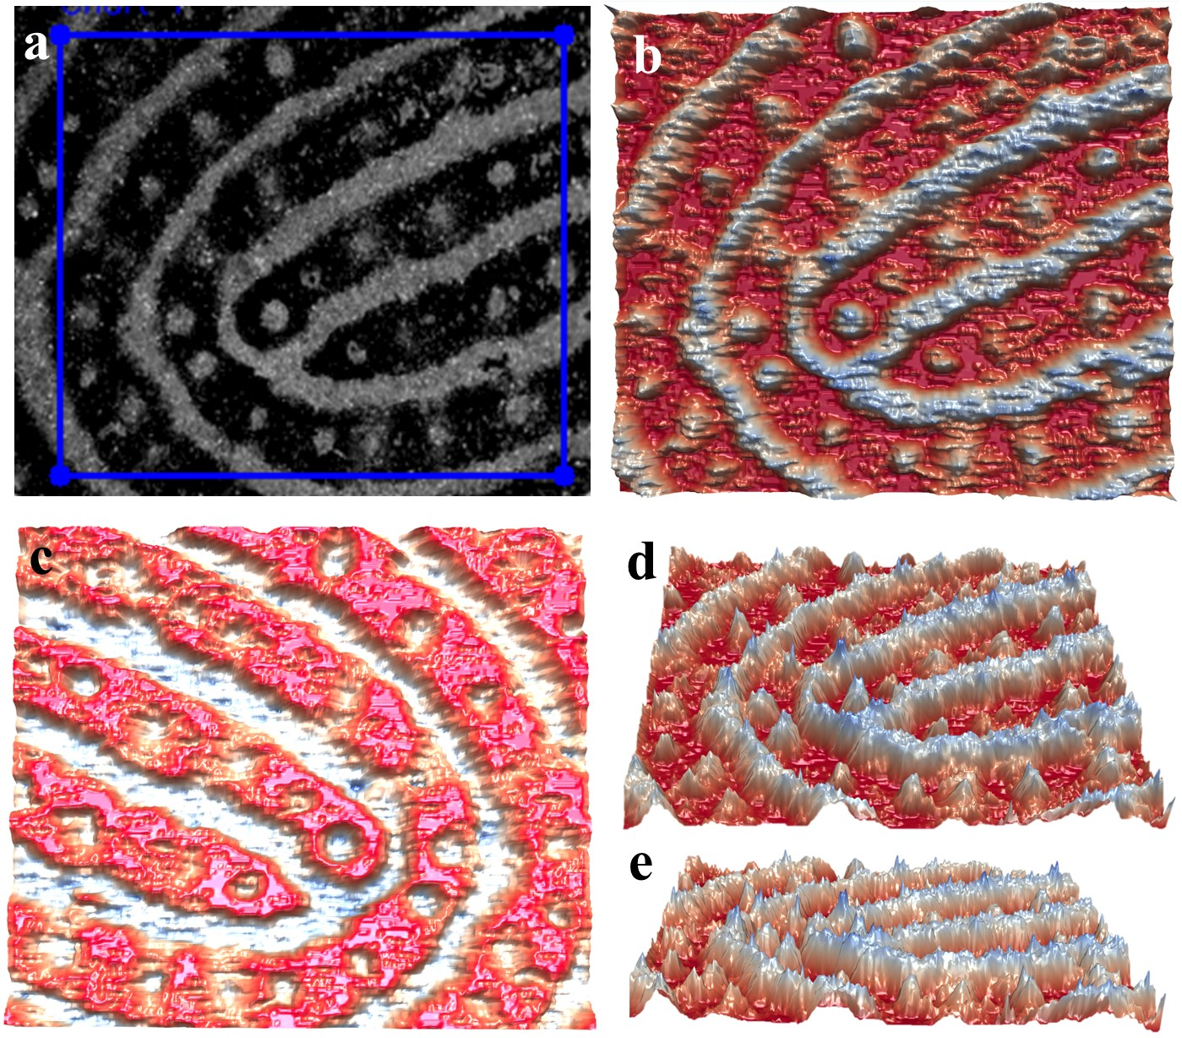

Supplementary Fig. 60. Fingerprint system for 3D fingerprint construction and mirror inversion processing.

Supplementary Table 24. Summary of fingerprint feature visualization technology.
Imaging area | Fingerprints collect | Summary of features | Substrate/aged LFPs | Ref.
• Fingerprint  • Palm  • Other body parts. | Non-contact nanofiber-based imaging technique (NFIT) | • The imaging approach is simple, compacted and immediate visualization with 1450 dpi resolution,  • the 2D fingerprint imaging can be extracted in 10s  • 3D fingerprint model construction is instantly constructed by the NFIT system.  • LFPs images can take pictures with smart phones.  • NFIT can distinguish living fingers from false fingerprints | • Tinfoil/glass/paper/iron/plastic  /quartz/leather  • The residue LFPs can be imaged by NFIT over 30 days, and the LFPs image can exhibit clear level-3 features after 81 days and clear level-2 features after 108 days | This study
• Fingerprint | Soaking method | • The synthesis is simple and non-toxic.  • Soaking method is more suitable for waterproof materials | • Tinfoil/stainless steel/glass  /leather/cardboard/wood/ceramics/plastic  • There was no significant effect after 7 days | 16
• Fingerprint | Soaking method | • The LFPs are almost undisturbed by background fluorescence  • Marble and plastic has influence on imaging. | • Smooth microscope slide | 17
• Fingerprint | Pressing method | • It can distinguish living fingers from false fingerprints  • Patterns can be extracted after taking pictures with smart phones  • Fingers touch the film; Hair has influence on fingerprint collection | • COF TPDA-TFPy thin film | 19
• Fingerprint  • Sweat holes/Threads | Soaking method | • Immediate visualization  • Few Level-3 detailed features of LFPs. | • Tinfoil/glass/paper/steel/leather  • There was no obvious change after 30 days. | 23
• Fingerprint | Soaking method | • Equipped with portable ultrasonic atomizer  •Fingerprint imaging is applicable to a wide range of materials  •The fingerprint that has been imaged is highly stable | • Ceramic/Steel/Plastic/Glass/Tin foil/Acrylic board  • Aging for 7 days had no significant effect. | 24
• Fingerprint | Spraying powder method | • Powder spraying requires higher magnification to see the secondary characteristics.  •Cleaning abstract and finger with grease are needed. | • Glass/Aluminum foil/Plastic/Iron | 25
• Fingerprint  • Palm | Spraying powder method | • Level 2 feature of LFPs can be extracted. | • Glass/plastic/ tinfoil/ ceramic tile/painted wood  • The fluorescence intensity decreased after 7 days | 29
• Fingerprint | Pressing method. | • Level 2 feature of LFPs can be extracted. | • Ceramic cup/Scissors/Beaker  /Knife/Glass | 30
• Fingerprints  • Palm | Pressing method | •The background color has an influence on characteristics | • Thin film | 31
• Fingerprint | Pressing method | • Humidity has an influence on the membrane.  • Pressing the membrane directly with fingers. | • Thin film  • After 110 days of storage, the prepared nanocrystals still have 70% of the initial. | 32

Supplementary Table 25. Cost evaluation of the NFIT system.
Accessory | Price (USD)
Handheld mini electrospinning device | 435.61
Mobile phone holder | 3.42
Smartphone | 186.30
A low-magnification (10×)  magnifier | 8.22
UV flashlight | 13.80
Total | 647.35

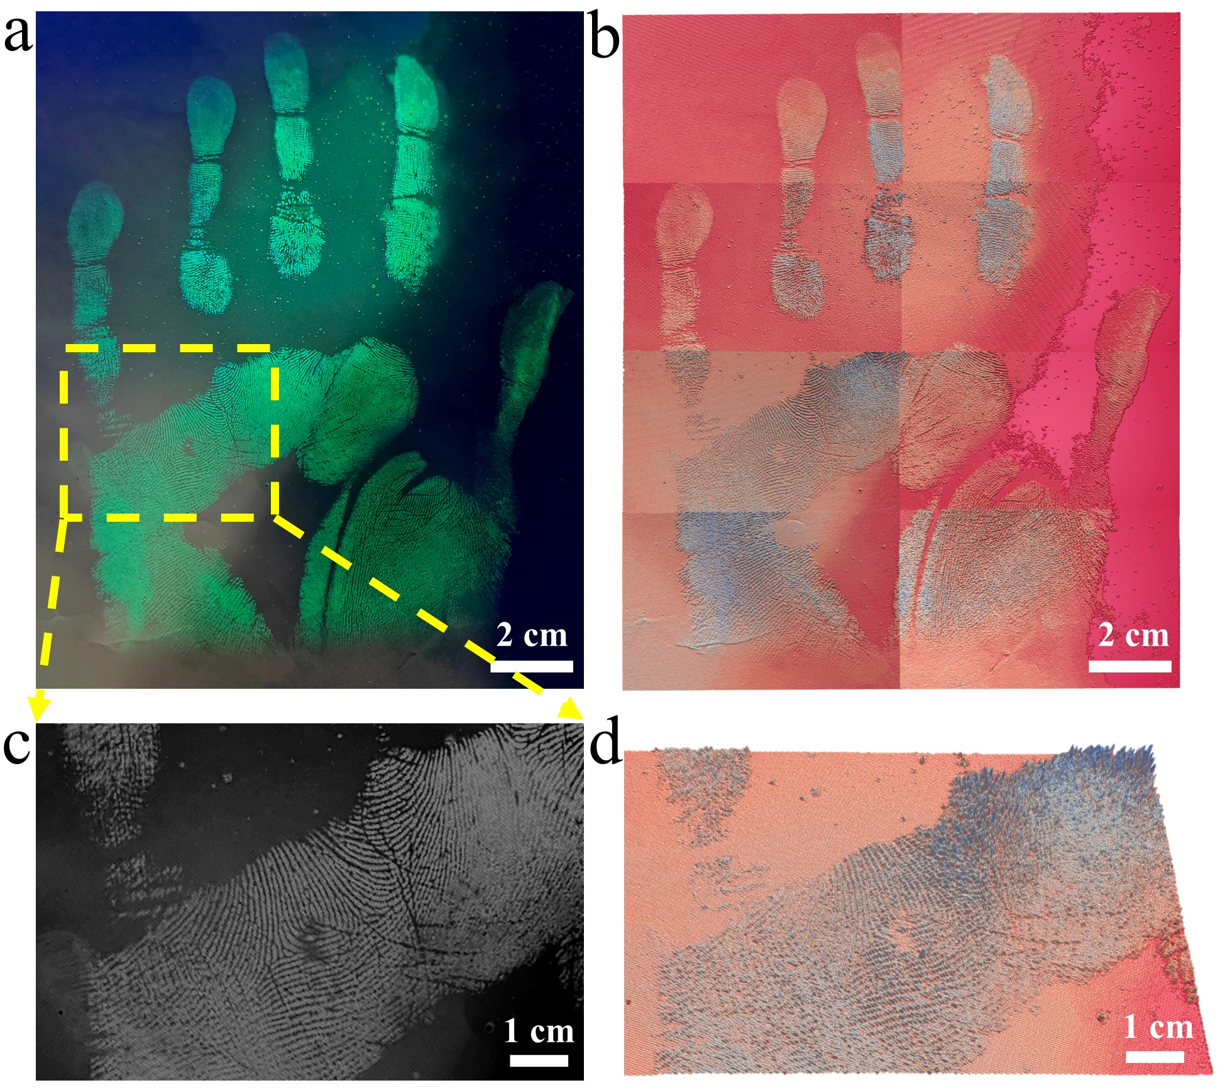

Supplementary Fig. 61. NFIT system for 3D palm construction. (a) The palm imaging by CsPbBr₃@HPβCD fibers. (b) 3D palm images by the system. (c) The local magnified grayscale image of (a). (d) 3D images by the system of (c).

