SUPPLEMENTARY MATERIALS

Time Delay Reservoir Computing in a Single Physical Node Enabled by Transient Photon Magnon Coupling

Haechan Jeon¹*, Loïc Millet¹*, Bojong Kim¹*, and Sang-Koog Kim¹†

¹ Research Center for Spin Dynamics & Spin-Wave Devices, Department of Materials Science and Engineering, Seoul National University, Seoul 08826, Republic of Korea

* These authors contributed equally to this work.
† Correspondence and requests for materials should be addressed to S.-K.K. (sangkoog@snu.ac.kr)

Supplementary S1. Anti-Crossing Behavior in the ISRR-YIG Hybrid System
To elucidate the anti-crossing dynamics associated with PMC, we investigated a hybrid system consisting of an Inverted Split Ring Resonator (ISRR) and a Yttrium Iron Garnet (YIG) thin film. Measurements were performed at room temperature using a Vector Network Analyzer (VNA), with a static magnetic field applied at a 33° angle relative to the x-axis, which is perpendicular to the microstrip line. Figure S2 presents the evolution of the transmission spectra ∣S₂₁∣ as the static magnetic field (H) varies from 48.77 mT to 77.85 mT. Initially, without coupling, the ISRR’s resonant frequency appears as a single, distinct dip at approximately 3.34 GHz. As H changes, the photon mode of the ISRR interacts with the magnon mode of the YIG film, producing a characteristic anti-crossing pattern in the spectra—direct evidence of coherent PMC.
The blue dashed lines in Figure S2 trace the evolution of the photon and magnon modes as the field is tuned. Near the coupling center (H ≈ 62.92 mT), the two modes approach each other and then repel, leading to the formation of hybrid modes 𝑓₋ and 𝑓₊. The observed coupling strength of about 70 MHz confirms the robust and coherent interaction between the ISRR-based photon mode and the YIG’s magnetization dynamics. As the magnetic field increases, the lower-frequency dip shifts upward, corresponding to the ferromagnetic resonance (FMR) mode of the YIG, while the higher-frequency dip remains relatively stable, representing the photon mode of the ISRR. This mutual influence at the point of closest approach induces mode hybridization and the characteristic anti-crossing behavior.
The fine structure visible in the spectra around the FMR mode indicates additional spin-wave modes arising from the multi-mode character of the magnonic system. These hybrid modes provide the nonlinearities necessary for processing temporal information, further supporting the robustness and versatility of PMC in complex dynamical regimes.
Supplementary Figure 1
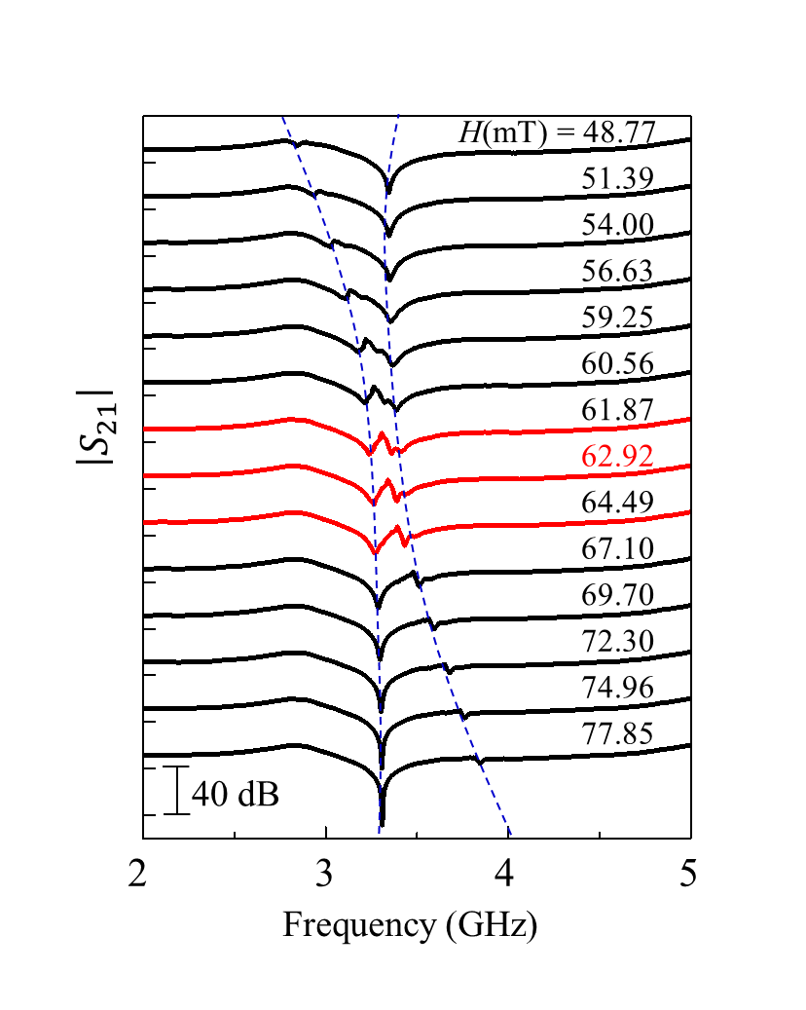

Supplementary S2. Magnetic Properties and FMR Characterization of YIG Film without ISRR
We measured the magnetization hysteresis (M-H) curves of the YIG film at room temperature using a vibrating sample magnetometer (VSM) with an in-plane applied magnetic field, as shown in Fig. S1(a). The film exhibits a saturation magnetization of 0.174 T and a coercivity of 0.3 mT.
To further characterize the YIG film, we performed ferromagnetic resonance (FMR) measurements to extract the damping constant and effective saturation magnetization. By analyzing the FMR peak positions as a function of the applied magnetic field and fitted them to Kittel’s equation[Fig.S1(b)], we extracted $γ=1.76 × {10}^{11} rad/T∙s$ and $μ_{0}M_{s}=0.172 T$ . These values are consistent with the magnetization results obtained from the M–H loop measurements.

Supplementary Figure 2
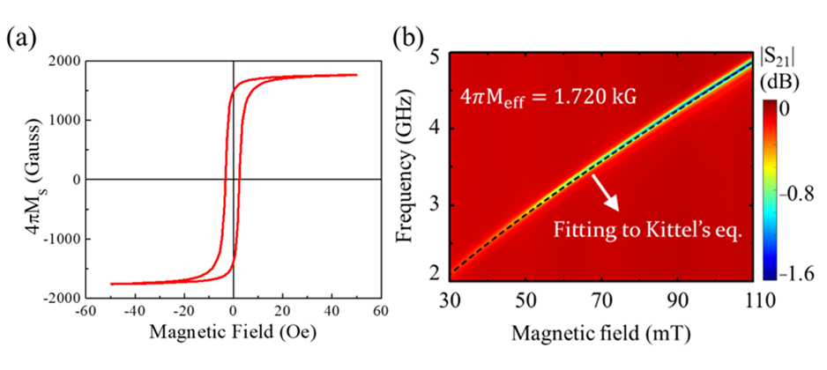
Supplementary S3. Calibration of ISRR and YIG Damping and Estimation of Photon-Magnon Coupling Strength
The damping in the ISRR was obtained using $β$ = ${∆ω_{HWHM}}/{ω_{ISRR}}$, where $∆ω_{HWHM}$ is the half width at half maximum of the S₂₁ spectra and $ω_{ISRR}$ is the angular resonance frequency of the ISRR without YIG. By fitting a Lorentzian function to the experimentally observed S₂₁ spectra, we extracted $∆ω_{HWHM}$ = 78.64 MHz and $ω_{ISRR}$ = 3.41 GHz, yielding $β$ = 2.3 $×$ ${10}^{-2}$. To estimate the damping constant in the YIG film, the measured FMR frequency linewidth($Δf$) was converted to the field linewidth($ΔH$) according to
$$ΔH= \frac{Δf}{γ} \frac{1}{\sqrt{1+{\left({γμ_{0}M_{s}}/{4πf}\right)}^{2}}}$$
where $γ$ is the gyraomagnetic ratio, Ploting $ΔH$ as a fuctiion of fr [Fig.S3(b) then allow us to fit
$$ΔH= ΔH_{0}+ \frac{4πf_{r}}{γ}$$
resulting in $α=3.2 × {10}^{-4}$ and $ΔH_{0}=0.23 mT$. Figures S3(c) and S3(d) show the measured and calculated transmission mappings as a function of the detuned parameters. The calculation resetuls closely match the experiemental data and the estimated coupling strength, obtained using the approach described in Ref.[31], is 70 MHz.

Supplementary Figure 3
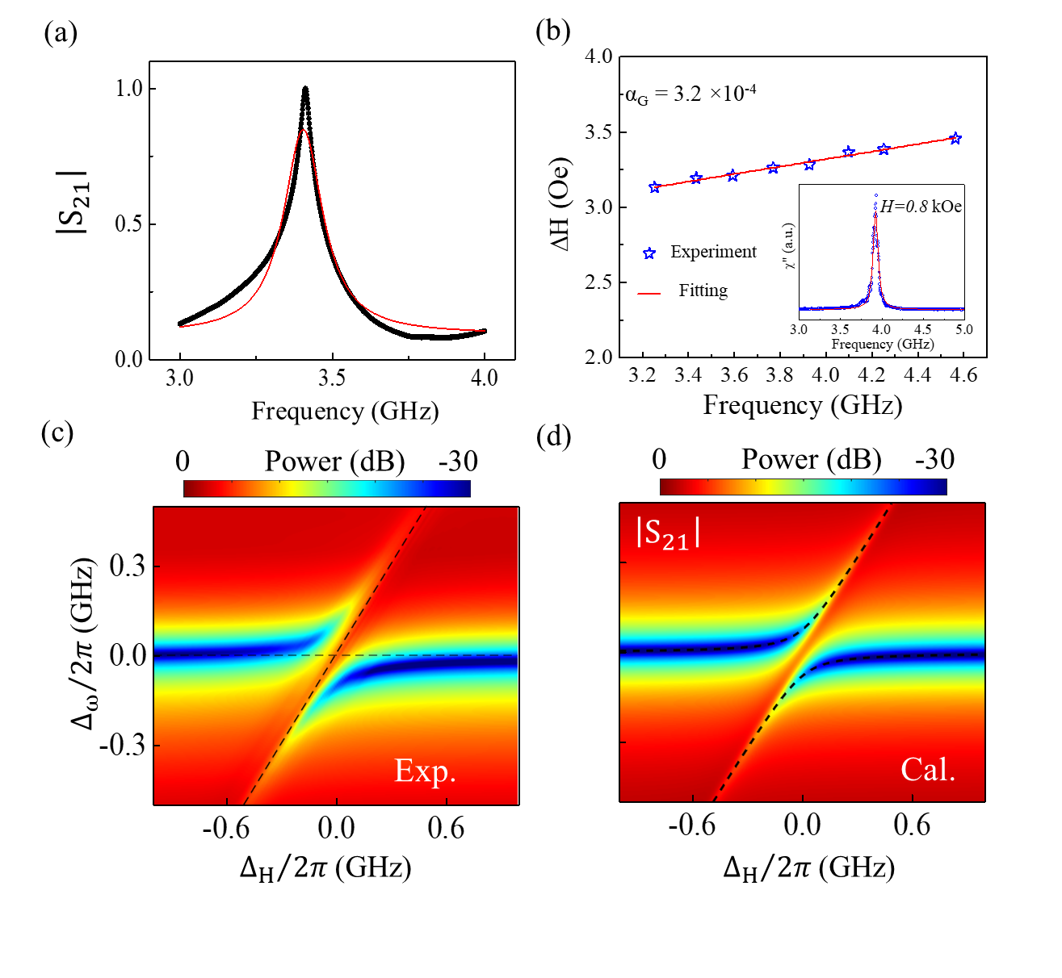

Supplementary S4. Frequency Analysis of the Transient Response in Photon-Magnon Coupling(PMC) Hybrid System
Figure S4 illustrates the frequency-domain analysis of the transient response associated with the PMC experiment described in Figure 2. This analysis aims to identify the distinct frequency components arising from both the coupling interaction and the input pulse characteristics. The integrated RF mixer in the experimental setup generates an output frequency according to $f_{mix}​=∣f_{RF}±f_{LO}​∣$, where $f_{RF}$ and $f_{LO}​$ represent the RF and local oscillator frequencies, respectively.
The frequency analysis reveals three prominent components at 3.2 GHz, 320 MHz, and within the 70–80 MHz range. The 3.2 GHz component corresponds to the primary frequency of the input pulse used in the experiment, serving as the fundamental driving force in the system. The 320 MHz frequency component precisely matches the inverse of the input pulse width (approximately 3.125 ns), confirming that the transient response faithfully encodes the temporal profile of the injected signal.
The frequency range of 70–80 MHz corresponds to the coupling strength between the photon and magnon modes, estimated at around 70 MHz from the observed anti-crossing behavior. This frequency component is indicative of the interaction dynamics that occur between the photons and magnons within the system, demonstrating the presence of strong coupling effects. Notably, consistent spectral splitting near 70 MHz indicates repeated coupling oscillations, generating harmonic frequencies (e.g., 140 MHz, 280 MHz) that further enrich the system’s dynamical complexity.
The presence of these three frequency components—3.2 GHz (input pulse frequency), 320 MHz (pulse width), and 70–80 MHz (coupling strength)—demonstrates that the transient response is shaped by multiple factors contributing to the overall dynamics of the system. Other spurious peaks arise from higher harmonics or mixing artifacts. The close alignment of these frequencies with the experimentally defined parameters validates the precision of the measurement and analysis. This detailed frequency characterization provides insight into the role of each component, indicating how the PMC mechanism contributes to the nonlinear state space essential for reservoir computing (RC) applications.

Supplementary Figure 4
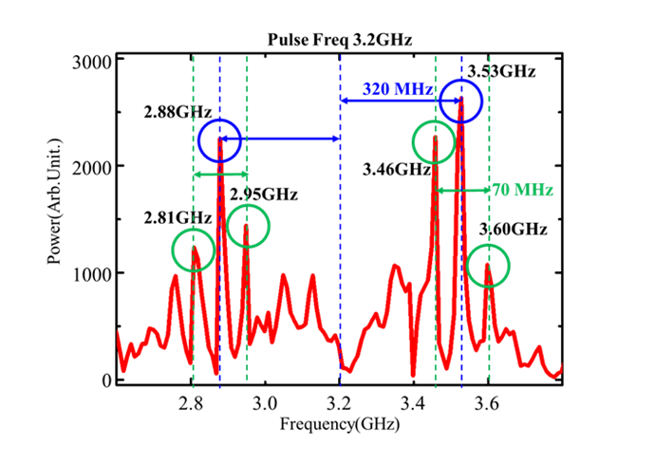

Supplementary S5. Input Pulse Amplitude Dependence on System Response
Figure S5 illustrates the effect of input pulse amplitude on the measured output response. The x-axis represents the input pulse voltage amplitude, while the y-axis denotes the maximum amplitude recorded using an oscilloscope. As the input amplitude initially increases, the output amplitude rises nearly linearly, indicating relatively weak nonlinearities at lower drive levels. However, as the input amplitude continues to increase, the system’s response begins to saturate, deviating from the initial linear trend. This saturation phenomenon arises from the inherent nonlinearities in the PMC mechanism, reflecting a common behavior in many physical systems where increasing the input beyond a certain point no longer yields proportional output gains. In the context of RC, this saturation is advantageous. It enriches the system’s dynamic range by providing a more complex, nonlinear response landscape. By approaching its intrinsic nonlinear limits, the system can more effectively capture intricate temporal patterns, enhancing its capacity for tasks such as temporal classification and pattern recognition.

Supplementary Figure 5
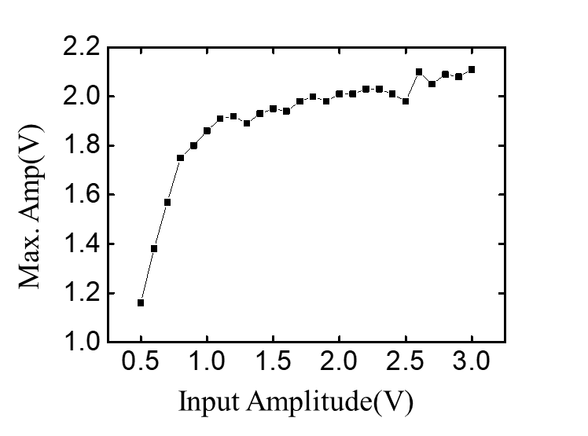

Supplementary S6. Influence of Pulse Separation on Transient Response
In this section, we examine how varying the pulse interval ($δ$) between two input pulses affects the transient response of the PMC system. Figure S6 shows the transient responses corresponding to pulse interval of (a) $δ$ = 2 ns, (b) $δ$ = 4 ns, and (c) $δ$ = 10 ns. The transient response behavior undergoes significant changes as the separation between the pulses increases.
Specifically, at $δ$ = 2 ns [Figure S6(a)], the transient response features rapid oscillations with substantial overlap between the effects of the two pulses. This overlap indicates that the system retains the memory of previous inputs for shorter durations, resulting in tighter inter-node coupling within the RC context.
By increasing the pulse interval to $δ$ = 4 ns [Figure S6(b)], the oscillatory response becomes more distinct, showing reduced overlap compared to the 2 ns case. This intermediate interval allows for more distinguishable interactions between pulses, balancing inter-node connections and moderate feedback that can support more nuanced temporal processing.
At $δ$ = 10 ns [Figure S6(c)], the responses are fully separated, showing well-defined oscillatory behavior that persists before the subsequent pulse arrives. This extended interval produces a clearer and more isolated transient state, promoting a better-defined nonlinear response and more independent recurrent feedback essential for the temporal processing capabilities of the RC system.
The variation in pulse interval not only affects the subsequent transient response but also directly influences the formation of inter-node connections and feedback loops within the reservoir. This finding emphasizes that adjusting $δ$ provides a means to fine-tune the system’s intrinsic delay line, optimizing the complexity needed for specific tasks. Such control over pulse intervals can be used to improve the system’s adaptability to diverse time-dependent computational problems.
These results demonstrate the importance of pulse timing as a control parameter that governs both the temporal memory and dynamic state diversity of the reservoir. By refining $δ$, one can enhance nonlinear dynamics and feedback efficacy, thereby improving the system’s capacity to handle tasks such as speech recognition and other time-dependent signal classifications.

Supplementary Figure 6

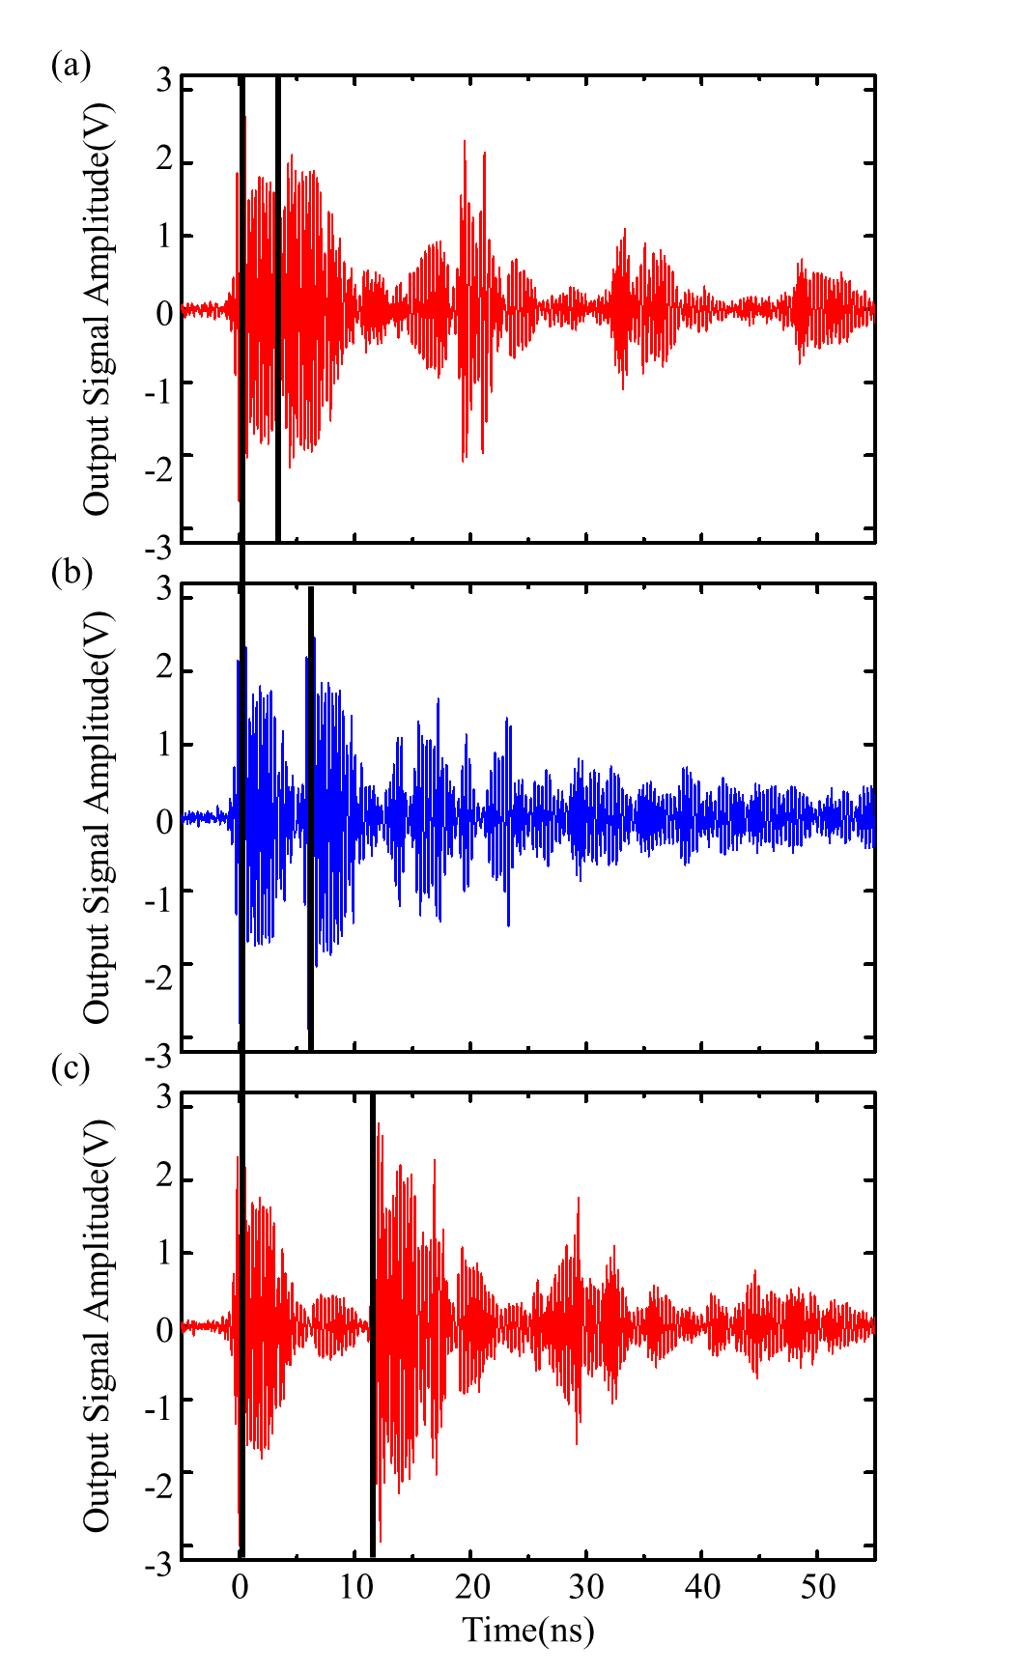

Supplementary S7. Algorithm of Time Delay-based Reservoir Computing (TDR)
This section explains the algorithm underlying the Time-Delay-Based Reservoir Computing (TDR) system, including data preprocessing, temporal segmentation into virtual nodes, inter-node connectivity, feedback loop integration, and output classification. The TDR approach employs a single physical node—here, a photon resonator—and expands it into multiple virtual nodes through time multiplexing. This method reduces hardware complexity while preserving high computational capacity.
The fundamental concept of TDR is that a single physical oscillator (the photon resonator) can be sampled repeatedly in time to emulate multiple nodes. Figure S7 in the main text schematically depicts the TDR system, where the total loop time τ is defined as the product of the number of virtual nodes and the time interval Δτ between them. To ensure both short-term and long-term memory in a RC context, τ must be shorter than the coupling decay time during which the nonlinear properties of the PMC remain active. Through this approach, the TDR framework utilizes the intrinsic dynamics of the PMC system for complex temporal data processing.
The initial step involves preparing the input signals so that they interact effectively with the reservoir. The raw input signals $u\left(t\right)$, often step functions, are divided into segments of length Δτ, enabling the single physical node to act as multiple virtual nodes. A masking process is then applied to enhance the representational diversity of the reservoir. The mask matrix M, composed of random values (e.g., ±1), is convolved with the time-multiplexed input $U\left(t\right)$ to produce $j\left(t\right)$. This time-multiplexing strategy allows a single physical node to mimic multiple virtual noes, enhancing the effective dimensionality of the reservoir. Following the masking operation, the signal is normalized and fed into the reservoir as $J\left(t\right)$. On top of Fig. S7, we show a schematic of the segmentation and masking procedures, while bottom of Fig. S7 illustrates how the resulting time-series $J\left(t\right)$is generated. By introducing a unique random mask to each segment, every virtual node experiences a distinct transformed version of the input. This diversity increases the richness of the reservoir’s internal states and ultimately improves performance in classification and prediction tasks.
The reservoir states $x_{i}\left(t\right)$are determined by passing the normalized input through the nonlinear activation induced by the PMC:
$$x_{i}\left(t\right)=f(W_{in}∙J\left(t\right))$$
where W_{in} is a fixed input weighting factor and f is the nonlinear activation function.
Figure S8(a) illustrates how the virtual nodes are temporally interconnected. After the input segment $J\left(t\right)$is processed by one node, the next virtual node at time $t+i∙∆τ$ is expressed as:
$$x_{i+1}(t+i∙∆τ)=f(W_{in}∙J\left(t+i∙∆τ\right)+W∙x_{i}\left(t\right))$$
Here, W is another fixed weight matrix defining inter-node connectivity. This temporal structure allows the reservoir to capture both short-term and long-term temporal correlations, resulting in a high-dimensional state space suitable for complex time-dependent patterns.
In addition, Figure S8(b) shows the feedback loop, which reintroduces past states into the system after a delay of τ. This recurrent feedback naturally arises from the oscillatory behavior of the PMC and adds memory capabilities to the reservoir. The recurrent update is given by:
$$x_{i}\left(t+τ\right)=f(W_{in}∙J\left(t\right)+W∙x_{i}\left(t\right)+W_{fb}∙J\left(t-τ\right))$$
where $W_{fb}$ represents the feedback weighting matrix. Incorporating this feedback loop enhances temporal complexity and nonlinearity, vital for tasks such as spoken digit recognition, where memory of past inputs is required.
After the signal propagates through the reservoir, the final step maps the reservoir states $x_{i}(t+τ)$ to the output $y_{τ}\left(t+τ\right)$:
$$y_{τ}\left(t+τ\right)=\sum_{i=1}^{N}{W_{out}^{i}x_{i}(t+τ)}$$
During training, the output weights $W_{out}^{i}$ are optimized to minimize prediction errors. In this work, multiclass logistic regression (softmax regression) is used at the output layer to classify the high-dimensional reservoir states into one of the digit classes (0–9). By applying the softmax function and minimizing the cross-entropy loss, the system learns to assign probabilities to each class and selects the one with the highest probability. This ensures effective discrimination among spoken digits based on the reservoir states.
By integrating time multiplexing, masking, nonlinear activation, inter-node connectivity, and a feedback loop, the TDR framework transforms a single physical oscillator into a powerful computational substrate for time-dependent tasks. The enhanced amplitude responses and oscillatory behavior of the PMC-based reservoir, combined with adjustable parameters such as Δτ, feedback strength, and inter-node connectivity, improve the system’s capacity to solve complex temporal classification problems. Through careful parameter tuning and exploitation of intrinsic system dynamics, the TDR approach supports efficient neuromorphic computing tasks, including spoken digit recognition.

Supplementary Figure 7
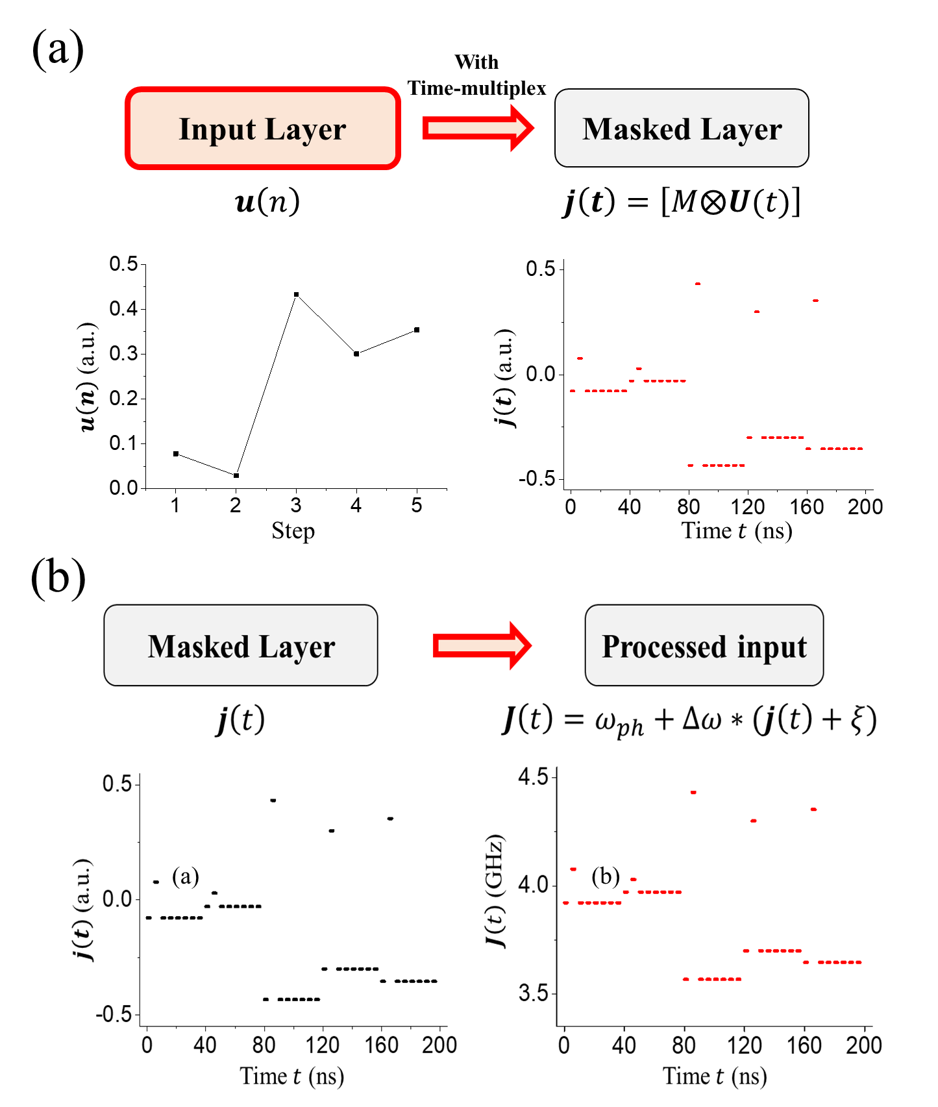

Supplementary Figure 8
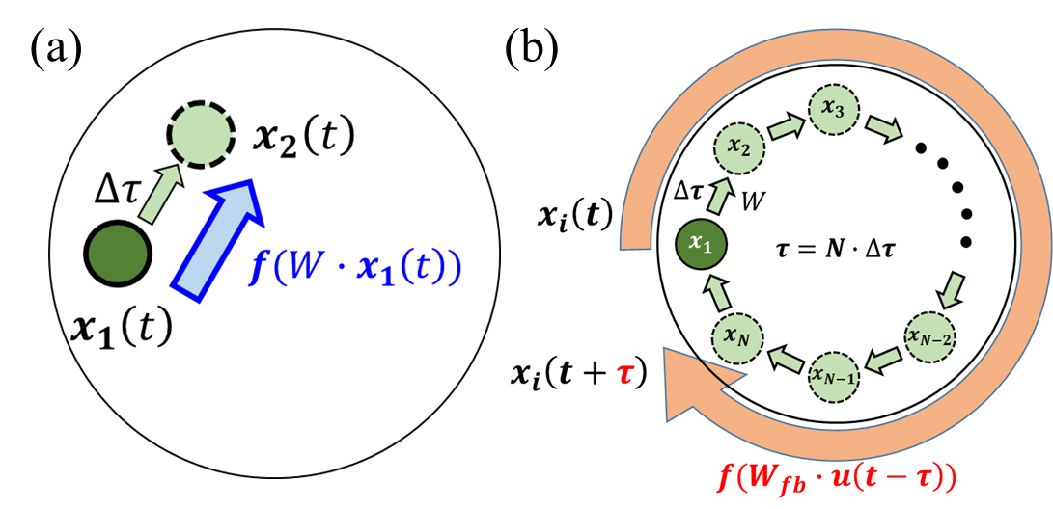

Supplementary S8. Logistic Regression and Softmax Regression in the TDR System
Logistic Regression is a widely used machine learning algorithm originally developed for binary classification tasks, where it predicts the probability that an input belongs to one of two classes. This probability is modeled using the logistic function, which maps real-valued inputs into the (0, 1) interval, providing a suitable measure of confidence in the class assignment. Given an input feature vector $x=\left(x_{1},x_{2}, … , x_{n}\right)$, the probability of the positive class (often denoted as $y=1$) is given by:
$$P\left(x\right)=\frac{1}{1+e^{-(β_{0}+\sum_{i=1}^{n}{β_{i}x_{i}})}}$$
Here, $β_{0}$ is the intercept, and $β_{i}$ are coefficients learned from training data via maximum likelihood estimation. Logistic Regression minimizes the binary cross-entropy (log-loss), systematically adjusting the coefficients 𝛽_{𝑖} to produce probabilities that closely match the observed data. The method is computationally efficient and inherently interpretable, as each coefficient 𝛽_{𝑖} corresponds to the change in log-odds of the outcome per unit increase in the associated feature 𝑥_{𝑖}. Such interpretability is valuable in fields like healthcare or finance, where understanding the influence of each feature is critical. While Logistic Regression is effective and can be enhanced with regularization techniques (e.g., L1 or L2) to prevent overfitting, it assumes a linear relationship between features and the log-odds of the outcome. For more complex data exhibiting nonlinear relationships, alternative models such as decision trees or neural networks may be more appropriate.
To extend Logistic Regression to multiclass problems, Softmax Regression (multiclass Logistic Regression) is employed. Instead of modeling a single binary probability, Softmax Regression handles 𝐾 classes by providing a probability distribution over all possible classes. Given an input 𝑥 and weight vectors 𝑊_{𝑘} for each class 𝑘:
$$P\left(x\right)=\frac{e^{W_{k}^{T}x}}{\sum_{j=1}^{K}{e^{W_{j}^{T}x}}}$$
This formulation ensures that probabilities across all 𝐾 classes sum to 1, producing a well-defined probability distribution. The model parameters 𝑊_{𝑘} are optimized to minimize the cross-entropy loss, which aligns the predicted probabilities with the true class distributions.
In our TDR system, we employ Softmax Regression as the output layer to perform multiclass classification. The TDR framework processes input signals through a high-dimensional dynamical reservoir, capturing temporal and spatial patterns in the data. After passing through the reservoir, the system obtains a set of reservoir states 𝑥_{𝑖}(𝑡 + 𝜏). These states are then mapped to output scores, which are converted into class probabilities using the Softmax function:
$$P\left(x\right)=\frac{e^{W_{out}^{c}x}}{\sum_{k=1}^{K}{e^{W_{out}^{k}x}}}$$
where $W_{out}^{c}$ is the weight vector for class 𝑐, and 𝐾 = 10 for digit classification (0–9). During training, the cross-entropy loss is minimized to adjust 𝑊_{out}, ensuring that the predicted probabilities align closely with the actual class labels.
By assigning a probability to each possible class, Softmax Regression enables the TDR system to distinguish among multiple categories and choose the class with the highest probability. This capability is essential for tasks such as spoken digit recognition, where a reliable and interpretable set of probabilities guides the final classification decision.
Supplementary S9. Cross-Correlation Analysis and its Impact on Misclassification in Spoken Digit Recognition
Figure S9 presents the cross-correlation matrix of the audio signals used for spoken digit recognition. This analysis indicates that the waveform similarities between different spoken digits play a critical role in the misclassification patterns observed in our RC system. Higher cross-correlation values correspond to greater waveform similarity, inherently increasing the complexity of the classification task.
In the confusion matrix shown in Figure 5(c), several notable misclassifications occur among digit pairs such as (0, 3), (0, 6), and (3, 6), with cross-correlation values of 5.0, 5.0, and 5.9, respectively. These elevated values demonstrate that the system is effectively learning the underlying waveform characteristics of the spoken digits. However, due to the high degree of acoustic similarity, the system struggles to distinguish among these particular digits. Other misclassified pairs, including (2, 4), (3, 8), (5, 7), and (6, 8), also display correlation values ranging from 1.3 to 6.8. Notably, the (5, 7) pair, with a cross-correlation of 6.8, further supports the notion that increased waveform similarity corresponds to a higher likelihood of misclassification.
This trend reflects both the strengths and limitations of the RC approach. On one hand, it confirms that the system is modeling the temporal and spectral properties of the input signals, as it tends to confuse digits that share similar acoustic features. On the other hand, it demonstrates the inherent difficulty of differentiating digits with closely related waveforms, even for advanced classification methods.
Although cross-correlation values alone do not fully account for all instances of misclassification, the observed pattern—where higher error rates coincide with greater waveform similarity—provides valuable insight into the system’s behavior. Misclassifications are especially concentrated among digit pairs with correlation values exceeding 5.0, suggesting that these strongly correlated signals represent a significant barrier to perfect digit differentiation.
To further enhance classification accuracy, especially for acoustically similar digits, future work may focus on improving the system’s ability to discriminate subtle differences in waveforms. Potential strategies include incorporating additional nonlinear transformations within the reservoir, applying more advanced feature extraction methods, or implementing dimensionality reduction techniques. Such refinements could enable the system to better capture fine-grained temporal and spectral distinctions, ultimately improving performance in challenging classification tasks.

Supplementary Figure 9

