Supplementary Information

Mitigating ion flux vortex enables reversible metal electrodeposition

Yuhang Dai^{1,2,#}, Wenjia Du^{2,#}, Haobo Dong^{1,5,#}, Xuan Gao^{1,2,}*, Chang Su⁶, Partha P. Paul^{3,4}, Bratislav Lukic^{3,4}, Chengyi Zhang⁸, Chumei Ye⁹, Jinghao Li⁷, Wei Zong², Jianwei Li¹, Yiyang Liu¹, Alexander Rack⁴, Liqiang Mai^{7,}*, Paul R. Shearing^{2,}*, Guanjie He^{1,}*

¹ Christopher Ingold Laboratory, Department of Chemistry, University College London, London WC1H 0AJ, UK
² Department of Engineering Science, University of Oxford, Oxford OX1 3PJ, UK
³ Henry Royce Institute, Department of Materials, The University of Manchester, Manchester M13 9PL, UK
⁴ ESRF - The European Synchrotron, 71 Avenue des Martyrs, Grenoble, 38000, France
⁵ School of Future Technology, South China University of Technology, Guangzhou 510641, China
⁶ Nuffield College, University of Oxford, Oxford OX1 1NF, UK
⁷ State Key Laboratory of Advanced Technology for Materials Synthesis and Processing, Wuhan University of Technology, Wuhan 430070, China
⁸ School of Chemical Sciences, University of Auckland, Auckland 1010, New Zealand
⁹ Department of Materials Science and Metallurgy, University of Cambridge, Cambridge CB3 0FS, UK
# These authors contributed equally to this work
* Email: xuan.gao@eng.ox.ac.uk; mlq518@whut.edu.cn; paul.shearing@eng.ox.ac.uk; g.he@ucl.ac.uk.

Supplementary Figure 1. Characterizations of LAPONITE powder. a-e, XPS spectra. f, SEM image. g, XRD pattern. The JCPDS No. 00-025-1385 corresponds to Na_{0.2}(Mg, Li)₃Si₄O₁₀(OH)₂·4H₂O.
Supplementary Figure 2. Density functional theory (DFT) calculation result of LAPONITE lamella. Analysis of charge density difference to investigate the adsorption behavior of Zn²⁺ and SO₄²⁻ on distinct sites (edge or surface) of LAPONITE. The chain structure of LAPONITE consists of [SiO₄] tetrahedra with Mg atoms between the chains. The blue area indicates electron loss, while the yellow area presents electron enrichment.
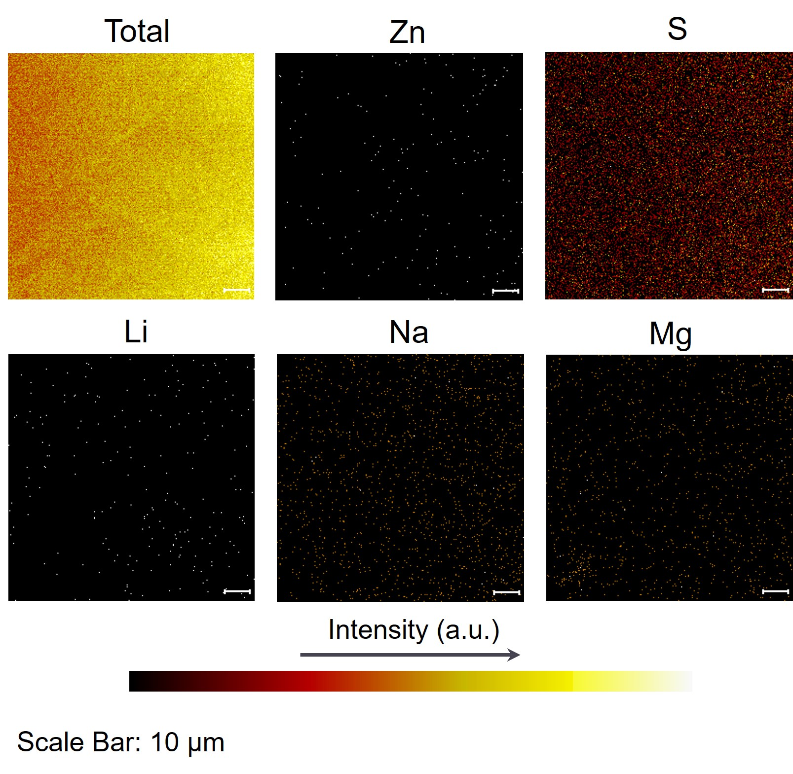
Supplementary Figure 3. Elemental mapping of the LAPONITE surface from time-of-flight secondary ion mass spectrometry (TOF-SIMS) test. After 1 cycle of deposition, LAPONITE was peeled off from the LAPO@Zn anode. The TOF-SIMS result was collected from negative mode. The Zn signal is low, while the S signal is high, indicating that LAPONITE selectively adsorbs SO₄²⁻ while allowing Zn²⁺ to pass through.
Supplementary Figure 4. Impedance spectra of bare Zn and LAPO@Zn electrodes before and after polarization. a, Electrochemical impedance spectroscopy (EIS) spectra based on bare Zn electrodes. b, EIS spectra based on LAPO@Zn electrodes. The inset shows the variation of current with time during polarization at an applied voltage of 10 mV and room temperature.
The transference number (t_{Zn2+}) values were measured by the potentiostatic polarization method, and determined by the Evans equation as below:
$t_{Zn}^{2+}=\frac{I_{s}(∆V-I_{0}R_{0})}{I_{0}(∆V-I_{s}R_{s})}$ (1)
where I₀ and I_{s} represent the currents at the initial and steady states, respectively. R₀ and R_{s} represent the interfacial resistances prior to and following polarization, respectively. The t_{Zn2+} values of bare Zn and LAPO@Zn are 0.33 and 0.82, respectively.
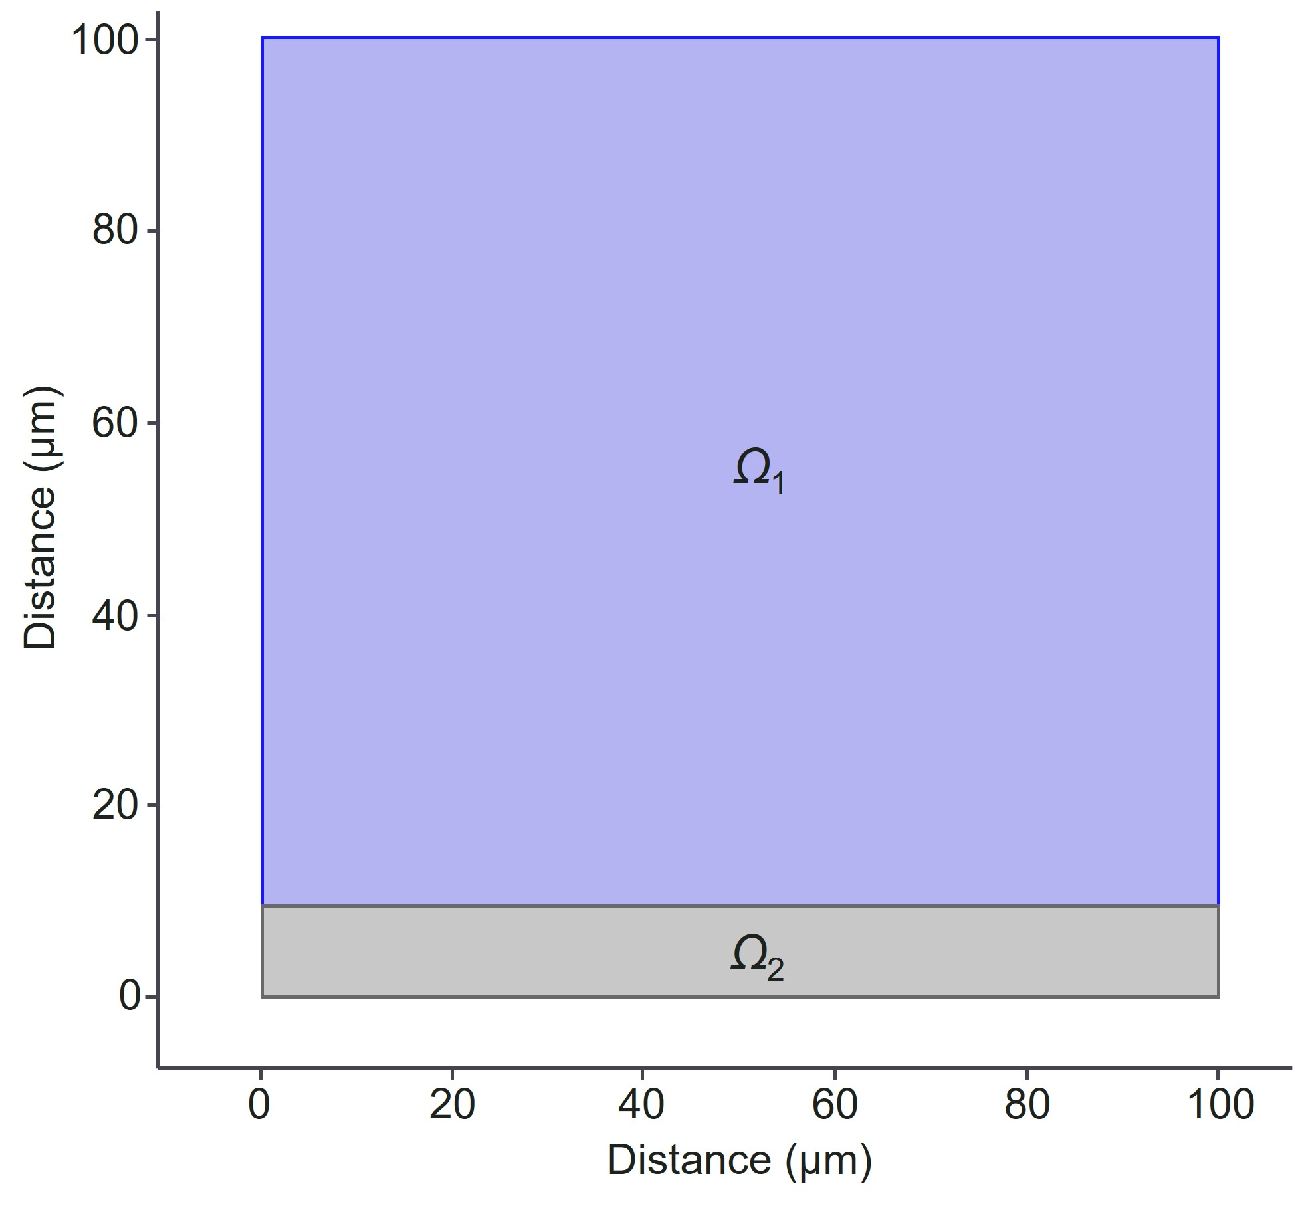
Supplementary Figure 5. Calculation model using the computational fluid dynamics (CFD) method for ion transport upon nanochannels.
Supplementary Figure 6. Ionic concentration fields upon bare Zn and coating. a, Ionic concentration fields upon bare Zn. b, Ionic concentration fields upon coating.

In a 10$\text{×}$10 μm two-dimensional region on the electrode surface, an artificial vortex (top-driven flow) was generated to simulate the smallest-scale turbulent motion of the solution at the electrode interface. Fluid motion within the porous coating adheres to Darcy's law, as depicted in the velocity field. The convection-diffusion equation is employed to depict the movement of Zn²⁺ and SO₄²⁻ concentrations near the electrode surface. The diffusion rate of ions within the LAPONITE coating is influenced by the concentration of absorbed SO₄²⁻.
Supplementary Figure 7. Velocity fields on different substrates. a-c, Ionic concentration fields upon bare Zn (a), LAPO@Zn (b), and general coating@Zn (c). d, Zn²⁺ flux density on the general coating@Zn surface.
N_{local} and N_{average} represent local and average Zn²⁺ flux densities, respectively. Deviation represents the residual sum of squares of individual data points relative to the dotted line. The general coating (like a conventional nanopore channeled coating) restricts ion diffusion, resulting in a more uniform distribution of metal ion concentration compared to bare Zn but less uniform than achieved with LAPO@Zn.
Supplementary Figure 8. Velocity fields upon cycled electrodes. a, Velocity field on bare Zn. b, Velocity field on LAPO@Zn.
Supplementary Figure 9. Electron distribution simulation. a, Visualization of the electron localization function. b, Related potential of the surface of LAPONITE.

Supplementary Figure 10. DFT simulation of the electron localization function. a, On LAPONITE slabs. b, On Zn slabs.

Supplementary Figure 11. EIS spectra at different temperatures. a, Bare Zn symmetric cells. b, LAPO@Zn symmetric cells.
Supplementary Figure 12. First-cycle discharge profiles of Zn||Zn symmetric cells using bare Zn and LAPO@Zn electrodes.
Supplementary Figure 13. Rate performance based on different electrodes. a, Plating/stripping curves of bare Zn and LAPO@Zn symmetric cells at 1 mA cm⁻², 2 mA cm⁻², 5 mA cm⁻², 10 mA cm⁻² with a fixed capacity of 1 mAh cm⁻². b, Exchange current density calculated from rate performance of Zn||Zn symmetric cells in (a).
This analysis allowed us to determine the exchange current densities following the equation provided below:
$i=i_{0}\frac{F}{RT}\frac{η}{2}$ (2)
where i is the current density, i₀ is the exchange current density, F is the Faraday constant, R is the gas constant, T is the absolute temperature, and η is the overpotential.
Supplementary Figure 14. 3D rendered Zn images after in-situ X-CT testing of LAPO@Zn (a) and Bare Zn (b).
Supplementary Figure 15. Statistical distribution of mean radius ranges for segmented Zn in LAPO@Zn and bare Zn after in-situ X-ray CT investigation.

Supplementary Figure 16. Zinc hydroxide sulfate (ZHS) detection from in-situ X-ray CT investigation and XRD pattern. a,b, Overlapped segmentation images of LAPO@Zn after in-situ X-CT testing. c, GIXRD patterns of bare Zn and LAPO@Zn after cycling.

Supplementary Figure 17. In-situ EIS spectra. These spectra were recorded at pristine, discharged, and charged states during the first cycle, including LAPO@Zn (a) and bare Zn (b) symmetric cells.

Supplementary Figure 18. The distribution of relaxation times (DRT) plot of the in-situ EIS data. These spectra attributed to bare Zn (a) and LAPO@Zn (b), after cycling. The P3-P5 peaks are attributed to the interfacial charge transfer impedance (R_{ct}). (Specific parameters can be found in Supplementary Table 1).
By conducting DRT analysis towards the in-situ EIS spectra, we partitioned the time constant into seven segments, where P2 corresponds to the solid-electrolyte interphase (SEI), and P3-P5 corresponds to the interfacial charge transfer resistance (R_{ct}). For the bare Zn electrode, a distinct P2 peak appeared after 1 h of discharging at 1 mA cm⁻², which remained after 1 h of charging at 1 mA cm⁻², indicating the irreversible formation of ZHS-contained SEI. In contrast, in the LAPO@Zn system, the signal of P2 peak is weak after one discharge and disappears when charging back, suggesting that the amount of ZHS generated on the LAPO@Zn surface is sparse and reversible. Consequently, the variation in the R_{ct} of the LAPO@Zn surface is also remarkably small due to the significant suppression of surface byproducts, whereas the R_{ct} of the bare Zn becomes significant after cycling.

Supplementary Figure 19. Operando X-ray radiography of symmetrical cells with bare Zn and LAPO@Zn electrodes. The scale bar in the images represents 50 μm.
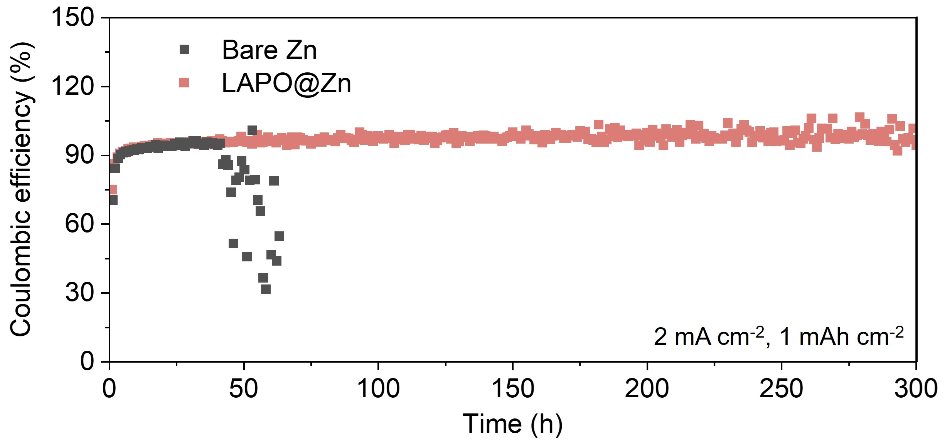
Supplementary Figure 20. Coulombic efficiency (CE) profile of Zn||Cu coin cells using bare Zn and LAPO@Zn anodes at 2 mA cm⁻², with a fixed capacity of 1 mAh cm⁻².

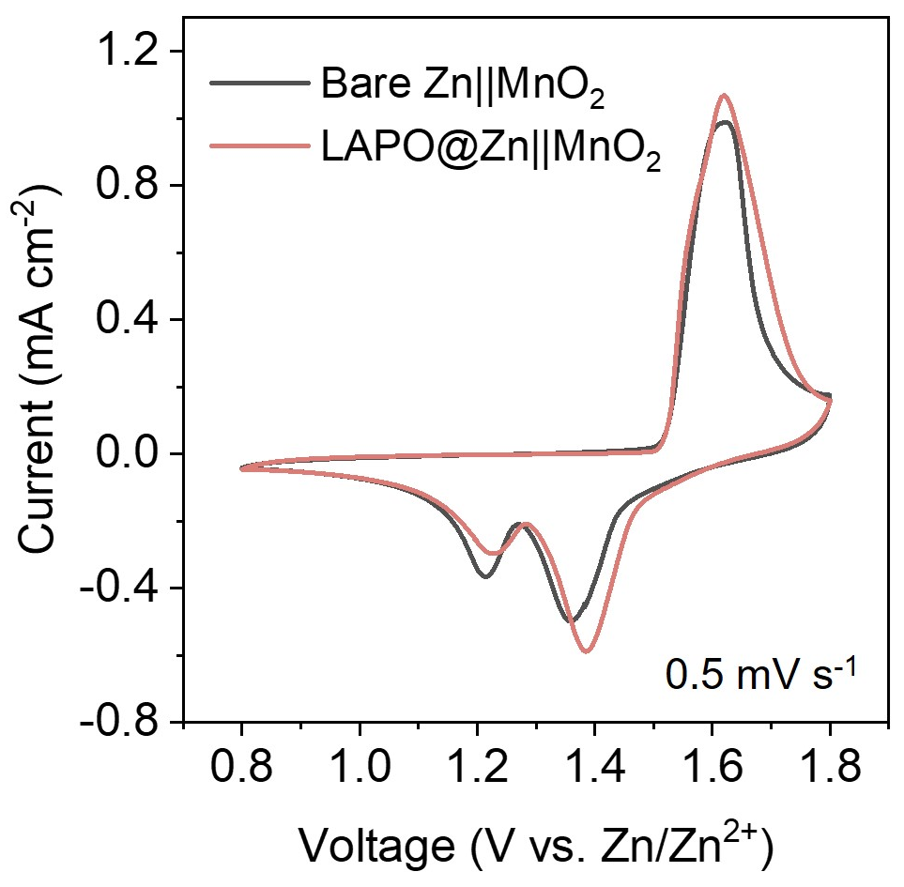
Supplementary Figure 21. CV curves of bare Zn||MnO₂ and LAPO@Zn||MnO₂ coin cells at a scan rate of 0.5 mV s⁻¹.

Supplementary Figure 22. Galvanostatic cycling performance of Zn||MnO₂ coin cells at 2 A g⁻¹.

Supplementary Figure 23. Galvanostatic cycling performance of the bare Zn||MnO₂ pouch cell at 0.2 A g⁻¹.

Supplementary Notes
Supplementary Figure 24. Additional investigations of LAPO@Zn. a, Fourier transform infrared (FTIR) of LAPONITE, CMC, and assembled coating composed of LAPONITE and CMC (LAPONITE+CMC). The peaks of LAPONITE+CMC are similar to those of the initial LAPONITE and CMC, indicating that our cell fabrication process does not significantly change the nature of LAPONITE. b,c, SEM images of the LAPONITE+CMC. The morphology of LAPONITE+CMC is presented differently from Fig. 3a,b in the main text, eliminating the possibility that the cubes are from LAPONITE or CMC.
Supplementary Figure 25. Contact angle test on bare Zn and LAPO@Zn anodes. The contact angle of water on the LAPO@Zn surface is 45.2°, which is much smaller than that of bare Zn surface (89.1°), suggesting that LAPONITE interlayer favors electrolyte penetration and may contribute to Zn²⁺ diffusion.

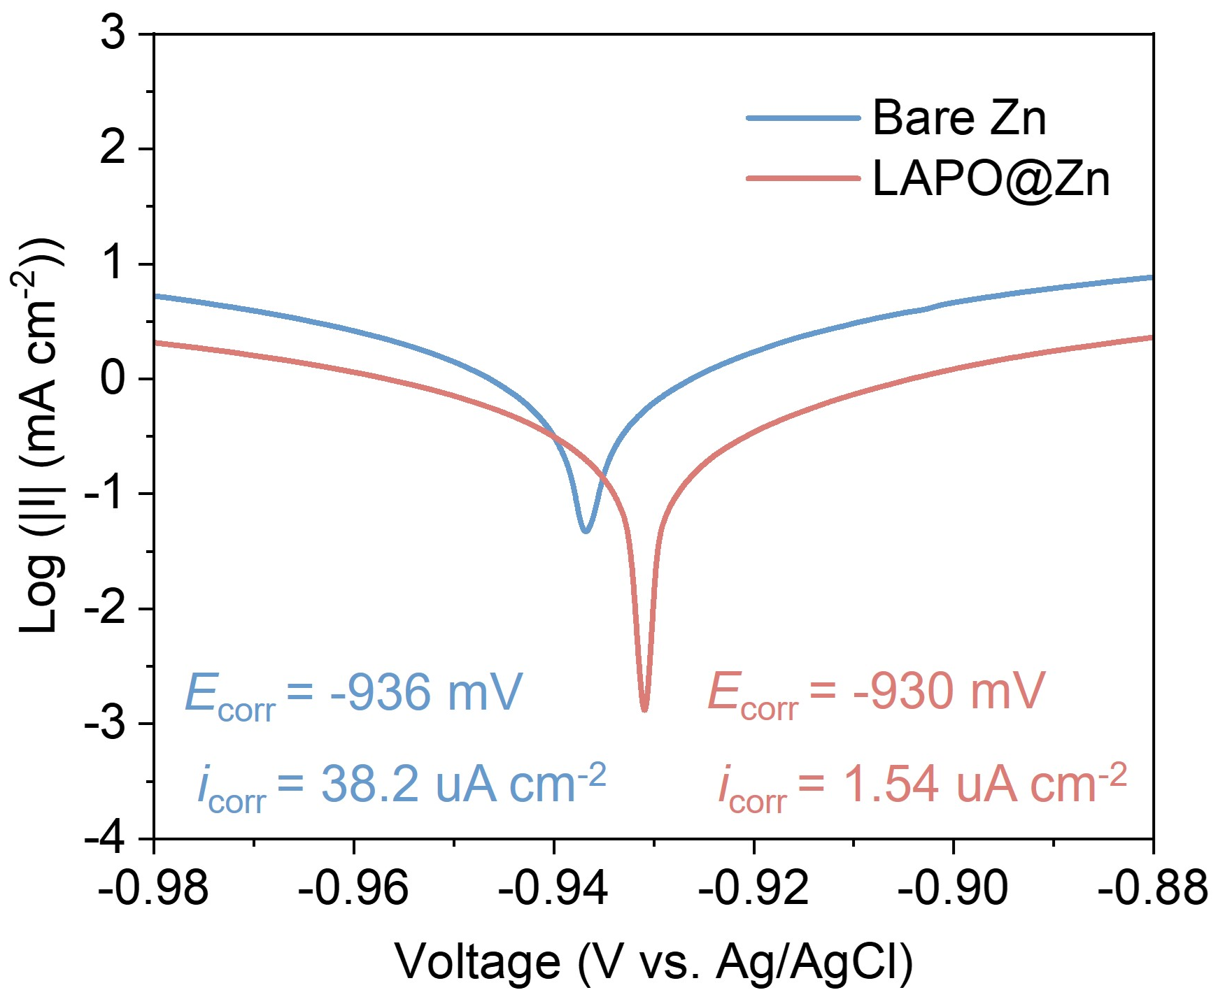
Supplementary Figure 26. Linear polarization curves of bare Zn and LAPO@Zn anodes. The corrosion is inhibited through the introduction of the LAPONITE interlayer.

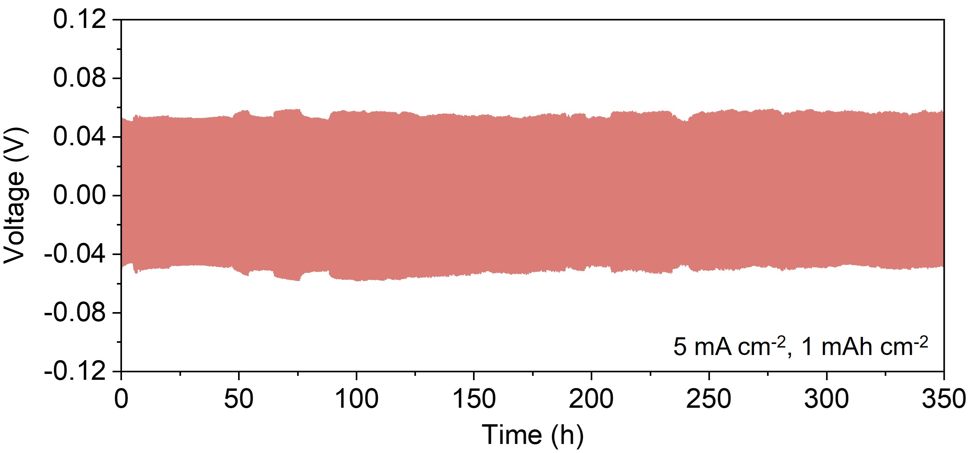
Supplementary Figure 27. Galvanostatic cycling curves of Zn||Zn symmetric cells at 5 mA cm⁻² with a fixed capacity of 1 mAh cm⁻².
Supplementary Table 1. Summary of application of DRT peaks calculated for a Zn||Zn symmetric cell.
DRT Peak | Approximate time constant, τ | Assignment
P1 | 11.22-12.88 µs | Double-layer relaxation
P2 | 19.5-22.38 µs | Solid-electrolyte interphase
P3 | 0.14-0.16 ms | Positive electrode charge transfer
P4 | 2.19-3.6 ms | Positive electrode charge transfer
P5 | 32.3-53.7 ms | Positive electrode charge transfer
P6 | 0.54-0.7 s | Diffusion
P7 | 5.75-6.1 s | Diffusion

Supplementary Table 2. Concentration of elements in the electrolyte in LAPO@Zn symmetric cell systems from inductively coupled plasma (ICP) results.
 | Mg (mg L⁻¹) | Zn (mg L⁻¹)
Before cycling | 132.8 | 2,644,192.8
After 50 cycles | 1,725.7 | 2,573,247.7

The Mg element concentration in the electrolyte (from dissolved LAPONITE) after cycling increases slightly, indicating the LAPONITE can be stably presented in the system during cycling.

