Supplemental Materials

Methods and Observations from Routinely Collected Electronic Health Record Data in a National Jail Population: Introducing the Registry of Electronic Archives in Correctional Healthcare (REACH) Database

Multicollinearity
The Variance Inflation Factor (VIF) for each predictor in our models were calculated to assess the potential issue of multicollinearity. As shown in Table S1, the degree to which models’ coefficients were elevated due to multicollinearity were within generally acceptable limits (VIF < 5) for Models 1 and 2a. Slightly elevated levels of multicollinearity were observed in Model 2b (interaction model), predominantly among variables and their corresponding interaction terms (see bolded). Multicollinearity is often unavoidable when modeling interactions because main effects and the interaction term will be naturally correlated, and slight elevations in the context of intrinsic multicollinearity are generally acceptable. The concern for these elevations can be further lessened due to the use of binary variables, as the impact of multicollinearity is often less severe in these cases than when continuous predictor variables are modeled.

Table S1
Variance Inflation Factor (VIF) Estimates for Predictors in Study Models
Variable |  | Model 1 | Model 2a | Model 2b
Sex
 | Female | 1.006 | 1.007 | 1.581
 | Unknown | 1.001 | 1.001 | 1.730
Race/Ethnicity
 | Asian | 1.234 | 1.235 | 1.947
 | Black or African American | 4.603 | 4.601 | 5.941
 | Indigenous | 1.072 | 1.072 | 1.618
 | Latine/o/a/x | 1.302 | 1.303 | 2.381
 | MENA | 1.001 | 1.001 | 8.044
 | South Asian | 1.004 | 1.004 | 2.559
 | White | 4.507 | 4.505 | 5.543
 | Multiracial | 1.020 | 1.020 | 2.587
Jail Location
 | Northeast | 1.137 | 1.137 | 2.350
 | Midwest | 1.210 | 1.212 | 1.874
 | South | 1.417 | 1.418 | 2.242
Jail Size
 | Large | 2.677 | 2.683 | 3.933
 | Mega | 2.868 | 2.870 | 4.110
Health Condition
 | Acute Infection | 1.013 | 1.013 | 1.903
 | Chronic Infection | 1.008 | 1.008 | 1.753
 | Chronic Care Condition | 1.147 | 1.148 | 1.956
 | Mental Illness | 1.153 | 1.153 | 1.959
Number of Bookings |  | -- | 2.850 | --
Number of Bookings (Quadratic) |  | -- | 2.865 | 2.871
Interactions
 | Female | -- | -- | 1.840
 | Unknown | -- | -- | 1.730
 | Asian | -- | -- | 1.758
 | Black or African American | -- | -- | 5.892
 | Indigenous | -- | -- | 1.558
 | Latine/o/a/x | -- | -- | 2.155
 | MENA | -- | -- | 8.043
 | South Asian | -- | -- | 2.555
 | White | -- | -- | 6.034
 | Multiracial | -- | -- | 2.572
 | Northeast | -- | -- | 2.303
 | Midwest | -- | -- | 2.620
 | South | -- | -- | 2.812
 | Large | -- | -- | 3.350
 | Mega | -- | -- | 6.737
 | Acute Infection | -- | -- | 1.932
 | Chronic Infection | -- | -- | 1.755
 | Chronic Care Condition | -- | -- | 2.010
 | Mental Illness | -- | -- | 2.111
Note. Given our focus on the interaction effects of Model 2b and issues of multicollinearity, the number of prior bookings main effect was omitted in this model. Bolded VIF values are those greater than 5. VIF of the number of prior bookings main effect when included in the interaction model was 31.54.

Non-Linearity and Polynomial Transformation
A non-linear relation was found between the number of bookings predictor variable and the LOS outcome (see Figure S1). A polynomial (quadratic) transformation was applied to capture the curvilinear relationship between these variables in effort to improve model fit and meet the linearity assumption. A likelihood ratio test and comparisons of models’ AIC and BIC were used to assess the performance of the polynomial transformation (see Table S2). For both Model 2a and Model 2b, quadratic transformation significantly improved model fit by modeling the non-linear relation between the number of bookings predictor variable and the LOS outcome.

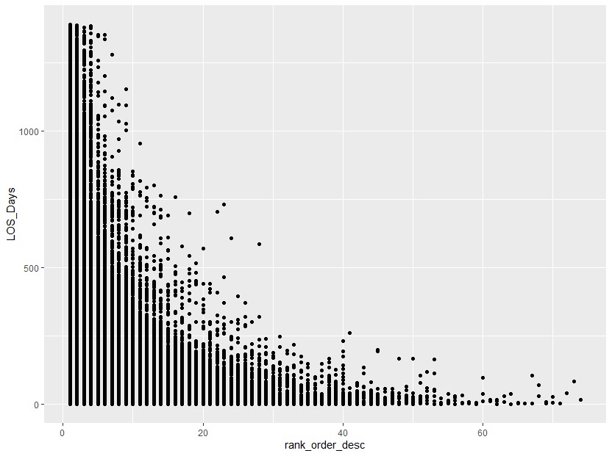
Number of Bookings
Length of Stay
Figure S1. Non-linear relation between variables

Table S2
Comparison of Original and Transformed Models
 | AIC |  | BIC |  | χ² |  | p
Model 2a
Original | 28922726 |  | 28923019
Transformed | 28922160 |  | 28922466 |  | 567.45 |  | < .001
Model 2b
Original | 28920405 |  | 28920927
Transformed | 28919628 |  | 28920163 |  | 779.13 |  | < .001

