Foraging in proximity to humans can shape social centrality in wild dolphins

Behavioral Ecology and Sociobiology

Kyra Bankhead^{1*}, Katherine A. McHugh², Randall S. Wells², Mauricio Cantor¹

1 Department of Fisheries, Wildlife and Conservation Sciences, Marine Mammal Institute, Oregon State University. Newport, OR, USA.
2 Sarasota Dolphin Research Program, Brookfield Zoo Chicago, c/o Mote Marine Laboratory. Sarasota, FL, USA.

*Corresponding Author: Kyra Bankhead (email: bankheak@oregonstate.edu)

Appendix 1. Data Analysis Approach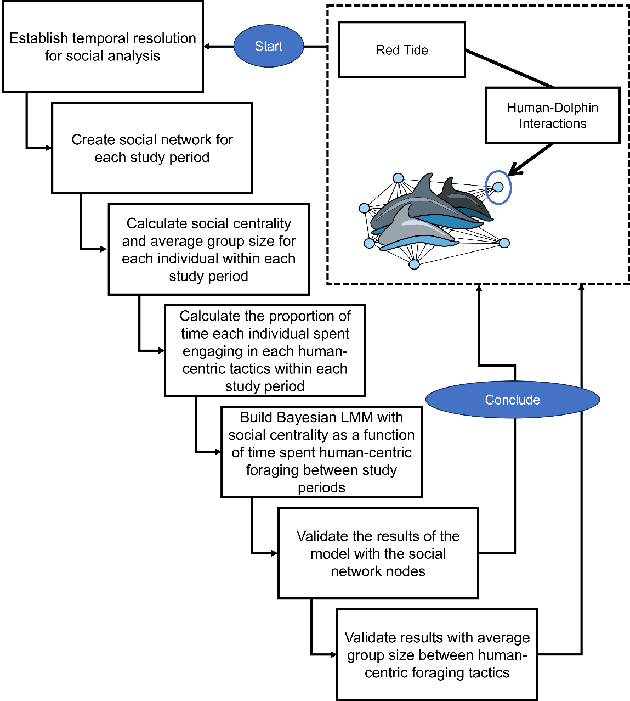

Fig. A1. The figure provides an overview on the data wrangling to ultimately use Bayesian inference and social network analysis to conclude on the hypothesis that human-dolphin interactions affect individuals’ sociality which is further impacted by red tide events. The black dashed frame indicates the hypothesis.

Appendix 2. Establishing Time Period Resolutions
Our analysis focused on a subset of the Sarasota Dolphin Research Program (SDRP) dataset, examining three distinct six-year periods relative to harmful algal bloom events. These periods were chosen based on various environmental, demographic, and methodological factors.
To understand the timing and intensity of harmful algal blooms, we examined weekly cell count data for Karenia brevis (the dinoflagellate algae responsible for red tides) that exceeded 100,000 cells/L, a widely accepted threshold indicative of potential fish kills (Gannon et al. 2009). We found that harmful algal blooms occurred throughout the three periods, with lower concentrations in the pre- and post- harmful algal bloom periods and higher levels during the actual blooms (Figure A2). The effects of harmful algal blooms on dolphin behavior persisted for three months after the bloom, affecting their ranging patterns, activity levels, and social interactions (McHugh et al. 2011). Furthermore, prey abundance returned to pre-bloom levels within a year following the bloom (Berens McCabe et al. 2021).
Social relationships among dolphins are dynamic, influenced by environmental factors as well as demographic shifts such as births, deaths, and life stage transitions. Therefore, it was crucial to establish a temporal resolution that accounted for these factors to provide a comprehensive view of social structure (Whitehead 1999, Cantor et al. 2012, Shizuka & Johnson 2019). The Sarasota population exhibits strong group affiliations, including nursery groups, juvenile groups, and adult male pairs (Wells et al. 1991). We focused on identifying periods of significant social bond changes, particularly the transition from nursery to juvenile groups, which occurs between ages 3 to 6 years (Wells 2014). Dolphins typically form most of their long-term social bonds during their first four years of life (Wells 2014). Despite the fluid nature of dolphin social dynamics, we adopted a static six-year timeframe for analysis. Our focus was on individuals born before the second six-year interval (in 2000) and those surviving through the third six-year segment (beginning in 2007). This approach allowed us to document social transitions precisely while observing unstable relationships and assessing cumulative impacts of red tides and human interactions.
Our choice of study periods also addressed differences in how human-centric behavior observations were recorded. Prior to 2007, these observations were recorded at the discretion of the boat captain. However, following increased human-related foraging and injuries in 2006, the SDRP implemented standardized measures for recording these behaviors from 2007 onwards. This included dedicated observation of human-centric activities during surveys, along with detailed descriptions and comments on confirmed occurrences.
After excluding individuals with unknown sex, fewer than 10 observations per period, or absence in all three periods, we selected 117 individual dolphins (63 female, 54 male) for analysis from the original 1,656 observed over 18 years. Including only individuals with complete data across all periods ensured accurate estimation of individual-specific effects, enhancing the model's ability to capture variability inherent to each individual and assess the impact of HABs and human-centric foraging (Baltagi 2008). Engagement in human-centric foraging behavior increased over time. Before harmful algal blooms, 14 individuals engaged in these behaviors; this number rose to 26 during the harmful algal blooms period and further increased to 48 in the post- harmful algal bloom period (Figure A2). This trend suggests a potential shift in dolphin foraging strategies in response to changing environmental conditions and human activity levels.

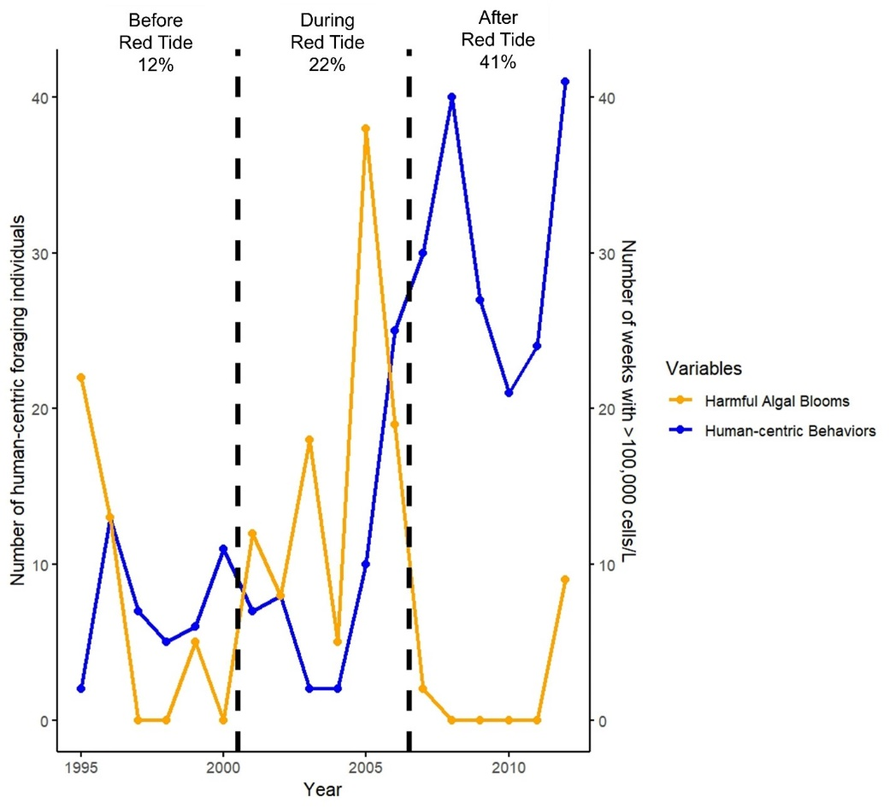
Fig. A2. Number of human-centric foraging bottlenose dolphins and harmful algal bloom intensity (# of weeks with >100,000 cells/L) in Sarasota Bay. The timeframe for each study period is indicated by dashed vertical lines. The percentage of the dolphin community members that were observed engaging in human-centric foraging behaviors is given for each study period.

