- Appendix
Entomological results
Table A1. Mosquitoes species composition by health center in both Konfra and Siradjouba villages in 2023.
Species | Niessoumala health subdistrict | Kabaya health subdistrict | Total (%)
Species | Konfra village | Siradjouba village | Total (%)
Anopheles gambiae complex members | 904 (91.41) | 85 (8.59) | 989 (100)
Culex spp | 1368 (36.55) | 2375 (63.45) | 3743 (100)
Total | 2272 (48.01) | 2460 (51.99) | 4732 (100)

Table A2. Estimation of the probability of infection by Wuchereria bancrofti in batches of the Anopheles gambiae complex collected in the villages of Konfra and Siradjouba in 2023.

Sub-district | Niessoumala | Kabaya | Total
Village | Konfra | Siradjouba | Total
#mosquitoes (#Pool) | 904 (46) | 85 (6) | 989 (52)
# mosquitoes/pool | [8-20] | [5-20] | [5-20]
# pools positives | 0 | 0 | 0
Probability of Wb infection [95% CI] | 0% [0-7.70] | 0% [0-45.93] | 0% [0-6.85]
#=number, Wb=Wuchereria bancrofti

Table A3. Estimation of the probability of infection by Wuchereria bancrofti in batches of the Culex spp collected in the villages of Konfra and Siradjouba in 2023.

Health subdistrict | Niessoumala | Kabaya | Total
Village | Konfra | Siradjouba | Total
#mosquitoes (#Pool) | 1368 (70) | 2375 (120) | 3743 (190)
# mosquitoes/pool | [4-20] | [9-20] | [4-20]
# pools positives | 0 | 1 | 1
Probability of Wb infection [95% CI] | 0% [0.00- 5.13] | 0.83% [0.02-4.55] | 0.53% [0.01-2.89]
#=number, Wb=Wuchereria bancrofti

Serological data results
Table A4. Some demographic characterization of the study population from 41 communities subdistrict health areas of both Bougouni and Yanfolila in 2023.

Health district | # participants | %
Bougouni | 1060 | 51,55
Yanfolila | 996 | 48,44
Gender
Female | 1245 | 60,55
Male | 811 | 39,44
Age group
6-7 years | 141 | 6,85
8-17 years | 558 | 25,14
18 years and over | 1357 | 66,00
Total | 2056 | 100
#= number

Table A5. Variation in filariasis test strips seroprevalence of Wuchereria bancrofti infection by age group in Bougouni and Yanfolila health districts.

Health districts | Age range | FTS result |  | Total n (%)
Health districts | Age range | # Negative (%) | # Positive (%) | Total n (%)
Bougouni | 6-7 years | 25(100) | 0(0) | 25(100)
Bougouni | 8-17 years | 207(100) | 0(0) | 207(100)
Bougouni | 18 years and over | 824(99.5) | 4(0.5) | 828(100)
Bougouni | Total Bougouni | 1056(99.62) | 4(0.38) | 1060(100)
Yanfolila | 6-7 years | 115(99.1) | 1(0.9) | 116(100)
Yanfolila | 8-17 years | 349(99.4) | 2(0.6) | 351(100)
Yanfolila | 18 years and over | 526(98.5) | 3(0.6) | 529(100)
Yanfolila | Total Yanfolila | 990(99.4) | 6(0.6) | 996(100)
Total |  | 2046 (99.51) | 10 (0.49) | 2056(100)
FTS = filariasis test strip, #= number of volunteers

Table A6. Comparison of the results of the xenomonitoring method with those of the last TAS of the National Lymphatic Filariasis Elimination Program in the Bougouni-Yanfolila evaluation unit.

Survey | Date | Test Used | Age range | Survey site | Survey method | Targeted population’s size | # tested (% of targeted population) | # Positives | % positives [95% CI]
TAS3 | 2019 | FTS | 6-7 years | School | clusters | 39910 | 1764 (4.42%) | 2 | 0.11  [0.01-0.37]
XenoFil | 2022-2023 | FTS | 6-7 years | CScom | Random selection of convenience | 69488 | 141 (0.20%) | 1 | 0.7%  [0.125-3.907]
#= number, TAS3= 3rd Transmission Assessment Survey, FTS= Filariasis Test Strip, Ag=Antigen, CScom= Community Health Center, XenoFil= LF xenomonitoring

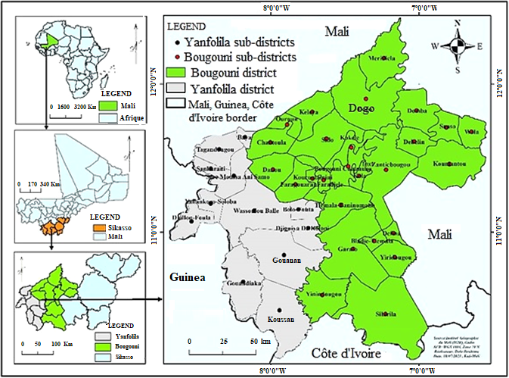
Figure A1: Map showing study sites in the Bougouni-Yanfolila Evaluation Unit

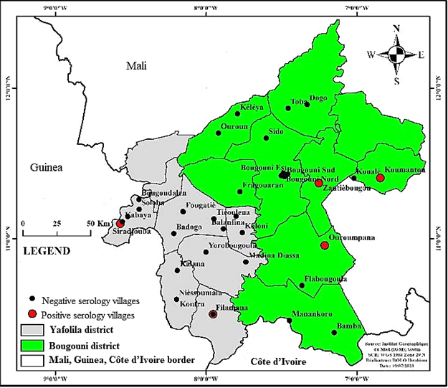
Figure A2: Map of the Bougouni-Yanfolila Evaluation Unit showing subdistrict health areas with positive and negative volunteers

