Supplementary Information - Potato Research

Early blight infection and the influence of biocontrol agents on wild potato relatives: Implications for integrated pest management (IPM) in potato
Åsa Lankinen¹, Christian B. Andersen^{1,2}, Hadis Mostafanezhad^{1,3}, Chiara De Pasqual¹, Veronica Hederström^{1,4}, Linnea J. Stridh^{1,5}, Erland Liljeroth¹, Laura Grenville-Briggs¹
¹ Department of Plant Protection Biology. Swedish University of Agricultural Sciences, Box 190, SE-324 22 Lomma, Sweden
² Present address: Carlsberg Research Laboratory, J.C. Jacobsens Gade 4, 1799, Copenhagen, Denmark
³ Present address: Department of Biological and Environmental Sciences and Gothenburg Global Biodiversity Centre, University of Gothenburg, Box 463, SE 405 30, Gothenburg, Sweden
⁴ Present address: Centre for Environmental and Climate Science (CEC), University of Lund, 22362, Lund, Sweden
⁵ Lyckeby Sveriges Stärkelseproducenter Förening U.P.a, Box 5036, 291 05 Kristianstad, Sweden

Corresponding author: Åsa Lankinen, asa.lankinen@slu.se

Confirmation of Alternaria solani infection in the wild species Solanum dulcamara and S. nigrum through PCR

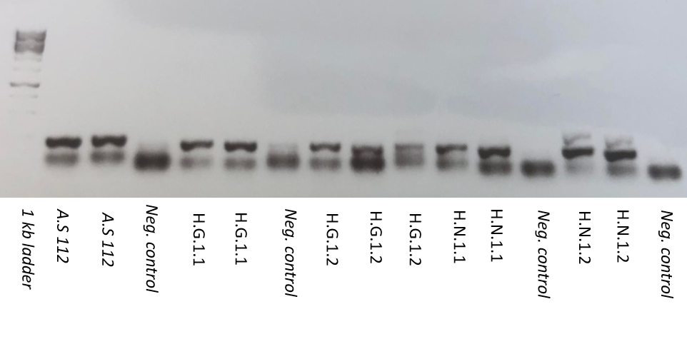
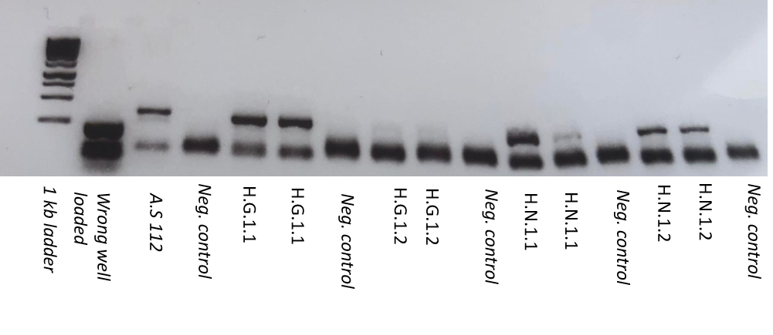
Fig. SI1 Confirmation was done by using two sets of primers in the PCR reaction followed by visualization of the PCR products on 1% agarose gel. The gel on top used AS1 and AS2 primers (Kumar et al., 2013) whereas the gel at the bottom used Asol 139 and 143R primers (Edin et al., 2019). List of samples: A.S 112 correspond to the laboratory strain maintained at SLU Alnarp and was used as positive control. Negative control consisted of distilled water. H.G.1.1 & H.G.1.2 correspond to A. solani isolated from S. dulcamara (Garden lab) and H.N.1.1 & H.N.1.2 correspond to A. solani isolated from S. nigrum (Helgegården)

References
Edin E, Liljeroth E, Andersson B (2019) Long term field sampling in Sweden reveals a shift in occurrence of cytochrome b genotype and amino acid substitution F129L in Alternaria solani, together with a high incidence of the G143A substitution in Alternaria alternata. Eur J Plant Pathol 155:627–641. https://doi.org/10.1007/s10658-019-01798-9
Kumar S, Singh R, Kashyap PL, Srivastava AK (2013) Rapid detection and quantification of Alternaria solani in tomato. Sci Hortic 151:184-189. https://dx.doi.org/10.1016/j.scienta.2012.12.026

