Supplementary Results

Slow Wave Types

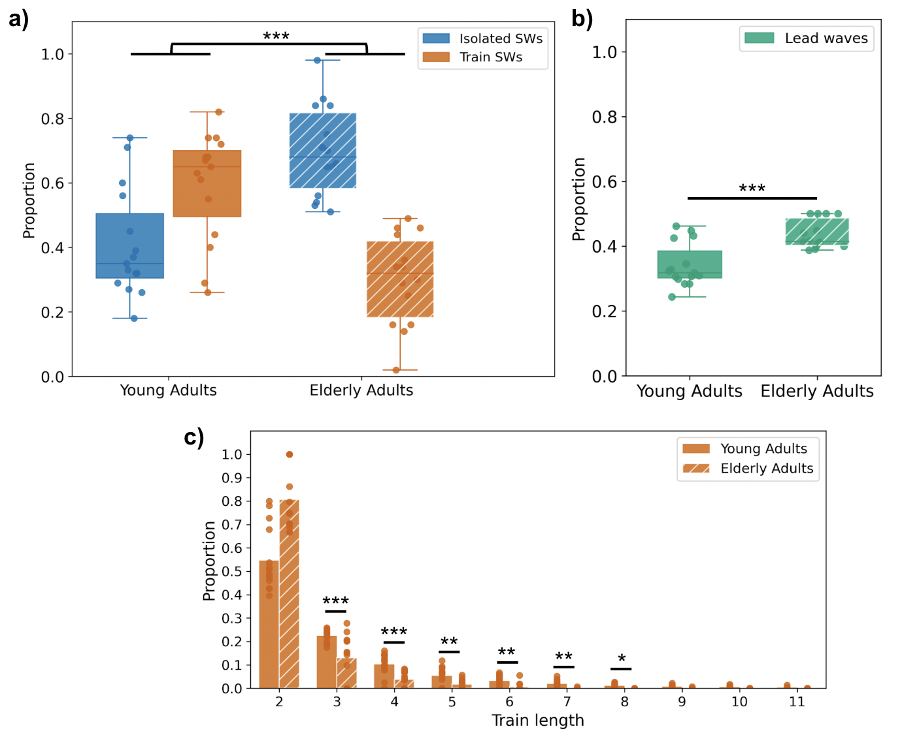
Figure 1: Differences in types of slow waves between young and elderly adults in NREM. a) Box plots of the proportions of each slow wave type for each group. b) Box plots of the proportions of lead waves relative to the total number of waves in trains for each group. c) Density histogram for oscillation train lengths. Distribution of oscillation train lengths ranging from 2 to 11 waves, with separate histograms for each group. Significance codes: ***, p < 0.001; **, p < 0.01; *, p < 0.05.

Elderly adults still exhibited a higher proportion of isolated slow waves and a reduced proportion of trains (Supplementary Figure 1a: Beta Regression with random intercepts; young adults isolated proportion mean ± SEM: 0.41 ± 0.04, elderly adults isolated proportion mean ± SEM: 0.7 ± 0.04; β1 = 1.2607, z = 4.706, p < 0.001). Again, elderly adults exhibited a higher proportion of lead waves compared to young adults (Supplementary Figure 1b: Beta Regression with random intercepts; young adults lead wave proportion mean ± SEM: 0.34 ± 0.02, elderly adults lead wave proportion mean ± SEM: 0.44 ± 0.01; β1 = -0.41080, z = -4.718, p < 0.001), and train lengths were significantly shorter for elderly adults. Elderly adults showed a smaller proportion of oscillatory trains across all train lengths between 3 and 8 (Supplementary Figure 1c: young, elderly mean ± SEM respectively, Dirichlet Regression with the "elderly" group being the reference category; length 2: 0.55 ± 0.03, 0.81 ± 0.04, β1 = 0.07754, z = 0.36, p = 0.719; length 3: 0.22 ± 0.01, 0.13 ± 0.03, β1 = 1.6257, z = 6.431, p < 0.001; length 4: 0.10 ± 0.01, 0.04 ± 0.01, β1 = 1.40041, z = 4.968, p < 0.001; length 5: 0.05 ± 0.01, 0.02 ± 0.01, β1 = 0.9978, z = 3.254, p = 0.001; length 6: 0.03 ± 0.01, 0.007 ± 0.004, β1 = 1.0224, z = 3.193, p = 0.001; length 7: 0.018 ± 0.004, 0.0005 ± 0.0005, β1 = 0.9304, z = 2.831, p = 0.005; length 8: 0.011 ± 0.003, 0.0 ± 0.0, β1 = 0.7427, z = 2.222, p = 0.026; length 9: 0.008 ± 0.002, 0.0005 ± 0.0005, β1 = 0.6100, z = 1.815, p = 0.070; length 10: 0.005 ± 0.001, 0.0 ± 0.0, β1 = 0.5114, z = 1.507, p = 0.132; length 11: 0.002 ± 0.001, 0.0 ± 0.0, β1 = 0.3342, z = 0.974, p = 0.330).

Slow Wave Detections

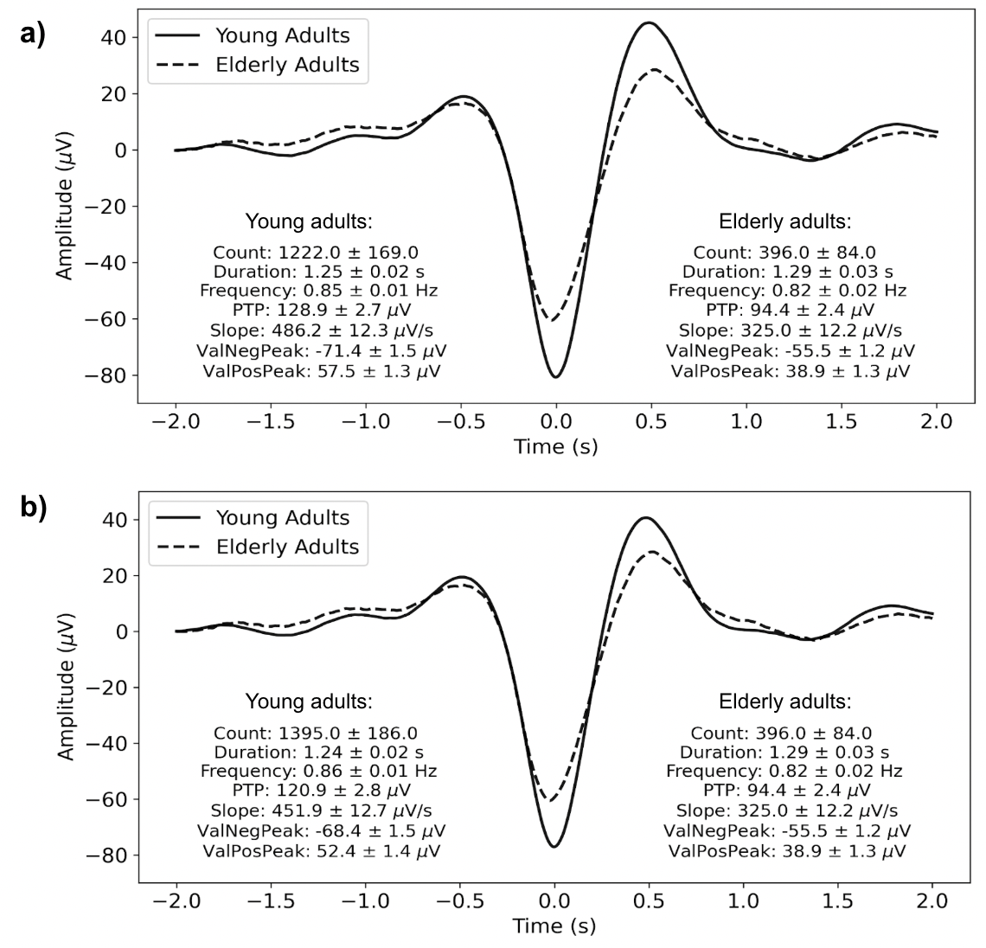
Figure 2: Average slow wave and features in NREM. a) Average slow wave and features in NREM using different PTP thresholds for each group. PTP minimum amplitude threshold was set to 75 µV for young and 60 µV for elderly adults. b) Average slow wave and features in NREM, using the same PTP thresholds for both groups. PTP minimum amplitude threshold was set to 60 µV for both young and elderly adults. Mean ± SEM values are shown.

 | Young adults | Elderly adults | Statistic, p-value
Count | 1395 ± 180 | 396 ± 81 | W = 21, p < 0.001
Duration (s) | 1.24 ± 0.02 | 1.29 ± 0.03 | W = 140, p = 0.134
Frequency (Hz) | 0.86 ± 0.01 | 0.82 ± 0.02 | W = 68, p = 0.112
PTP amplitude (uV) | 120.86 ± 2.74 | 94.41 ± 2.31 | W = 5, p < 0.001
Slope (uV/s) | 451.9 ± 12.29 | 325.0 ± 11.71 | W = 2, p < 0.001
Neg. peak (uV) | -68.42 ± 1.42 | -55.55 ± 1.14 | W = 203, p < 0.001
Pos. peak (uV) | 52.44 ± 1.37 | 38.86 ± 1.27 | W = 4, p < 0.001
Table 1: Slow wave quantity and features analysis, using the same PTP thresholds for both groups. Mean count, duration, frequency, peak to peak amplitude, slope, negative and positive peak amplitudes ± SEM for each group in NREM. PTP minimum amplitude threshold was set to 60 µV for young and 60 µV for elderly adults. Wilcoxon rank-sum tests were used. Significant p-values are highlighted in bold.

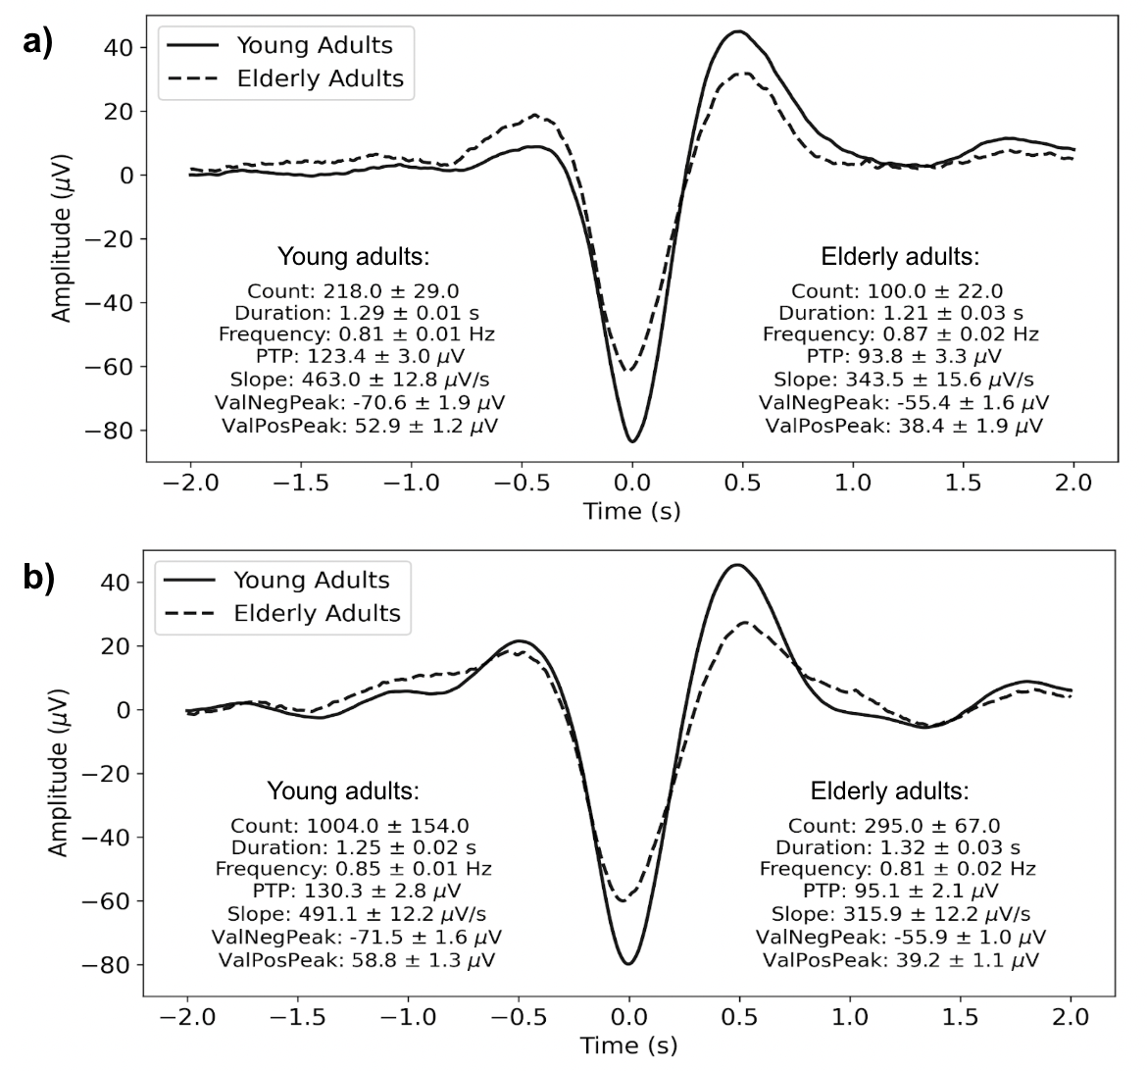
Figure 3: Average slow wave and features in N2 and N3, using different PTP thresholds for each group. PTP minimum amplitude threshold was set to 75 µV for young and 60 µV for elderly adults. a) Average slow wave and features in N2. b) Average slow wave and features in N3. Mean ± SEM values are shown.

