Supplementary Note.
Fluid and imaging biomarkers assessment
We collected the results of amyloid positron emission tomography (PET), cerebrospinal fluid (CSF) testing, 2β-carbometoxy-3β-(4-iodophenyl)-N-(3-fluoropropyl) nortropane (FP-CIT) single-photon emission computed tomography (SPECT), and metaiodobenzylguanidine (MIBG) myocardial scintigraphy performed within 3 years from the first visit for cross-sectional comparison. If the amyloid PET and CSF p-tau were not concordant, the amyloid PET result was used as the AD biomarker result; if FP-CIT SPECT and MIBG myocardial scintigraphy did not match, either positive result was used as the LBD biomarker result. We used ¹⁸F-Florbetapir and ¹⁸F-Flutemetamor amyloid PET results and CSF p-tau levels as AD biomarkers. The amyloid PET results depended on those determined by nuclear radiologists. CSF collection and p-tau measurement followed our previously described methods (Satake et al. 2024). Only the samples collected after April 2022 were analyzed with SRL, Inc. using a fully automated chemiluminescent enzyme immunoassay Lumipulse® (Fujirebio, Tokyo). The reference range set by the company was 21.5–59.0 pg/mL, and samples with a value of ≥59.0 were judged to have AD pathology.

Supplementary Table 1. Demographic data of the participants and the unenrolled patients with VLOSLP
 | Participants (n=19) | Unenrolled VLOSLP (n=48) | p
Age, years | 81 [68–85] | 80.5 [75–84] | 0.358
Sex, n of female | 17 (89.5%) | 40 (85.1%) | 1
Onset age, years | 68 [65–82] | 78 [72–81.8] | 0.24
Education, years | 12 [12–14] | 12[9.5–12] | 0.189
MMSE | 26 [25–28] | 26 [25–27] | 0.789
CDR | 0.5 [0.5–0.5] | 0.5 [0.5–0.5] | 0.394
Cases with AD biomarkers, n | 15 | 15 | -
Positive cases | 6 (40%) | 7 (46.7%) | 1
Cases with LBD biomarkers, n | 19 | 28 | -
Positive cases | 6 (31.6%) | 5 (17.8%) | 0.312
Followed-up cases, n | 19 | 5 | -
Data are presented as median [interquartile range], n (%), or number. The Mann–Whitney U test was used for continuous variables, and Fisher’s exact test was used for categorical. A p-value of less than 0.05 indicated a significant difference in a two-tailed test. Abbreviations: VLOSLP, very-late-onset schizophrenia-like psychosis; MMSE, Mini-Mental State Examination; CDR, Clinical Dementia Rating; AD, Alzheimer’s Disease; LBD, Lewy Body Disease.

Supplementary Table 2. Demographic data of the three groups of participants
 | BMs-neg (n=7) | AD-pos/LBD-neg (n=6) | LBD-pos (n=6) | H | p | post-hoc analysis
Age, years | 72 [67.5–81.5] | 84.5 [70–86] | 79.5 [74–85] | 3.259 | 0.196
Sex, n of female | 7 (100%) | 6 (85.7%) | 5 (83.3%) | ˗ | 0.509
Onset age, years | 65 [63–67] | 82.5 [68–83] | 77 [68–82] | 6.866 | 0.032 | BMs-neg < AD-pos/LBD-neg
Education, years | 14 [12–14] | 12 [12–15] | 12 [12–12] | 1.315 | 0.518
Time to the follow-up, days | 474 [426–510] | 427 [378.5–619.5] | 436 [375–544] | 0.022 | 0.989
MMSE | 29 [26–29.5] | 26 [25–28] | 25 [24–27] | 3.499 | 0.174
WMS-R LM I | 17 [15–20] | 10 [8–19] | 6 [4–7] | 8.106 | 0.017 | BMs-neg > LBD-pos
WMS-R LM II | 14 [13–15] | 3 [1–6] | 5 [1–6] | 11.926 | 0.003 | BMs-neg > AD-pos/LBD-neg, LBD-pos
CDR | 0.5 [0.5–0.5] | 0.5 [0.5–0.5] | 0.5 [0.5–0.5] | 1.714 | 0.424
CDR-SOB | 2 [1.8–2.5] | 2 [1.3–3.3] | 2.5 [1.5–3] | 0.737 | 0.692
Data are presented as the median [interquartile range] or n (%). The Kruskal–Wallis test with the Dunn–Bonferroni post–hoc test was used for continuous variables, and Fisher’s exact test was used for categorical variables. A p-value of less than 0.05 indicated a significant difference in a two-tailed test. Abbreviations: BMs-neg, biomarker-negative group; AD-pos/LBD-neg, Alzheimer’s disease biomarker-positive and Lewy body disease biomarker-negative group; LBD-pos, Lewy body disease biomarker-positive group; MMSE, Mini-Mental State Examination; WMS-R, Wechsler Memory Scale-revised; LM, Logical Memory; CDR, Clinical Dementia Rating; CDR-SB, CDR sum of boxes; NPI-psychosis, sum of scores of delusions and hallucinations of the Neuropsychiatric Inventory.

Supplementary Table 3. Post-hoc analysis for CDR-SB in mixed ANOVA
 | BMs-neg (n=7) | AD-pos/LBD-neg (n=6) | LBD-pos (n=6) | F | p
First | 1.9 (1.0) | 2.1 (1.1) | 2.4 (0.8) | 0.412 | 0.67
Follow-up | 1.2 (1.3) | 5.4 (2.8) | 3.4 (1.5) | 7.152 | 0.007
F | 0.088 | 0.035 | 5.932 | – | –
p-value | 0.778 | 0.861 | 0.072 | – | –

Items containing parentheses are presented as means (standard deviations). F- and p-values were calculated after fixing one of the main effects of group and time, respectively. We assumed that a p-value < 0.01 (0.05 / 5) indicates a significant difference with Bonferroni correction; the relevant p-values are shown in bold. Abbreviations: CDR-SB, CDR sum of boxes; BMs-neg, biomarker-negative group; AD-pos/LBD-neg, Alzheimer’s disease biomarker-positive and Lewy body disease biomarker-negative group; LBD-pos, Lewy body disease biomarker-positive group

Supplementary Table 4. Post-hoc analysis for MMSE in mixed ANOVA
 | BMs-neg (n=7) | AD-pos/LBD-neg (n=6) | LBD-pos (n=6) | F | p
First | 27.7 (2.4) | 26.2 (1.6) | - | 0.905 | 0.364
Follow-up | 27.3 (2.2) | 23.7 (3.3) | - | 7.508 | 0.021
First | 27.7 (2.4) | - | 25.5 (1.6) | 2.462 | 0.148
Follow-up | 27.3 (2.2) | - | 23.3 (1.4) | 12.01 | 0.006
First | - | 26.2 (1.6) | 25.5 (1.6) | 0.432 | 0.527
Follow-up | - | 23.7 (3.3) | 23.3 (1.4) | 0.023 | 0.884
We assumed that a p-value < 0.0083 (0.05 / 6) indicates a significant difference with Bonferroni correction; the relevant p-values are shown in bold. Abbreviations: MMSE, Mini-Mental State Examination; BMs-neg, biomarker-negative group; AD-pos/LBD-neg, Alzheimer’s disease biomarker-positive and Lewy body disease biomarker-negative group; LBD-pos, Lewy body disease biomarker-positive group.

Supplementary Table 5. Details of the biomarker results, symptoms, and medications of the participants

Group | No. | Age | Onset | Sex | AD biomarker | LBD biomarker | CF | VH | RBD | Pism | conversion into dementia | At the first visit | Medication | At the follow-up visit | Medication | NPI-score of psychosis
BMs-neg | 1 | 64 | 61 | F | PET | MIBG | - | - | - | - | no | PD: Her colleagues in her office are spying on her and harassing her over the airwaves. Even strangers are watching her. | none | PD: Being suspicious that someone is trying to intrude into her house | 4mg of bronanserin | 6 to 2
BMs-neg | 2 | 67 | 65 | F | PET | FP-CIT | + | + | - | - | no | PD, AH: A strange monk living upstairs threatened her; something white sometimes appeared in front of her | none | PD, AH: The monk was "dead," but her son, grandson, and unknown fat lady's voices fell down to her from upstairs | 12.5mg of quetiapine | 20 to 14
BMs-neg | 3 | 68 | 65 | F | PET, CSF | MIBG | + | - | - | - | neurosis (CDR=1) | VH: A cockroach was in a spaghetti; a spider was in a cup of coffee | none | No psychosis | none | 4 to 0
BMs-neg | 4 | 72 | 68 | F | CSF | MIBG | - | - | - | - | no | PD, AH: A neighbor living upstairs makes annoying noises (previously, she thought the neighbor was harassing and targeting her with lasers, and she was admitted to another hospital within the 2 years, but her psychosis improved with changing of medications) | none | AH: A neighbor living upstairs makes annoying noises | none | 3 to 1
BMs-neg | 5 | 81 | 66 | F | PET, CSF | FP-CIT | - | - | - | - | no | PD: A neighbor living upstairs spied on her | none | PD: A neighbor living upstairs spied on her and harasses her | none | 1 to 4
BMs-neg | 6 | 82 | 60 | F | PET, CSF | MIBG | - | - | - | - | no | PD: Neighbors bad-mouthed her; she was able to negotiate with the city capitol to create a new airport in her town | none | No psychosis | none | 10 to 0
BMs-neg | 7 | 82 | 82 | F | PET | FP-CIT | - | - | - | - | no | PD: Neighbors bad-mouthed her | none | Only a slight sense of being observed | none | 9 to 0
AD-pos/LBD-neg | 8 | 68 | 68 | F | PET, CSF | FP-CIT | - | - | - | - | ADD | PD: Unspecified neighbors intruded into her house, moved her belongings, followed her out of her house, and cast lights on her | 5mg of clotiazepam | PD: The mother of her husband's relative's child, who temporarily lived together with her, stole her ring. | 4.5mg of rivastigmine | 3 to 2
AD-pos/LBD-neg | 9 | 70 | 68 | F | PET | MIBG | - | - | - | - | ADD | PD: Items from a self-employed beauty salon are stolen by a thief; Neighbors tried to break into her salon; the post office took her savings | 9mg of rivastigmine, 2.5mg of yokukansan | PD: Items from a self-employed beauty salon are stolen by a thief | 13.5mg of rivastigmine | 6 to 7
AD-pos/LBD-neg | 10 | 84 | 84 | F | CSF | MIBG | - | + | - | - | no | PD, AH: An unknown male and female staying beyond her house's wall threatened her | none | PD, AH: An unknown male and female staying beyond her house's wall threatened her | 25mg of quetiapine | 16 to 24
AD-pos/LBD-neg | 11 | 85 | 82 | F | PET, CSF | MIBG | - | - | - | - | no | PD, AH: Her sister-in-law living in the neighborhood intruded into her house and stole things; the intruders made noises | none | PD, AH: her sister-in-law moved to a long-term care facility, and the target of persecutory delusions changed into her close friend. The contents of the delusions were similar. | 12.5mg of quetiapine, 5g of Yokukansan | 24 to 8
AD-pos/LBD-neg | 12 | 86 | 83 | M | PET, CSF | FP-CIT, MIBG | - | - | - | - | ADD | PD, AH: An unknown male and female living upstairs observed and threatened him | 25mg of quetiapine, 5mg of donepezil, 15 mg of suvolexant | None (but he was frightened that they might threatened again). | 0.5mg of risperidone, 25mg of quetiapine, 2.5mg of yokukansan, 5mg of donepezil | 24 to 0
AD-pos/LBD-neg | 13 | 86 | 83 | F | CSF | FP-CIT | + | - | - | - | ADD | PD: Her eldest son was entering without permission, stealing money and goods, and withdrawing money from her account | 50mg of sulpiride, 1mg of ethyl loflazepate | PD: Her laundry was stolen; her son might kill her | 0.5mg of brexpiprazole, 10mg of escitalopram, 20mg of memantine | 12 to 12
LBD-pos | 15 | 66 | 64 | M | - | FP-CIT | + | + | + | - | DLB | PD, AH, VH: Visual hallucinations of strangers and black shadows; strangers ransacked his house | 5mg of donepezil | VH, MD: Visual hallucinations of fire in his house; sense of presence; TV misidentification | 10mg of donepezil | 6 to 24
LBD-pos | 19 | 74 | 73 | F | - | FP-CIT | - | - | + | - | DLB | PD: Her children thought that she was poor; someone upstairs stalked her. | none | VH, MD: Visual hallucinations of her son; sense of presence; she believed things that are not true influenced by hallucinations | none | 2 to 12
LBD-pos | 14 | 77 | 68 | F | CSF | FP-CIT | - | - | - | - | possible iNPH | PD: Someone who spied on her was entering her home | 0.25mg of brotizolam | PD: Her things were stolen; her surgery was postponed | none | 6 to 3
LBD-pos | 18 | 82 | 81 | F | CSF | FP-CIT | - | - | - | - | no | PD: Her husband's affair partner intruded into the home, stole things, moved things from place to place, and ironed clothes. | none | PD: Her husband had an affair (but her husband died during the follow-up period) | 25mg of quetiapine | 14 to 2
LBD-pos | 17 | 85 | 82 | F | - | FP-CIT | + | - | - | - | no | SH: Odd sense in her oral cavity, such as a bitter taste, foam coming out of her mouth, or a feeling of a film | 5mg of nitrazepam | VH, SH: Odd senses were present but improved a little; a visual hallucination of her husband | 18.75mg of quetiapine, 4.5mg of rivastigmine | 12 to 8
LBD-pos | 16 | 88 | 85 | F | - | FP-CIT, MIBG | + | + | + | - | no | VH: Visual hallucinations of her grandchild | none | none | 5mg of donepezil | 3 to 0

Meaning and Abbreviations: BMs-neg, biomarkers-negative group; AD-pos/LBD-neg, Alzheimer’s disease biomarker-positive and Lewy body disease biomarker-negative group; LBD-pos, Lewy body disease biomarker-positive group; F, female; M, male; AD, Alzheimer’s Disease; LBD, Lewy Body Disease; CF, cognitive fluctuation; VH, visual hallucination; RBD, REM sleep behavior disorder; Pism, parkinsonism; NPI-psychosis, the sum of scores of delusions and hallucinations of the Neuropsychiatric Inventory; PET, amyloid positron emission tomography; CSF, cerebrospinal fluid; FP-CIT, FP-CIT SPECT; MIBG, MIBG myocardial scintigraphy; ADD, AD dementia; DLB, Dementia with Lewy bodies; iNPH, idiopathic normal pressure hydrocephalus; PD, persecutory delusions; AH, auditory hallucinations; VH, visual hallucinations; SH, somatic hallucinations.

Supplementary Figure 1. Enrollment flowchart
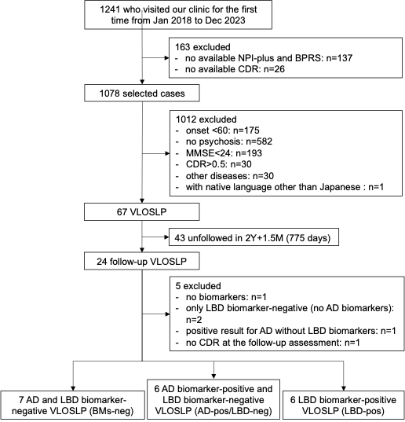
Abbreviation: NPI-plus, Neuropsychiatric inventory-plus; BPRS, Brief Psychiatric Rating Scale; CDR, Clinical Dementia Rating; MMSE, Mini-Mental State Examination; VLOSLP, very-late-onset schizophrenia-like psychosis; AD, Alzheimer’s disease; LBD, Lewy body disease

Supplementary Figure 2. The longitudinal changes of mean MMSE, CDR-SB, and NPI-psychosis score
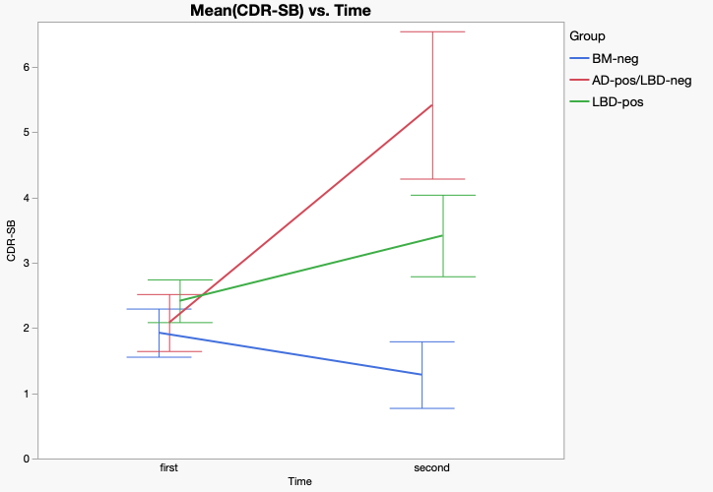
A. CDR-SB

B. MMSE
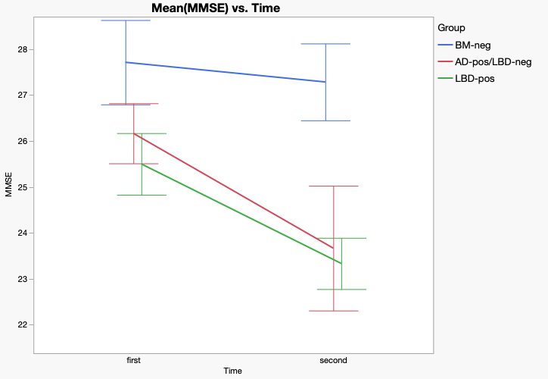

C. NPI-psychosis
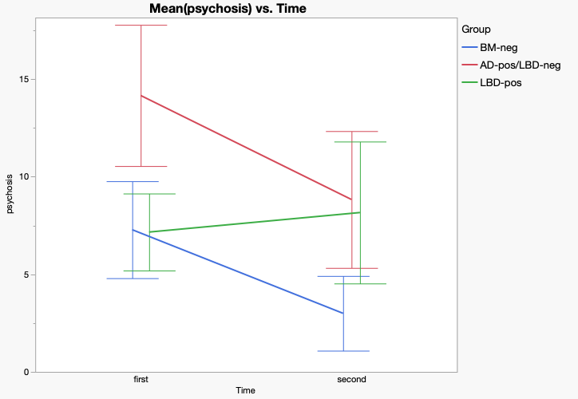

The line graphs show the mean changes and the error bars indicate standard errors. Abbreviations: BMs-neg, biomarker-negative group; AD-pos/LBD-neg, Alzheimer’s disease biomarker-positive and Lewy body disease biomarker-negative group; LBD-pos, Lewy body disease biomarker-positive group; MMSE, Mini-Mental State Examination; CDR-SB, CDR sum of boxes; NPI-psychosis, sum of scores of delusions and hallucinations on the Neuropsychiatric Inventory

