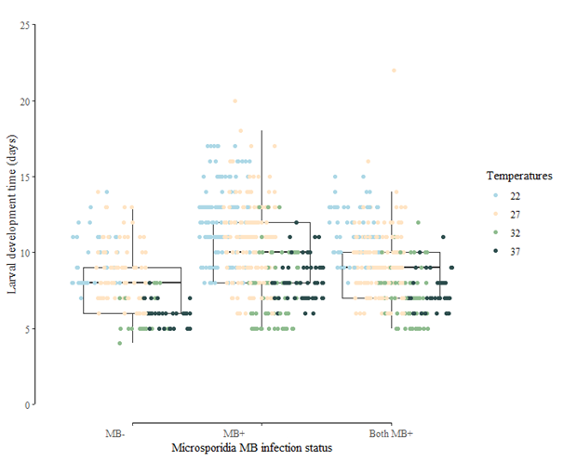
Supplementary figure 1: An. arabiensis that were MB⁺ due to maternal transmission increased the chance to pupate more than one days faster compared to uninfected larvae coming from MB⁺ female An. arabiensis (MB⁺ offspring of MB⁺ female An. arabiensis only: 10.2 (9.93-10.52) days; MB⁺ female An. arabiensis and offspring: 9.1 (8.85-9.40) days (χ²= 50.92, df = 2, p < 0.001), especially at the temperature treatment 27°C (MB⁺ female An. arabiensis only: 11.1 (10.66-11.46) days; both MB⁺: 9.4 (9.06-9.83) days; Tukey: p _{MB+ G0 female An. arabiensis} = 0.02; χ²= 21.92, df = 6, p = 0.001). At 22°C, 32°C, and 37°C, all larvae coming from MB+ An. arabiensis had similar development times (all Tukey test p > 0.05)

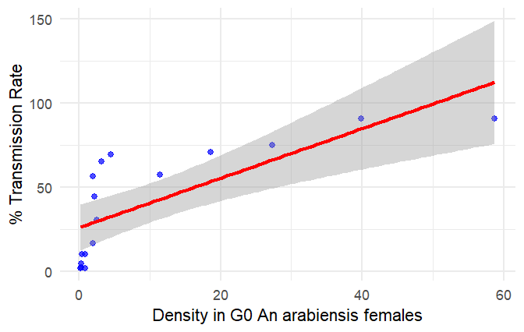
Supplementary figure 2: The infection rate in the F1 offspring was positively correlated with the density of Microsporidia MB in the G₀ female An. arabiensis (y= 26.09 + 1.47, r² = 0.5612) (χ²= 19.18, df = 1, p < 0.0005).
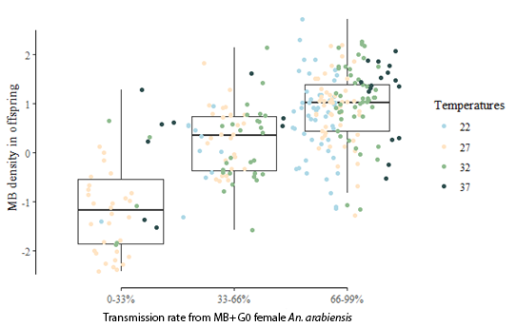
Supplementary figure 3: When G₀ female An. arabiensis had a transmission rate higher than 50%, the Microsporidia MB density in F1 offspring was higher (between 0 and 33%: 0.08 (0.021-0.144); between 33% and 66%: 0.33 (0.216-0.445); between 66% and 99%: 0.85 (0.734-0.981); (Tukey: p_{low-medium} and p_{low-high} < 0.001, p_{medium-high} = 0.001; χ²= 162.66, df = 2, p < 0.001).

- Stochastic Simulation
To introduce realistic variation in fecundity, we allowed fecundity rates to fluctuate around the average by approximately ±10%. Each simulation run selected a slightly different fecundity rate based on a normal distribution. This approach means that while the average fecundity rate remains our central value, individual rates vary within a small range to reflect natural differences that might occur in real conditions. To ensure statistical robustness, we conducted 1000 Monte Carlo simulations with this stochastic variation, enhancing the model's predictive power
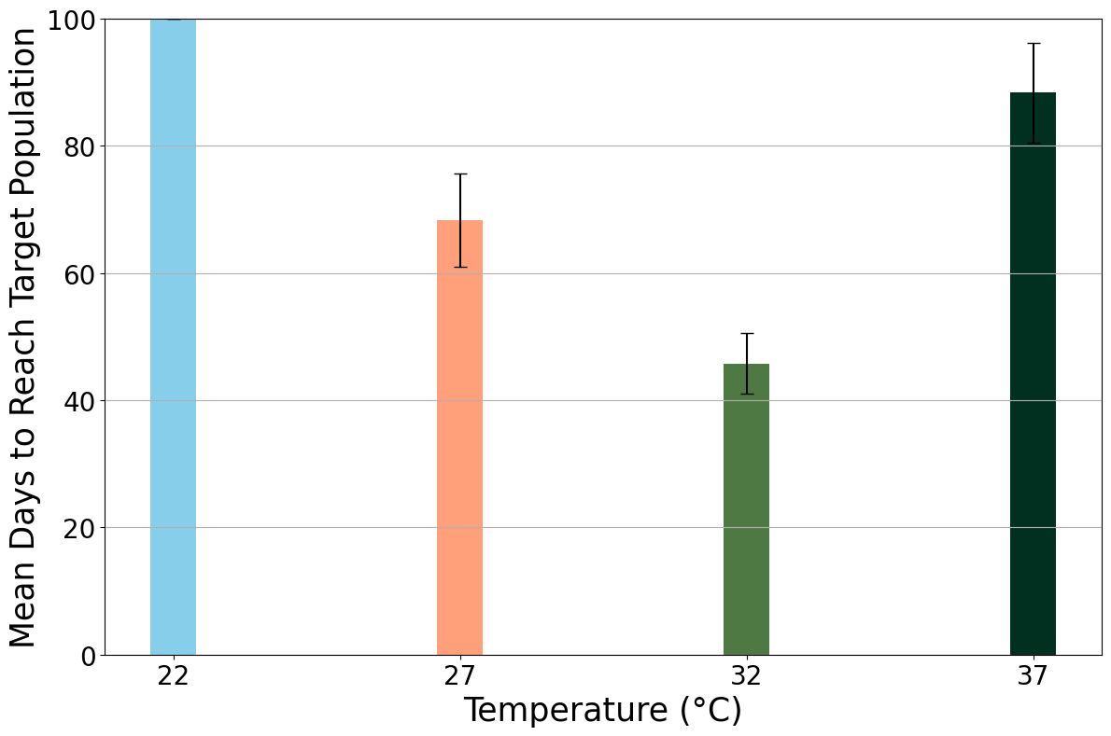
Supplementary figure 4: Mean Days to Reach Target Population of 1000 Mothers with Monte Carlo Simulations Across Different Temperatures (fecundity = 99 offspring per female). This plot shows the average number of days required for an infected offspring population to reach a target size of 1000 offspring under varying temperature conditions, based on 1000 Monte Carlo simulations. Starting with an initial population of G₀ female An. arabiensis, each simulation introduces 10% random variability in fecundity to model natural variation, with an average fecundity of 99 offspring per female and a sex ratio of 0.5. For each temperature (22°C, 27°C, 32°C, and 37°C), Gaussian parameters A, mu, and sigma) reflect age-based pupation probability, influencing effective growth rates alongside the fecundity and sex ratio. Each bar represents the mean time to reach the target, with error bars showing standard deviations across simulations, demonstrating how temperature significantly impacts population growth speed and variability.
Link to the code used in modelling https://colab.research.google.com/drive/1WrqpWw_8QvrL1B0H3HkhEhsbIbMJanr6?usp=sharing

