Supporting Information for “Signatures of Submarine Explosive Volcanism at the Northern Reykjanes Ridge”

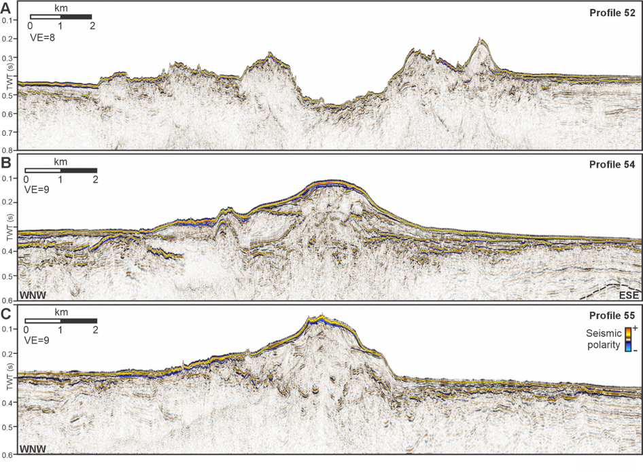
Supplementary Figure S1: Un-interpreted versions of the seismic images across the Northern Reykjanes Ridge (Fig. 3). For locations, see Figure 3a. VE = Vertical Exaggeration.
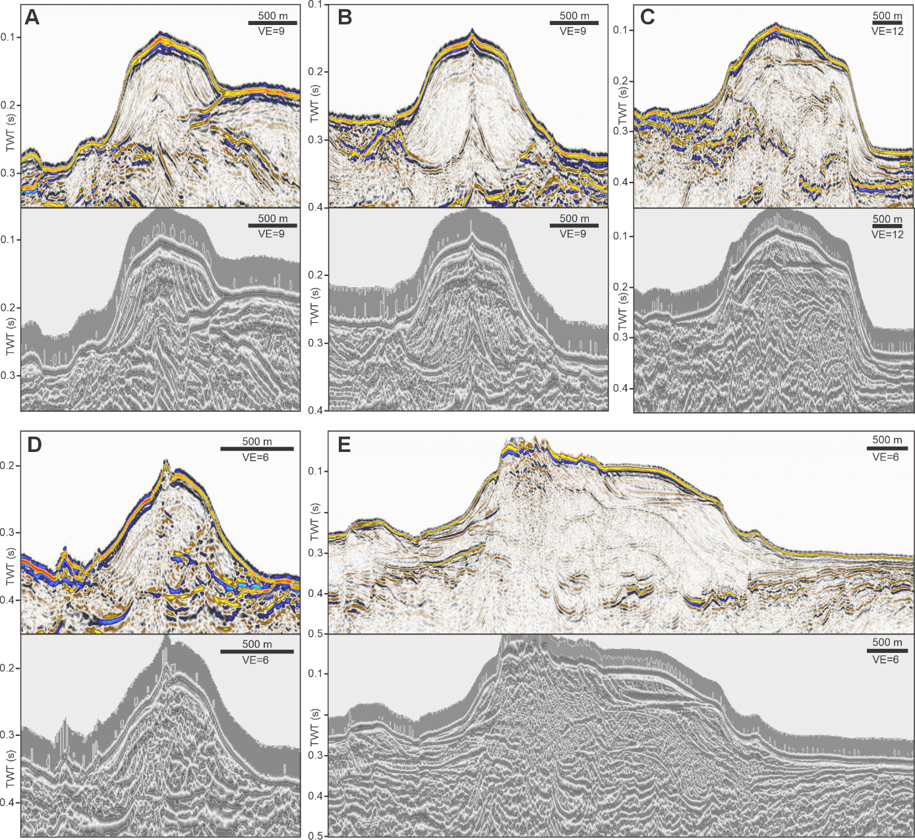
Supplementary Figure S2: Un-interpreted versions of Figure 4. Displayed are amplitude representations of seismic profiles crossing volcanic cones at the Northern Reykjanes Ridge and instantaneous phase plots. For locations see Figure 3a. VE = Vertical Exaggeration.

