Appendix 1 – Chronology of the assessment of clinical and paraclinical data
 | General | Neurological assessment
Admission (Day 1) | Baseline characteristics  Adjustment variables (GCS prior to sedation, SAPS-II, Brain injury)  Administration of sedatives, analgesics and/or NMBA | GCS prior to sedation, GCS at inclusion, FOUR, BRASS, RASS€, BPS, Pupilar abnormailities, brainstem reflexes^{β}
Time of neurophysiological test (Day 3) | Vital signs, SOFA, biological data, reason of sedation, cumulative dose of sedative and analgesics, administration of NMBA | GCS, FOUR, RASS€, BRASS, BPS, brainstem reflexes^{β}
From day 3 to day 28 | Mortality | RASS€, BPS, GCS*, FOUR* & CAM-ICU
ICU discharge | Duration of MV  Length of ICU stay  Death  Occurrence of sepsis | Duration of sedation,  Time of awakening,  Delayed awakening,  Occurrence of delirium,  Occurrence of intracranial hypertension,  Neuroimaging (when available)
€ in sedated patients
^{β} in patients without neuromuscular blocking agent
*The GCS and FOUR were assessed daily up to day 28. Indeed, although GCS and FOUR are modified by both sedation and underlying brain suffering, they allow to monitor neurological deterioration or improvement in clinical routine, particularly with the progressive decrease in sedation.
Abbreviations: BPS Behavioral Pain Scale; BRASS Brainstem Assessment Sedation Scale; CAM-ICU Confusion Assessment Method; FOUR the Full Outline of Unresponsiveness (FOUR) score; GCS Glasgow coma scale; ICU Intensive Care Unit; NMBA: Neuromuscular Blocking Agent; MV Mechanical Ventilation; RASS Richmond Assessment Sedation Scale; SAPSII simplified acute physiological score II; SOFA sequential organ failure assessment.

Appendix 2 - Brainstem Response Assessment Sedation Scale (BRASS)
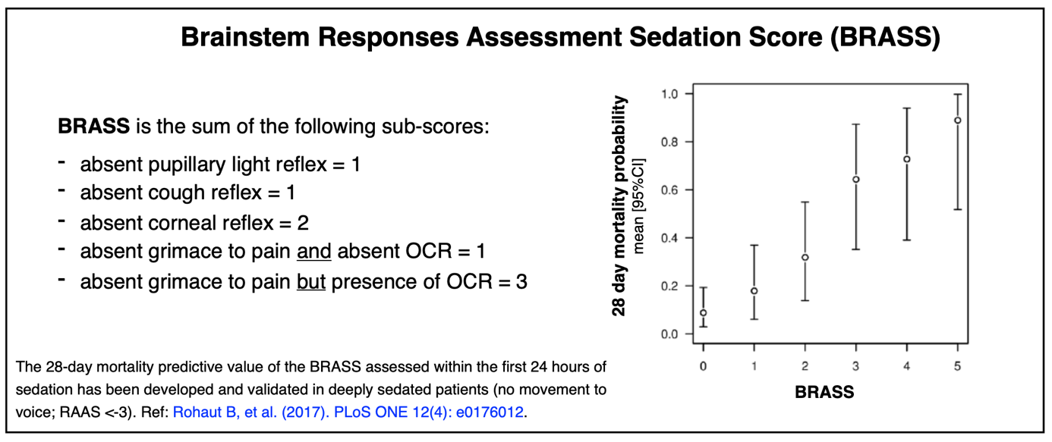
Absence of cough reflex was defined as the absence of audible coughing or movement of air through the endotracheal tube and the absence of visible contraction of the abdominal muscles.

Appendix 3 - Neurophysiological tests - SSEPs recordings
SSEPs and BAEPs were recorded using Natus (Middleton, WI) or Micromed (Treviso, Italy) devices.
SSEPs were measured after both right and left stimulation of the median nerve at the wrist using a bipolar surface electrode. Stimulation intensity was adjusted to produce visible thumb twitches; if neuromuscular blocking agents were administered, Erb’s component amplitudes were used instead. Stimulus frequency was set at 2–5 Hz during 200ms. Impedance was kept below 5 kΩ. Post stimulus recording lasted 50ms (bandwidth: 30 Hz–3 kHz, sampling frequency: 50 kHz). Two or three sets of 300–1000 responses were averaged. Recording of the proximal peripheral nerve (brachial plexus) response N9 was performed through an electrode placed at the ipsilateral Erb’s point, while the reference electrode was situated over the frontal region (Fz). Recording and reference electrodes were placed at Cv7 (7th cervical vertebra) and Fz respectively for the N13 cervical spinal cord response and Cz and cSh (contralateral shoulder) for the subcortical far-field potential: P14. The cortical components, N20 and P25, were recorded at the contralateral C3′ or C4′ positions (2 cm behind C3 or C4) according to the international 10–20 system. BAEPs were recorded following auditory stimulation of each ear, alternatively as described by André-Obadia et al (Neurophysiologie Clinique, 2018). Peak latencies and interpeak latencies were measured in milliseconds (ms).
Table A: Presumed origins of the median nerve somato-sensory evoked potentials
Wave recorded | Presumed origin
N9 | Brachial plexus, assessing the peripheral response
N13 | Segmental activity in the dorsal horn of the cervical spinal cord
P14 | Upper to the cervico-medullary junction and inferior part of the medulla
N20 | Primary somatosensory cortex (SI), contralateral to the side of stimulation
P25 | Primary somatosensory cortex
Median electric nerve stimulation is performed at the wrist with a bipolar electrode.
Proximal peripheral nerve conduction time is estimated by the N9-N13 interpeak latency
Central conduction time is estimated by the P14-N20 interpeak latency (reflecting the intracranial conduction time).
Table B: Presumed origins of the brainstem auditory evoked potentials

Wave recorded | Presumed origin
I | Auditory nerve (distal portion), ipsilateral to the stimulation
III | Cochlear nucleus or superior olivary complex : at the junction between the medulla and the pons (mainly ipsilateral to the stimulation side)
V | Inferior colliculus (midbrain), mainly contralateral to the stimulation side
Auditory stimulation is obtained with a mono-aural click stimulation using ear inserts.
III-V interval reflects the intrapontique conduction time. I-III interval corresponds to the auditory conduction between the auditory nerve and the inferior part of the brainstem.

Normal latencies are presented in Appendix 4. SSEPs and BAEPs components were considered absent (abolished) if their amplitude was less than 0.2 µV and/or indistinguishable from background noise. IPL were considered not assessable when the first or the last response was abolished.

Appendix 4 – Normal values of evoked potentials data, from healthy subjects of Azabou et al (Annals of Intensive Care, 2017)

Evoked potential data | Mean latency ± SD | Mean latency ± 2.5 SD
SSEPs components
N9 PL  N13 PL  P14 PL  N20 PL  N9-N13 IPL  P14-N20 IPL (ICCT) | 9.8 ± 0.6  13.2 ± 0.8  14.6 ± 0.9  18.8 ± 1.0  3.4 ± 0.4  4.1 ± 0.5 | ±11.4  ±15.2  ±16.8  ±21.4  ±4.4  ±5.3
BAEPs components
I PL  III PL  IV PL  I-III IPL  III-V IPL | 1.5 ± 0.2  3.6 ± 0.2  5.6 ± 0.2  2.1 ± 0.2  2.0 ± 0.2 | ±2.0  ±4.1  ±6.3  ±2.6  ±2.5

Appendix 5 – Statistical analysis
Furthermore, we also calculated that it was necessary to include 173 patients to demonstrate an adjusted OR of death at day 28 for patients with an abolished cough reflex at day 3 versus not abolished of 3.5 with a power of 90% (two-sided test at 5% risk), assuming that in the targeted population the 28-day mortality rate was 35%, that 33% of patients would have an abolished cough reflex at day 3.

Appendix 6 - Main primary diagnoses of admission, both for brain injury and non-brain injury patients

Causes of primary brain injury, n (%) | 140
Traumatic | 30 (21)
Ischemic stroke | 12 (9)
Hemorrhagic stroke | 37 (26)
Subarachnoid hemorrhage | 35 (25)
Subdural hematoma | 5 (4)
Encephalitis | 3 (2)
Others | 23 (16)
Causes of critical illness (without primary brain injury), n (%) | 124
Sepsis or septic shock | 32 (23)
Acute respiratory failure | 61 (49)
ARDS | 22 (18)
Others | 9 (7)

Appendix 7 - Neurophysiological responses in brain and non-brain injured patients

 | Patients  (n=264) |  | Brain injured  (n=140) |  | Non-brain injured  (n=124)
Neurophysiological test
Distal PNC, m/s | 217 | 61⋅1 [55⋅7-68⋅0] | 113 | 62 [55⋅5-67⋅5] | 104 | 60⋅4 [55⋅8-69⋅6]
Distal PNC < 55, m/s | 217 | 48 (22⋅1) | 113 | 27 (23⋅9) | 104 | 21 (20⋅2)
Proximal PNC, ms | 235 | 3⋅6 [3; 4] | 122 | 3⋅5 [3; 4] | 113 | 3⋅6 [3; 4⋅1]
SSEP, bilateral P14 PL > 16ms | 264 | 76 (28⋅8) | 140 | 37 (26⋅4) | 124 | 39 (31⋅5)
SSEP, P14 PL, ms | 263 | 15⋅3 [14⋅2; 16⋅4] | 39 | 15⋅1 [14; 16⋅1] | 124 | 15⋅4 [14⋅6;16⋅9]
SSEP, N20 PL, ms | 254 | 20⋅6 [19⋅4; 22⋅2] | 130 | 20⋅4 [19⋅1;22] | 124 | 20⋅9 [19⋅8;22⋅6]
SSEP, P14-N20 IPL, ms | 209 | 4⋅8 [4⋅1; 5⋅6] | 88 | 4⋅6 [3⋅9; 5⋅5] | 121 | 4⋅8 [4⋅3; 5⋅6]
SSEP, P14-N20 IPL > 5.4ms | 209 | 63 (30⋅1) | 88 | 25 (28⋅4) | 121 | 38 (31⋅4)
SSEP, N20-P25 IPL, ms | 188 | 3⋅3 [2⋅6; 4⋅9] | 74 | 3 [2⋅5; 4⋅2] | 114 | 3⋅4 [2⋅6; 5⋅4]
AEP, V PL, ms | 239 | 5⋅8 [5⋅4; 6⋅1] | 135 | 5⋅9 [5⋅5; 6⋅2] | 104 | 5⋅6 [5⋅3; 6]
AEP, III-V IPL, ms | 204 | 1⋅9 [1⋅8; 2⋅1] | 108 | 1⋅9 [1⋅8; 2⋅1] | 96 | 1⋅9 [1⋅7; 2⋅1]

AEP Auditory Evoked Potentials; BRASS Brainstem Assessment Sedation Scale; PL peak latency; ICCT intracranial conduction; IPL inter-peak latency; IPCT intra pontine conduction; IQR interquartile range; PNC peripheral conduction time; PSSEP Somatosensory Evoked Potentials

Appendix 8 – Cumulative dose of sedatives and analgesics in patients with and without delayed P14 latency

Cumulative dose | P14 latency < 16 ms | P14 latency > 16 ms
Midazolam mg | 240 [120 ;480] | 200 [123 ;354]
Propofol mg | 3200 [1965 ;4800] | 2800 [1191 ;4800]
Sufentanil µg | 240 [168 ;480] | 240 [145 ;360]

Appendix 9 – Forest plot showing the effect in each brain injury subset, with interaction tests.

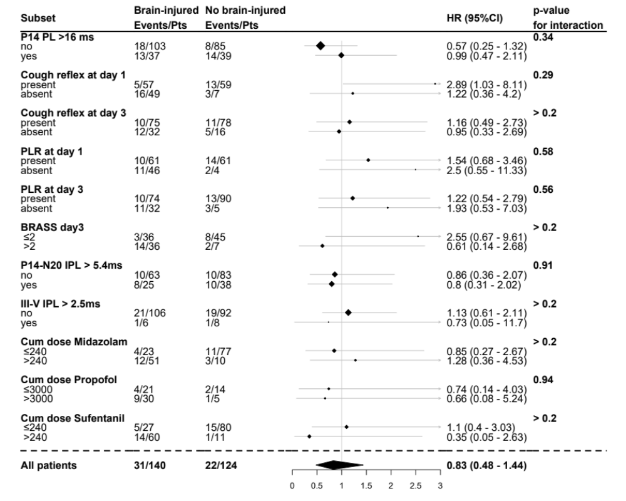

There was no evidence of any significant interaction of the effect of predictors, including that of high cumulative dose of midazolam, propofol and sufentanil, according to brain injury.

Appendix 10 – Characteristics of neurophysiologically tested patients, according to occurrence of delayed awakening

 | Patients  (n=264) |  | Delayed awakening  (n=131) | No delayed awakening  (n=133)
Women | 264 | 99 (37⋅5) | 51 (38⋅9) | 48 (36⋅1)
Age, years | 264 | 62 [50; 71] | 62 [52; 73] | 61 [49;70]
Brain-Injured patients | 264 | 140 (53) | 86 (65⋅6) | 54 (40⋅6)
At inclusion (Day 1)
SAPS-II | 264 | 49 [40; 62] | 50 [41.5; 63.5] | 47 [39 ;61]
Conscious and sedation scale
GCS before sedation | 258 | 11 [6; 15] | 8 [6; 14] | 13 [7; 15]
GCS at inclusion | 264 | 3 [3; 3] | 3[3; 3] | 3[3; 3]
Sedated patients | 264 | 260 (98⋅5) | 129 (98⋅5) | 131 (98⋅5)
RASS€ | 260 | -5 [-5; -4] | -5 [-5; -4] | -5 [-5; -4]
BPS score | 223 | 3 [3; 3] | 3[3; 3] | 3[3; 3]
Brainstem reflexes (present)
Cough reflex | 172 | 116 (67⋅4) | 46 (53⋅5) | 70 (81⋅4)
PLR | 172 | 168 (65⋅4) | 55 (62⋅5) | 67 (79⋅8)
OCR | 144 | 57 (22⋅7) | 19 (22⋅4) | 33 (40⋅2)
At time of neurophysiological test
SOFA | 264 | 8 [6; 10] | 8 [6.5; 10] | 7 [5; 10]
Temperature, °C | 257 | 37⋅0  [36⋅4; 37⋅5] | 36.8 [36.3; 37.3] | 37.1 [36.58; 37.5]
Natremia, mmol/L | 245 | 143 [140; 146] | 43 [140.2; 147] | 42 [139; 145]
Creatinine level, µmol/L | 246 | 71 [49; 108] | 74 [52; 134.5] | 68 [47.5; 96]
Sedated patients | 264 | 251 (95⋅1) | 122 (93⋅1) | 129 (97⋅0)
Reason for sedation
Synchronization | 251 | 129 (51) | 52 (39⋅7) | 77 (57⋅9)
Control of ICH | 251 | 98 (39) | 34 (25⋅6) | 64 (48⋅9)
Agitation | 251 | 17 (7) | 16 (12⋅0) | 1 (0⋅8)
Sedative/analgesic agents
Midazolam | 251 | 173 (69) | 85 (64⋅9) |  | 88 (66⋅2)
Cumulative dose of Midazolam (mg) |  | 240 [120;464] | 240 [132.5; 480] |  | 181.5 [112.5; 345.2]
Propofol | 251 | 75 (30) | 39 (29⋅8) |  | 36 (27⋅1)
Cumulative dose of Propofol (mg) |  | 3000 [1825;4800] | 3600 [1935; 4800] |  | 2800 [1823; 4162]
Sufentanil | 251 | 203 (81) | 98 (74⋅8) |  | 105 (78⋅9)
Cumulative dose of Sufentanil (µg) |  | 240 [160;480] | 240 [240; 480] |  | 240 [120; 360]
Neuromuscular blockers | 264 | 56 (21) | 40 (31⋅0) |  | 46 (34⋅6)
GCS | 264 | 3 [3; 6] | 3[3; 3] |  | 3[3; 7]
FOUR score
Eye response | 264 | 0 [0; 0] | 0[0;0] |  | 0[0;2]
Motor response | 264 | 0 [0; 2] | 0[0;0] |  | 0[0;3]
Brainstem reflexes | 197 | 4 [2; 4] | 4 [2;4] |  | [4;4]
Respiration | 256 | 0 [0; 1] | 0[0;1] |  | 0[0;1]
RASS | 251 | -5 [-5; -4] | -5 [-5 ;-4] |  | -4 [-5 ;-3]
BPS score | 213 | 3 [3; 3] | 3[3;3] |  | 3[3;3]
Brainstem reflex (present)
Pupils light reflex | 201 | 164 (81⋅6) | 70 (72⋅2) |  | 94 (90⋅4)
Myosis | 208 | 112 (53⋅8) | 49 (45⋅4) |  | 63 (63⋅0)
Unilateral mydriasis | 201 | 6 (3) | 5 (5⋅2) |  | 1 (1⋅0)
Bilateral mydriasis | 201 | 4 (2) | 2 (1⋅9) |  | 2 (2⋅1)
Corneal reflex | 201 | 167 (83⋅1) | 74 (75⋅5) |  | 93 (90⋅3)
OCR | 172 | 81 (47⋅1) | 52 (50⋅0) |  | 29 (30⋅5)
Grimace | 199 | 95 (47⋅7) | 35 (36⋅5) |  | 60 (58⋅3)
Cough reflex | 201 | 153 (76⋅1) | 90 (86⋅5) |  | 63 (64⋅3)
BRASS | 124 | 2 [0; 3] | 2 [0.5;4] |  | 1 [0;3]
Brain imaging
Brainstem lesion* | 77 | 9 (11⋅7) | 9 (19⋅0) | 0 (0⋅0)
Neurophysiological test
SSEP, P14 PL, ms | 263 | 15⋅3 [14⋅2; 16⋅4] | 130 | 15⋅6 [14⋅2; 16⋅9] | 133 | 15 [14⋅2;16]
SSEP, N20 PL, ms | 254 | 20⋅6 [19⋅4; 22⋅2] | 126 | 21 [19⋅6;22⋅8] | 128 | 20⋅3 [19⋅3;21⋅7]
AEP, V PL, ms | 239 | 5⋅8 [5⋅4; 6⋅1] | 122 | 5⋅9 [5⋅5; 6⋅2] | 117 | 5⋅7 [5⋅4; 6]
SSEP, N9-N13 IPL, ms | 235 | 3⋅6 [3; 4] | 121 | 3⋅6 [3⋅1; 4⋅0] | 114 | 3⋅5 [2⋅9; 4]
SSEP, N13-P14 IPL, ms | 228 | 0⋅5 [0⋅2; 0⋅9] | 117 | 0⋅5 [0⋅2; 0⋅9] | 111 | 0⋅5 [0⋅2; 0⋅9]
SSEP, P14-N20 IPL, ms | 209 | 4⋅8 [4⋅1; 5⋅6] | 93 | 5⋅0 [4⋅2; 5⋅7] | 116 | 4⋅6 [4⋅1; 5⋅3]
SSEP, P14-N20 IPL > 5.4ms | 209 | 63/209 (30) | 93 | 35 (38) | 116 | 28 (24)
SSEP, N20-P25 IPL, ms | 188 | 3⋅3 [2⋅6; 4⋅9] | 85 | 3⋅2 [2⋅5; 4⋅3] | 103 | 3⋅2 [2⋅6; 5⋅1]
AEP, III-V IPL, ms | 204 | 1⋅9 [1⋅8; 2⋅1] | 99 | 2 [1⋅8; 2⋅1] | 105 | 1⋅9 [1⋅7; 2⋅1]
Abbreviations: AEP Auditory Evoked Potentials; BRASS Brainstem Assessment Sedation Scale; EEG electroencephalogram; ERP event-related evoked potential; FOUR the Full Outline of Unresponsiveness (FOUR) score; GCS Glasgow coma scale; OCR oculocephalic reflex; PL peak latency; ICCT intracranial : peripheral nervous conduction; IPL inter-peak latency; IPCT intra pontine conduction; IQR interquartile range; PNC peripheral conduction time; PLR pupilar light reflex; RASS Richmond Assessment Sedation Scale; SAPSII simplified acute physiological score II; SOFA sequential organ failure assessment; SSEP Somatosensory Evoked Potentials
*We only collected whether MRI was performed and, if so, whether there was a brainstem lesion

The day-28 mortality was significantly greater in patients with than those without delayed awakening (46/131 (35%) versus 7/133 (5%), p<0.0001, exact Fisher test).

Delayed awakaning is arbitrarly but a priori defined. There is no temporal criterion to affirm that an absence of awakening after stopping deep sedation is pathological, being then rather linked to the primary or secondary aggression rather than to a persistent effect of sedation.
A delayed awakening of 3 days has not the same clinical significance in non-brain-injured and brain-injured patients. In the brain injured, it is likely to be due to a delayed clearance of sedatives or encephalopathy (related to sepsis, renal failure, liver failure, drugs toxicity, metabolic disturbances). In brain injured patient, it is likely to be due to the severity and localization of the brain lesion.
Compared to patients without delayed awakening (see Table 6 in the Supplementary Appendix), we found that patients with delayed awakening
1. are older,
2. are more frequently brain injured,
3. have a lower Glasgow coma score prior to sedation
4. Have higher SAPS-II score.
5. Have been more deeply sedated (longer duration of sedation, dose of sedatives and analgesic).

In our study, it should be noted that half of the patients did not wake up before 3 days after stopping sedation. Among the 38 patients who never opened their eyes after stopping sedation, all but 4 died.
In addition, the 131 patients with delayed awakening had poor outcomes, with increased mortality at day 28, with 46 (35%) of these 131 patients dying compared to 7 (5%) of the 133 patients who awakened within 3 days of the end of sedation (p<0.0001 by the exact Fisher test).

In conclusion, despite its arbitrary definition, we believe that delayed awakening is a relevant outcome for intensive care physicians.

Appendix 11 – Characteristics of neurophysiologically tested patients, according to occurrence of delirium

 | Patients  (n=264) |  | Delirium  (n=103) |  | No delirium  (n=161)
Women | 264 | 99 (37⋅5) | 31 (30⋅1) |  | 68 (42⋅2)
Age, years | 264 | 62 [50; 71] | 63.5 [53.75 ;70.85] |  | 59.9 [49.4 ;72.8]
Brain-Injured patients | 264 | 140 (53) | 46 (44⋅7) |  | 94 (58⋅4)
At inclusion (Day 1)
SAPS-II | 264 | 49 [40; 62] | 50 [35.5 ;64.5] |  | 49 [41; 60]
Conscious and sedation scales
GCS before sedation | 258 | 11 [6; 15] | 13 [8 ;15] |  | 8 [6 ;15]
GCS at inclusion | 264 | 3 [3; 3] | 3[3;3] |  | 3[3;3]
Sedated patients | 264 | 260 (98⋅5) | 102 (99⋅0) |  | 158 (98⋅1)
RASS€ | 260 | -5 [-5; -4] | -5 [-5 ;-4] |  | -5 [-5 ;-4]
BPS score | 223 | 3 [3; 3] | 3[3;3] |  | 3[3;3]
Brainstem reflexes (present)
Cough reflex | 172 | 116 (67⋅4) | 49 (80⋅3) |  | 67 (60⋅4)
PLR | 172 | 168 (65⋅4) | 48 (81⋅4) |  | 74 (65⋅5)
OCR | 144 | 57 (22⋅7) | 24 (40⋅0) |  | 28 (26⋅2)
At time of neurophysiological test
Days from ICU admission | 264 | 3 [2; 5] | X |  | X
SOFA | 264 | 8 [6; 10] | 9 [6 ;11] |  | 8 [7 ;11]
Temperature, °C | 257 | 37⋅0  [36⋅4; 37⋅5] | 37 [36.55 ;37.5] |  | 37 [36.5 ;37.7]
Natremia, mmol/L | 245 | 143 [140; 146] | 141 [138 ;144] |  | 41 [138 ;144]
Creatinine level, µmol/L | 246 | 71 [49; 108] | 88 [61 ;120] |  | 88 [54 ;123]
Sedated patients | 264 | 251 (95⋅1) | 97 (94⋅2) |  | 154 (95⋅7)
Reason for sedation
Synchronization | 251 | 129 (51) | 60 (58⋅3) |  | 69 (42⋅9)
Control of ICH | 251 | 98 (39) | 60 (58⋅3) |  | 69 (42⋅9)
Agitation | 251 | 17 (7) | 13 (12⋅6) |  | 4 (2⋅5)
Sedative/analgesic agents
Midazolam | 251 | 173 (69) | 70 (68⋅0) |  | 103 (64⋅0)
Cumulative dose of Midazolam (mg) |  | 240 [120;464] | 194 [120 ;309.8] |  | 240 [120 ;480]
Propofol | 251 | 75 (30) | 29 (28⋅2) |  | 46 (28⋅6)
Cumulative dose of Propofol (mg) |  | 3000 [1825;4800] | 3600 [1860 ;4800] |  | 2800 [1848 ;4800]
Sufentanil | 251 | 203 (81) | 81 (78⋅6) |  | 122 (75⋅8)
Cumulative dose of Sufentanil (µg) |  | 240 [160;480] | 240 [151.2 ;356.2] |  | 240 [168.8 ;480]
Neuromuscular blockers | 264 | 56 (21) | 41 (39⋅8) |  | 45 (28⋅3)
GCS | 264 | 3 [3; 6] | 3[3;3] |  | 3[3;3]
FOUR score
Eye response | 264 | 0 [0; 0] | 0[0;0] |  | 0[0;0]
Motor response | 264 | 0 [0; 2] | 0[0;0] |  | 0[0;0]
Brainstem reflexes | 197 | 4 [2; 4] | 4 [4;4] |  | 4 [2;4]
Respiration | 256 | 0 [0; 1] | 0[0;0] |  | 0[0;1]
RASS | 251 | -5 [-5; -4] | -5 [-5 ;-4] |  | -5 [-5 ;-4]
BPS score | 213 | 3 [3; 3] | 3[3;3] |  | 3[3;3]
Brainstem reflex (present)
Pupils light reflex | 201 | 164 (81⋅6) | 71 (88⋅8) |  | 93 (76⋅9)
Myosis | 208 | 112 (53⋅8) | 43 (52⋅4) |  | 69 (54⋅8)
Unilateral mydriasis | 201 | 6 (3) | 1 (1⋅3) |  | 5 (4⋅1)
Bilateral mydriasis | 201 | 4 (2) | 0 (0⋅0) |  | 4 (3⋅3)
Corneal reflex | 201 | 167 (83⋅1) | 94 (77⋅7) |  | 73 (91⋅2)
OCR | 172 | 81 (47⋅1) | 37 (46⋅8) |  | 44 (36⋅7)
Grimace | 199 | 95 (47⋅7) | 47 (61⋅0) |  | 48 (39⋅3)
Cough reflex | 201 | 153 (76⋅1) | 66 (83⋅5) |  | 87 (70⋅7)
BRASS | 124 | 2 [0; 3] | 2 [0.25; 3.75] |  | 1 [0; 3]
Brain imaging
Brainstem lesion | 77 | 9 (11⋅7) | 4 (15⋅4) |  | 5 (10⋅4)
Neurophysiological test
SSEP, P14 PL, ms | 263 | 15⋅3 [14⋅2; 16⋅4] | 102 | 15⋅2 [14⋅4; 16⋅1] | 161 | 15⋅3 [14⋅2;16⋅5]
SSEP, N20 PL, ms | 254 | 20⋅6 [19⋅4; 22⋅2] | 100 | 20⋅9 [19⋅6;22⋅4] | 154 | 20⋅5 [19⋅3;22⋅1]
AEP, V PL, ms | 239 | 5⋅8 [5⋅4; 6⋅1] | 103 | 5⋅7 [5⋅3; 6] | 145 | 5⋅9 [5⋅5; 6⋅2]
SSEP, N9-N13 IPL, ms | 235 | 3⋅6 [3; 4] | 97 | 3⋅5 [2⋅9; 4⋅1] | 138 | 3⋅6 [3⋅1; 4]
SSEP, N13-P14 IPL, ms | 228 | 0⋅5 [0⋅2; 0⋅9] | 95 | 0⋅6 [0⋅3; 0⋅9] | 133 | 0⋅5 [0⋅2; 0⋅9]
SSEP, P14-N20 IPL, ms | 209 | 4⋅8 [4⋅1; 5⋅6] | 84 | 4⋅7 [4⋅1; 5⋅5] | 125 | 4⋅8 [4⋅1; 5⋅6]
SSEP, P14-N20 IPL > 5.4ms | 209 | 63/209 (30) | 84 | 22 (26) | 125 | 41 (33)
SSEP, N20-P25 IPL, ms | 188 | 3⋅3 [2⋅6; 4⋅9] | 80 | 3⋅4 [2⋅5; 4⋅3] | 108 | 3⋅3 [2⋅6; 6⋅3]
AEP, III-V IPL, ms | 204 | 1⋅9 [1⋅8; 2⋅1] | 83 | 1⋅9 [1⋅7; 2⋅1] | 121 | 1⋅9 [1⋅8; 2⋅1]

Appendix 12 – Sensitivity analyses of delirium handling missing data due to competing deaths

 | Complete Case Analysis |  |  | Deaths are considered as events
 | Total (n=221) | Delirium (n=103) | Adjusted* OR  (95% CI) | Total (n=264) | Delirium (n=146) | Adjusted* OR  (95% CI)
Brainstem reflexes
OCR at day 1
Present | 47 | 24 (51) | 1⋅00 | 52 | 29 (56) | 1⋅00
Absent | 72 | 27 (38) | 0.81 [0⋅4-1.9] | 92 | 47 (51) | 1.13 [0⋅5-2.4]
OCR at day 3
Present | 73 | 37 (51) | 1⋅00 | 81 | 45 (56) | 1⋅00
Absent | 73 | 29 (40) | 0⋅7 [0⋅4-1⋅4] | 91 | 47 (52) | 0.90 [0⋅5-1.7]
Neurophysiological responses
AEP, V
Present | 199 | 94 (47) | 1⋅00 | 239 | 134 (56) | 1⋅00
Absent | 6 | 2 (33) | 0⋅42 [0⋅01-2⋅6] | 8 | 4 (50) | 0⋅50 [0⋅1-2.4]
AEP, III-V IPL > 2⋅5ms
No | 165 | 81 (49) | 1⋅00 | 198 | 114 (58) | 1⋅00
Yes | 12 | 4 (33) | 0⋅4 [0⋅1-1⋅3] | 14 | 6 (43) | 0.40 [0.1-1.1]

Data are n (%) or median [IQR]
*Adjusted on the type of admission (brain-injury versus non-brain-injury), SAPSII and GCS prior to sedation
Abbreviations: GCS Glasgow coma scale; OR Odds Ratio; IPL inter-peak latency; ms milliseconds; PLR, pupilar light reflex; OCR, oculocephalic reflex; SAPSII simplified acute physiological score

