SUPPLEMENTARY DATA
Supplementary figures legends

Supplementary Table 1.
Demographic, clinical and laboratory characteristics of the volunteers

Supplementary Figure 1.
Assessment of agreement and concordance between LTA and ODFA for SPA measurement in hirudin-PRP
(A) Spearman correlation of SPA percentages measured by ODFA (y-axis) and LTA (x-axis) in hirudin-PRP from 91 volunteers. (B) The Bland-Altman plot shows the difference in SPA percentage between LTA and ODFA (y-axis) versus the mean of SPA measured by both (x-axis) in hirudin-PRP. The line represents the mean difference (-0.754%), while the two dashed lines indicate the 95% upper and lower limits of agreement between LTA and ODFA (mean difference ± 1.96 * SD of the difference; +0.817% at the upper limit and -2.324% at the lower limit).

Supplementary Table 1.

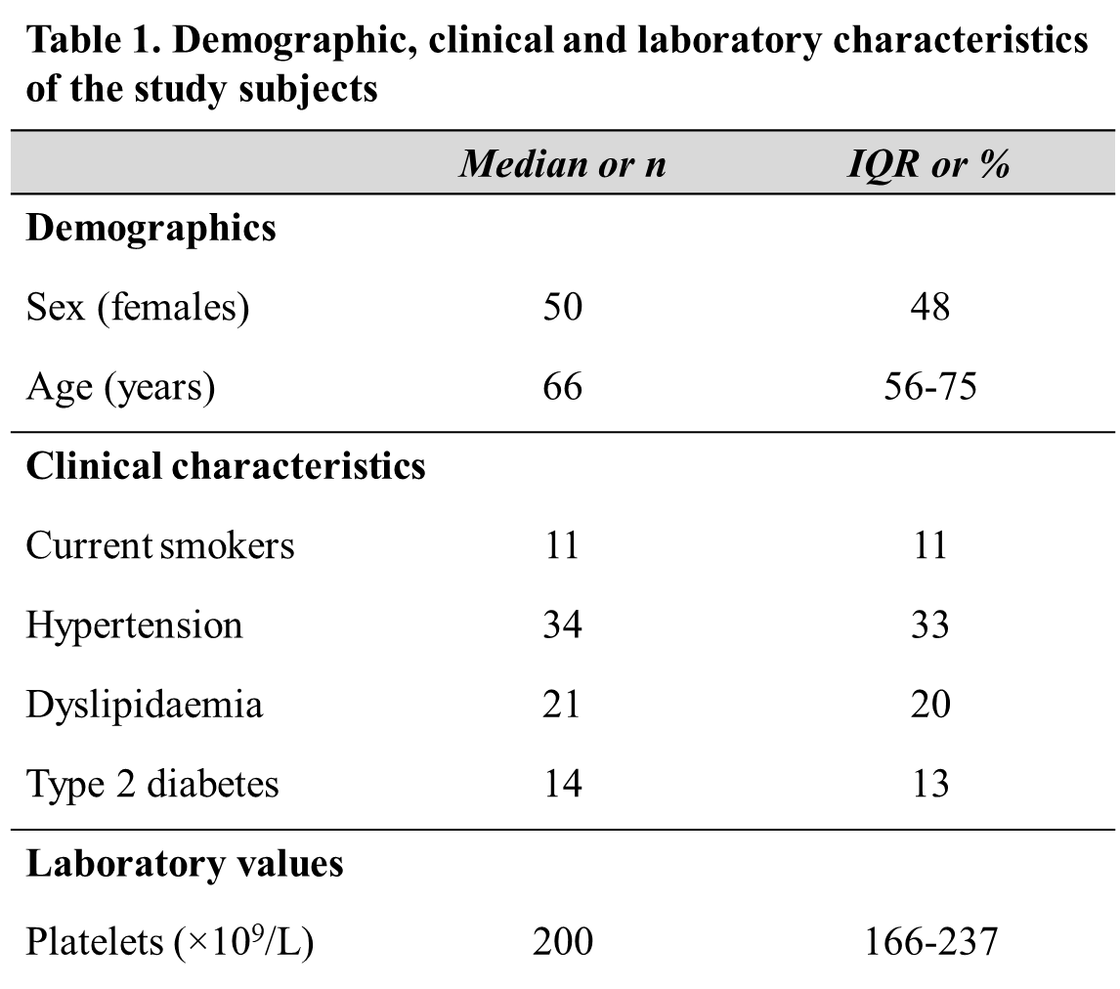

Supplementary Figure 1

