Appendix
The outcomes of the simulation demonstrate a considerable degree of generality concerning productivity losses and resource allocation indices. Consequently, the statistical summary of the distribution plots resulting from the Monte Carlo simulations conducted in Egypt can be extended to other countries. In interpreting the results for these nations, it is noted that their future plans and outcomes closely align with the corresponding analyses performed for Egypt. The relevant tables and plots for these countries are presented in the appendix below.
Table 1. Statistical Summary of Monte Carlo Simulation Outputs for Health and Productivity Indices in Egypt
Index | count | mean | std | min | 25% | 50% | 75% | max
HAPLI | 10000 | 0.135231 | 0.007745 | 0.106167 | 0.130034 | 0.135319 | 0.140538 | 0.164435
EVHI | 10000 | 0.023465 | 0.001817 | 0.016297 | 0.022234 | 0.023459 | 0.024713 | 0.030598
TPLTI | 10000 | 0.176602 | 1.502243 | -5.14418 | -0.82482 | 0.164408 | 1.177085 | 6.270191
RLCL | 10000 | 0.132114 | 0.007567 | 0.10372 | 0.127037 | 0.132201 | 0.1373 | 0.160645
IHAPI_Score | 10000 | 0.467412 | 1.502479 | -4.88237 | -0.53514 | 0.456195 | 1.472325 | 6.551785
RAEI | 10000 | 0.998563 | 0.100489 | 0.618985 | 0.931244 | 0.998827 | 1.06697 | 1.420594
HSRI | 10000 | 1.000235 | 0.099787 | 0.545776 | 0.932229 | 0.99927 | 1.067003 | 1.397035
CBRPI | 10000 | 1.000936 | 0.099282 | 0.644106 | 0.93472 | 1.000759 | 1.066322 | 1.471701
PPI | 10000 | 0.99978 | 0.099679 | 0.605761 | 0.933772 | 1.00041 | 1.065553 | 1.417279
SD_HEI | 10000 | 0.944824 | 4.194891 | -13.9608 | -1.85282 | 0.915875 | 3.743901 | 17.94847

Table 1. The results of 10,000 Monte Carlo simulations for Egypt are compiled in this output, with an emphasis on economic and health indicators. An explanation of each metric and its descriptive data are provided below:
HAPLI (Health-Adjusted Productivity Loss Index)
Mean: 0.1352310.1352310.135231 — This value represents the average HAPLI score derived from simulations, indicating the relative impact of productivity loss attributable to health factors within Egypt. Standard Deviation: 0.0077450.0077450.007745 — The low variability observed suggests that the HAPLI estimates exhibit relative stability across simulations. Range: 0.1061670.1061670.106167 to 0.1644350.1644350.164435 — This range indicates that HAPLI remains within a narrow spectrum, affirming its stability.
EVHI (Economic Value of Health Investment)
Mean: 0.0234650.0234650.023465 — This figure reflects a relatively modest economic return on health investments in comparison to the scale of other indices. Standard Deviation: 0.0018170.0018170.001817 — Very low variability indicates a high degree of consistency in the estimates pertaining to health investments. Range:0.0162970.0162970.016297 to 0.0305980.0305980.030598 — This range suggests only modest differences in the efficiency of health investments across the simulations.
TPLTI (Total Productivity Loss Due to Illness)
Mean: 0.1766020.1766020.176602 — This metric indicates the average value of productivity lost as a consequence of health-related burdens. Standard Deviation:1.5022431.5022431.502243 — The high level of variability reflects considerable uncertainty or sensitivity regarding productivity loss estimates. Range: −5.14418-5.14418−5.14418 to 6.2701916.2701916.270191 — The extensive variation includes negative values, which may denote recovery or minimal loss in certain scenarios, as well as high extremes in productivity losses.
RLCL (Resource Allocation Calculated Loss Index)
Mean: 0.1321140.1321140.132114 — This figure denotes a modest level of loss that can be attributed to suboptimal resource allocation. Standard Deviation:0.0075670.0075670.007567 — Low variability reflects consistent estimates in this context. Range: 0.103720.103720.10372 to 0.1606450.1606450.160645 — The narrow range underscores stable estimates of resource allocation efficiency.
IHAPI Score (Integrated Health and Productivity Index)
Mean: 0.4674120.4674120.467412 — This score represents the aggregate overall impact of health and productivity, consolidating all component indices. Standard Deviation:1.5024791.5024791.502479 — High variability in this index is primarily influenced by the variability observed in the TPLTI component. Range: −4.88237-4.88237−4.88237 to 6.5517856.5517856.551785 — The wide range indicates that the IHAPI Score may fluctuate significantly based on varying health and economic conditions across different scenarios.
RAEI (Resource Allocation Efficiency Index)
Mean: 0.9985630.9985630.998563 — Approaching a value of one, this figure suggests effective resource allocation in the majority of simulations. Standard Deviation:0.1004890.1004890.100489 — Moderate variability indicates the presence of scenarios in which resource utilization is less efficient. Range:0.6189850.6189850.618985 to 1.4205941.4205941.420594 — This highlights a select number of outliers where resource efficiency deviates markedly from the average.
HSRI (Health System Resilience Index)
Mean:1.0002351.0002351.000235 — This value indicates a robust health system on average across the simulations conducted. Standard Deviation:0.0997870.0997870.099787 — The variability is comparable to that of the RAEI, revealing several scenarios with lower resilience levels. Range:0.5457760.5457760.545776 to 1.3970351.3970351.397035 — The range suggests predominately resilient outcomes, interspersed with occasional lower values.
CBRPI (Cause-Based Resource Prioritization Index)
Mean: 1.0009361.0009361.000936 — This value is near 1, suggesting that the impact of risk factors on productivity is balanced. Standard Deviation: 0.0992820.0992820.099282 — The low variability confirms the consistency of results across the simulations. Range: 0.6441060.6441060.644106 to 1.4717011.4717011.471701 — This range reflects the variability in how risk factors influence productivity.
PPI (Productivity Parity Index)
Mean: 0.999780.999780.99978 — This value indicates near parity in productivity across the scenarios examined. Standard Deviation: 0.0996790.0996790.099679 — The low variability reinforces the consistency in productivity parity. Range:0.6057610.6057610.605761 to 1.4172791.4172791.417279 — This range suggests some divergence in productivity parity in specific scenarios.
SD-HEI (Sustainable Development Health Equity Index)
Mean: 0.9448240.9448240.944824 — The value reflects a slight underperformance in sustainable health equity, potentially indicative of existing disparities. Standard Deviation: 4.1948914.1948914.194891 — The high variability indicates significant uncertainty surrounding the sustainability of health equity. Range: −13.9608 to 17.9484717.9484717.94847 — The extremely wide range suggests that negative values may signify severe inequities or setbacks in certain simulations, while high positive values reflect favorable equity outcomes.

Stable Indices
The indices HAPLI, EVHI, RLCL, and IHAPI demonstrate relatively stable means and narrow ranges, with the exception of TPLTI, which considerably elevates variability.

High Variability Indices
TPLTI and SD-HEI display substantial uncertainty, likely attributed to sensitivity to variations in Disability-Adjusted Life Year (DALY) growth rates and changes in health equity.

Systemic Resilience
The indices RAEI, HSRI, and RFRPI average near 1, indicating effective resource utilization, strong health system resilience, and manageable levels of risk factors in the majority of scenarios examined.

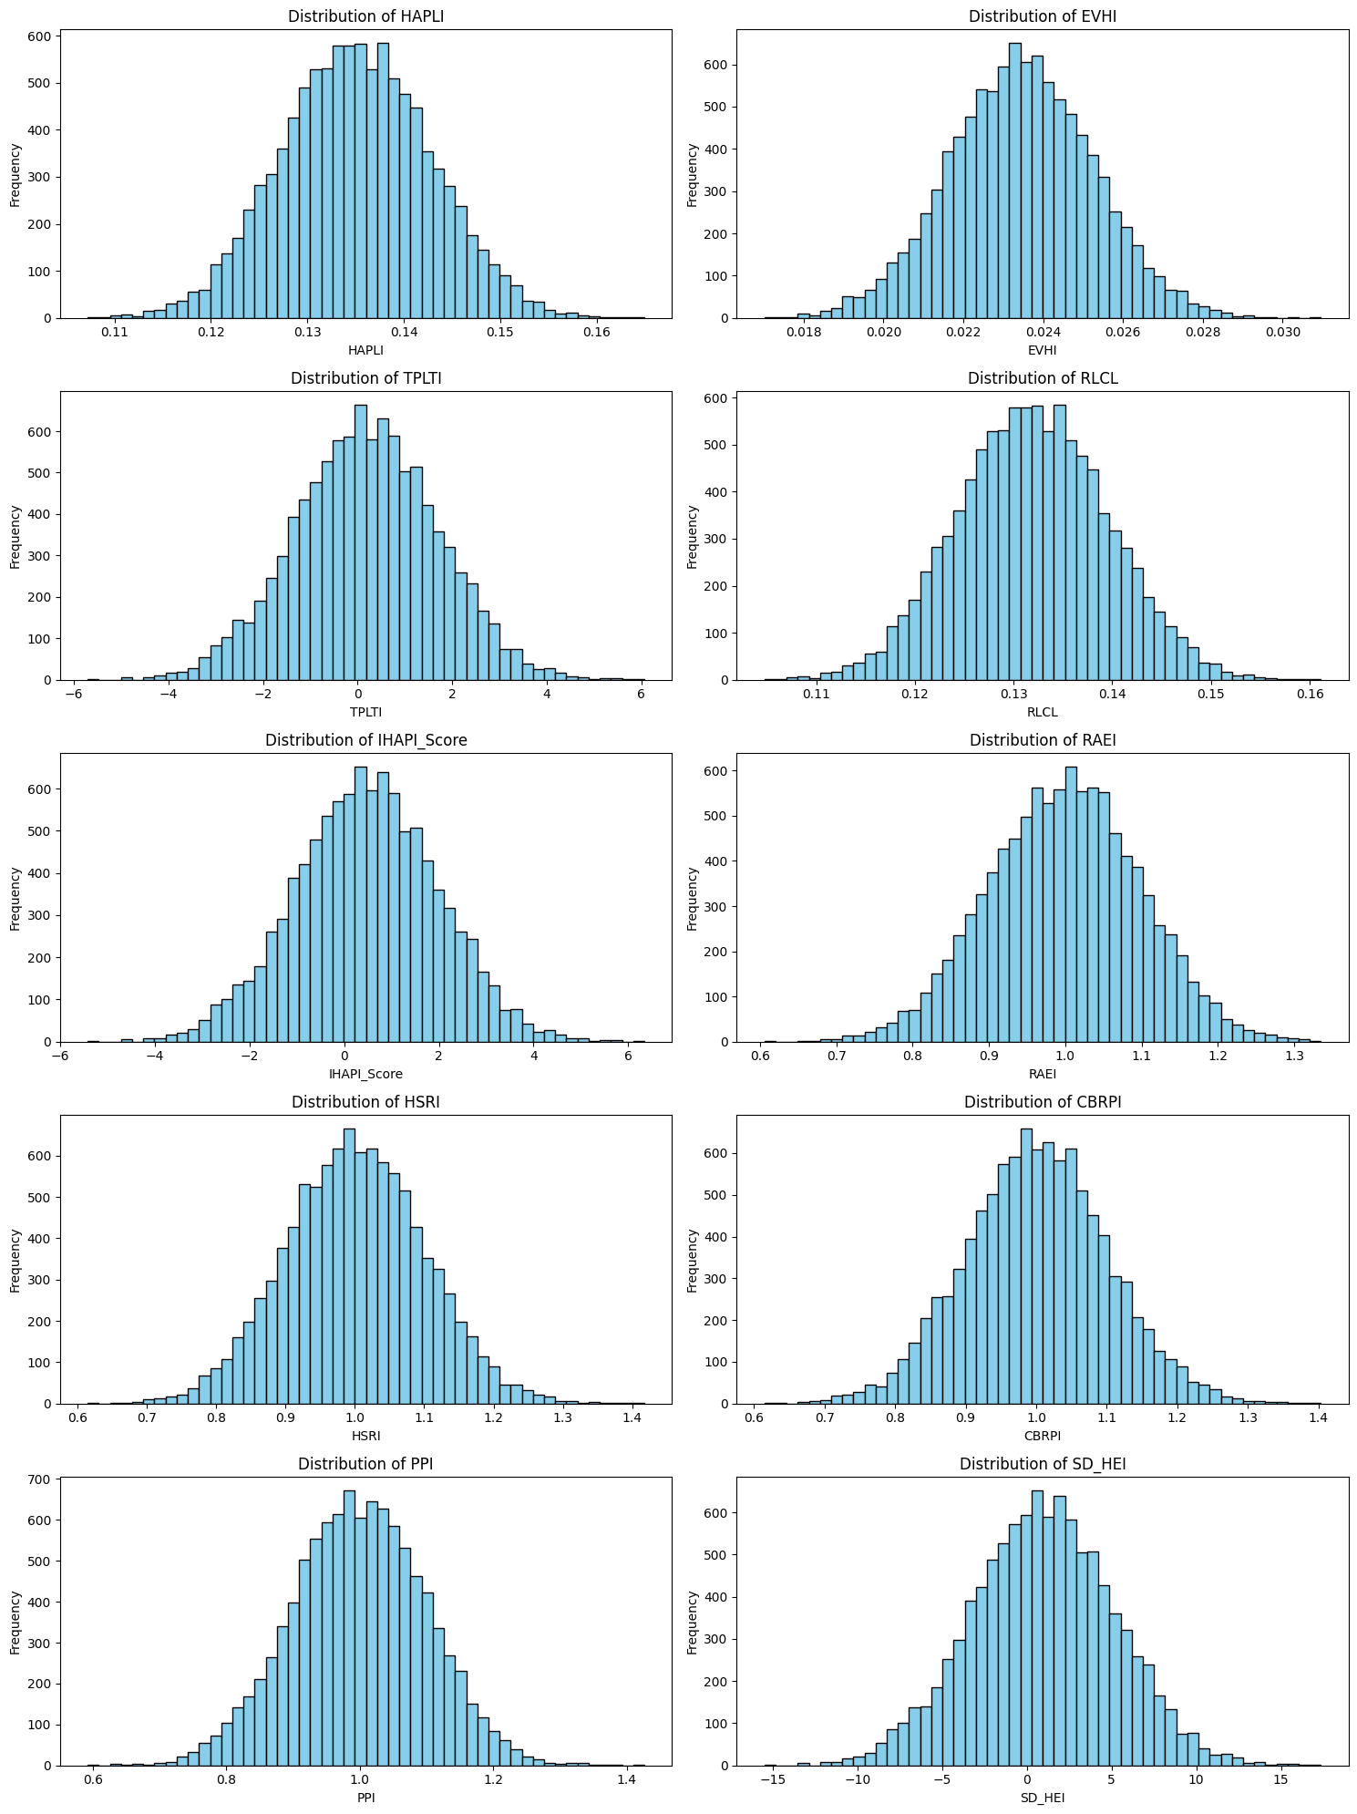
Figure 1. Distributions of Monte Carlo Simulation Outputs for Health and Productivity Indices in Egypt

The distribution of indices produced by your Monte Carlo simulation for Egypt is displayed in this graphic as histograms.
Top Row
HAPLI (Health-Adjusted Productivity Loss Index): The distribution exhibits symmetry and approximates a normal distribution, with a central tendency around 0.135. This observation suggests stable and predictable health-adjusted productivity losses within the simulations.
EVHI (Economic Value of Health Investment): This index also demonstrates a symmetric and normal distribution, centered at approximately 0.023. The consistency of this value indicates a reliable return on health investments, characterized by minimal variation.
TPLTI (Total Productivity Loss Due to Illness): The distribution is normal yet wider, encompassing both negative and significant positive values. This suggests a notable variability in productivity loss outcomes, which may represent extreme scenarios in certain simulations.
RLCL (Resource Allocation Calculated Loss Index): The distribution is symmetric and narrow, centered around 0.13, which indicates that inefficiencies in resource allocation are generally predictable and stable across the conducted simulations.

Middle Row
IHAPI Score (Integrated Health and Productivity Index): The distribution mirrors that of TPLTI, likely due to the significant influence TPLTI has on IHAPI. The wide range indicates substantial variability in health and productivity outcomes across scenarios, influenced by factors such as Disability-Adjusted Life Years (DALYs) or economic fluctuations.
RAEI (Resource Allocation Efficiency Index): The distribution is symmetric and narrow, centered around 1.0, reflecting efficient resource allocation in most scenarios, with occasional inefficiencies resulting in slight variations.
HSRI (Health System Resilience Index): This index is also centered around 1.0, signifying a robust health system characterized by consistent resilience, with few simulations indicating a lower level of resilience.

CBRPI (Cause-Based Resource Prioritization Index): Similar to both HSRI and RAEI, the distribution is centered around 1.0, demonstrating that risk factors exert a balanced and predictable effect on productivity.

Bottom Row
PPI (Productivity Parity Index): Centered around 1.0 and exhibiting a normal distribution, this index indicates near-equal productivity impacts across the simulated scenarios, with minor deviations attributable to specific conditions.
SD-HEI (Sustainable Development Health Equity Index): The distribution is broader, extending into both negative and high positive values, indicating significant variability in health equity outcomes. Negative values may reflect scenarios of inequities or health regressions, while positive values suggest progress and improvement.
• The narrow, symmetric distributions of the majority of indices (such as HAPLI, EVHI, RLCL, RAEI, HSRI, RFRPI, and PPI) show stability and predictability.
• The distributions of TPLTI, IHAPI Score, and SD-HEI are wider, indicating more ambiguity and variability in the results of productivity loss and equity. Extreme changes in DALY or in the distribution of resources may have an impact on these indexes.
• The large range of SD-HEI and the presence of negative values point to possible injustices under specific simulated circumstances, necessitating additional research.

Table 2. Statistical Summary of Monte Carlo Simulation Outputs for Health and Productivity Indices in the Islamic Republic of Iran
Index | count | mean | std | min | 25% | 50% | 75% | max
HAPLI | 10000 | 0.160007 | 0.009194 | 0.129709 | 0.153768 | 0.160094 | 0.166282 | 0.200222
EVHI | 10000 | 0.028429 | 0.009398 | -0.00735 | 0.021932 | 0.028446 | 0.034752 | 0.067948
TPLTI | 10000 | 951.4005 | 55927.91 | -208122 | -37399.2 | 937.9122 | 38323.2 | 223211.8
RLCL | 10000 | 0.159303 | 0.009153 | 0.129138 | 0.153092 | 0.15939 | 0.16555 | 0.199341
IHAPI_Score | 10000 | 951.7483 | 55927.91 | -208122 | -37398.9 | 938.2523 | 38323.56 | 223212.1
RAEI | 10000 | 0.99927 | 0.099704 | 0.661961 | 0.932757 | 0.999944 | 1.066129 | 1.402912
HSRI | 10000 | 0.998616 | 0.100169 | 0.606546 | 0.9311 | 0.998436 | 1.064206 | 1.421802
CBRPI | 10000 | 1.00082 | 0.099309 | 0.650019 | 0.933313 | 1.001196 | 1.06824 | 1.367674
PPI | 10000 | 1.000146 | 0.099467 | 0.598005 | 0.934622 | 1.001224 | 1.068014 | 1.370503
SD_HEI | 10000 | 414.1921 | 24316.48 | -90487.5 | -16260 | 408.3244 | 16662.82 | 97049.17

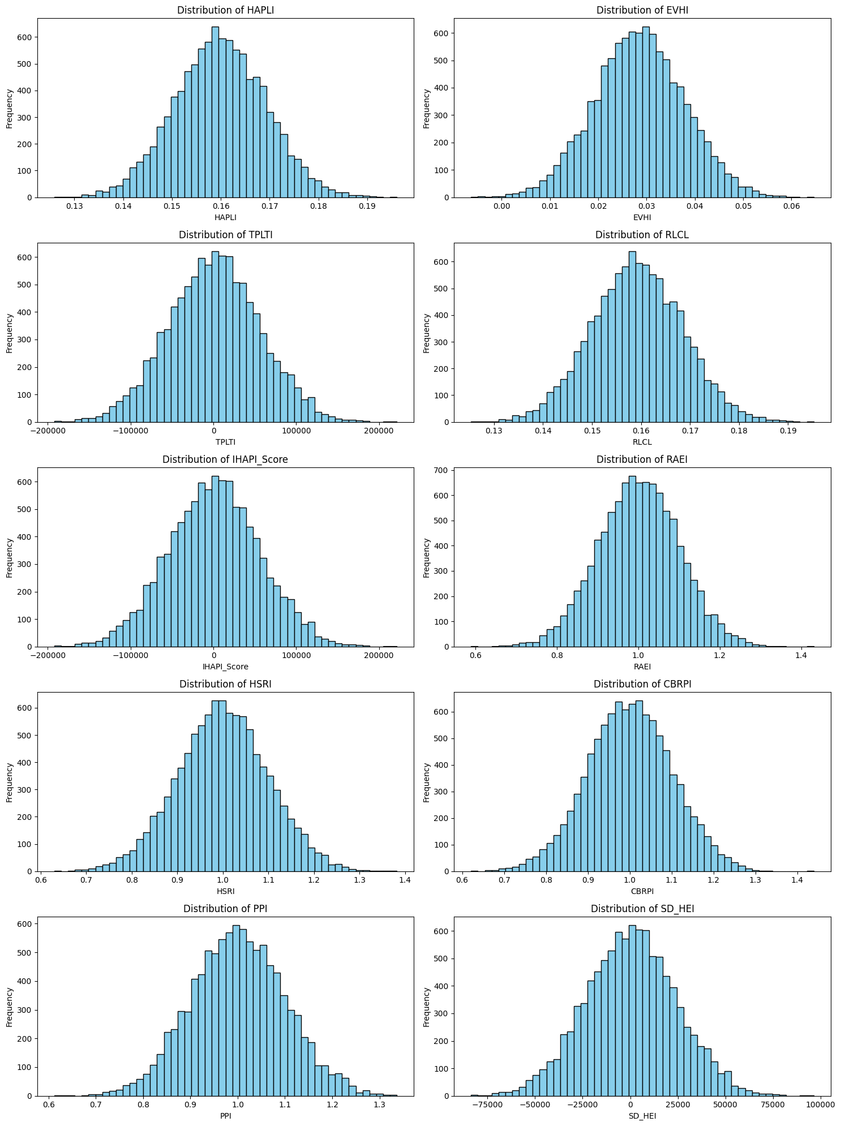
Figure 2. Distributions of Monte Carlo Simulation Outputs for Health and Productivity Indices in the Islamic Republic of Iran

Table 3. Statistical Summary of Monte Carlo Simulation Outputs for Health and Productivity Indices in Jordan
Index | count | mean | std | min | 25% | 50% | 75% | max
HAPLI | 10000 | 0.166508 | 0.010962 | 0.124573 | 0.159058 | 0.166543 | 0.173876 | 0.210891
EVHI | 10000 | 0.040072 | 0.004738 | 0.022626 | 0.03688 | 0.040104 | 0.043266 | 0.056113
TPLTI | 10000 | 2620.303 | 141320.2 | -545695 | -92677.3 | 1082.712 | 98637.6 | 561954.3
RLCL | 10000 | 0.162818 | 0.010719 | 0.121812 | 0.155534 | 0.162852 | 0.170022 | 0.206218
IHAPI_Score | 10000 | 2620.673 | 141320.2 | -545695 | -92676.9 | 1083.055 | 98637.98 | 561954.7
RAEI | 10000 | 1.001704 | 0.099157 | 0.629445 | 0.93402 | 1.001471 | 1.069691 | 1.37782
HSRI | 10000 | 0.998747 | 0.100683 | 0.646411 | 0.930328 | 0.999061 | 1.065619 | 1.357569
CBRPI | 10000 | 1.001448 | 0.100151 | 0.612134 | 0.93239 | 1.002442 | 1.068484 | 1.356494
PPI | 10000 | 1.001602 | 0.100303 | 0.605668 | 0.934304 | 1.001967 | 1.069219 | 1.389161
SD_HEI | 10000 | 16329.98 | 880690.8 | -3400708 | -577554 | 6747.857 | 614698.7 | 3502035

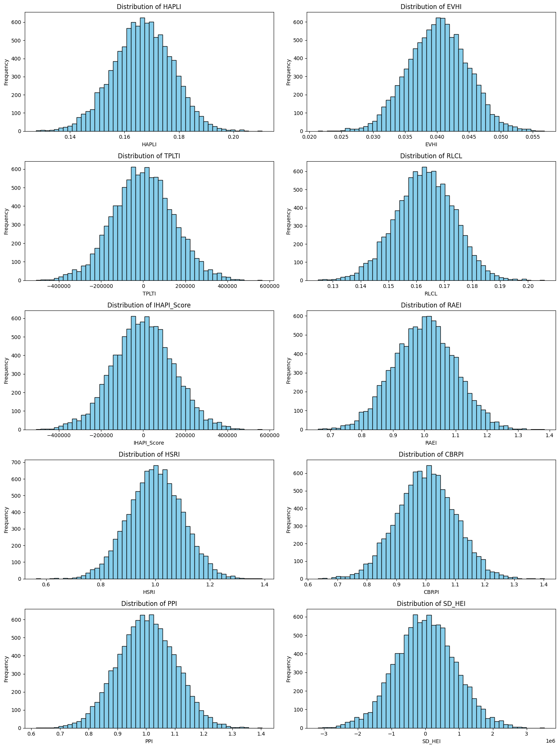
Figure 3. Distributions of Monte Carlo Simulation Outputs for Health and Productivity Indices in Jordan

Table 4. Statistical Summary of Monte Carlo Simulation Outputs for Health and Productivity Indices in Kuwait
Index | count | mean | std | min | 25% | 50% | 75% | max
HAPLI | 10000 | 0.196498 | 0.010546 | 0.158359 | 0.189473 | 0.19649 | 0.203632 | 0.234968
EVHI | 10000 | 0.014008 | 0.005685 | -0.00469 | 0.010142 | 0.013962 | 0.017848 | 0.038163
TPLTI | 10000 | 0.494169 | 2.820878 | -9.07651 | -1.43012 | 0.503864 | 2.37955 | 11.86314
RLCL | 10000 | 0.192967 | 0.010356 | 0.155513 | 0.186068 | 0.192959 | 0.199973 | 0.230746
IHAPI_Score | 10000 | 0.897642 | 2.820729 | -8.67465 | -1.03155 | 0.905843 | 2.78055 | 12.2547
RAEI | 10000 | 1.001187 | 0.098622 | 0.611241 | 0.93506 | 1.001178 | 1.067646 | 1.375103
HSRI | 10000 | 0.999093 | 0.099916 | 0.651547 | 0.93066 | 0.999724 | 1.067547 | 1.381674
CBRPI | 10000 | 1.000138 | 0.100336 | 0.615543 | 0.932756 | 1.00049 | 1.068202 | 1.397871
PPI | 10000 | 0.999134 | 0.100028 | 0.62113 | 0.93008 | 0.998631 | 1.067622 | 1.37083
SD_HEI | 10000 | 0.91477 | 1.481043 | -4.1192 | -0.09609 | 0.924223 | 1.907051 | 6.850534

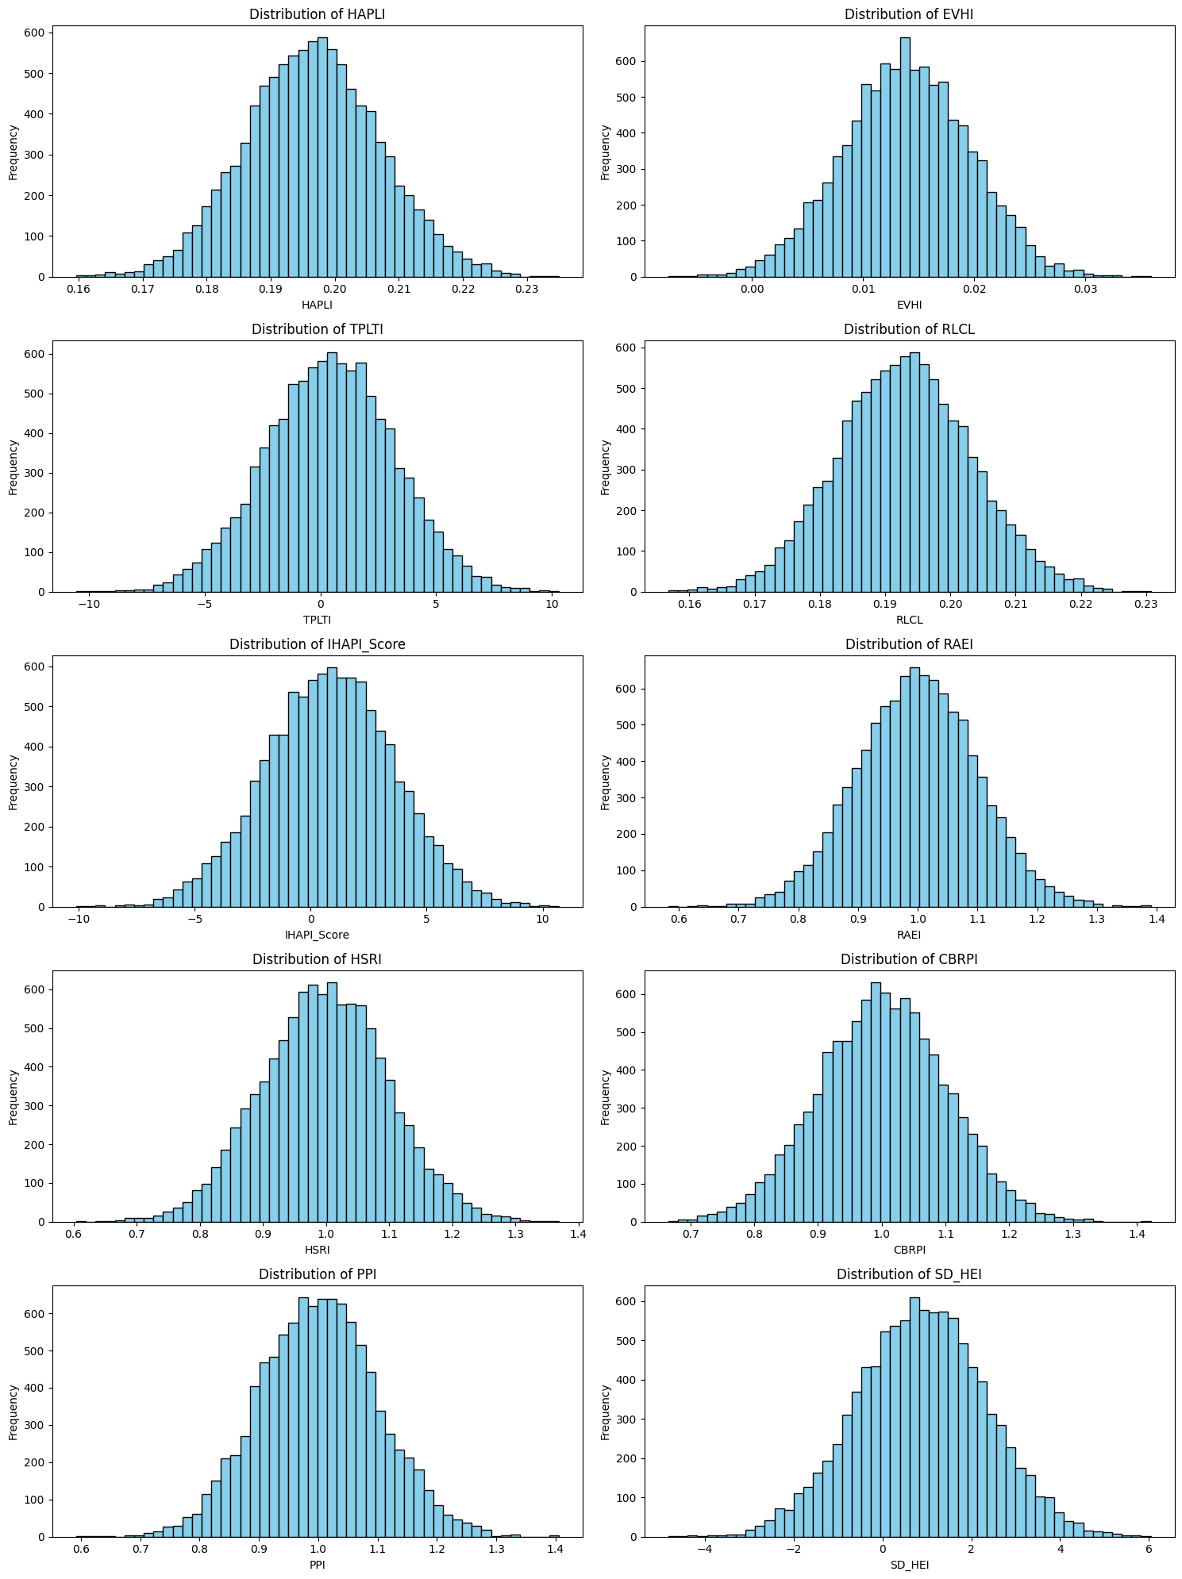
Figure 4. Distributions of Monte Carlo Simulation Outputs for Health and Productivity Indices in Kuwait

Table 5. Statistical Summary of Monte Carlo Simulation Outputs for Health and Productivity Indices in Oman
Index | count | mean | std | min | 25% | 50% | 75% | max
HAPLI | 10000 | 0.177066 | 0.012266 | 0.128353 | 0.16873 | 0.177 | 0.185292 | 0.227493
EVHI | 10000 | 0.014474 | 0.003643 | 0.001617 | 0.012063 | 0.01447 | 0.016954 | 0.028371
TPLTI | 10000 | 232.4239 | 3845.982 | -15372 | -2369.93 | 181.2761 | 2835.961 | 15159.18
RLCL | 10000 | 0.1753 | 0.012144 | 0.127073 | 0.167048 | 0.175235 | 0.183445 | 0.225225
IHAPI_Score | 10000 | 232.7908 | 3845.982 | -15371.7 | -2369.55 | 181.6391 | 2836.353 | 15159.53
RAEI | 10000 | 1.002385 | 0.099874 | 0.621023 | 0.936193 | 1.002988 | 1.070031 | 1.434029
HSRI | 10000 | 1.000639 | 0.100787 | 0.565834 | 0.933007 | 0.999459 | 1.067763 | 1.387637
CBRPI | 10000 | 0.999275 | 0.099733 | 0.593771 | 0.933188 | 0.999363 | 1.066387 | 1.432898
PPI | 10000 | 0.999778 | 0.099415 | 0.64726 | 0.933875 | 0.998395 | 1.066422 | 1.406877
SD_HEI | 10000 | 264.9876 | 4375.059 | -17486.1 | -2695.36 | 206.7915 | 3226.729 | 17245.14

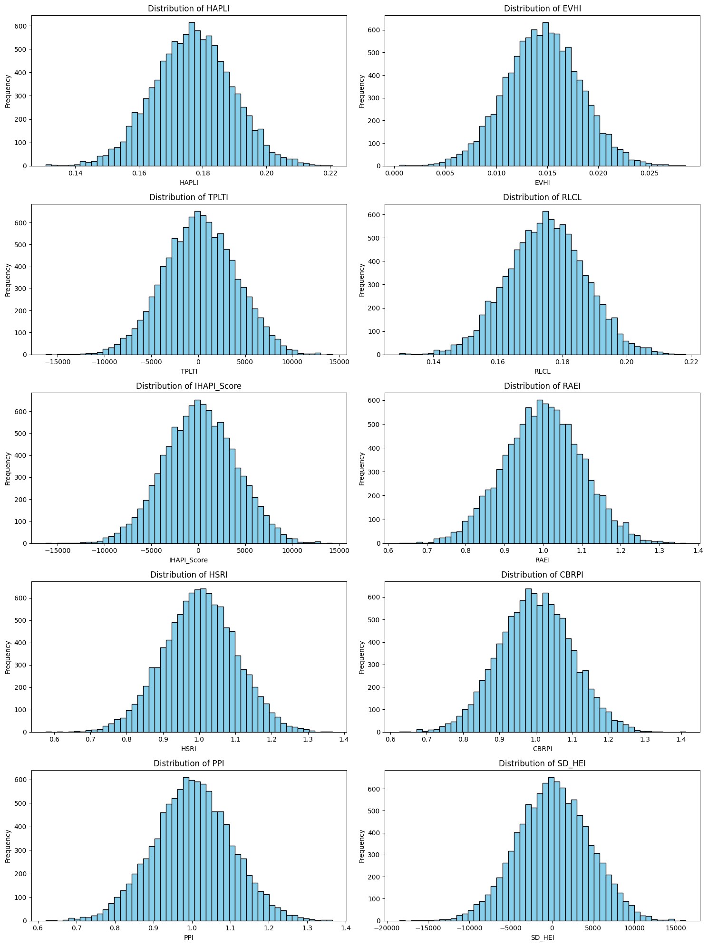
Figure 5. Distributions of Monte Carlo Simulation Outputs for Health and Productivity Indices in Oman

Table 6. Statistical Summary of Monte Carlo Simulation Outputs for Health and Productivity Indices in Saudi Arabia
Index | count | mean | std | min | 25% | 50% | 75% | max
HAPLI | 10000 | 0.184725 | 0.013457 | 0.128471 | 0.175663 | 0.184684 | 0.193691 | 0.233688
EVHI | 10000 | 0.021402 | 0.004887 | 0.00048 | 0.018081 | 0.021399 | 0.024708 | 0.039183
TPLTI | 10000 | 2396.902 | 167494.9 | -687252 | -110649 | 3769.774 | 115612.9 | 638343
RLCL | 10000 | 0.183838 | 0.013393 | 0.127854 | 0.174819 | 0.183798 | 0.192761 | 0.232566
IHAPI_Score | 10000 | 2397.292 | 167494.9 | -687252 | -110648 | 3770.142 | 115613.3 | 638343.4
RAEI | 10000 | 1.000556 | 0.100104 | 0.58437 | 0.932816 | 1.000104 | 1.068051 | 1.353243
HSRI | 10000 | 1.001303 | 0.10053 | 0.610097 | 0.933598 | 1.001713 | 1.068879 | 1.371454
CBRPI | 10000 | 0.99977 | 0.10119 | 0.656403 | 0.931918 | 0.998837 | 1.069372 | 1.362343
PPI | 10000 | 1.000128 | 0.101231 | 0.580438 | 0.933386 | 1.000055 | 1.069469 | 1.366673
SD_HEI | 10000 | 3068.083 | 214353.6 | -879519 | -141603 | 4824.995 | 147957.6 | 816927.6

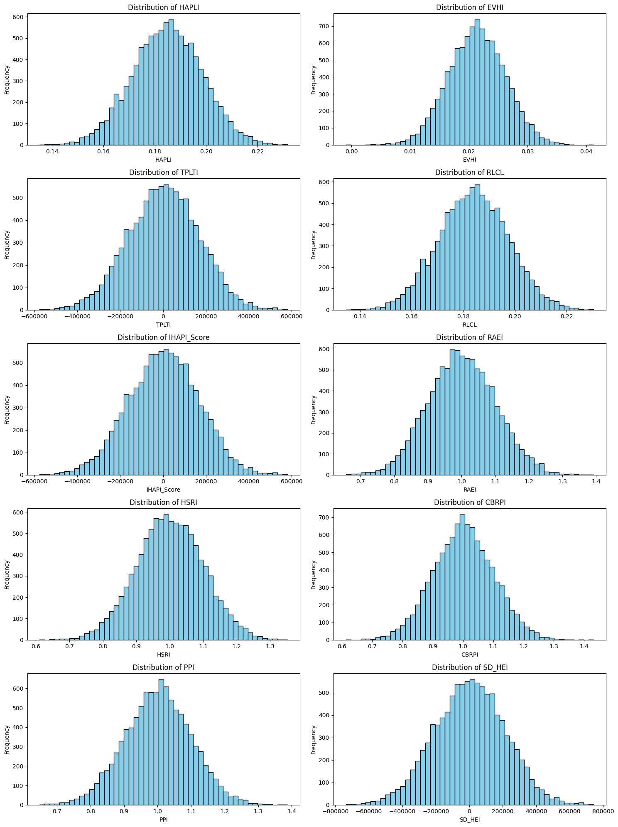
Figure 6. Distributions of Monte Carlo Simulation Outputs for Health and Productivity Indices in Saudi Arabi

Table 7. Statistical Summary of Monte Carlo Simulation Outputs for Health and Productivity Indices in Turkey
Index | count | mean | std | min | 25% | 50% | 75% | max
HAPLI | 10000 | 0.155583 | 0.013837 | 0.098266 | 0.146257 | 0.155556 | 0.164864 | 0.208523
EVHI | 10000 | 0.022396 | 0.001964 | 0.015312 | 0.021057 | 0.022372 | 0.023723 | 0.029974
TPLTI | 10000 | 95388.94 | 4315326 | -1.8E+07 | -2814578 | 53692.47 | 2992342 | 17670659
RLCL | 10000 | 0.155086 | 0.013793 | 0.097952 | 0.145789 | 0.155059 | 0.164338 | 0.207856
IHAPI_Score | 10000 | 95389.27 | 4315326 | -1.8E+07 | -2814578 | 53692.78 | 2992342 | 17670660
RAEI | 10000 | 0.997505 | 0.101629 | 0.601262 | 0.927032 | 0.998311 | 1.067254 | 1.438517
HSRI | 10000 | 0.99854 | 0.101254 | 0.59507 | 0.930896 | 0.999374 | 1.067321 | 1.422192
CBRPI | 10000 | 0.999317 | 0.099732 | 0.643586 | 0.932403 | 0.998818 | 1.066449 | 1.379623
PPI | 10000 | 1.000921 | 0.098967 | 0.641061 | 0.933926 | 1.000279 | 1.06759 | 1.378674
SD_HEI | 10000 | 189895.2 | 8590695 | -3.6E+07 | -5603094 | 106888.3 | 5956978 | 35177702

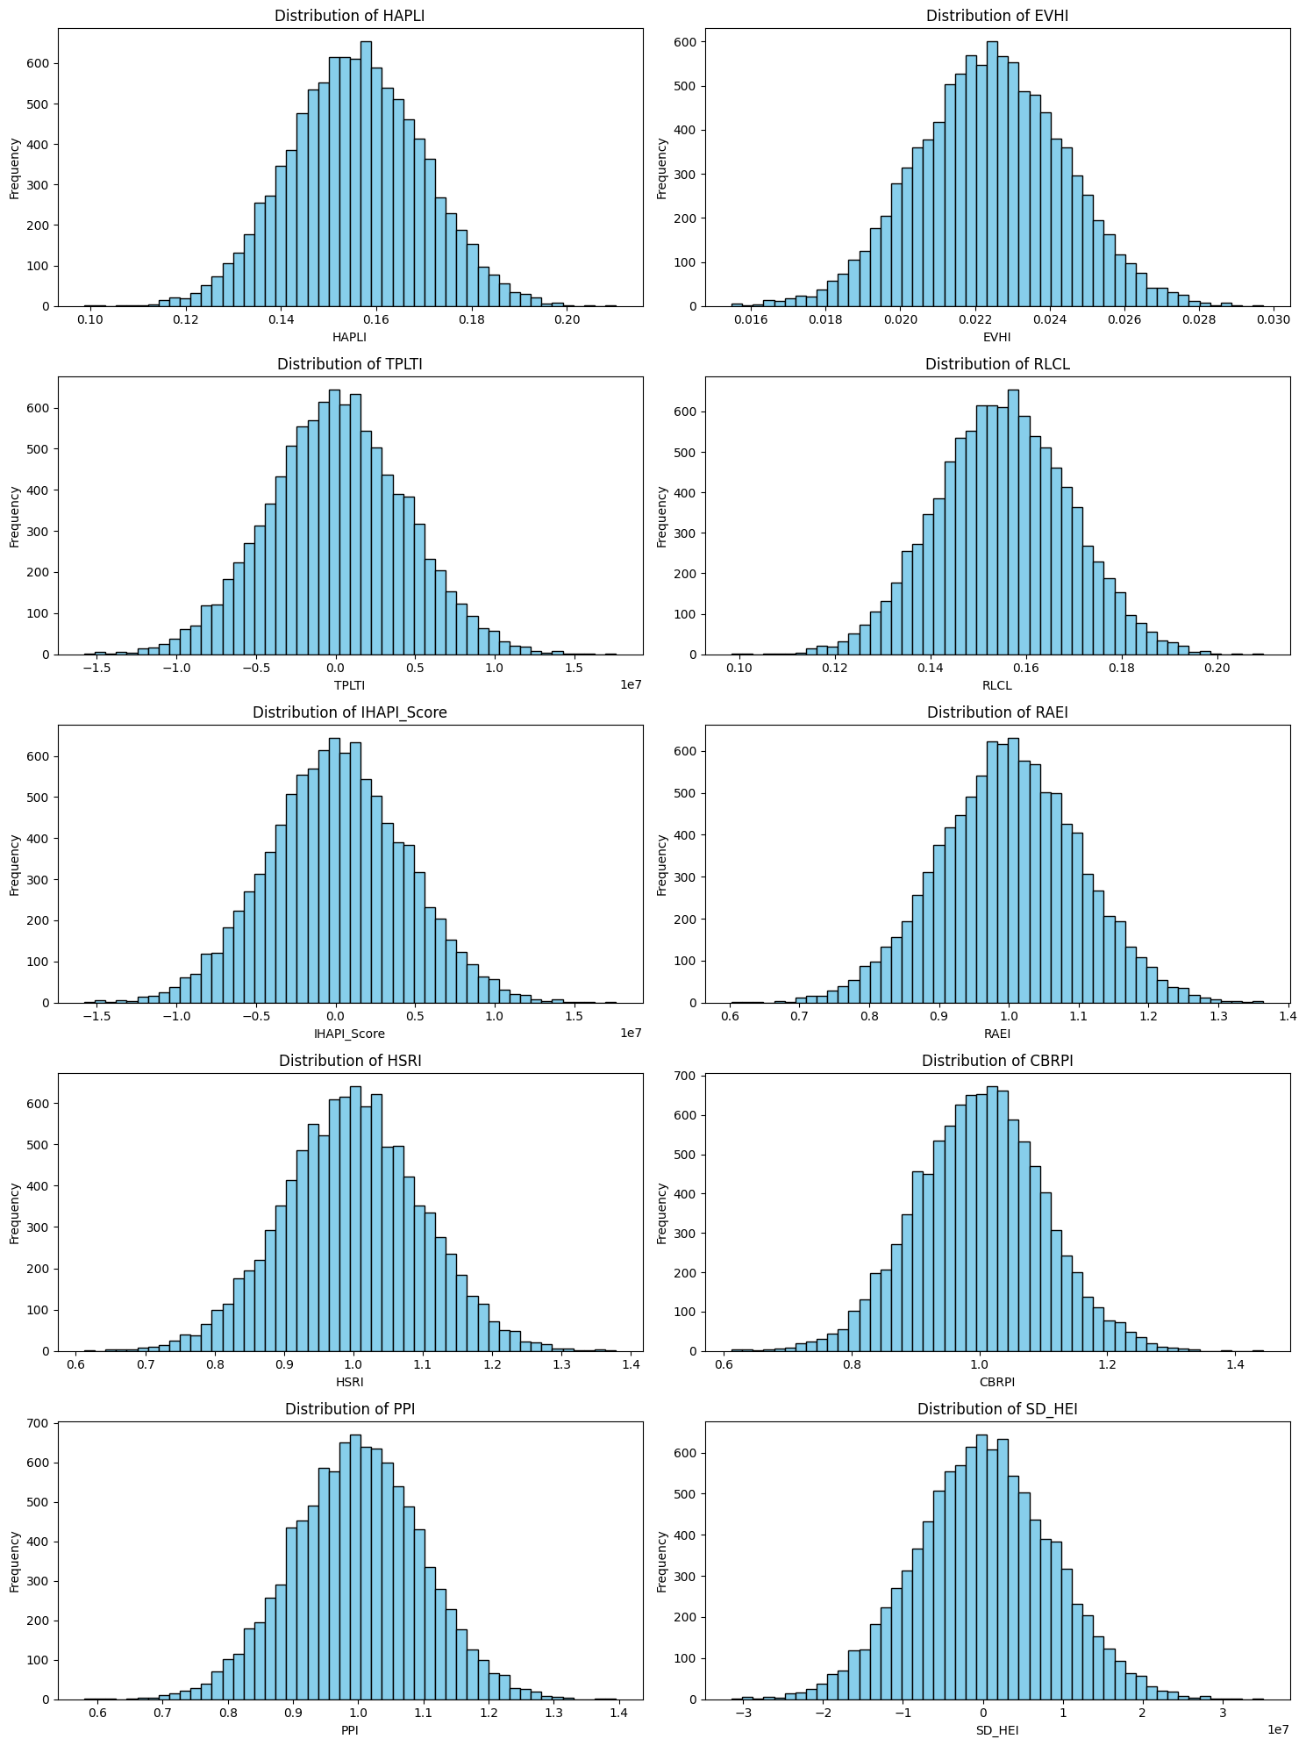
Figure 7. Distributions of Monte Carlo Simulation Outputs for Health and Productivity Indices in Turkey
Table 8. Statistical Summary of Monte Carlo Simulation Outputs for Health and Productivity Indices in the United Arab Emirates
Index | count | mean | std | min | 25% | 50% | 75% | max
HAPLI | 10000 | 0.204729 | 0.006663 | 0.176343 | 0.200259 | 0.204718 | 0.209125 | 0.232527
EVHI | 10000 | 0.01427 | 0.003892 | -0.00248 | 0.011647 | 0.014263 | 0.016914 | 0.028486
TPLTI | 10000 | 294.4526 | 11988.39 | -41956.4 | -7735.29 | 296.1631 | 8310.193 | 47906.47
RLCL | 10000 | 0.204075 | 0.006641 | 0.175779 | 0.199619 | 0.204064 | 0.208457 | 0.231783
IHAPI_Score | 10000 | 294.8757 | 11988.39 | -41956 | -7734.86 | 296.5953 | 8310.601 | 47906.89
RAEI | 10000 | 0.997065 | 0.09957 | 0.599263 | 0.929174 | 0.997544 | 1.064319 | 1.421484
HSRI | 10000 | 0.998033 | 0.099638 | 0.631854 | 0.930159 | 0.999153 | 1.064861 | 1.378592
CBRPI | 10000 | 0.999307 | 0.100711 | 0.573625 | 0.932803 | 0.999402 | 1.067854 | 1.376005
PPI | 10000 | 0.998977 | 0.100472 | 0.589598 | 0.931263 | 0.998066 | 1.067544 | 1.380731
SD_HEI | 10000 | 150.169 | 6086.196 | -21299.5 | -3926.32 | 151.0478 | 4219.536 | 24321.56

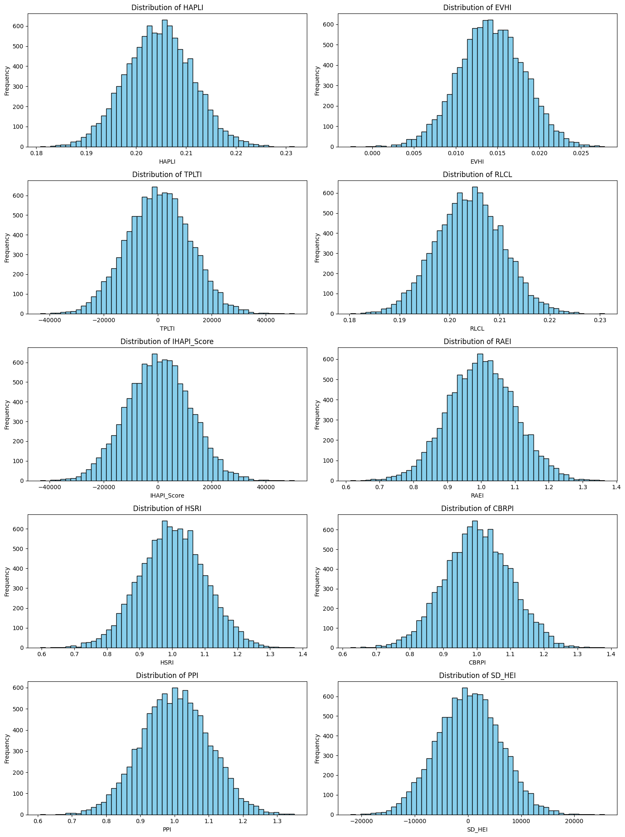
Figure 8. Distributions of Monte Carlo Simulation Outputs for Health and Productivity Indices in the United Arab Emirates

