Supplementary Fig. 1 The response of Arabidopsis to Na-PPi with or without NaCl treatment. Arabidopsis of 40 DAG in response to 1 mM Na-PPi combined with or without 50 mM NaCl stress (A). And the corresponding measurements of plant height (B) and fresh weight (C).

Supplementary Fig. 2 The growth response of Arabidopsis to varying concentrations of K₄P₂O₇ under both non-saline and saline conditions. The growth status of 9 DAG Arabidopsis seedlings cultivated on 0 mM and 50 mM NaCl plates containing K₄P₂O₇ at concentrations of 0, 0.5, 1, 1.5, and 2 mM (A). And the corresponding quantification for fresh weight (B) and root length (C) across these different treatments. Different lowercase letters and uppercase letters represent significant differences between K-PPi treatments at different concentrations under 0 mM and 50 mM NaCl stress, respectively. NA stands for non-available. Bars = 1cm.

Supplementary Fig. 3 The response of Arabidopsis to varying medium pH levels regulated by different concentrations of Na-PPi. The growth state of 9 DAG Arabidopsis seedlings under pH conditions of 5.85, 6.80, 7.30, and 7.90, mimicked by the exogenous application of 0, 0.5, 1, and 1.5 mM Na-PPi, respectively (A). And the corresponding results for root length (B) and fresh weight (C) of seedlings.

Supplementary Fig. 4 The response of mineral element contents to PPi under different NaCl concentrations. The determination of K (A), Na (B), Mg (D), Ca (E), and Fe (F) contents and K/Na ratio (C) in Arabidopsis seedlings under 0 and 50 mM NaCl concentrations with or without 1 mM Na-PPi.

Supplementary Fig. 5 The number of up- and down-regulated DEGs induced by 1 mM Na-PPi under 0 and 50 mM NaCl concentrations.

Supplementary Fig. 6 Heat maps showing the canonical DEGs associated with "MAPK signaling pathway" (A), "response to oxidative stress" (B) and "response to salt/osmotic stress" (C). Color panels represent log₂(fold change). Asterisks indicate statistically significant differences with FDR < 0.05 and fold change ≥ 2.

Supplementary Fig. 7 The distribution patterns of Na-PPi-induced DEGs under 0 and 50 mM NaCl concentrations. Venn diagram illustrating the number of DEGs identified in the comparative groups between “1 mM Na-PPi vs CK” and “50 mM NaCl + 1 mM Na-PPi vs 50 mM NaCl” (A). GO enrichment analysis of 451 uniquely expressed genes in “1 mM Na-PPi vs CK” (B). GO enrichment analysis of 208 uniquely expressed genes in “50 mM NaCl + 1 mM Na-PPi vs 50 mM NaCl” (C). GO enrichment analysis of 71 co-expressed DEGs shared between the two comparative groups (D). Heatmap displaying eight DEGs with distinct expression patterns and five canonical DEGs with consistent expression profiles across treatments (E).
Supplementary Fig. 8 The response of anthocyanin content in Arabidopsis seedlings to 1 mM Na-PPi, 50 mM NaCl and 1 mM Na-PPi + 50 mM NaCl treatments.

Supplementary Fig. 9 Transcriptional responses of pyrophosphatase genes to NaCl and Na-PPi treatments. qPCR analysis of the expression responses of PPa1 (A), PPa2 (B), PPa3 (C), PPa4 (D), PPa5 (E), PPa6 (F), VP2 (G), and AVP1 (H) genes to 50 mM NaCl, 1 mM Na-PPi and the combination of 50 mM NaCl and 1 mM Na-PPi treatments.

Supplementary Fig. 10 The responses of pyrophosphatase to NaCl and Na-PPi treatments. The response of alkaline inorganic pyrophosphatase (A), acid inorganic pyrophosphatase (B), and AVP1 (C) activities to 50 mM NaCl, 1 mM Na-PPi, and the combination of 50 mM NaCl and 1 mM Na-PPi treatments.

Supplementary Fig. 11 The transcriptional responses of SOS genes to NaCl and Na-PPi treatments. The transcriptional response of SOS1 (A), SOS2 (B), and SOS3 (C) to the 50 mM NaCl and 1 mM Na-PPi treatment.

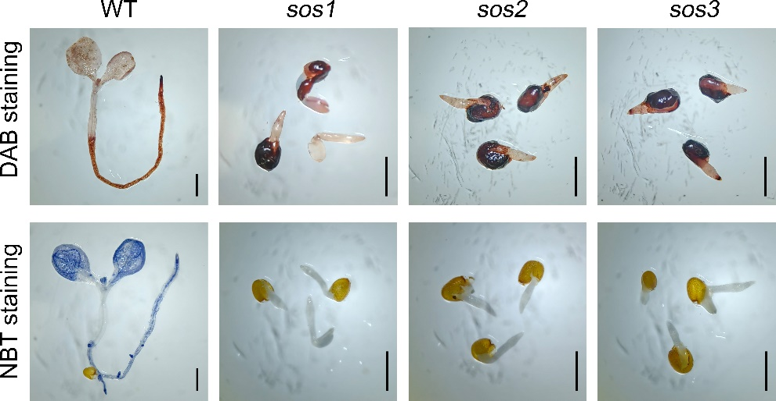
Supplementary Fig. 12 DAB and NBT staining for the sos mutants. ROS accumulation in WT, sos1, sos2, and sos3 mutants was visualized by DAB and NBT staining following 50 mM NaCl + 1 mM Na-PPi treatment. Bar = 1 mm.

Supplementary Table 1. The primer pairs used for the q-PCR analysis.
Genes | Forward (5’-3’) | Reverse (5’-3’)
IOS1 | GCTATGAACATTTCGCTAGTCG | GACGTGGTGAAATTAAGTGGTC
PRB1 | AAAGTCACAAGCTACTCTCGAA | GAGTCTGCAGTCTCCTTTTAGT
ZAT11 | GATTTTCTTCGTTTCAAGCCCT | TTTCACATCTTTCTGCTCAACG
OSM34 | GACGAACCAATACTGTTGTACG | GTAGTTAGTGTTGGTGCAAGTG
SRO5 | GATGGGATGAGATTCTTGTTGC | TGATGCAAACAAGAAACTCAGG
AT2G21640 | GAAGGATGATAACGCCACTTTC | TTAGTCACTGCTGTCTGAAGAG
ZAT7 | TCTCATCCTTGTCCGATATGTG | GAAAAGAACGTGTAACCAACGA
ALMT1 | AAATCAGGCATCTTGAACGATG | GAATCCGACTTCTCGTATAGCA
PAP1 | GAAAAAGAGAGACATTACGCCC | ATTAACGTCAACTTTTGGTGGG
MIOX2 | AAGGAAACTGATGCATTCGATG | AGTCATAGGTCTGGTGAATGTG
ASN1 | TTGTGAAGTCATTGCTCACTTG | GTCATCGTTTAGGCCTTTCATC
HAK5 | CATGGTCATTGGTGATGGAATC | GAGAATCCAACTTTATCGGTGC
CRK6 | AAGTTTTGTTTCCTCCACGATG | GTACAAATTCTGGTATGCGGTC
GSTF12 | AGATACTACGCTACCAAGTTCG | TGATTAGGTTAATCACGAGGGG
PPa1 | GACCCCATTGATGTCTTAGTCA | TCTTTGATGTCAGTGTAGTGCT
PPa2 | CTAGACAAGAACAGTGGCCTTA | ACATCCATTGGATCACTGTCTT
PPa3 | ACAAAATCATAGCCGTATGTGC | CTGAATAGCTTCATGTGCACTC
PPa4 | GTCTCATTAAGGTCGACCGTAT | TGTAATGGCGATACTCTGGATC
PPa5 | TTTGTCTAAGAGATCGGTTGCT | TCATATTTGACTTTGCTCCCCT
PPa6 | TAGACTGGAAGATTGTTGCCAT | CCATCTGGGATCTTGTAGTCTC
VP2 | CTATGCTCATGTTTGCAACAGT | AGTCGCAAGCATTTTTATGAGG
AVP1 | CTGTCATTGCTGATAATGTCGG | GATTCCCATTGAACTGATGAGC
SOS1 | ATTTTGATGCAGTCAGTGGATG | GCAAGCAGATTCTAGTCTTTCG
SOS2 | GCGAACTCAATGGGTTTTAAGT | CTTACGTCTACCATGAAAAGCG
SOS3 | CCGGTCCATGAAAAAGTCAAAT | CTCTTTCAATTCTTCTCGCTCG
UBQ10 | AATTGGAGGATGGTCGTACTTT | CAAAGTCTTGACGAAGATCTGC

