Additional file 1: Figure S1.
Phenotype analysis of TaWRKY28/33/40/47 gene silencing plants under drought
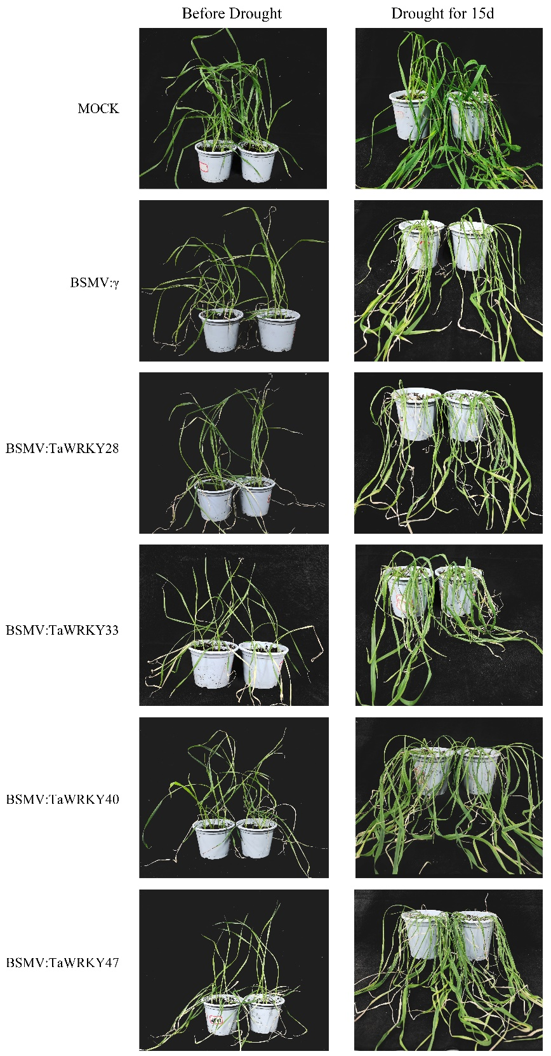

Additional file 1: Table S1.

NO. | Gene name | primer | Product size (bp)
1 | TraesCS3A02G325100.3 | F: TGAGGTCGAGAGGATCAAGGCG  R: CTGGAAGAAACAAGGAGGCAGTC | 122
2 | TraesCS7D02G334600.1 | F: AGTGATGGCGAGCAGCGTC  R: TCGGCTCTACATCCTTCTCGCT | 149
3 | TraesCSU02G151100.1 | F: CGTCCGCGGGGAGATGGCCAA  R: CGTCGGTCGATTCCAGCAGG | 128
4 | TraesCS2A02G108000.1 | F: CCAATGCAGAAAATGACCTCCCAC  R: GCCTCGTTGTAGATCCTGTTCCTG | 166
5 | TraesCS1B02G096300.1 | F: TACAAGCACACGTGCCCGCAG  R: CACGTAGGCTGGGGTTGTTCG | 208
6 | TraesCS1B02G354800.1 | F: CGTCATGGAGAAGGCCATCTCC  R: GGTCCAGGAGGACGGAAGCAT | 110
7 | TraesCS1B02G330500.1 | F: GTCGAGAGAGTGAAGGCCGC  R: GTCGGTCTCGTTGGAAATGGAC | 168
8 | TraesCS1B02G355200.1 | F: CGTCATGGAGAAGGCCATCTCC  R: GGCTGAGTTTCTCCGGTGTCG | 146
9 | TraesCS1A02G070400.1 | F: GACGCTGAGCGATATAGACATACTC  R: ATCACCGCGCGGTTGTCGTG | 168
10 | TraesCS1A02G301100.1 | F: TTGAGGAACAAGTTTGAGACAAGC  R: TTGTTCATCACCGGCTACCA | 92
11 | TraesCS2A02G214400.1 | F: AGTTGATATCTGCCTCTGCGTGGC  R: CTCTGCATCCTCAGAGCATGCTCC | 123
12 | TraesCSU02G016900.2 | F: TCCGCTGCCAAGCTGCTTTCAG  R: CTTATCCGCCCGTCCTTGTCTATGT | 145
13 | TraesCS6D02G136200.1 | F: AGAAGGTGACCAAGGACAAC  R: CTTCCTGCTTGTGCTGCT | 264
14 | TraesCS5A02G225600.1 | F: GATGCCAACAGCGACAAG  R: TCCGCCATTGATACCCAT | 166
15 | TraesCS3D02G238300.1 | F: ACGCAGGTGAGGGTGAACTCC  R: TGGGTACTTGGCTCCGAGGATG | 102
16 | β-actin | F: CGACTCTGGTGATGGTGTGAG  R: AGCAAGGTCCAAACGAAGGA | 86

Additional file 1: Table S2.

Primer name | Sequence of primer(5’- 3’)
γ-TaWRKY28 | F: TTTTTAGCTAGCTGATTAATTAACTAGTCACCGCGAGCCC  R: TCCGTTGCTAGCTGAGCGGCCGCCGAACTCGTCGGGAAGG
γ-TaWRKY33 | F: TTTTTAGCTAGCTGATTAATTAAAGAACGACGGCTCCGGC  R: TCCGTTGCTAGCTGAGCGGCCGCTCCCTCGTCAGCGTCATG
γ-TaWRKY40 | F: TTTTTAGCTAGCTGATTAATTAAGAGCCGTCTCCGGCGAG  R: TCCGTTGCTAGCTGAGCGGCCGCGGTTATTAGCGTACAGGTAGC
γ-TaWRKY47 | F: TTTTTAGCTAGCTGATTAATTAAACGCTAGTGTCGAGCATGC  R: TCCGTTGCTAGCTGAGCGGCCGCCTTCTTGGACTGCCCAGC

